Supplemental Text 2. Forest plots (age and gender stratified subgroup analysis).

Severe loneliness
No access to outdoor facilities vs access to outdoor facilities

Severe loneliness
Household density ≥43m² vs <43m²
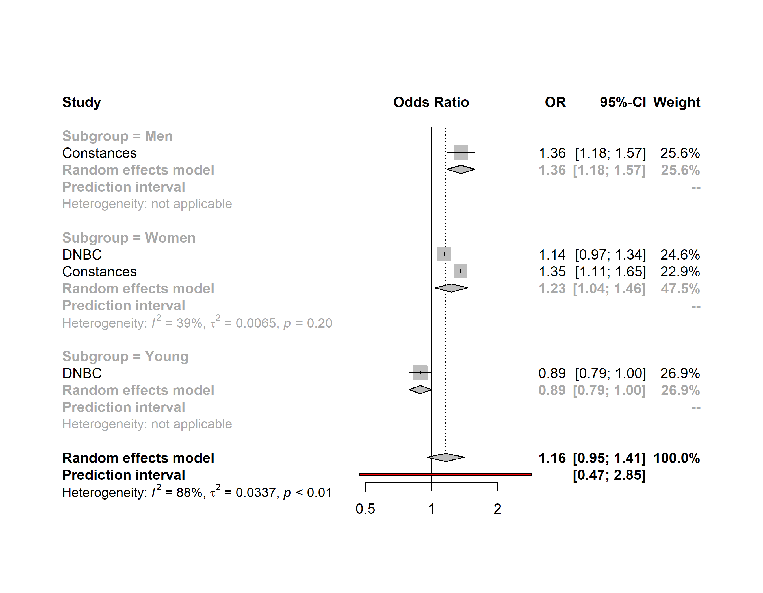

Severe loneliness
Household crowded vs. ideal
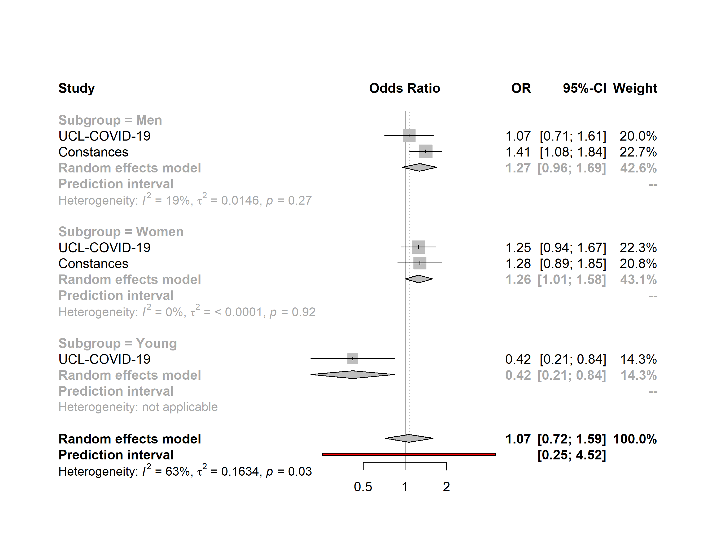

Severe loneliness
Household underoccupied vs. ideal
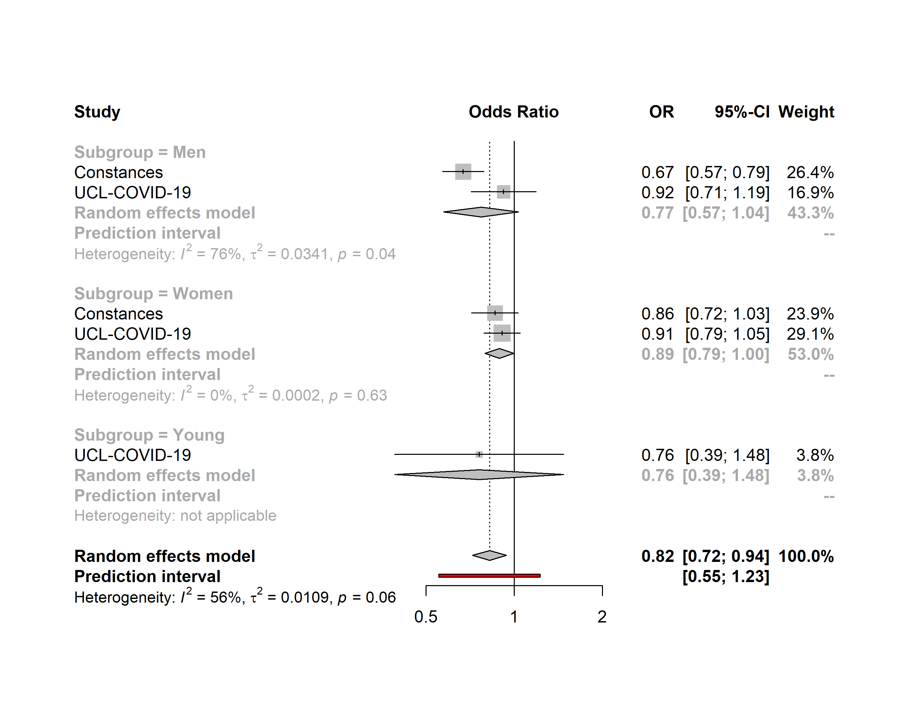

Severe loneliness
Households with children vs. Adults-only households
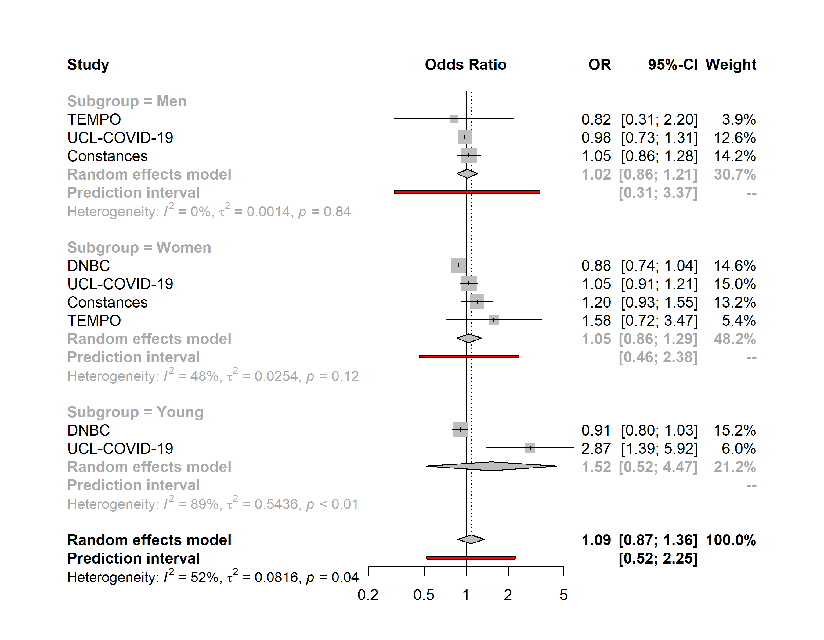

Severe loneliness
Living alone vs. Adults-only households
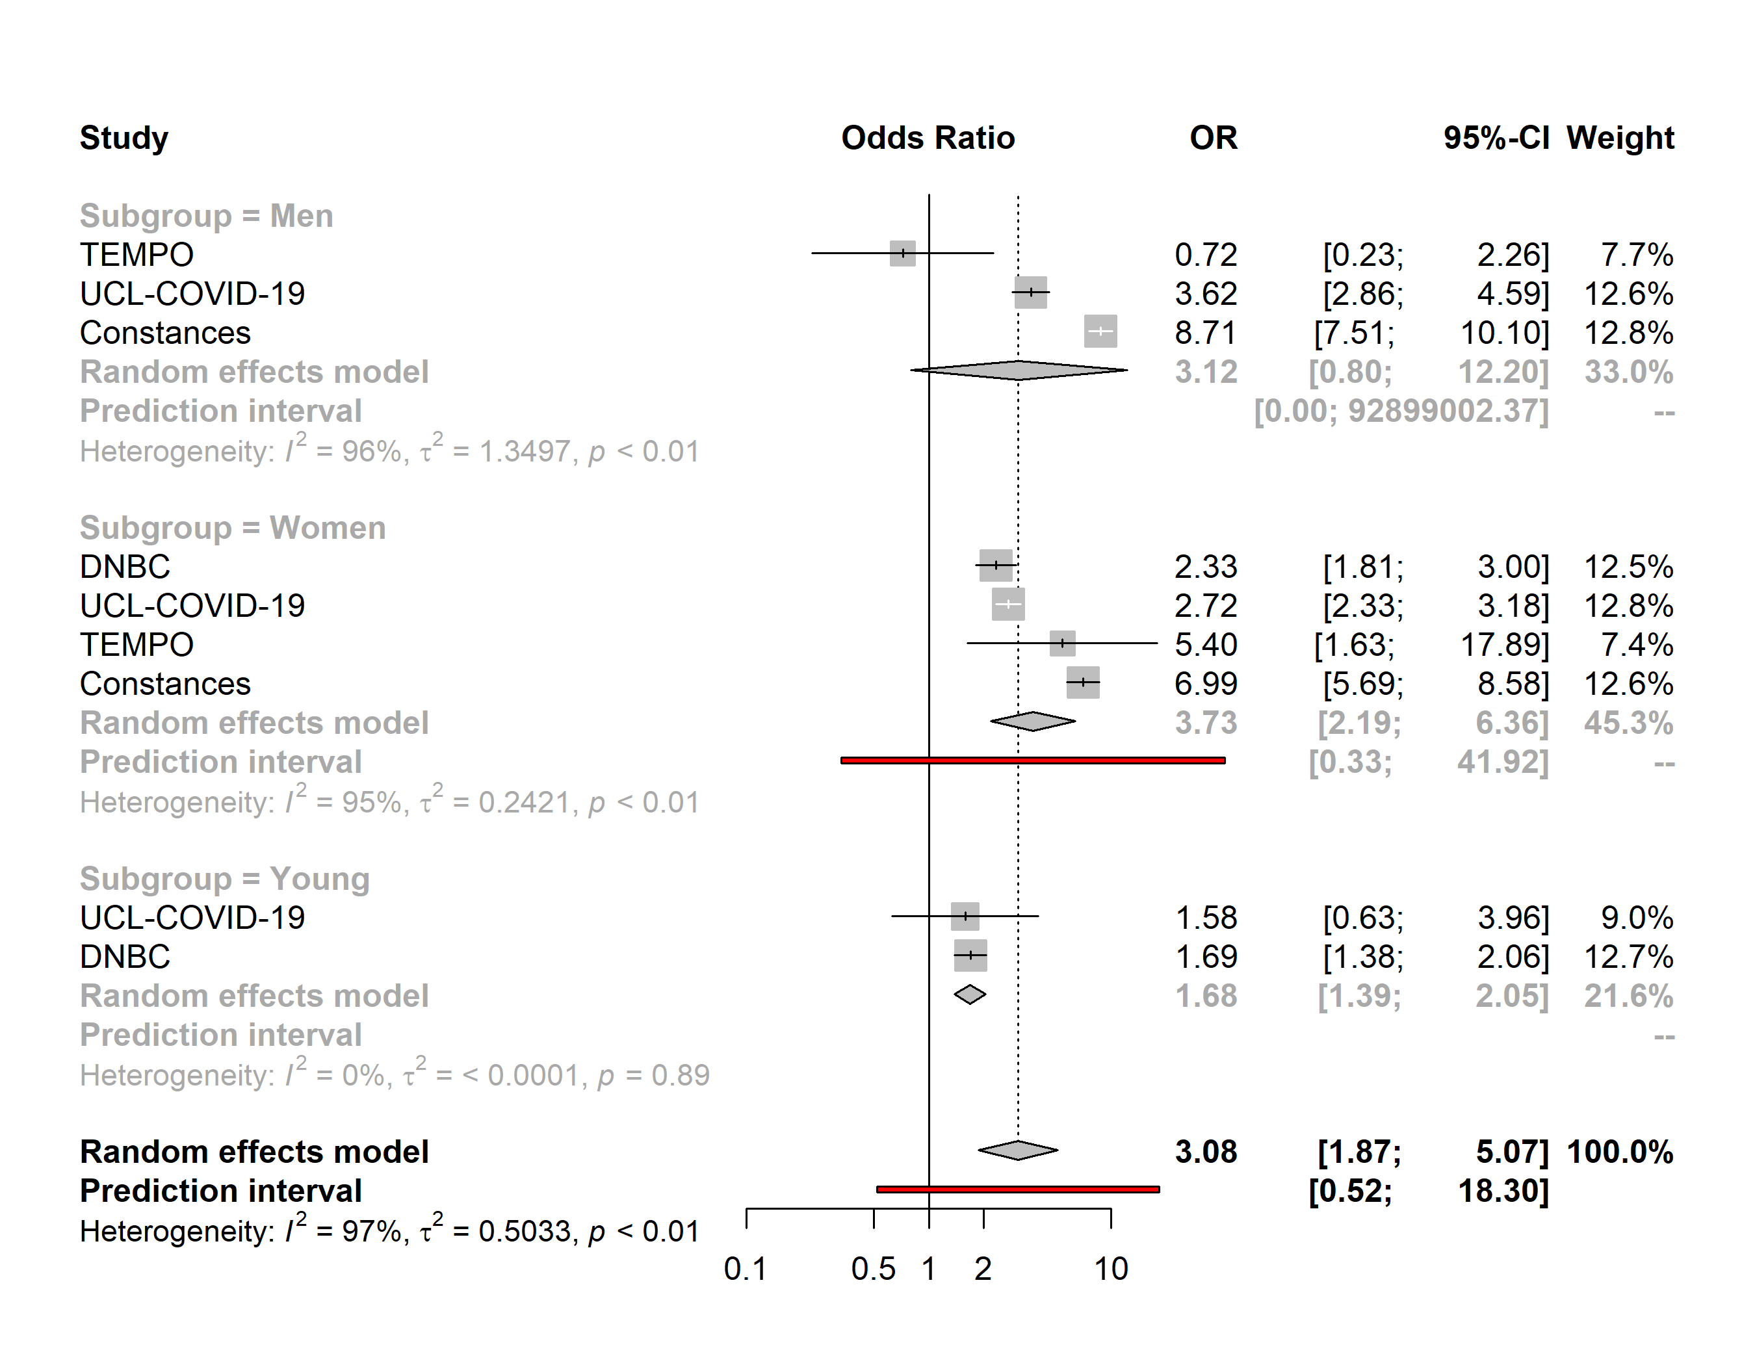

Severe loneliness
Apartment vs. House
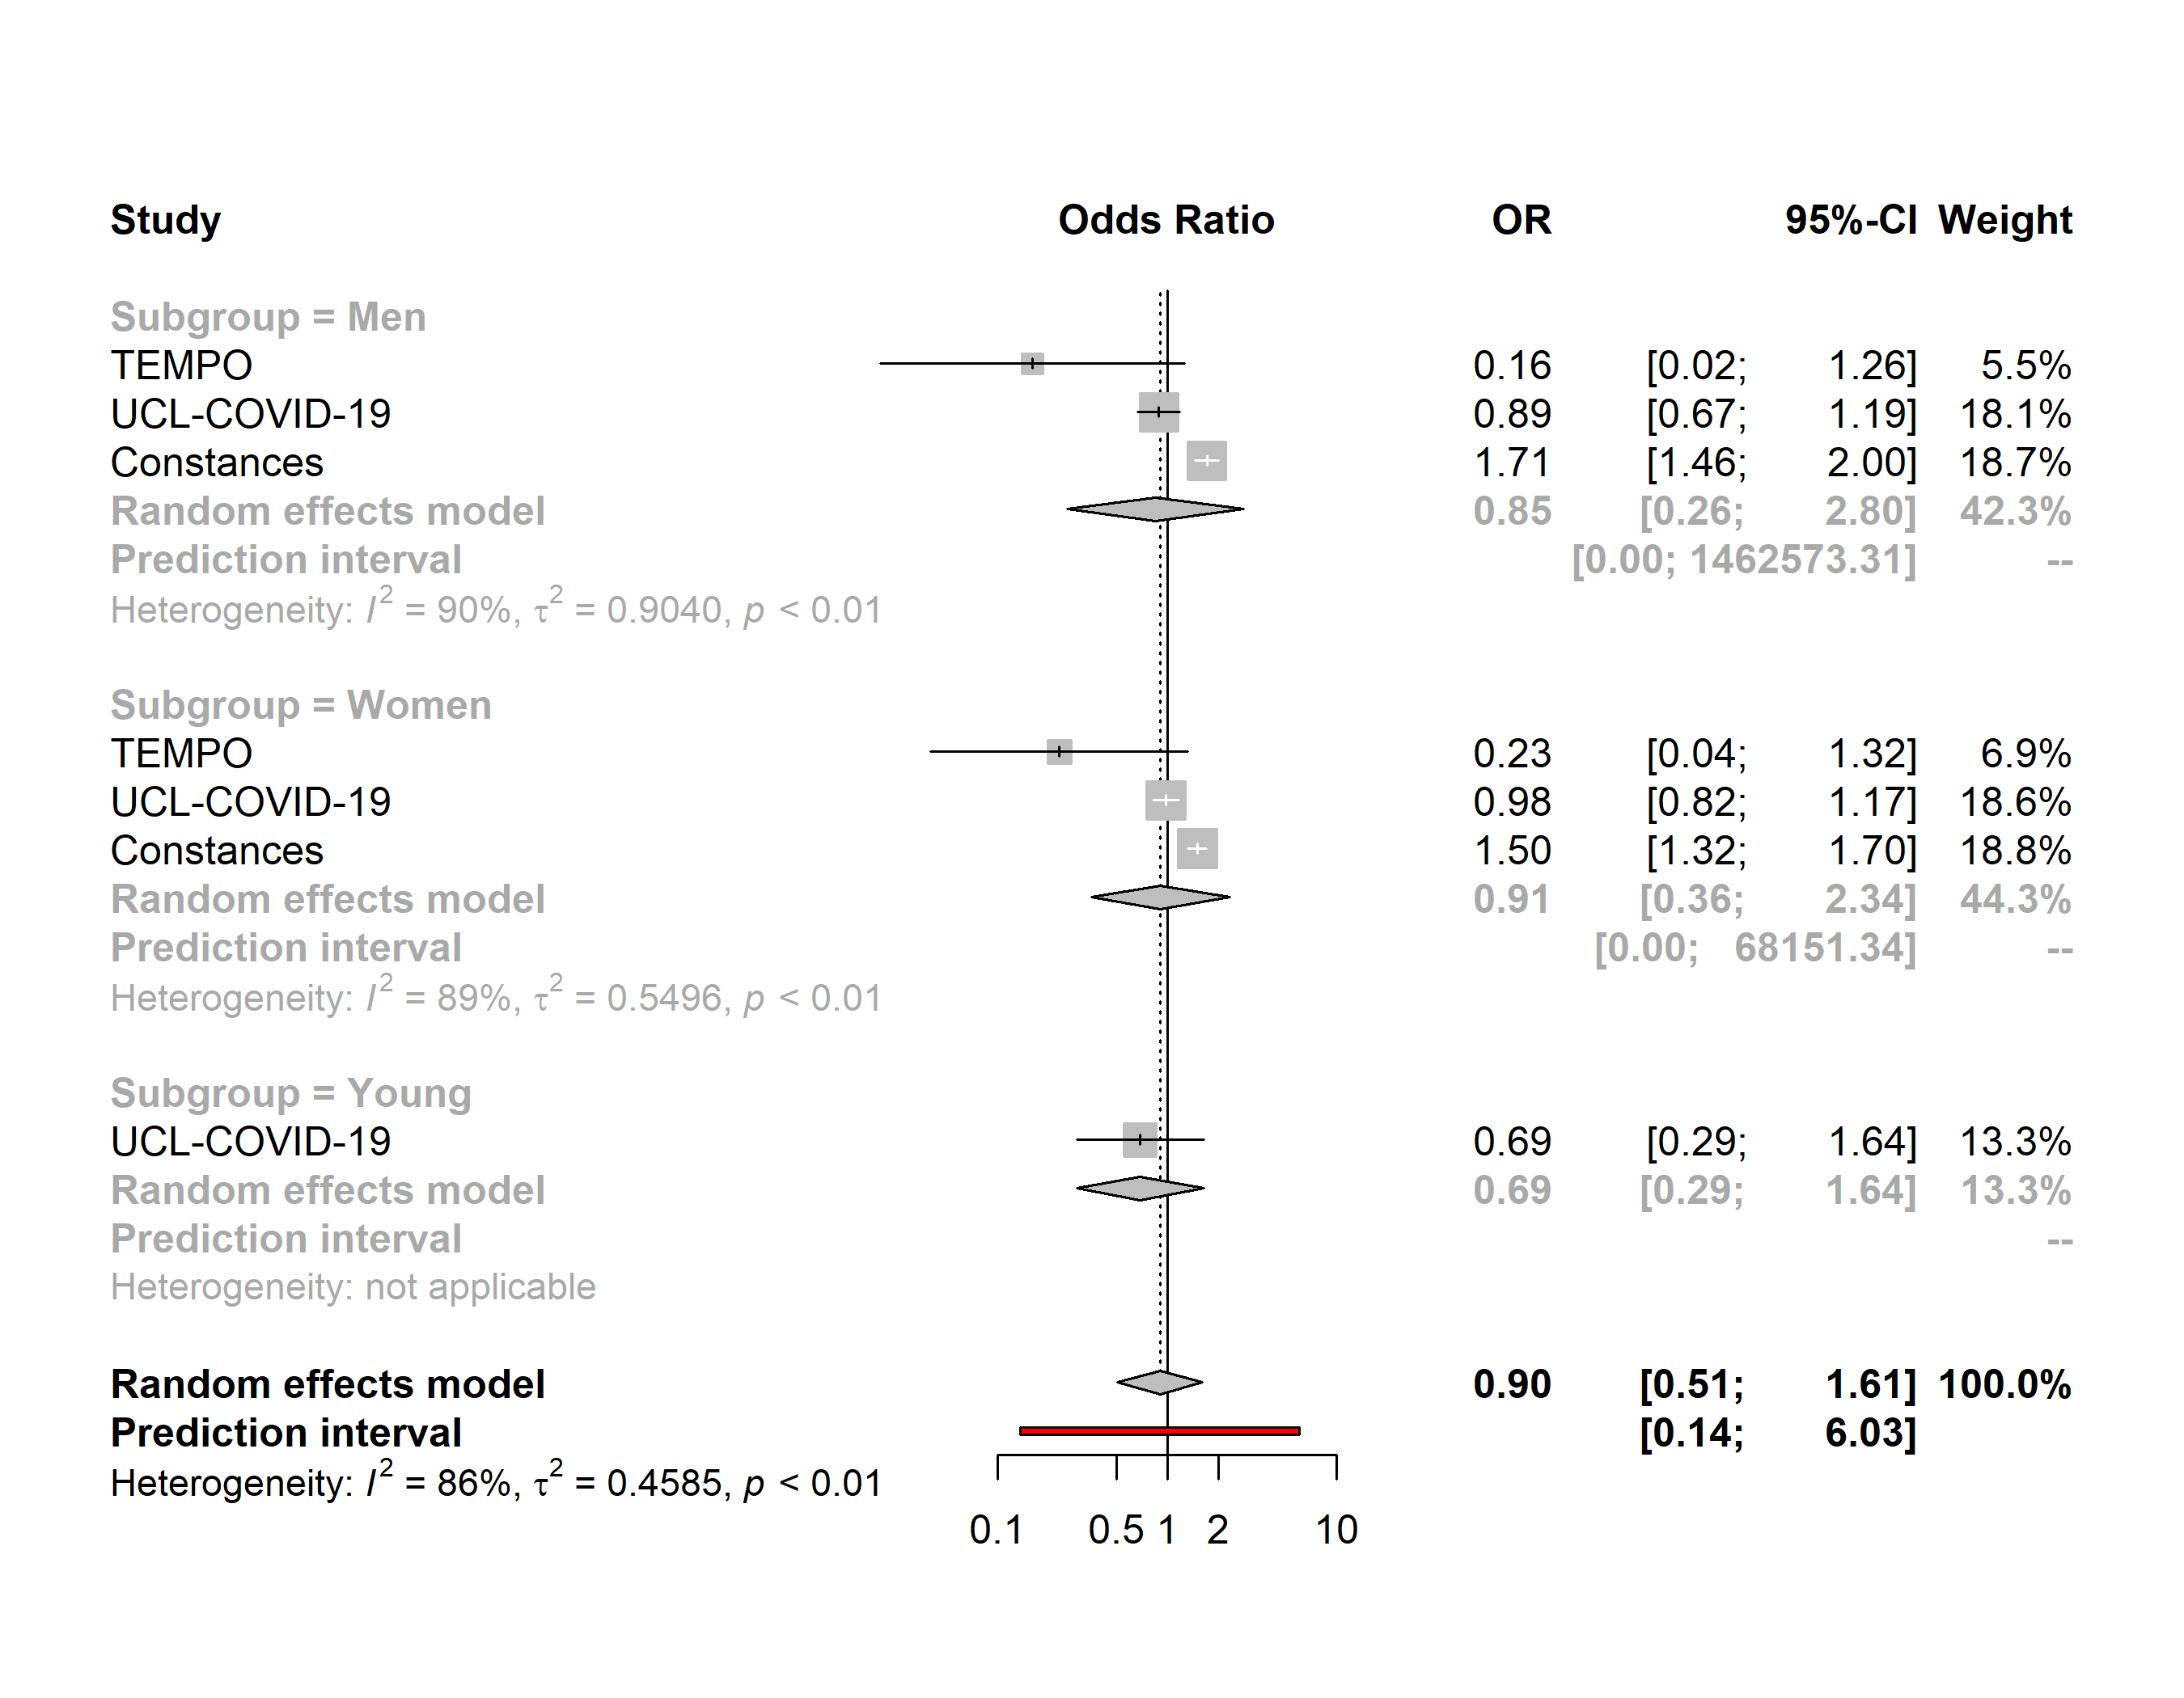

Severe loneliness
Semi-urban environment vs. Urban environment
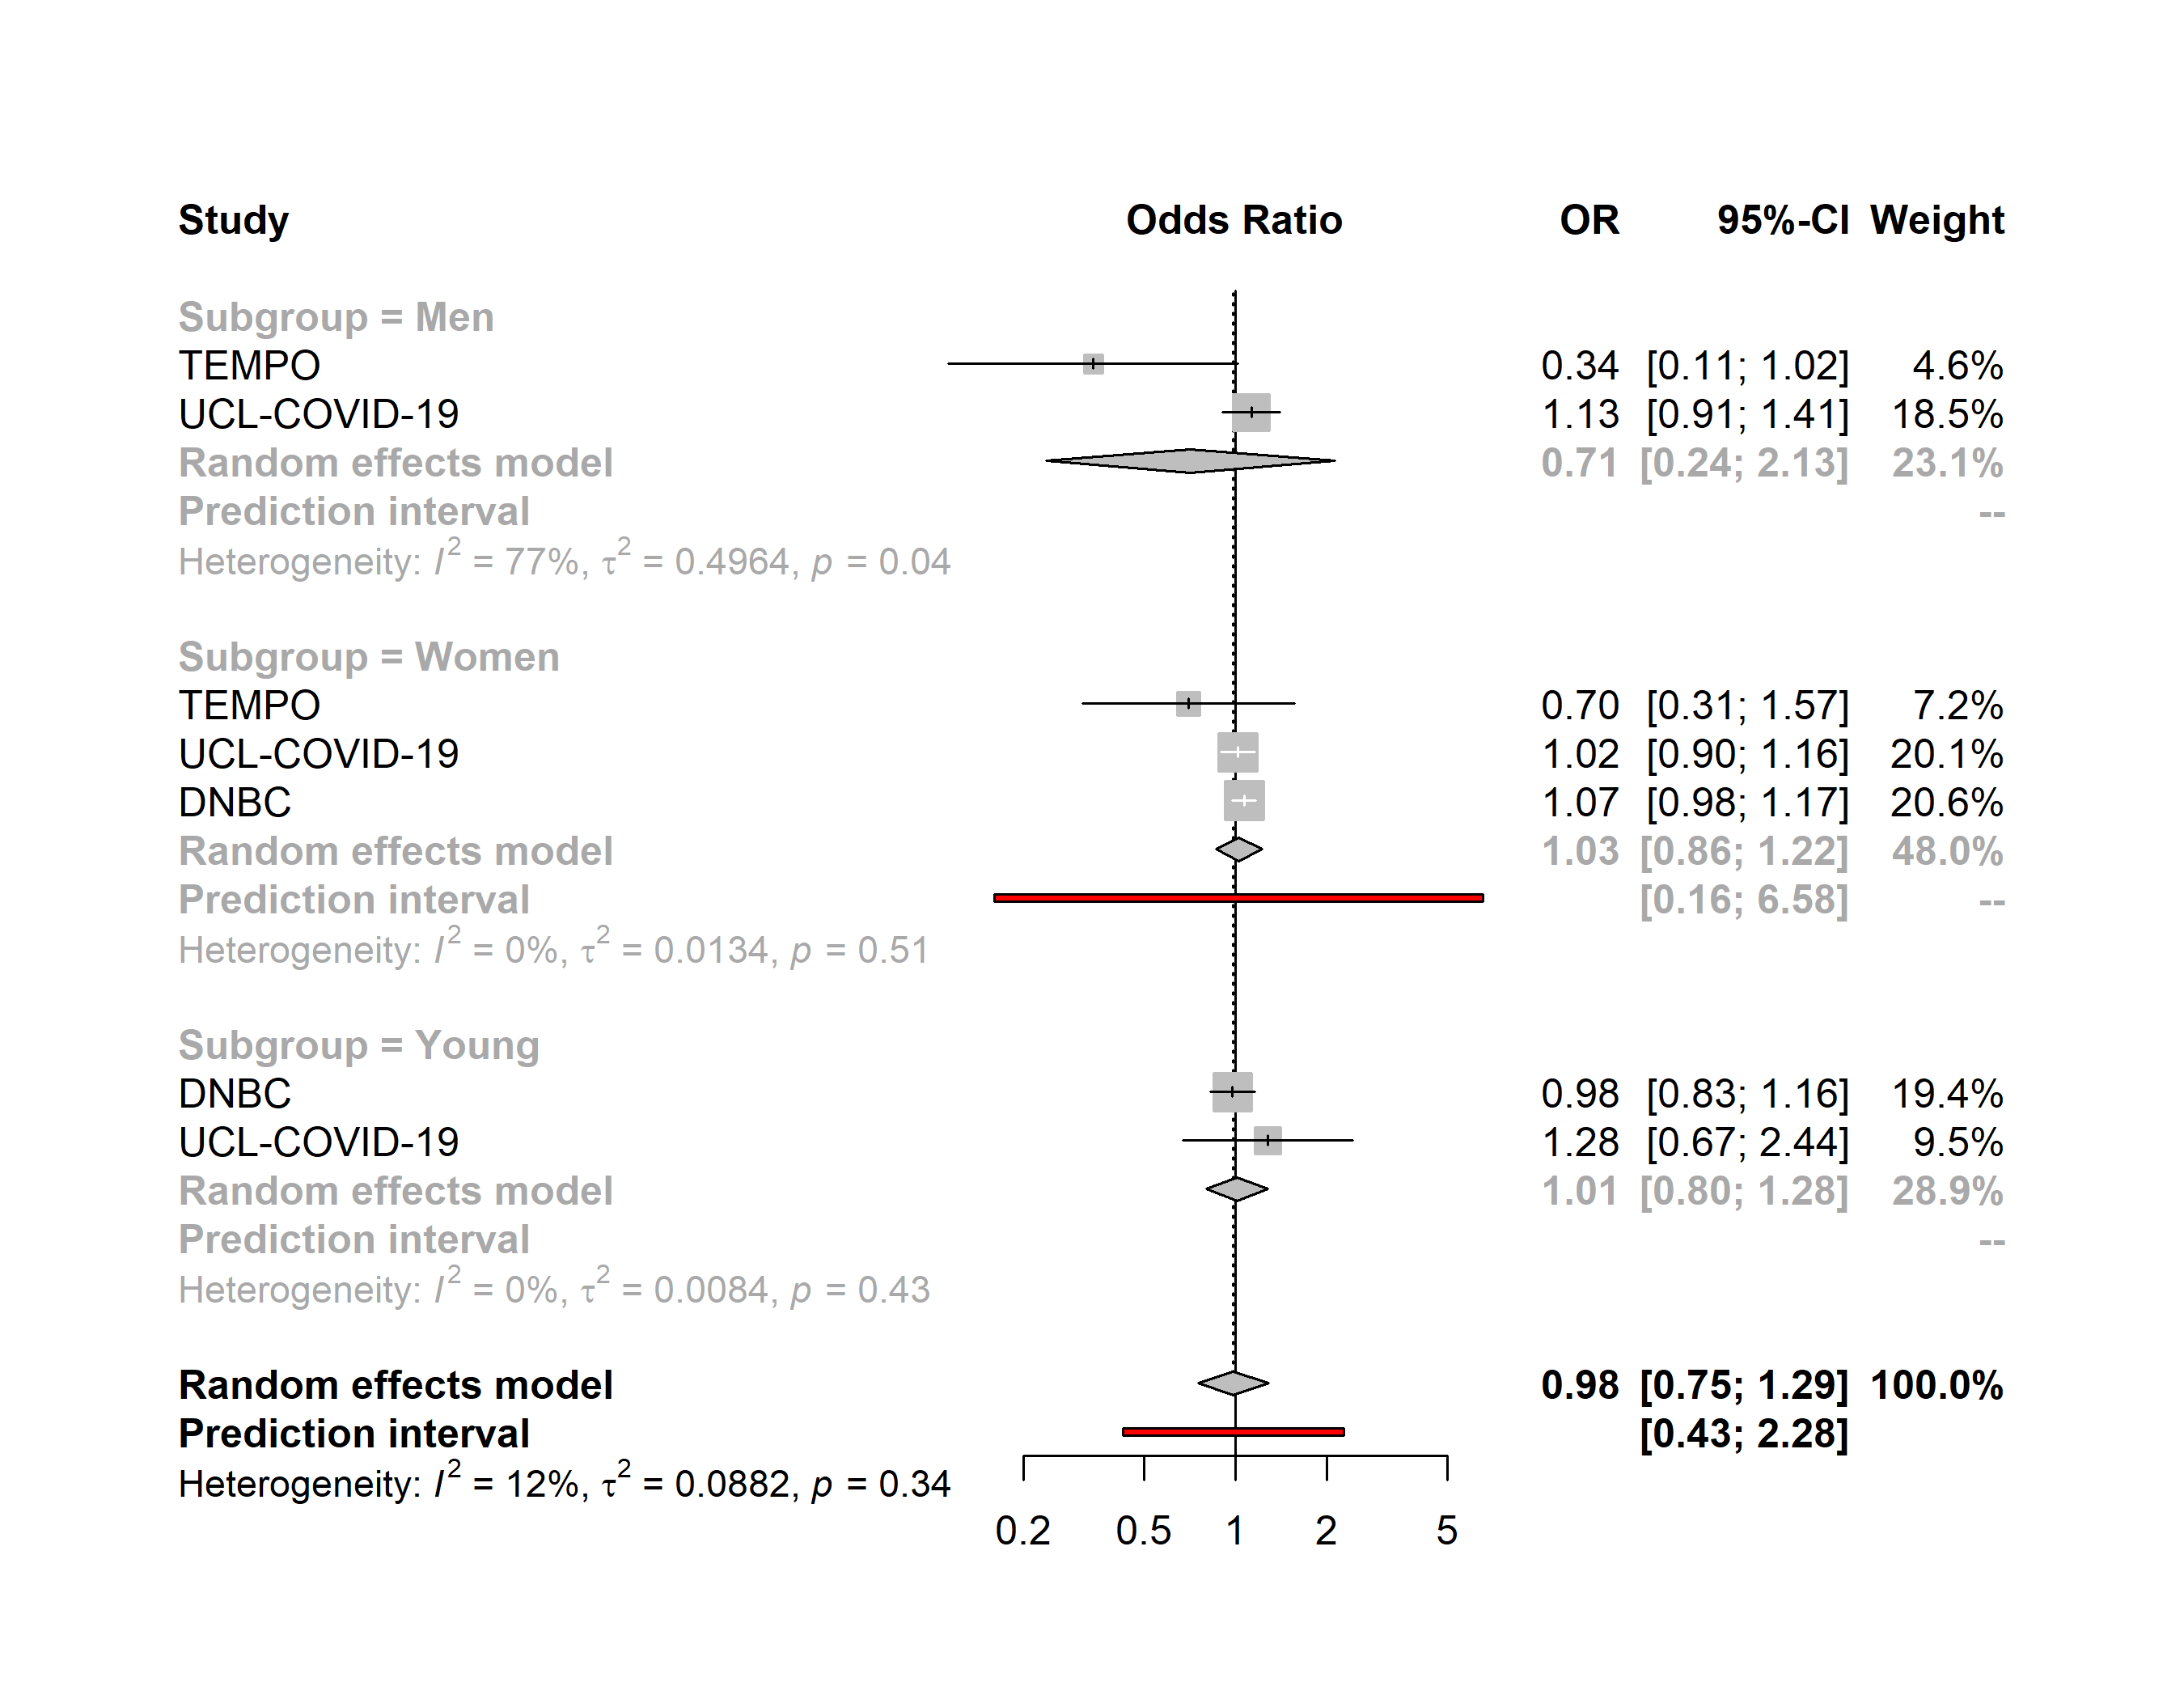

Severe loneliness
Rural environment vs. Urban environment
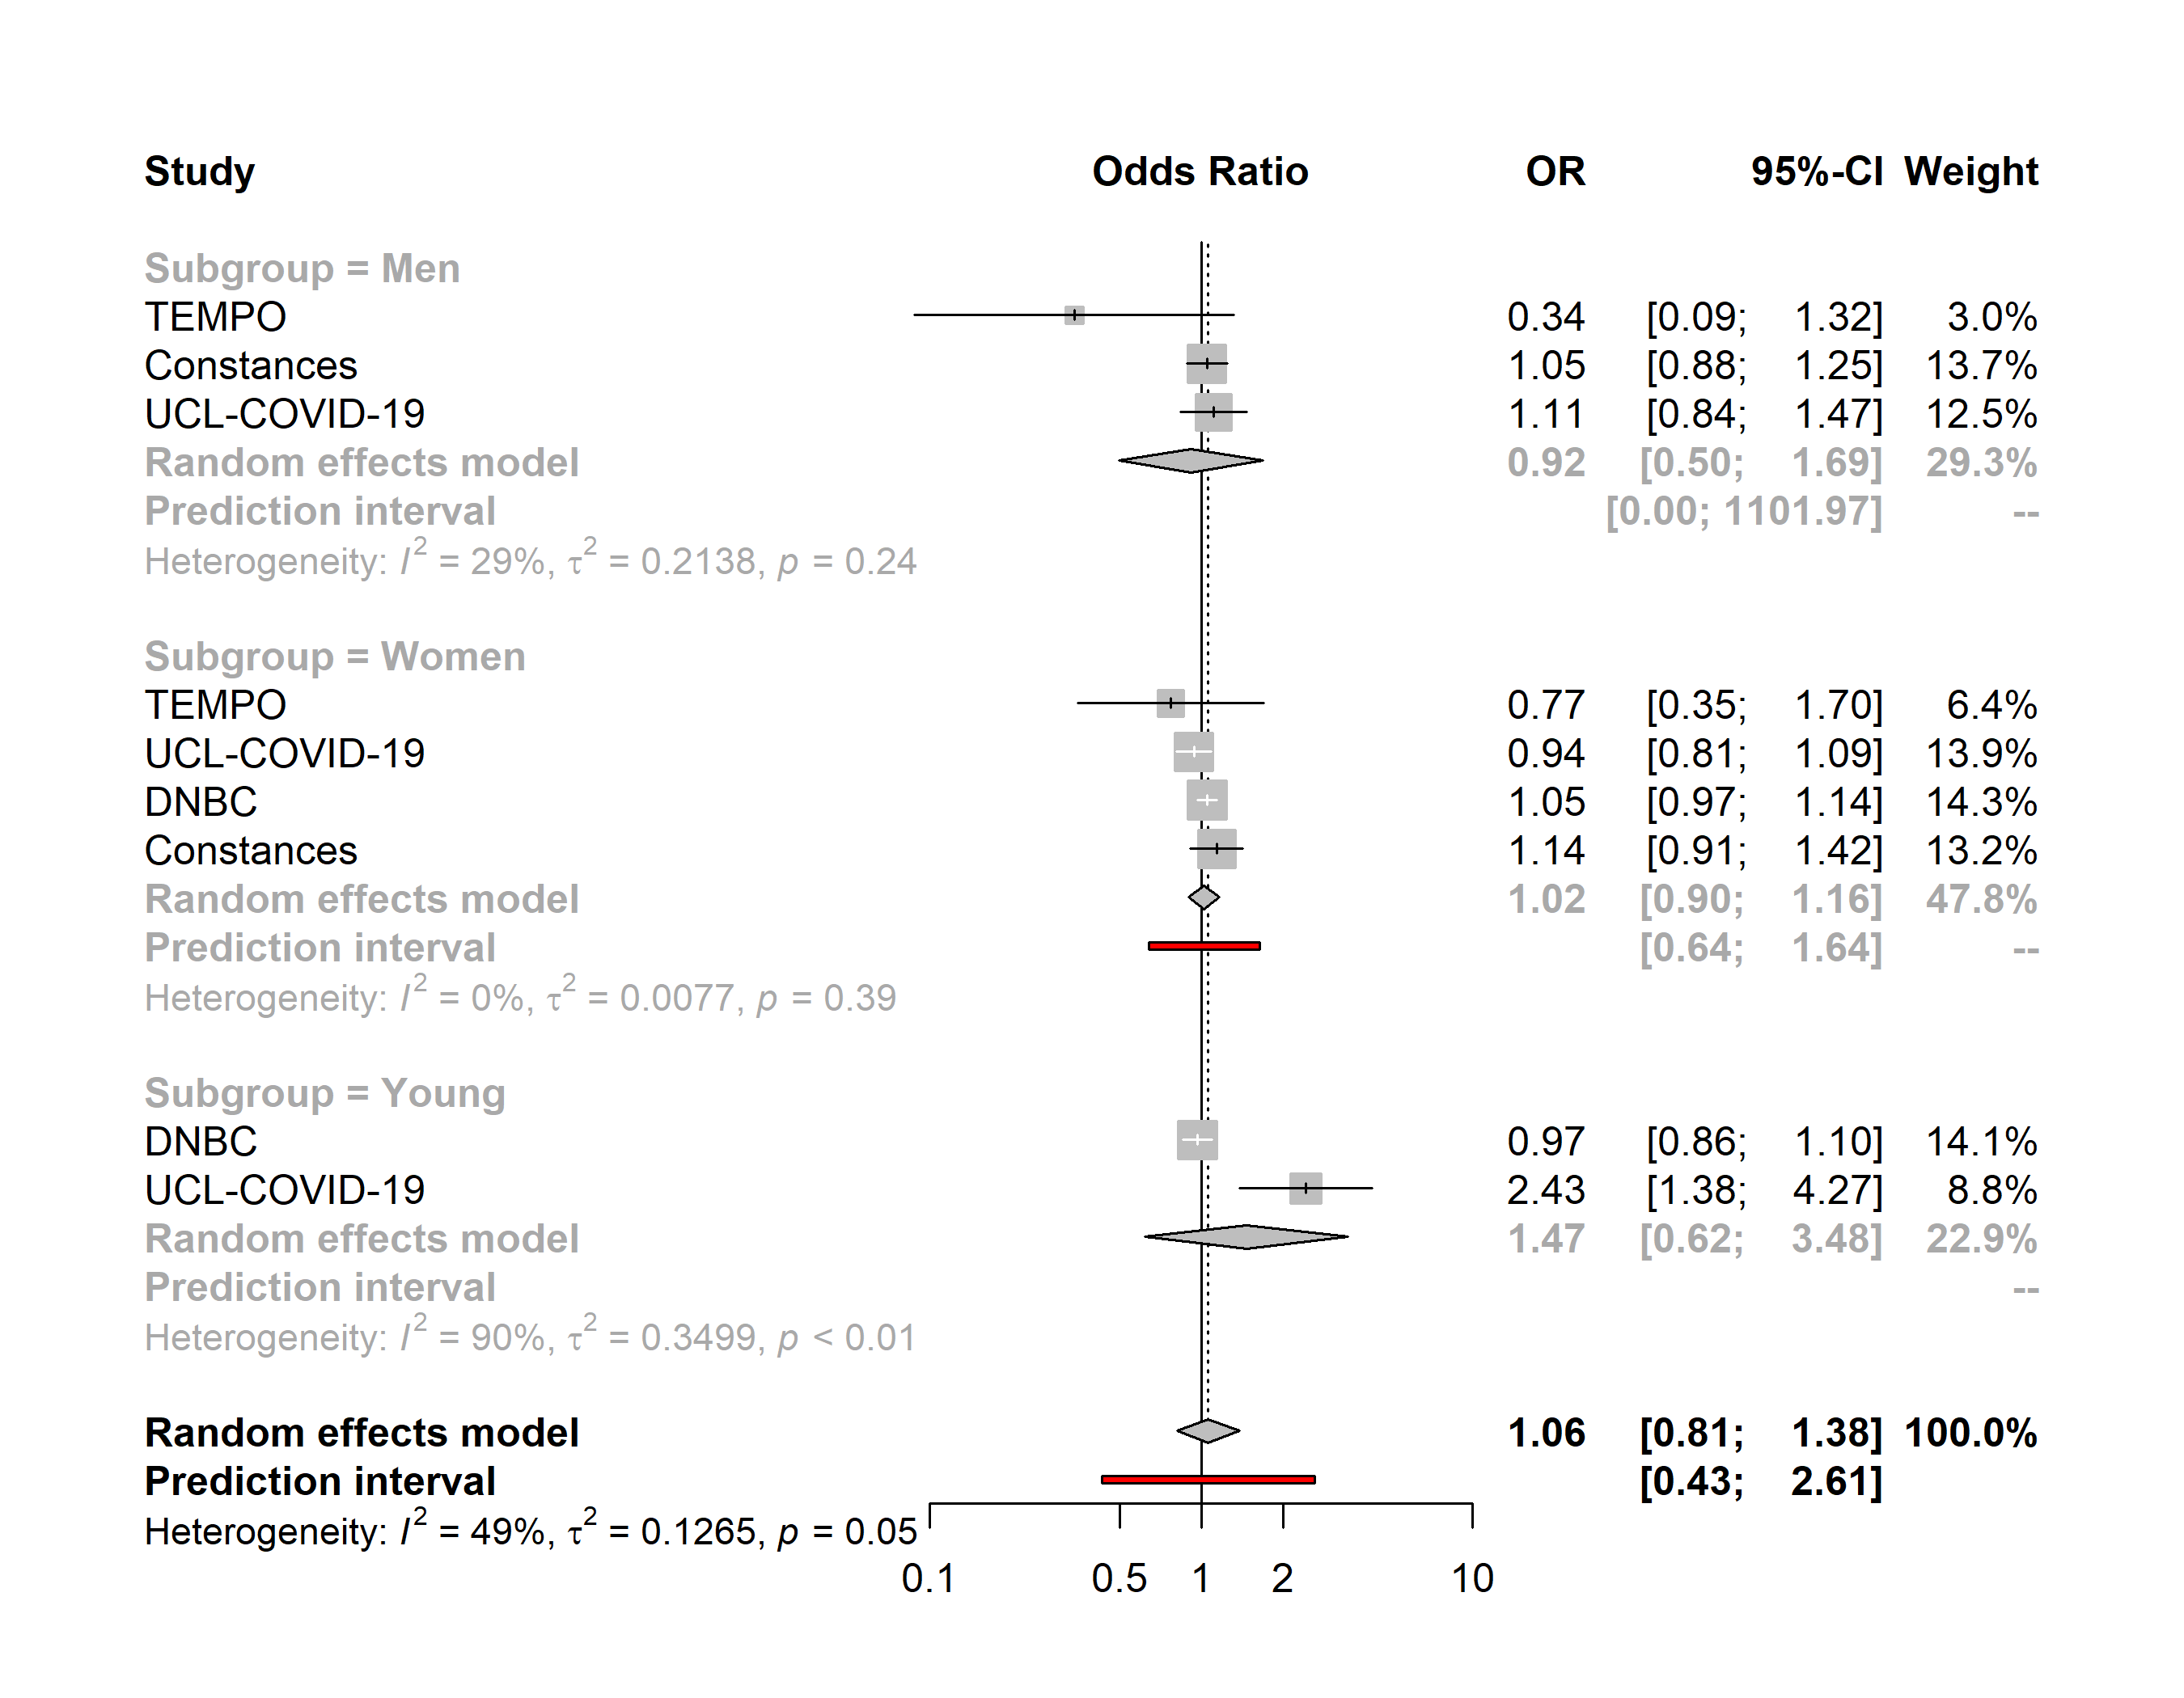

Severe anxiety
No access to outdoor facilities vs access to outdoor facilities
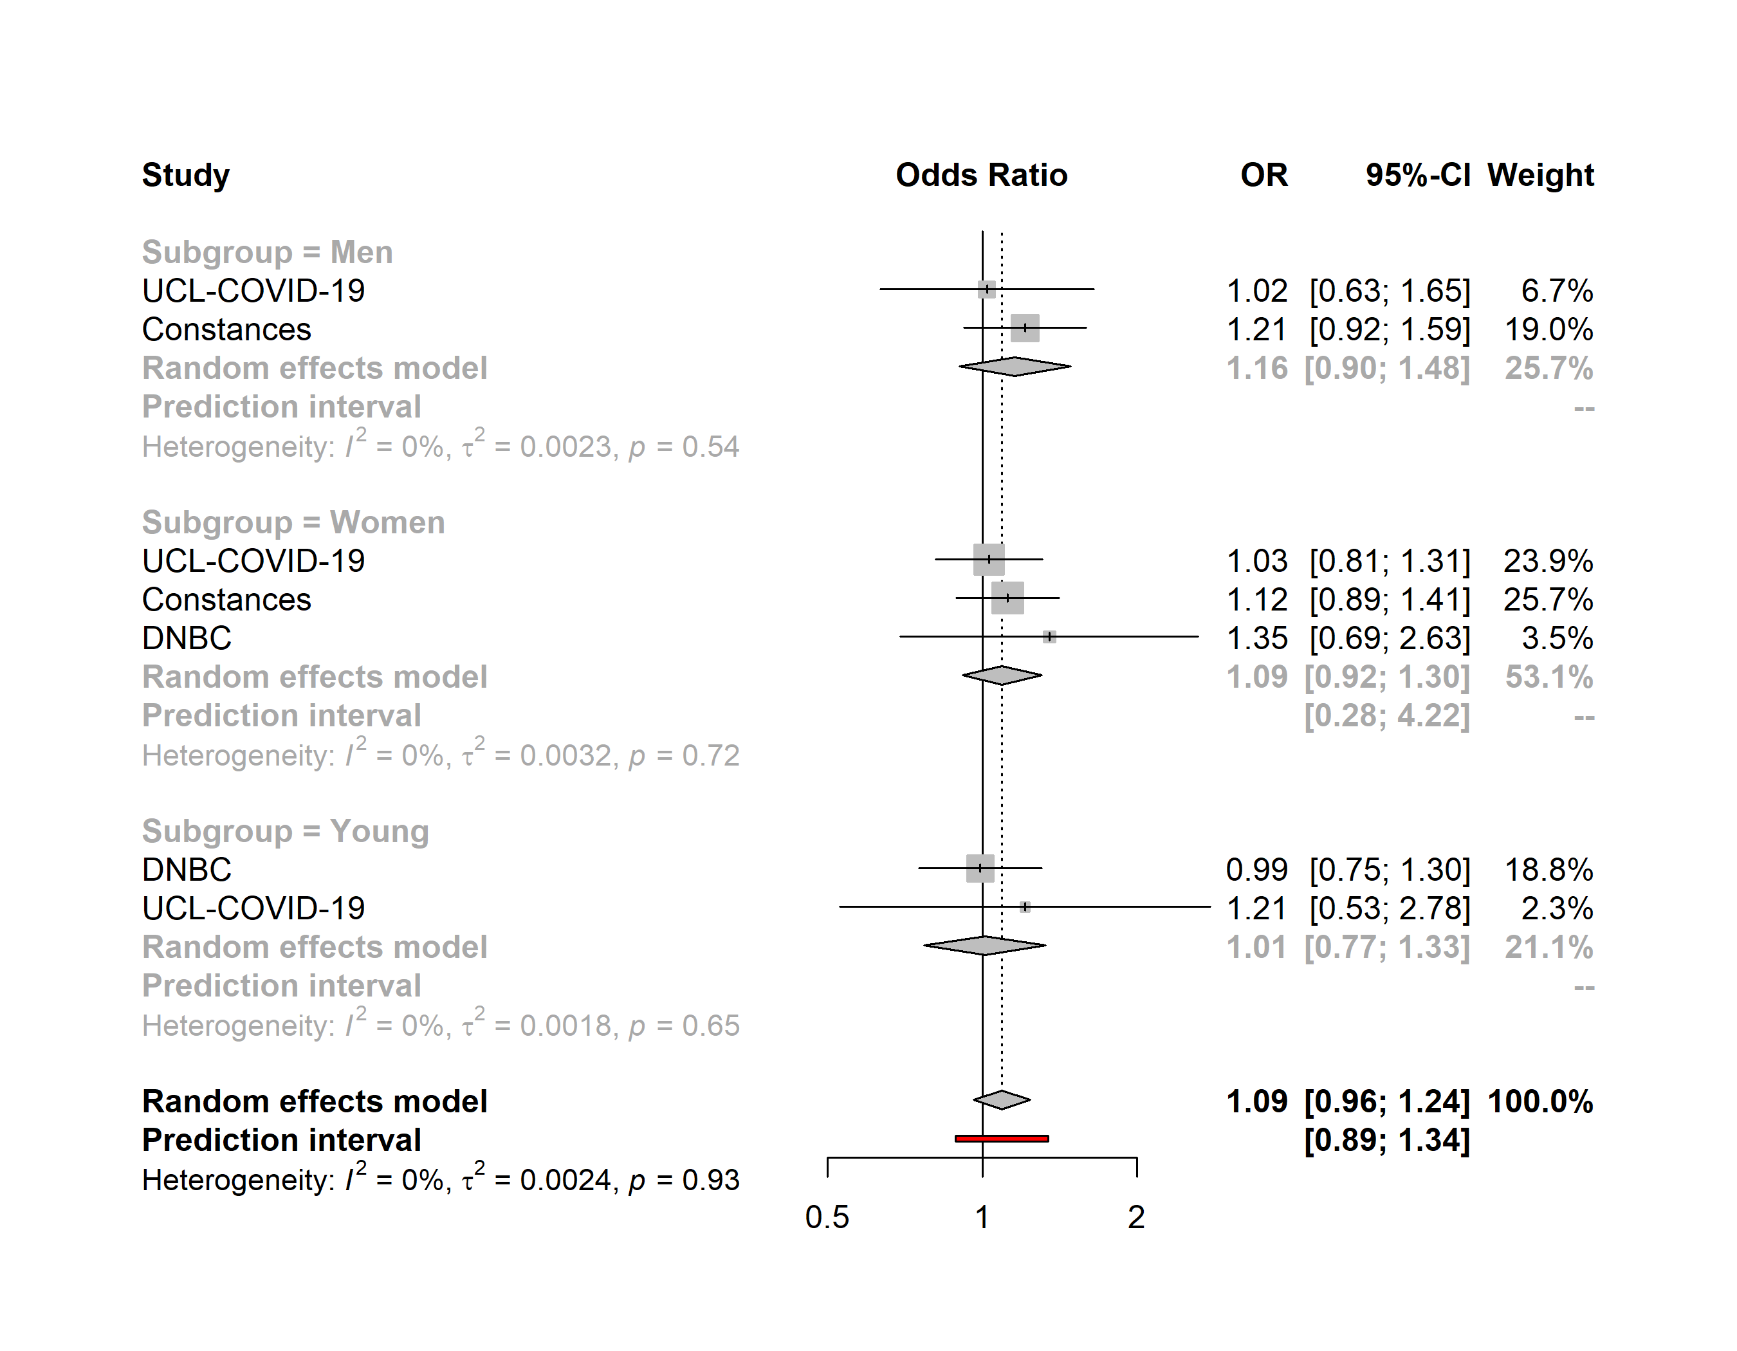

Severe anxiety
Household density ≥43m² vs <43m²
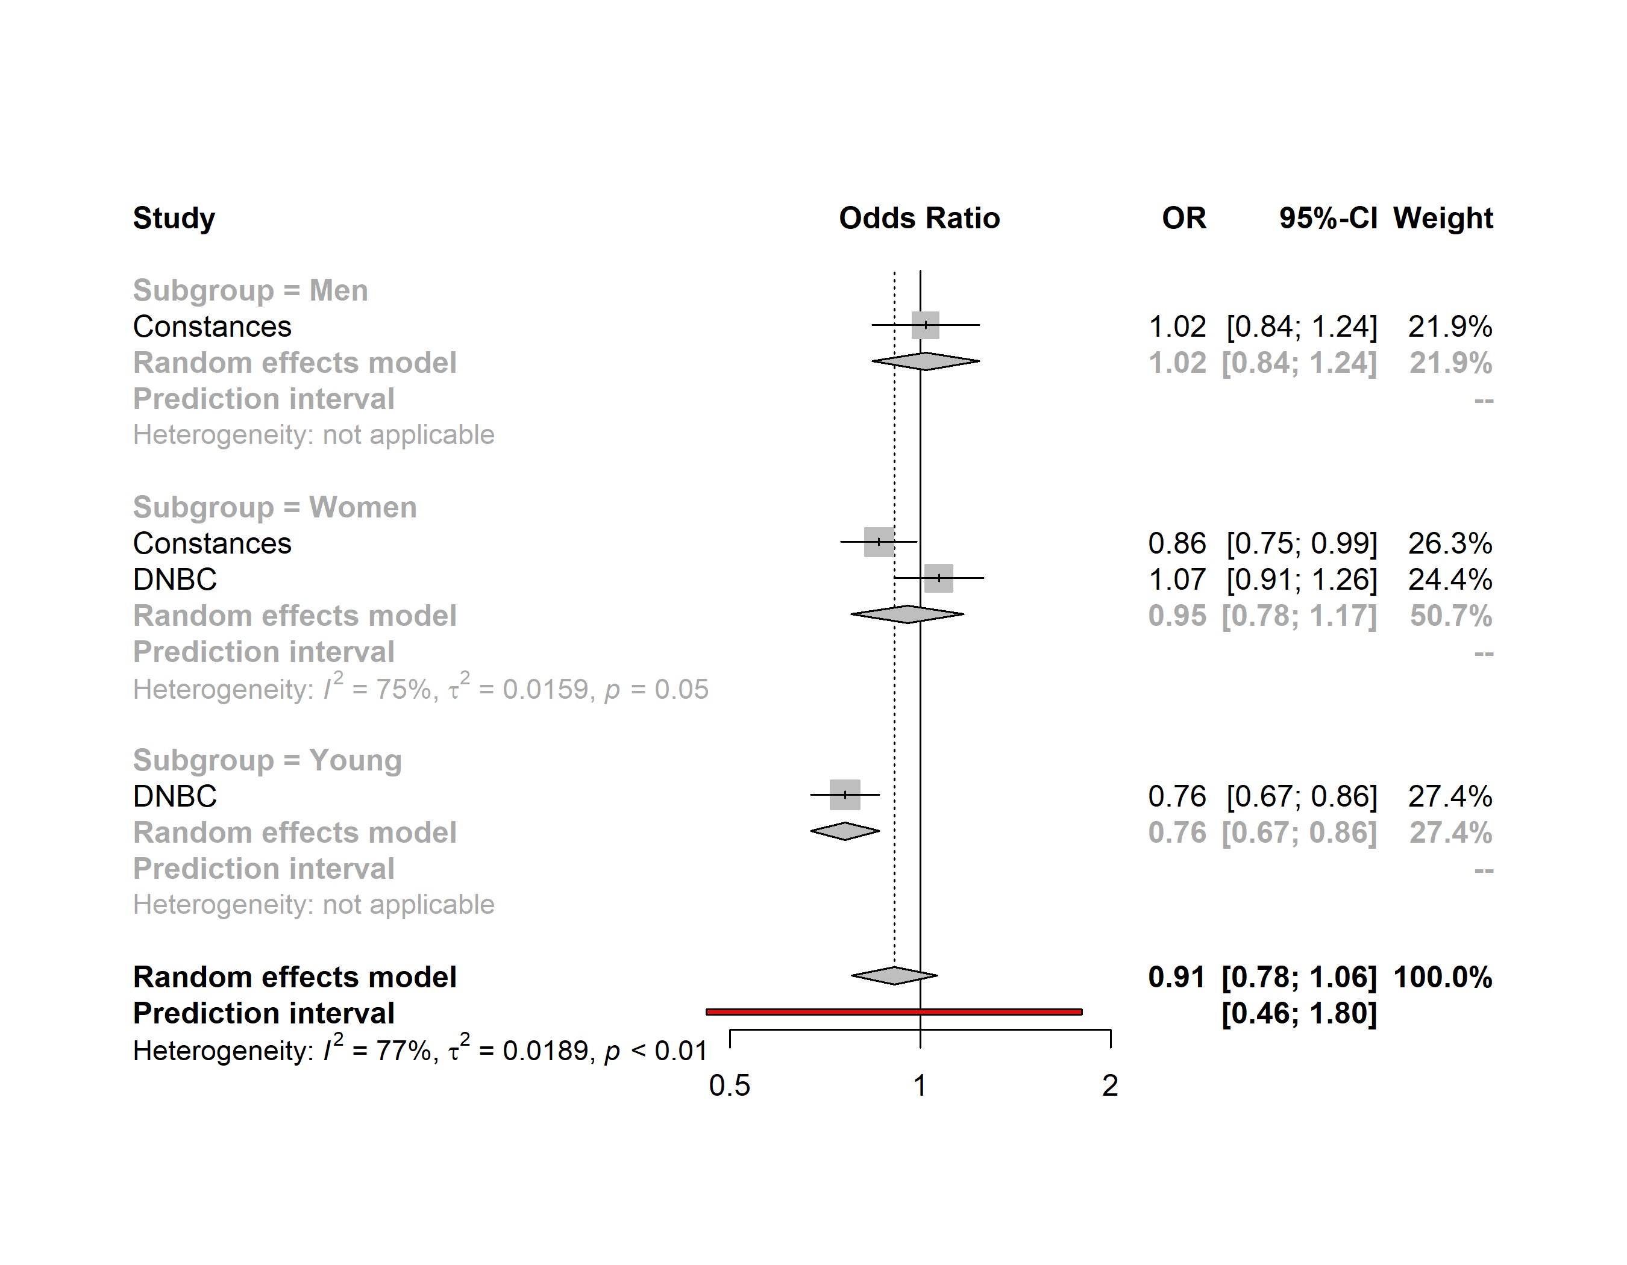

Severe anxiety
Household crowded vs. ideal
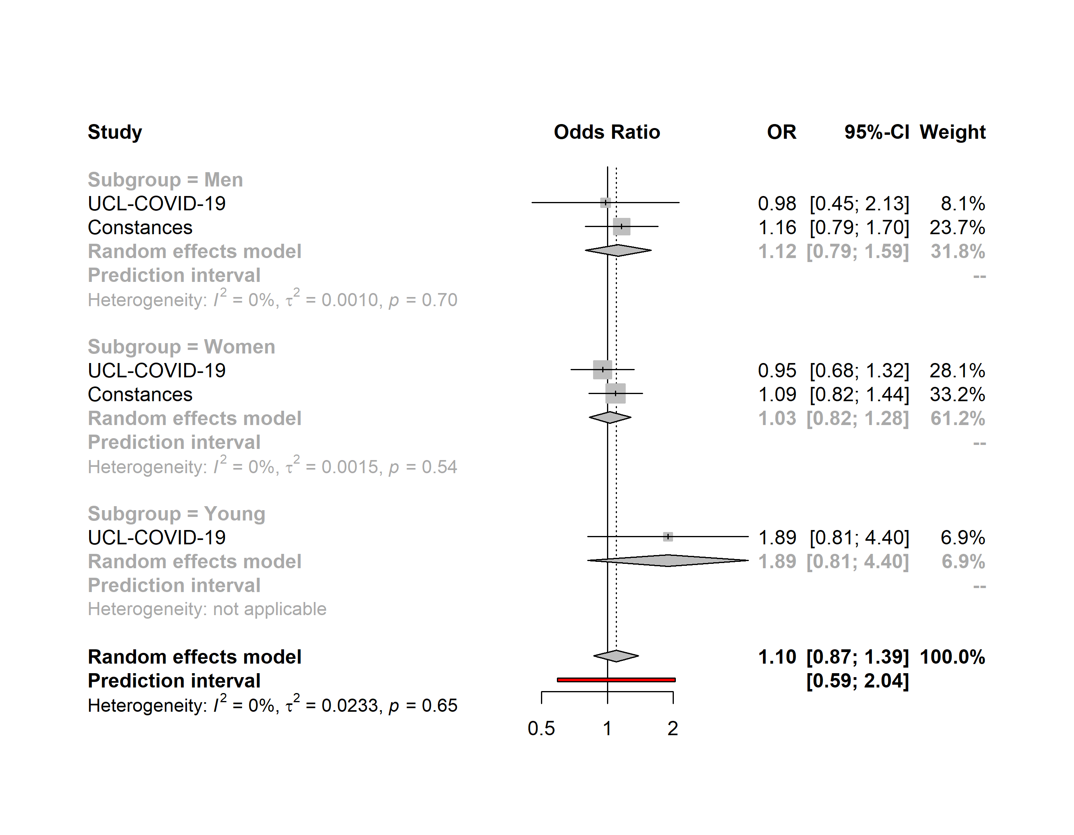

Severe anxiety
Household underoccupied vs. ideal
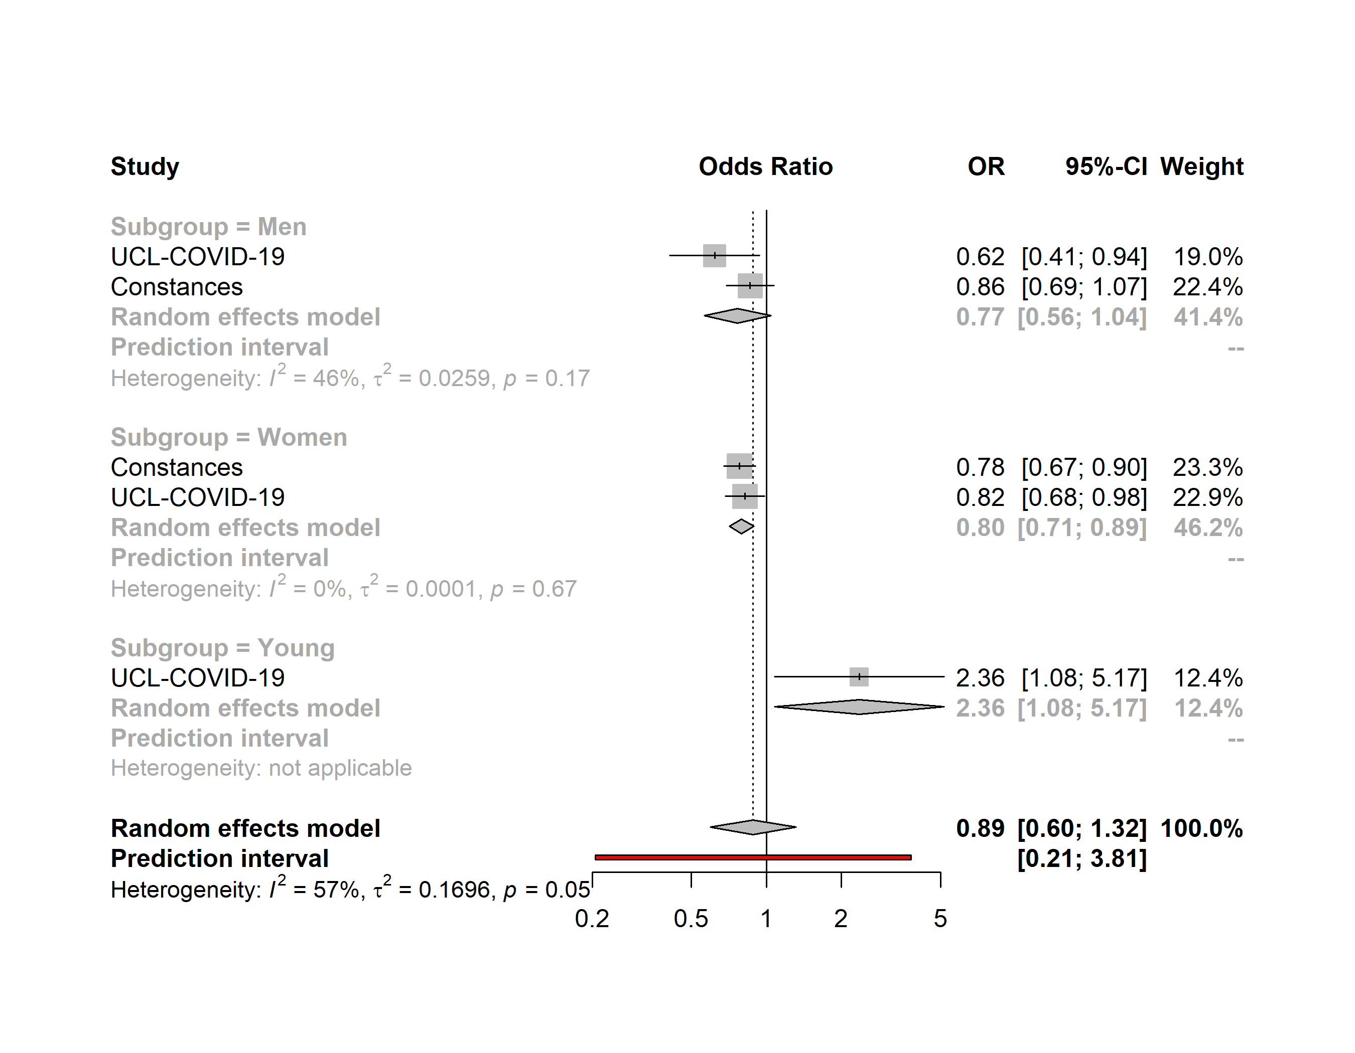

Severe anxiety
Households with children vs. Adults-only households
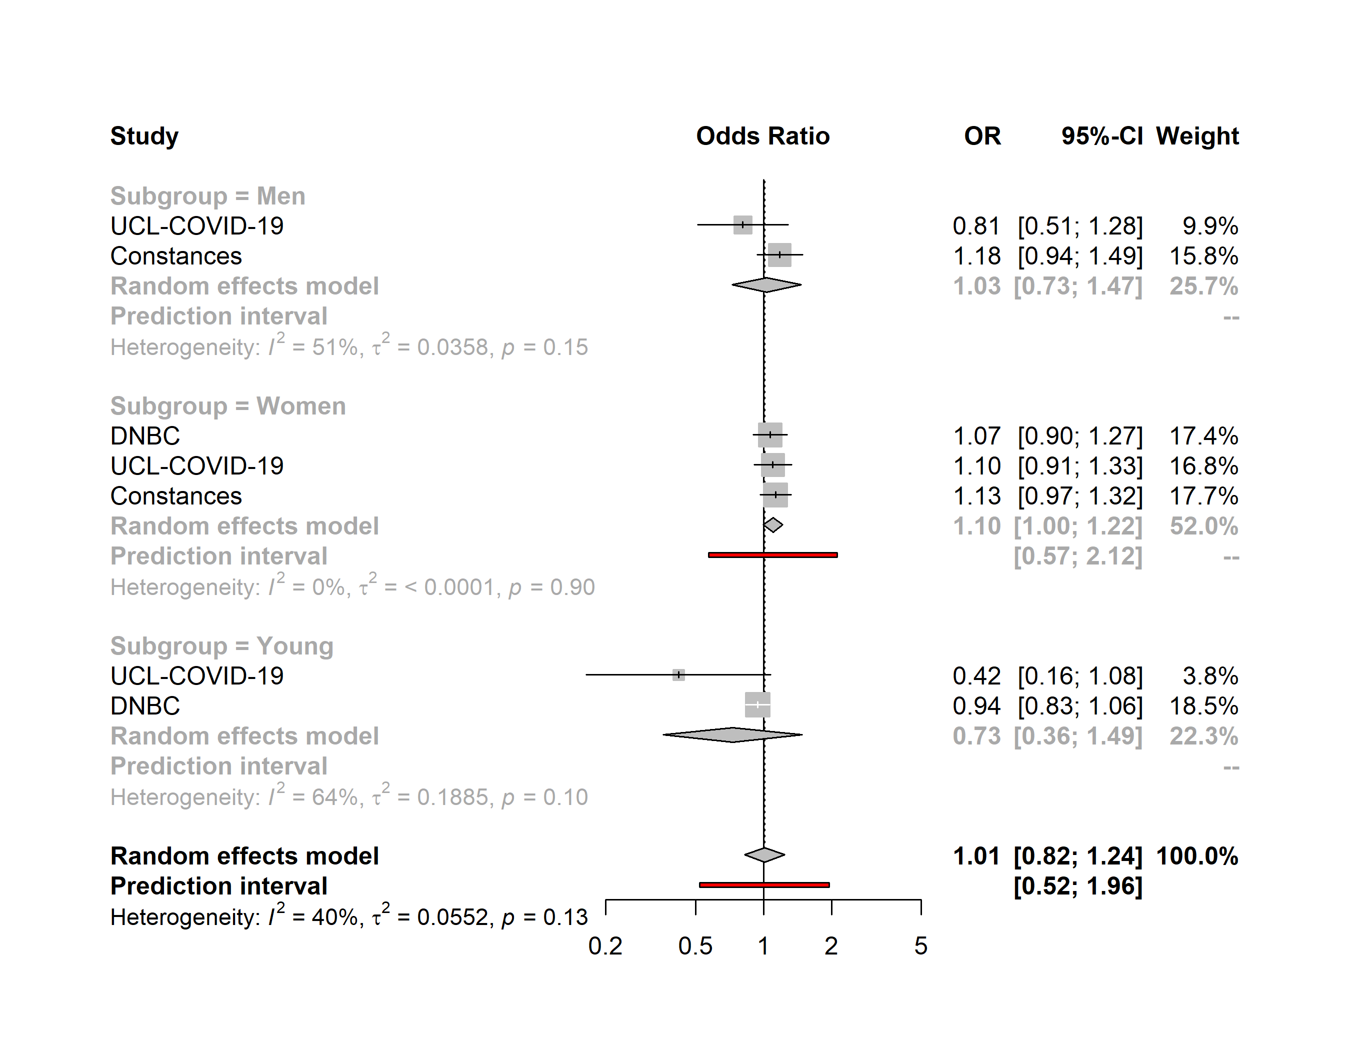

Severe anxiety
Living alone vs. Adults-only households
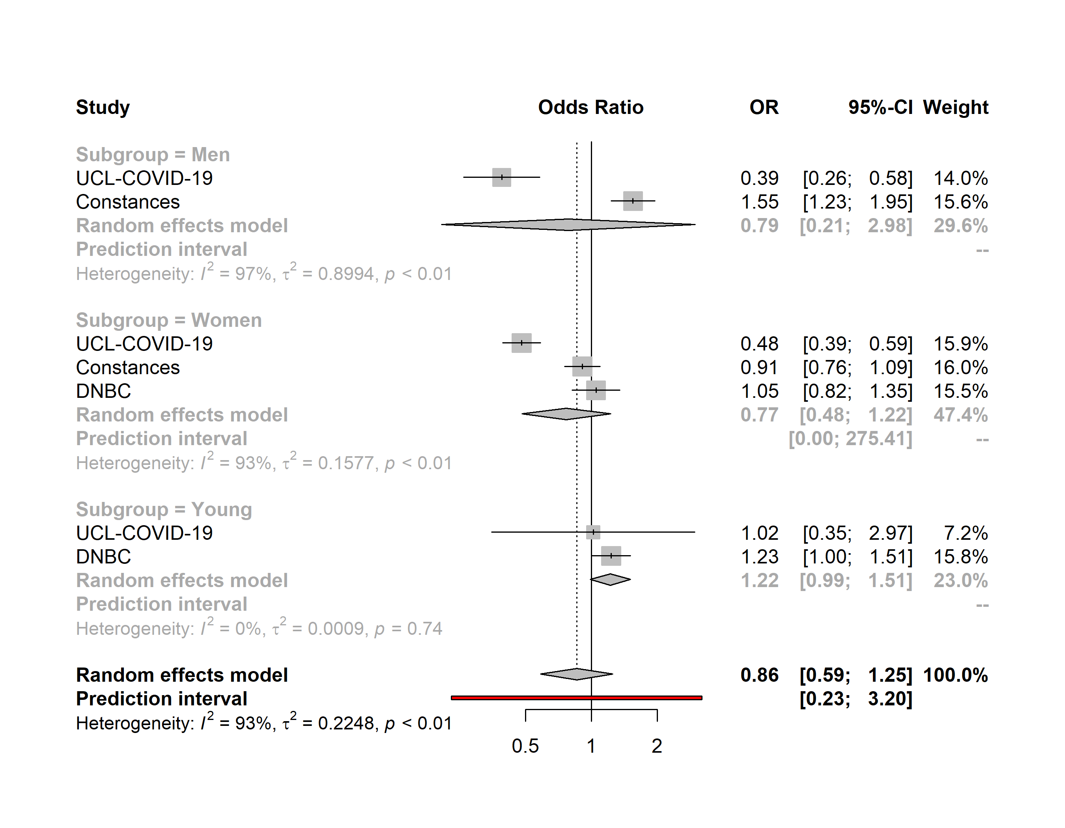

Severe anxiety
Apartment vs. House
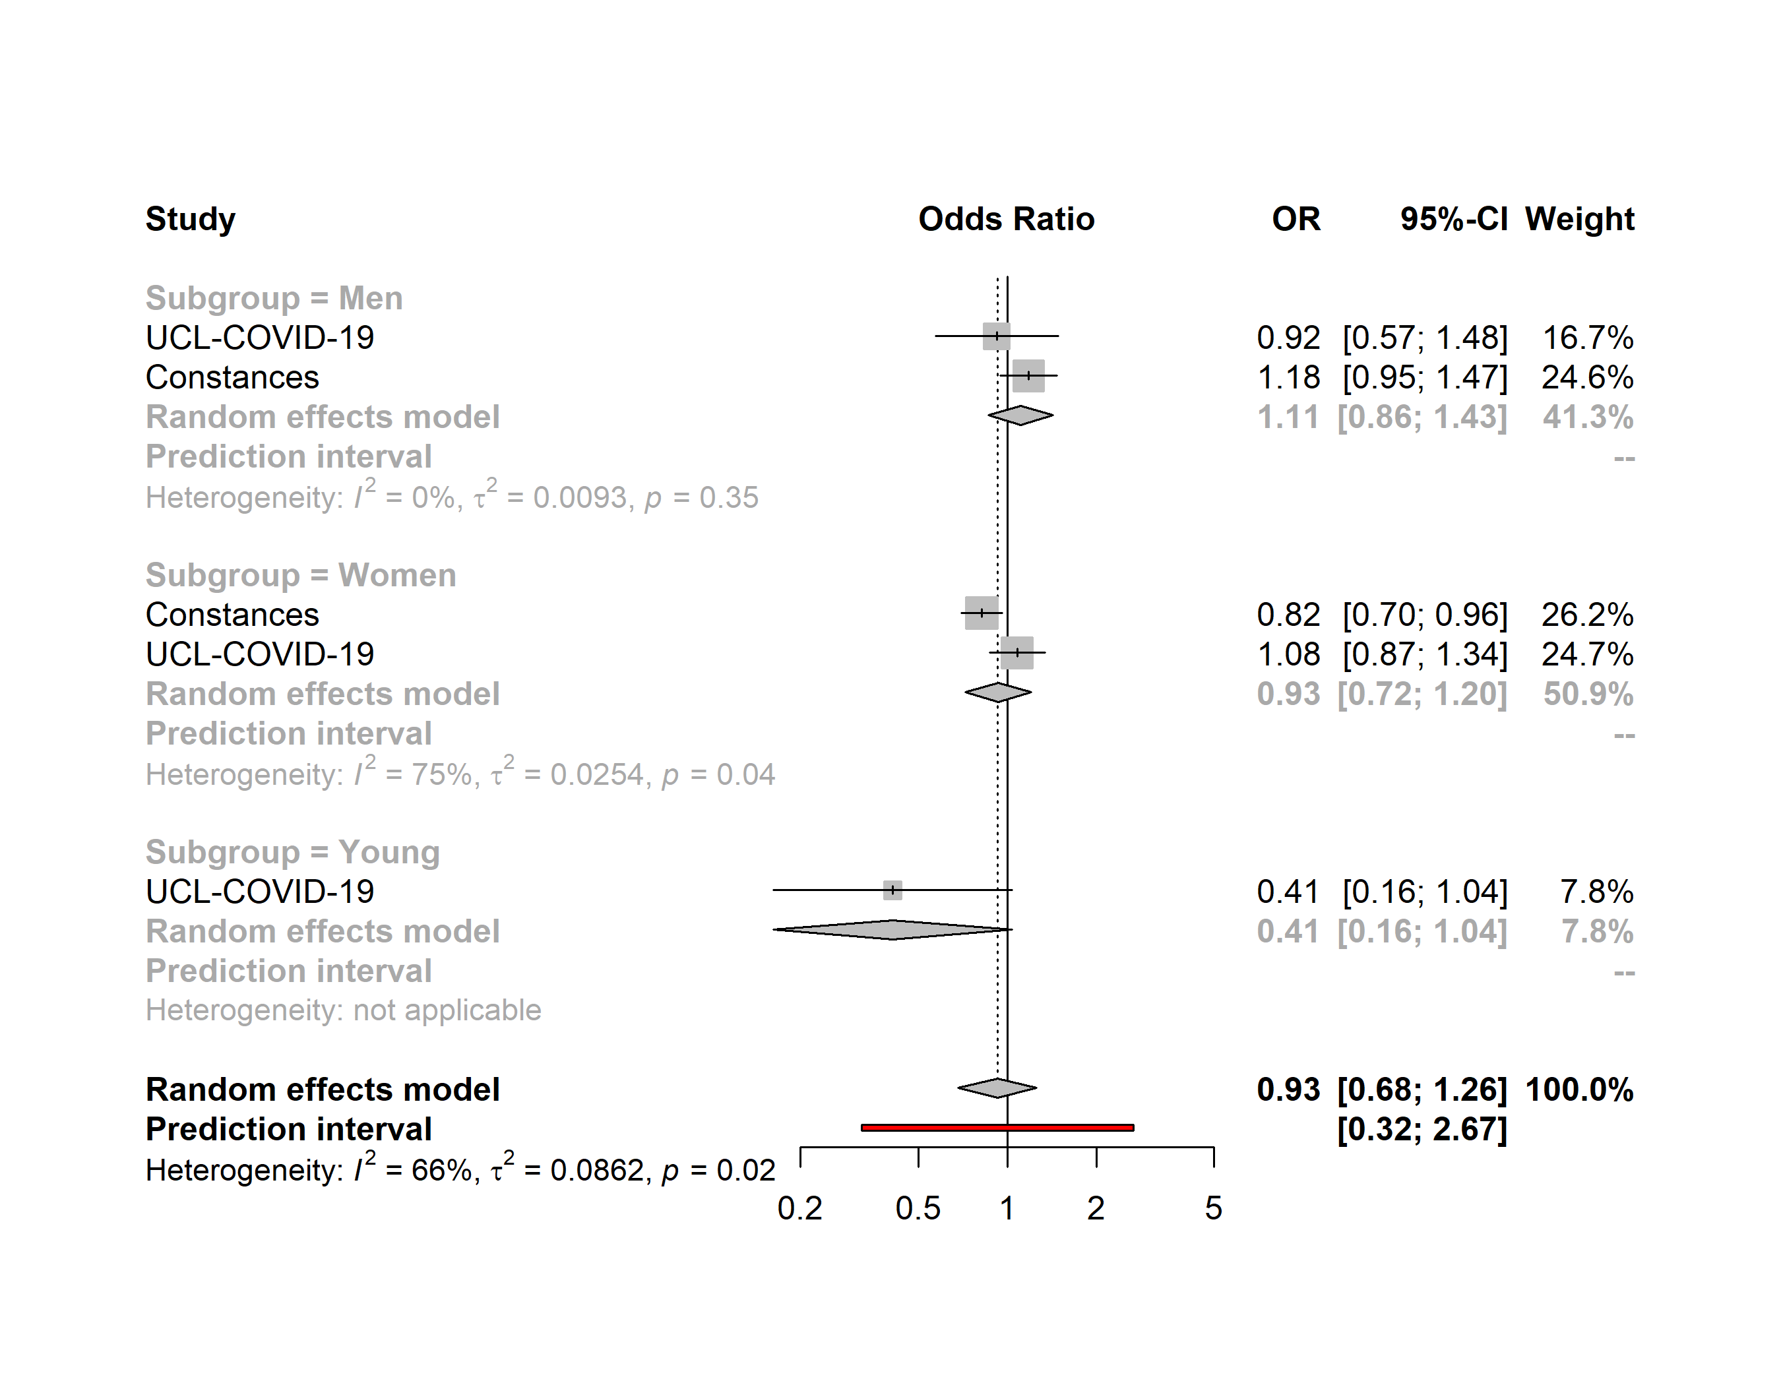

Severe anxiety
Semi-urban environment vs. Urban environment
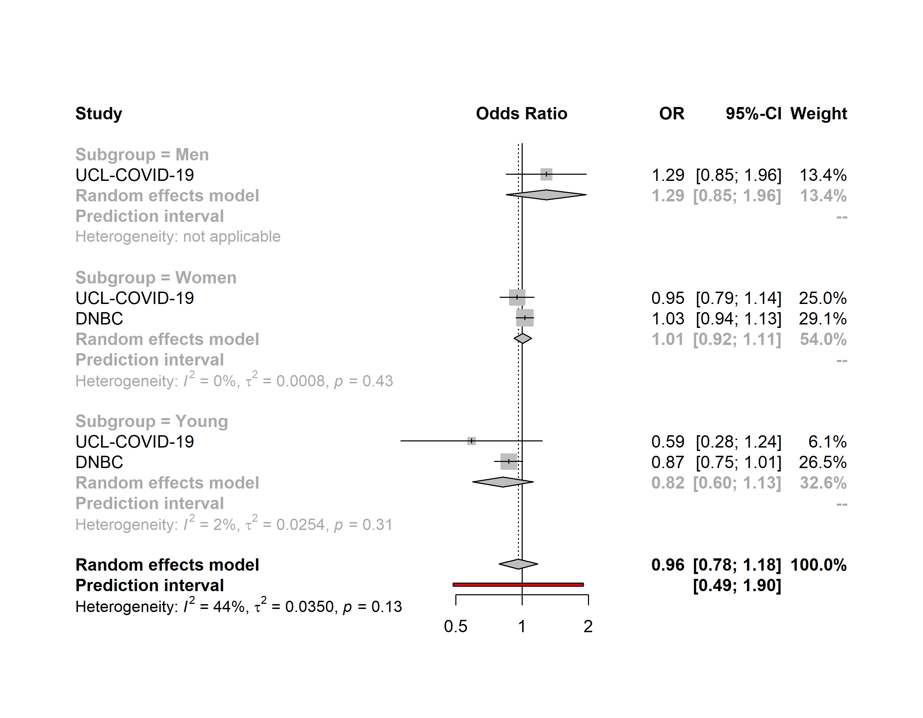

Severe anxiety
Rural environment vs. Urban environment
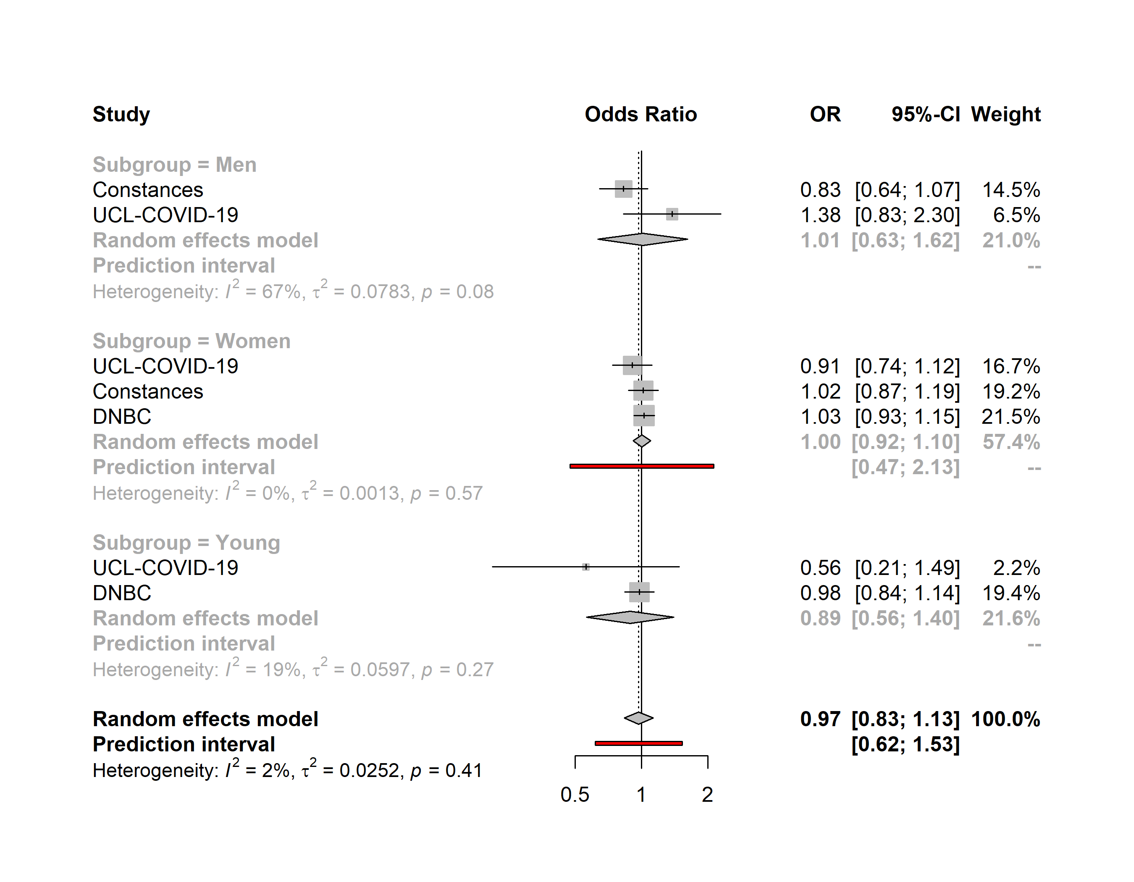

High life satisfaction
No access to outdoor facilities vs access to outdoor facilities
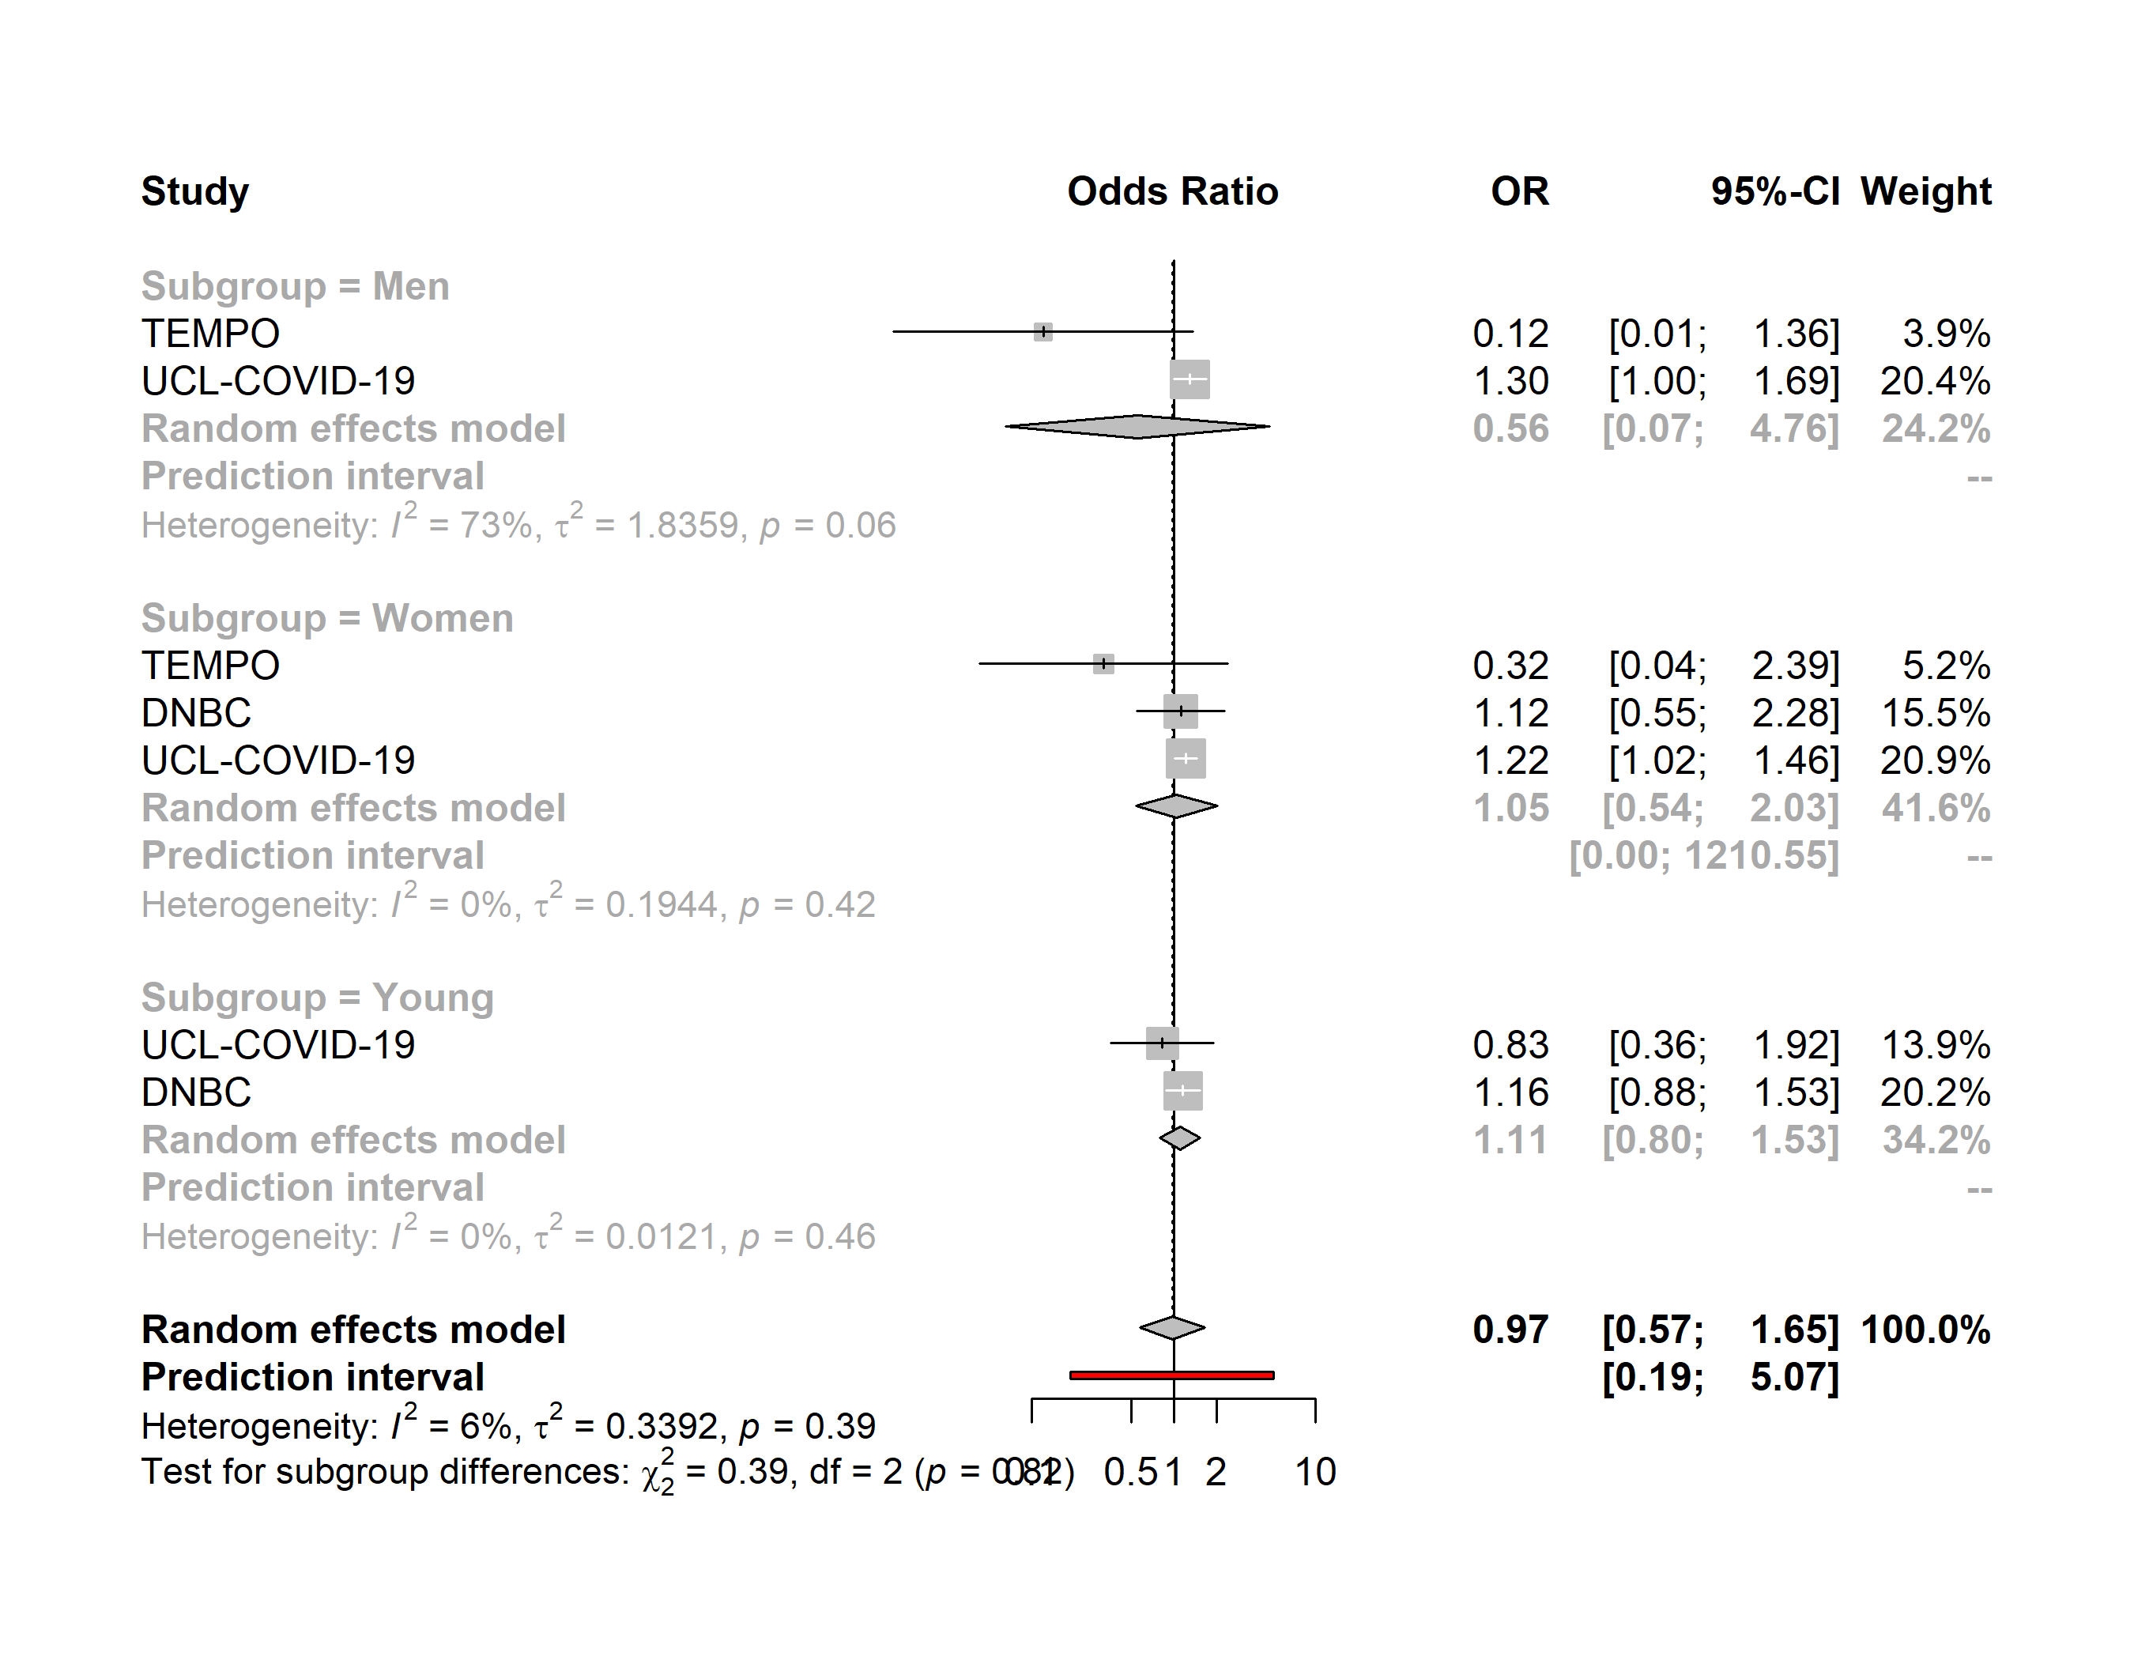

High life satisfaction
Household density ≥43m² vs <43m²
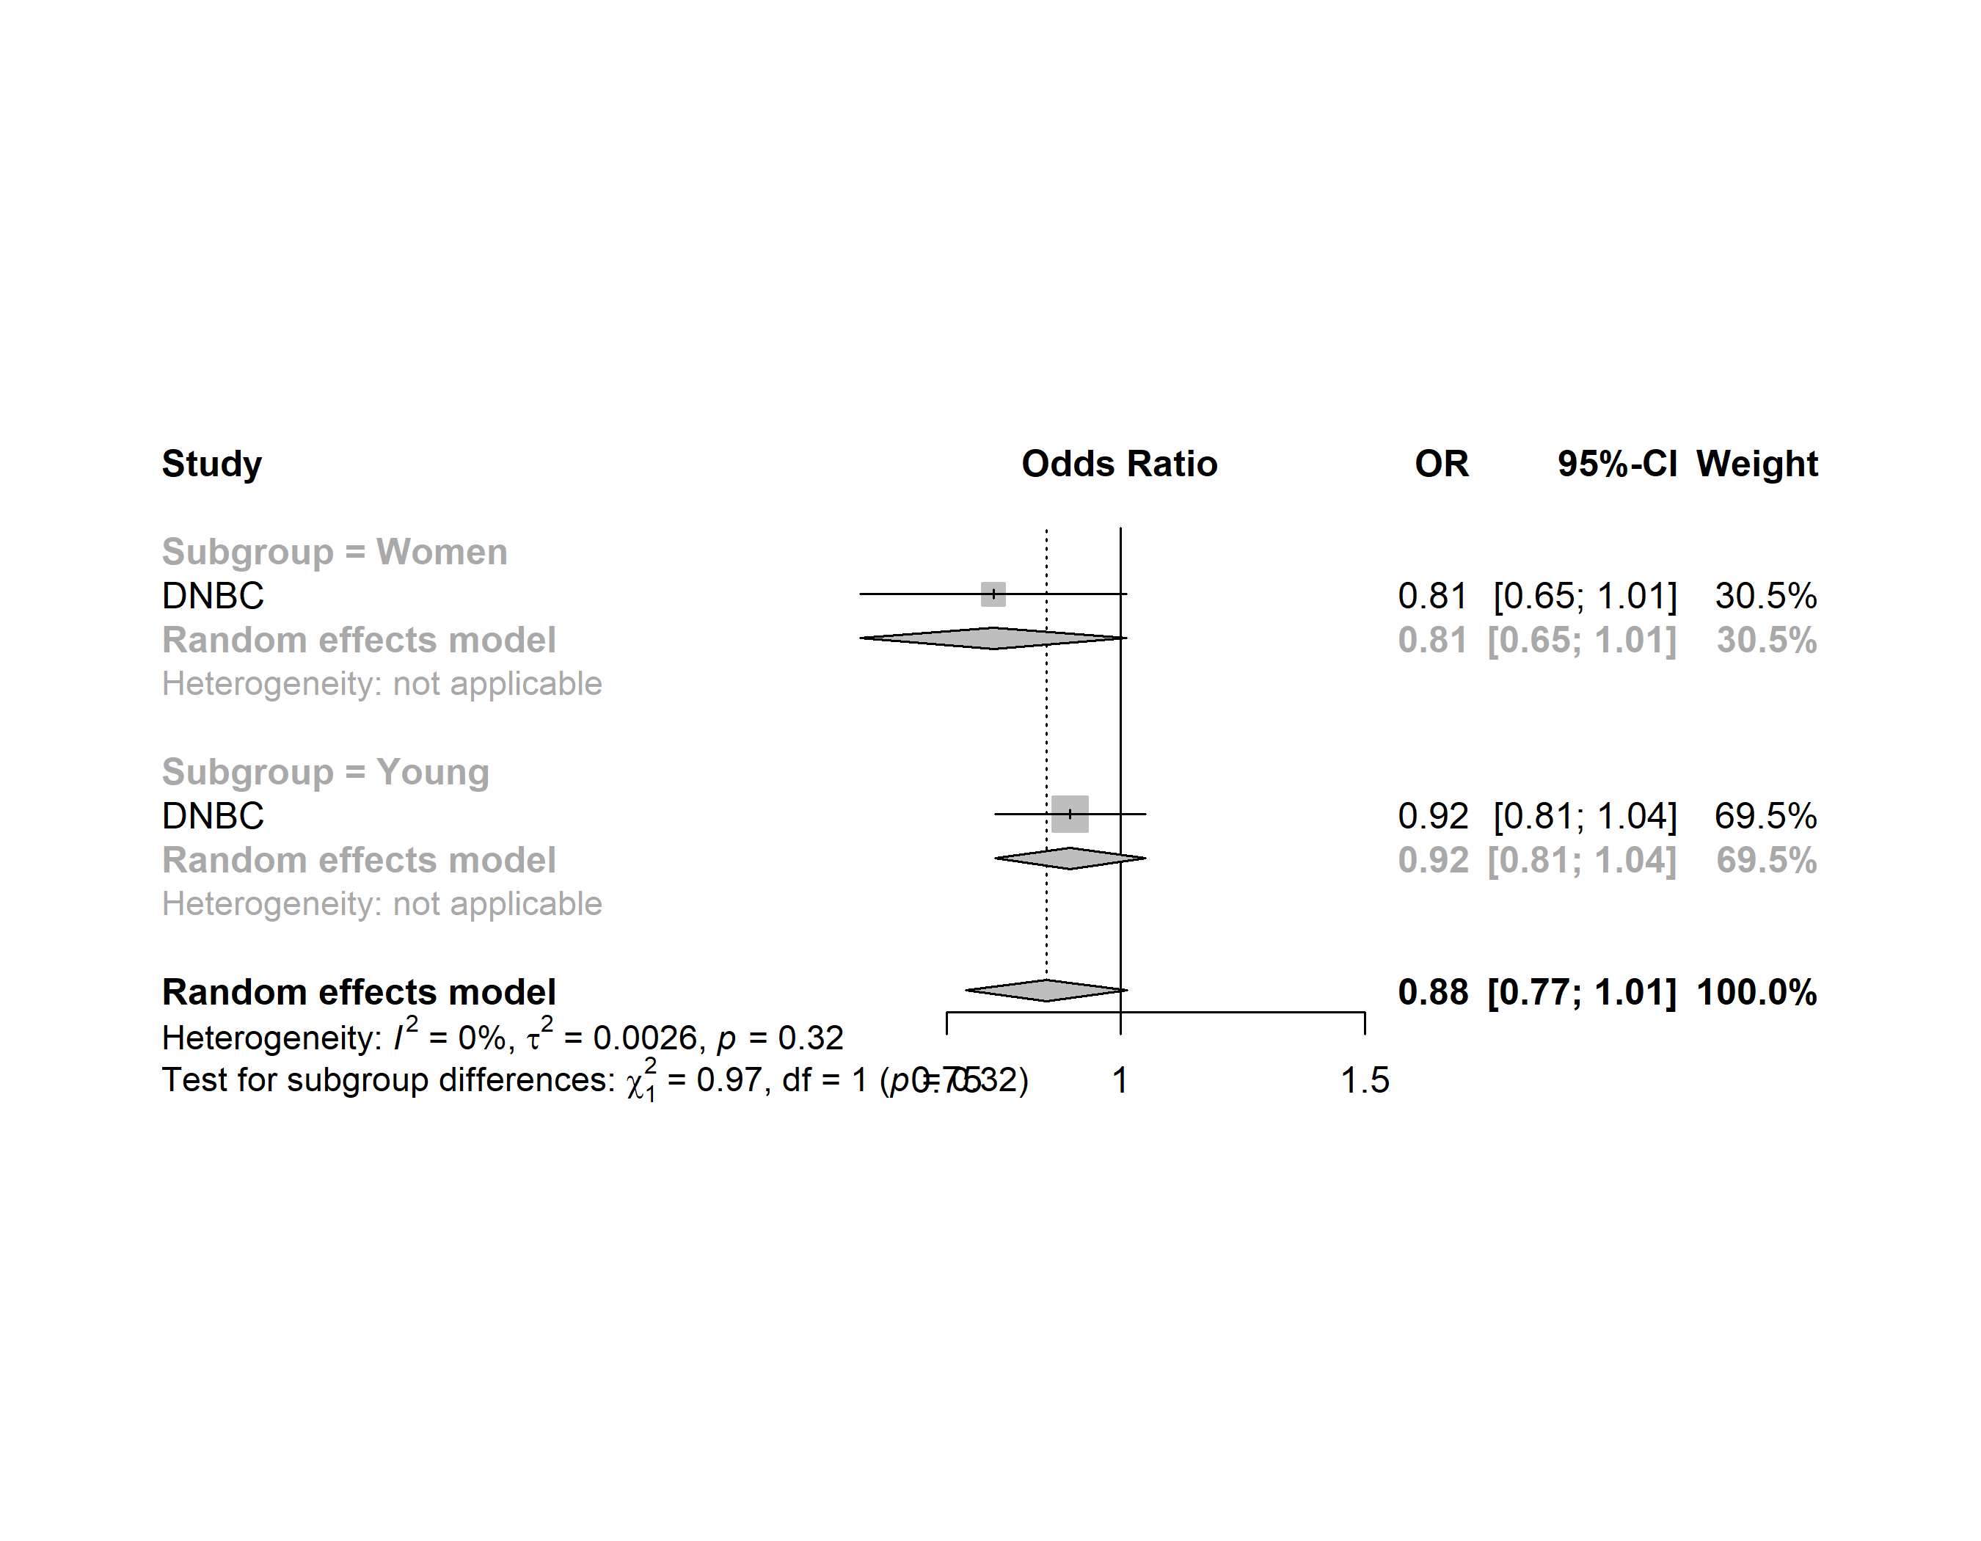

High life satisfaction
Household crowded vs. ideal
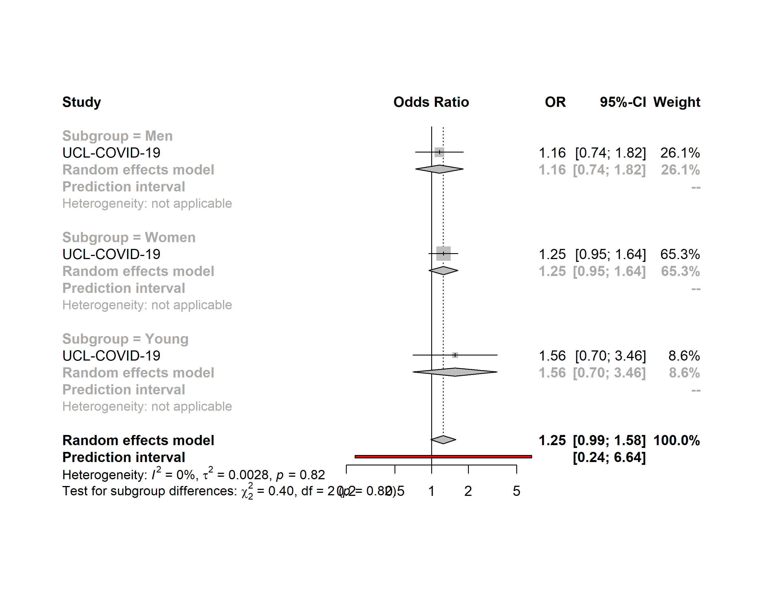

High life satisfaction
Household underoccupied vs. ideal
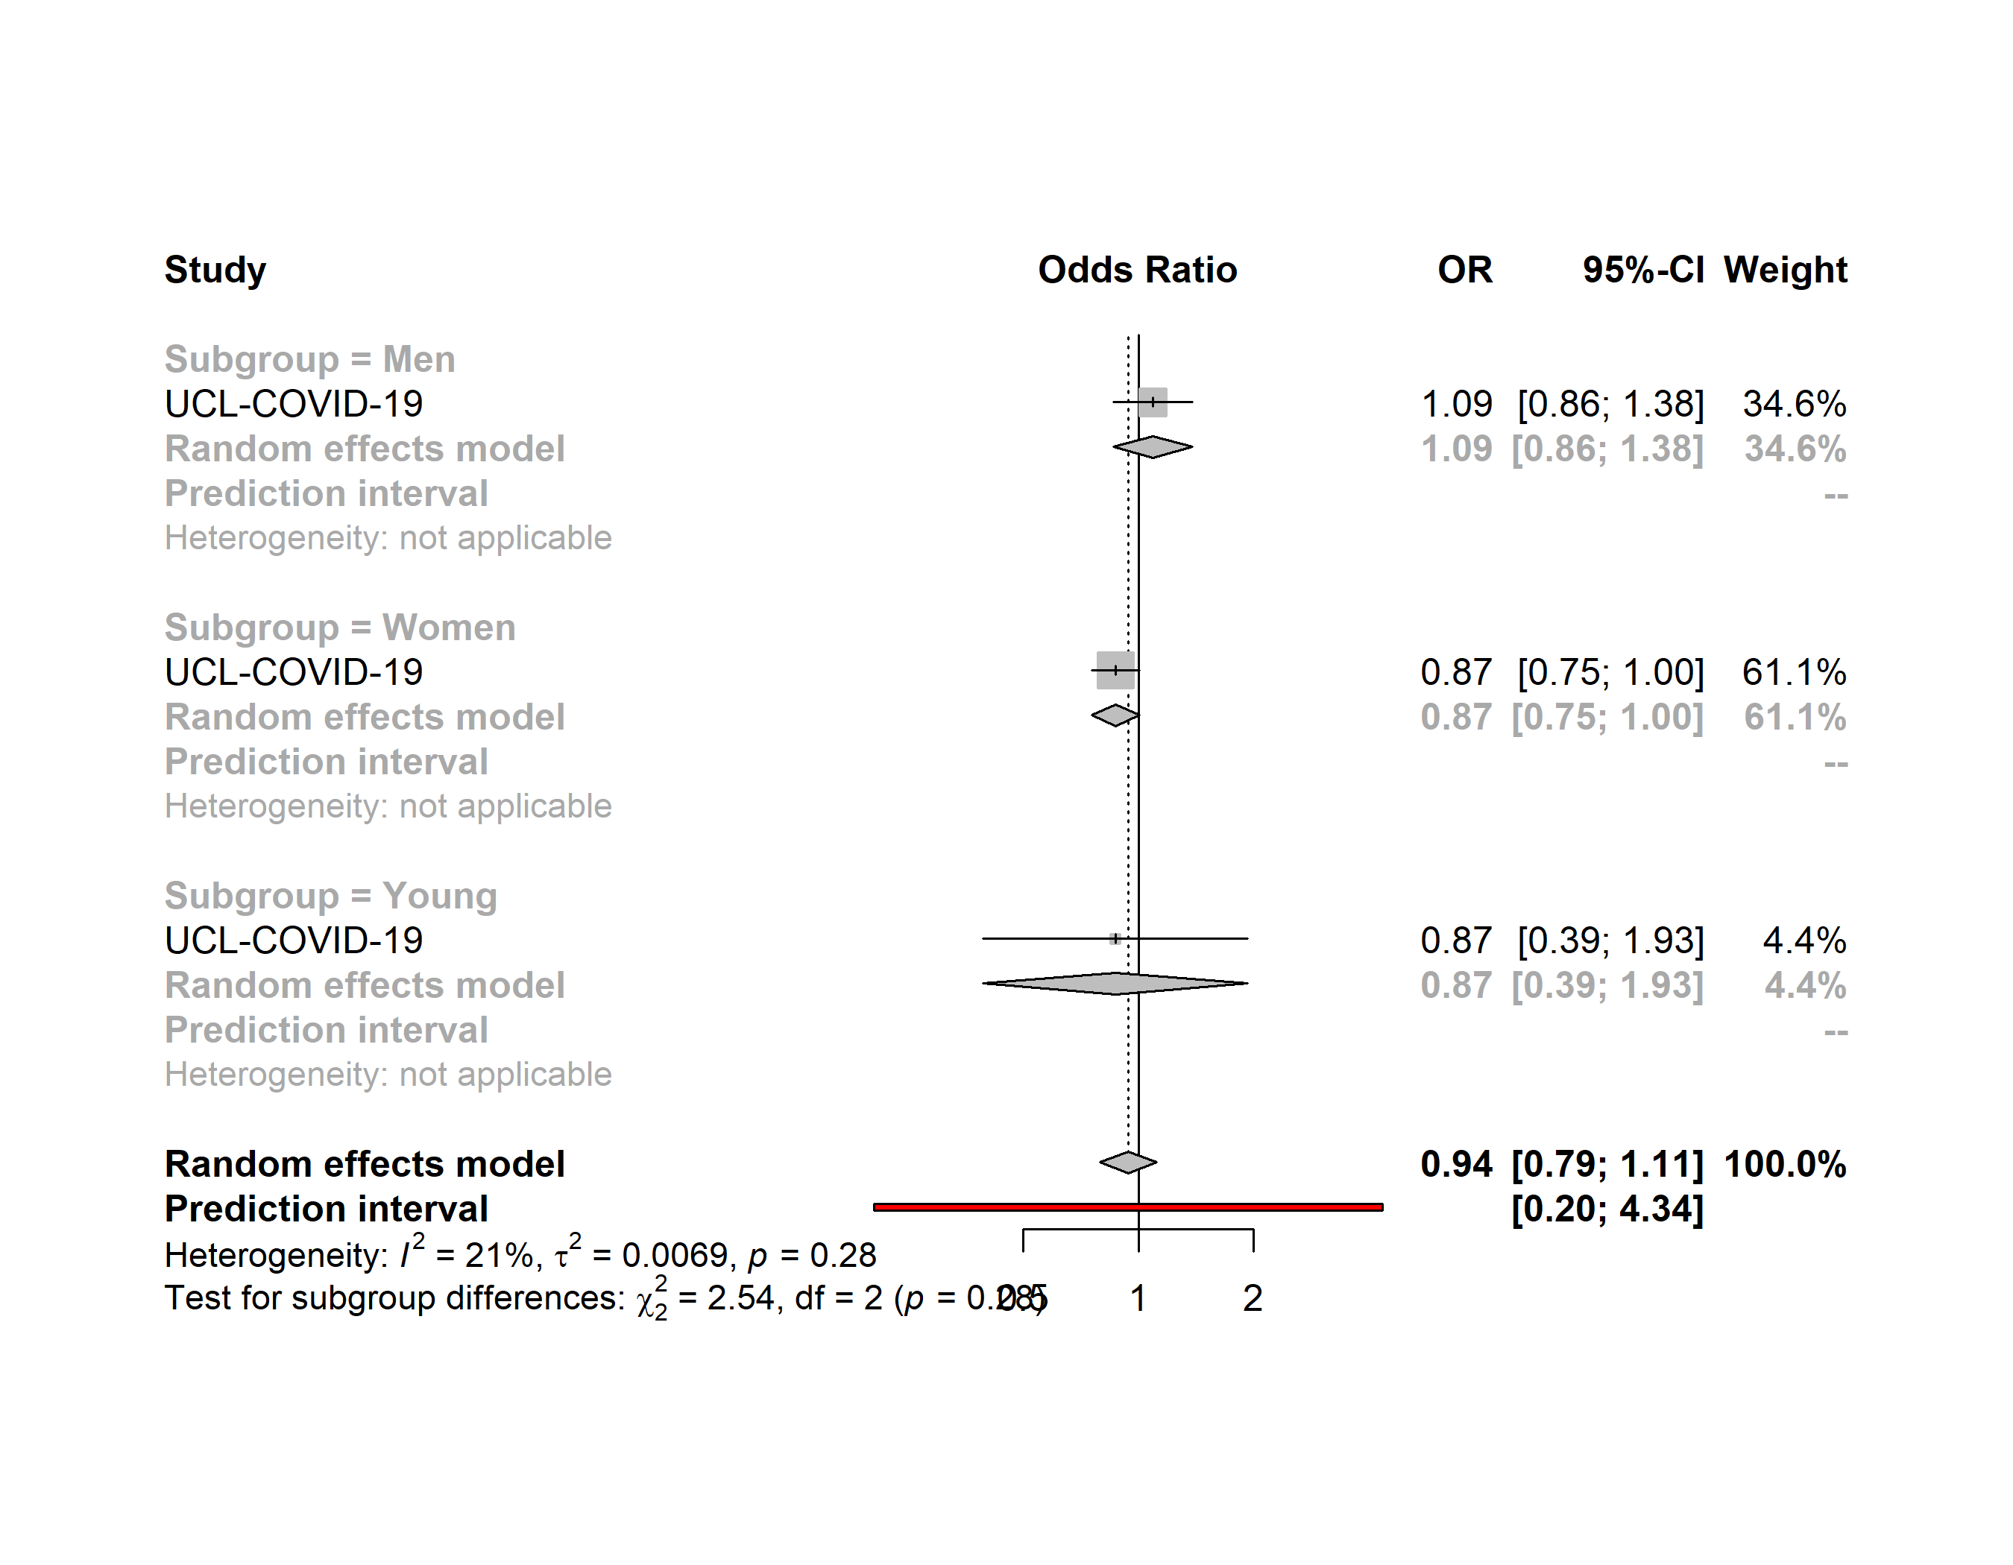

High life satisfaction
Households with children vs. Adults-only households
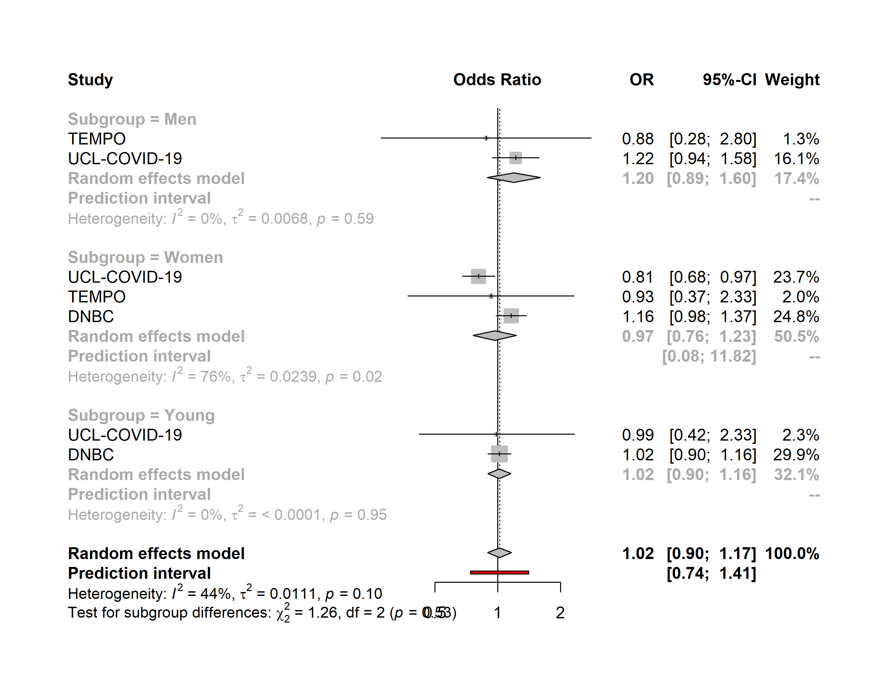

High life satisfaction
Living alone vs. Adults-only households
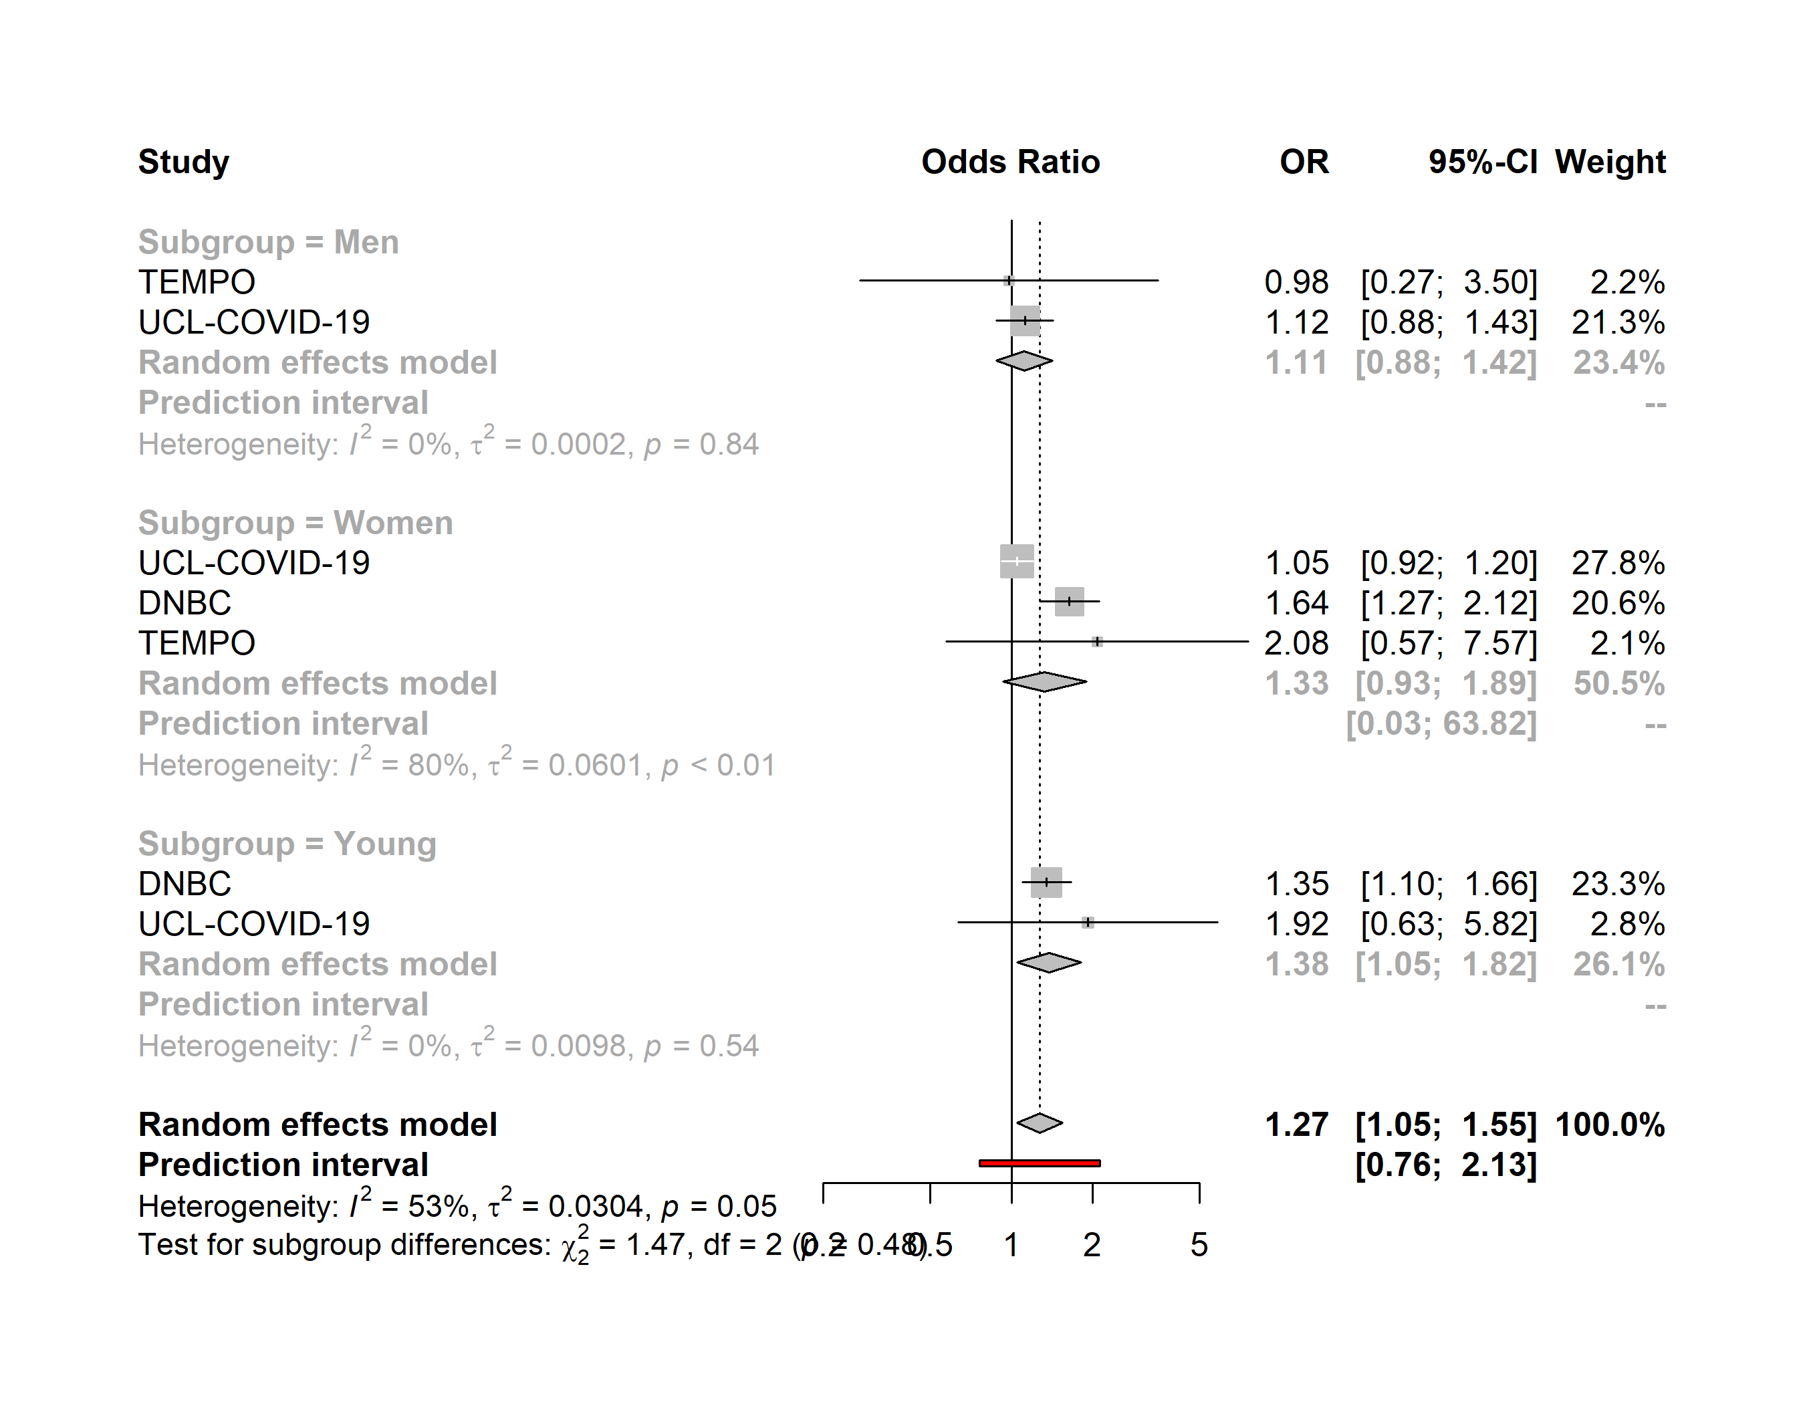

High life satisfaction
Apartment vs. House
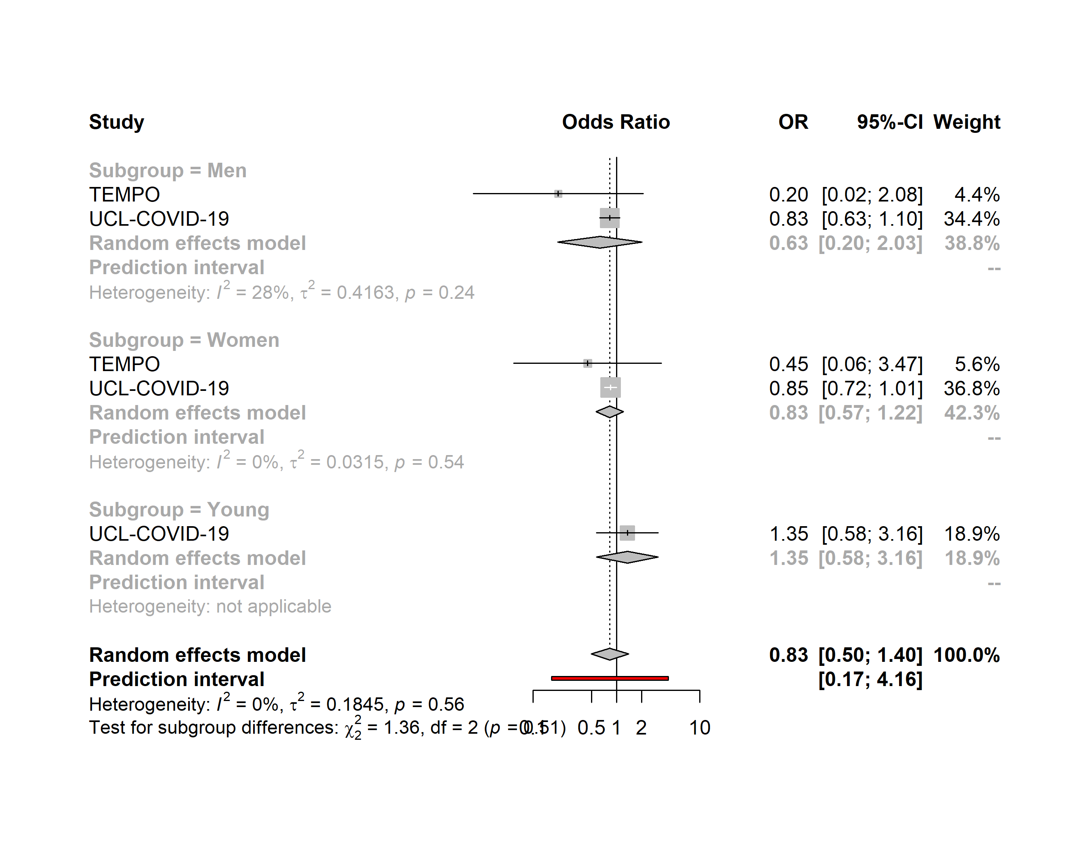

High life satisfaction
Semi-urban environment vs. Urban environment
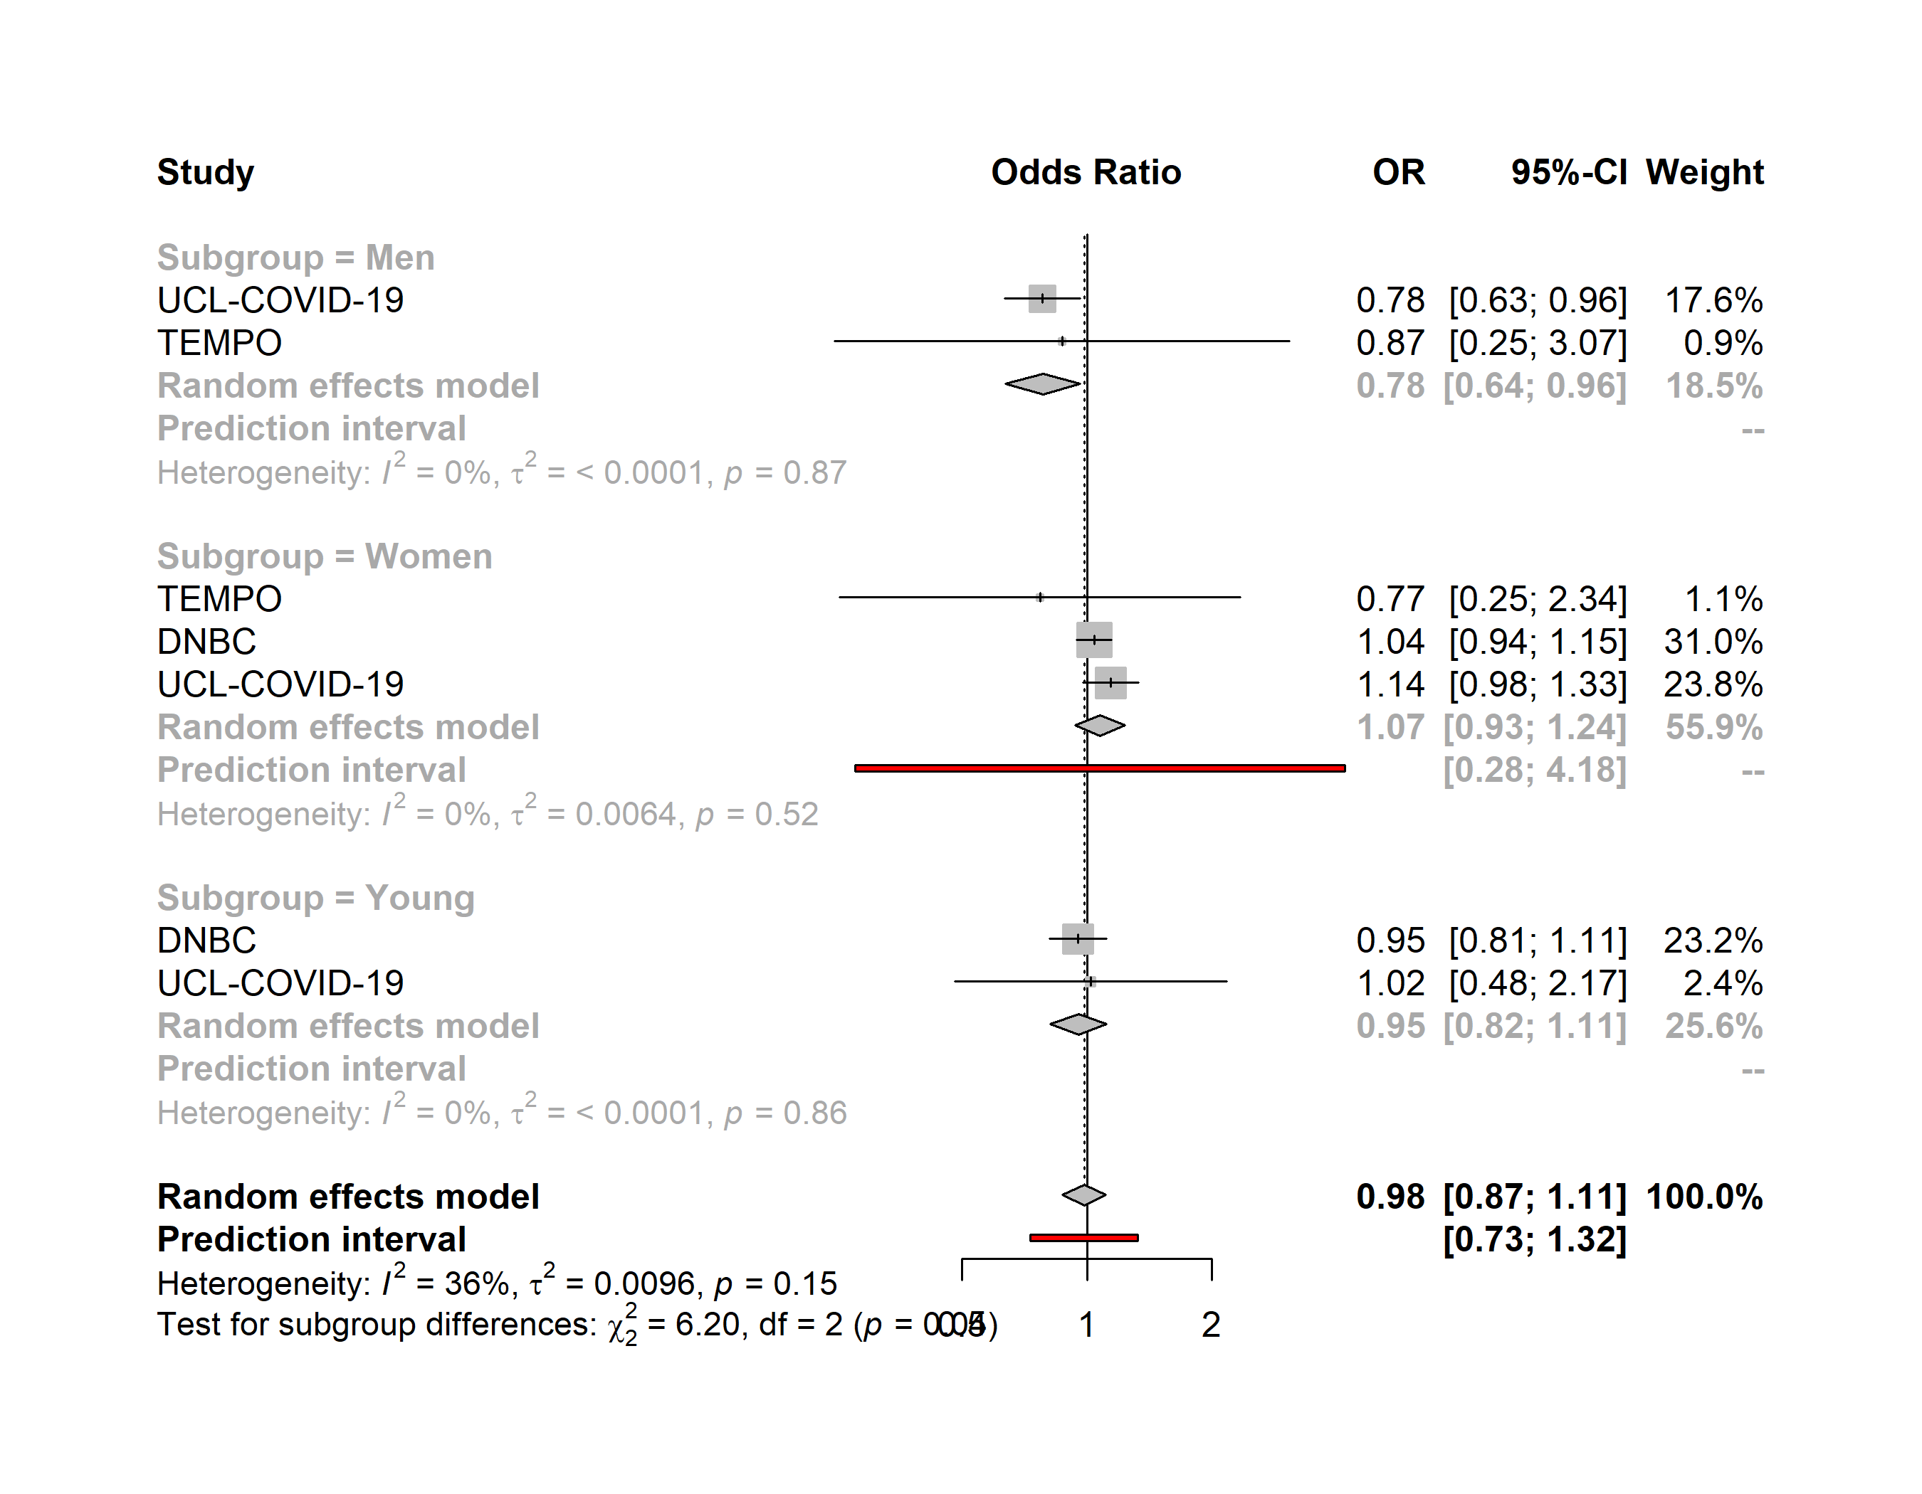

High life satisfaction
Rural environment vs. Urban environment
