Supplementary data 1a. Primer sequences for each gene using the qRT-PCR.

Gene | Sequence | Accession Number
Nestin | F TCCAGGAACGGAAAATCAAG  R GCCTCCTCATCCCCTACTTC | NM_006617.1
Hb-9 | F AGCACCAGTTCAAGCTCAACA  R ACCAAATCTTCACCTGGGTCTC | NM_005515.3
Islet-1 | F ATATCAGGTTGTACGGGATCAAATG  R CACGCATCACGAAGTCGTTC | NM_002202.2
ChAT | F GCA GGAGAAGACAGCCAACT  R TGCAAACCTCAGCTGGTCAT | NM_020549.4
SMI-32 | F CAGAGCTGGAGGCACTGAAA  R CTGCTGAATGGCTTCCTGGT | NM_021076.3
GAPDH | F CTCATTTCCTGGTATGACAAC  R CTTCCTCTTGTGCTCTTGCT | NM_002046.5

Supplementary data 1b. List of sequences of primers used for data validation.
miRNA | Primer Type |  | Primer Sequences
hsa-let-7i-5p | RT | CTCAACTGGTGTCGTGGAGTCCGGCAATTCAGTTGAGAACAGCAC
hsa-mir-146a-5p | RT | CTCAACTGGTGTCGTGGAGTCCGGCAATTCAGTTGAGAACCCATG
hsa-mir-328-3p | RT | CTCAACTGGTGTCGTGGAGTCCGGCAATTCAGTTGAGACGGAAGG
hsa-mir-335-3p | RT | CTCAACTGGTGTCGTGGAGTCCGGCAATTCAGTTGAGGGTCAGGA
hsa-mir-432-5p | RT | CTCAACTGGTGTCGTGGAGTCCGGCAATTCAGTTGAGCCACCCAA
hsa-mir-663a-5p | RT | CTCAACTGGTGTCGTGGAGTCCGGCAATTCAGTTGAGGCGGTCCC
novel_mir_1 | RT | CTCAACTGGTGTCGTGGAGTCCGGCAATTCAGTTGAGTCCTCCCT
novel_ mir_2 | RT | CTCAACTGGTGTCGTGGAGTCCGGCAATTCAGTTGAGAAAATGGA
novel_mir_4 | RT | CTCAACTGGTGTCGTGGAGTCCGGCAATTCAGTTGAGTCTGCTTG
novel_mi_17 | RT | CTCAACTGGTGTCGTGGAGTCCGGCAATTCAGTTGAGCAAAATCT
novel_miR_21 | RT | CTCAACTGGTGTCGTGGAGTCCGGCAATTCAGTTGAGGCCAGTTT
novel_mir_53 | RT | CTCAACTGGTGTCGTGGAGTCCGGCAATTCAGTTGAGAGCCGCCG
hsa-let-7i-5p | F | ACACTCCAGCTGGGTGAGGTAGTA
hsa-mir-146a-5p | F | ACACTCCAGCTGGGTGAGAACTGA
hsa-mir-328-3p | F | ACACTCCAGCTGGGCTGGCCCTCT
hsa-mir-335-3p | F | ACACTCCAGCTGGGTTTTTCATTA
hsa-mir-432-5p | F | ACACTCCAGCTGGGTCTTGGAGTA
hsa-mir-663a-5p | F | ACACTCCAGCTGGGCGGGGCGCCG
novel_mir_1 | F | ACACTCCAGCTGGGAGAGCTTATG
novel_mir_2 | F | ACACTCCAGCTGGGGCTTGTTGTG
novel_mir_4 | F | ACACTCCAGCTGGGAAAATGAAGG
novel_mir_17 | F | ACACTCCAGCTGGGTTTGCTTGTG
novel_mir_21 | F | ACACTCCAGCTGGGTCTACAACTG
novel_mir_53 | F | ACACTCCAGCTGGGCTTCTCGAGG
miR | Rev | AACTGGTGTCGTGGAG
GAPDH | F | CTCATTTCCTGGTATGACAAC
GAPDH | R | CTTCCTCTTGTGCTCTTGCT

Supplementary data 2. Statistical analysis of high-throughput sequencing reads for the three libraries.

 | Control |  | Test 1 |  | Test2
Type | Count | Percent (%) | Count | Percent (%) | Count | Percent (%)
total_reads | 11400602 |  | 12235949 |  | 12366199
high_quality | 11138629 | 100 | 12019568 | 100 | 11910647 | 100
3'adapter_null | 276454 | 2.48 | 144971 | 1.21 | 238208 | 2.00
insert_null | 36112 | 0.32 | 15210 | 0.13 | 12799 | 0.11
5'adapter_contaminants | 5238 | 0.05 | 5356 | 0.04 | 5205 | 0.04
smaller_than_18nt | 83030 | 0.75 | 264380 | 2.20 | 265619 | 2.23
polyA | 140 | 0.00 | 876 | 0.01 | 1231 | 0.01
clean_reads | 10737655 | 96.40 | 11588775 | 96.42 | 11387585 | 95.61

Supplementary data 3. Distribution of small RNAs among different categories.
 | Control |  | Test 1 |  | Test2
Category | Unique sRNAs | Total sRNAs | Unique sRNAs | Total sRNAs | Unique sRNAs | Total sRNAs
exon_antisense | 338 | 447 | 751 | 1571 | 1053 | 1849
exon_sense | 55744 | 81781 | 48846 | 68869 | 67734 | 110823
intron_antisense | 1578 | 2996 | 4756 | 16200 | 5389 | 14196
intron_sense | 9403 | 13475 | 17526 | 37747 | 24307 | 38894
miRNA | 3685 | 2141761 | 3651 | 1900656 | 3394 | 975144
rRNA | 191043 | 3958612 | 140948 | 1966523 | 193351 | 4015757
snRNA | 4986 | 35201 | 5395 | 42612 | 6183 | 48435
snoRNA | 6995 | 30560 | 6319 | 24186 | 9022 | 42183
tRNA | 46433 | 1857060 | 44154 | 1434700 | 35630 | 869903
unann | 436298 | 2541485 | 1034446 | 5998357 | 1229690 | 5130252
Total | 756503 | 10663378 | 1306792 | 11491421 | 1575753 | 11247436

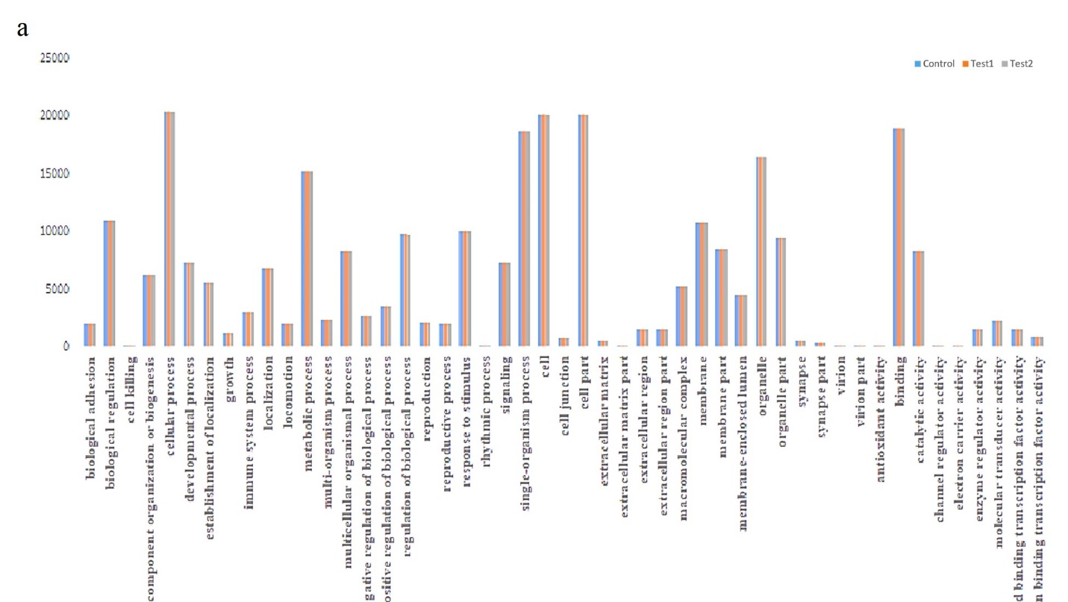
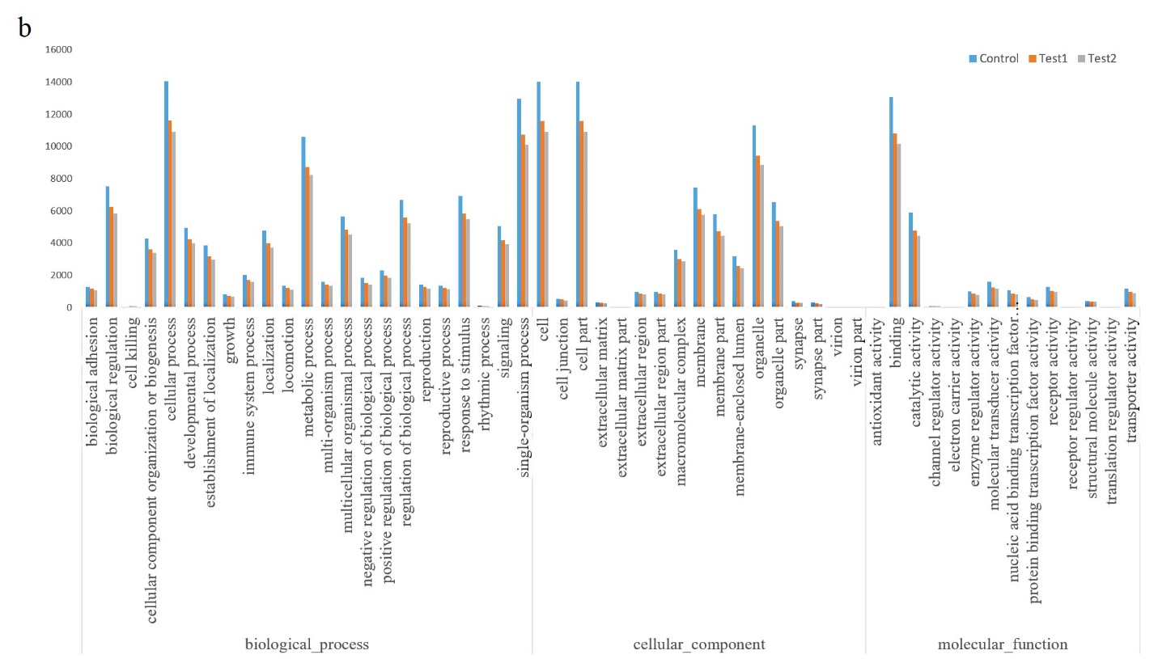
Supplementary data 4. miRNA target genes prediction and annotation. Target genes of conserved (a) and novel (b) miRNAs were categorized in 23, 17 and 14 classes as cellular component, biological process and molecular function, respectively. The most over-represented GO terms in the biological process were cellular process, single organism process and metabolic process. In the cellular component, however, the most over-expressed GO terms were in cell, cell part and organelle classes. Binding and catalytic activities were classes in which most of miRNAs were expressed in molecular function superclass.

