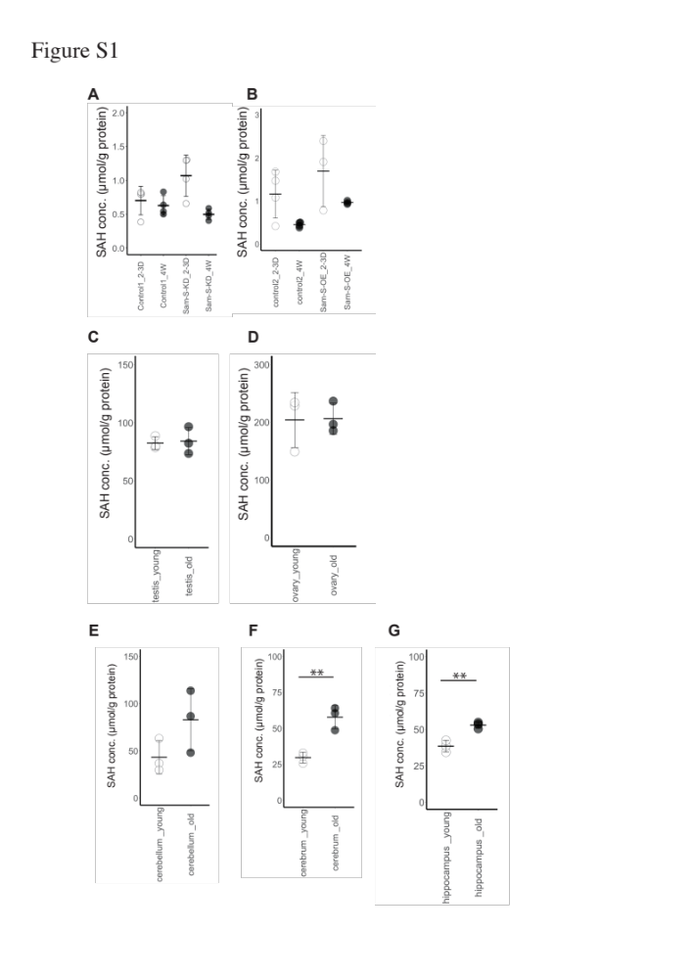

Figure S1. Age-related changes in SAH levels in fly ovaries and mouse tissues
(A, B) Age-related change in the SAH levels in the control (A; Control1, B; Control2) and Sam-S genetically manipulated (A, Sam-S-KD, B, Sam-S-OE) ovaries. For multiple comparison analyses in A and B, statistical significance was calculated using Dunnett’s test by using the young control ovaries as the controls; * indicates p < 0.1. (C–G) Age-related change in SAH levels in mouse reproductive tissues (C; Testis, D; Ovaries) and parts of the brain (E; Cerebellum, F; Cerebrum, G; Hippocampus). In C–G, statistical significance was calculated using the Welch’s t-test; ** indicates p < 0.05.

