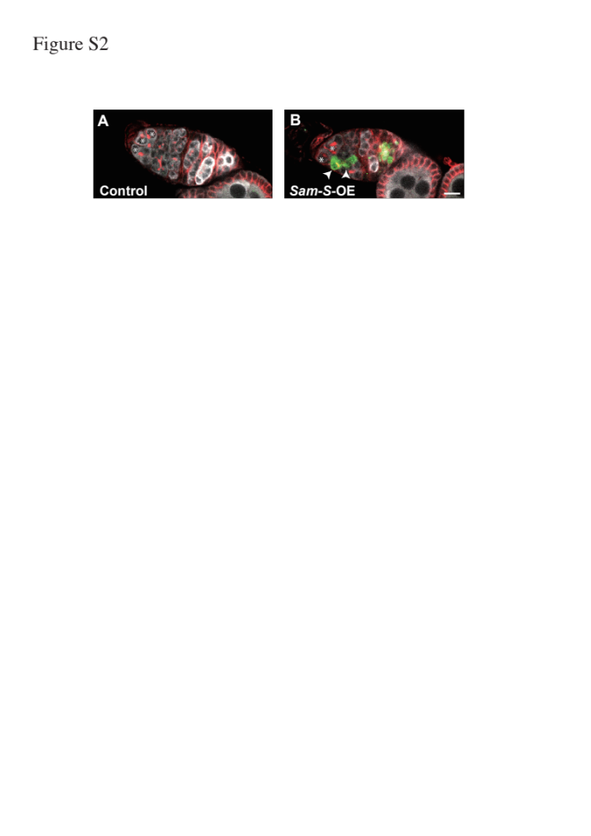

Figure S2. Germline cell death in germarium.
(A, B) Germline cell death in the germarium of control2 (A) and Sam-S-OE ovaries from young females. In germarium of Sam-S-OE ovaries, 36.9% of germarium contained germline cells causing apoptosis labeled by active-Caspase 3 antibody (Green) in contrast to 20.4% of germarium in control2 ovaries (P< 0.05, Significance was calculated with Fisher’s test. The number of ovarioles observed was; Control2: 446, Sam-S-OE: 412). Anti-Hts antibody stains fusome (red) and anti-Vasa antibody stains germline cells (Gray). Asterisks indicate GSC and arrowheads indicate germline cells causing apoptosis. Bar; 10µm.

