High adsorption capacity of phenol and methylene blue using activated carbon derived from lignocellulosic agriculture wastes
Haitham M. El-Bery*, Moushira Saleh, Reem A. El-Gendy, Mahmoud R. Saleh*, Safinaz M. Thabet
Advanced Multifunctional Materials Laboratory, Chemistry Department, Faculty of Science, Assiut University, Assiut 71515, Egypt.

*Corresponding Author Email: Haitham.El-Bery@aun.edu.eg; mahmoudrabie@aun.edu.eg

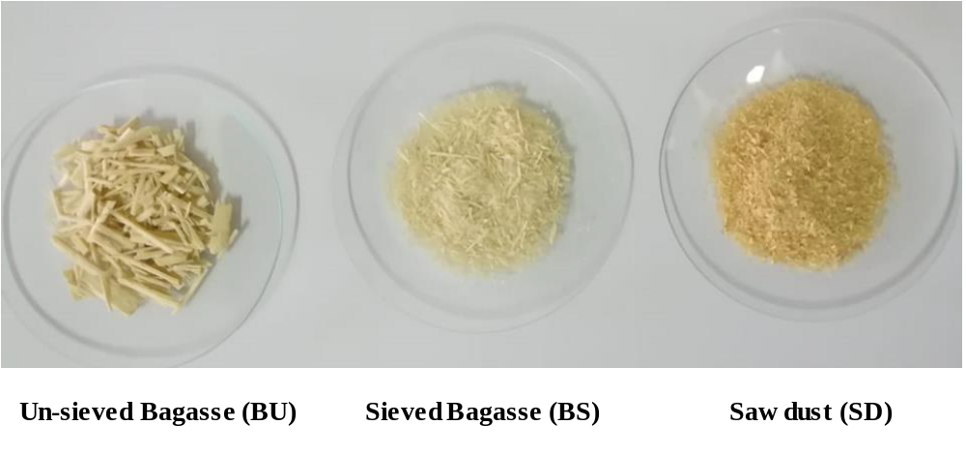
Fig. S1. Photographic images of bagasse un-sieved (BU), bagasse sieved (BS) and sawdust (SD).

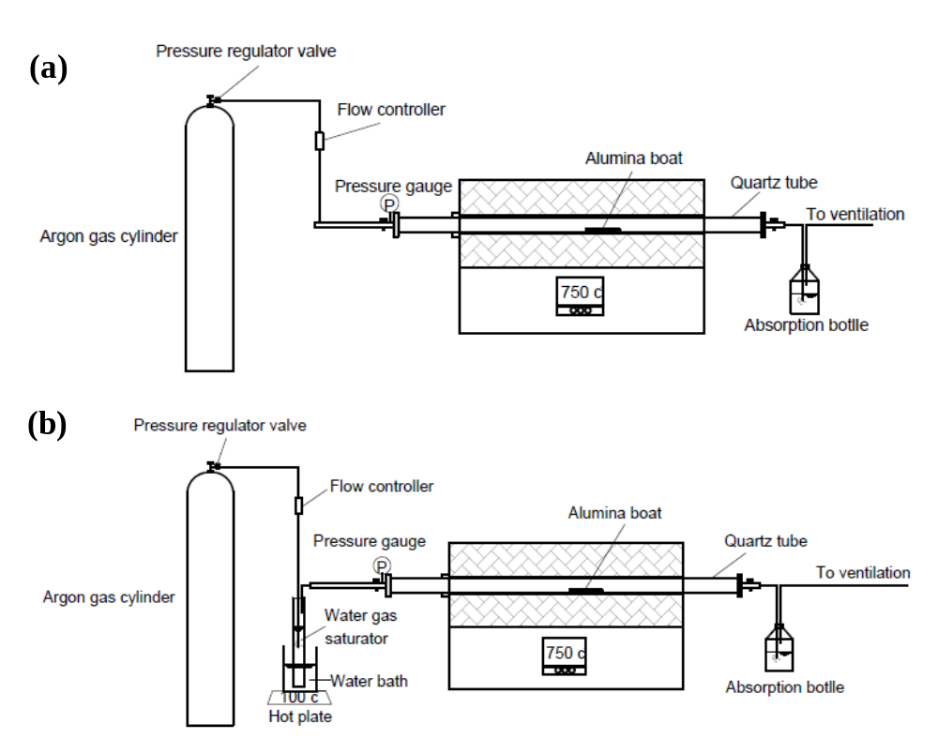
Fig. S2. Schematic diagram of the experimental setup: (a) carbonization test, (b) water activation test.

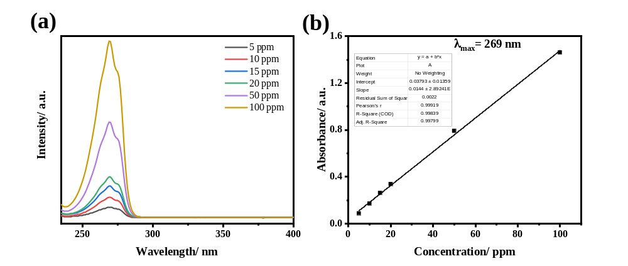
Fig. S3. UV-vis spectrum of phenol solution at different concentrations (a). The calibration curve calibration curve constructed based on Beer’s-Lambert law (b).

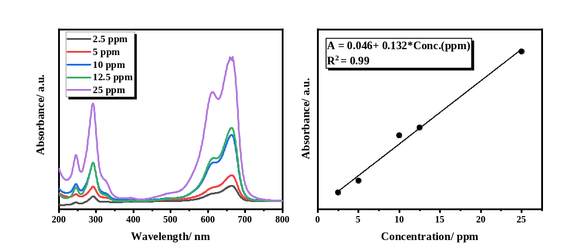
Fig. S4. UV-vis spectrum of methylene blue solution at different concentrations (a). The calibration curve calibration curve constructed based on Beer’s-Lambert law (b).

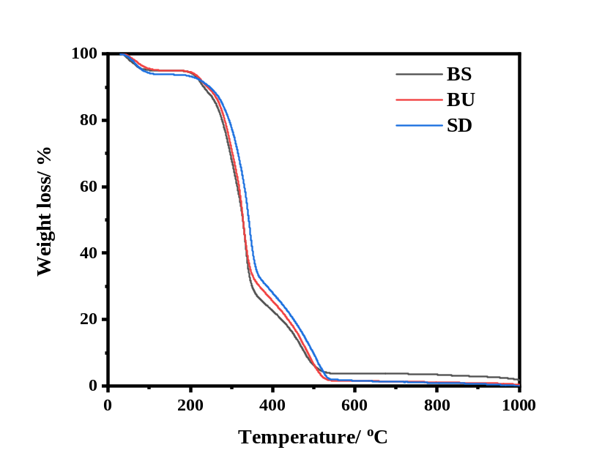
Fig. S5. TGA curves of BS, BU, and SD measured from room temperature until 1000ºC with heating rate of 10ºC/min.

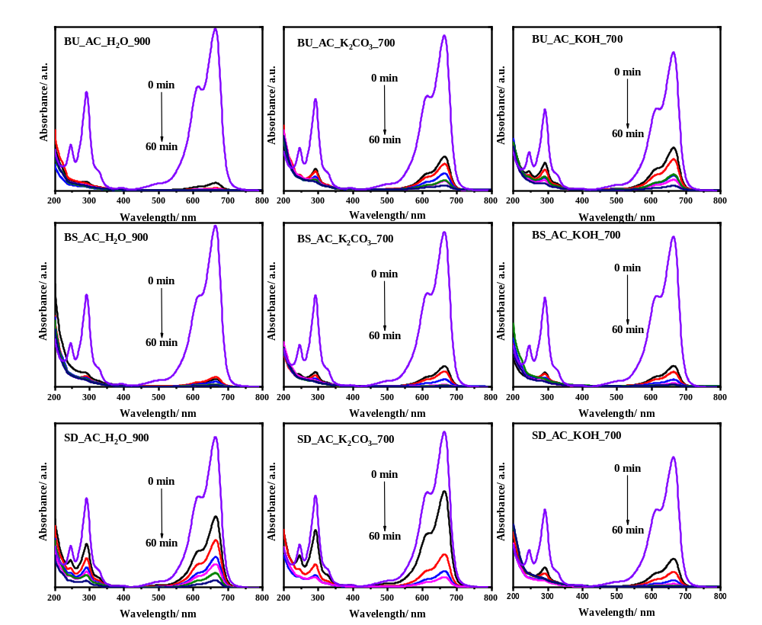
Fig. S6. UV-vis spectrum of methylene blue solution at different time intervals for optimized samples.
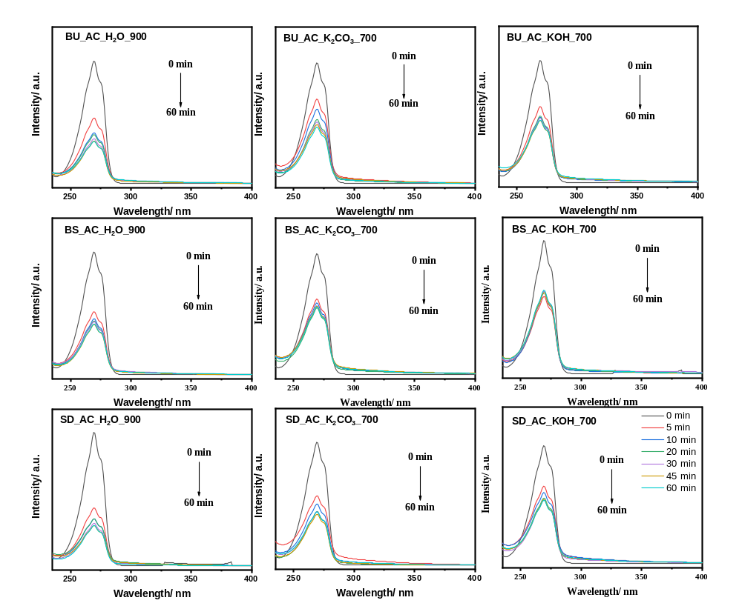
Fig. S7. UV-vis spectrum of phenol solution at different time intervals for optimized samples.

Table S1: Raw lignocellulosic materials analysis
Analysis/  Samples | Cellulose  (%) | Hemicellulose  (%) | Lignin  (%) | Moisture  (M) (%) | Volatile matters  (VC) (%) | Ash  (AC) (%) | Fixed carbon  (FC) (%)
BU | 45.6 | 17.0 | 24.4 | 6 | 87.1 | 6.5 | 6.4
BS | 39.2 | 24.0 | 17.9 | 6.1 | 88.3 | 4.3 | 7.4
SD | 35.6 | 15.2 | 42.4 | 7 | 86.8 | 4.7 | 8.56

Table S2: Surface texture properties BU-car sample activated with various activators, water vapor, K₂CO₃, and KOH, at different temperatures and different weight of chemical activators
Sample | BET method |  | t method |  | BJH method
Sample | Surface area (m²/g) | Micropore volume (cm³/g) | Micropore area (m²/g) | External area (m²/g) | Pore volume (cm³/g) | Pore radius (Aº)
BU_car | 664 | 0.34 | 646 | 18 | 0.03 | 18.0
BU_AC_H₂O_800 | 987 | 0.46 | 928 | 59 | 0.11 | 18.1
BU_AC_H₂O_850 | 1346 | 0.63 | 1180 | 167 | 0.27 | 18.1
BU_AC_H₂O_900 | 1470 | 0.69 | 1332 | 138 | 0.25 | 18.2
BU_AC_H₂O_950 | 1771 | 0.72 | 1399 | 372 | 0.68 | 18.0
BU_AC_K₂CO₃_700 | 1392 | 0.68 | 1332 | 61 | 0.09 | 18.0
BU_AC_K₂CO₃_750 | 1935 | 0.92 | 1831 | 104 | 0.10 | 18.2
BU_AC_K₂CO₃_800 | 2120 | 1.01 | 2007 | 113 | 0.16 | 15.7
BU_AC_KOH_700 | 1463 | 0.70 | 1392 | 71 | 0.11 | 18.1
BU_AC_KOH_750 | 2088 | 0.96 | 1938 | 149 | 0.19 | 15.8
BU_AC_KOH_800 | 2490 | 1.13 | 2262 | 229 | 0.34 | 15.7
BU_AC_K₂CO₃ (1:1) | 1392 | 0.68 | 1332 | 61 | 0.09 | 18.0
BU_AC_K₂CO₃ (1:2) | 897 | 0.44 | 856 | 41 | 0.06 | 18.1
BU_AC_K₂CO₃ (1:3) | 529 | 0.354 | 505 | 24 | 0.04 | 18.1
BU_AC_KOH (1:1) | 1463 | 0.70 | 1392 | 71 | 0.11 | 18.1
BU_AC_KOH (1:2) | 990 | 0.46 | 924 | 65 | 0.08 | 15.7
BU_AC_KOH (1:3) | 826 | 0.38 | 772 | 54 | 0.07 | 15.7

Table S3: Comparison of adsorption efficiency of phenol, specific surface area and yield of different carbon samples activated by chemical and physical processes
Sample | Yield  (%) | Specific surface area  (m² g) | Adsorption capacity  (mg g⁻¹)
BU_car | -- | 664 | 36.4
BU_AC_H₂O_900 | 42 | 1470 | 142.2
BU_AC_k₂CO₃_700 | 62 | 1392 | 119.8
BU_AC_KOH_700 | 61 | 1463 | 105.6
BS_car | -- | 243 | 37.8
BS_AC_H₂O_900 | 53 | 1228 | 127.7
BS_AC_k₂CO₃_700 | 41 | 1482 | 85.2
BS_AC_KOH_700 | 31 | 1204 | 88.0
SD_car | -- | 534 | 29.4
SD_AC_H₂O_900 | 53 | 1053 | 158.8
SD_AC_k₂CO₃_700 | 67 | 1528 | 123.4
SD_AC_KOH_700 | 50 | 1544 | 96.8

