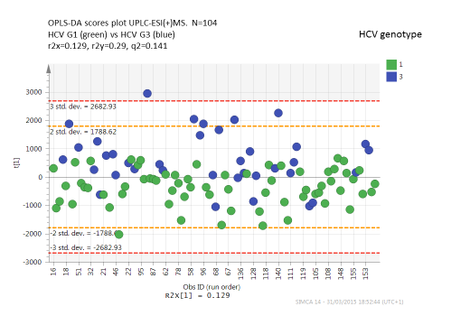
Supplemental figure 1. OPLS-DA scores plot to identify those variables with greatest influence on separation of HCV genotypes 1 and 3 in ESI positive mode.

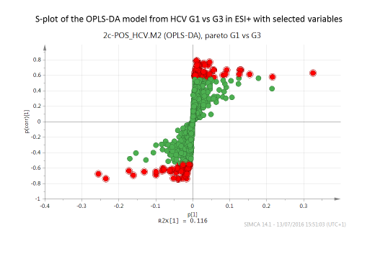
Supplemental figure 2: S-plot to determine variables with the greatest contribution to HCV genotypes 1 and 3 separation in fasting samples.

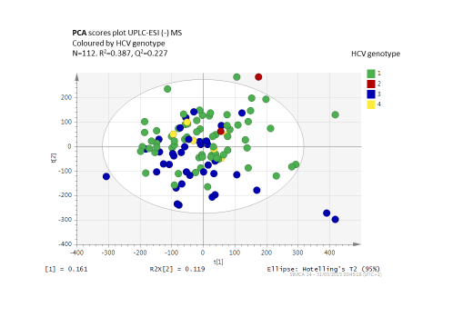
Supplemental figure 3. Principal components analysis (PCA) of fasting sera in negative electrospray ionisation mode demonstrating separation between HCV genotypes

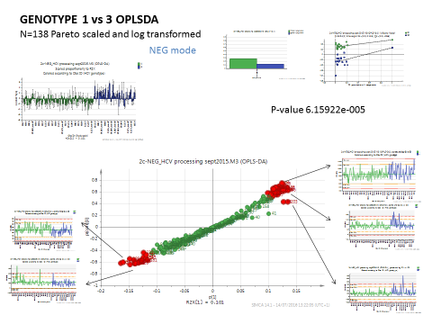
Supplemental figure 4. OPLS-DA and S-plot to determine variables with the greatest contribution to HCV genotypes 1 and 3 separation in fasting samples in negative electrospray ionisation mode.

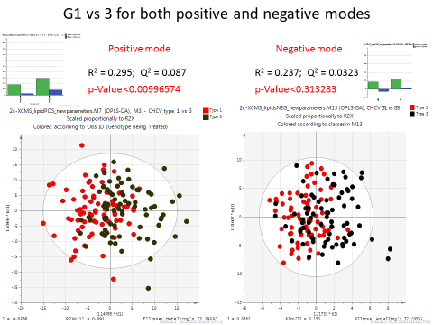
Supplemental figure 5. Principal components analysis (PCA) of non-fasting sera, (cohort 2 HCV RNA positive viraemic) in both positive and negative electrospray ionisation mode demonstrating separation between HCV genotypes 1 and 3.

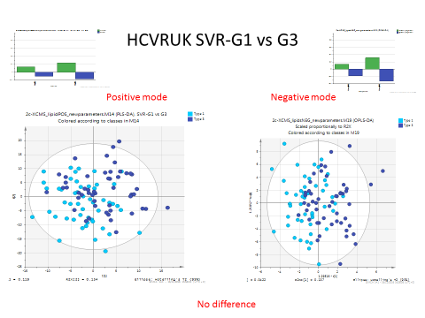

Supplemental figure 6. Principal components analysis (PCA) of non-fasting sera, (cohort 3 HCV RNA negative, non-viraemic) following sustained virological response to pegylated interferon-alpha and ribavirin in both positive and negative electrospray ionisation mode demonstrating no significant separation between HCV genotypes 1 and 3.

