Complex drought patterns robustly explain global yield loss for major crops
Monia Santini^{1,*}, Sergio Noce¹, Marta Antonelli^{1,2} and Luca Caporaso^{1,3}
¹ Impacts on Agriculture, Forests and Ecosystem Services (IAFES) Division, Foundation Euro-Mediterranean Center on Climate Change (CMCC), 01100 Viterbo, Italy
² Barilla Center for Food & Nutrition (BCFN) Foundation, 43121 Parma, Italy
³ European Commission – Joint Research Centre (JRC), 21027 Ispra, Italy
*corresponding author: Monia Santini, monia.santini@cmcc.it

Supplementary Information

Table S1. Average asymmetry. 2
Table S2. List of countries. 3
Figure S1. Frequency significance of co-occurring lower-than-normal both moisture and yield. 5
Figure S2. Significance of differences in SYI magnitude under different SPEI intervals. 6
Figure S3. Significance of differences in SPEI magnitude under different SYI intervals. 7
Figure S4. Frequency significance of co-occurring higher-than-normal both moisture and yield. 8
Figure S5. Spatial distribution of crop harvested areas. 9
Table S3. Harvested areas per crop system and country. 10
Table S4. Crop susceptibility per country and year. 17
Table S5. Aggregated crop susceptibility per country and year. 24
References 26

Table S1. Average asymmetry.
Aggregated results per cropping system (first column) in terms of Asymmetry (fourth column, quantifying the average prevalence of the LY_D macro-class with respect to any other macro-class, see Eqs. 6-9 in Methods). Enter brackets, the share of duration-timing contingency tables presenting full Asymmetry is shown as calculated over the total number of combinations analysed (third column). The global statistics of growing season length is also reported in the second column.
Cropping system | Growing season length (in months)  mean±st.dev. [maximum] | N. of  contingency tables analysed | Asymmetry  [and % of contingency tables with full Asymmetry > 50%]
Maize main season | 5.1±1.2 [7.1] | 42 | 71% [95%]
Maize 2nd season | 4.7±0.9 [5.8] | 25 | 66% [76%]
Rice main season | 5±0.9 [7.2] | 33 | 57% [48%]
Rice 2nd season | 4.2±0.5 [5.4] | 12 | -
Soybean | 5±0.7 [6.1] | 33 | 67% [91%]
Wheat (spring) | 4.6±0.9 [7.2] | 25 | 67% [84%]
Wheat (winter) | 7.5±2.2 [11.6] | 85 | 63% [68%]
Average |  |  | 64% [76%]

Table S2. List of countries.
List (with ID code) of the 177 countries considered in the analysis as extracted from the Database of Global Administrative Areas (GADM).
ID | Country name | ID | Country name
1 | Afghanistan | 69 | Egypt
3 | Albania | 70 | El Salvador
4 | Algeria | 71 | Equatorial Guinea
7 | Angola | 72 | Eritrea
11 | Argentina | 73 | Estonia
12 | Armenia | 74 | Ethiopia
14 | Australia | 75 | Falkland Islands
15 | Austria | 77 | Fiji
16 | Azerbaijan | 78 | Finland
17 | Bahamas | 79 | France
19 | Bangladesh | 80 | French Guiana
21 | Belarus | 82 | French Southern Territories
22 | Belgium | 83 | Gabon
23 | Belize | 84 | Gambia
24 | Benin | 85 | Georgia
26 | Bhutan | 86 | Germany
27 | Bolivia | 87 | Ghana
29 | Bosnia and Herzegovina | 89 | Greece
30 | Botswana | 90 | Greenland
32 | Brazil | 94 | Guatemala
35 | Brunei | 96 | Guinea
36 | Bulgaria | 97 | Guinea-Bissau
37 | Burkina Faso | 98 | Guyana
38 | Burundi | 99 | Haiti
39 | Cambodia | 101 | Honduras
40 | Cameroon | 103 | Hungary
41 | Canada | 104 | Iceland
45 | Central African Republic | 105 | India
46 | Chad | 106 | Indonesia
47 | Chile | 107 | Iran
48 | China | 108 | Iraq
52 | Colombia | 109 | Ireland
55 | Costa Rica | 111 | Israel
56 | Cote d'Ivoire | 112 | Italy
57 | Croatia | 113 | Jamaica
58 | Cuba | 114 | Japan
60 | Cyprus | 116 | Jordan
61 | Czech Republic | 117 | Kazakhstan
62 | Democratic Republic of the Congo | 118 | Kenya
63 | Denmark | 120 | Kosovo
64 | Djibouti | 121 | Kuwait
66 | Dominican Republic | 122 | Kyrgyzstan
67 | East Timor | 123 | Laos
68 | Ecuador | 124 | Latvia

ID | Country name | ID | Country name
125 | Lebanon | 198 | Saudi Arabia
126 | Lesotho | 199 | Senegal
127 | Liberia | 200 | Serbia
128 | Libya | 202 | Sierra Leone
130 | Lithuania | 205 | Slovakia
131 | Luxembourg | 206 | Slovenia
133 | Macedonia | 207 | Solomon Islands
134 | Madagascar | 208 | Somalia
135 | Malawi | 209 | South Africa
136 | Malaysia | 210 | South Georgia and the South Sandwich Islands
138 | Mali | 211 | South Korea
142 | Mauritania | 212 | South Sudan
145 | Mexico | 213 | Spain
147 | Moldova | 215 | Sri Lanka
149 | Mongolia | 216 | Sudan
150 | Montenegro | 217 | Suriname
152 | Morocco | 218 | Svalbard and Jan Mayen
153 | Mozambique | 219 | Swaziland
154 | Myanmar | 220 | Sweden
155 | Namibia | 221 | Switzerland
157 | Nepal | 222 | Syria
158 | Netherlands | 223 | Taiwan
159 | New Caledonia | 224 | Tajikistan
160 | New Zealand | 225 | Tanzania
161 | Nicaragua | 226 | Thailand
162 | Niger | 227 | Togo
163 | Nigeria | 230 | Trinidad and Tobago
166 | North Korea | 231 | Tunisia
168 | Norway | 232 | Turkey
169 | Oman | 233 | Turkmenistan
170 | Pakistan | 236 | Uganda
172 | Palestina | 237 | Ukraine
173 | Panama | 238 | United Arab Emirates
174 | Papua New Guinea | 239 | United Kingdom
175 | Paraguay | 240 | United States
176 | Peru | 242 | Uruguay
177 | Philippines | 243 | Uzbekistan
179 | Poland | 244 | Vanuatu
180 | Portugal | 246 | Venezuela
181 | Puerto Rico | 247 | Vietnam
182 | Qatar | 250 | Western Sahara
183 | Republic of Congo | 251 | Yemen
185 | Romania | 252 | Zambia
186 | Russia | 253 | Zimbabwe
187 | Rwanda

a) maize main season  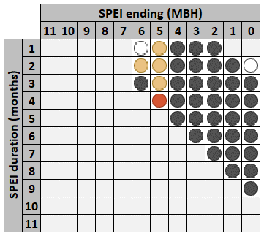 | b) maize second season  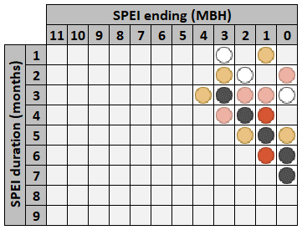
c) rice main season  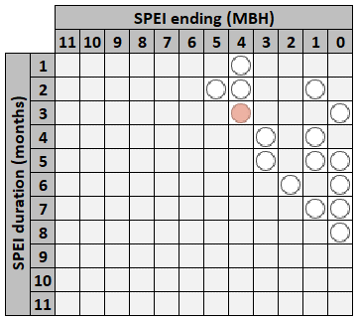 | d) rice second season  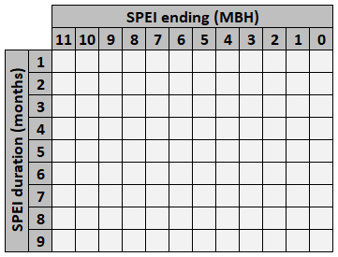
e) soybean  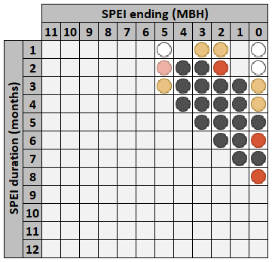 | f) spring wheat  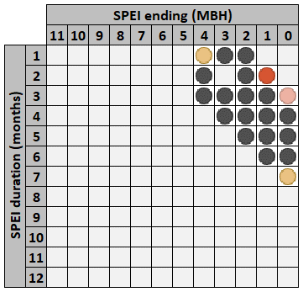
g) winter wheat  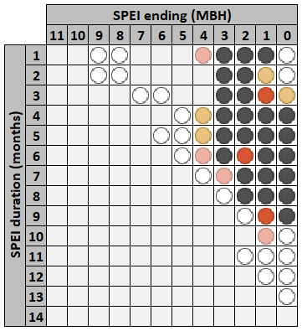 | Legend  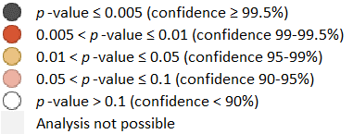

Figure S1. Frequency significance of co-occurring lower-than-normal both moisture and yield.
SPEI duration-timing matrix of p-values from the Fisher exact test between anomalous macro-classes of contingency tables, showing the significance of the Asymmetry fully skewed towards the co-occurrence of lower-than-normal both yield and moisture. Grey cells represent excluded contingency tables, i.e., when the minimum sample to do the analysis is no reached or when there is no dominance of the LY_D macro-class over all the other macro-classes. Coloured symbols refer to p-value classification as reported in the legend. SPEI ending (in Months Before the Harvesting month, MBH) represents the timing.

a) maize main season  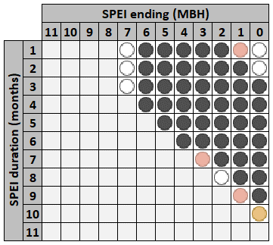 | b) maize second season  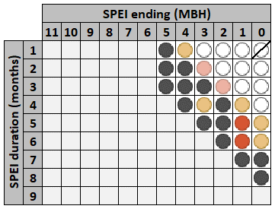
c) rice main season  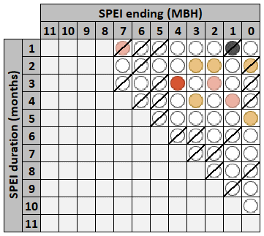 | d) rice second season  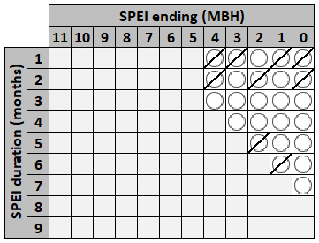
e) soybean  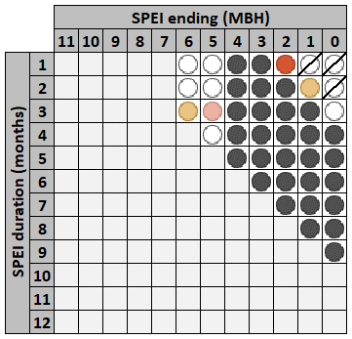 | f) spring wheat  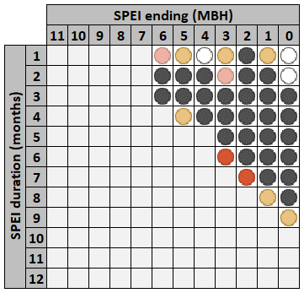
g) winter wheat  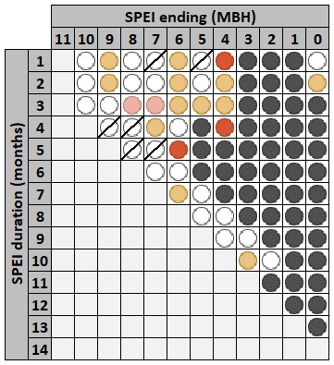 | Legend  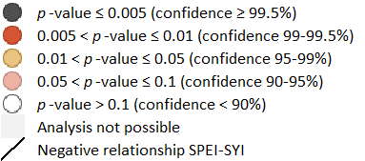

Figure S2. Significance of differences in SYI magnitude under different SPEI intervals.
SPEI duration-timing matrix of p-values of the Wilcoxon rank sum test for independent sample made between the series of SYI values under SPEI ≤ -1 (drought conditions) vs. SPEI > -1. Coloured symbols refer to p-value classification as reported in the legend. Grey cells represent no minimum sample reached to do the analysis. Diagonal lines indicate the case of overall SYI higher under drought (drier-than-normal) conditions. SPEI ending (in Months Before the Harvesting month, MBH) represents the timing.
a) maize main season  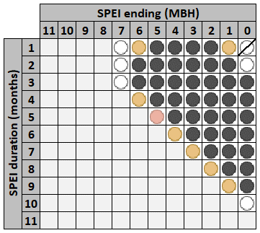 | b) maize second season  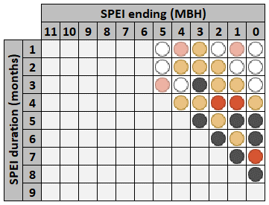
c) rice main season  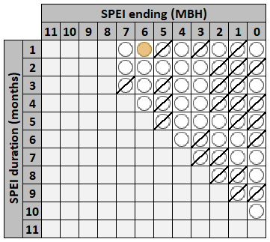 | d) rice second season  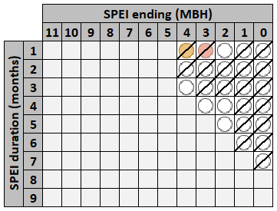
e) soybean  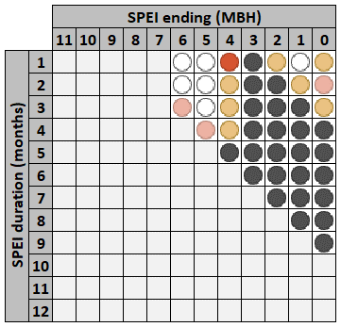 | f) spring wheat  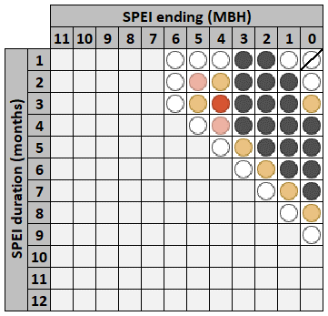
g) winter wheat  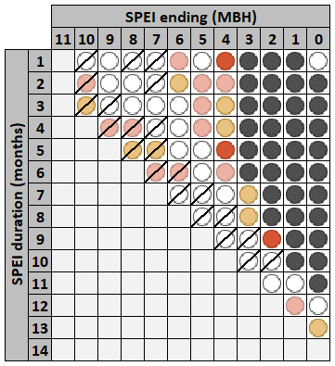 | Legend

Figure S3. Significance of differences in SPEI magnitude under different SYI intervals.
SPEI duration-timing matrix of p-values of the Wilcoxon rank sum test for independent sample made between the series of SPEI values under SYI ≤ -1 (yield lower-than-normal) vs. SYI > -1. Coloured symbols refer to p-value classification as reported in the legend. Grey cells represent no minimum sample reached to do the analysis. Diagonal lines indicate the case of SPEI on average found higher under the occurrence of lower-than-normal yields. SPEI ending (in Months Before the Harvesting month, MBH) represents the timing.

a) maize main season  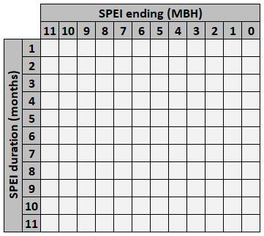 | b) maize second season  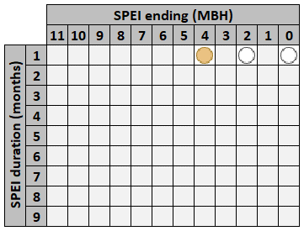
c) rice main season | d) rice second season  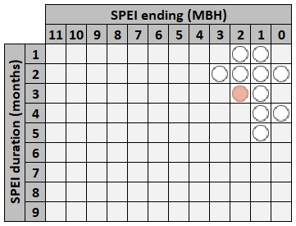
e) soybean  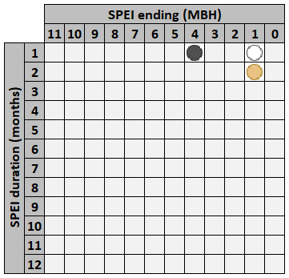 | f) spring wheat  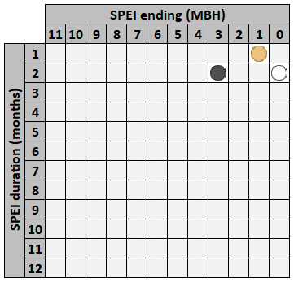
g) winter wheat  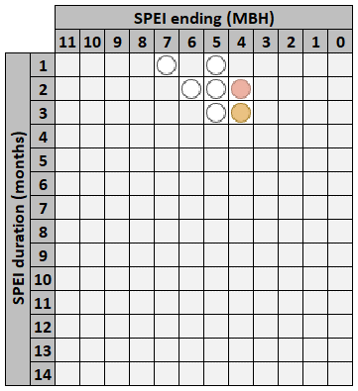 | Legend

Figure S4. Frequency significance of co-occurring higher-than-normal both moisture and yield.
SPEI duration-timing matrix of p-values from the Fisher exact test among anomalous macro-classes of contingency tables, showing the significance of the asymmetry fully skewed towards the co-occurrence of higher-than-normal both yield and moisture. Grey cells represent excluded contingency tables, i.e., when minimum sample to do the analysis is no reached or there is no dominance of the HY_W macro-class over all the other macro-classes. Coloured symbols refer to p-value classification as reported in the legend. SPEI ending (in Months Before the Harvesting month, MBH) represents the timing.

Figure S5. Spatial distribution of crop harvested areas.
Maps showing the spatial distribution of surface (in km²) devoted to each crop system, derived from the cultivated cells for each crop system according to the crop yield database (1) multiplied by the fraction of harvested area of the related crop (2) and by the cell area calculated from (3). A few inconsistencies with the maps in Figure 2 and with Table S3 can be due to spatial discrepancy among fraction cover, yield, and calendar datasets, and to simplified countries boundaries because of gridded spatial discretization.

Table S3. Harvested areas per crop system and country.
Surface (in km²) devoted to each crop system per country, derived from the cultivated cells for each crop system according to the crop yield database (1) multiplied by the fraction of harvested area of the related crop (2) and by the cell area calculated from (3). A few inconsistencies with the maps in Figure 2 and Figure S5 can be due to spatial discrepancy among fraction cover, yield, and calendar datasets, and to simplified countries boundaries because of gridded spatial discretization.
 |  | Harvested surface in km²
ID | Country name | maize main | maize 2nd | rice main | rice 2nd | soybean | spring wheat | winter wheat
1 | Afghanistan | 52.456 |  |  |  |  |  | 1'398.815
3 | Albania | 444.515 |  |  |  |  |  | 702.586
4 | Algeria |  |  |  |  |  |  | 14'975.297
7 | Angola | 6'716.228 | 136.479 | 4.028
11 | Argentina | 27'772.594 | 744.810 | 2'185.616 |  | 90'431.129 |  | 55'863.892
12 | Armenia |  |  |  |  |  | 475.523 | 1'049.396
14 | Australia | 475.190 |  | 1'032.702 |  |  | 101'261.354
15 | Austria | 894.696 |  |  |  |  |  | 1'100.509
16 | Azerbaijan | 55.968 |  | 6.219 |  |  |  | 1'690.847
17 | Bahamas
19 | Bangladesh |  |  | 86'781.457 | 86'781.457 |  |  | 5'184.390
21 | Belarus |  |  |  |  |  | 245.290 | 278.464
22 | Belgium | 40.446 |  |  |  |  |  | 499.452
23 | Belize | 23.627
24 | Benin | 3'019.612 | 3'019.612 | 190.285 | 73.508 | 0.871
26 | Bhutan |  |  | 10.295 | 10.295 | 0.345
27 | Bolivia | 2'674.936 | 10.354 | 1'371.683 |  | 5'742.437 | 0.833 | 1'397.423
29 | Bosnia and Herzegovina | 1'794.883 |  |  |  |  |  | 837.823
30 | Botswana | 364.372 |  |  |  | 0.070 | 1.884 | 2.020
32 | Brazil | 90'030.929 | 89'887.426 | 26'898.568 |  | 126'544.194 |  | 16'855.641
35 | Brunei |  |  | 2.633
36 | Bulgaria | 3'849.018 |  | 2.253 |  |  | 361.988 | 10'903.669
37 | Burkina Faso | 2'038.042 | 54.109 | 296.028
38 | Burundi | 1'293.216 | 1'293.216 | 96.311
39 | Cambodia | 544.198 |  | 19'199.039 | 19'199.039
40 | Cameroon | 2'961.854 | 2'961.854 | 199.447 | 43.486 | 13.399
41 | Canada | 5'600.997 |  |  |  | 5'126.403 | 98'718.294 | 1'569.090
45 | Central African Republic | 550.395 | 533.463 | 96.792
46 | Chad | 906.816 | 244.992 | 185.778
47 | Chile | 761.212 |  | 206.899 |  |  | 0.228 | 2'379.497
48 | China | 208'313.929 |  | 284'976.239 | 152'399.629 | 72'535.197 | 36'927.005 | 163'275.821
52 | Colombia | 5'924.353 |  | 4'479.260 |  | 298.693 | 166.503
55 | Costa Rica | 35.618 | 35.618 | 164.504 | 164.504
56 | Cote d'Ivoire | 7'247.684 | 7'247.684 | 4'405.027
57 | Croatia | 4'460.410 |  |  |  |  |  | 2'462.351
58 | Cuba | 626.748 | 626.748 | 928.046 | 928.046
60 | Cyprus
61 | Czech Republic |  |  |  |  |  |  | 596.852
62 | Democratic Republic of the Congo | 17'181.089 | 16'602.788 | 4'754.455
63 | Denmark |  |  |  |  |  |  | 2'127.439
64 | Djibouti
66 | Dominican Republic | 102.407 | 102.407 | 532.327 | 532.327
67 | East Timor
68 | Ecuador | 119.653 |  | 2'416.376 |  |  | 239.039
69 | Egypt | 8'277.509 |  | 4'675.286 |  |  |  | 8'893.211
70 | El Salvador | 1'117.406 | 1'117.406 | 20.630 | 20.630
71 | Equatorial Guinea
72 | Eritrea | 143.231 |  |  |  |  | 172.501
73 | Estonia
74 | Ethiopia | 11'886.927 | 421.928 | 0.012 |  |  | 7'720.227 | 124.862
75 | Falkland Islands
77 | Fiji
78 | Finland
79 | France | 16'108.707 |  | 3.577 |  | 0.668 | 28.985 | 44'115.224
80 | French Guiana |  |  | 17.660
82 | French Southern Territories
83 | Gabon | 98.917 | 98.917
84 | Gambia | 55.929 |  | 14.331
85 | Georgia | 1'690.310 |  |  |  |  | 139.922 | 1'027.131
86 | Germany | 209.953 |  |  |  |  |  | 24'377.441
87 | Ghana | 6'341.453 | 6'341.453 | 1'193.195
89 | Greece | 500.407 |  | 1.879 |  |  | 331.289 | 1'272.188
90 | Greenland
94 | Guatemala | 5'655.749 | 5'655.413 | 127.845 | 17.082
96 | Guinea | 808.589 | 190.687 | 4'546.847
97 | Guinea-Bissau | 89.926 |  | 220.083
98 | Guyana | 0.083 |  | 216.759
99 | Haiti | 423.233 | 423.233 | 353.401 | 353.401
101 | Honduras | 395.424 | 395.424 | 10.337 | 5.175
103 | Hungary | 10'267.812 |  |  |  |  | 127.161 | 10'689.433
104 | Iceland
105 | India | 12'786.469 |  | 218'930.432 | 81'769.546 | 63'639.877 |  | 52'609.078
106 | Indonesia | 13'348.703 |  | 47'875.178 | 46'316.573
107 | Iran | 1'491.482 |  | 5'250.415 |  |  | 103.437 | 47'170.974
108 | Iraq | 732.490 |  | 543.078 |  |  | 17.755 | 1'211.354
109 | Ireland |  |  |  |  |  |  | 1.750
111 | Israel | 44.629 |  |  |  |  |  | 1'069.754
112 | Italy | 9'303.087 |  | 2'578.099 |  | 2'045.685 | 11'549.161 | 11'549.161
113 | Jamaica
114 | Japan |  |  | 7'070.742 |  |  |  | 999.349
116 | Jordan | 11.437 |  |  |  |  |  | 189.335
117 | Kazakhstan | 134.382 |  | 4.820 |  |  | 95'738.626
118 | Kenya | 14'796.988 | 14'796.988 | 64.383 |  |  | 1'330.357 | 58.872
120 | Kosovo | 1'456.695 |  |  |  |  |  | 799.955
121 | Kuwait
122 | Kyrgyzstan | 545.178 |  |  |  |  |  | 4'497.458
123 | Laos | 148.324 |  | 5'942.301 | 5'942.301 | 4.362
124 | Latvia |  |  |  |  |  |  | 1'171.059
125 | Lebanon |  |  |  |  |  |  | 5.867
126 | Lesotho | 1'213.356 |  |  |  | 12.710 |  | 248.838
127 | Liberia |  |  | 828.619
128 | Libya
130 | Lithuania |  |  |  |  |  |  | 4'247.413
131 | Luxembourg |  |  |  |  |  |  | 24.437
133 | Macedonia | 371.352 |  | 49.011 |  |  |  | 1'391.671
134 | Madagascar | 1'020.848 |  | 8'944.028
135 | Malawi | 7'774.232 |  | 361.613 |  |  | 15.437
136 | Malaysia | 6.829 |  | 2'302.725 | 72.638
138 | Mali | 1'587.841 | 6.353 | 2'305.098 | 0.319
142 | Mauritania | 78.265 |  | 217.025 | 217.025
145 | Mexico | 69'025.998 | 1'637.355 | 732.733 |  | 353.803 |  | 3'404.322
147 | Moldova | 4'514.469 |  |  |  |  | 1'750.134 | 3'804.050
149 | Mongolia | 7.149 |  | 1.112 |  | 3.071 | 42.014
150 | Montenegro | 1'199.843 |  |  |  |  |  | 658.903
152 | Morocco | 1'198.657 |  |  |  |  |  | 21'871.377
153 | Mozambique | 8'812.044 |  | 14.329 |  |  | 0.801 | 0.364
154 | Myanmar | 1'928.133 |  | 44'164.625 | 44'164.625 | 57.912 |  | 726.466
155 | Namibia | 276.873
157 | Nepal | 6'044.050 |  | 10'482.649 |  | 39.031 |  | 4'456.309
158 | Netherlands |  |  |  |  |  |  | 125.135
159 | New Caledonia
160 | New Zealand
161 | Nicaragua | 3'411.372 | 3'411.372 | 772.013 | 26.085
162 | Niger | 9.419 | 7.882 | 161.611 | 2.765
163 | Nigeria | 35'623.652 | 35'623.652 | 22'943.897 | 22'943.897 | 4'015.856
166 | North Korea | 2'523.453 |  | 2'691.692 |  | 1'104.315 | 223.826 | 294.724
168 | Norway
169 | Oman
170 | Pakistan | 8'354.867 |  | 22'435.656 |  |  |  | 79'235.971
172 | Palestina |  |  |  |  |  |  | 144.135
173 | Panama | 232.052 | 88.822 | 274.152 | 70.359
174 | Papua New Guinea
175 | Paraguay | 3'376.320 | 223.585 | 291.006 |  | 9'269.331 |  | 1'871.869
176 | Peru | 14.096 |  | 2'770.839 |  |  | 1'269.587 | 31.205
177 | Philippines | 10'527.237 |  | 15'519.698
179 | Poland |  |  |  |  |  | 469.808 | 21'853.530
180 | Portugal | 232.757 |  | 41.639 |  |  |  | 411.708
181 | Puerto Rico
182 | Qatar
183 | Republic of Congo | 64.612 | 64.612 | 0.377
185 | Romania | 31'133.693 |  |  |  |  | 762.182 | 20'903.677
186 | Russia | 28.027 |  | 25.171 |  | 13.689 | 16'007.105 | 365.058
187 | Rwanda | 952.268 | 952.268 | 4.823
198 | Saudi Arabia | 28.946 |  |  |  |  |  | 1'846.836
199 | Senegal | 792.938 |  | 444.777 | 48.435
200 | Serbia | 9'808.685 |  |  |  |  |  | 5'386.513
202 | Sierra Leone | 45.626 |  | 1'215.078
205 | Slovakia | 409.521 |  |  |  |  | 4.462 | 1'453.224
206 | Slovenia | 305.309 |  |  |  | 0.004 | 79.108 | 247.345
207 | Solomon Islands
208 | Somalia | 1'480.287 | 1'480.287 |  |  |  | 0.890
209 | South Africa | 29'736.827 |  |  |  | 1'008.833 | 0.636 | 5'639.625
210 | South Georgia and the South Sandwich Islands
211 | South Korea | 90.864 |  | 5'518.057 |  |  |  | 4.316
212 | South Sudan | 225.364 | 16.113 | 0.991 |  |  | 38.216 | 102.755
213 | Spain | 4'229.422 |  | 886.458 |  |  |  | 20'890.798
215 | Sri Lanka | 156.339 |  | 3'593.330
216 | Sudan | 50.992 |  |  |  |  | 66.881 | 835.227
217 | Suriname |  |  | 230.762
218 | Svalbard and Jan Mayen
219 | Swaziland | 1'076.243 |  |  |  |  |  | 0.643
220 | Sweden |  |  |  |  |  |  | 842.858
221 | Switzerland | 82.549 |  |  |  |  |  | 74.400
222 | Syria | 445.423 |  |  |  | 3.419 | 2'615.299 | 12'557.131
223 | Taiwan
224 | Tajikistan | 49.476 |  |  |  |  |  | 3'066.336
225 | Tanzania | 12'619.769 | 5'368.553 | 1'767.067 |  |  | 570.357
226 | Thailand | 11'794.847 |  | 95'247.483 | 95'247.483 |  |  | 0.145
227 | Togo | 2'649.918 | 2'649.918 | 330.953
230 | Trinidad and Tobago
231 | Tunisia |  |  |  |  |  |  | 5'685.965
232 | Turkey | 4'500.330 |  | 215.869 |  | 128.574 | 82'037.998 | 82'037.998
233 | Turkmenistan | 118.495 |  | 26.706 |  |  |  | 5'783.398
236 | Uganda | 9'640.196 | 4'614.625 | 214.860 |  |  | 38.286 | 2.151
237 | Ukraine | 882.140 |  |  |  |  | 49'172.752 | 3'280.029
238 | United Arab Emirates
239 | United Kingdom |  |  |  |  |  |  | 12'971.383
240 | United States | 285'465.242 |  | 12'667.564 |  | 287'737.752 | 89'278.981 | 175'884.604
242 | Uruguay | 333.872 | 37.937 | 1'189.784 |  | 95.674 |  | 1'164.717
243 | Uzbekistan | 404.623 |  |  |  |  | 334.091 | 3'887.436
244 | Vanuatu
246 | Venezuela | 3'944.715 |  | 1'526.952
247 | Vietnam | 689.356 |  | 47'627.651 | 47'627.651 | 228.847
250 | Western Sahara
251 | Yemen
252 | Zambia | 5'386.711 |  | 6.935 |  |  | 0.174 | 117.604
253 | Zimbabwe | 11'058.302 |  |  |  | 18.231 | 390.831 | 390.831

Table S4. Crop susceptibility per country and year.
Counts, for each country and year, of all duration-timing combinations with SPEI ≤ -1 in case of SYI ≤ -1 for: a) maize main season; b) maize second season; c) rice main season; d) rice second season; e) soybean; f) spring wheat; g) winter wheat. Empty cells represent country-year combination for which SYI > -1. Light to dark tones represent increasing counts according to colors used in Figure 3 for each cropping system. Countries (rows) and years (columns) are flagged in case they present a significantly different counts’ distribution with respect to that of all countries and all years, respectively, under the Wilcoxon rank sum test for independent sample: * if 0.05 < p-value ≤ 0.1 (confidence 90-95%); ** 0.01 < p-value ≤ 0.05 (confidence 95-99%); *** p-value ≤ 0.01 (confidence ≥ 99%).

Table S5. Aggregated crop susceptibility per country and year.
Cumulated counts across all cropping systems, for each country and year, of all duration-timing combinations with SPEI ≤ -1 in case of SYI ≤ -1. Empty cells represent country-year combination for which SYI > -1. Light to dark tones represent increasing counts. Countries and years are flagged in case they present a significantly different counts’ distribution with respect to that of all countries and all years, respectively, under the Wilcoxon rank sum test for independent sample: * if 0.05 < p-value ≤ 0.1 (confidence 90-95%); ** 0.01 < p-value ≤ 0.05 (confidence 95-99%); *** p-value ≤ 0.01 (confidence ≥ 99%).

References
- Iizumi, T. & Sakai, T. The global dataset of historical yields for major crops 1981–2016. Scientific Data 7, 97 (2020).
- Monfreda, C., Ramankutty, N. & Foley, J. A. Farming the planet: 2. Geographic distribution of crop areas, yields, physiological types, and net primary production in the year 2000. Global Biogeochemical Cycles 22, GB1022 (2008).
- Santini, M., Taramelli, A. & Sorichetta, A. ASPHAA: a GIS-based algorithm to calculate cell area on a latitude-longitude (geographic) regular grid. Transactions in GIS 14(3), 351-377 (2010).

