Supplemental Figure 1. Polyacrylamide gel electrophoresis images, with 12.5% (m/v) obtained by 2D-PAGE electrophoresis;13 cm polyacrylamide gel strips containing immobilized ampholytes with pH gradients at 3 to10; T1: 25 % starch and Monensin; T2: 25 % starch and Blend Essential Oil + α-Amylase; T3: 35 % starch and Monensin; T4: 35 % starch and Blend Essential Oil + α-Amylase; T5: 45 % starch and Monensin; T6: 45 % starch and Blend Essential Oil + α-Amylase.

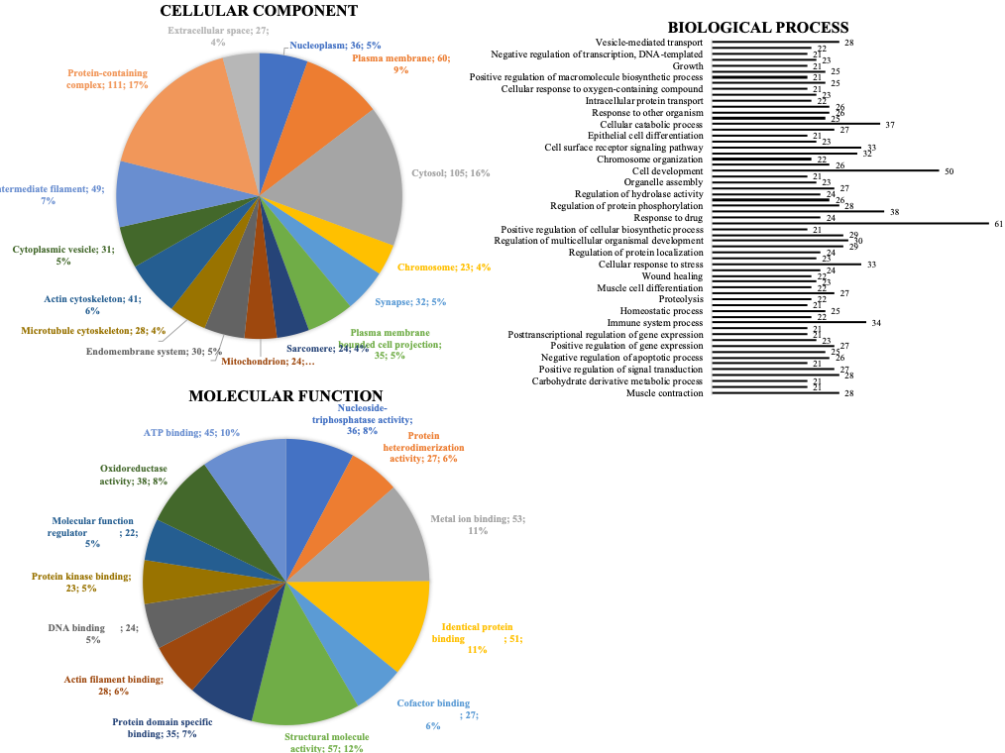
Supplemental Figure 2. Classification of the proteins sequences found in beef cattle cecum proteome using OMICSBOX software analysis (Blast2GO).

Supplemental Table 1. Values of Reactome Statistical analysis.
Pathway | Raw P.value | FDR Adjusted P.Value
Pyruvate Metabolism | 3.2E-2 | 1.58E-1
Gluconeogenesis | 3.51E-2 | 1.58E-1
Pyruvate Metabolism and Citric Acid (TCA) Cycle | 5.62E-2 | 1.58E-1
Glycolysis | 7.88E-2 | 1.58E-1
Glucose Metabolism | 9.81E-2 | 1.7E-1
The Citric acid (TCA) cycle and respiratory electron transport | 1.7E-1 | 1.7E-1
Metabolism Carbohydrate | 2.73E-1 | 2.73E-1
Neutrophil degranulation | 4.02E-1 | 4.02E-1
Metabolism | 6.88E-1 | 6.88E-1
Innate Immune System | 7.32E-1 | 7.32E-1

