Appendix 1
The urea production flow adopted in this study is discussed in Ecoinvent database (Ruiz et al. 2020). Urea or carbamide is an amide compound with chemical formula (NH₂)₂CO. It plays an important role in mammals’ metabolism and has various industrial applications. A schematic of a urea production process is illustrated in Fig. 1. The basic urea process consists of two main reactions shown in Equations (1) and (2):
2 NH₃ + CO₂ ⇌ H₂N-COONH₄ ΔH 298 =−58.87 kJ/mol (Carbamate formation) | (1)
H₂N-COONH₄ ⇌ (NH₂)₂CO + H₂O ΔH 298 =−56.46 kJ/mol (Urea conversion) | (2)
The first reaction is fast exothermic and happens at high temperature and high pressure to produce ammonium carbamate (H₂N-COONH₄). This component is decomposed through a slow endothermic reaction in the second stage to form ammonia. The detailed reactions in all stages of the production are mentioned at the end of this appendix.
The typical production flow of urea is shown in Fig. 1. The summarized urea production flow used in this study is shown in Fig. 2 exported from ecoinvent (Moreno et al. 2019).
Generally, for producing one tonne of urea, 0.735–0.750 t CO₂ is consumed (Muradov, 2014). One of the key applications of urea is in fertilizers where it reacts with water, releasing CO₂ and ammonia to the soil. Furthermore, the amount of CO₂ emissions in the urea production process is 2.27 tonnes of CO₂-eq. per tonne of CO₂ utilized (Brinckerhoff, 2011). Consequently, the concept of CO₂ utilization in urea production is not recognized as a carbon reduction measure (Muradov, 2014) which was adopted in this study following ecoinvent database (Ruiz et al. 2020).
The production of 1 kg of urea following the discussed method produces massive number of by-products into the water, soil, and air. The total number of main and sub process are 14693 according to ecoinvent utilization in Simapro. Most 30 affecting parameters are summarized in Table 1 exported from Simapro for production of 1 kg of urea. The detailed description of each stage is followed after Table 1.

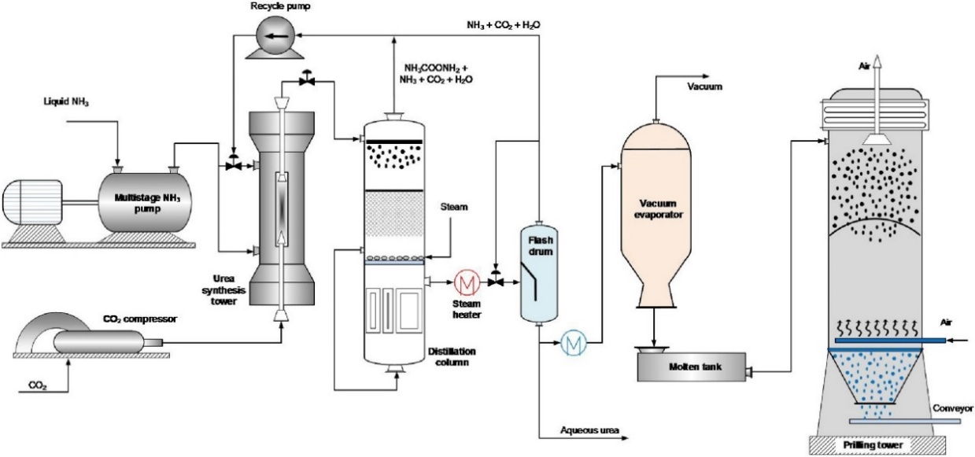
Fig 1. Typical conventional urea production plant (Exported from Rafiee et al. 2019)
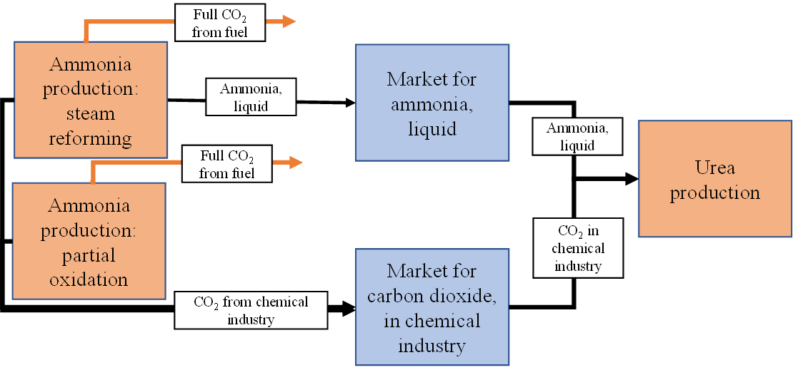
Fig. 2: Adopted urea production flow in Ecoinvent 3.7 database
References:
Brinckerhoff, P. (2011). Accelerating the uptake of CCS: industrial use of captured carbon dioxide. Global CCS Institute, 260.
Rafiee, A., Khalilpour, K. R., & Milani, D. (2019). CO2 conversion and utilization pathways. In Polygeneration with Polystorage for Chemical and Energy Hubs (pp. 213-245). Academic Press.
Moreno Ruiz, E., Valsasina, L., Fitzgerald, D., Brunner, F., Symeonidis, A., Bourgault, G., & Wernet, G. (2019). Documentation of changes implemented in the Ecoinvent database v3. 6. Ecoinvent Association, Zürich, Switzerland.
Moreno Ruiz, E., Valsasina, L., FitzGerald, D., Symeonidis, A., Turner, D., Müller, J., ... & Wernet, G. (2020). Documentation of changes implemented in ecoinvent database v3. 7 & v3. 7.1. ecoinvent Association. Zürich, Switzerland.
Muradov, N. (2014). Industrial Utilization of CO 2: A Win–Win Solution. In Liberating Energy from Carbon: Introduction to Decarbonization (pp. 325-383). Springer, New York, NY.

Table 1. Most affecting parameters for producing 1 kg of urea (exported from Simapro software following Ecoinvent database)
No | Process | Unit | Required amount to obtain 1 kg of urea
1 | Total water used | m³ | 6.53153962
2 | Water, RoW | m³ | 3.872522791
3 | Gas, natural/m3 | m³ | 0.870148009
4 | Radon-222 | Bq | 39642.868
5 | Noble gases, radioactive, unspecified | Bq | 9909.831
6 | Hydrogen-3, Tritium | Bq | 1265.8423
7 | Xenon-133 | Bq | 35.769845
8 | Radioactive species, other beta emitters | Bq | 32.025582
9 | Hydrogen-3, Tritium | Bq | 20.448217
10 | Xenon-135 | Bq | 12.207114
11 | Carbon-14 | Bq | 10.303005
12 | Radium-226 | Bq | 5.6577107
13 | Xenon-135m | Bq | 4.8139607
14 | Thorium-228 | Bq | 4.0234613
15 | Radium-228 | Bq | 3.6717515
16 | Radon-220 | Bq | 1.5292543
17 | Radioactive species, Nuclides, unspecified | Bq | 1.2992353
18 | Xenon-138 | Bq | 1.1316678
19 | Radium-224 | Bq | 1.0058648
20 | Thorium-230 | Bq | 0.72267094
21 | Krypton-85m | Bq | 0.71544358
22 | Xenon-131m | Bq | 0.52445453
23 | Strontium-90 | Bq | 0.48344162
24 | Polonium-210 | Bq | 0.36644578
25 | Uranium alpha | Bq | 0.33322535
26 | Lead-210 | Bq | 0.28247689
27 | Krypton-85 | Bq | 0.26525137
28 | Lead-210 | Bq | 0.20761849
29 | Cesium-137 | Bq | 0.20486507
30 | Niobium-95 | Bq | 0.16440164

This dataset was already contained in the ecoinvent database version 2. It was not individually updated during the transfer to ecoinvent version 3. Life Cycle Impact Assessment results may still have changed, as they are affected by changes in the supply chain, i.e. in other datasets. This dataset was generated following the ecoinvent quality guidelines for version 2. It may have been subject to central changes described in the ecoinvent version 3 change report (http://www.ecoinvent.org/database/ecoinvent-version-3/reports-of-changes/), and the results of the central updates were reviewed extensively. The changes added e.g. consistent water flows and other information throughout the database. The documentation of this dataset can be found in the ecoinvent reports of version 2, which are still available via the ecoinvent website. The change report linked above covers all central changes that were made during the conversion process.]
This dataset represents the production of urea-compounds (1 kg of active ingredient). Raw materials are modelled with a stoichiometric calculation. Energy consumption is modelled with data from a similar process. The emissions are estimated. Infrastructure is included with a default value.
Production volume: 4900020.35195531 kg
Included activities start: From reception of precursors (acetic anhydride, acetonitrile, acrylonitrile, aluminium, ammonia, ammonium chloride, calcium carbide, carbon dioxide, chlorine, cumene, dichloromethane, dimethylamine, dimethylsulfate, ethanol, hydrochloric acid, hydrogen, hydrogen cyanide, hydrogen fluoride, hydrogen sulfide, natural gas, nitrogen, oxygen, methanol, nitric acid, o-dichlorobenzene, p-dichlorobenzene, phosgene, 1-propanol, propylene, sodium chloride, sodium hydroxide, sulfur, sulfuric acid, sulfur dioxide, sulfur trioxide, toluene, water decarbonised) at the factory gate.
Included activities end: This activity ends with (sulfonyl)urea-compounds at the factory gate. The dataset includes the input materials, energy uses, infrastructure and emissions. The dataset doesn't include emulsives, additives etc.
Geography: The inventory is modelled for rest of the world
Technology level: 3
Technology: [Sulfonyl ] urea are herbicidal compounds with a urea functional group (urea) or a urea functional group having a sulfonyl substituent (sulfonyl urea). Urea are produced by phosgenation of an amine with an amination of the resulting isocyanate. Sulfonylureas are usually produced by reacting a sulfonamide with an amine, or a sulfonamide isocyanate with an amine, or a sulfonamide carbamate with an amine.
The dataset [sulfonyl]urea-compounds was calculated from the arithmetic mean of all inputs and outputs of the production of amidosulfuron, chlortoluron, diuron, isoproterenol, lufenuron, metsulfuron-methyl, nicosulfuron, and thifensulfuron-methyl.

Amidosulfuron is produced in five steps from methane shown in Equations (3) to (7):
CH₄ + SO₃ → CH₄SO₃ | (3)
CH₄SO₃ + SOCl₂ → CH₃ClO₂S + SO₂ + HCl | (4)
CH₃ClO₂S + CH₅N → C₂H₇NSO₂ + HCl | (5)
C₂H₇NSO₂ + CClNO₃S → C₃H₆N₂S₂O₅ + HCl | (6)
C₃H₆N₂O₅S₂ + C₆H₉N₃O₂ → C₉H₁₅N₅O₇S₂ | (7)

Precursors that are used for the amidosulfuron production are amino-₄,₆-dimethoxy pyrimidine (C₆H₉N₃O₂), chlorosulfonyl isocyanate sulfonamide (CClNO₃S), dimethyl malonate (C₅H₈O₄), and thionyl chloride (SOCl₂).
Chlorotoluron is produced in five steps from toluene shown in Equations (8) to (12):
C₇H₈ + HNO₃ → C₇H₇NO₂ + H₂O | (8)
C₇H₇NO₂ + Cl₂ → C₇H₆ClNO₂ + HCl | (9)
C₇H₆ClNO₂ + ₃ H₂ → C₇H₈ClN + ₂ H₂O | (10)
C₇H₈ClN + COCl₂ → C₈H₆ClNO + ₂ HCl | (11)
C₈H₆ClNO + C₂H₇N → C₁₀H₁₄ClN₂O | (12)

Diuron is produced in four steps from dichlorobenzene shown in Equations (13) to (16):
C₆H₄Cl₂ + HNO₃ → C₆H₃Cl₂NO₂ + H₂O | (13)
C₆H₃Cl₂NO₂ + ₃ H₂ → C₆H₅Cl₂N + ₂ H₂O | (14)
C₆H₅Cl₂N + COCl₂ → C₇H₃Cl₂ON + ₂ HCl | (15)
C₇H₃Cl₂NO + C₂H₇N → C₉H₁₀Cl₂N₂O | (16)

Isoproturon is produced in four steps from cumene shown in Equations (17) to (20):
C₉H₁₂ + HNO₃ → C₉H₁₁NO₂ + H₂O | (17)
C₉H₁₁NO₂ + ₃ H₂ → C₉H₁₄N + ₂ H₂O | (18)
C₉H₁₄N + COCl₂ → C₁₀H₁₁NO + ₂ HCl | (19)
C₁₀H₁₁NO + C₂H₇N → C₁₂H₁₈N₂O | (20)

Lufenuron is produced in five steps from ₁,₄-dichlorobenzene shown in Equations (21) to (25):
C₆H₄Cl₂ + Cl₂ → C₆H₃Cl₃ + HCl | (21)
C₆H₃Cl₃ + C₃H₂F₆O → C₉H₄Cl₂F₆O + HCl | (22)
C₉H₄Cl₂F₆O + HNO₃ → C₉H₃Cl₂F₆NO₃ + H₂O | (23)
C₉H₃Cl₂F₆NO₃ + ₃ H₂ → C₉H₅Cl₂F₆NO + ₂ H₂O | (24)
C₉H₅Cl₂F₆NO + C₈H₃F₂NO₂ → C₁₇H₈Cl₂F₈N₂O₃ | (25)

Precursors that are used for the lufenuron production are ₂,₄-difluorobenzyl isocyanate (C₈H₃F₂NO₂) and ₁,₁,₂,₃,₃,₃-hexafluoropropanol (C₃H₂F₆O).
Metsulfuron-methyl is produced in seven steps from sulfur trioxide shown in Equations (26) to (32):
SO₃ + HCl → ClSO₂OH | (26)
HSO₃Cl + C₇H₈ → C₇H₇ClO₂S + H₂O | (27)
C₇H₇ClO₂S + NH₃ → C₇H₉NO₂S + HCl | (28)
C₇H₉NO₂S + H₂O → C₇H₅NO₃S + ₃ H₂ | (29)
C₇H₅NO₃S + CH₄O → C₈H₉NO₄S | (30)
C₈H₉NO₄S + C₃H₅ClO₂ → C₁₁H₁₄NO₆S + HCl | (31)
C₁₁H₁₄NO₆S + C₅H₈N₄O → C₁₄H₁₅N₅O₆S + C₂H₆O | (32)

Precursors that are used for the metsulfuron-methyl production are ₂-amino-₄-methoxy-₆-methyl-₁,₃,₅-triazine (C₅H₈N₄O), cyanamide (CH₂N₂), ethyl-chloro formate (C₃H₅ClO₂), and o-methyl-isourea (C₂H₆N₂O).
Nicosulfuron is produced in eleven steps from propene shown in Equations (33) to (43):
C₃H₆ + O₂ → C₃H₄O + H₂O | (33)
2C₃H₄O + NH₃ → C₆H₇N + 2H₂O | (34)
C₆H₇N + 4Cl₂ → C₆H₃Cl₄N + 4HCl | (35)
C₆H₃Cl₄N + ₂ H₂O → C₆H₄ClNO₂ + 3HCl | (36)
C₆H₄ClNO₂ + H₂S → C₆H₅NO₂S + HCl | (37)
C₆H₅NO₂S + CH₄O → C₇H₇NO₂S + H₂O | (38)
C₇H₇NO₂S + 2H₂O + 3Cl₂ → C₇H₆ClNO₄S + 5 HCl | (39)
C₇H₆ClNO₄S + C₄H₁₁N → C₁₁H₁₆N₂O₄S + HCl | (40)
C₁₁H₁₆N₂O₄S + C₄H₁₂NAl → C₁₂H₁₉N₃O₃S + C₃H₉OAl | (41)
C₁₂H₁₉N₃O₃S + C₂HF₃O₂ → C₈H₁₁N₃O₃S + C₆H₉F₃O₂ | (42)
C₈H₁₁N₃O₃S + C₇H₇N₃O₃ → C₁₅H₁₈N₆O₆S | (43)
Precursors that are used for the nicosulfuron production are tert-butyl amine (C₄H₁₁N), (N,N-dimethyl amino)-dimethyl aluminium (C₄H₁₂NAl), dimethyl malonate (C₅H₈O₄), ₂-isocyanato-₄,₆-dimethoxy pyrimidine (C₇H₇N₃O₃), sodium (Na), and trifluoroacetic acid (C₂HF₃O₂).
Thifensulfuron-methyl is produced in nine steps from acetic acid shown in Equations (44) to (52):
C₂H₄O₂ + Cl₂ → C₂H₃ClO₂ + HCl | (44)
C₂H₃ClO₂ + NaSH → C₂H₄O₂S + NaCl | (45)
C₂H₄O₂S + CH₄O → C₃H₆O₂S + H₂O | (46)
C₃H₆O₂S + CH₂ClN₃ → C₆H₇NO₂S + HCl | (47)
C₆H₇NO₂S + ₂ NaNO₂ + HCl → C₆H₅ClN₂O₂S + 2 H₂O + NaCl | (48)
C₆H₅ClN₂O₂S + SO₂ → C₆H₅ClO₄S₂ + N₂ | (49)
C₆H₅ClO₄S₂ + NH₃ → C₆H₇NO₄S₂ + HCl | (50)
C₆H₇NO₄S₂ + COCl₂ → C₇H₅NO₅S₂ + 2 HCl | (51)
C₇H₅NO₅S₂ + C₅H₈N₄O → C₁₂H₁₄N₅O₆S₂ | (52)

Precursors that are used for the thifensulfuron-methyl production are ₂-amino-₄-methoxy-₆-methyl-₁,₃,₅-triazine (C₅H₈N₄O), chloroacrylonitrile (CH₂ClN₃), cyanamide (CH₂N₂), sodium hydrogensulfide (NaSH), and sodium nitrite (NaNO₂).
Precursors :
Amino-₄,₆-dimethoxy pyrimidine (C₆H₉N₃O₂) is produced in five steps from calcium carbide shown in Equations (53) to (57):
CaC₂ + N₂ → CaCN₂ + C | (53)
CaCN₂ + CO₂ + H₂O → CH₂N₂ + CaCO₃ | (54)
CH₂N₂ → C₂H₄N₄ | (55)
C₂H₄N₄ + 2 NH₄Cl → CH₅N₃ + 2 HCl | (56)
CH₅N₃ + C₅H₈O₄ → C₆H₉N₃O₂ + 2 H₂O | (57)

₂-Amino-₄-methoxy-₆-methyl-₁,₃,₅-triazine (C₅H₈N₄O) is produced in three steps from acetonitrile shown in Equations (58) to (60):
C₂H₃N + CH₄O → C₃H₇NO | (58)
C₃H₇NO + CH₂N₂ → C₄H₆N₂O + NH₃ | (59)
C₄H₆N₂O + C₂H₆N₂O → C₅H₈N₄O + CH₄O | (60)

tert-Butyl amine (C₄H₁₁N) is produced in two steps from ₂-methylpropene shown in Equations (61) to (62):
C₄H₈ + H₂O + HCN + H₂SO₄ → C₅H₁₁NO + H₂SO₄ | (61)
C₅H₁₁NO + H₂O + H₂SO₄ + 3 NaOH → C₄H₁₁N + NaCHO₂ + Na₂SO₄ + 3 H₂O | (62)

Chloroacrylonitrile (CH₂ClN₃) is produced from acrylonitrile and chlorine shown in Equation (63):
C₃H₃N + Cl₂ → CH₂ClN₃ + HCl | (63)

Chlorosulfonyl isocyanate sulfonamide (CClNO₃S) is produced in three steps from hydrogen chloride and sulfur trioxide shown in Equations (64) to (66):
HCl + SO₃ → ClSO₂OH | (64)
HSO₃Cl + NH₃ → H₂SNO₂Cl + H₂O | (65)
H₂SNO₂Cl + COCl₂ → CClNO₃S + 2 HCl | (66)
Cyanamide (CH₂N₂) is produced in two steps from calcium carbide shown in Equations (67) and (68):
CaC₂ + N₂ → CaCN₂ + C | (67)
CaCN₂ + CO₂ + H₂O → CH₂N₂ + CaCO₃ | (68)
₂,₄-Difluorobenzyl isocyanate (C₈H₃F₂NO₂) is produced in five steps from toluene shown in Equations (69) to (73):
C₇H₈ + 2 Cl₂ → C₇H₆Cl₂ + 2 HCl | (69)
C₇H₆Cl₂ + ₂ HF → C₇H₆F₂ + 2 HCl | (70)
C₇H₆F₂ + HNO₃ → C₇H₄F₂O₂ + H₂O | (71)
C₇H₄F₂O₂ + NH₃ → C₇H₅F₂NO + H₂O | (72)
C₇H₅F₂NO + COCl₂ → C₈H₃F₂NO₂ + 2 HCl | (73)

(N,N-Dimethyl amino)-dimethyl aluminium (C₄H₁₂NAl) is produced in three steps from methylchloride shown in Equations (74) to (76):
3 CH₃Cl + 2 Al → C₃H₉Al₂Cl₃ | (74)
C₃H₉Al₂Cl₃ + 3 CH₃Cl + 6 Na → C₆H₁₈Al₂ + 6 NaCl | (75)
C₆H₁₈Al₂ + 2 C₂H₇N → 2 C₄H₁₂NAl + 2 CH₄ | (76)

Dimethyl malonate (C₅H₈O₄) is produced in four steps from acetic acid shown in Equations (77) to (80):
C₂H₄O₂ + Cl₂ → C₂H₃ClO₂ + HCl | (77)
C₂H₃ClO₂ + HCN → C₃H₃NO₂ + HCl | (78)
C₃H₃NO₂ + NaOH → NaC₃H₂NO₂ + H₂O | (79)
NaC₃H₂NO₂ + 2 CH₄O + HCl → C₅H₈O₄ + NH₃ + NaCl | (80)

Ethyl chloroformate (C₃H₅ClO₂) is produced from ethanol and phosgene shown in Equation (81):
C₂H₆O + CCl₂O → C₃H₅ClO₂ + HCl | (81)
₁,₁,₂,₃,₃,₃-Hexafluoropropanol (C₃H₂F₆O) is produced in two steps from propanol shown in Equations (82) and (83):
C₃H₈O + 6 Cl₂ → C₃H₂Cl₆O + 6 HCl | (82)
C₃H₂Cl₆O + 6 HF → C₃H₂F₆O + 6 HCl | (83)

₂-Isocyanato-₄,₆-dimethoxy pyrimidine (C₇H₇N₃O₃) is produced in two steps from calcium carbide shown in Equations (84) to (89):
CaC₂ + N₂ → CaCN₂ + C | (84)
CaCN₂ + CO₂ + H₂O → CH₂N₂ + CaCO₃ | (85)
CH₂N₂ → C₂H₄N₄ | (86)
C₂H₄N₄ + ₂ NH₄Cl → CH₅N₃ + 2 HCl | (87)
CH₅N₃ + C₅H₈O₄ → C₆H₉N₃O₂ + 2 H₂O | (88)
C₆H₉N₃O₂ + COCl₂ → C₇H₇N₃O₃ + 2 HCl | (89)

o-Methyl-isourea (C₂H₆N₂O) is produced from cyanamide and methanol shown in Equation (90):
CH₂N₂ + CH₄O → C₂H₆N₂O | (90)
Sodium (Na) is produced by electrolysis of sodium chloride shown in Equation (91):
2 NaCl → 2 Na + Cl₂ | (91)
Sodium hydrogen sulfide (NaSH) is produced from hydrogen sulfide and sodium hydroxide shown in Equation (92):
H₂S + NaOH → NaSH + H₂O | (92)
Sodium nitrite (NaNO₂) is produced in three steps from ammonia as shown in Equations (93) to (95):
4 NH₃ + ₅ O₂ → 4 NO + 6 H₂O | (93)
2 NO + O₂ → 2 NO₂ | (94)
NO₂+ NO + 2 NaOH → 2 NaNO₂ + H₂O | (95)
Thionyl chloride (SOCl₂) is produced in two steps from sulphur shown in Equations (96) and (97):
S + Cl₂ → SCl₂ | (96)
SCl₂ + SO₂ + Cl₂ → 2 SOCl₂ | (97)

Trifluoroacetic acid (C₂HF₃O₂) is produced in two steps from acetic acid shown in Equations (98) and (99)::
C₂H₄O₂ + 3 Cl₂ → C₂HCl₃O₂ + 3 HCl | (98)
C₂HCl₃O₂ + 3 HF → C₂HF₃O₂ + 3 HCl | (99)

Start date: 01/01/2000
End date: 31/12/2019
Is data valid for entire period: True
Time period: Time of publications
Macro-economic scenario name: Business-as-Usual

Version: 3.0.8.0
Created: 7/28/2010 6:05:02 PM
Last edited: 9/22/2011 5:27:51 PM
Source: f0cbefe0-1979-4cb3-87c6-2bda57196b48_4c2b1cc3-84e5-4e35-b74e-8815eadbc674.spold
UUID: f0cbefe0-1979-4cb3-87c6-2bda57196b48

