Supplementary Information
Host-pathogen dynamics in longitudinal clinical specimens from patients with COVID-19

Michelle J. Lin¹, Victoria M. Rachleff^{1,2,3}, Hong Xie¹, Lasata Shrestha¹, Nicole A.P. Lieberman¹, Vikas Peddu¹, Amin Addetia¹, Amanda M. Casto⁴, Nathan Breit¹, Patrick C. Mathias¹, Meei-Li Huang^{1,2}, Keith R. Jerome*^{¶1,2}, Alexander L. Greninger*^{¶1,2}, Pavitra Roychoudhury*^{¶1,2}

¹Department of Laboratory Medicine and Pathology, University of Washington School of Medicine, Seattle, WA, USA, 98102
²Vaccine and Infectious Disease Division, Fred Hutchinson Cancer Research Center, Seattle, WA, USA
³Program in Molecular and Cellular Biology, University of Washington School of Medicine, Seattle, WA, USA
⁴Division of Allergy and Infectious Diseases, University of Washington School of Medicine, Seattle, WA, USA

Supplementary Table S1. Description of patients included in this study.
¹at sample collection. IP = inpatient, ER = emergency room, OP = outpatient, NH = nursing home, NP = nasopharyngeal, OP = oropharyngeal
Patient | Age | Sex | Status when tested | Comorbidities | Treatment for COVID-19 | Sample type(s) | Time points
P001 | 72 | F | NH | CLL, hypogammaglobulinemia, hypothyroidism | Hydroxychloroquine, Convalescent Plasma x 2 | Naso-  pharyngeal | 2
P002 | 42 | M | Unknown | Asthma, Hypertension, Sleep Apnea | Azithromycin, ACTT-1 Trial (Remdesivir versus Placebo) | Naso-  pharyngeal | 2
P003 | 49 | M | Unknown | Unknown | Unknown | Naso-  pharyngeal | 2
P004 | 98 | M | IP | Lewy Body Dementia, Coronary Artery Disease, Chronic Kidney Disease, Hypertension, Heart Failure, Benign Prostatic Hypertrophy | Azithromycin | Naso-  pharyngeal, Oro-  pharyngeal | 3
P005 | 90 | F | OP | Dementia, Diabetes, Hypertension |  | Naso-  pharyngeal | 2
P006 | 88 | F | NH | Hypertension, Hyperlipidemia, Cardiomyopathy, Previous Stroke, Chronic Kidney Disease |  | Naso-  pharyngeal, Oro-  pharyngeal | 1
P007 | 54 | M | OP / IP | Obesity, Protein S Deficiency, Hyperlipidemia, Sleep Apnea | ACTT-1 Trial (Remdesivir versus Placebo), Tocilizumab, Azithromycin | Naso-  pharyngeal | 2
P008 | 80 | F | ER / IP | Hypertension, Neurocognitive Disorder with delusions | Hydroxychloroquine | Naso-  pharyngeal | 2
P009 | 70 | M | ER / IP | Heart Failure, COPD, Obesity, Sleep Apnea, Chronic Kidney Disease, Diabetes, Coronary Artery Disease, | None | Naso-  pharyngeal | 2
P010 | 73 | M | IP | Dementia, Benign Prostatic Hyperplasia | None | Naso-  pharyngeal | 4
P011 | 80 | M | ER / IP | Diabetes, Hypertension, Hyperlipidemia, Chronic Kidney Disease | Azithromycin | Naso-  pharyngeal | 3
P012 | 51 | M | ER | Chronic Hepatitis B | None | Naso-  pharyngeal | 1
P013 | 44 | M | ER / IP | Seizure Disorder, Chronic Kidney Disease, Sleep Apnea, Hypertension, Hyperlipidemia | None | Naso-  pharyngeal | 2
P014 | 83 | M | NH | Dementia, Hypertension, Hyperlipidemia | None | Naso-  pharyngeal | 2
P015 | 78 | F | ER / IP | Mitral Stenosis, Tachy-brady Syndrome, Coronary Artery Disease, Heart Failure, Kidney Transplant, Diabetes | None | Naso-  pharyngeal | 3
P016 | 98 | F | IP | Atrial Fibrillation, Sick Sinus Syndrome, Peripheral Vascular Disease, Hyperlipidemia, Hypertension, Chronic Kidney Disease | None | Naso-  pharyngeal | 2
P017 | 77 | M | IP | Atrial Fibrillation, Diabetes, Hypertension, Diabetes, Stroke, Aortic Stenosis | Azithromycin | Naso-  pharyngeal | 2
P018 | 69 | M | IP | Renal Failure, Multiple Myeloma, Heart Failure, Coronary Artery Disease, Chronic Obstructive Pulmonary Disease, Diabetes | Convalescent plasma, Dexamethasone, Empiric Vitamin C, Thiamine | Naso-  pharyngeal | 2
P019 | 42 | F | OP | Unknown | Unknown | Naso-  pharyngeal | 2
P020 | 59 | M | OP | Chronic Liver Disease/Liver Failure, Anemia, Coronary Artery Disease, Diabetes | None | Naso-  pharyngeal | 2

Supplementary Figure S1. Viral loads for all patients included in the study with samples that returned positive (DET), negative (NDET, Ct >42), and inconclusive (INCON) result by RT-PCR.
Red dots represent samples for which we attempted sequencing for this study. Legend above the plot matches shapes of dots to respective RT-PCR results.
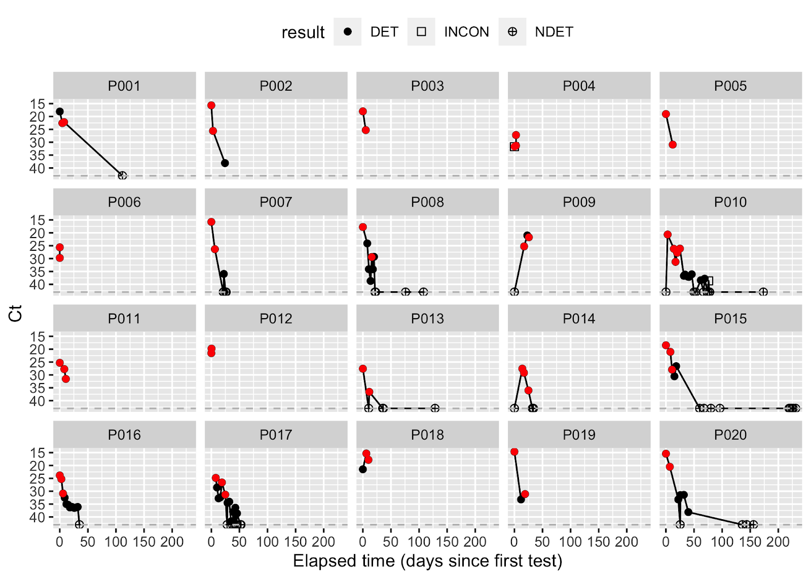

Supplementary Figure S2. Sequencing quality and reproducibility.
(A) Samples were sequenced by metagenomic, probe-capture or amplicon-based approaches. Hollow circles show samples for which a consensus genome could not be recovered. Genome completeness indicates the percentage of non-N nucleotides in consensus sequence (an N was called when there was less than 5X coverage at a site). (B) Each dot represents a coding change in a single sample relative to the Wuhan-Hu-1 (NC_045512.2) reference genome with variant allele frequency between 5-100%, at least 100x coverage at the site, and intra-host reproducibility across longitudinal samples of the same patient. Color scale represents the change in allele frequency across time points in the same patient with darker colors representing variants that had greater changes in frequency across samples. Small dark grey marks along the top margin shows positions with variant frequencies >95% (fixed mutations relative to the reference). Size of circles indicates sequencing depth at the site. Marginal histogram shows distribution of variants using bin width of 500 nucleotides.

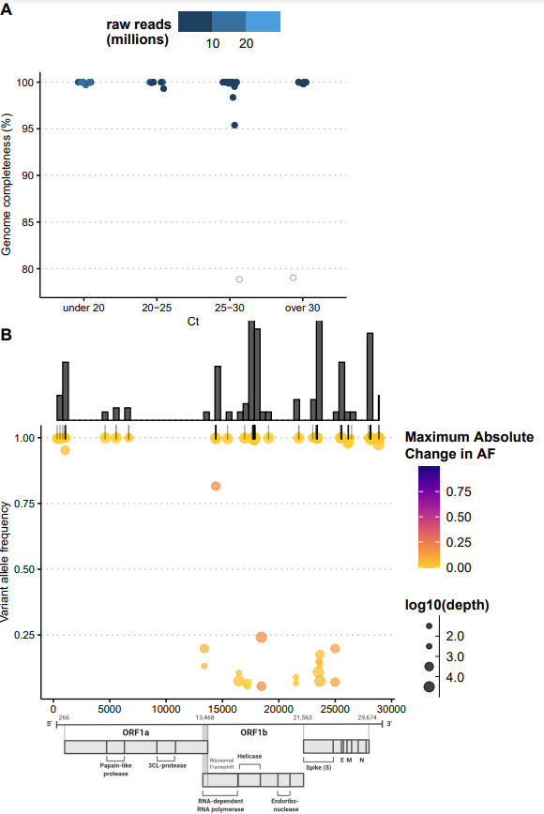

Supplementary Table S2. Data availability (NCBI Bioproject PRJNA610428).
Table of consensus sequences and their respective GISAID accession numbers and sequencing platforms. Information on whether samples were sequenced multiple times for reproducibility analysis is also included.
Patient | Sample # | GISAID accession | Sequencing platform | Has replicate?
P001 | 1 | EPI_ISL_792092 | MiSeq | Yes
P001 | 2 | EPI_ISL_570115 | MiSeq | No
P003 | 1 | EPI_ISL_416643 | NextSeq | No
P003 | 2 | EPI_ISL_418914 | MiSeq | Yes
P005 | 1 | EPI_ISL_427186 | NextSeq | No
P005 | 2 | NA | NextSeq | No
P006 | 1 | EPI_ISL_416454 | NextSeq | No
P006 | 1 | EPI_ISL_792093 | NextSeq | No
P007 | 1 | EPI_ISL_416448 | NextSeq | No
P007 | 2 | EPI_ISL_418942 | NovaSeq | No
P008 | 1 | EPI_ISL_424228 | NovaSeq | No
P008 | 2 | EPI_ISL_461429 | NextSeq | No
P009 | 1 | EPI_ISL_570975 | NextSeq | No
P009 | 2 | EPI_ISL_792094 | NextSeq | Yes
P010 | 1 | EPI_ISL_416717 | NextSeq | No
P010 | 2 | EPI_ISL_515280 | MiSeq | No
P010 | 3 | EPI_ISL_792095 | MiSeq | Yes
P010 | 4 | EPI_ISL_486097 | MiSeq | Yes
P011 | 1 | EPI_ISL_570059 | NextSeq | Yes
P011 | 2 | EPI_ISL_486102 | MiSeq | Yes
P011 | 3 | EPI_ISL_461405 | MiSeq | No
P012 | 1 | EPI_ISL_424190 | NovaSeq | No
P012 | 1 | EPI_ISL_424205 | NovaSeq | No
P013 | 1 | EPI_ISL_792096 | MiSeq | No
P013 | 2 | EPI_ISL_460634 | MiSeq | Yes
P014 | 1 | EPI_ISL_486103 | MiSeq | No
P014 | 2 | EPI_ISL_792097 | MiSeq | No
P015 | 1 | EPI_ISL_424262 | NextSeq | Yes
P015 | 2 | EPI_ISL_485994 | NextSeq | Yes
P015 | 3 | EPI_ISL_792098 | MiSeq | Yes
P016 | 1 | EPI_ISL_570071 | MiSeq | No
P016 | 2 | EPI_ISL_825015 | MiSeq | No
P016 | 3 | EPI_ISL_486110 | NextSeq | Yes
P017 | 1 | EPI_ISL_792099 | MiSeq | No
P017 | 2 | EPI_ISL_570078 | MiSeq | No
P018 | 1 | NA | NextSeq | No
P018 | 2 | NA | NextSeq | No
P019 | 1 | EPI_ISL_570762 | NextSeq | No
P019 | 2 | EPI_ISL_570779 | MiSeq | No
P020 | 1 | NA | NextSeq | Yes
P020 | 2 | EPI_ISL_570503 | NextSeq | No

Supplementary Table S3. Samples used for host gene expression analysis using RNAseq.
Patient | Sample # | COVID Positivity | Reads Pseudo-aligned to Human Transcriptome
P001 | 1 | repeat | 914378
P002 | 1 | initial | 1458465
P003 | 1 | initial | 920298
P003 | 2 | repeat | 2115575
P004 | 1 | initial | 11890988
P007 | 2 | repeat | 2450327
P008 | 1 | initial | 1113231
P009 | 1 | initial | 5543628
P015 | 1 | initial | 1544930
P016 | 1 | initial | 1179241

Supplementary Figure S3. Dynamics of metagenomically classified pathogens. A) Summary of read classifications from CLOMP. Individual bars represent unique samples collected from each patient. Colors correspond to different taxonomic classifications. Reads mapping to SARS-CoV-2 are included in “Viral reads.” B) Longitudinal RPM values for Moraxella catarrhalis and Staphylococcus aureus detected by metagenomic analysis.

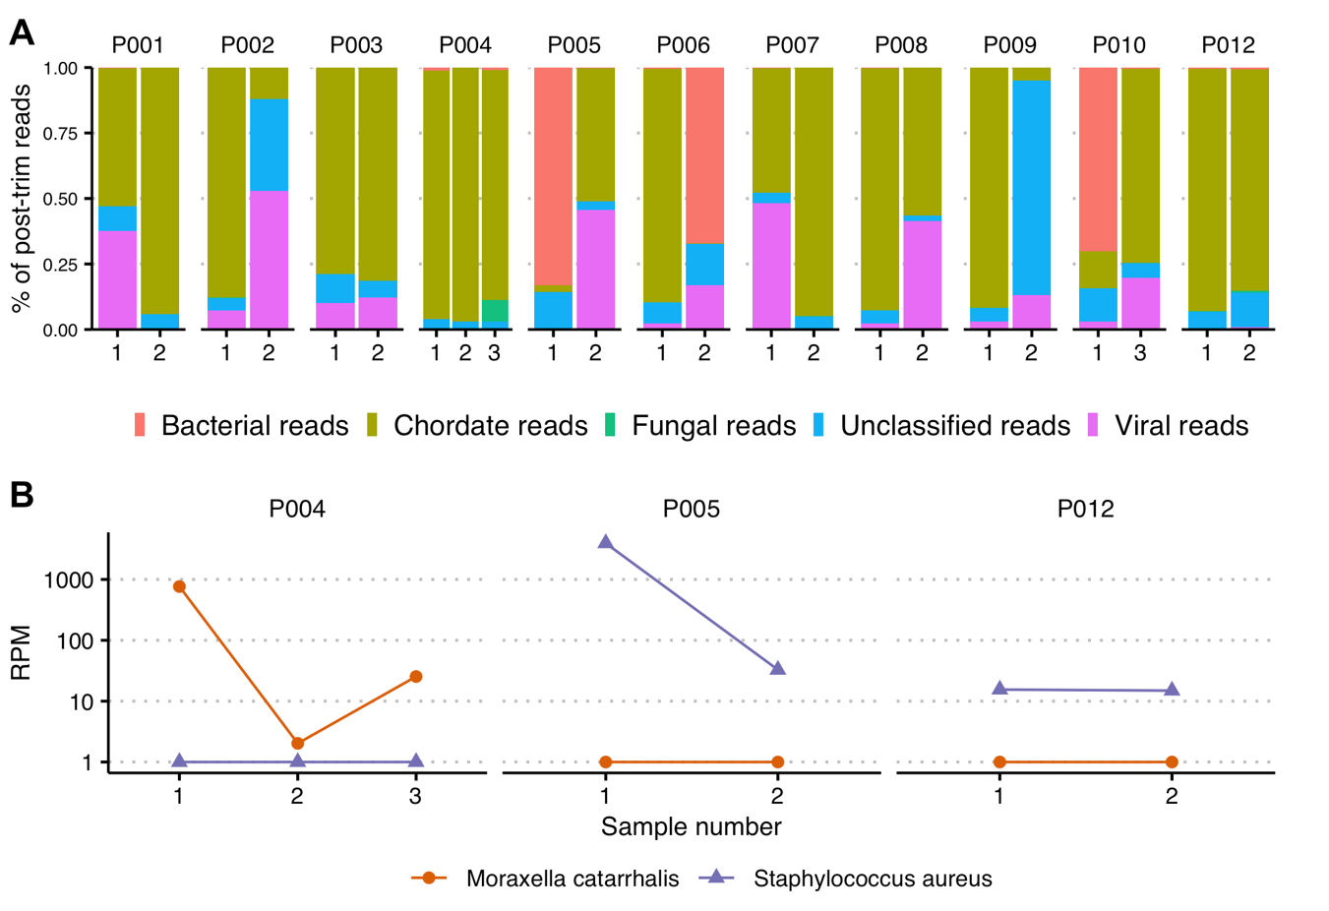

Supplementary Figure S4. Post-trimmed reads used as input to metagenomic analysis.
Samples with under 10,000 reads after trimming, and samples that underwent targeted sequencing (non-metagenomic) were excluded from downstream analysis.
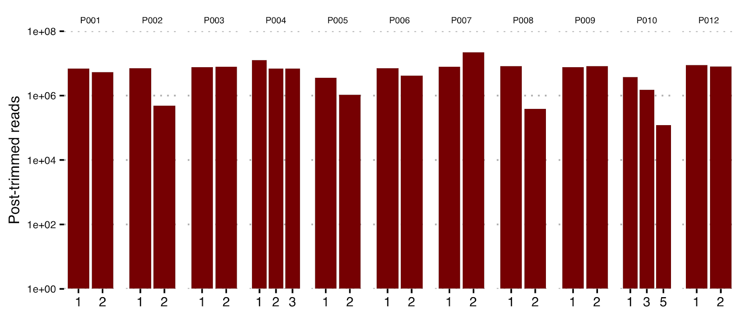

Supplementary Table S4. Clinically relevant taxa.
List of species and their respective NCBI taxonomic IDs deemed clinically relevant. Of these, Moraxella catarrhalis and Staphylococcus aureus were present in our dataset at significant RPMs.
Name | Rank | taxID
Adenoviridae | F | 10508
Human coronavirus HKU1 | S | 290028
Rousettus bat coronavirus HKU9 | S | 694006
Human coronavirus NL63 | S | 277944
Human coronavirus 229E | S | 11137
Severe acute respiratory syndrome-related coronavirus | S | 694009
Enterovirus | G | 12059
Rhinovirus C | S | 463676
Propionibacterium phage PacnesP2 | S | 1983621
Propionibacterium phage pa33 | S | 2079406
Propionibacterium phage Aquarius | S | 2041558
Propionibacterium phage Moyashi | S | 1654781
Propionibacterium phage PHL055N00 | S | 1500802
Propionibacterium virus Pacnes201215 | S | 1982270
Propionibacterium phage Pacnes 2012-15 | - | 1498188
Streptococcus virus MS1 | S | 1962672
environmental samples | - | 2100420
uncultured Caudovirales phage | S | 2100421
unclassified Papillomaviridae | - | 333774
Human papillomavirus types | - | 173087
Human papillomavirus | S | 10566
Betacoronavirus BtCoV/Rhi_hip/R8-09/SPA/2010 | S | 1346312
Bat Hp-betacoronavirus Zhejiang2013 | S | 2501961
Bat Hp-betacoronavirus/Zhejiang2013 | - | 1541205
Colobus guereza | S | 33548
Influenza A virus | S | 11320
Bordetella pertussis | S | 520
Staphylococcus aureus | S | 1280
Staphylococcus aureus | S | 1280
Haemophilus influenzae | S | 727
Pseudomonas aeruginosa | S | 287
Pseudomonas oleovorans/pseudoalcaligenes group | - | 1232139
Streptococcus pneumoniae | S | 1313
Streptococcus sp. A12 | S | 1759399
Streptococcus pseudopneumoniae | S | 257758
Streptococcus pseudopneumoniae IS7493 | - | 1054460
Streptococcus sp. I-G2 | S | 1156431
Moraxella catarrhalis | S | 480

