Appendix
The following supplementary materials show the results of our sensitivity analyses yielding overall incidence rate ratios, overall breast cancer-specific mortality rate ratios, and age-specific incidence rate ratios based on full case- (exclude missing stage-cases) vs. available case-comparisons (include missing stage-cases), as depicted in Figure A1 and Figure A2. The analyses show increases in missing stage-cases when considering overall incidence (age-unspecific) and overall breast cancer-specific mortality (age-unspecific) (Figure A1). The results of the analysis on age-specific incidence rate ratios (Figure A2) suggest a tendency of larger increases in missing stage-cases in younger age groups.

Figure A1 Overall incidence and overall breast cancer-specific mortality rate ratios of breast cancer in women in Austria (1983–2017) in a full case- vs. available case-analysis

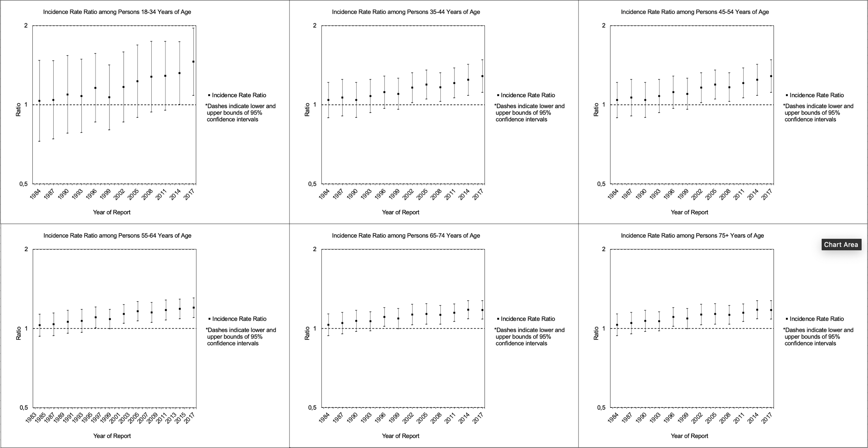
Figure A2 Age-specific incidence rate ratios of breast cancer in women in Austria (1983–2017) in a full case- vs. available case-analysis

