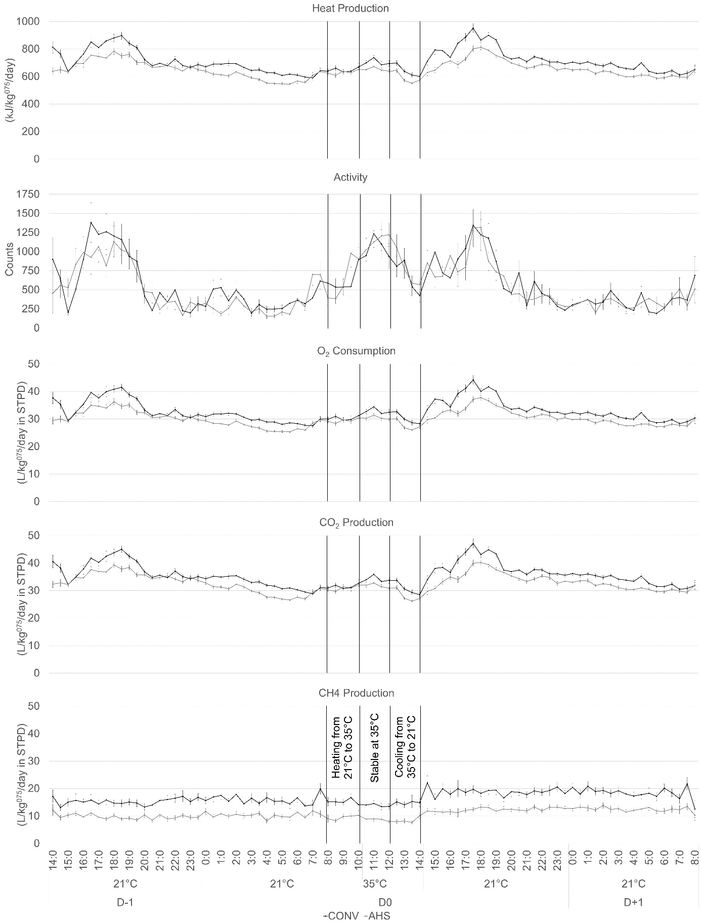
Supplementary Figure 1: Heat production, O₂ consumption, CO₂ production, respiratory quotient, CH₄ production and activity during the heat stress challenge of pigs housed in an alternative (AHS, grey line) or conventional system (CONV, black line).

