Supplementary Figures
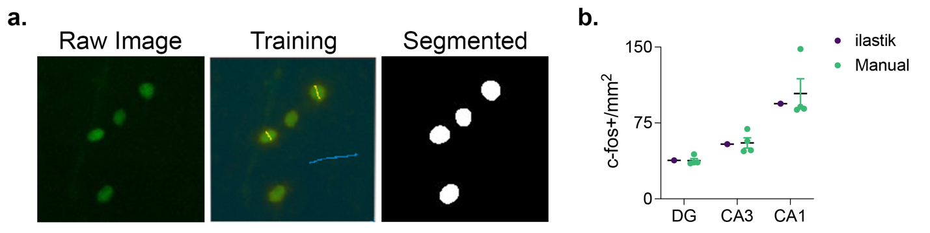
Supplementary Figure S1 | Semi-automated c-fos+ cell segmentation using the supervised machine learning-based tool ilastik. (a) Using supervised machine learning, the user interactively defined the criteria by which ilastik segmented c-fos+ cells from photomicrographs. (b) The segmentation of c-fos+ cells by ilastik yielded counts which were within the 95% confidence intervals of densities reported through independent hand scoring (n = 4) of the same image sets in the dentate gyrus, CA3, and CA1. One outlier was identified in the manual counts for area CA1 using a Grubb’s analysis. We chose to leave this data point in as it is part of the distribution of user-generated counts. Removal of this outlier would bring the manual counts into closer agreement with the ilastik-generated count. Data shown are mean ± 95% CI.

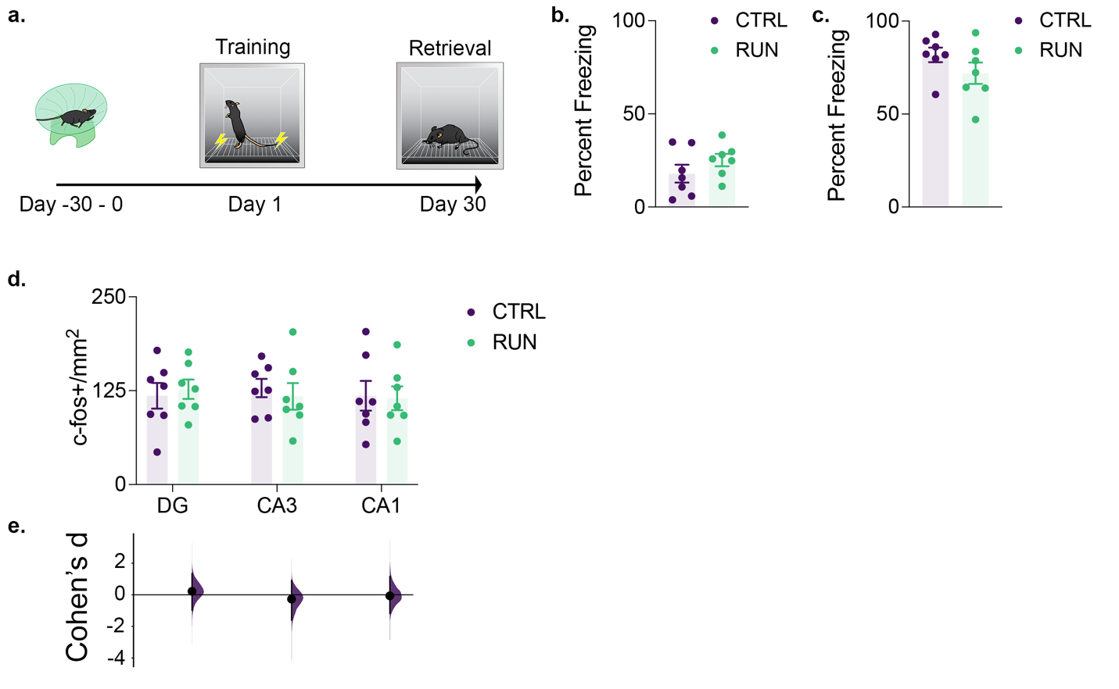
Supplementary Figure S2 | The retrieval and underlying hippocampal activity of memories acquired after running-induced increased neurogenesis is not altered. (a) After 30 days of running wheel access (n = 7) or conventional housing (n = 7), mice were contextually fear conditioned. Contextual memory retrieval was assessed 30 days later during context reintroduction. During both (b) training and (c) retrieval, prior running wheel access did not alter the proportion of the trial spent freezing. (d) The density of c-fos+ cells tagged to context reintroduction in the dentate gyrus, CA3, and CA1 did not change with prior running wheel access. (e) The magnitudes of effect sizes (Cohen’s d) of the differences in c-fos+ cells in all three of the examined hippocampal subregions did not differ from a bootstrapped 95% confidence interval. Data analysis used Two-Sample T-Test (b,c), ANOVA (d) with Tukey’s test during post-hoc multiple comparisons, and Multiple Two-Groups estimation statistics with Cohen’s d as a measure of effect size (h). *P < 0.05. Data shown are mean ± s.e.m. See Supplementary Table S5 for full statistical analysis

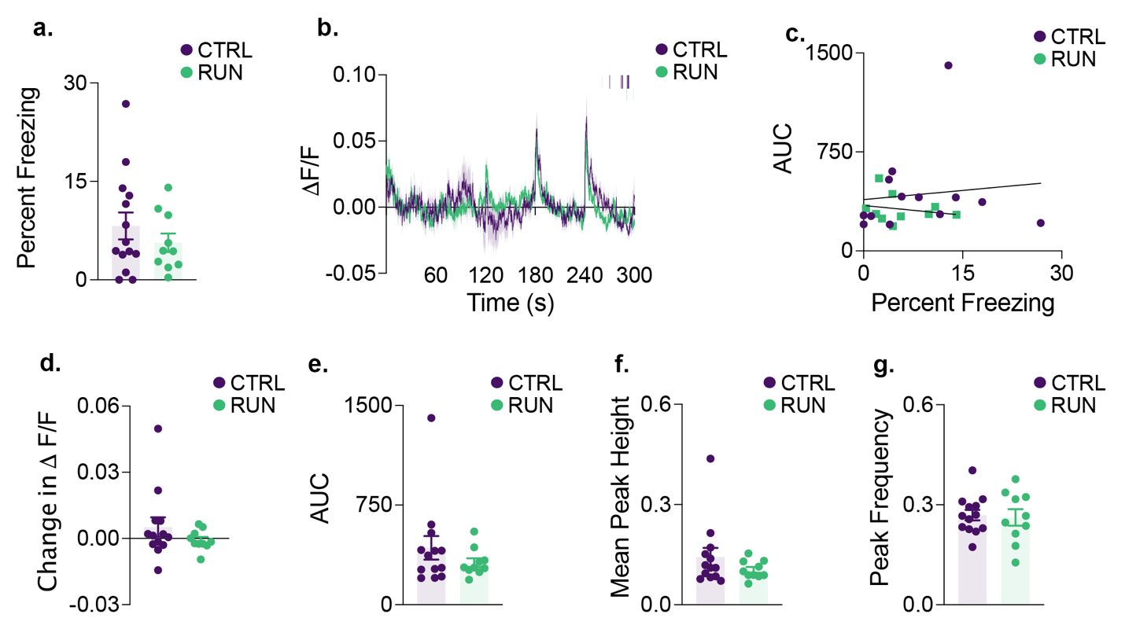
Supplementary Figure S3 | CA1 activity does not differ during contextual conditioning prior to running-induced changes in neurogenesis. (a) During contextual fear conditioning prior to running wheel access (n = 10) or conventional housing (n = 14), there was no difference in the extent to which mice froze during the trial. (b) Mean GCaMP7f fluorescence across the context reintroduction trial with the mode of group freezing plotted above. (c) The area under the curve of the GCaMP7f fluorescence curve did not correlate with percent freezing in either group during this training trial. (d) When mice were transferred from the home cage to the conditioning chambers, neither group showed a significant change in mean GCaMP7f fluorescent signal. Throughout the training trial, neither group differed in (e) overall area under the GCaMP7f fluorescent curve, (f) mean photometry signal peak height, or (g) the frequency of peaks in the photometry signal. Data analysis used Two-Sample T-Test (a,d,e,f,g). *P < 0.05. Data shown are mean ± s.e.m. See Supplemental Table S6 for full statistical analysis

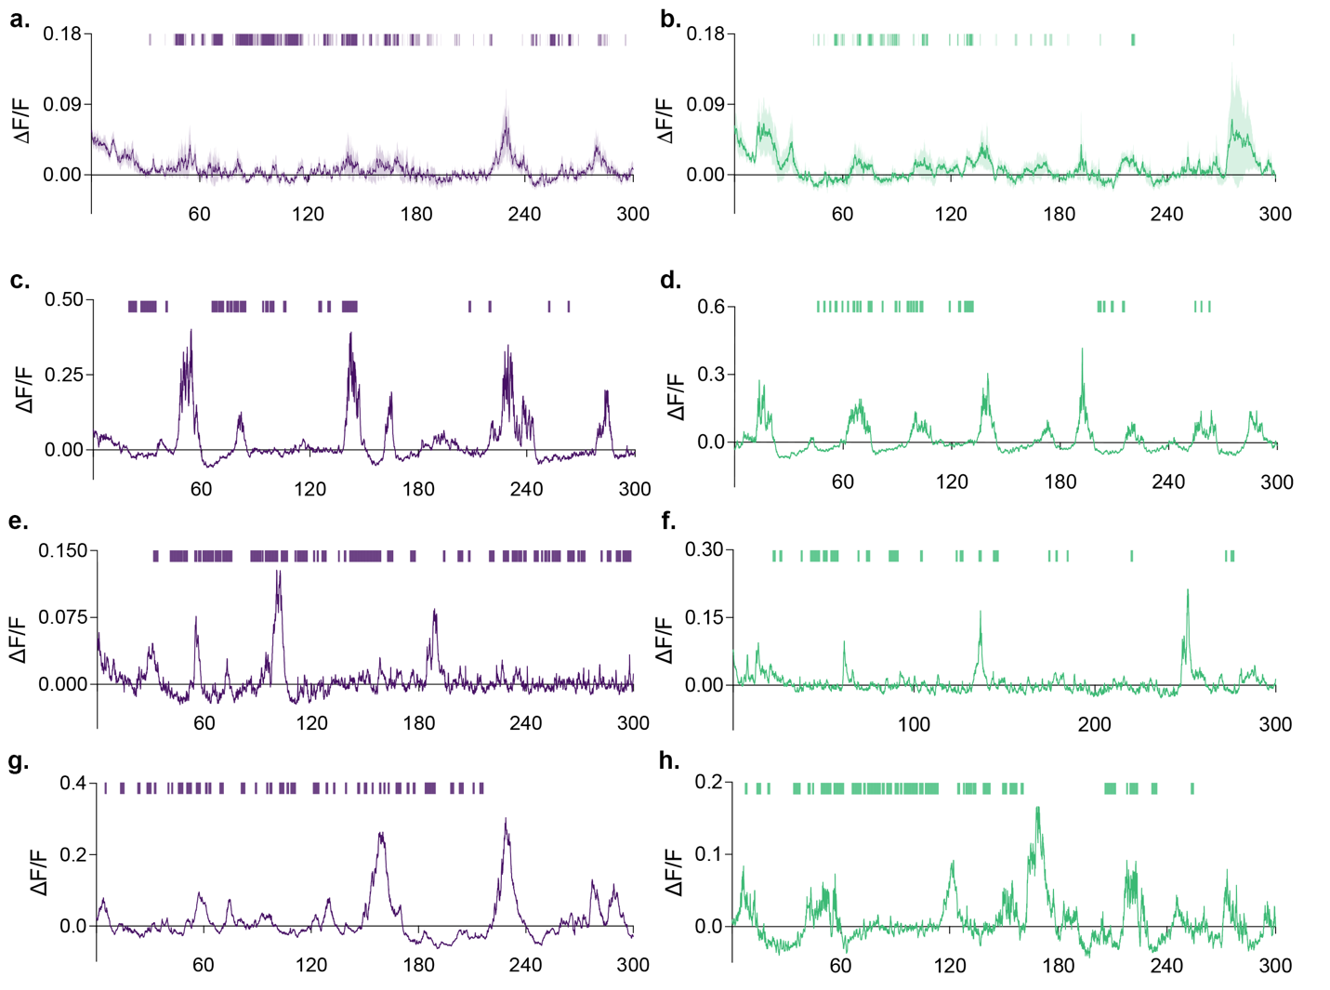
Supplementary Figure S4 | Non-baseline corrected group and representative individual recordings of CA1 activity during contextual memory retrieval. Group mean traces from control (a, n = 8) and runners (b, n = 7) prior to baseline correction, with median group freezing plotted above. Representative individual traces and instantaneous freezing from control (c,e,g) and running (d,f,h) groups. Data shown are mean ± s.e.m.

