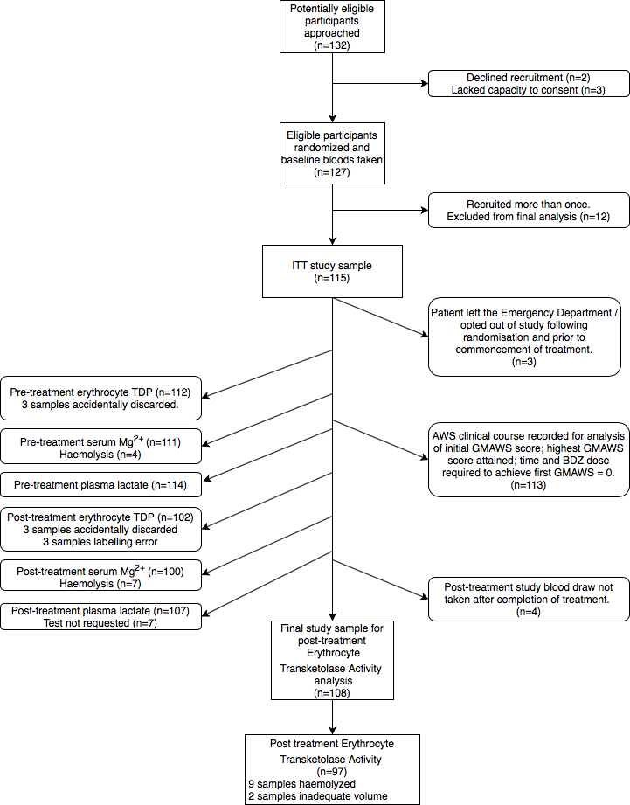

Appendix A. Consort Diagram detailing patient recruitment and participation in randomised controlled trial

