Supplementary information
S1: Map of the sampling area for the vessel sailing time dataset. The marked cross represents the location of the acoustic recording station of the LoVe Ocean Observatory, with the distance radii used in estimates of effects of sailing time on sound levels (0-5 km, 5-10 km, 10-15 km, 15-20 km, 20 -25 km). The figure was made using the ggplot ⁹³ R ⁸⁷ package. High resolution geography data was acquired through the GSHHG (Global Self-consistent, Hierarchical, High-resolution Geography) database ⁹⁸.

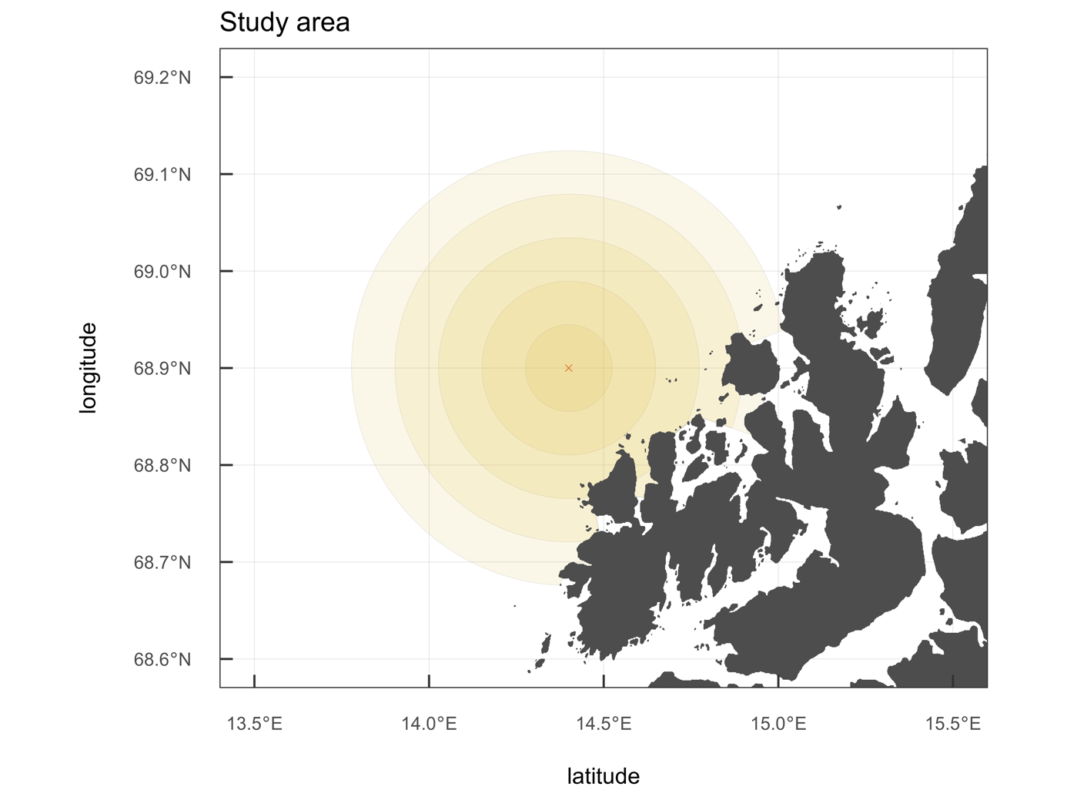

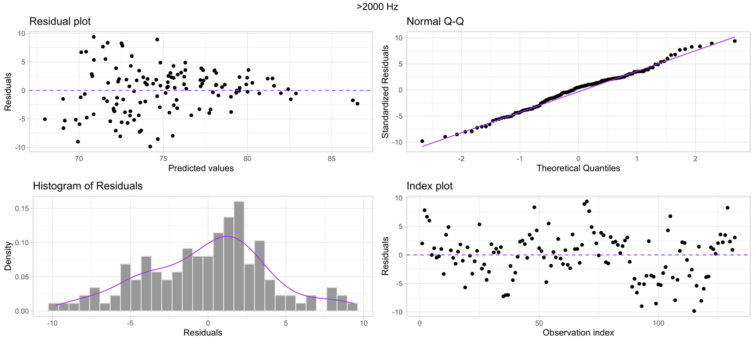
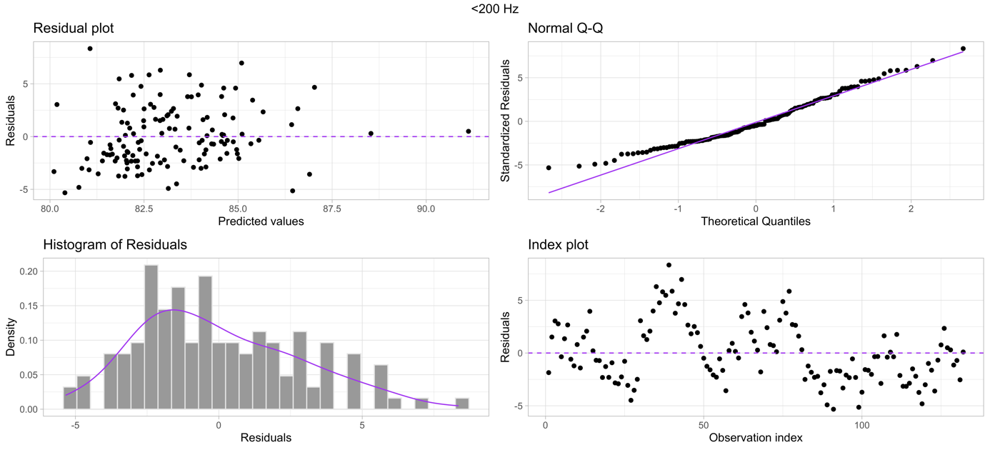
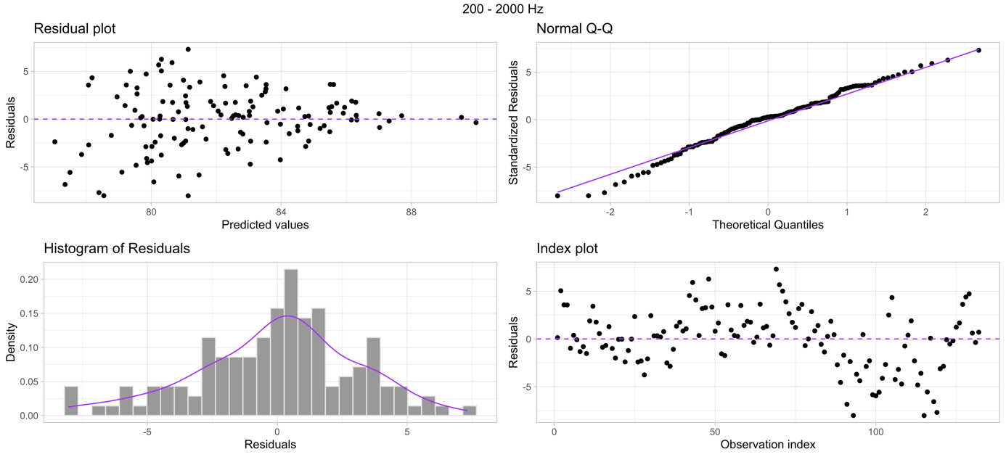
S2: Model diagnostics plots for the 3 selected models, representing the contributions to the soundscape for frequencies below 200 Hz, between 200 Hz and 2 kHz, and above 2 kHz.

S3: Model selection tables for each of the three frequency bins assessed (< 200 Hz, 200 Hz – 2 kHz, and > 2 kHz).
< 200 Hz
 | Modnames | K | AIC | Delta_AIC | ModelLik | AICWt | Res.LL | Cum.Wt
2 | Ws + sail_010km_All | 5 | 627.8926 | 0.000000 | 1.0000000 | 0.9439464 | -308.9463 | 0.9439464
3 | Ws + sail_015km_All | 5 | 634.8807 | 6.988129 | 0.0303771 | 0.0286744 | -312.4403 | 0.9726208
1 | Ws + sail_05km_All | 5 | 635.4535 | 7.560976 | 0.0228116 | 0.0215329 | -312.7268 | 0.9941537
4 | Ws + sail_020km_All | 5 | 638.4620 | 10.569400 | 0.0050686 | 0.0047844 | -314.2310 | 0.9989382
5 | Ws + sail_025km_All | 5 | 641.4727 | 13.580138 | 0.0011249 | 0.0010618 | -315.7364 | 1.0000000

< 200 kHz
 | Modnames | K | AIC | Delta_AIC | ModelLik | AICWt | Res.LL | Cum.Wt
2 | Ws + sail_10km_All | 5 | 634.6039 | 0.0000000 | 1.0000000 | 0.6046386 | -312.3019 | 0.6046386
1 | Ws + sail_05km_All | 5 | 635.4535 | 0.8496616 | 0.6538804 | 0.3953614 | -312.7268 | 1.0000000

< 200 kHz
 | Modnames | K | AIC | Delta_AIC | ModelLik | AICWt | Res.LL | Cum.Wt
6 | Ws + sail_10km_fishing + sail_10km_passenger + sail_10km_cargo + sail_10km_tanker + sail_10km_other | 9 | 622.0423 | 0.00000 | 1.0000000 | 0.9988902 | -302.0211 | 0.9988902
5 | Ws + sail_10km_other | 5 | 636.8000 | 14.75776 | 0.0006243 | 0.0006236 | -313.4000 | 0.9995138
3 | Ws + sail_10km_cargo | 5 | 637.3994 | 15.35711 | 0.0004626 | 0.0004621 | -313.6997 | 0.9999759
1 | Ws + sail_10km_fishing | 5 | 643.6380 | 21.59575 | 0.0000204 | 0.0000204 | -316.8190 | 0.9999964
2 | Ws + sail_10km_passenger | 5 | 647.8702 | 25.82797 | 0.0000025 | 0.0000025 | -318.9351 | 0.9999988
4 | Ws + sail_10km_tanker | 5 | 649.3427 | 27.30048 | 0.0000012 | 0.0000012 | -319.6714 | 1.0000000

200 Hz - 2 kHz
Modnames | K | AIC | Delta_AIC | ModelLik | AICWt | Res.LL | Cum.Wt
Ws + sail_05km_All | 5 | 666.0210 | 0.000000 | 1.0000000 | 0.5952912 | -328.0105 | 0.5952912
Ws + sail_010km_All | 5 | 667.7258 | 1.704831 | 0.4263838 | 0.2538225 | -328.8629 | 0.8491137
Ws + sail_015km_All | 5 | 669.5054 | 3.484366 | 0.1751377 | 0.1042579 | -329.7527 | 0.9533716
Ws + sail_020km_All | 5 | 671.9961 | 5.975086 | 0.0504112 | 0.0300093 | -330.9981 | 0.9833810
Ws + sail_025km_All | 5 | 673.1780 | 7.157002 | 0.0279175 | 0.0166190 | -331.5890 | 1.0000000

200 Hz - 2 kHz
 | Modnames | K | AIC | Delta_AIC | ModelLik | AICWt | Res.LL | Cum.Wt
3 | Ws + sail_05km_cargo | 5 | 665.2178 | 0.000000 | 1.0000000 | 0.7690215 | -327.6089 | 0.7690215
6 | Ws + sail_05km_fishing + sail_05km_passenger + sail_05km_cargo + sail_05km_tanker + sail_05km_other | 9 | 668.3887 | 3.170914 | 0.2048541 | 0.1575372 | -325.1943 | 0.9265587
2 | Ws + sail_05km_passenger | 5 | 671.5586 | 6.340872 | 0.0419853 | 0.0322876 | -330.7793 | 0.9588463
1 | Ws + sail_05km_fishing | 5 | 672.3037 | 7.085957 | 0.0289270 | 0.0222455 | -331.1519 | 0.9810918
5 | Ws + sail_05km_other | 5 | 673.4211 | 8.203396 | 0.0165446 | 0.0127231 | -331.7106 | 0.9938150
4 | Ws + sail_05km_tanker | 5 | 674.8637 | 9.645972 | 0.0080427 | 0.0061850 | -332.4319 | 1.0000000

> 2 kHz
Modnames | K | AIC | Delta_AIC | ModelLik | AICWt | Res.LL | Cum.Wt
Ws + sail_05km_All | 5 | 716.9555 | 0.000000 | 1.0000000 | 0.5116198 | -353.4778 | 0.5116198
Ws + sail_010km_All | 5 | 719.0666 | 2.111091 | 0.3480026 | 0.1780450 | -354.5333 | 0.6896648
Ws + sail_015km_All | 5 | 719.6298 | 2.674218 | 0.2626037 | 0.1343533 | -354.8149 | 0.8240181
Ws + sail_020km_All | 5 | 720.3106 | 3.355046 | 0.1868362 | 0.0955891 | -355.1553 | 0.9196072
Ws + sail_025km_All | 5 | 720.6569 | 3.701314 | 0.1571339 | 0.0803928 | -355.3284 | 1.0000000

> 2 kHz
 | Modnames | K | AIC | Delta_AIC | ModelLik | AICWt | Res.LL | Cum.Wt
3 | Ws + sail_05km_cargo | 5 | 714.4924 | 0.000000 | 1.0000000 | 0.5603476 | -352.2462 | 0.5603476
2 | Ws + sail_05km_passenger | 5 | 716.5931 | 2.100718 | 0.3498121 | 0.1960164 | -353.2965 | 0.7563640
1 | Ws + sail_05km_fishing | 5 | 718.4455 | 3.953118 | 0.1385452 | 0.0776335 | -354.2227 | 0.8339975
5 | Ws + sail_05km_other | 5 | 718.4728 | 3.980463 | 0.1366638 | 0.0765792 | -354.2364 | 0.9105767
4 | Ws + sail_05km_tanker | 5 | 719.0365 | 4.544088 | 0.1031012 | 0.0577725 | -354.5182 | 0.9683492
6 | Ws + sail_05km_fishing + sail_05km_passenger + sail_05km_cargo + sail_05km_tanker + sail_05km_other | 9 | 720.2400 | 5.747591 | 0.0564841 | 0.0316508 | -351.1200 | 1.0000000

Legends supplementary material
S1: Map of the sampling area for the vessel sailing time dataset. The marked cross represents the location of the acoustic recording station of the LoVe Ocean Observatory, with the distance radii used in estimates of effects of sailing time on sound levels (0-5 km, 5-10 km, 10-15 km, 15-20 km, 20 -25 km). The figure was made using the ggplot ⁹³ R ⁸⁷ package. High resolution geography data was acquired through the GSHHG (Global Self-consistent, Hierarchical, High-resolution Geography) database ⁹⁸.

S2: Model diagnostics plots for the 3 selected models, representing the contributions to the soundscape for frequencies below 200 Hz, between 200 Hz and 2 kHz, and above 2 kHz.

S3: Model selection tables for each of the three frequency bins assessed (< 200 Hz, 200 Hz – 2 kHz, and > 2 kHz).

