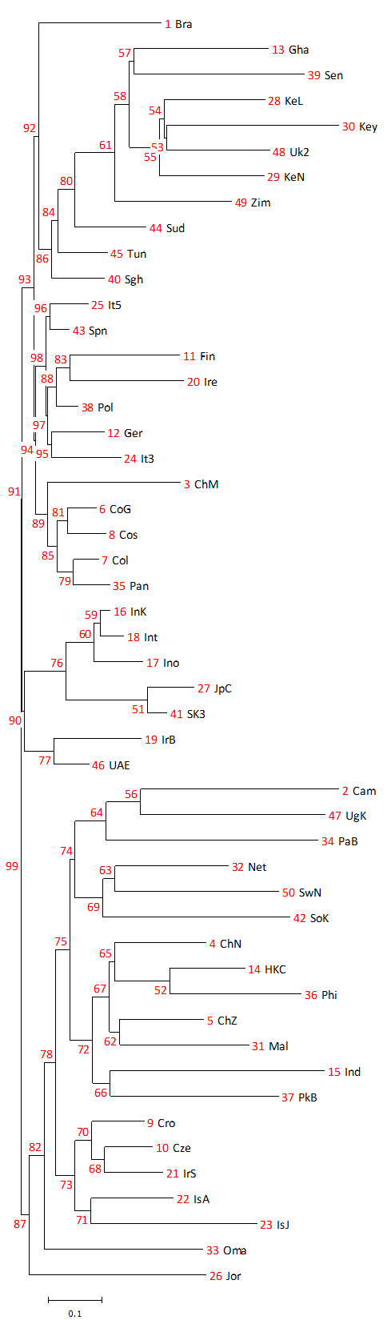
Figure S1 Complete neighbor-joining phylogenetic tree showing relatedness between the current UAE cohort and 49 other populations calculated using frequencies of HLA-A, -B and -DRB1 loci. For the complete list of abbreviations and descriptions of datasets used, refer to Table S 7.

