SUPPLEMENTAL INFORMATION

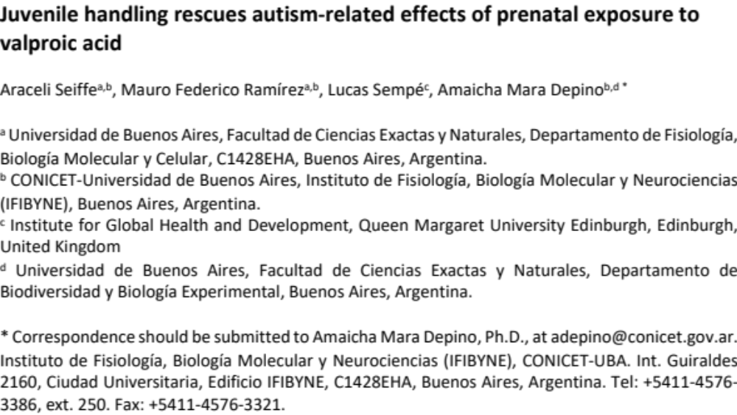

SUPPLEMENTAL FIGURES

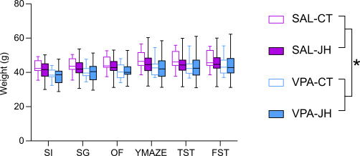

Supplemental figure 1. Effect of prenatal VPA exposure ant juvenile handling (JH) on adult body weight. Animals were weighted after each behavioural test. In comparison to SAL animals, VPA-exposed mice show reduced body weight in adulthood. LME model with repeated measures, * p < 0.05. N_{SAL-CT} = 15, N_{SAL-JH} = 15, N_{VPA-CT} = 10, N_{VPA-JH} =13. Data are shown as boxplot with min-to-max whiskers.

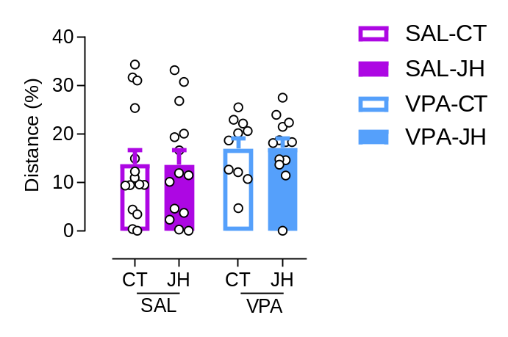

Supplemental figure 2. Percentage of distance walked in the center of the open field. We did not find evidence of anxiety-related behavior in the OF, as all animals walked a similar percentage of their distance in the center. Data are shown as individual values (dots) and mean + s.e.m.

