Supplementary data

Groove rhythm stimulates prefrontal cortex function in groove enjoyers

Takemune Fukuie¹, Kazuya Suwabe^{1,2,3}, Satoshi Kawase⁴, Takeshi Shimizu⁵, Genta Ochi^{1,2,6}, Ryuta Kuwamizu¹, Yosuke Sakairi², & Hideaki Soya^{1,2}*

¹Laboratory of Exercise Biochemistry and Neuroendocrinology, Faculty of Health and Sport Sciences, University of Tsukuba, Ibaraki 305-8574, Japan
²Sports Neuroscience Division, Department of Mind, Advanced Research Initiative for Human High Performance (ARIHHP), Faculty of Health and Sport Sciences, University of Tsukuba, Ibaraki 305-8574, Japan
³Faculty of Health and Sport Sciences, Ryutsu Keizai University, Ibaraki 301-8555, Japan
⁴Faculty of Psychology, Kobe Gakuin University, Hyogo 651-2180, Japan
⁵School of Information and Communication, Meiji University, Tokyo 101-8301, Japan
⁶Department of Health and Sports, Niigata University of Health and Welfare, Niigata 950-3198, Japan

Table S1. Comparison of basic individual specifications of music/dance between clusters
 | “Groove-familiar”  cluster | “Low feeling clear-headed”  cluster | “Groove-unfamiliar”  cluster | F-value | P-value
Individual specification of music/dance
Beat processing ability (Judgement) | 89.75 (11.19) | 83.13 (12.86) | 87.91 (10.61) | F(2, 50) =1.34 | p=0.27
Beat processing ability (Tapping) | 96.79 (4.59) | 93.88 (5.96) | 93.54 (5.96) | F(2, 50) =1.54 | p=0.22
Dance familiarity | 3.68 (2.86) | 3.14 (2.95) | 2.45 (2.66) | F(2, 50) =0.54 | p=0.58

Table S2. Demographics of participants. Values are shown as mean (SD). Note: BMI = Body Mass Index; BDI = Beck Depression Inventory.
Measure | All
Sample Size | 51 (28 female)
Age [yr] | 20.19 (1.84)
Height [cm] | 163.61 (8.00)
Weight [kg] | 54.37 (8.60)
BMI [kg/m²] | 20.19 (1.91)
BDI-2 | 6.78 (5.07)
Beat processing ability (Judgement) | 87.25 (11.52)
Beat processing ability (Tapping) | 94.76 (5.63)
Dance familiarity | 3.13 (2.78)

Table S3. Details of GR. We made an approximately three-minute drum break by combining drum patterns which were showed in a previous study (Witek et al., 2015).
The number of drum breaks sample  (Witek et al., 2015) | Duration | Time course | Syncopation degree | Number of snares | Number of basses
4 | 32" | 0”-16” | 7 | 16 | 24
4 | 32" | 16”-32” | 7 | 16 | 24
9 | 32" | 32”-48” | 13 | 20 | 40
9 | 32" | 48”-64” | 13 | 20 | 40
3 | 32" | 64”-80” | 6 | 12 | 20
3 | 32" | 80”-96” | 6 | 12 | 20
24 | 32" | 96”-112” | 29 | 12 | 24
24 | 32" | 112”-128” | 29 | 12 | 24
26 | 48" | 128”-144” | 34 | 8 | 9
26 | 48" | 144”-160” | 34 | 8 | 9
26 | 48" | 160”-176” | 34 | 8 | 9

A
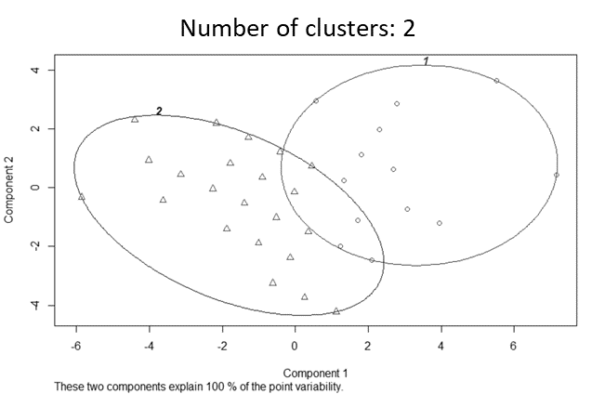

B
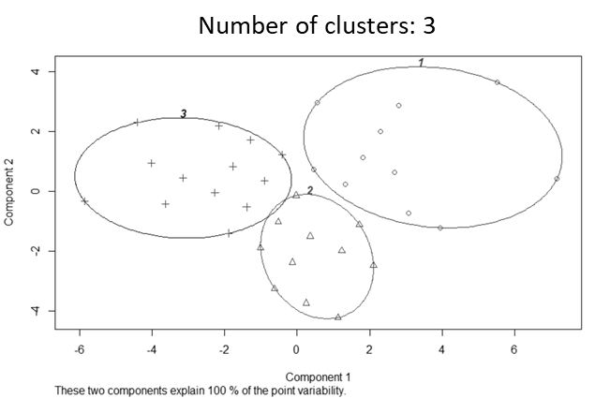

Fig. S1. (A) Cluster plots of the two-cluster solution. Circle number one shows the high “Good nori” and high “Feeling clear-headed” groups. Circle number two shows the low “Good nori” and low “Feeling clear-headed” groups. There was overlapping of two clusters in the plot. (B) Cluster plot of the three-cluster solution. Circle number one shows the high “Good nori” and high “Feeling clear-headed” groups (“Groove-familiar” cluster). Circle number two shows the middle “Good nori” and low “Feeling clear-headed” groups (“Low feeling clear-headed” cluster). Circle number three shows the low “Good nori” and low “Feeling clear-headed” groups (“Groove-unfamiliar” cluster). The horizontal and vertical axes of the cluster plot shown in Fig. S1 represent the first and second principal components, respectively, and do not correspond exactly to the “groove sensation” and “psychological state” used as variables.

