Phylogeography of the veined Squid, Loligo forbesii, in European Waters
Anika Göpel^{1,2}, Daniel Oesterwind^{1*}, Christopher Barrett³, Rita Cannas⁸, Luis Silva Caparro¹⁰, Pierluigi Carbonara⁹, Marilena Donnaloia⁹, Maria Cristina Follesa⁸, Angela Larivain⁶, Vladimir Laptikhovsky³, Evgenia Lefkaditou⁴, Jean-Paul Robin⁶, Maria Begoña Santos¹¹, Ignacio Sobrino¹⁰, Julio Valeiras¹¹, Maria Valls⁷, Hugo C. Viera¹², Kai Wieland^{5,} Ralf Bastrop²

¹ Thünen Institute of Baltic Sea Fisheries, Alter Hafen Süd 2, 18069 Rostock, Germany
² University of Rostock, Institute of Biological Sciences, Albert-Einstein-Str. 3, D-18059, Rostock, Germany
³ Cefas Laboratory, Pakefield Rd, Lowestoft NR33 0HT, UK
⁴ Hellenic Centre for Marine Research, Institute of Marine Biological Resources and Inland Waters, 576 SideRD Vouliagmenis Ave GR-16452, Athens, Greece
⁵ Technical University of Denmark, National Institute of Aquatic Resources, Nordsøen Forskerpark, Willemoesvej 2, DK-9850 Hirtshals, Denmark
⁶ University of Caen Normandy, CS 14032, 14032, Caen cedex 05, France
⁷ Instituto Español de Oceanografía (IEO), Centre Oceanográfic de les Balears s/n, 07015 Palma, Spain
⁸ Department of Life and Environmental Sciences, University of Cagliari, Cagliari, Italy
⁹ COISPA Tecnologia & Ricerca, via dei Trulli, 18-20, Bari, Italy.
¹⁰ Instituto Español de Oceanografía, Centro Oceanográfico de Cádiz, Puerto Pesquero, Muelle de Levante s/n, 11006 Cádiz, Spain
¹¹ Instituto Español de Oceanografía (IEO), Centro Oceanográfico de Vigo, Subida a Radio Faro, 50, 36390 Vigo, Spain
¹² CESAM - Centre for Environmental and Marine Studies, Department of Biology, University of Aveiro, Campus de Santiago, 3810-193 Aveiro, Portugal

*corresponding Author: daniel.oesterwind@thuenen.de

Supplementary Tables and Figures
Table S1. Number of individuals per sampled areas.
Sampled area | Number of individuals
Aegean Sea (A) | 19
Balearic Sea (B) | 28
Gulf of Cadiz (C) | 20
South Adriatic Sea (D) | 15
East Ionian Sea (I) | 30
Celtic Sea (K) | 19
English Channel (L) | 30
North Sea (N) | 64
East coast of Sardinia (O) | 30
Bay of Biscay (S) | 24
West coast of Sardinia (W) | 21
Azores (Z) | 47

Table S2. Internal primers for the COI-gene.
Forward primer | Reverse primer
GCTGTAGAAAGAGGGGCTGGTAC | GGAGCAATTAACTTCATCACAACC
AGGGCCTTCAGTAGATTTAGCC | GGAGCAATTACAATACTTTTAACTGAC

Table S3. Gene flow (Nm; below the diagonale) and F_{ST} value (above the diagonale) for COI-data; Data from Adriatic Sea (D) not included due to low number of sequences.
 | North Sea (N) | English Channel (L) | Celtic Sea (K) | Bay of Biscay (S) | Gulf of Cadiz (C) | Balearic Sea (B) | West coast of Sardinia (W) | East coast of Sardinia (O) | East Ionian Sea (I) | Aegean Sea (A) | Azores (Z)
Total (N) | 48 | 20 | 6 | 10 | 18 | 13 | 14 | 19 | 20 | 9 | 41
N |  | 0.015 | 0.019 | 0.047 | 0.033 | 0.947 | 0.290 | 0.333 | 0.899 | 0.904 | 0.957
L | 16.49 |  | 0.000 | 0.081 | 0.109 | 0.975 | 0.343 | 0.934 | 0.934 | 0.936 | 0.976
K | 12.97 | n.d. |  | 0.089 | 0.118 | 0.985 | 0.352 | 0.396 | 0.945 | 0.946 | 0.983
S | 5.10 | 2.84 | 2.56 |  | 0.051 | 0.888 | 0.204 | 0.260 | 0.839 | 0.843 | 0.920
C | 7.31 | 2.03 | 1.88 | 4.64 |  | 0.849 | 0.167 | 0.775 | 0.775 | 0.790 | 0.895
B | 0.01 | 0.01 | 0.00 | 0.03 | 0.04 |  | 0.695 | 0.714 | 0.565 | 0.203 | 0.968
W | 0.61 | 0.48 | 0.46 | 0.98 | 1.25 | 0.11 |  | -0.061 | 0.603 | 0.627 | 0.804
O | 0.50 | 0.40 | 0.38 | 0.71 | 0.97 | 0.10 | -4.36 |  | 0.618 | 0.645 | 0.813
I | 0.03 | 0.02 | 0.01 | 0.05 | 0.07 | 0.19 | 0.16 | 0.15 |  | 0.110 | 0.934
A | 0.03 | 0.02 | 0.01 | 0.05 | 0.07 | 0.98 | 0.15 | 0.14 | 2.02 |  | 0.935
Z | 0.01 | 0.01 | 0.00 | 0.02 | 0.03 | 0.01 | 0.06 | 0.06 | 0.02 | 0.01

Table S4. Overview of the values of the microsatellite analysis; allelic richness and private allelic richness (pAR) based on 15 individuals; Ho = observed heterozygosity; He = expected Heterozygosity; significant deviations marked with *.
 | North Sea | English Channel | Celtic Sea | Bay of Biscay | Gulf of Cadiz | Balearic Sea | West-Sardinia | East-Sardinia | Adriatic Sea | Ionian Sea | Aegean Sea
n | 64 | 30 | 19 | 24 | 20 | 28 | 21 | 30 | 15 | 30 | 19
Lfor1 | total allele number: 20
allele number | 17 | 11 | 13 | 12 | 10 | 10 | 11 | 12 | 11 | 11 | 8
allelic richness | 11.236 | 8.831 | 12.279 | 10.329 | 9.476 | 7.797 | 9.824 | 9.838 | 11.000 | 7.221 | 6.461
fragment size | 137-188 | 137-182 | 128-170 | 137-170 | 137-182 | 137-182 | 137-173 | 137-179 | 137-188 | 137-182 | 137-170
pAR | 0.247 | 0.033 | 1.667 | 0.000 | 0.044 | 0.010 | 0.000 | 0.002 | 0.994 | 0.010 | 0.000
Ho | 0.475* | 0.400* | 0.778 | 0.333* | 0.500* | 0.393* | 0.450* | 0.357* | 0.308* | 0.357* | 0.444*
He | 0.892* | 0.850* | 0.927 | 0.887* | 0.894* | 0.798* | 0.845* | 0.882* | 0.911* | 0.858* | 0.803*
Lfor2 | total allele number: 11
allele number | 10 | 11 | 9 | 8 | 9 | 9 | 7 | 8 | 8 | 8 | 8
allelic richness | 7.752 | 9.260 | 8.508 | 7.286 | 8.176 | 7.885 | 6.815 | 7.065 | 8.000 | 6.687 | 7.322
fragment size | 133-160 | 133-163 | 133-157 | 133-163 | 133-160 | 133-160 | 133-157 | 133-157 | 133-154 | 133-160 | 133-160
pAR | 0.000 | 0.040 | 0.000 | 0.066 | 0.000 | 0.000 | 0.000 | 0.000 | 0.001 | 0.000 | 0.000
Ho | 0.810* | 0.833 | 0.765 | 0.792 | 0.950 | 0.786 | 0.800 | 0.767 | 0.667 | 0.800 | 0.789
He | 0.793* | 0.846 | 0.761 | 0.771 | 0.799 | 0.797 | 0.794 | 0.777 | 0.694 | 0.723 | 0.750
Lfor3 | total allele number:32
allele number | 22 | 17 | 19 | 16 | 15 | 16 | 13 | 19 | 10 | 16 | 14
allelic richness | 15.426 | 13.702 | 17.531 | 13.338 | 14.185 | 12.615 | 11.479 | 15.042 | 10.000 | 11.896 | 12.642
fragment size | 102-192 | 108-192 | 102-174 | 108-177 | 105-165 | 111-171 | 108-183 | 108-195 | 108-168 | 90-168 | 108-180
pAR | 0.282 | 0.514 | 0.368 | 0.233 | 0.213 | 0.012 | 0.546 | 0.848 | 0.053 | 0.678 | 0.791
Ho | 0.930 | 0.900 | 1.000 | 0.870 | 0.842 | 0.893 | 1.000 | 0.815 | 0.667 | 0.767* | 0.789
He | 0.938 | 0.932 | 0.963 | 0.925 | 0.916 | 0.909 | 0.911 | 0.936 | 0.841 | 0.849* | 0.906
Lfor4 | total allele number: 12
allele number | 10 | 9 | 9 | 9 | 8 | 10 | 7 | 7 | 8 | 11 | 9
allelic richness | 8.161 | 8.124 | 8.743 | 8.049 | 7.665 | 8.215 | 6.633 | 6.401 | 8.000 | 8.999 | 8.492
fragment size | 202-229 | 202-229 | 202-232 | 202-226 | 202-229 | 202-235 | 202-229 | 202-223 | 205-229 | 202-235 | 202-232
pAR | 0.002 | 0.000 | 0.093 | 0.003 | 0.000 | 0.056 | 0.000 | 0.000 | 0.000 | 0.066 | 0.086
Ho | 0.922 | 0.900 | 0.824 | 0.833 | 0.800 | 0.821 | 0.810 | 0.828 | 0.692 | 0.933 | 0.368
He | 0.832 | 0.839 | 0.863 | 0.828 | 0.828 | 0.755 | 0.819 | 0.822 | 0.812 | 0.838 | 0.839
Lfor5 | total allele number: 27
allele number | 17 | 17 | 17 | 11 | 11 | 18 | 9 | 12 | 12 | 14 | 10
allelic richness | 11.476 | 12.397 | 15.465 | 9.418 | 10.324 | 13.036 | 8.057 | 10.024 | 12.000 | 10.721 | 9.615
fragment size | 97-147 | 79-129 | 97-163 | 95-119 | 97-123 | 95-131 | 97-117 | 97-127 | 97-129 | 97-133 | 97-121
pAR | 0.594 | 0.978 | 4.413 | 0.160 | 0.004 | 0.576 | 0.003 | 0.009 | 0.024 | 0.084 | 0.366
Ho | 0.797 | 0.867 | 0.944 | 0.875 | 0.850 | 0.893 | 0.714 | 0.733 | 0.867 | 0.800 | 0.889
He | 0.876 | 0.898 | 0.944 | 0.866 | 0.859 | 0.914 | 0.804 | 0.867 | 0.917 | 0.856 | 0.867
Lfor6 | total allele number: 24
allele number | 15 | 14 | 14 | 14 | 9 | 12 | 9 | 8 | 7 | 9 | 10
allelic richness | 9.523 | 9.872 | 13.063 | 11.317 | 7.635 | 9.420 | 7.267 | 6.957 | 7.000 | 7.337 | 9.037
fragment size | 86-126 | 84-122 | 78-120 | 82-150 | 82-124 | 82-126 | 86-118 | 86-110 | 86-116 | 82-122 | 86-118
pAR | 0.094 | 0.042 | 2.430 | 1.267 | 0.834 | 0.171 | 0.000 | 0.000 | 0.000 | 0.065 | 0.961
Ho | 0.734 | 0.600 | 0.667* | 0.708 | 0.500 | 0.786 | 0.571 | 0.533 | 0.643 | 0.600 | 0.737
He | 0.740 | 0.746 | 0.898* | 0.808 | 0.594 | 0.783 | 0.595 | 0.605 | 0.651 | 0.623 | 0.708
Lfor8 | total allele number: 30
allele number | 25 | 18 | 13 | 8 | 13 | 11 | 6 | 11 | 9 | 13 | 12
allelic richness | 13.216 | 14.125 | 13.000 | 7.267 | 11.134 | 9.581 | 6.000 | 9.414 | 9.000 | 10.460 | 11.116
fragment size | 96-276 | 180-264 | 96-261 | 189-210 | 96-249 | 189-270 | 192-252 | 186-261 | 189-216 | 96-258 | 192-261
pAR | 0.938 | 1.488 | 0.257 | 0.000 | 0.057 | 0.751 | 0.000 | 0.538 | 1.004 | 0.023 | 0.099
Ho | 0.823 | 0.643* | 0.750 | 0.826 | 0.700 | 0.440* | 0.267* | 0.524 | 0.750 | 0.931 | 0.722
He | 0.906 | 0.897* | 0.902 | 0.829 | 0.868 | 0.886* | 0.754* | 0.830 | 0.867 | 0.878 | 0.892
Lfor10 | total allele number: 21
allele number | 14 | 10 | 12 | 10 | 9 | 10 | 9 | 9 | 9 | 9 | 12
allelic richness | 8.694 | 7.949 | 11.496 | 8.792 | 8.822 | 8.804 | 8.666 | 7.664 | 9.000 | 7.773 | 10.933
fragment size | 111-198 | 96-189 | 162-561 | 108-195 | 117-192 | 108-192 | 108-189 | 117-195 | 96-195 | 168-195 | 117-198
pAR | 0.507 | 0.019 | 3.440 | 0.036 | 0.001 | 0.024 | 0.059 | 0.001 | 0.501 | 0.000 | 0.128
Ho | 0.891 | 0.900 | 0.647* | 0.870 | 0.800 | 0.889 | 0.750 | 0.862 | 1.000 | 0.867 | 0.842
He | 0.860 | 0.824 | 0.891* | 0.861 | 0.886 | 0.868 | 0.883 | 0.781 | 0.880 | 0.836 | 0.900
Lfor11 | total allele number: 24
allele number | 17 | 17 | 12 |  | 15 | 14 | 14 | 13 |  | 13 | 15
allelic richness | 12.771 | 13.834 | 12.000 |  | 13.581 | 11.614 | 13.378 | 11.295 |  | 10.974 | 14.358
fragment size | 188-242 | 182-239 | 182-242 |  | 197-245 | 191-248 | 197-242 | 197-239 |  | 189-242 | 191-251
pAR | 0.000 | 0.000 | 0.000 |  | 0.411 | 0.000 | 0.000 | 0.000 |  | 0.000 | 0.000
Ho | 0.919 | 0.897* | 0.923 |  | 0.900 | 0.885 | 0.706 | 0.750 |  | 0.800 | 0.706
He | 0.922 | 0.936* | 0.929 |  | 0.935 | 0.902 | 0.932 | 0.880 |  | 0.890 | 0.943
Lfor12 | total allele number: 49
allele number | 43 | 31 | 21 | 26 | 24 | 22 | 17 | 19 | 13 | 17 | 18
allelic richness | 21.378 | 21.662 | 21.000 | 20.323 | 19.944 | 16.001 | 14.788 | 15.081 | 13.000 | 13.438 | 16.783
fragment size | 178-322 | 193-322 | 211-322 | 196-319 | 181-316 | 181-298 | 199-313 | 184-283 | 202-259 | 205-313 | 202-310
pAR | 1.042 | 0.463 | 0.878 | 0.592 | 0.519 | 0.493 | 0.097 | 0.440 | 0.005 | 0.033 | 0.013
Ho | 0.844* | 1.000 | 0.923 | 0.696* | 0.737* | 0.714 | 0.900 | 0.769 | 0.692 | 0.900 | 0.889
He | 0.975* | 0.977 | 0.982 | 0.968* | 0.967* | 0.944 | 0.928 | 0.938 | 0.923 | 0.928 | 0.956
Lfor13 | total allele number: 16
allele number | 11 | 12 | 10 | 10 | 10 | 8 | 10 | 10 | 7 | 9 | 10
allelic richness | 8.728 | 9.575 | 10.000 | 9.294 | 9.180 | 7.326 | 9.589 | 9.294 | 7.000 | 7.630 | 9.426
fragment size | 229-253 | 217-253 | 229-253 | 225-243 | 229-247 | 227-243 | 227-247 | 227-255 | 229-243 | 231-249 | 229-249
pAR | 0.000 | 0.559 | 0.287 | 0.715 | 0.000 | 0.000 | 0.001 | 0.715 | 0.000 | 0.042 | 0.194
Ho | 0.813 | 0.897 | 0.750 | 0.476* | 0.900 | 0.577 | 0.667 | 0.667 | 0.833 | 0.793 | 0.944
He | 0.830 | 0.861 | 0.859 | 0.880* | 0.882 | 0.817 | 0.822 | 0.882 | 0.879 | 0.815 | 0.856
Lfor16 | total allele number: 16
allele number | 14 | 10 | 9 | 12 | 7 | 11 | 7 | 12 | 9 | 10 | 8
allelic richness | 9.184 | 8.373 | 9.000 | 9.847 | 6.723 | 9.710 | 6.409 | 9.884 | 9.000 | 8.464 | 7.662
fragment size | 138-164 | 142-160 | 140-160 | 136-162 | 142-156 | 138-162 | 142-156 | 140-164 | 142-164 | 140-160 | 140-166
pAR | 0.011 | 0.000 | 0.020 | 0.629 | 0.000 | 0.140 | 0.000 | 0.003 | 0.011 | 0.000 | 0.790
Ho | 0.828 | 0.700 | 0.769 | 0.750 | 0.750 | 0.857 | 0.762 | 0.923 | 0.929 | 0.833 | 0.789
He | 0.839 | 0.835 | 0.834 | 0.871 | 0.817 | 0.870 | 0.815 | 0.824 | 0.786 | 0.850 | 0.725

Table S5. Overview of all investigated isolates and GenBank samples with geographic origin and haplotype in both networks. The short sequences correspond to the long sequences from bp63 to bp494. Unless otherwise stated, all samples were collected by the authors themselves.
Isolate number/  Accession number | geographic origin | haplotype in long network* | haplotype in short network | Source
A1 | Aegean Sea |  | H14 | This study
A2 | Aegean Sea | H3 | H14 | This study
A3 | Aegean Sea |  |  | This study
A4 | Aegean Sea | H3 | H14 | This study
A5 | Aegean Sea |  |  | This study
A6 | Aegean Sea | H3 | H14 | This study
A7 | Aegean Sea | H3 | H14 | This study
A8 | Aegean Sea | H4 | H14 | This study
A9 | Aegean Sea |  |  | This study
A10 | Aegean Sea |  | H14 | This study
A11 | Aegean Sea |  | H14 | This study
A12 | Aegean Sea |  |  | This study
A13 | Aegean Sea |  |  | This study
A14 | Aegean Sea | H3 | H14 | This study
A15 | Aegean Sea | H4 | H14 | This study
A16 | Aegean Sea | H3 | H14 | This study
A17 | Aegean Sea | H4 | H14 | This study
A18 | Aegean Sea |  | H14 | This study
A19 | Aegean Sea |  | H14 | This study
B1 | Balearic Sea |  | H14 | This study
B2 | Balearic Sea |  |  | This study
B3 | Balearic Sea |  | H14 | This study
B4 | Balearic Sea |  |  | This study
B5 | Balearic Sea | H3 | H14 | This study
B6 | Balearic Sea |  | H14 | This study
B7 | Balearic Sea |  | H14 | This study
B8 | Balearic Sea |  | H13 | This study
B9 | Balearic Sea | H3 | H14 | This study
B10 | Balearic Sea |  |  | This study
B11 | Balearic Sea |  | H14 | This study
B12 | Balearic Sea |  | H14 | This study
B13 | Balearic Sea | H3 | H14 | This study
B14 | Balearic Sea | H3 | H14 | This study
B15 | Balearic Sea |  |  | This study
B16 | Balearic Sea | H3 | H14 | This study
B17 | Balearic Sea |  | H14 | This study
B18 | Balearic Sea | H1 | H11 | This study
B19 | Balearic Sea | H3 | H14 | This study
B20 | Balearic Sea |  |  | This study
B21 | Balearic Sea | H3 | H14 | This study
B22 | Balearic Sea | H3 | H14 | This study
B23 | Balearic Sea |  |  | This study
B24 | Balearic Sea | H3 | H14 | This study
B25 | Balearic Sea |  |  | This study
B26 | Balearic Sea | H3 | H14 | This study
B27 | Balearic Sea | H3 | H14 | This study
B28 | Balearic Sea | H3 | H14 | This study
C1 | Gulf of Cadiz | H7 | H17 | This study
C2 | Gulf of Cadiz | H7 | H17 | This study
C3 | Gulf of Cadiz | H7 | H17 | This study
C4 | Gulf of Cadiz |  | H17 | This study
C5 | Gulf of Cadiz | H7 | H17 | This study
C6 | Gulf of Cadiz | H7 | H17 | This study
C7 | Gulf of Cadiz | H4 | H14 | This study
C8 | Gulf of Cadiz | H7 | H17 | This study
C9 | Gulf of Cadiz | H4 | H14 | This study
C10 | Gulf of Cadiz | H7 | H17 | This study
C11 | Gulf of Cadiz | H7 | H17 | This study
C12 | Gulf of Cadiz | H7 | H17 | This study
C13 | Gulf of Cadiz | H7 | H17 | This study
C14 | Gulf of Cadiz |  | H17 | This study
C15 | Gulf of Cadiz | H7 | H17 | This study
C16 | Gulf of Cadiz | H7 | H17 | This study
C17 | Gulf of Cadiz | H7 | H17 | This study
C18 | Gulf of Cadiz | H4 | H14 | This study
C19 | Gulf of Cadiz | H7 | H17 | This study
C20 | Gulf of Cadiz | H7 | H17 | This study
D1 | South Adriatic Sea |  |  | This study
D2 | South Adriatic Sea |  |  | This study
D3 | South Adriatic Sea | H4 | H14 | This study
D4 | South Adriatic Sea |  |  | This study
D5 | South Adriatic Sea | H4 | H14 | This study
D6 | South Adriatic Sea | H3 | H14 | This study
D7 | South Adriatic Sea | H4 | H14 | This study
D8 | South Adriatic Sea |  |  | This study
D9 | South Adriatic Sea |  |  | This study
D10 | South Adriatic Sea |  |  | This study
D11 | South Adriatic Sea |  |  | This study
D12 | South Adriatic Sea |  |  | This study
D13 | South Adriatic Sea |  |  | This study
D14 | South Adriatic Sea |  |  | This study
D15 | South Adriatic Sea |  |  | This study
D16 | South Adriatic Sea |  |  | This study
D17 | South Adriatic Sea |  |  | This study
D18 | South Adriatic Sea |  |  | This study
I1 | East Ionian Sea |  | H14 | This study
I2 | East Ionian Sea | H4 | H14 | This study
I3 | East Ionian Sea | H3 | H14 | This study
I4 | East Ionian Sea | H4 | H14 | This study
I5 | East Ionian Sea | H3 | H14 | This study
I6 | East Ionian Sea | H3 | H14 | This study
I7 | East Ionian Sea | H4 | H14 | This study
I8 | East Ionian Sea |  | H14 | This study
I9 | East Ionian Sea | H3 | H14 | This study
I10 | East Ionian Sea |  | H14 | This study
I11 | East Ionian Sea |  | H14 | This study
I12 | East Ionian Sea |  | H14 | This study
I13 | East Ionian Sea |  | H14 | This study
I14 | East Ionian Sea | H3 | H14 | This study
I15 | East Ionian Sea | H4 | H14 | This study
I16 | East Ionian Sea | H4 | H14 | This study
I17 | East Ionian Sea | H4 | H14 | This study
I18 | East Ionian Sea |  | H14 | This study
I19 | East Ionian Sea | H4 | H14 | This study
I20 | East Ionian Sea |  | H14 | This study
I21 | East Ionian Sea |  | H14 | This study
I22 | East Ionian Sea |  | H14 | This study
I23 | East Ionian Sea | H4 | H14 | This study
I24 | East Ionian Sea | H3 | H14 | This study
I25 | East Ionian Sea | H4 | H14 | This study
I26 | East Ionian Sea | H4 | H14 | This study
I27 | East Ionian Sea | H3 | H14 | This study
I28 | East Ionian Sea | H4 | H14 | This study
I29 | East Ionian Sea | H4 | H14 | This study
I30 | East Ionian Sea | H4 | H14 | This study
K1 | Celtic Sea |  |  | This study
K2 | Celtic Sea | H7 | H17 | This study
K3 | Celtic Sea |  |  | This study
K4 | Celtic Sea | H7 | H17 | This study
K5 | Celtic Sea | H7 | H17 | This study
K6 | Celtic Sea |  |  | This study
K7 | Celtic Sea |  |  | This study
K8 | Celtic Sea | H7 | H17 | This study
K9 | Celtic Sea |  |  | This study
K10 | Celtic Sea |  | H17 | This study
K11 | Celtic Sea |  |  | This study
K12 | Celtic Sea |  | H17 | This study
K13 | Celtic Sea |  |  | This study
K14 | Celtic Sea | H7 | H17 | This study
K15 | Celtic Sea |  |  | This study
K16 | Celtic Sea | H7 | H17 | This study
K17 | Celtic Sea |  | H17 | This study
K18 | Celtic Sea |  | H17 | This study
K19 | Celtic Sea |  |  | This study
L1 | English Channel | H7 | H17 | This study
L2 | English Channel | H7 | H17 | This study
L3 | English Channel | H7 | H17 | This study
L4 | English Channel | H7 | H17 | This study
L5 | English Channel | H7 | H17 | This study
L6 | English Channel |  |  | This study
L7 | English Channel |  | H17 | This study
L8 | English Channel | H7 | H17 | This study
L9 | English Channel | H7 | H17 | This study
L10 | English Channel | H9 | H17 | This study
L11 | English Channel |  | H17 | This study
L12 | English Channel | H7 | H17 | This study
L13 | English Channel | H7 | H17 | This study
L14 | English Channel |  |  | This study
L15 | English Channel |  | H17 | This study
L16 | English Channel | H7 | H17 | This study
L17 | English Channel | H7 | H17 | This study
L18 | English Channel |  |  | This study
L19 | English Channel |  |  | This study
L20 | English Channel | H7 | H17 | This study
L21 | English Channel | H7 | H17 | This study
L22 | English Channel | H7 | H17 | This study
L23 | English Channel |  | H17 | This study
L24 | English Channel | H7 | H17 | This study
L25 | English Channel | H7 | H17 | This study
L26 | English Channel | H7 | H17 | This study
L27 | English Channel | H7 | H17 | This study
L28 | English Channel |  |  | This study
L29 | English Channel |  |  | This study
L30 | English Channel | H7 | H17 | This study
N26 | North Sea |  |  | This study
N27 | North Sea |  | H17 | This study
N29 | North Sea | H7 | H17 | This study
N30 | North Sea |  |  | This study
N31 | North Sea | H7 | H17 | This study
N32 | North Sea | H7 | H17 | This study
N33 | North Sea | H7 | H17 | This study
N34 | North Sea | H7 | H17 | This study
N35 | North Sea | H7 | H17 | This study
N36 | North Sea | H7 | H17 | This study
N37 | North Sea | H7 | H17 | This study
N38 | North Sea | H7 | H17 | This study
N39 | North Sea | H7 | H17 | This study
N40 | North Sea | H7 | H17 | This study
N41 | North Sea | H7 | H17 | This study
N42 | North Sea | H7 | H17 | This study
N43 | North Sea | H7 | H17 | This study
N44 | North Sea | H7 | H17 | This study
N45 | North Sea | H7 | H17 | This study
N46 | North Sea | H4 | H14 | This study
N47 | North Sea | H7 | H17 | This study
N48 | North Sea | H4 | H14 | This study
N49 | North Sea |  | H17 | This study
N50 | North Sea |  |  | This study
N51 | North Sea | H7 | H17 | This study
N52 | North Sea |  | H17 | This study
N53 | North Sea | H7 | H17 | This study
N54 | North Sea |  | H14 | This study
N59 | North Sea | H7 | H17 | This study
N60 | North Sea |  | H17 | This study
N61 | North Sea |  | H17 | This study
N62 | North Sea |  | H17 | This study
N63 | North Sea |  | H17 | This study
N64 | North Sea |  | H17 | This study
N65 | North Sea | H10 | H17 | This study
N81 | North Sea | H7 | H17 | This study
N82 | North Sea | H7 | H17 | This study
N83 | North Sea |  | H17 | This study
N84 | North Sea | H7 | H17 | This study
N85 | North Sea | H7 | H17 | This study
N86 | North Sea | H7 | H17 | This study
N87 | North Sea | H7 | H17 | This study
N88 | North Sea | H7 | H17 | This study
N89 | North Sea | H7 | H17 | This study
N90 | North Sea | H7 | H17 | This study
N91 | North Sea | H7 | H17 | This study
N92 | North Sea | H7 | H17 | This study
N93 | North Sea | H7 | H17 | This study
N94 | North Sea | H7 | H17 | This study
N95 | North Sea | H7 | H17 | This study
N96 | North Sea | H7 | H17 | This study
N97 | North Sea | H7 | H17 | This study
N98 | North Sea |  | H17 | This study
N99 | North Sea | H7 | H17 | This study
N100 | North Sea | H7 | H17 | This study
N101 | North Sea | H7 | H17 | This study
N102 | North Sea |  | H17 | This study
N103 | North Sea | H7 | H17 | This study
N104 | North Sea | H7 | H17 | This study
N105 | North Sea | H7 | H17 | This study
N106 | North Sea | H7 | H17 | This study
N107 | North Sea | H7 | H17 | This study
N108 | North Sea | H7 | H17 | This study
N109 | North Sea |  | H17 | This study
O1 | East coast of Sardinia | H5 | H15 | This study
O2 | East coast of Sardinia | H5 | H15 | This study
O3 | East coast of Sardinia | H4 | H14 | This study
O4 | East coast of Sardinia | H5 | H15 | This study
O5 | East coast of Sardinia |  |  | This study
O6 | East coast of Sardinia | H4 | H14 | This study
O7 | East coast of Sardinia | H5 | H15 | This study
O8 | East coast of Sardinia | H5 | H15 | This study
O9 | East coast of Sardinia | H2 | H12 | This study
O10 | East coast of Sardinia | H5 | H15 | This study
O11 | East coast of Sardinia | H5 | H15 | This study
O12 | East coast of Sardinia |  |  | This study
O13 | East coast of Sardinia | H4 | H14 | This study
O14 | East coast of Sardinia | H5 | H15 | This study
O15 | East coast of Sardinia | H2 | H12 | This study
O16 | East coast of Sardinia | H5 | H15 | This study
O17 | East coast of Sardinia |  |  | This study
O18 | East coast of Sardinia | H5 | H15 | This study
O19 | East coast of Sardinia | H5 | H15 | This study
O20 | East coast of Sardinia |  |  | This study
O21 | East coast of Sardinia | H5 | H15 | This study
O22 | East coast of Sardinia |  |  | This study
O23 | East coast of Sardinia | H5 | H15 | This study
O24 | East coast of Sardinia | H4 | H14 | This study
O25 | East coast of Sardinia |  |  | This study
O26 | East coast of Sardinia |  |  | This study
O27 | East coast of Sardinia |  |  | This study
O28 | East coast of Sardinia |  |  | This study
O29 | East coast of Sardinia |  |  | This study
O30 | East coast of Sardinia |  |  | This study
S1 | Bay of Biscay |  | H17 | This study
S2 | Bay of Biscay |  | H17 | This study
S3 | Bay of Biscay |  |  | This study
S4 | Bay of Biscay |  | H17 | This study
S5 | Bay of Biscay |  |  | This study
S6 | Bay of Biscay |  |  | This study
S7 | Bay of Biscay |  |  | This study
S8 | Bay of Biscay |  |  | This study
S9 | Bay of Biscay |  | H17 | This study
S10 | Bay of Biscay |  |  | This study
S11 | Bay of Biscay | H7 | H17 | This study
S12 | Bay of Biscay | H8 | H18 | This study
S13 | Bay of Biscay |  | H17 | This study
S14 | Bay of Biscay | H7 | H17 | This study
S15 | Bay of Biscay | H7 | H17 | This study
S16 | Bay of Biscay | H7 | H17 | This study
S17 | Bay of Biscay | H7 | H17 | This study
S18 | Bay of Biscay | H7 | H17 | This study
S19 | Bay of Biscay |  |  | This study
S20 | Bay of Biscay |  | H17 | This study
S21 | Bay of Biscay | H7 | H17 | This study
S22 | Bay of Biscay | H5 | H15 | This study
S23 | Bay of Biscay |  |  | This study
S24 | Bay of Biscay | H8 | H18 | This study
W1 | West coast of Sardinia | H5 | H15 | This study
W2 | West coast of Sardinia |  |  | This study
W3 | West coast of Sardinia | H5 | H15 | This study
W4 | West coast of Sardinia |  |  | This study
W5 | West coast of Sardinia |  | H15 | This study
W6 | West coast of Sardinia | H5 | H15 | This study
W7 | West coast of Sardinia |  |  | This study
W8 | West coast of Sardinia | H4 | H14 | This study
W9 | West coast of Sardinia | H3 | H14 | This study
W10 | West coast of Sardinia | H6 | H16 | This study
W11 | West coast of Sardinia | H2 | H12 | This study
W12 | West coast of Sardinia | H5 | H15 | This study
W13 | West coast of Sardinia | H5 | H15 | This study
W14 | West coast of Sardinia | H4 | H14 | This study
W15 | West coast of Sardinia | H5 | H15 | This study
W16 | West coast of Sardinia | H5 | H15 | This study
W17 | West coast of Sardinia |  |  | This study
W18 | West coast of Sardinia | H5 | H15 | This study
W19 | West coast of Sardinia |  |  | This study
W20 | West coast of Sardinia |  |  | This study
W21 | West coast of Sardinia | H7 | H17 | This study
AF075402 | English Channel |  | H17 | Anderson (2000)
KF369140 | West coast of Portugal |  | H17 | Lobo et al. (2013)
KF854077 | unknown | H7 | H17 | de Luna Sales et al. (2013)
KF854078 | unknown | H7 | H17 | de Luna Sales et al. (2013)
KM517903 | North Sea | H7 | H17 | Gebhardt & Knebelsberger (2015)
KM517904 | North Sea | H7 | H17 | Gebhardt & Knebelsberger (2015)
KM517905 | North Sea | H7 | H17 | Gebhardt & Knebelsberger (2015)
KM517906 | North Sea | H7 | H17 | Gebhardt & Knebelsberger (2015)
KM517907 | North Sea | H10 | H17 | Gebhardt & Knebelsberger (2015)
KM517908 | North Sea | H7 | H17 | Gebhardt & Knebelsberger (2015)
KM517909 | North Sea | H7 | H17 | Gebhardt & Knebelsberger (2015)
KM517910 | North Sea | H7 | H17 | Gebhardt & Knebelsberger (2015)
KM517911 | North Sea | H7 | H17 | Gebhardt & Knebelsberger (2015)
KM517912 | North Sea | H7 | H17 | Gebhardt & Knebelsberger (2015)
KM517913 | North Sea | H10 | H17 | Gebhardt & Knebelsberger (2015)
KM517915 | North Sea | H7 | H17 | Gebhardt & Knebelsberger (2015)
KM517916 | North Sea | H7 | H17 | Gebhardt & Knebelsberger (2015)
KM517917 | North Sea | H7 | H17 | Gebhardt & Knebelsberger (2015)
KM517918 | North Sea | H7 | H17 | Gebhardt & Knebelsberger (2015)
KM517919 | North Sea | H7 | H17 | Gebhardt & Knebelsberger (2015)
KM517920 | North Sea | H7 | H17 | Gebhardt & Knebelsberger (2015)
KM517921 | North Sea | H7 | H17 | Gebhardt & Knebelsberger (2015)
KM517922 | North Sea | H7 | H17 | Gebhardt & Knebelsberger (2015)
KM517923 | North Sea | H7 | H17 | Gebhardt & Knebelsberger (2015)
KM517924 | North Sea | H7 | H17 | Gebhardt & Knebelsberger (2015)
KM517925 | North Sea | H7 | H17 | Gebhardt & Knebelsberger (2015)
MH293018 | North East Atlantic | H7 | H17 | Tatulli et al. (2020)
MH293090 | North East Atlantic |  | H17 | Tatulli et al. (2020)
Z1 | Terceira Island, Azores (38°39'04.3"N 27°12'56.2"W). | H25 | H25 | This study
Z2 | Terceira Island, Azores (38°39'04.3"N 27°12'56.2"W). | H25 | H25 | This study
Z3 | Terceira Island, Azores (38°39'04.3"N 27°12'56.2"W). | H25 | H25 | This study
Z4 | Terceira Island, Azores (38°39'04.3"N 27°12'56.2"W). | H25 | H25 | This study
Z5 | Terceira Island, Azores (38°39'04.3"N 27°12'56.2"W). | H25 | H25 | This study
Z7 | Terceira Island, Azores (38°39'04.3"N 27°12'56.2"W). | H25 | H25 | This study
Z9 | Terceira Island, Azores (38°39'04.3"N 27°12'56.2"W). | H25 | H25 | This study
Z10 | Terceira Island, Azores (38°39'04.3"N 27°12'56.2"W). | H25 | H25 | This study
Z11 | Terceira Island, Azores (38°39'04.3"N 27°12'56.2"W). | H25 | H25 | This study
Z12 | Terceira Island, Azores (38°39'04.3"N 27°12'56.2"W). | H25 | H25 | This study
Z13 | Terceira Island, Azores (38°39'04.3"N 27°12'56.2"W). | H26 | H26 | This study
Z14 | Terceira Island, Azores (38°39'04.3"N 27°12'56.2"W). | H22 | H22 | This study
Z25 | Terceira Island, Azores (38°39'04.3"N 27°12'56.2"W). | H25 | H25 | This study
Z29 | Terceira Island, Azores (38°39'04.3"N 27°12'56.2"W). | H25 | H25 | This study
Z30 | Terceira Island, Azores (38°39'04.3"N 27°12'56.2"W). | H25 | H25 | This study
Z31 | Terceira Island, Azores (38°39'04.3"N 27°12'56.2"W). | H21 | H21 | This study
Z32 | Terceira Island, Azores (38°39'04.3"N 27°12'56.2"W). | H25 | H25 | This study
Z33 | Terceira Island, Azores (38°39'04.3"N 27°12'56.2"W). | H25 | H25 | This study
Z36 | Terceira Island, Azores (38°39'04.3"N 27°12'56.2"W). | H25 | H25 | This study
Z37 | Terceira Island, Azores (38°39'04.3"N 27°12'56.2"W). | H24 | H25 | This study
Z38 | Terceira Island, Azores (38°39'04.3"N 27°12'56.2"W). | H25 | H25 | This study
Z39 | Terceira Island, Azores (38°39'04.3"N 27°12'56.2"W). | H25 | H25 | This study
Z40 | Terceira Island, Azores (38°39'04.3"N 27°12'56.2"W). | H25 | H25 | This study
Z41 | Terceira Island, Azores (38°39'04.3"N 27°12'56.2"W). | H25 | H25 | This study
Z42 | Terceira Island, Azores (38°39'04.3"N 27°12'56.2"W). | H25 | H25 | This study
Z43 | Terceira Island, Azores (38°39'04.3"N 27°12'56.2"W). | H25 | H25 | This study
Z44 | Terceira Island, Azores (38°39'04.3"N 27°12'56.2"W). | H25 | H25 | This study
Z48 | Terceira Island, Azores (38°39'04.3"N 27°12'56.2"W). | H25 | H25 | This study
Z57 | Terceira Island, Azores (38°39'04.3"N 27°12'56.2"W). |  | H25 | This study
Z58 | Terceira Island, Azores (38°39'04.3"N 27°12'56.2"W). |  | H25 | This study
Z59 | Terceira Island, Azores (38°39'04.3"N 27°12'56.2"W). | H25 | H25 | This study
Z60 | Terceira Island, Azores (38°39'04.3"N 27°12'56.2"W). |  | H25 | This study
Z61 | Terceira Island, Azores (38°39'04.3"N 27°12'56.2"W). | H25 | H25 | This study
Z62 | Terceira Island, Azores (38°39'04.3"N 27°12'56.2"W). | H25 | H25 | This study
Z64 | Terceira Island, Azores (38°39'04.3"N 27°12'56.2"W). | H25 | H25 | This study
Z65 | Terceira Island, Azores (38°39'04.3"N 27°12'56.2"W). | H25 | H25 | This study
Z68 | Terceira Island, Azores (38°39'04.3"N 27°12'56.2"W). | H25 | H25 | This study
Z69 | Terceira Island, Azores (38°39'04.3"N 27°12'56.2"W). | H25 | H25 | This study
Z70 | Terceira Island, Azores (38°39'04.3"N 27°12'56.2"W). | H25 | H25 | This study
Z71 | Terceira Island, Azores (38°39'04.3"N 27°12'56.2"W). |  | H25 | This study
Z72 | Terceira Island, Azores (38°39'04.3"N 27°12'56.2"W). | H25 | H25 | This study
Z74 | Terceira Island, Azores (38°39'04.3"N 27°12'56.2"W). |  | H25 | This study
Z76 | Terceira Island, Azores (38°39'04.3"N 27°12'56.2"W). | H25 | H25 | This study
Z78 | Terceira Island, Azores (38°39'04.3"N 27°12'56.2"W). | H25 | H25 | This study
Z79 | Terceira Island, Azores (38°39'04.3"N 27°12'56.2"W). | H25 | H25 | This study
Z79 | Terceira Island, Azores (38°39'04.3"N 27°12'56.2"W). | H25 | H25 | This study
Z80 | Terceira Island, Azores (38°39'04.3"N 27°12'56.2"W). | H25 | H25 | This study
AZB030-20 | Graciosa Island, Azores (38°39'04.3"N 27°12'56.2"W). | H25 | H25 | BoldSystems
MT919766 | Portugal, Azores | H25 | H25 | Velasco et al. (2021)
MT491734 | Portugal, Azores | H25 | H25 | Luz, A. & Keskin, E. (unpubl.)
*GenBank Accession numbers for haplotype network with long sequences: H1: OK135754, H2: OK135755, H3: OK135756, H4: OK135757, H5: OK135758, H6: OK135759, H7: OK135760, H8: OK135761, H9: OK135762, H10: OK135763, H21: OK135764, H22: OK135765, H23: OK135766, H24: OK135767, H25: OK135768, H26: OK135769.
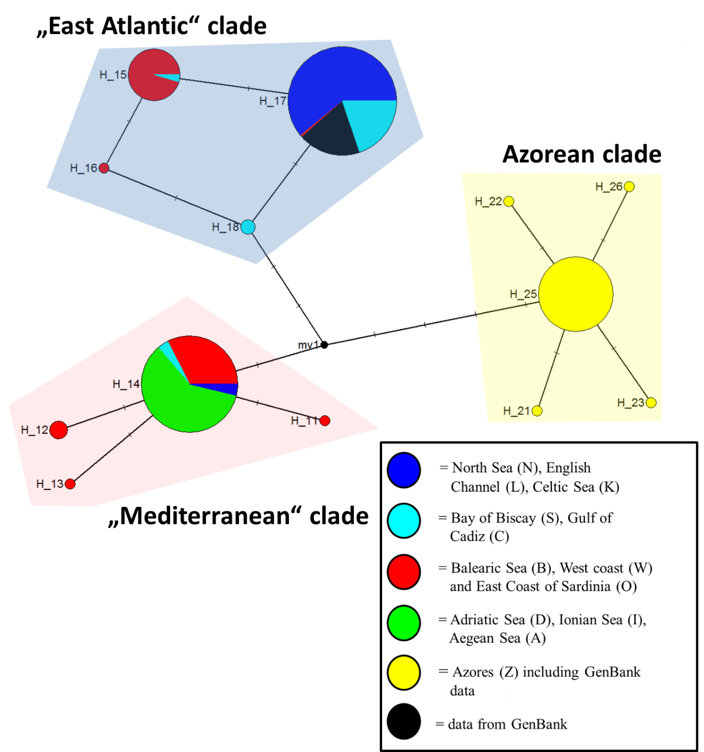
Figure S1. Median-Joining Haplotype network for L. forbesii (haplotypes 11-18, 21-23, 25, 26) representing 282 COI-sequence fragments (432 bp); black coloured GenBank data by various authors originate all from North East Atlantic individuals (Anderson (2000), Gebhardt & Knebelsberger (2015), Lobo et al. (2013), de Luna Sales et al. (2013), Tatulli et al. (2020)); yellow coloured including GenBank data (Velasco et al. (2021), Luz & Keskin (unpublished)) and BoldSystems data (AZB030-20). The short sequences correspond to the long sequences from bp63 to bp494.
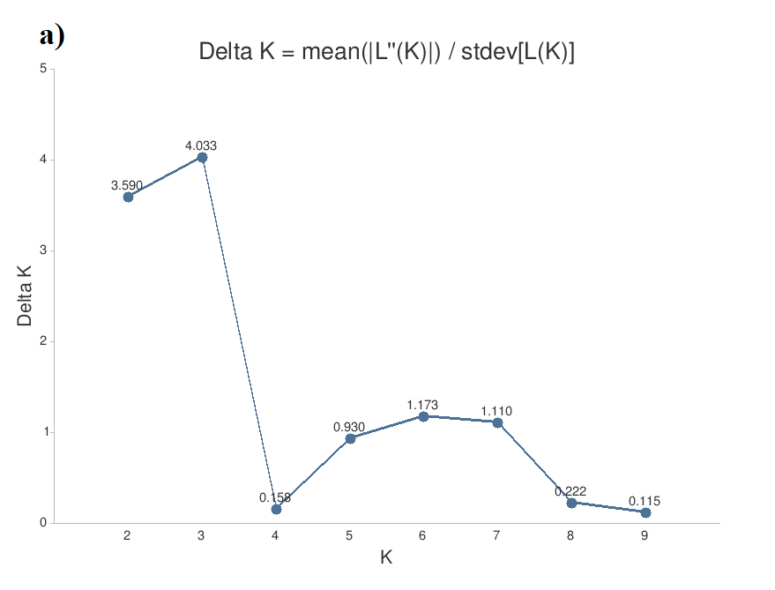
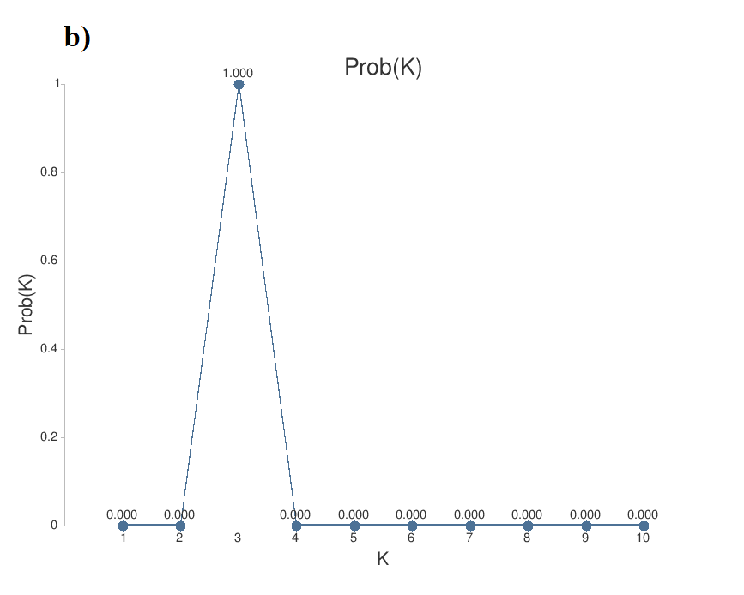
Figure S2. Results for best k by Evanno of the STRUCTURE Analysis; a) Delta K graph - optimal K by Evanno is: 3; b) Probability by K graph - using median values of Ln(Pr Data) the k for which Pr(K=k) is highest: 3.
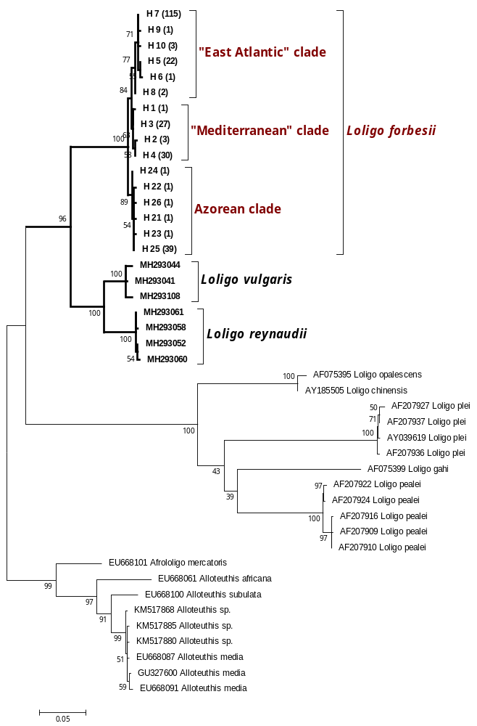
Figure S3: The evolutionary history of Loliginidae was inferred by using the Maximum Likelihood method based on the General Time Reversible model (Nei & Kumar, 2000). The tree with the highest log likelihood (-2967.7473) is shown. The percentage of trees in which the associated taxa clustered together is shown next to the branches. A discrete Gamma distribution was used to model evolutionary rate differences among sites (16 categories (+G, parameter = 0.4934)). The rate variation model allowed for some sites to be evolutionarily invariable ([+I], 0.0000% sites). The tree is drawn to scale, with branch lengths measured in the number of substitutions per site. There is a total of 561 positions in the final dataset. Evolutionary analyses were conducted in MEGA6 (Tamura et al., 2013).
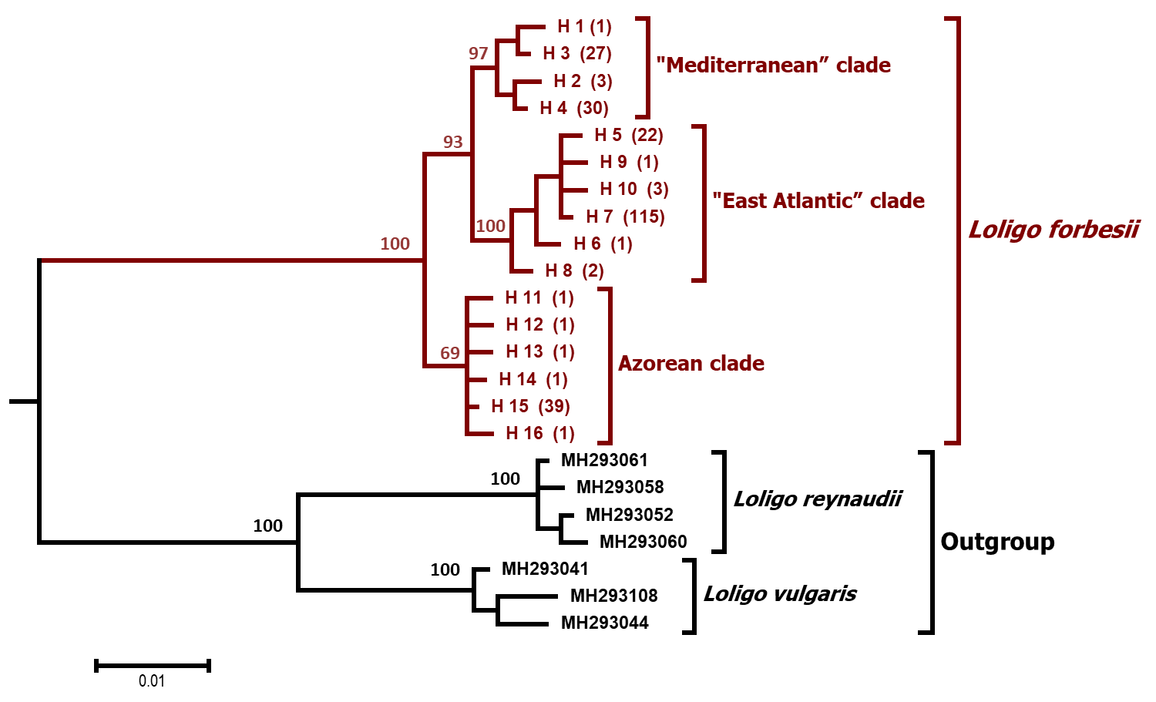
Figure S4. Phylogenetic tree based on 561 base pairs (bp) of the COI-sequences. The evolutionary history was inferred by using the K80+G model (Kimura, 1980). Bayesian posterior probabilities in percent (> 50%, BI) are given at the branches. The scale indicates sequence divergence in percent.

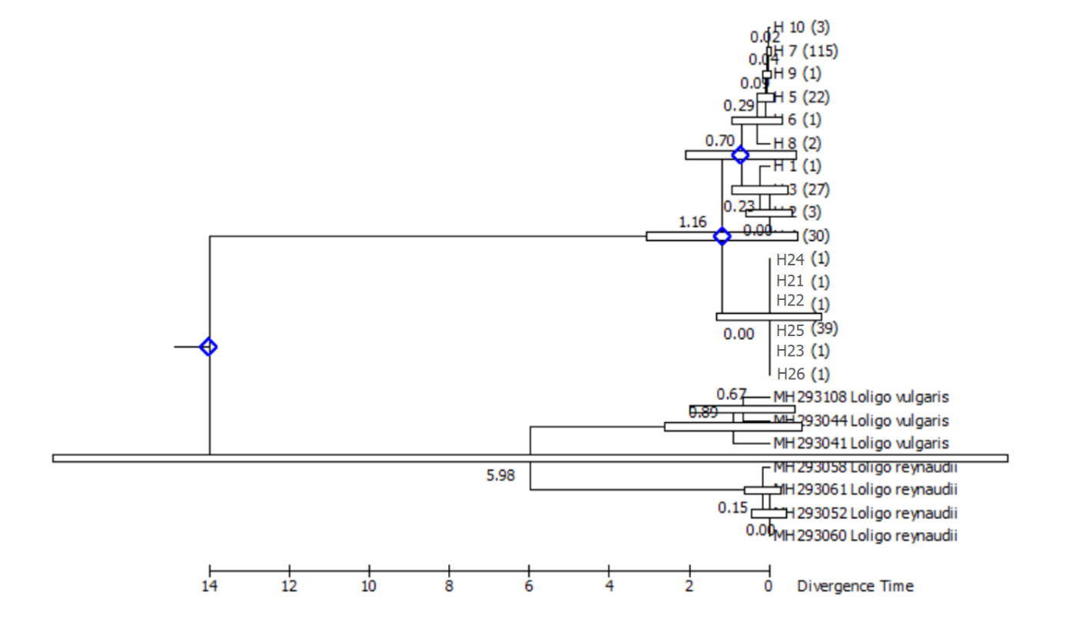

Figure S5. Timetree analysis by Maximum Likelihood method;
The timetree was generated using the RelTime method (Tamura et al., 2012). Divergence times (in million years ago) for all branching points in the user-supplied topology were calculated using the Maximum Likelihood method based on the Tamura-Nei model (Tamura & Nei, 1993). Relative times were optimized and converted to absolute divergence times (shown next to branching points) based on user-supplied calibration constraints. Bars around each node represent 95% confidence intervals which were computed using the method described in Tamura et al. (2013). The estimated log likelihood value of the topology shown is -1264.5023. A discrete Gamma distribution was used to model evolutionary rate differences among sites (5 categories (+G, parameter = 0.2727)). The tree is drawn to scale, with branch lengths measured in the relative number of substitutions per site. The analysis involved 23 nucleotide sequences. There was a total of 561 positions in the final dataset. Evolutionary analyses were conducted in MEGA6 (Tamura et al. 2013).

Calibration points were chosen as follows: separation of L. forbesii and sister taxon 11.0-16.0 million years ago (Ma), main branch of L. forbesii 1.0-5.5 Ma and establishing of the Mediterranean clade 0.1-1 Ma.

References
Anderson, F. E. (2000) Phylogeny and historical biogeography of the loliginid squids (Mollusca: Cephalopoda) based on mitochondrial DNA sequence data. Mol. Phylogenet. Evol. 15, 191–214.
BoldSystems: https://boldsystems.org/index.php/Public_RecordView?processid=AZB030-20; accessed 22-05-02.
de Luna Sales, J. B. et al. (2013) New molecular phylogeny of the squids of the family Loliginidae with emphasis on the genus Doryteuthis Naef, 1912: Mitochondrial and nuclear sequences indicate the presence of cryptic species in the southern Atlantic Ocean. Mol. Phylogenet. Evol. 68, 293–299.
Gebhardt, K. & Knebelsberger, T. (2015) Identification of cephalopod species from the North and Baltic Seas using morphology, COI and 18S rDNA sequences. Helgol. Mar. Res. 69, 259–271.
Kimura, M. (1980) A simple method for estimating evolutionary rates of base substitutions through comparative studies of nucleotide sequences. J. Mol. Evol. 16, 111–120.
Lobo, J. et al. (2013) Enhanced primers for amplification of DNA barcodes from a broad range of marine metazoans. BMC Ecol. 13, 1–8.
Luz, A. & Keskin, E. (unpublished) Building Reference Library for Marine Fish Species of Azores Archipelago and Bio-monitoring via DNA Metabarcoding. https://www.ncbi.nlm.nih.gov/nuccore/MT491734
Nei, M. & Kumar, S. (2000) Molecular evolution and phylogenetics. Oxford University Press, USA.
Tamura, K. & Nei, M. (1993) Estimation of the number of nucleotide substitutions in the control region of mitochondrial DNA in humans and chimpanzees. Mol. Biol. Evol. 10, 512–526.
Tamura, K. et al. (2012) Estimating divergence times in large molecular phylogenies. Proc. Natl. Acad. Sci. U. S. A. 109, 19333–19338.
Tamura, K. et al. (2013) MEGA6: Molecular evolutionary genetics analysis version 6.0. Mol. Biol. Evol. 30, 2725–2729.
Tatulli, G. et al. (2020) A Rapid Colorimetric Assay for On-Site Authentication of Cephalopod Species. Biosensors 10, 3–10.
Velasco, A. et al. (2021) A new rapid method for the authentication of common octopus (Octopus vulgaris) in seafood products using recombinase polymerase amplification (rpa) and lateral flow assay (lfa). Foods 10.

