Supplementary Information
Supplementary Figure 1
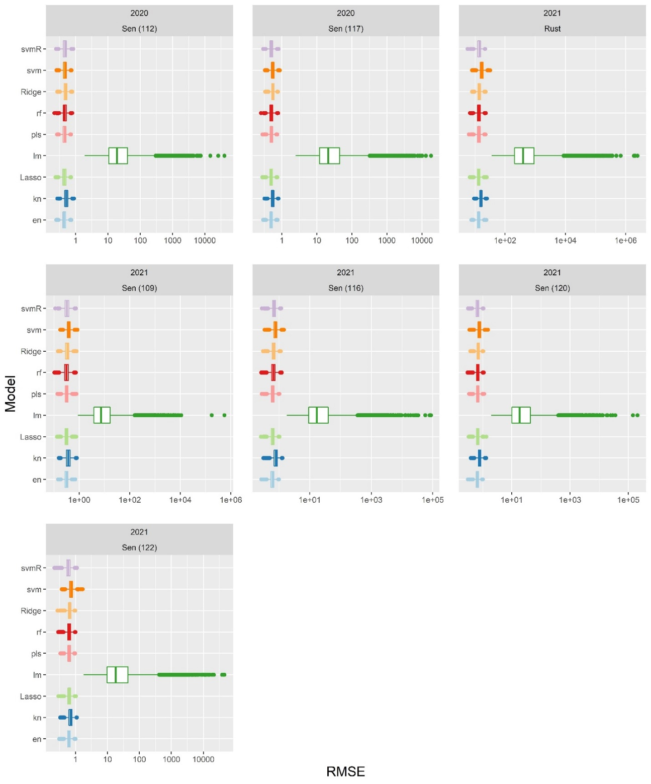

Supplementary Figure 1. Root mean square error (RMSE) values are displayed for each machine learning regression alongside the linear model for each predicted trait. Each model was evaluated 500 times across all seven predicted traits; the spread of RMSE values is represented as a boxplot for each model. Individual plots are named according to the year for which that trait was predicted along with the trait’s name (example: 2020 Sen(112) refers to the 2020 planting season, and specifically senescence at 112 days after planting).

Supplementary Figure 2
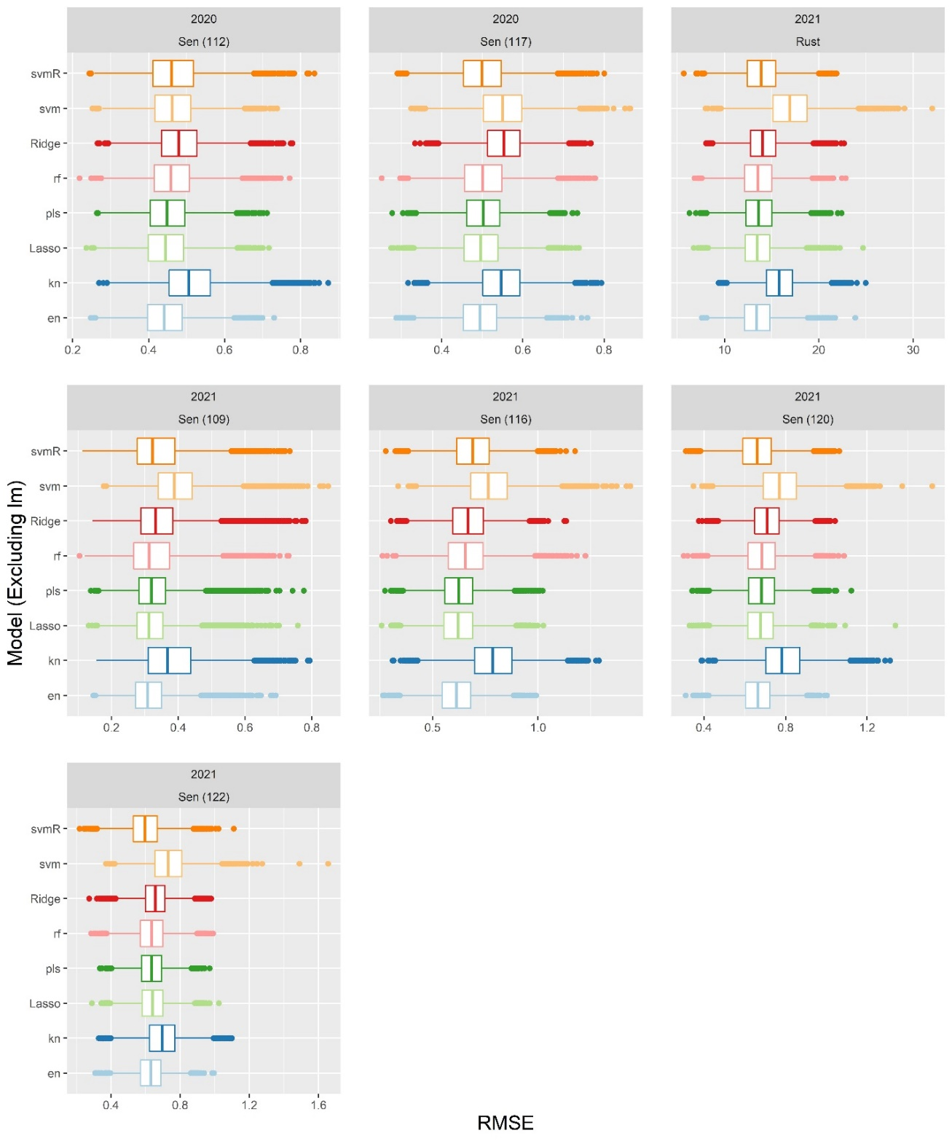
Supplementary Figure 2. RMSE spreads are shown strictly for machine learning models (the linear model is excluded for better comparison between machine learning models). Each model was evaluated 500 times across each of seven predicted traits.

Supplementary Table 1. Vegetation indices used in this study with their formulae and references.
Vegetation Index (VI) | Formula | Reference(s)
Brightness index (BI) | $$sqrt(\frac{R^{2}+G^{2}+B^{2}}{3})$$ | Richardson et al., 1977¹
Green leaf index (GLI) | $$\frac{2*G-R-B}{2*G+R+B}$$ | Louhaichi et al., 2001²
Normalized green-red difference index (NGRDI) | $$\frac{G-R}{G+R}$$ | Tucker, 1979³
Visible atmospherically resistant index (VARI) | $$\frac{G-R}{G+R-B}$$ | Gitelson et al., 2002⁴
Blue green pigment index (BGI) | $$\frac{B}{G}$$ | Zarco-Tejada et al., 2005⁵
Blue chromatic coordinate index (BCC) | $$\frac{B}{R+G+B}$$ | Woebbecke et al., 1995⁶
Color index of vegetation extraction (CIVE) | $$0.441R-0.811G+$$  $$0.385B+18.78745$$ | Kataoka et al., 2003⁷
Combined indices 1 (COM1) | $$EXG+CIVE+EXGR+VEG$$ | Guijarro et al., 2011⁸
Combined indices 2 (COM2) | $$0.36EXG+0.47CIVE+0.17VEG$$ | Guerrero et al., 2012⁹
Excessive green (ExG) | $$\left(2*G\right)-R-B$$ | Woebbecke et al., 1995⁶
Normalized excess green index (ExG2) | $$\frac{2G-R-B}{G+R+B}$$ | Woebbecke et al., 1995⁶
Excess green minus excess red index (ExGR) | $$\left(3*G\right)-\left(2.4*R\right)-B$$ | Meyer & Neto, 2008¹⁰
Excessive red (EXR) | $$1.4R-G$$ | Meyer et al., 1999¹¹
Green minus blue index (G-B) | $$G-B$$ | Woebbecke et al., 1995⁶
Green minus red index (G-R) | $$G-R$$ | Woebbecke et al., 1995⁶
Green blue simple ratio index (G/B) | $$\frac{G}{B}$$ | Woebbecke et al., 1995⁶
Green red simple ratio index (G/R) | $$\frac{G}{R}$$ | Woebbecke et al., 1995⁶
Green chromatic coordinate index (GCC) | $$\frac{G}{R+G+B}$$ | Woebbecke et al., 1995⁶
Modified excess green index (MExG) | $$1.262G-0.884R-0.311B$$ | Burgos-Artizzu et al., 2011¹²
Modified green red index (MGVRI) | $$\frac{G^{2}- R^{2}}{G^{2}+ R^{2}}$$ | Bendig et al., 2015¹³
Normalized difference index (NDI) | $$128*\left(\left(\frac{G-R}{G+R}\right)+1\right)$$ | Hamuda et al., 2016¹⁴
Normalized difference red blue index (NDRBI) | $$\frac{R-B}{R+B}$$ | Golzarian & Frick, 2011¹⁵
Normalized green-blue difference index (NGBDI) | $$\frac{G-B}{G+B}$$ | Hunt et al., 2005¹⁶
Red minus blue index (R-B) | $$R-B$$ | Woebbecke et al., 1995⁶
Red blue simple ratio index (R/B) | $$\frac{R}{B}$$ | Woebbecke et al., 1995⁶
Red chromatic coordinate index (RCC) | $$\frac{R}{R+G+B}$$ | Woebbecke et al., 1995⁶
Modified red chromatic coordinate index (MRCC) | $$\frac{R^{3}}{R+G+B}$$ | Created in this study
Red green blue index (RGBVI) | $$\frac{G^{2}-R*B}{G^{2}+R*B}$$ | Bendig et al., 2015¹³
Triangular greenery index (TGI) | $$G-\left(0.39R 0 0.69B\right)$$ | Hunt et al., 2011¹⁷
Vegetative (VEG) | $$\frac{G}{R^{0.667}*B^{0.334}}$$ | Hague et al., 2006¹⁸
Normalized red minus blue index (NRMBI) | $$\frac{R-B}{G}$$ | Created in this study
Modified Simple Ratio Green and Red (MSRGR) | $$sqrt\left(\frac{G}{R}\right)$$ | Tucker, 1979³
Transformed normalized green and red (TNDGR) | $$sqrt\left(\left(\frac{G-R}{G+R}\right)+0.5\right)$$ | Tucker, 1979³

Supplementary Table 2. Connecting letters reports from student’s t-tests of phenomic predictive model accuracies.
CV2 DTA 2020 | Mean | Letter
rf | 0.68 | A
svmR | 0.68 | B
lasso | 0.67 | B
en | 0.67 | B
pls | 0.66 | C
ridge | 0.65 | D
svm | 0.64 | E
knn | 0.61 | F
lm | 0.02 | G
CV2 DTS 2020 | Mean
rf | 0.68 | A
svmR | 0.68 | A
lasso | 0.67 | B
en | 0.67 | B
pls | 0.65 | C
ridge | 0.65 | D
svm | 0.64 | D
knn | 0.61 | E
lm | 0.02 | F
CV2 EHT 2020 | Mean
en | 0.50 | A
ridge | 0.49 | AB
pls | 0.49 | B
lasso | 0.47 | C
rf | 0.46 | C
svm | 0.42 | D
svmR | 0.41 | E
knn | 0.33 | F
lm | 0.00 | G
CV2 FHT 2020 | Mean
en | 0.76 | A
lasso | 0.76 | A
pls | 0.76 | A
ridge | 0.75 | B
rf | 0.74 | C
svm | 0.73 | D
svmR | 0.72 | E
knn | 0.70 | F
lm | 0.02 | G
CV2 PHT 2020 | Mean
en | 0.77 | A
lasso | 0.77 | A
pls | 0.77 | A
ridge | 0.76 | B
rf | 0.75 | B
svm | 0.73 | C
svmR | 0.73 | C
knn | 0.70 | D
lm | 0.03 | E
CV2 Senescence_07072020 2020 | Mean
en | 0.70 | A
lasso | 0.70 | A
svm | 0.69 | B
pls | 0.67 | C
rf | 0.67 | D
svmR | 0.65 | E
ridge | 0.65 | E
knn | 0.55 | F
lm | 0.02 | G
CV2 Senescence_07122020 2020 | Mean
lasso | 0.77 | A
en | 0.77 | A
rf | 0.77 | B
svmR | 0.77 | B
pls | 0.76 | C
svm | 0.73 | D
ridge | 0.72 | E
knn | 0.71 | F
lm | 0.03 | G
CV2 YLD2 2020 | Mean
en | 0.64 | A
ridge | 0.64 | A
svm | 0.64 | A
svmR | 0.64 | AB
rf | 0.64 | AB
knn | 0.63 | ABC
pls | 0.63 | BC
lasso | 0.62 | C
lm | 0.02 | D
CV2 DTA 2021 | Mean
ridge | 0.65 | A
en | 0.64 | AB
lasso | 0.64 | BC
rf | 0.63 | CD
pls | 0.63 | DE
svmR | 0.62 | DE
svm | 0.62 | E
knn | 0.61 | F
lm | 0.07 | G
CV2 DTS 2021 | Mean
ridge | 0.72 | A
en | 0.72 | A
rf | 0.71 | B
pls | 0.71 | B
knn | 0.71 | B
svmR | 0.70 | BC
lasso | 0.70 | C
svm | 0.66 | D
lm | 0.07 | E
CV2 EHT 2021 | Mean
en | 0.55 | A
ridge | 0.54 | A
lasso | 0.52 | B
pls | 0.52 | BC
rf | 0.51 | C
svmR | 0.49 | D
knn | 0.44 | E
svm | 0.40 | F
lm | 0.02 | G
CV2 FHT 2021 | Mean
en | 0.77 | A
lasso | 0.77 | AB
pls | 0.76 | BC
ridge | 0.76 | CD
rf | 0.75 | D
svmR | 0.74 | E
svm | 0.69 | F
knn | 0.69 | F
lm | 0.04 | G
CV2 PHT 2021 | Mean
en | 0.76 | A
lasso | 0.76 | A
pls | 0.75 | B
ridge | 0.74 | BC
rf | 0.74 | C
svmR | 0.72 | D
svm | 0.71 | E
knn | 0.67 | F
lm | 0.03 | G
CV2 Rust 2021 | Mean
rf | 0.72 | A
en | 0.7 | B
lasso | 0.7 | B
ridge | 0.69 | C
svmR | 0.69 | C
pls | 0.68 | C
svm | 0.62 | D
knn | 0.59 | E
lm | 0.04 | F
CV2 Senescence_71621 | Mean
lasso | 0.73 | A
en | 0.73 | A
rf | 0.71 | B
pls | 0.69 | C
svmR | 0.67 | D
ridge | 0.67 | D
svm | 0.64 | E
knn | 0.61 | F
lm | 0.03 | G
CV2 Senescence_72321 | Mean
lasso | 0.79 | A
en | 0.79 | A
pls | 0.77 | B
rf | 0.76 | C
ridge | 0.76 | C
svmR | 0.73 | D
svm | 0.71 | E
knn | 0.66 | F
lm | 0.03 | G
CV2 Senescence_72721 | Mean
svmR | 0.8 | A
en | 0.8 | A
lasso | 0.8 | A
rf | 0.79 | A
ridge | 0.78 | B
pls | 0.78 | B
svm | 0.77 | C
knn | 0.71 | D
lm | 0.06 | E
CV2 Senescence_72921 | Mean
svmR | 0.75 | A
rf | 0.73 | B
lasso | 0.73 | B
en | 0.73 | B
pls | 0.73 | B
ridge | 0.71 | C
svm | 0.7 | D
knn | 0.66 | E

Supplementary Table 3. Comparisons between traditional and UAS-based phenotyping methods.
 | Traditional field-based phenotyping | UAS-based high throughput phenotyping
Cost | Hourly wages for personnel. Specialized personnel are not necessary but likely improve accuracy. | Phantom 4 Pro v2 Drone: $1500  Agisoft Metashape Professional (Education Edition): $549/year  GPS for ground control points: $1000+  Desktop computer with adequate CPU/GPU/RAM/storage: $2000+
Time | Scoring and recording data for 200 hybrids requires between 2-2.5 hours of time for one rater (provided field is dry enough for walking). | Each UAS flight takes roughly 30 minutes; mosaicking process requires between 4 to 8 hours to stitch images together (mostly computational, approximately 2 hours of manual input); and manual scoring of each hybrid from a mosaic requires approximately 6 hours per mosaic.
Accuracy | Rater bias is subject to level of expertise, environmental factors, lighting conditions, weather, and fatigue. | Orthomosaics provide uniform arrangement of plants to be scored; subject to lighting conditions during UAS flight, quality of image stitching, and (to a lesser degree) rater bias.
Resolution | No image resolution limitations, however limited to lower and mid-level leaves at the end of plot, the interior of plots is more challenging to observe; canopy can be difficult to phenotype when plants are at maximum height. | Pixel size of mosaics is determined by UAS flying height, speed and camera resolution and ability; visible plant area restricted to canopy and some mid-level leaves.
Scale | Limited by available and trained personnel in the field. | Limited by the available number of batteries for UAS and willingness of operator in the field. Limited by available and trained personnel in the lab.

References

1 Richardson, A. J. & Wiegand, C. L. Distinguishing vegetation from soil background information. Photogrammetric engineering and remote sensing 43, 1541-1552 (1977).
2 Louhaichi, M., Borman, M. M. & Johnson, D. E. Spatially located platform and aerial photography for documentation of grazing impacts on wheat. Geocarto International 16, 65-70 (2001).
3 Tucker, C. J. Red and photographic infrared linear combinations for monitoring vegetation. Remote sensing of Environment 8, 127-150 (1979).
4 Gitelson, A. A., Kaufman, Y. J., Stark, R. & Rundquist, D. Novel algorithms for remote estimation of vegetation fraction. Remote sensing of Environment 80, 76-87 (2002).
5 Zarco-Tejada, P. J. et al. Assessing vineyard condition with hyperspectral indices: Leaf and canopy reflectance simulation in a row-structured discontinuous canopy. Remote Sensing of Environment 99, 271-287 (2005).
6 Woebbecke, D. M., Meyer, G. E., Von Bargen, K. & Mortensen, D. A. Color indices for weed identification under various soil, residue, and lighting conditions. Transactions of the ASAE 38, 259-269 (1995).
7 Kataoka, T., Kaneko, T., Okamoto, H. & Hata, S. b1079-b1083 (IEEE).
8 Guijarro, M. et al. Automatic segmentation of relevant textures in agricultural images. Computers and Electronics in Agriculture 75, 75-83 (2011).
9 Guerrero, J. M., Pajares, G., Montalvo, M., Romeo, J. & Guijarro, M. Support vector machines for crop/weeds identification in maize fields. Expert Systems with Applications 39, 11149-11155 (2012).
10 Meyer, G. E. & Neto, J. C. Verification of color vegetation indices for automated crop imaging applications. Computers and electronics in agriculture 63, 282-293 (2008).
11 Meyer, G. E., Hindman, T. W. & Laksmi, K. 327-335 (International Society for Optics and Photonics).
12 Burgos-Artizzu, X. P., Ribeiro, A., Guijarro, M. & Pajares, G. Real-time image processing for crop/weed discrimination in maize fields. Computers and Electronics in Agriculture 75, 337-346 (2011).
13 Bendig, J. et al. Combining UAV-based plant height from crop surface models, visible, and near infrared vegetation indices for biomass monitoring in barley. International Journal of Applied Earth Observation and Geoinformation 39, 79-87 (2015).
14 Hamuda, E., Glavin, M. & Jones, E. A survey of image processing techniques for plant extraction and segmentation in the field. Computers and Electronics in Agriculture 125, 184-199 (2016).
15 Golzarian, M. R. & Frick, R. A. Classification of images of wheat, ryegrass and brome grass species at early growth stages using principal component analysis. Plant Methods 7, 1-11 (2011).
16 Hunt, E. R., Cavigelli, M., Daughtry, C. S. T., McMurtrey, J. E. & Walthall, C. L. Evaluation of digital photography from model aircraft for remote sensing of crop biomass and nitrogen status. Precision Agriculture 6, 359-378 (2005).
17 Hunt, E. R., Daughtry, C. S. T., Eitel, J. U. H. & Long, D. S. Remote sensing leaf chlorophyll content using a visible band index. (2011).
18 Hague, T., Tillett, N. D. & Wheeler, H. Automated crop and weed monitoring in widely spaced cereals. Precision Agriculture 7, 21-32 (2006).

