TAVI-CT score to evaluate the anatomic risk in patients undergoing transcatheter aortic valve implantation
Online supplement

Table 1S. Distribution of TAVI-CT (transcatheter aortic valve implantation-computed tomography) score and its components.
Feature | Count (%)
Patients | 200
TAVI-CT score
1 | 23 (11.5%)
2 | 48 (24.0%)
3 | 50 (25.0%)
4 | 42 (21.0%)
5 | 14 (7.0%)
6 | 12 (6.0%)
7 | 5 (2.5%)
8 | 2 (1.0%)
9 | 1 (0.5%)
TAVI-CT score components
Nodular calcium (scored from 0 to 3)
None | 140 (70.4%)
1 cuspid involved | 49 (24.6%)
2 cuspids involved | 10 (5.0%)
3 cuspids involved | 0
Subvalvular calcium (scored from 0 to 1) | 32 (16.2%)
Elliptical index (scored from 0 to 2)
≤0.7 | 34 (17.0%)
>0.7 to ≤0.8 | 103 (51.5%)
>0.8 | 63 (31.5%)
Aortic isthmus angle ≤95° (scored from 0 to 1) | 41 (23.0%)
Aorta-ventricle angle ≤55° (scored from 0 to 1) | 137 (74.5%)
Bicuspid (scored from 0 to 1) | 8 (4.0%)
Coronary height ≤10 mm (scored from 0 to 1) | 12 (6.0%)
Ilio-femoral calcification (scored from 0 to 2)
None | 144 (72.4%)
Mild | 39 (19.6%)
Moderate or severe | 16 (8.0%)
Vascular endograft (scored from 0 to 1) | 6 (3.0%)
Access size ≤6.0 mm (scored from 0 to 1) | 15 (7.5%)
Planned access (scored from 0 to 2)
Femoral | 185 (92.5%)
Axillary | 11 (5.5%)
Aortic, apical, caval, carotid, or subclavian | 4 (2.0%)

Table 2S. Clinical and imaging outcomes at 1-month follow-up discounting planned access from the TAVI-CT (transcatheter aortic valve implantation-computed tomography) score.

Feature | Low score (0-2) | Intermediate score (3) | High score (≥4) | P value
Patients | 80 | 57 | 63 | -
Total length of stay (days) | 5.4±1.8 | 5.7±1.9 | 5.9±2.2 | 0.363
Major adverse event* | 2 (2.5%) | 5 (8.8%) | 4 (6.4%) | 0.263
Death | 1 (1.3%) | 2 (3.5%) | 0 | 0.374
Cardiac death | 1 (1.3%) | 1 (1.8%) | 0 | 0.747
Myocardial infarction | 1 (1.3%) | 1 (1.8%) | 0 | 0.747
Stroke | 0 | 1 (1.8%) | 0 | 0.285
Bleeding |  |  |  | 0.192
None | 80 (100%) | 55 (96.5%) | 62 (98.4%)
Type 1 | 0 | 2 (3.5%) | 1 (1.6%)
Type 2 | 0 | 0 | 0
Type 3 | 0 | 0 | 0
Type 4 | 0 | 0 | 0
Vascular complication |  |  |  | 0.103
None | 80 (100%) | 56 (98.3%) | 60 (95.2%)
Minor | 0 | 1 (1.8%) | 3 (4.8%)
Major | 0 | 0 | 0
Surgical conversion | 0 | 0 | 0 | 1
Aortic dissection | 0 | 0 | 0 | 1
Anulus rupture | 0 | 0 | 0 | 1
Bailout percutaneous coronary intervention | 1 (1.3%) | 1 (1.8%) | 0 | 0.747
Permanent pacemaker implantation | 6 (7.5%) | 7 (12.3%) | 9 (14.3%) | 0.413
Left ventricular ejection fraction (%) | 52.3±8.0 | 52.3±9.3 | 52.5±9.0 | 0.989
Peak gradient (mm Hg) | 13.6±5.1 | 13.4±5.6 | 14.5±6.3 | 0.531
Mean gradient (mm Hg) | 7.7±3.2 | 7.5±3.3 | 8.2±3.6 | 0.522
Aortic regurgitation |  |  |  | 0.019
None | 18 (22.5%) | 6 (10.5%) | 12 (19.1%)
1+ | 57 (71.3%) | 51 (89.5%) | 44 (98.4%)
2+ | 5 (6.3%) | 0 | 7 (11.1%)
*composite of death, myocardial infarction, stroke, bleeding, or vascular complication

Table 3S. Areas under the curve (AUC) with 95% confidence intervals of the receiver-operator characteristic curves for different versions of the TAVI-CT (transcatheter aortic valve implantation-computed tomography) score.

Feature | TAVI-CT score | TAVI-CT score, excluding planned access | Abridged TAVI-CT score | Abridged TAVI-CT score, excluding planned access
Major adverse event* | 0.66  (0.50-0.83) | 0.66  (0.49-0.83) | 0.63  (0.45-0.81) | 0.60  (0.46-0.74)
Vascular complication | 0.88  (0.71-1.00) | 0.90  (0.74-1.00) | 0.63  (0.56-0.70) | 0.62  (0.48-0.77)
*composite of death, myocardial infarction, stroke, bleeding, or vascular complication

Table 4S. Impact of individual components of the TAVI-CT (transcatheter aortic valve implantation-computed tomography) score on the risk of major adverse events.*

Feature | No major adverse event | Major adverse event | P value
Patients | 189 | 11 | -
Nodular calcium (scored from 0 to 3) |  |  | 0.343
None | 131 (69.7%) | 9 (81.8%)
1 cuspid involved | 48 (25.5%) | 1 (9.1%)
2 cuspids involved | 9 (4.8%) | 1 (9.1%)
3 cuspids involved | 0 | 0
Subvalvular calcium (scored from 0 to 1) | 32 (17.1%) | 0 | 0.217
Elliptical index (scored from 0 to 2) |  |  | 0.335
≤0.7 | 33 (17.5%) | 1 (9.1%)
>0.7 to ≤0.8 | 99 (52.4%) | 4 (36.4%)
>0.8 | 57 (30.2%) | 6 (54.6%)
Aortic isthmus angle ≤95° (scored from 0 to 1) | 37 (22.0%) | 4 (40.0%) | 0.242
Aorta-ventricle angle ≤55° (scored from 0 to 1) | 129 (74.1%) | 8 (80.0%) | 1
Bicuspid (scored from 0 to 1) | 7 (3.7%) | 1 (9.1%) | 0.371
Coronary height ≤10 mm (scored from 0 to 1) | 11 (5.8%) | 1 (9.1%) | 0.503
Ilio-femoral calcification (scored from 0 to 2) |  |  | 0.084
None | 137 (72.9%) | 7 (63.6%)
Mild | 38 (20.2%) | 1 (9.1%)
Moderate or severe | 13 (6.9%) | 3 (27.3%)
Vascular endograft (scored from 0 to 1) | 5 (2.7%) | 1 (9.1%) | 0.291
Access size ≤6.0 mm (scored from 0 to 1) | 13 (6.9%) | 2 (18.2%) | 0.195
Planned access (scored from 0 to 2) |  |  | 0.195
Femoral | 176 (93.1%) | 9 (81.8%)
Axillary | 9 (4.8%) | 2 (18.2%)
Aortic, apical, caval, carotid, or subclavian | 4 (2.1%) | 0
*composite of death, myocardial infarction, stroke, bleeding, or vascular complication

Table 5S. Impact of individual components of the TAVI-CT (transcatheter aortic valve implantation-computed tomography) score on the risk of vascular complications.*

Feature | No major adverse event | Major adverse event | P value
Patients | 196 | 4 | -
Nodular calcium (scored from 0 to 3) |  |  | 0.156
None | 137 (70.3%) | 3 (75.0%)
1 cuspid involved | 49 (25.1%) | 0
2 cuspids involved | 9 (4.6%) | 1 (25.0%)
3 cuspids involved
Subvalvular calcium (scored from 0 to 1) | 32 (16.5%) | 0 | 1
Elliptical index (scored from 0 to 2) |  |  | 0.016
≤0.7 | 34 (17.4%) | 0
>0.7 to ≤0.8 | 103 (52.6%) | 0
>0.8 | 59 (30.1%) | 4 (100%)
Aortic isthmus angle ≤95° (scored from 0 to 1) | 40 (22.9%) | 1 (33.3%) | 0.546
Aorta-ventricle angle ≤55° (scored from 0 to 1) | 134 (74.0%) | 3 (100%) | 0.571
Bicuspid (scored from 0 to 1) | 7 (3.6%) | 1 (25.0%) | 0.152
Coronary height ≤10 mm (scored from 0 to 1) | 12 (6.1%) | 0 | 1
Ilio-femoral calcification (scored from 0 to 2) |  |  | 0.017
None | 143 (73.3%) | 1 (25.0%)
Mild | 38 (19.5%) | 1 (25.0%)
Moderate or severe | 14 (7.2%) | 2 (50.0%)
Vascular endograft (scored from 0 to 1) | 5 (2.6%) | 1 (25.0%) | 0.116
Access size ≤6.0 mm (scored from 0 to 1) | 13 (6.6%) | 2 (50.0%) | 0.029
Planned access (scored from 0 to 2) |  |  | 0.270
Femoral | 182 (92.9%) | 3 (75.0%)
Axillary | 10 (5.1%) | 1 (25.0%)
Aortic, apical, caval, carotid, or subclavian | 4 (2.0%) | 0

Figure 1S. Flowchart detailing patient selection.

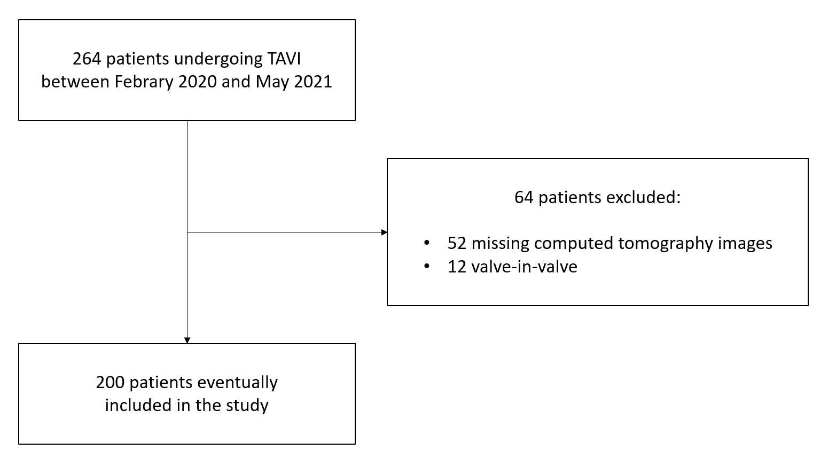

Figure 2S. Computation of the TAVI-CT (transcatheter aortic valve implantation-computed tomography) score.

Nodular calcium
None -> 0
One cuspid involved -> 1
Two cuspids involved -> 2
Three cuspids involved -> 3

Subvalvular calcium
No -> 0
Yes -> 1

Elliptical index
minimum diameter / maximum diameter >0.8 -> 0
minimum diameter / maximum diameter >0.7 to ≤0.8 -> 1
minimum diameter / maximum diameter ≤0.7 -> 2

Aortic isthmus angle
>95° -> 0
≤95° -> 1

Aorta-ventricle angle
>55° -> 0
≤55° -> 1

Bicuspid
No -> 0
Yes -> 1

Coronary height
>10 mm -> 0
≤10 mm -> 1

Ilio-femoral calcification
None -> 0
Mild -> 1
Moderate or severe -> 2

Vascular endograft
No -> 0
Yes -> 1

Access size
>6.0 mm -> 0
≤6.0 mm -> 1

Planned access
Femoral -> 0
Axillary -> 1
Aortic, apical, carotid, caval, or subclavian -> 2

Figure 3S. Distribution of the TAVI-CT (transcatheter aortic valve implantation-computed tomography) score.

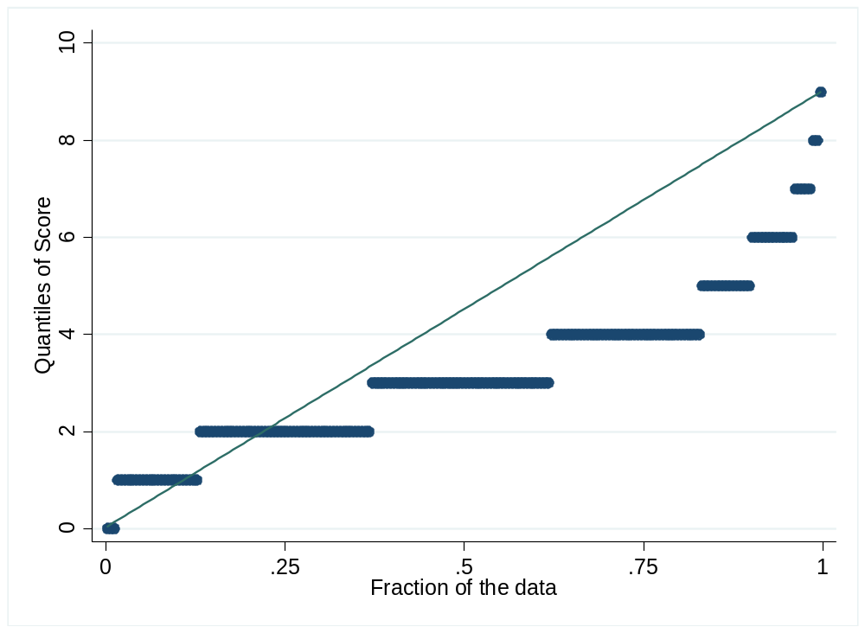

Figure 4S. Receiver-operator characteristic (ROC) curve for the association between TAVI-CT (transcatheter aortic valve implantation-computed tomography) score and risk of vascular complications. se=standard error.

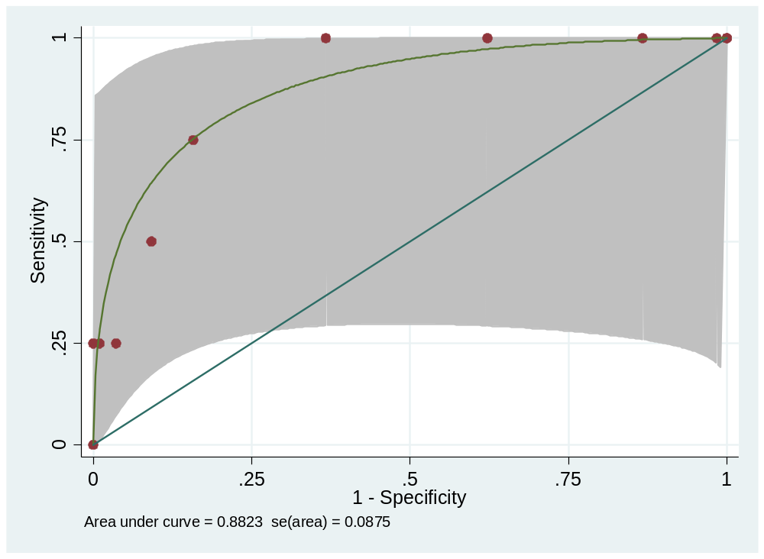.

Figure 5S. Receiver-operator characteristic (ROC) curve for the association between TAVI-CT (transcatheter aortic valve implantation-computed tomography) score and risk of vascular complications, excluding planned access. se=standard error.

