Supplementary Material

Metagenomic sequencing characterizes a wide diversity of viruses in field mosquito samples in Nigeria
​​Judith U. Oguzie^{1,2}, Udoka C. Nwangwu³, Paul E Oluniyi^{1,2}, Testimony J. Olumade^{1,2}, Uwem E. George^{1,2}, Akano Kazeem^{1,2}, Bolajoko E. Bankole^{1,2}, Farida O. Brimmo¹, Chukwuemeka C. Asadu³, Okechukwu C. Chukwuekezie³, Josephine C. Ochu³, Catherine O. Makwe⁴, Festus A. Dogunro³, Cosmas O. Onwude³, William E. Nwachukwu⁵, Ebuka K. Ezihe³, Gilkenny K. Okonkwo⁴, Ndubuisi E. Umazi⁴, Jacob Maikere⁴, Nneka O. Agashi³, Emelda I. Eloy³, Stephen O. Anokwu³, Angela I. Okoronkwo³, Ebuka M. Nwosu³, Sandra O. Etiki³, Ifeoma M. Ngwu³, Chikwe Ihekweazu⁵, Onikepe A. Folarin^{1,2}, Isaac O.O Komolafe^{1,2}, Christian T. Happi^{1,2*}
- African Centre of Excellence for Genomics of Infectious Diseases (ACEGID), Redeemer’s University, Ede, Osun State, Nigeria.
- Department of Biological Sciences, Faculty of Natural Sciences, Redeemer’s University, Ede, Osun State, Nigeria.
- National Arbovirus and Vectors Research Centre (NAVRC), Enugu, Enugu State, Nigeria
- Médecins Sans Frontières (MSF Belgium).
- Nigeria Center for Disease Control, Abuja, Nigeria.
*Correspondences: Professor Christian T. Happi (email: happic@run.edu.ng; Tel: +234-8023383684)

Supplementary Table S1: Metadata

ID | STATE | SPECIES | SEX | TOTAL SEQUENCING READS | MEAN SEQUENCE QUALITY (PHRED SCORE)
B1S_20 | Ebonyi | Ae. simpsoni complex | female | 692232 | 36
B1S_45 | Anambra | Ae. albopictus | female | 2503602 | 37
B1S_59 | Edo | Ae. aegypti | female | 3469076 | 37
B1S_70 | Osun | Ae. albopictus | female | 2724416 | 37
B1S_88 | Edo | Ae. aegypti | female | 849566 | 37
B1S_100b | Kwara | Ae. aegypti | female | 1498252 | 37
B1S_100c | Kwara | Ae. aegypti | female | 2755048 | 35
B1S_101 | Kwara | Ae. aegypti | female | 1700618 | 35
B1S_102A | Kwara | Ae. Aegypti | female | 1296946 | 35
B2S_15 | Ebonyi | Ae. albopictus | female | 993776 | 36
B2S_48 | Ebonyi | Ae. albopictus | female | 2892896 | 35
B2S_50 | Ebonyi | Ae. albopictus | female | 1717588 | 37
B2S_51 | Ebonyi | Ae. albopictus | female | 2308992 | 37
B2S_69 | Ebonyi | Ae. albopictus | female | 876344 | 37
B2S_73 | Ebonyi | Ae. aegypti | female | 1715760 | 36
B2S_75 | Ebonyi | Ae. albopictus | female | 1221702 | 36
B2S_83 | Ebonyi | Ae. albopictus | female | 2796030 | 33
B2S_91 | Ebonyi | Ae. aegypti | female | 1012258 | 25
NB3_58 | Ebonyi | Ae. aegypti | male | 449324 | 35
NB3_99 | Nassarawa | Ae. luteocephalus | female | 1414536 | 35
NB3_120 | Nassarawa | Ae. aegypti | male | 445198 | 35
NB3_122 | Ebonyi | Ae. albopictus | male | 247396 | 34
NB3_126 | Ebonyi | Ae. aegypti | female | 1484712 | 36
NB3_146 | Niger | Anopheles coustani | female | 872232 | 35
NB3_150 | Benue | Ae. aegypti | female | 941410 | 35
NB3_173 | Enugu | Ae. simpsoni complex | female | 1364862 | 33

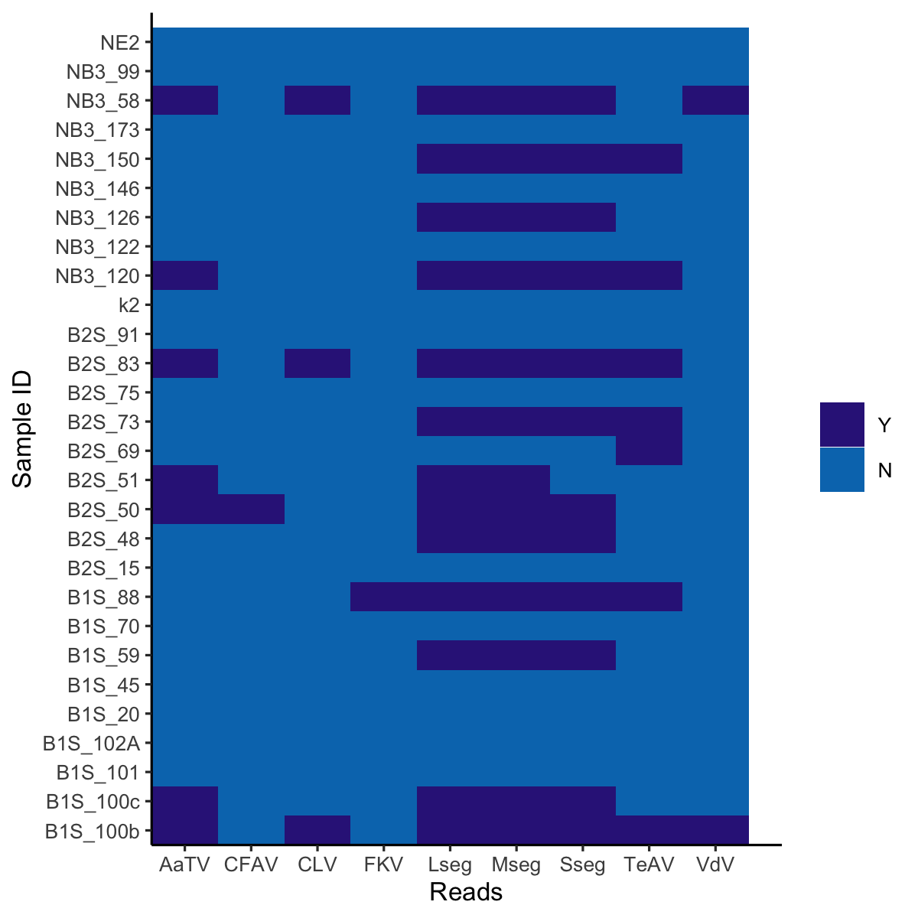
Supplementary Figure S1: Heatmap of Assembled Viruses.
Legend: AaTV =Aedes aegypti totivirus, CLV= Chaq like-virus, CFAV= cell fusing virus, FKV= Fako virus, LSeg = L segment of Phasi Charoen like phasivirus, MSeg = M segment of Phasi Charoen like phasivirus, SSeg = S segment of Phasi Charoen like phasivirus, TeAV= Tesano Aedes virus, VdV= Verdadero virus.

