Targeted Metabolomics Analysis of Amino Acids and Acylcarnitines as Risk Markers for Diabetes by LC-MS/MS Technique
Shaghayegh Hosseinkhani^{1,2}, Babak Arjmand³, Arezou Dilmaghani-Marand⁴, Sahar Mohammadi Fateh⁴, Hojat Dehghanbanadaki⁵, Niloufar Najjar⁶, Sepideh Alavi-Moghadam⁶, Robabeh Ghodssi-Ghassemabadi⁷, Ensieh Nasli-Esfahani¹, Farshad Farzadfar^{4,8}, Bagher Larijani⁸, Farideh Razi^{6,1}*
Supplementary Table 1. Significantly altered metabolites among groups’ classification using independent sample T-test or Mann-Whitney U test.
No. | Metabolites (µmol/L) | Non-diabetes | Diabetes | P-value | FDR
1 | C2 | 14.621±0.297 | 15.527±0.307 | 0.020 | 0.048
2 | C3 | 0.881±0.0263 | 0.955±0.025 | 0.009 | 0.028
3 | C3DC | 0.082±0.003 | 0.102±0.004 | 0.000 | 0.000
4 | C4 | 0.4816±0.027 | 0.527±0.03 | 0.034 | 0.076
5 | C4OH | 0.055±0.002 | 0.069±0.002 | 0.000 | 0.000
6 | C4DC | 0.07±0.002 | 0.102±0.004 | 0.000 | 0.000
7 | C5 | 0.230±0.007 | 0.245±0.007 | 0.046 | 0.090
8 | C5:1 | 0.04±0.002 | 0.058±0.003 | 0.000 | 0.000
9 | C5OH | 0.064±0.001 | 0.073±0.001 | 0.000 | 0.000
10 | C14OH | 0.013±0.000 | 0.015±0.001 | 0.004 | 0.013
11 | C16OH | 0.012±0.000 | 0.013±0.001 | 0.001 | 0.004
12 | C18 | 0.071±0.002 | 0.066±0.001 | 0.037 | 0.077
13 | C18:1 | 0.194±0.005 | 0.180±0.005 | 0.017 | 0.045
14 | C18OH | 0.009±0.000 | 0.011±0.000 | 0.000 | 0.000
15 | C18:2OH | 0.030±0.001 | 0.035±0.002 | 0.035 | 0.076
16 | Alanine | 417.00±6.146 | 468.514±6.146 | 0.000 | 0.000
17 | Leucine | 121.671±1.718 | 138.766±2.052 | 0.000 | 0.000
18 | Valine | 255.130±3.388 | 292.508±4.084 | 0.000 | 0.000
19 | Arginine | 70.627±1.364 | 66.965±1.316 | 0.020 | 0.048
20 | Citrulline | 39.494±0.710 | 36.896±0.813 | 0.017 | 0.045
21 | Glycine | 269.422±5.398 | 246.747±5.196 | 0.001 | 0.004
22 | Ornithine | 94.047±1.834 | 86.963±1.433 | 0.011 | 0.032
23 | Threonine | 139.347±2.268 | 128.614±2.406 | 0.000 | 0.000
24 | Serine | 102.895±1.962 | 91.101±1.825 | 0.000 | 0.000
25 | Histidine | 82.907±1.0814 | 77.1647±1.257 | 0.001 | 0.004
26 | Tryptophan | 69.722±1.0317 | 67.251±1.324 | 0.047 | 0.090
 | Concentrations are reported as mean± SEM.

Supplementary Table 2. The odds ratio (OR) with a 95% confidence interval (CI) (per metabolite) was calculated using binary logistic regression analysis.
Metabolites | OR | 95% CI |  |  | P- value | P- value † | P- value †
C0 | 0.904 | (0.744 | - | 1.098) | 0.484 | 0.516 | 0.196
C2 | 1.236 | (1.014 | - | 1.508) | 0.095 | 0.095 | 0.167
C3 | 1.217 | (0.998 | - | 1.485) | 0.115 | 0.146 | 0.814
C3DC | 1.620 | (1.250 | - | 2.098) | 0.000 | 0.000 | 0.000
C4 | 1.128 | (0.912 | - | 1.395) | 0.435 | 0.383 | 0.517
C4OH | 1.870 | (1.442 | - | 2.425) | 0.000 | 0.000 | 0.000
C4DC | 3.009 | (2.159 | - | 4.194) | 0.000 | 0.000 | 0.000
C5 | 1.155 | (0.948 | - | 1.406) | 0.273 | 0.304 | 0.448
C5:1 | 2.013 | (1.509 | - | 2.687) | 0.000 | 0.000 | 0.000
C5OH | 1.600 | (1.277 | - | 2.005) | 0.000 | 0.000 | 0.000
C5DC | 1.033 | (0.852 | - | 1.254) | 0.885 | 0.906 | 0.814
C6 | 1.084 | (0.892 | - | 1.318) | 0.576 | 0.592 | 0.694
C8 | 1.021 | (0.841 | - | 1.239) | 0.885 | 0.906 | 0.900
C8:1 | 1.087 | (0.895 | - | 1.320) | 0.576 | 0.559 | 0.446
C10 | 0.977 | (0.805 | - | 1.186) | 0.885 | 0.906 | 1.000
C10:1 | 0.974 | (0.803 | - | 1.182) | 0.885 | 0.906 | 1.000
C12 | 0.969 | (0.798 | - | 1.177) | 0.885 | 0.756 | 1.000
C14 | 0.977 | (0.804 | - | 1.187) | 0.885 | 0.798 | 1.000
C14:1 | 0.923 | (0.758 | - | 1.123) | 0.576 | 0.531 | 0.900
C14:2 | 0.930 | (0.766 | - | 1.130) | 0.597 | 0.592 | 1.000
C14OH | 1.391 | (1.095 | - | 1.767) | 0.022 | 0.028 | 0.067
C16 | 1.078 | (0.888 | - | 1.309) | 0.589 | 0.675 | 0.927
C16OH | 1.470 | (1.158 | - | 1.866) | 0.008 | 0.000 | 0.036
C16:1OH | 1.012 | (0.834 | - | 1.229) | 0.939 | 0.959 | 1.000
C16:1 | 0.954 | (0.786 | - | 1.158) | 0.791 | 0.654 | 1.000
C18 | 0.812 | (0.664 | - | 0.992) | 0.100 | 0.075 | 0.105
C18:1 | 0.808 | (0.659 | - | 0.991) | 0.100 | 0.075 | 0.250
C18OH | 1.397 | (1.102 | - | 1.771) | 0.020 | 0.028 | 0.036
C18:1OH | 1.117 | (0.918 | - | 1.359) | 0.435 | 0.545 | 0.385
C18:2OH | 1.360 | (1.070 | - | 1.729) | 0.035 | 0.028 | 0.088
Alanine | 1.860 | (1.488 | - | 2.325) | 0.000 | 0.000 | 0.000
Aspartic Acid | 1.006 | (0.829 | - | 1.221) | 0.952 | 0.980 | 1.000
Glutamic Acid | 1.156 | (0.950 | - | 1.407) | 0.273 | 0.269 | 0.842
Leucine | 2.010 | (1.585 | - | 2.549) | 0.000 | 0.000 | 0.000
Methionine | 0.882 | (0.725 | - | 1.072) | 0.357 | 0.328 | 0.280
Phenylalanine | 1.243 | (1.000 | - | 1.544) | 0.114 | 0.130 | 0.444
Tyrosine | 1.082 | (0.891 | - | 1.314) | 0.576 | 0.592 | 0.838
Valine | 2.197 | (1.717 | - | 2.812) | 0.000 | 0.000 | 0.000
Arginine | 0.825 | (0.678 | - | 1.004) | 0.115 | 0.130 | 0.105
Citrulline | 0.785 | (0.643 | - | 0.959) | 0.048 | 0.028 | 0.125
Glycine | 0.738 | (0.603 | - | 0.902) | 0.011 | 0.000 | 0.036
Ornithine | 0.732 | (0.595 | - | 0.900) | 0.011 | 0.000 | 0.088
Proline | 1.172 | (0.961 | - | 1.431) | 0.236 | 0.240 | 0.814
Threonine | 0.721 | (0.589 | - | 0.883) | 0.008 | 0.000 | 0.000
Serine | 0.626 | (0.502 | - | 0.781) | 0.000 | 0.000 | 0.000
Histidine | 0.706 | (0.577 | - | 0.864) | 0.005 | 0.000 | 0.000
Lysine | 1.029 | (0.848 | - | 1.249) | 0.885 | 0.906 | 0.814
Tryptophan | 0.863 | (0.709 | - | 1.051) | 0.273 | 0.304 | 0.182
Asparagine | 0.920 | (0.758 | - | 1.117) | 0.576 | 0.592 | 0.838
Glutamine | 0.991 | (0.817 | - | 1.203) | 0.947 | 0.906 | 1.000
P-value, crude model
P-value†, adjusted by blood pressure
P-value††, adjusted by blood pressure and lipid profile (HDL-C, cholesterol, triglyceride)
OR has been reported for the crude model.
All P-values are adjusted for multiple testing using the Benjamin-Hochberg false discovery rate.

Supplementary Table 3. Significantly altered metabolites among groups’ classification using independent sample T-test or Mann-Whitney U test according to sex differences.
 | Non-diabetes |  |  |  |  | Diabetes
Metabolites (µmol/L) | Female |  | Male |  | P-value | Female |  | Male |  | P-value
 | mean | SEM | mean | SEM |  | mean | SEM | mean | SEM
C0 | 59.191 | 1.047 | 56.312 | 1.355 | 0.238 | 55.688 | 1.220 | 57.700 | 1.463 | 0.676
C2 | 15.057 | 0.386 | 14.092 | 0.459 | 0.171 | 15.843 | 0.395 | 15.150 | 0.480 | 0.300
C3 | 0.844 | 0.030 | 0.932 | 0.045 | 0.360 | 0.880 | 0.031 | 1.044 | 0.039 | 0.008
C3DC | 0.081 | 0.003 | 0.084 | 0.004 | 0.600 | 0.097 | 0.006 | 0.108 | 0.006 | 0.086
C4 | 0.462 | 0.019 | 0.504 | 0.056 | 0.430 | 0.527 | 0.040 | 0.528 | 0.045 | 0.963
C4OH | 0.055 | 0.002 | 0.055 | 0.004 | 0.238 | 0.071 | 0.003 | 0.066 | 0.002 | 0.580
C4DC | 0.070 | 0.002 | 0.070 | 0.002 | 0.799 | 0.100 | 0.005 | 0.104 | 0.006 | 0.826
C5 | 0.219 | 0.010 | 0.245 | 0.010 | 0.025 | 0.226 | 0.009 | 0.266 | 0.010 | 0.008
C5:1 | 0.043 | 0.003 | 0.036 | 0.002 | 0.519 | 0.057 | 0.004 | 0.059 | 0.004 | 0.676
C5OH | 0.064 | 0.002 | 0.064 | 0.002 | 0.907 | 0.071 | 0.002 | 0.075 | 0.002 | 0.083
C5DC | 0.308 | 0.011 | 0.350 | 0.011 | 0.008 | 0.310 | 0.010 | 0.355 | 0.011 | 0.008
C6 | 0.218 | 0.016 | 0.177 | 0.008 | 0.579 | 0.217 | 0.014 | 0.202 | 0.011 | 0.852
C8 | 0.328 | 0.027 | 0.310 | 0.021 | 0.626 | 0.326 | 0.026 | 0.324 | 0.023 | 0.691
C8:1 | 0.372 | 0.018 | 0.312 | 0.016 | 0.025 | 0.402 | 0.021 | 0.310 | 0.015 | 0.017
C10 | 0.434 | 0.036 | 0.418 | 0.028 | 0.547 | 0.417 | 0.031 | 0.421 | 0.029 | 0.676
C10:1 | 0.398 | 0.027 | 0.379 | 0.023 | 0.922 | 0.375 | 0.024 | 0.393 | 0.023 | 0.548
C12 | 0.149 | 0.010 | 0.155 | 0.007 | 0.276 | 0.146 | 0.007 | 0.152 | 0.007 | 0.620
C14 | 0.061 | 0.004 | 0.060 | 0.002 | 0.547 | 0.059 | 0.002 | 0.061 | 0.002 | 0.472
C14:1 | 0.141 | 0.009 | 0.131 | 0.007 | 0.579 | 0.129 | 0.006 | 0.132 | 0.006 | 0.821
C14:2 | 0.100 | 0.005 | 0.100 | 0.005 | 0.842 | 0.091 | 0.004 | 0.102 | 0.004 | 0.077
C14OH | 0.013 | 0.001 | 0.013 | 0.001 | 0.922 | 0.015 | 0.001 | 0.016 | 0.001 | 0.557
C16 | 0.184 | 0.005 | 0.190 | 0.006 | 0.579 | 0.189 | 0.005 | 0.193 | 0.006 | 0.965
C16OH | 0.011 | 0.000 | 0.012 | 0.000 | 0.519 | 0.013 | 0.001 | 0.014 | 0.001 | 0.608
C16:1OH | 0.019 | 0.001 | 0.018 | 0.001 | 0.922 | 0.019 | 0.001 | 0.020 | 0.001 | 0.689
C16:1 | 0.054 | 0.002 | 0.046 | 0.002 | 0.050 | 0.051 | 0.002 | 0.048 | 0.002 | 0.261
C18 | 0.068 | 0.002 | 0.074 | 0.003 | 0.108 | 0.064 | 0.002 | 0.068 | 0.002 | 0.437
C18:1 | 0.200 | 0.008 | 0.188 | 0.006 | 0.576 | 0.176 | 0.006 | 0.185 | 0.007 | 0.691
C18OH | 0.009 | 0.000 | 0.009 | 0.001 | 0.547 | 0.011 | 0.001 | 0.011 | 0.001 | 0.938
C18:1OH | 0.013 | 0.001 | 0.013 | 0.001 | 0.519 | 0.014 | 0.001 | 0.014 | 0.001 | 0.691
C18:2OH | 0.032 | 0.001 | 0.028 | 0.001 | 0.467 | 0.035 | 0.002 | 0.035 | 0.002 | 0.691
Alanine | 420.222 | 7.737 | 413.087 | 9.877 | 0.843 | 480.571 | 8.028 | 454.148 | 9.313 | 0.082
Aspartic Acid | 12.616 | 0.390 | 12.861 | 0.366 | 0.448 | 12.200 | 0.354 | 13.405 | 0.402 | 0.082
Glutamic Acid | 64.985 | 1.100 | 70.794 | 1.317 | 0.008 | 68.585 | 1.362 | 70.528 | 1.270 | 0.234
Leucine | 115.147 | 2.077 | 129.599 | 2.634 | 0.000 | 132.503 | 2.580 | 146.228 | 3.126 | 0.008
Methionine | 27.920 | 0.574 | 29.365 | 0.497 | 0.008 | 26.513 | 0.477 | 29.469 | 0.647 | 0.000
Phenylalanine | 63.715 | 1.192 | 65.368 | 1.200 | 0.276 | 66.494 | 1.898 | 68.387 | 1.157 | 0.030
Tyrosine | 72.534 | 1.561 | 73.955 | 1.476 | 0.430 | 72.239 | 1.355 | 76.942 | 1.655 | 0.082
Valine | 247.912 | 4.585 | 263.901 | 4.903 | 0.025 | 285.283 | 5.350 | 301.118 | 6.196 | 0.134
Arginine | 69.852 | 1.727 | 71.569 | 2.179 | 0.547 | 64.104 | 1.549 | 70.374 | 2.174 | 0.086
Citrulline | 38.435 | 0.983 | 40.781 | 1.013 | 0.100 | 34.881 | 1.089 | 39.297 | 1.179 | 0.017
Glycine | 292.531 | 8.192 | 241.344 | 5.380 | 0.000 | 264.802 | 7.942 | 225.235 | 5.617 | 0.008
Ornithine | 93.025 | 2.319 | 95.289 | 2.936 | 0.807 | 84.470 | 1.865 | 89.933 | 2.191 | 0.145
Proline | 242.242 | 7.686 | 275.344 | 7.840 | 0.000 | 265.862 | 9.107 | 275.825 | 8.201 | 0.300
Threonine | 137.340 | 2.952 | 141.785 | 3.520 | 0.519 | 124.729 | 3.307 | 133.243 | 3.461 | 0.086
Serine | 107.263 | 2.939 | 97.587 | 2.378 | 0.247 | 91.210 | 2.688 | 90.971 | 2.411 | 0.900
Histidine | 82.561 | 1.416 | 83.327 | 1.673 | 0.746 | 77.387 | 1.852 | 76.899 | 1.659 | 0.723
Lysine | 179.782 | 3.793 | 174.663 | 4.698 | 0.480 | 177.431 | 4.011 | 180.196 | 4.357 | 0.840
Tryptophane | 66.985 | 1.274 | 73.048 | 1.620 | 0.021 | 64.967 | 1.988 | 69.973 | 1.642 | 0.017
Asparagine | 44.296 | 1.579 | 45.393 | 1.739 | 0.671 | 41.761 | 1.977 | 45.082 | 1.881 | 0.234
Glutamine | 519.510 | 10.829 | 505.365 | 13.059 | 0.547 | 504.861 | 11.124 | 520.691 | 11.500 | 0.676
Concentrations are reported as mean± SEM.
All P-values are adjusted for multiple testing using the Benjamin-Hochberg false discovery rate.

Supplementary Figure 1. Scree plot for exploratory factor analysis (IBM SPSS Statistics software version 26).
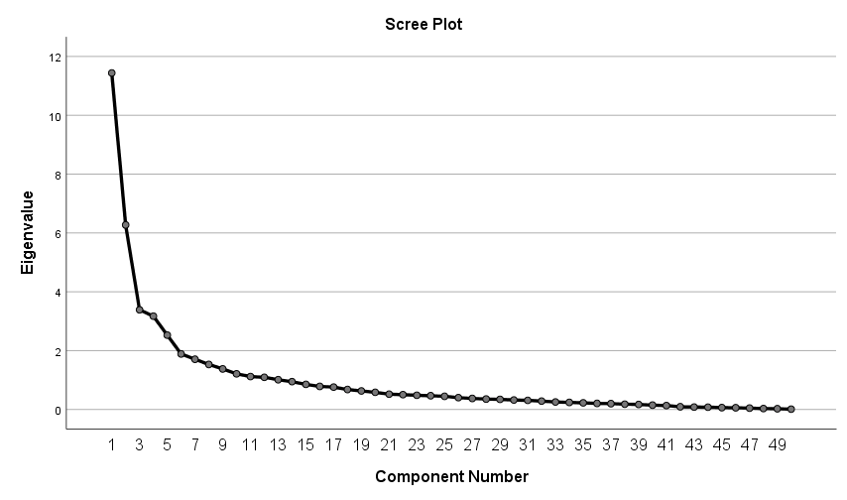

Supplementary Figure 2. Correlation heatmap based on Pearson correlation coefficient (Metaboanalyst software version 5.0).
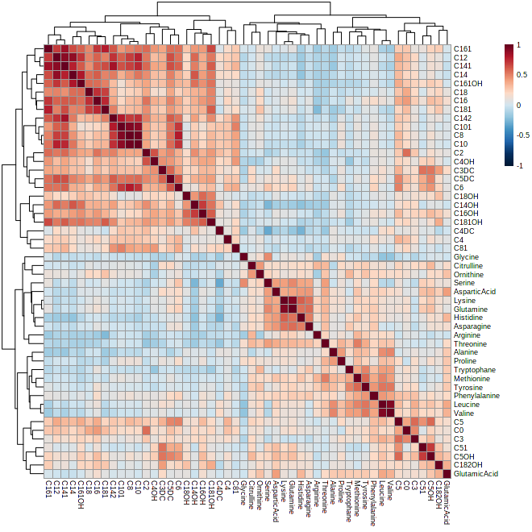
Metabolites with the most correlation coefficient:
Valine and leucine r = 0.923
Glutamine and lysine r = 0.922
C8 AND C10 r = 0.969
C8 AND C10:1 r = 0.924
C10 AND C10:1 r = 0.897
C12 AND C14 r = 0.885
C12 AND C14:1 r = 0.899
C14:1 AND C14:2 r = 0.83
Supplementary Table 4. Extracted factors based on PCA and loadings.
Factor 1 | Loading | Factor 3 | Loading | Factor 6 | Loading | Factor 10 | Loading
C8 | 0.94 | Tyrosine | 0.794 | C16OH | 0.767 | Alanine | 0.719
C10 | 0.936 | Leucine | 0.743 | C18OH | 0.749 | Proline | 0.719
C10:1 | 0.935 | Valine | 0.723 | C14OH | 0.702 | Factor 11 | Loading
C14:2 | 0.76 | Methionine | 0.721 | C18:1OH | 0.549 | C18:2OH | 0.711
C6 | 0.742 | Tryptophan | 0.679 | Factor 7 | Loading | Glutamic Acid | 0.588
C14:1 | 0.672 | Phenylalanine | 0.604 | C3 | 0.714 | Factor 12 | Loading
C12 | 0.659 | Factor 4 | Loading | C0 | 0.685 | Citrulline | 0.818
C5DC | 0.529 | Lysine | 0.865 | C4 | 0.528 | Ornithine | 0.591
C14 | 0.399 | Glutamine | 0.848 | Factor 8 | Loading | Factor 13 | Loading
Factor 2 | Loading | Asparagine | 0.785 | C4OH | 0.722 | Arginine | 0.83
C16 | 0.831 | Histidine | 0.751 | C2 | 0.629
C18:1 | 0.804 | Aspartic Acid | 0.544 | C8:1 | 0.62
C18 | 0.796 | Factor 5 | Loading | Factor 9 | Loading
C16:1 | 0.71 | C5:1 | 0.886 | Serine | 0.674
C14 | 0.688 | C5OH | 0.793 | Glycine | 0.63
C16:1OH | 0.687 | C3DC | 0.675 | Threonine | 0.344
 |  | C5 | 0.527 | C4DC | -0.624

Supplementary Table 5. Details of pathway analysis.
 | Metabolite Set | Total | Hits | Expect | P-value | FDR
﻿ | Aminoacyl-tRNA biosynthesis | 48 | 6 | 0.347 | 2.94E-7 | 2.47E-5
﻿ | Valine, leucine and isoleucine biosynthesis | 8 | 3 | 0.0578 | 1.54E-5 | 6.49E-4
﻿ | Glycine, serine and threonine metabolism | 33 | 2 | 0.239 | 0.0222 | 0.621
﻿ | Valine, leucine and isoleucine degradation | 40 | 2 | 0.289 | 0.0319 | 0.67
﻿ | Histidine metabolism | 16 | 1 | 0.116 | 0.11 | 1.0
﻿ | Pantothenate and CoA biosynthesis | 19 | 1 | 0.137 | 0.129 | 1.0
﻿ | Selenocompound metabolism | 20 | 1 | 0.145 | 0.136 | 1.0
﻿ | beta-Alanine metabolism | 21 | 1 | 0.152 | 0.142 | 1.0
﻿ | Alanine, aspartate and glutamate metabolism | 28 | 1 | 0.202 | 0.185 | 1.0
﻿ | Glutathione metabolism | 28 | 1 | 0.202 | 0.185 | 1.0
﻿ | Porphyrin and chlorophyll metabolism | 30 | 1 | 0.217 | 0.197 | 1.0
﻿ | Glyoxylate and dicarboxylate metabolism | 32 | 1 | 0.231 | 0.209 | 1.0
﻿ | Primary bile acid biosynthesis | 46 | 1 | 0.332 | 0.287 | 1.0
Hit: actually matched number from the data
FDR: P-value adjusted using False Discovery Rate

