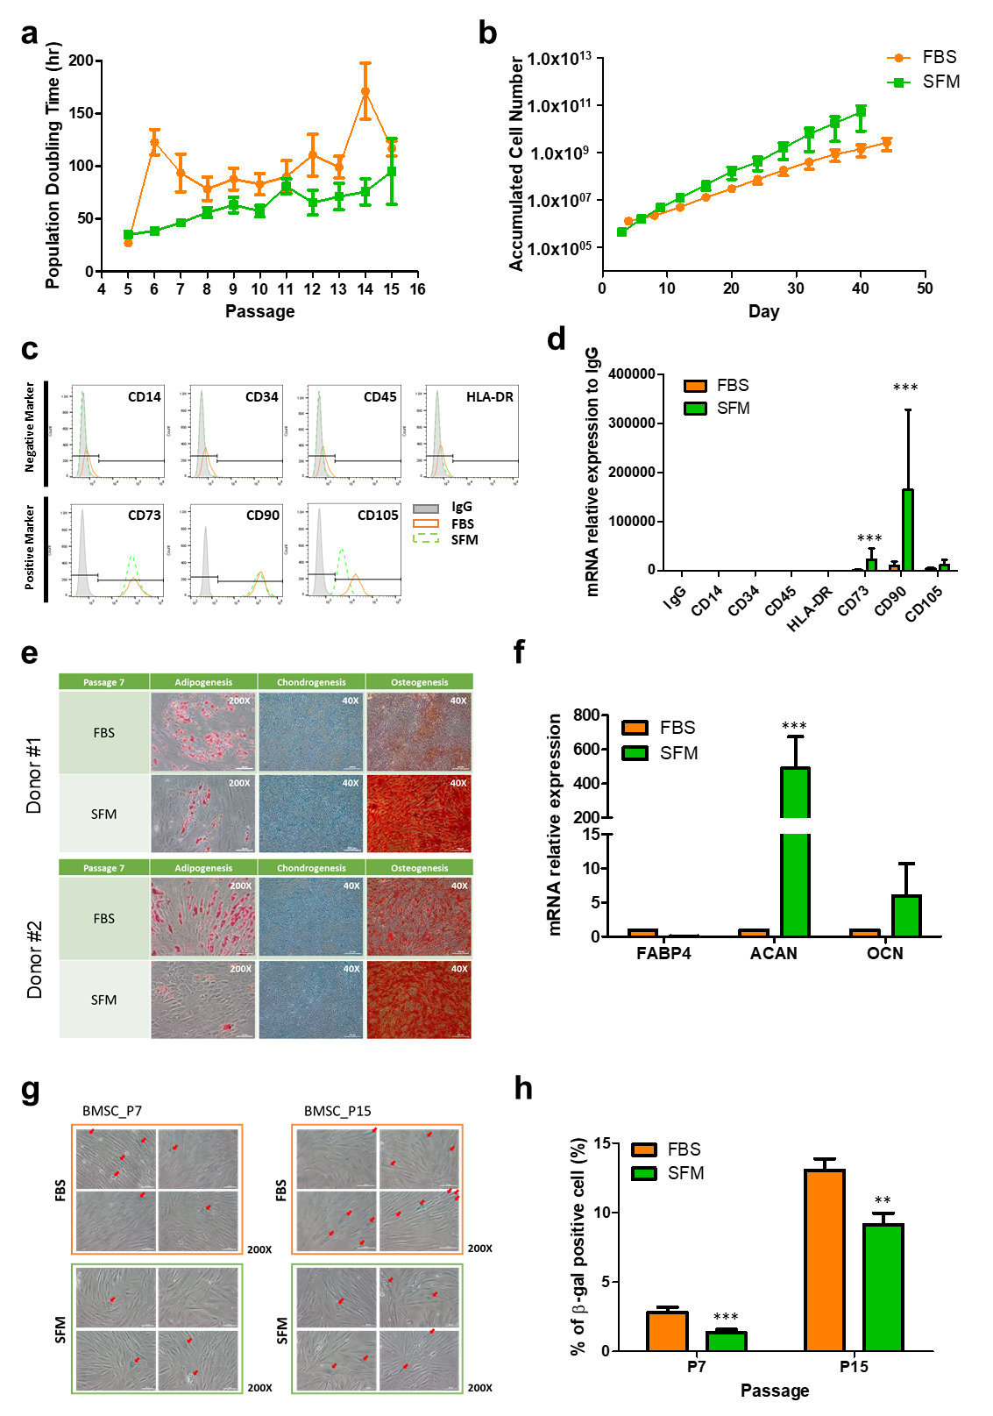
Supplementary Fig. 2 | Comparison of BMSC characteristics after cultivation in SFM and FBS containing media. Calculated a, PDT and b, ACN. BMSCs from three donors cultured in SFM showed the lower PDT across the entire passage than that in FBS. At P15, BMSCs cultured in SFM exhibited a higher increase in ACN compared to that in FBS. c, Flow cytometric analysis of expression of surface markers of cultured BMSCs. BMSCs were positive for CD73, CD90, and CD105 and negative for CD14, CD34, CD45, and HLA-DR in BMSCs cultured with both SFM and FBS. A representative image from ndependent experiments is shown. d, Expression of surface markers by qRT-PCR analysis of isolated total RNAs. The expression of CD73 and CD90 was significantly up-regulated in BMSCs cultivated in SFM. Multilineage differentiation potential of BMSCs cultured in FBS and SFM were examined. e, All BMSCs were induced toward differentiation into adipocytes (verified by Oil Red O), chondrocytes (verified by Alcian Blue), and osteocytes (verified by Alizarin Red S). A representative image is shown. f, qRT-PCR analysis of relative mRNA expression levels of FABP4, ACAN, and OCN. ACAN expression was significantly up-regulated in BMSCs cultured in SFM. g, Cellular senescence. BMSCs at P7 and P15 were seeded and cultured for 24h, then stained for senescence-associated β-galactosidase activity. Red arrows indicate β-galactosidase positive cell; h, β-galactosidase positive cells were counted and presented as a percentage. Data represent the mean ± SEM * vs. corresponding passage FBS containing media. * p < 0.05, *** p <0.001. BMSC, bone marrow-derived stem cell; SFM, serum-free media; FBS, fetal bovine serum, PDT, population doubling time; ACN, accumulated cell number; BMSCs, bone marrow derived stem cells; FABP4, fatty acid binding protein 4; ACAN, aggrecan; OCN, osteocalcin.

