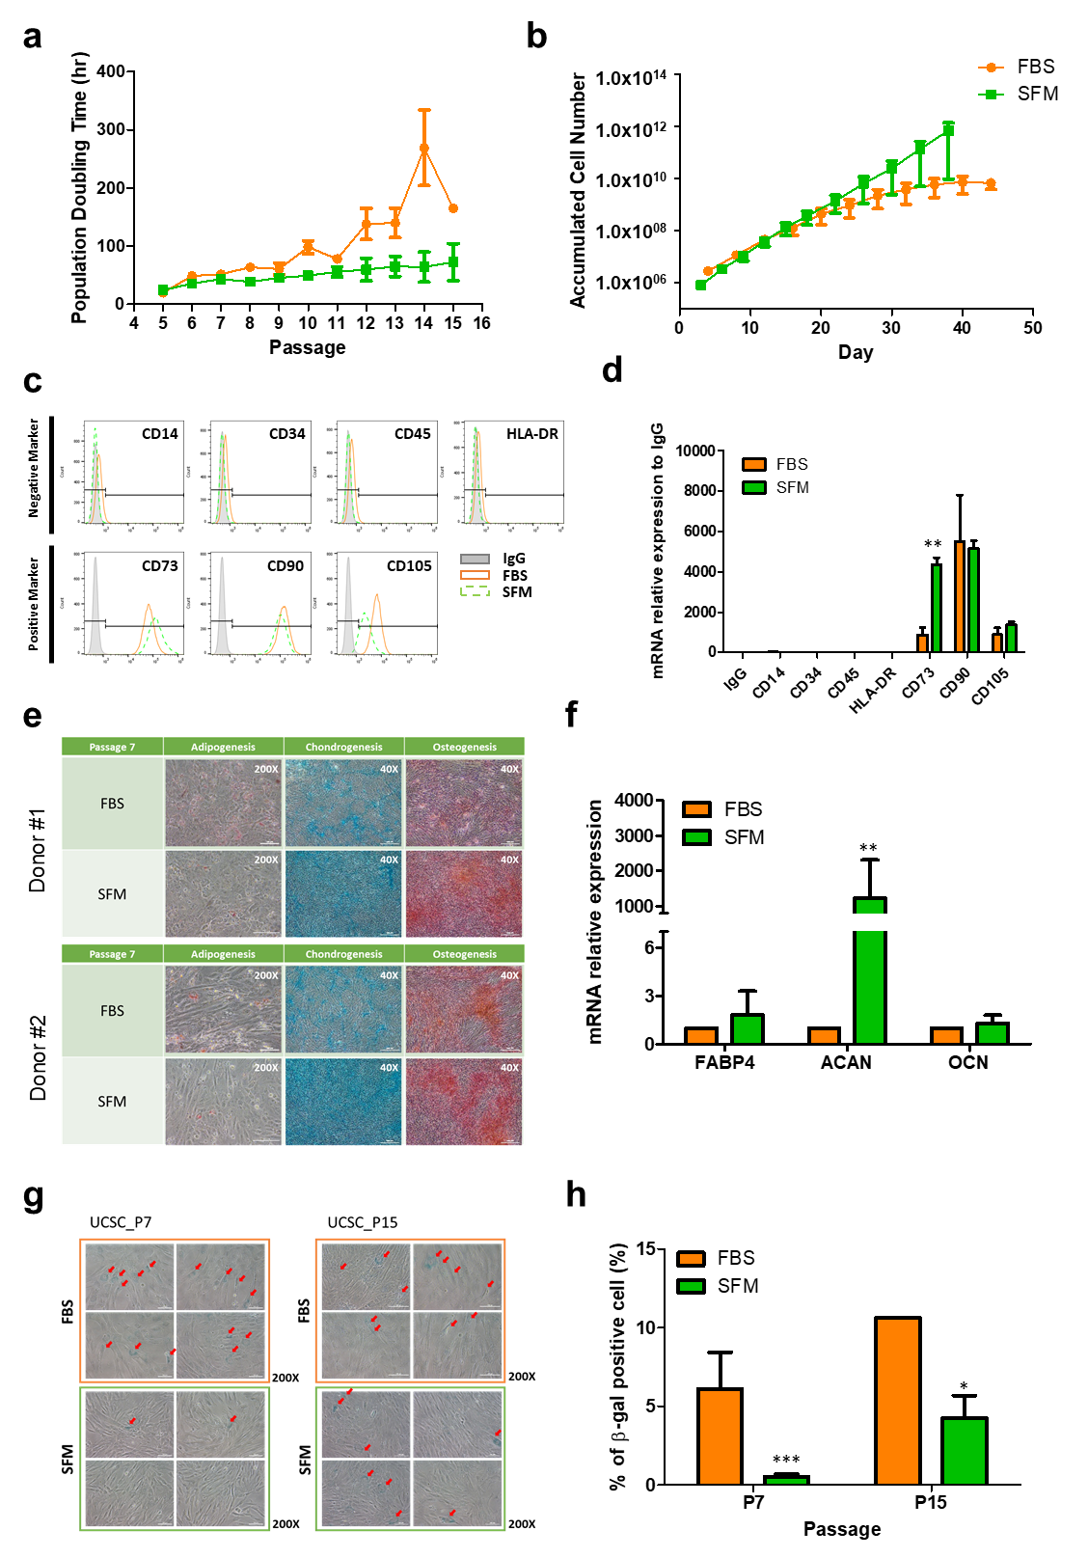
Supplementary Fig. 3 | Comparison of UCSC characteristics after cultivation in SFM and FBS containing media. Calculated a, PDT and b, ACN. UCSCs from three donors cultured with SFM showed the lower PDT across the entire passage compare to that in FBS. At P15, UCSCs cultured in SFM exhibited a higher ACN increase than that in FBS. c, Flow cytometric analysis of expression of surface markers of cultured UCSCs. UCSCs were positive for CD73, CD90, and CD105 and negative for CD14, CD34, CD45 in both media. A representative image from experiments is shown. d, Expression of surface markers by qRT-PCR analysis of isolated total RNAs. CD73 expression was significantly up-regulated in UCSCs cultured in SFM. Multilineage differentiation potential of UCSCs. e, All UCSCs were induced toward differentiation into adipocytes (verified by Oil Red O), chondrocytes (verified by Alcian Blue), and osteocytes (verified by Alizarin Red S). A representative image is shown. f, qRT-PCR analysis of relative mRNA expression levels of FABP4, ACAN, and OCN. ACAN expression was significantly up-regulated in UCSCs cultured in SFM. g, Cellular senescence of UCSCs. UCSCs at P7 and P15 were seeded and cultured for 24 h, then stained for senescence-associated β-galactosidase activity. Red arrows indicate β-galactosidase-positive cells; h, β-galactosidase-positive cells were counted and presented as a percentage. Data represent the mean ± SEM * vs. corresponding passage FBS containing media. * p < 0.05, *** p < 0.001. UCSC, umbilical cord derived stem cell; SFM, serum free media; FBS, fetal bovine serum; PDT, population doubling time; ACN, accumulated cell number; FABP4, fatty acid binding protein 4; ACAN, aggrecan; OCN, osteocalcin.

