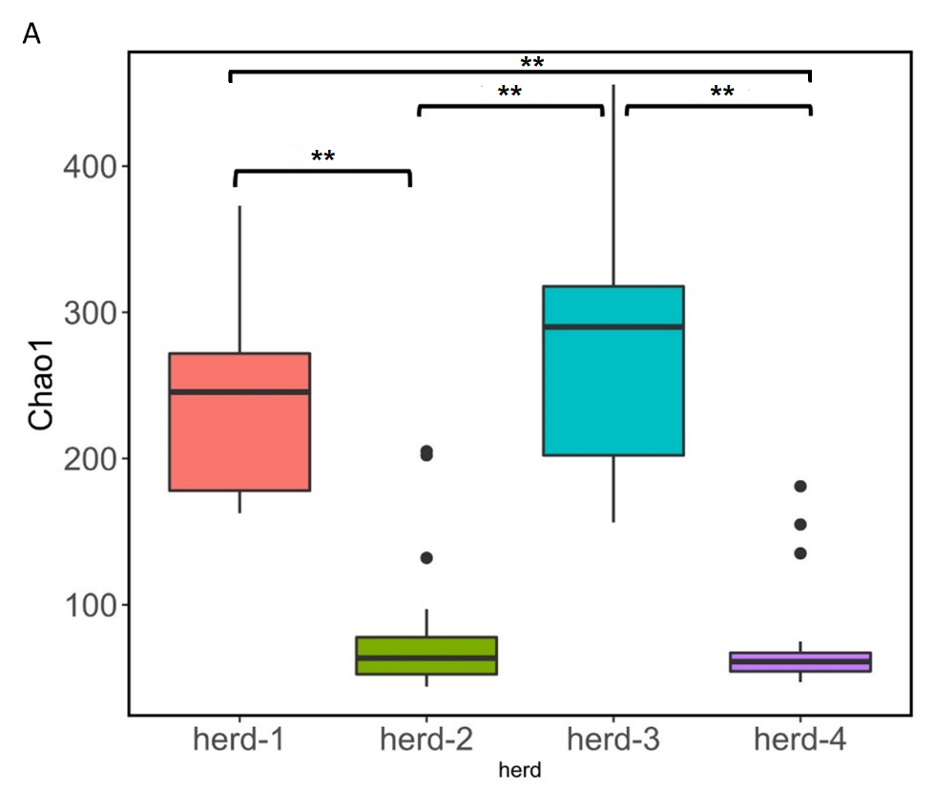
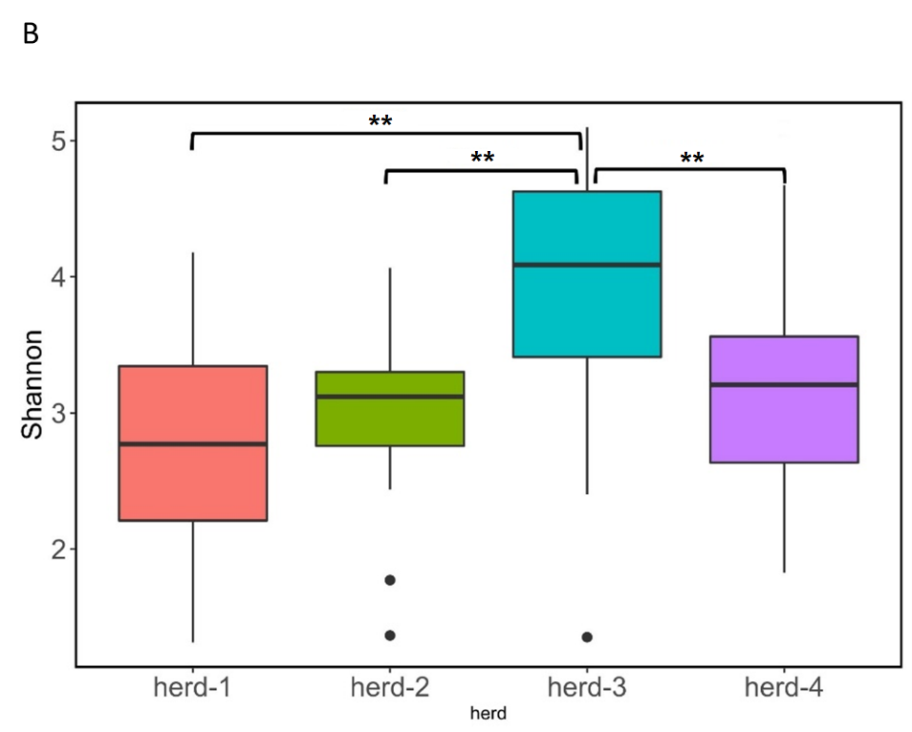

Figure S1: Alpha diversity box-plots for (A) Chao1 and (B) Shannon indices for the four herds from sows where sows were sampled. ** Indicates significant differences between herds (Kruskal-Wallis test, p < 0.01).
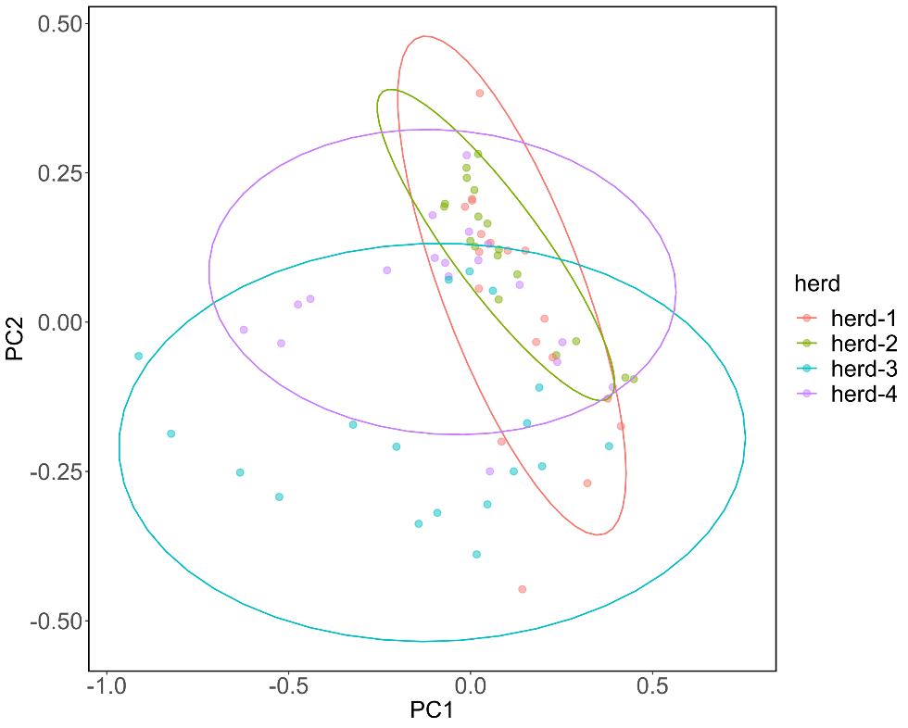

Figure S2: Weighted UniFrac Principal Coordinates Analysis (PCoA) between herds. Herd-1 and herd-2 were not different from each other, but differences were observed between herd-1 vs. herd-3; herd-1 vs. herd-4; herd-2 vs. herd-3; herd-2 vs. herd-4 and herd-3 vs. herd-4 (PERMANOVA, p < 0.05; q < 0.05)
Table S1: Fisher’s Exact Test p-value between herds for the main agents and between VD vs. HE sows for MALDI-TOF identification data.
Agent | Fisher’s Exact Test p-value between herds | Fisher’s Exact Test p-value between VD and HE sows
Streptococcus suis | 0.76 | 0.05
Staphylococcus hyicus | 0.27 | 0.09
Streptococcus dysgalactiae | 0.81 | 0.09
Escherichia coli | 0.30 | 0.06
Enterococcus faecalis | 0.42 | 0.02
Rothia nasimurium | 0.45 | 0.18
Streptococcus hyovaginalis | 0.09 | 0.04
Acinetobacter lwolffii | - | 0.04

