Supplementary data

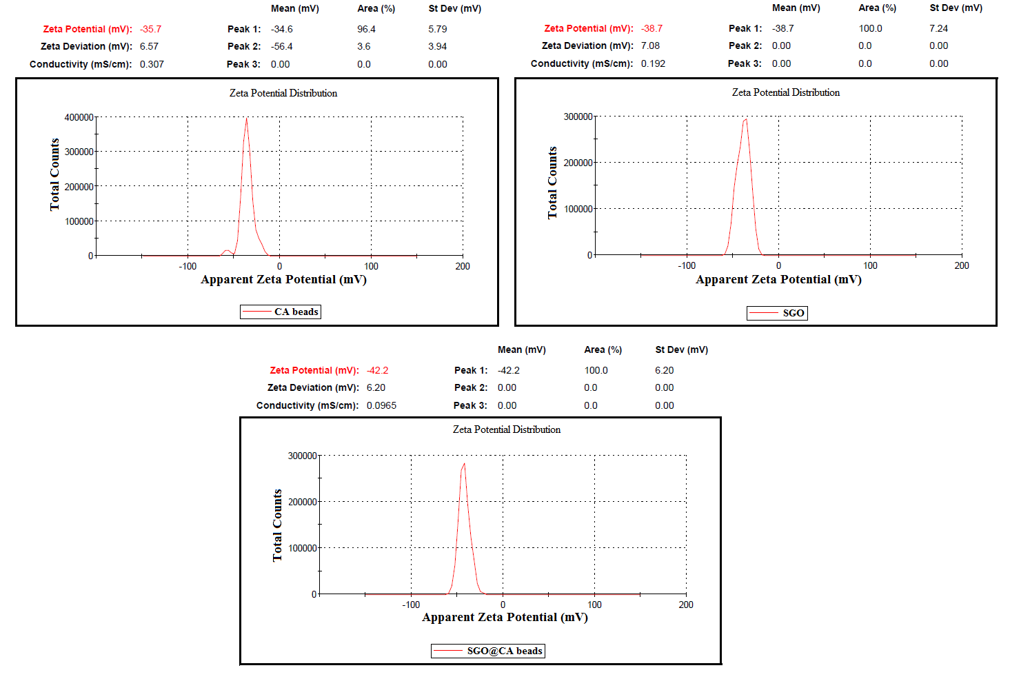
Fig. S1. ZP measurements of CA beads, SGO and SGO@CA composite beads.

(A) | (B)
Fig. S2. The linear isotherm model of (A) Temkin and (b) D-R for the MB dye adsorption onto SGO@CA composite beads.

Table S1: Variables affecting MB adsorption capacity process and tested levels for Plackett-Burman experiment.
Variable | Variable code | Low level (-1) | High level (+1)
Time (min) | X1 | 10 | 30
pH | X2 | 3 | 11
Adsorbent dose (g) | X3 | 0.005 | 0.025
Temperature (ºC) | X4 | 25 | 55
Initial dye concentration (g/L) | X5 | 50 | 300

Table S2: Randomized Plackett-Burman experimental design for evaluating factors affecting dye adsorption capacity using SGO@CA composite beads.
Trial | Time | pH | Adsorbent dose (g) | Temperature (ºC) | Initial dye concentration (mg/L) | Adsorption capacity (mg/g)
1 | 1 | 1 | 1 | 1 | -1 | 46.6
2 | -1 | 1 | -1 | 1 | -1 | 29.6
3 | 1 | -1 | -1 | -1 | -1 | 117.4
4 | 1 | -1 | 1 | -1 | -1 | 55.9
5 | 1 | 1 | -1 | -1 | 1 | 286.1
6 | -1 | -1 | 1 | 1 | -1 | 49.8
7 | -1 | 1 | 1 | -1 | 1 | 143.3
8 | -1 | -1 | 1 | -1 | 1 | 136
9 | -1 | 1 | -1 | -1 | -1 | 96.6
10 | 1 | 1 | 1 | 1 | 1 | 146.7
11 | -1 | -1 | -1 | 1 | 1 | 235.3
12 | 1 | -1 | -1 | 1 | 1 | 285

Table S3: The levels of variables chosen for the Box–Behnken optimization experiments for the adsorption of MB dye by SGO@CA composite beads.
Variable | Variable code | -1 | 0 | +1
Time (min) | X1 | 3 | 10 | 30
pH | X2 | 3 | 7 | 11
Adsorbent dose | X3 | 0.005 | 0.01 | 0.025
Initial dye concentration (mg/L) | X4 | 50 | 100 | 300
Table S4: Box–Behnken factorial experimental design, representing the response of dye adsorption capacity (mg/g) as influenced by time, pH, adsorbent dose and initial MB concentration for SGO@CA composite beads.
Trial | X₁ | X₂ | X₃ | X₄ | Adsorption capacity (mg/g)
 |  |  |  |  | Measured | Predicted | Accuracy (%)
1 | +1 | 0 | 0 | -1 | 240.3 | 245.7 | 97.8
2 | 0 | 0 | +1 | -1 | 55.9 | 49.7 | 112.3
3 | 0 | +1 | +1 | 0 | 125.6 | 129.4 | 96.9
4 | 0 | +1 | -1 | 0 | 173 | 181.4 | 95.3
5 | -1 | -1 | 0 | 0 | 122.1 | 114.7 | 106.4
6 | -1 | 0 | +1 | 0 | 103.4 | 102.7 | 100.6
7 | +1 | 0 | +1 | 0 | 142.7 | 142.7 | 99.9
8 | -1 | +1 | 0 | 0 | 135.5 | 136.3 | 99.4
9 | +1 | +1 | 0 | 0 | 174 | 174.2 | 99.8
10 | 0 | 0 | 0 | 0 | 152.1 | 152.1 | 100
11 | 0 | 0 | 0 | 0 | 152.1 | 152.1 | 100
12 | 0 | +1 | 0 | +1 | 223.6 | 211.5 | 105.6
13 | 0 | -1 | -1 | 0 | 172.3 | 177.2 | 97.1
14 | +1 | 0 | -1 | 0 | 211.1 | 210.0 | 100.4
15 | +1 | -1 | 0 | 0 | 168.5 | 160.5 | 104.9
16 | 0 | 0 | -1 | +1 | 249.9 | 248.8 | 100.4
17 | 0 | 0 | +1 | +1 | 177.2 | 179.6 | 98.6
18 | 0 | -1 | 0 | +1 | 199.3 | 198.9 | 100.1
19 | -1 | 0 | 0 | -1 | 66.7 | 70.1 | 95.0
20 | -1 | 0 | -1 | 0 | 168.1 | 166.3 | 101.0
21 | 0 | 0 | -1 | -1 | 121 | 111.4 | 108.6
22 | +1 | 0 | 0 | -1 | 87.3 | 90.5 | 96.3
23 | 0 | +1 | 0 | -1 | 84.3 | 82.9 | 101.6
24 | -1 | 0 | 0 | 1 | 176.8 | 182.3 | 96.9
25 | 0 | -1 | +1 | 0 | 98 | 98.3 | 99.6
26 | 0 | -1 | 0 | -1 | 49.9 | 60.2 | 82.8
27 | 0 | 0 | 0 | 0 | 152.1 | 152.1 | 100

Table S5: Values of estimated regression coefficient and corresponding t-and P-value.
 | Coefficients | Standard Error | t Stat | P-value
Intercept | 152.1379 | 4.437377 | 34.28556 | 2.41E-13
X1 | 20.94488 | 2.218688 | 9.440206 | 6.65E-07
X2 | 8.825 | 2.218688 | 3.977575 | 0.001834
X3 | -32.7167 | 2.218688 | -14.7459 | 4.72E-09
X4 | 66.83654 | 2.218688 | 30.12435 | 1.12E-12
X1X2 | -1.975 | 3.842881 | -0.51394 | 0.616628
X1X3 | -0.925 | 3.842881 | -0.2407 | 0.813847
X1X4 | 10.73463 | 3.842881 | 2.79338 | 0.016242
X2X3 | 6.725 | 3.842881 | 1.749989 | 0.105621
X2X4 | -2.525 | 3.842881 | -0.65706 | 0.523545
X3X4 | -1.9 | 3.842881 | -0.49442 | 0.629936
X1X1 | 1.559243 | 3.328033 | 0.468518 | 0.64781
X2X2 | -7.24557 | 3.328033 | -2.17713 | 0.050151
X3X3 | 1.76693 | 3.328033 | 0.530923 | 0.605159
X4X4 | -6.47826 | 3.328033 | -1.94657 | 0.075377

Table S6: Data of Intra-particle diffusion kinetic model for the MB dye adsorption onto SGO@CA composite beads.
C₀(mg/l) | Intra-particle diffusion kinetic model
C₀(mg/l) | First step  C K R² |  |  | Second step  C K R²
50 | 40.828 | 14.341 | 0.9201 | 71.088 | 3.4821 | 0.8184
100 | 96.078 | 19.193 | 0.8753 | 107.57 | 14.699 | 0.8756
200 | 56.636 | 48.563 | 0.9894 | 177.6 | 5.952 | 0.9803
300 | 128.52 | 27.687 | 0.9965 | 168.31 | 16.204 | 0.9957

Table S7: Thermodynamic parameters for the adsorption of MB dye onto SGO@CA composite beads.
T(K) | ΔGº | ΔHº | ΔSº
T(K) | (KJ/mol) | (KJ/mol) | (J/mol.K)
298 | -28.22 | +3.059 | +94.716
308 | -29.17 | +3.059 | +94.716
318 | -30.117 | +3.059 | +94.716

