Supplementary information
Manuscript:
Preparation and application of Chikungunya pseudovirus containing double reporter genes
Chunyan Su¹, Kaiyun Ding¹, Jingwen Xu¹, Jianchao Wu¹, Jiansheng Liu¹, Jiayuan Shen², Hongning Zhou², Hongqi Liu^{1, *}
¹Institute of Medical Biology, Chinese Academy of Medical Sciences and Peking Union Medical College, Kunming, 650118, China; ²Yunnan Provincial Key Laboratory of Vector-borne Diseases Control and Research, Yunnan Institute of Parasitic Diseases, Simao Pu’ er, Yunnan 665000, China
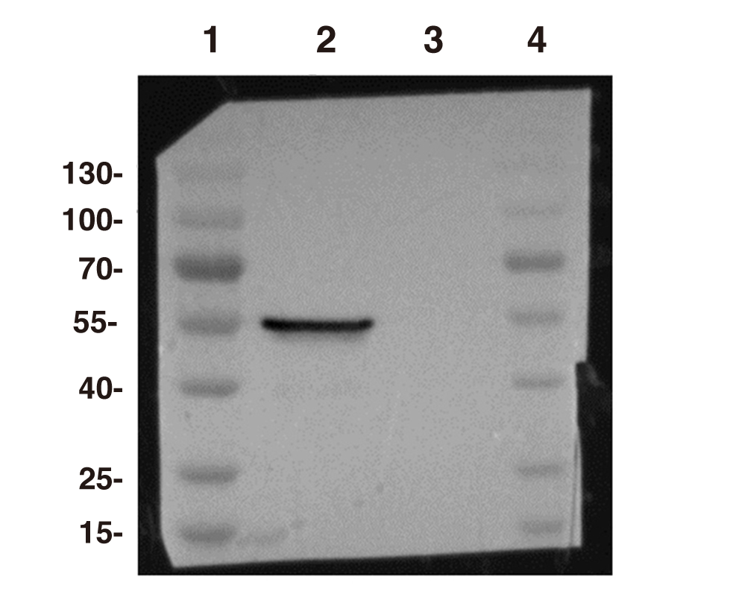
Figure S1. Production of CHIKV pseudovirus (PsV). The PsV particles concentrated by ultracentrifugation were analyzed by Western blotting using mouse Monoclonal antibody against E1. 1: 180 kDa protein marker; 2: the lysate of CHIKV PsVs; 3: the lysate of VSV-G PsVs.

