Title | Development of a DNA barcode library of plants in the Thai Herbal Pharmacopoeia and Monographs for authentication of herbal products.
Authors | Santhosh Kumar J. Urumarudappa^{1,2} , Chayapol Tungphatthong^{1,2} , Jirayut Jaipaew^{1,2}, Natapol Pornputtapong^{1,3}, Duangkamol Pakdeesattayapong⁴, Sornkanok Vimolmangkang² and Suchada Sukrong^{1,2,*}
Affiliation | ¹ Center of Excellence in DNA Barcoding of Thai Medicinal Plants, Chulalongkorn University, Bangkok 10330, Thailand
Affiliation | ² Department of Pharmacognosy and Pharmaceutical Botany, Faculty of Pharmaceutical Sciences, Chulalongkorn University, Bangkok 10330, Thailand
Affiliation | ³ Department of Biochemistry and Microbiology, Faculty of Pharmaceutical Sciences, Chulalongkorn University, Bangkok 10330, Thailand
Affiliation | ⁴ Herbal Products Division, Food and Drug Administration. Ministry of Public Health, Bangkok 11000, Thailand
*Corresponding author | Professor Suchada Sukrong, Ph.D.
*Corresponding author | Center of Excellence in DNA Barcoding of Thai Medicinal Plants,
*Corresponding author | Department of Pharmacognosy and Pharmaceutical Botany,
*Corresponding author | Faculty of Pharmaceutical Sciences, Chulalongkorn University,
*Corresponding author | Bangkok 10330, Thailand
*Corresponding author | Phone: +6681-819-6742, Fax: +6622-558-227
*Corresponding author | Email: suchada.su@chula.ac.th

Table. S3: Nucleotide BLAST results from the 20 herbal samples.
1_Bacopa monnieri

ITS
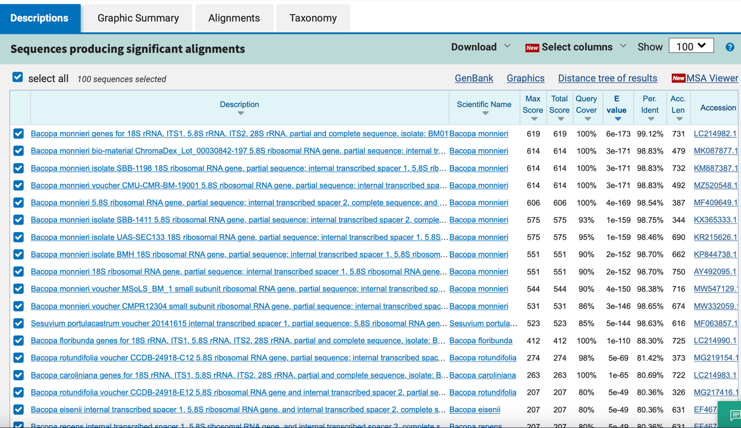

matK
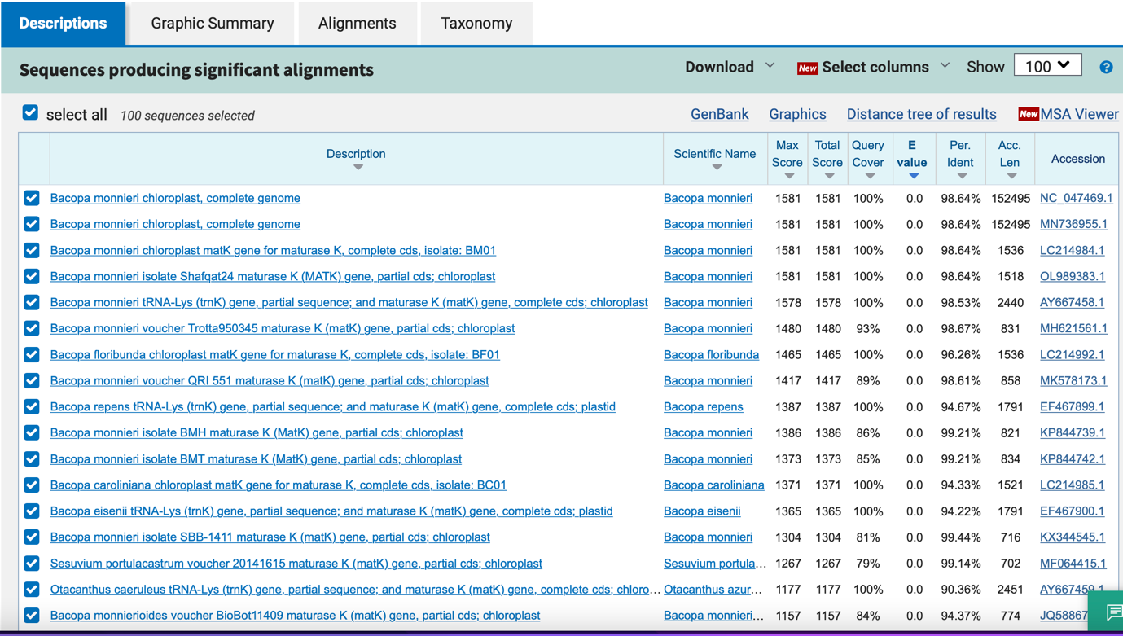

psbA_trnH
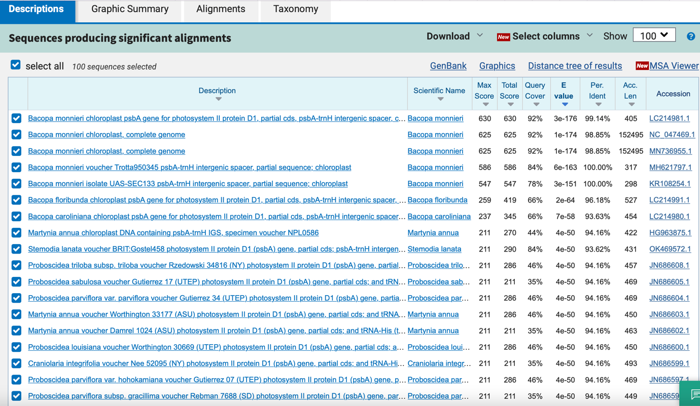

rbcL
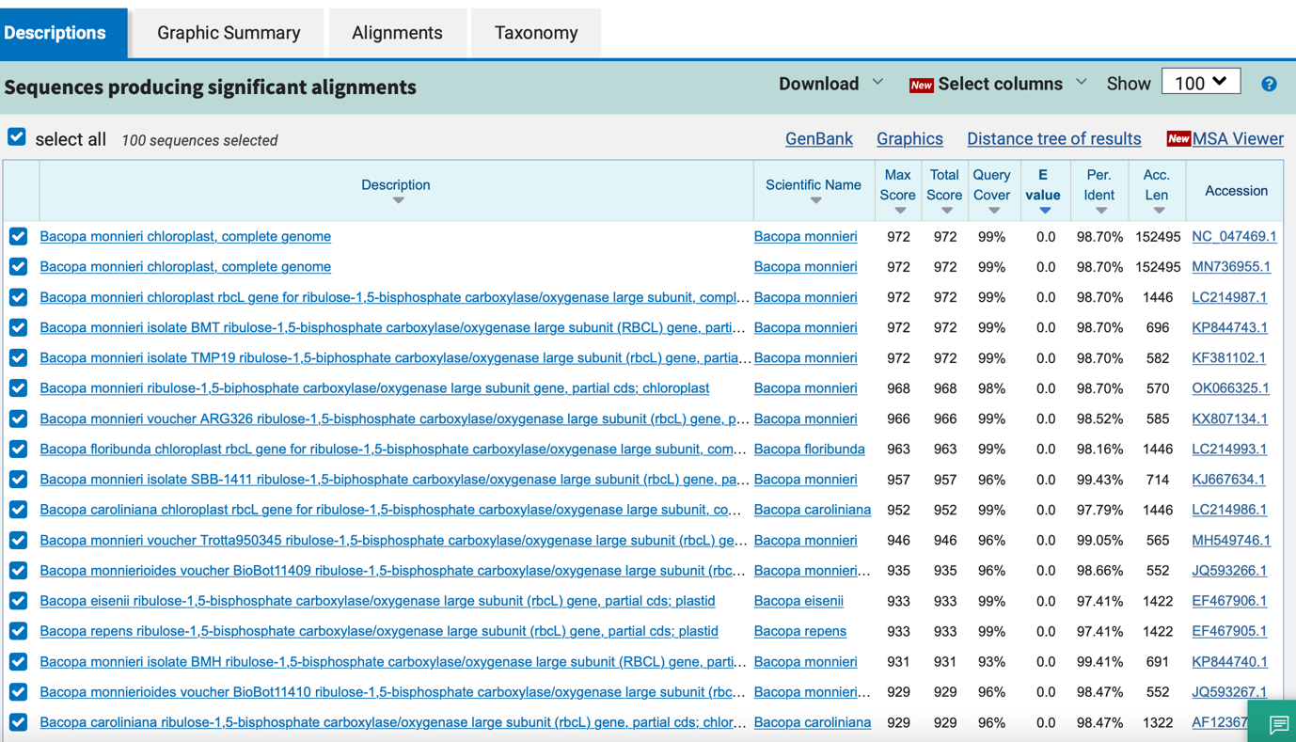

2_ Aristolochia pierrei

ITS
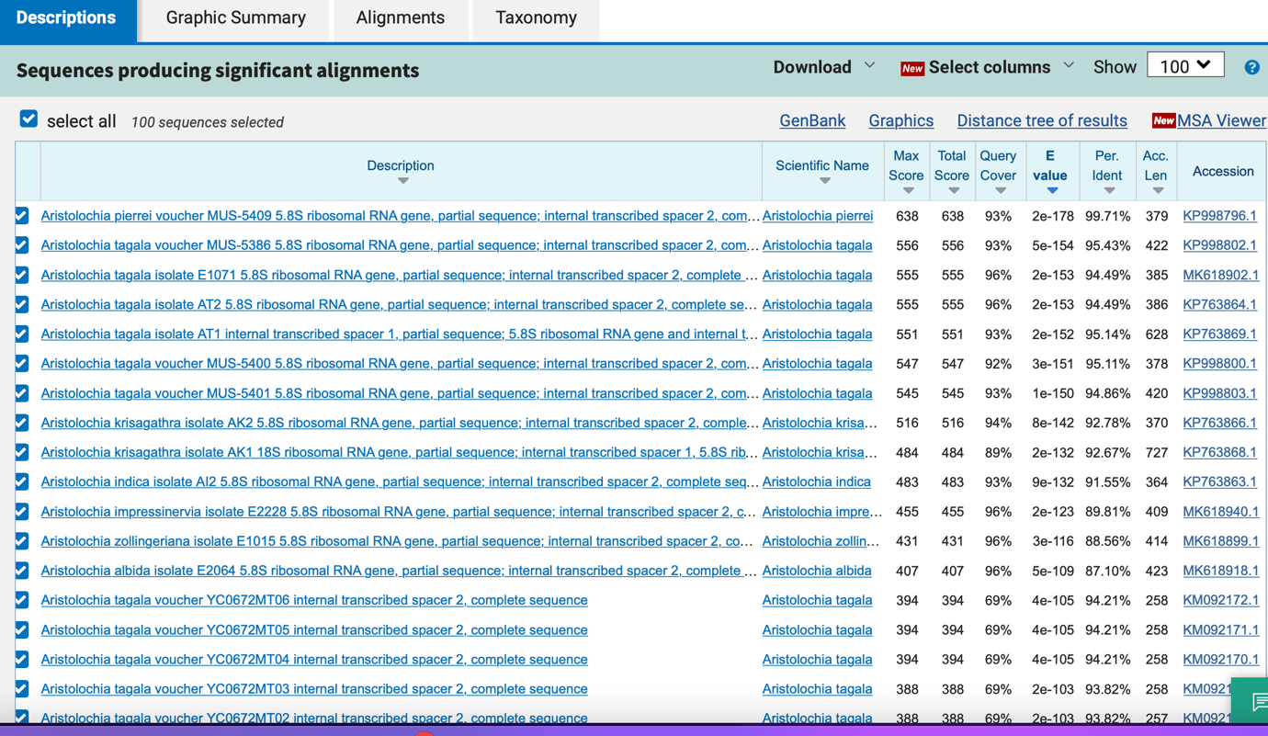

matK
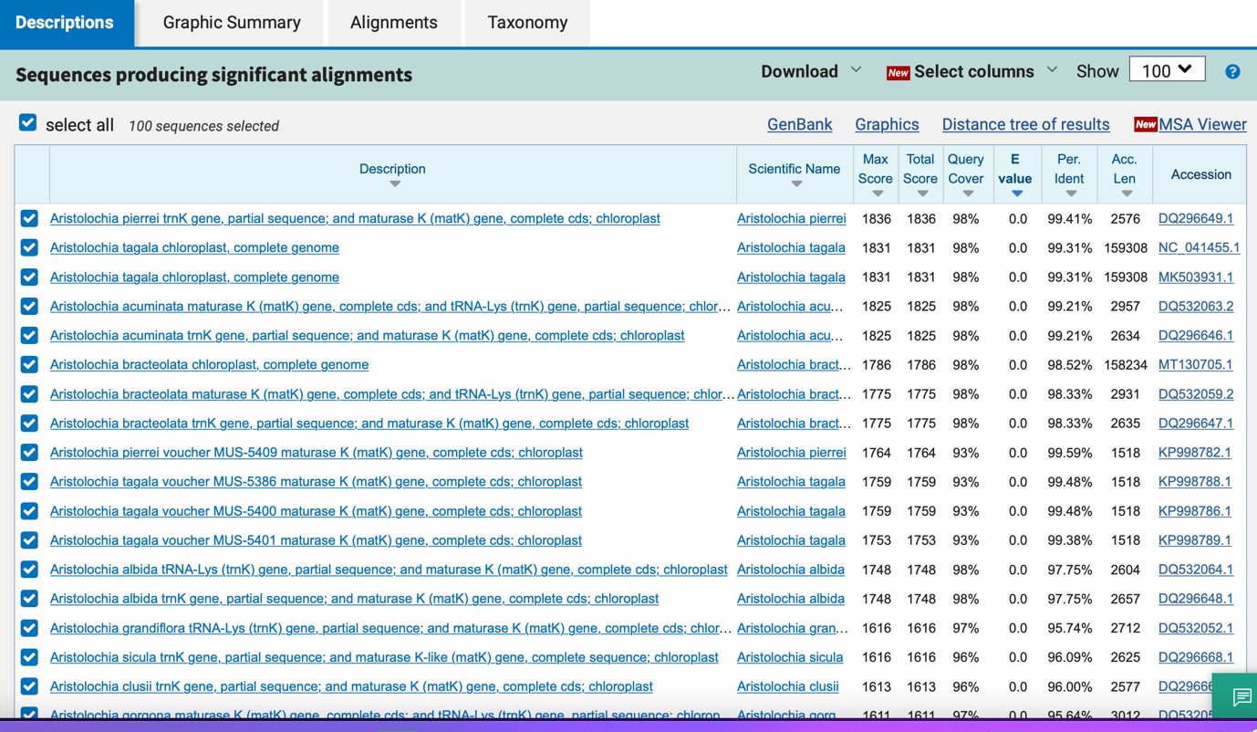

psbA_trnH
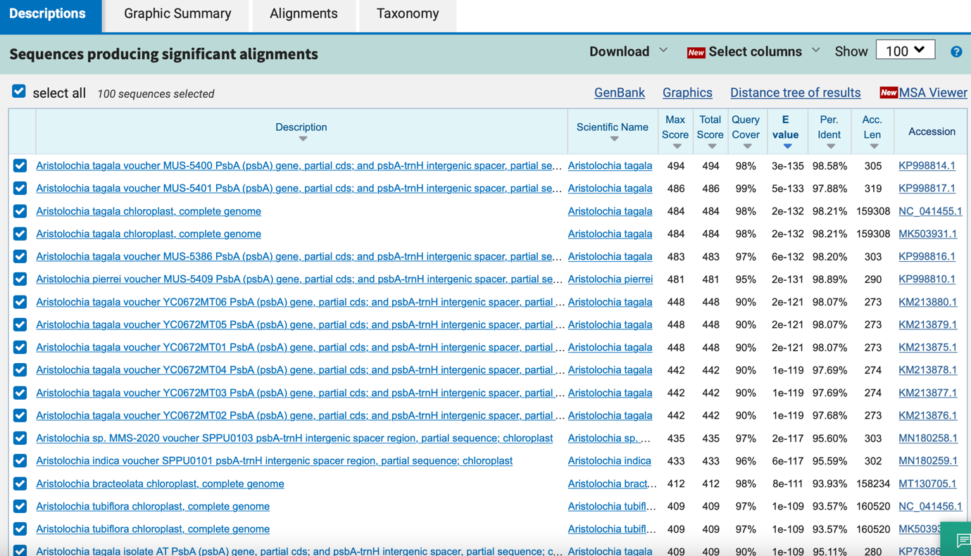

rbcL
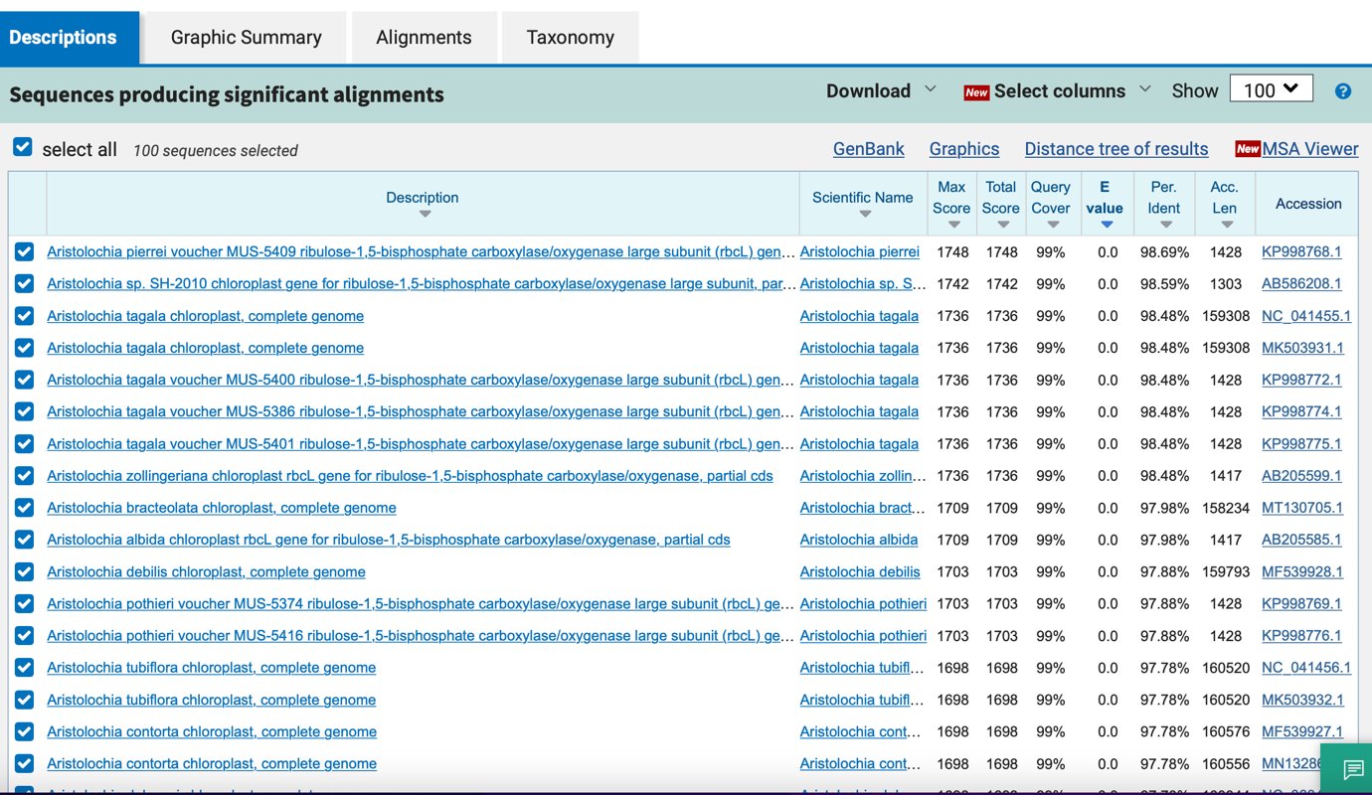

3_Cyanthillium cinereum

ITS

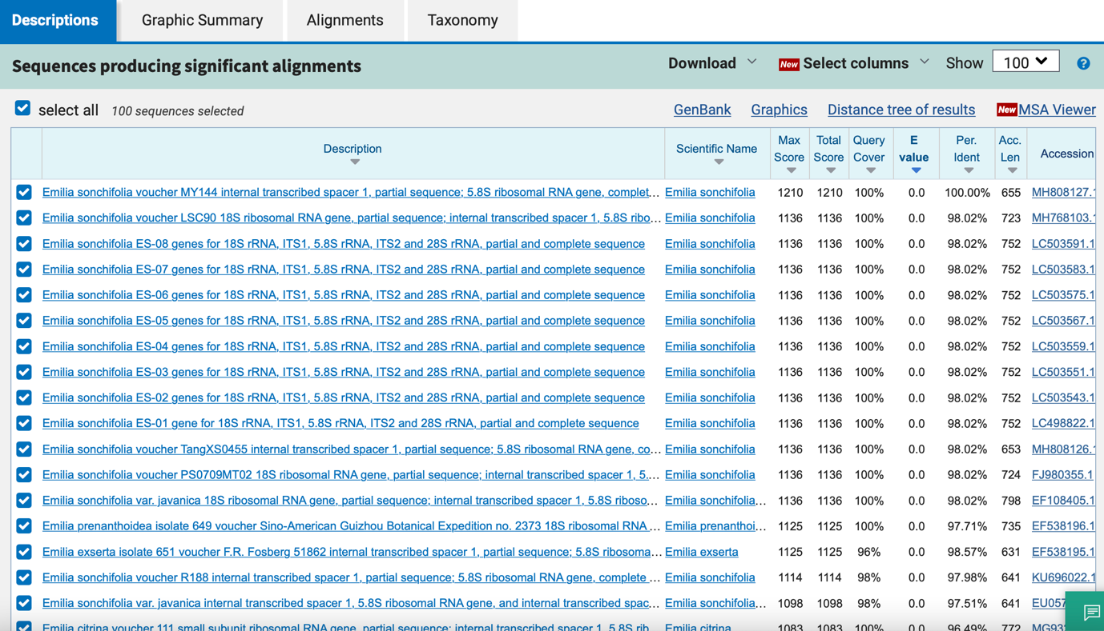

matK

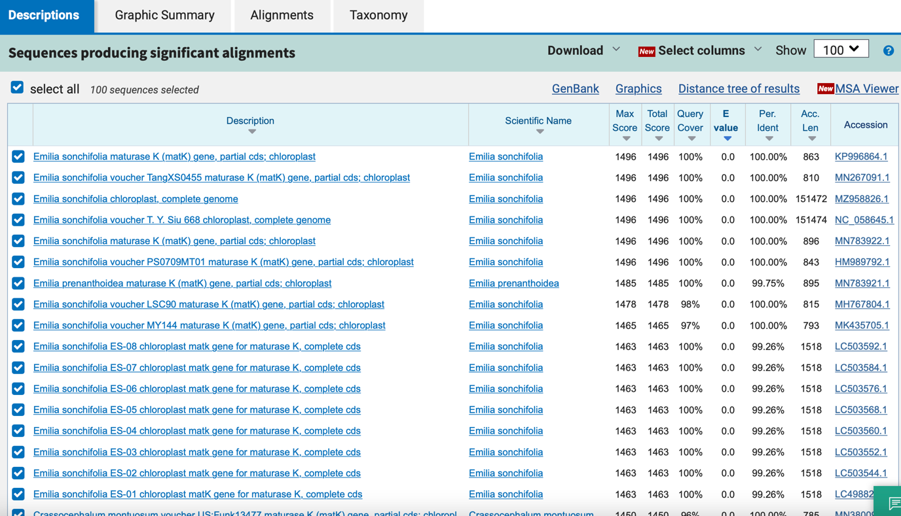

psbA_trnH

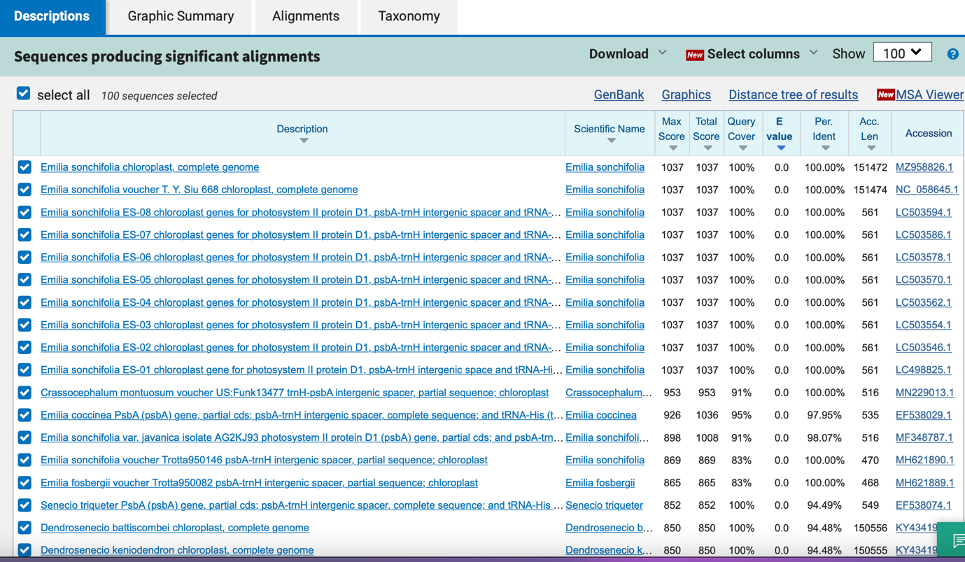

rbcL

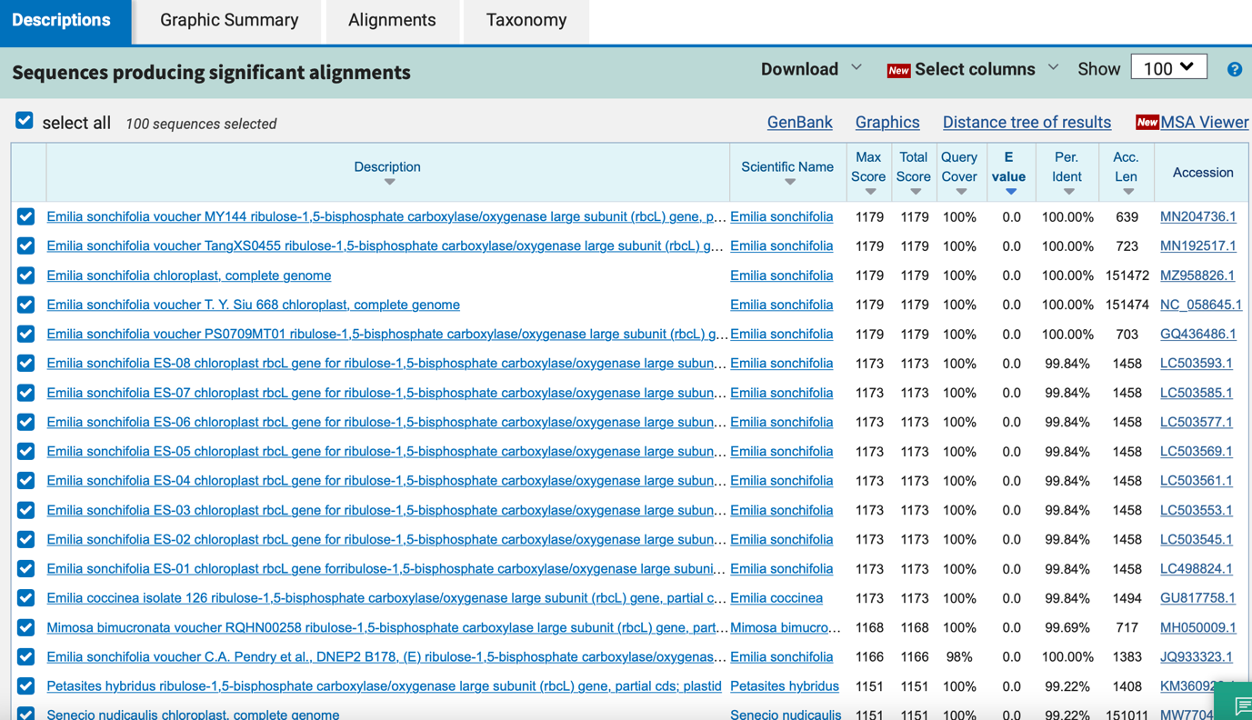

4_ Thunbergia laurifolia

ITS
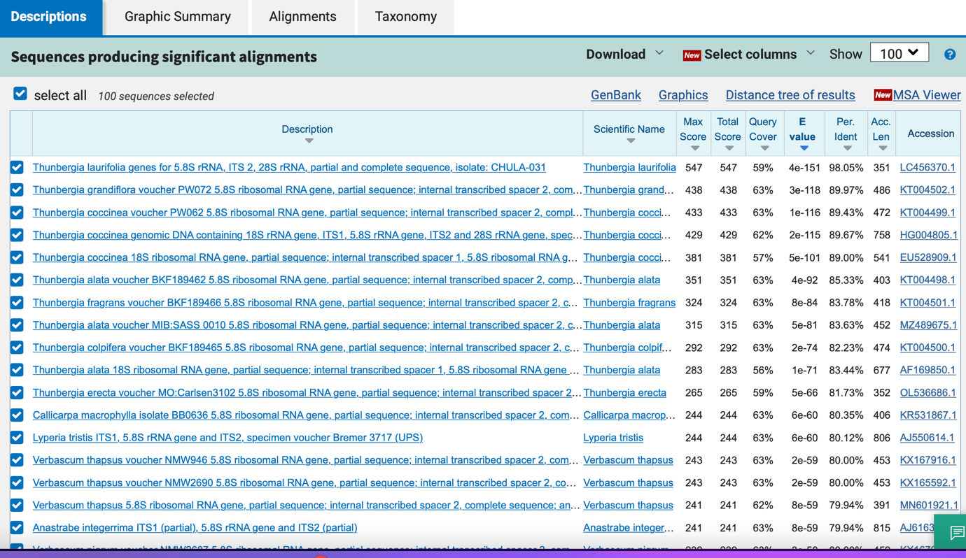

matK
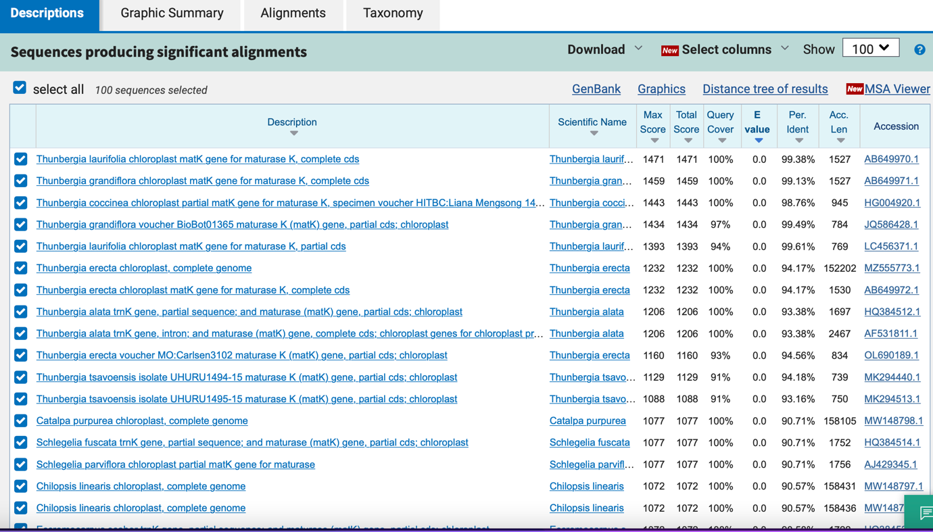

psbA_trnH
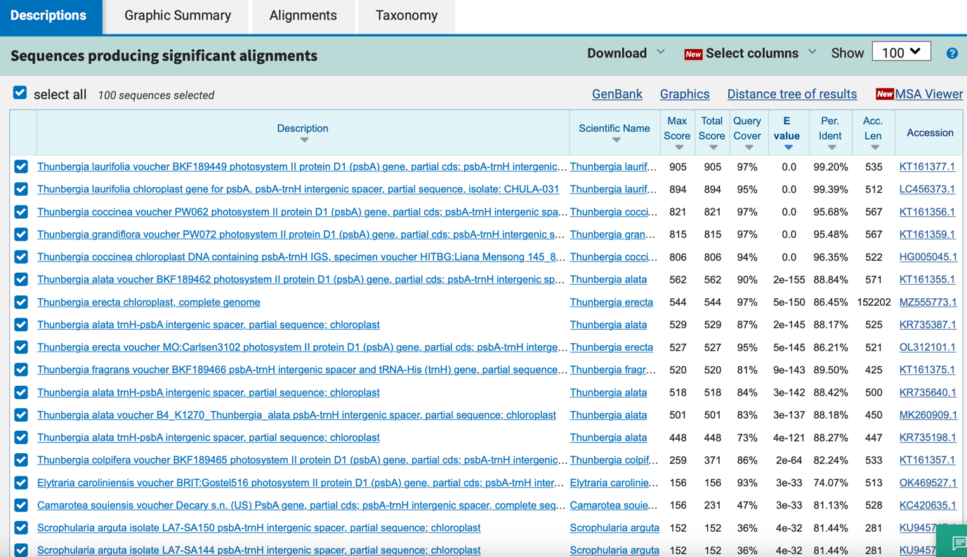

rbcL
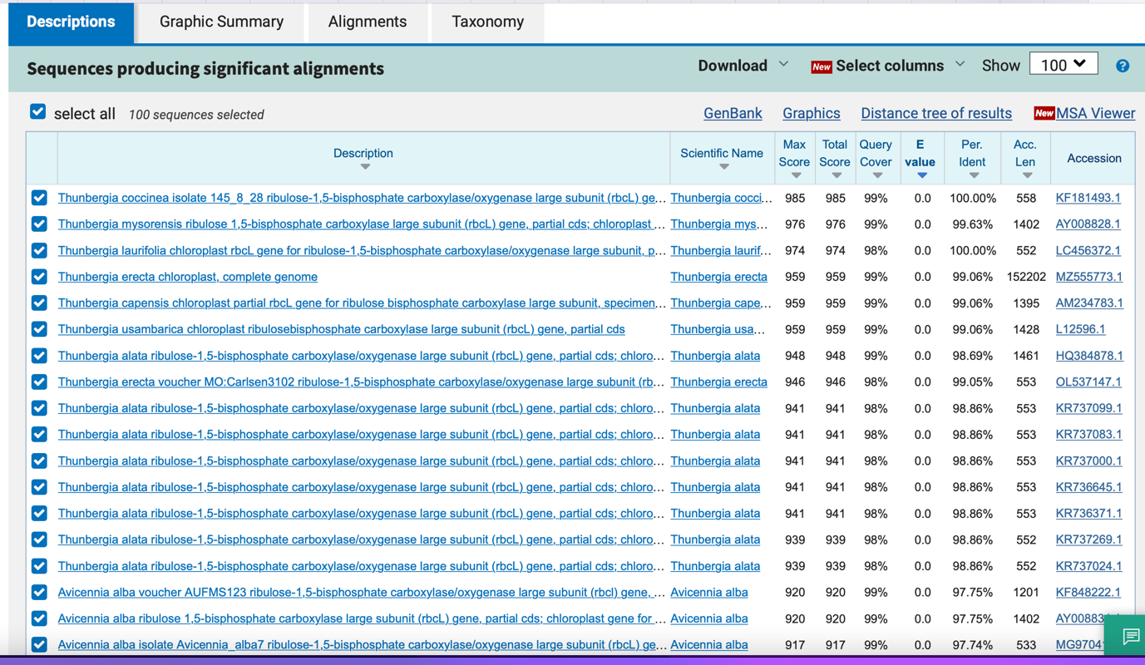

5_ Phyllanthus emblica

ITS
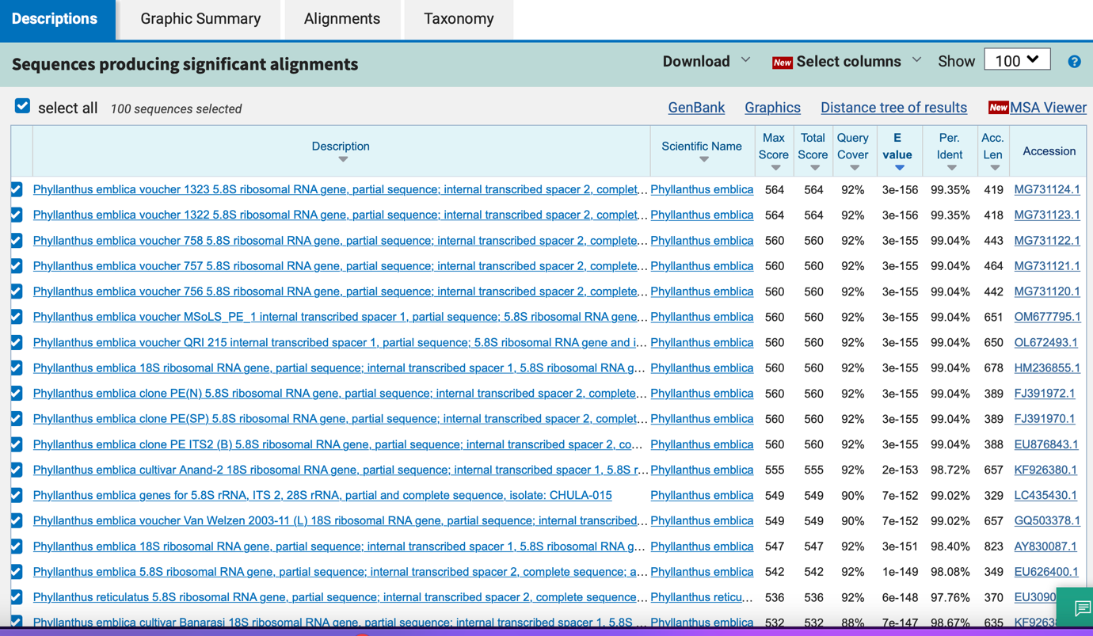

matK
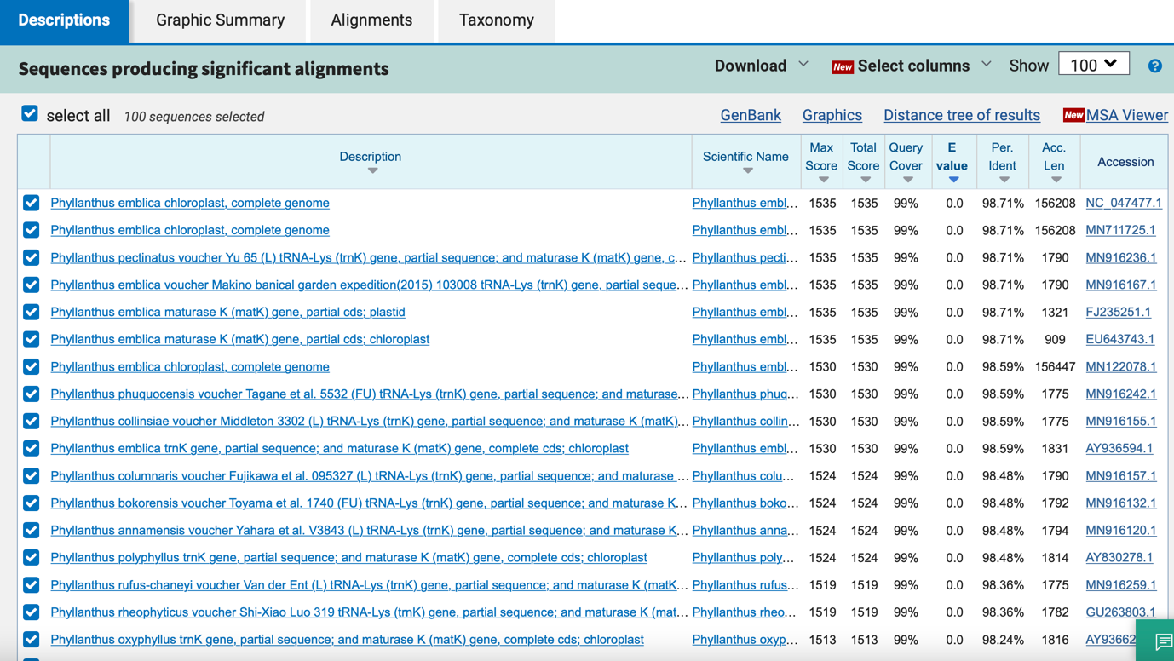

psbA_trnH
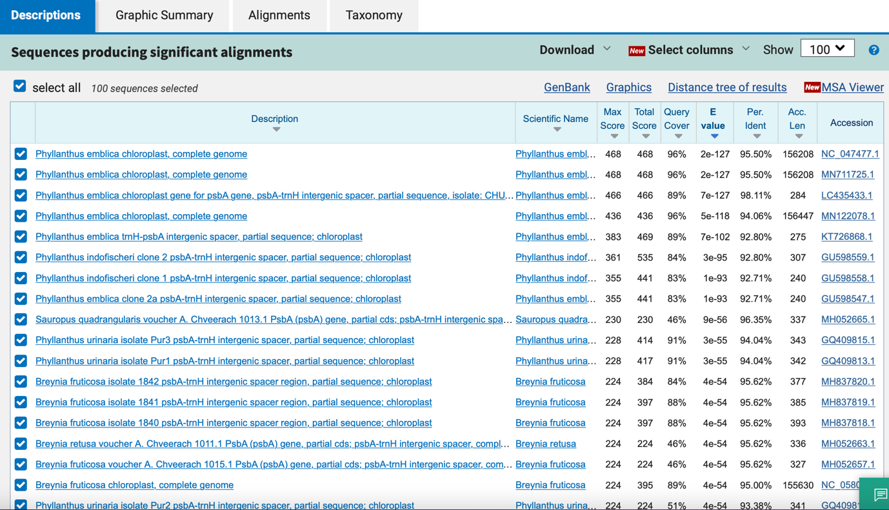

rbcL
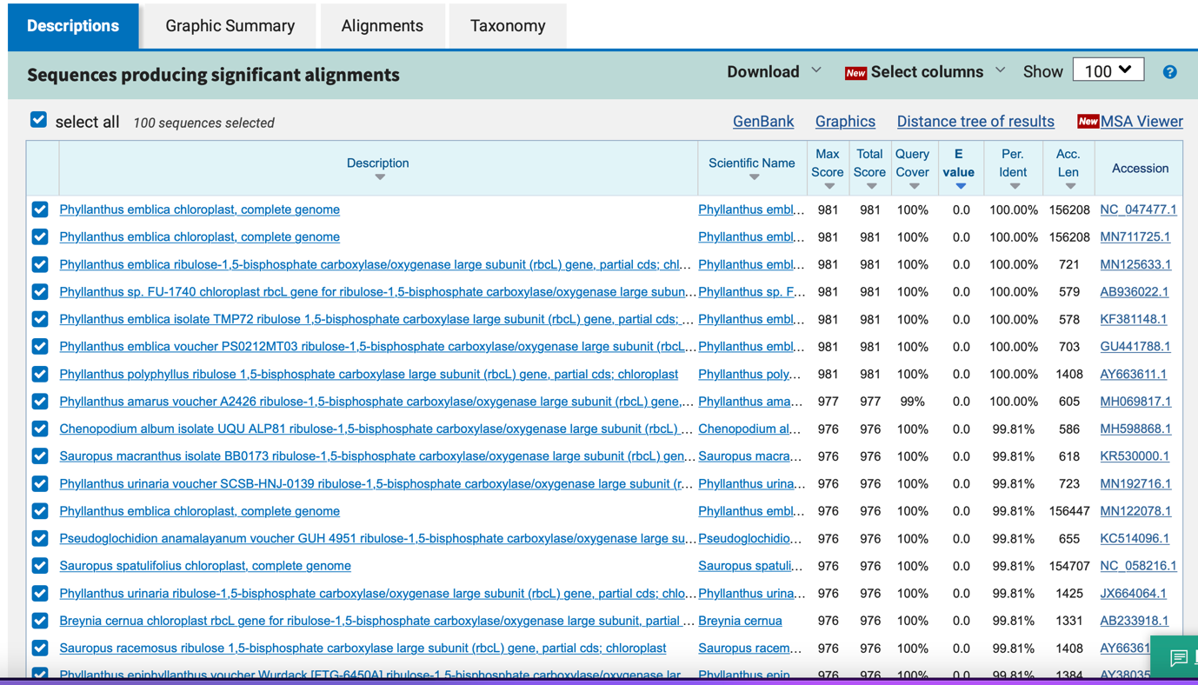

6_ Andrographis paniculata

ITS
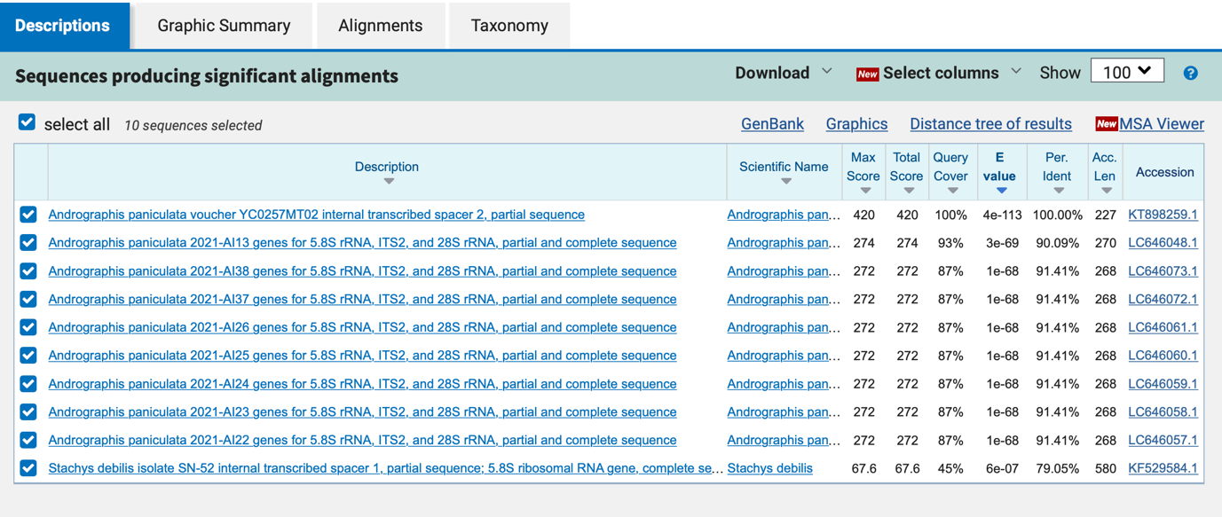

matK
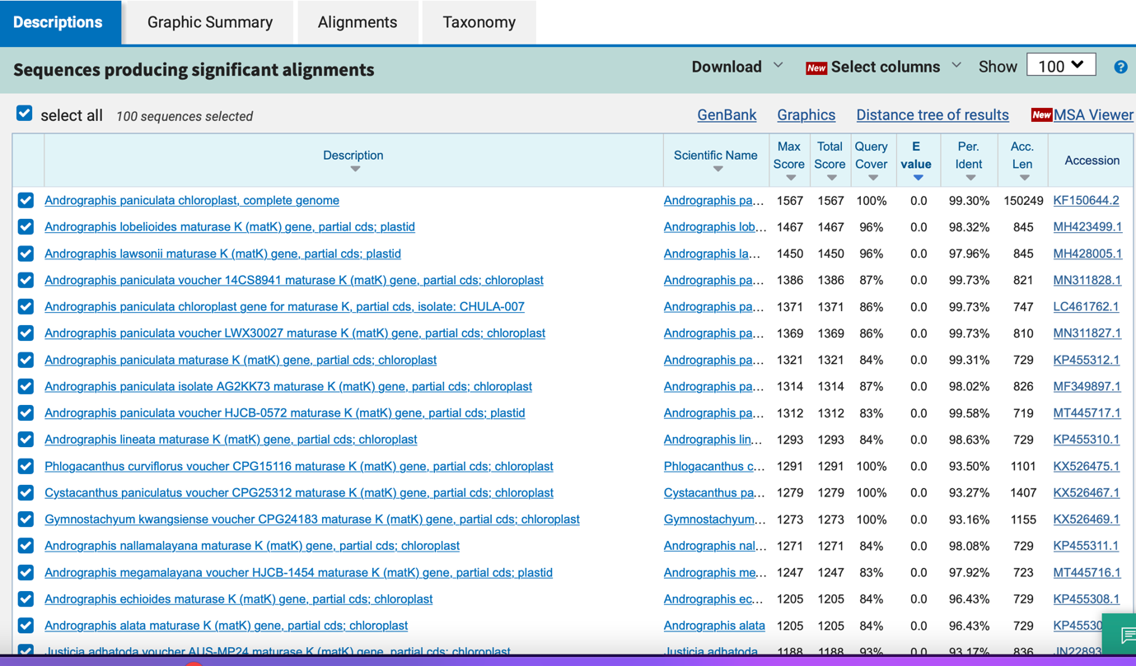

psbA_trnH
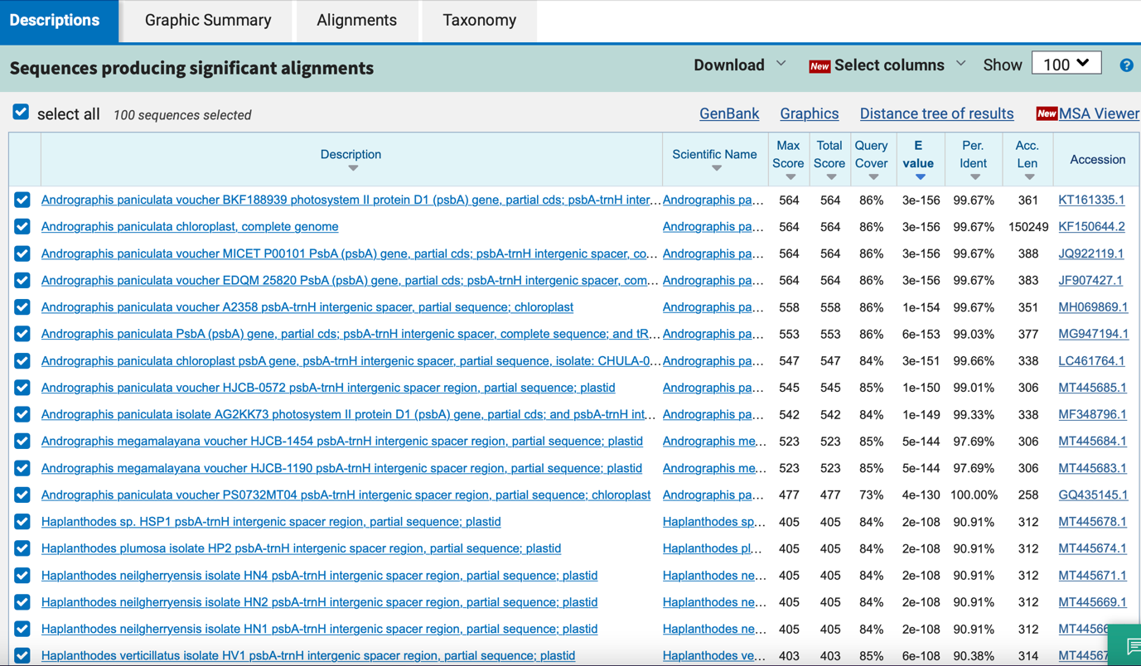

rbcL

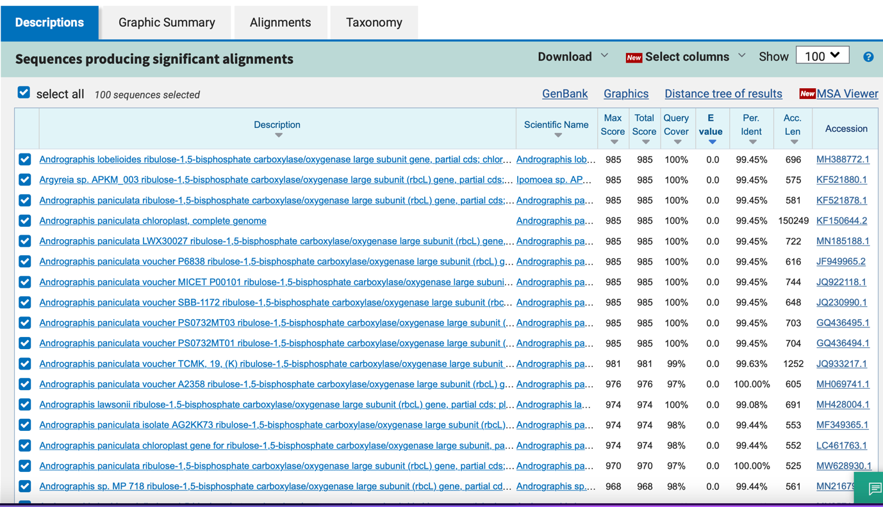

7_ Pueraria candollei

ITS
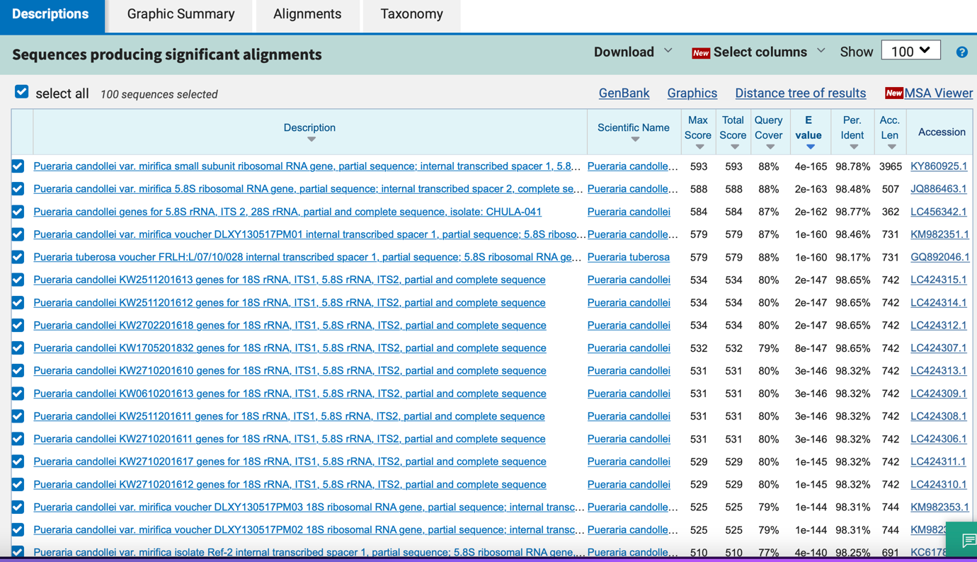

matK
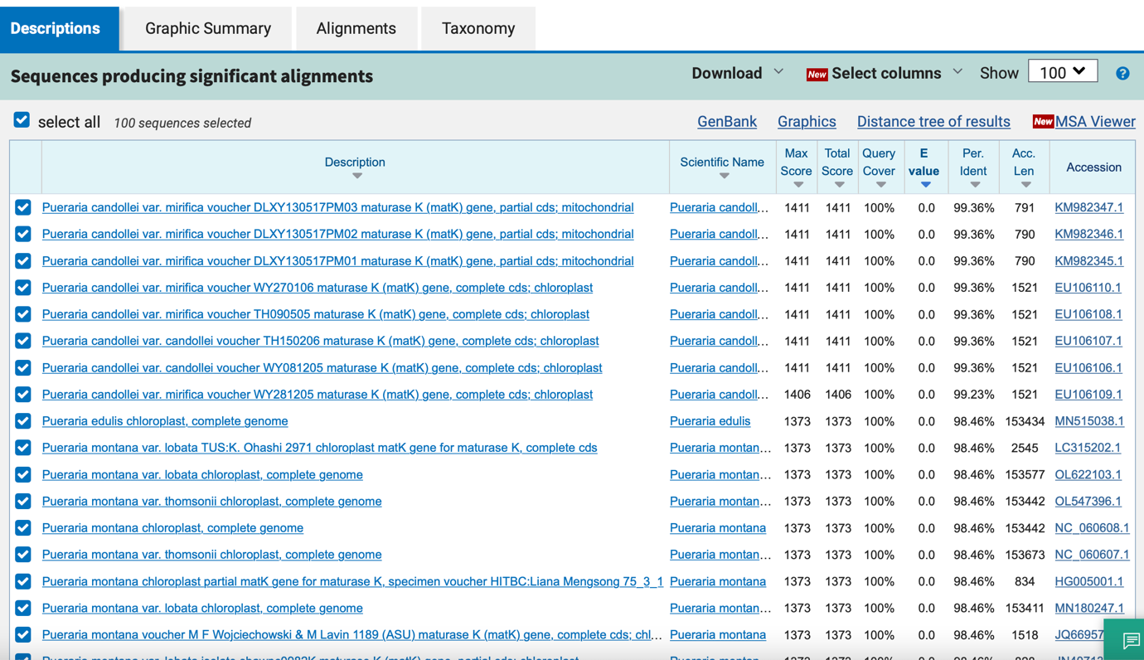

psbA_trnH
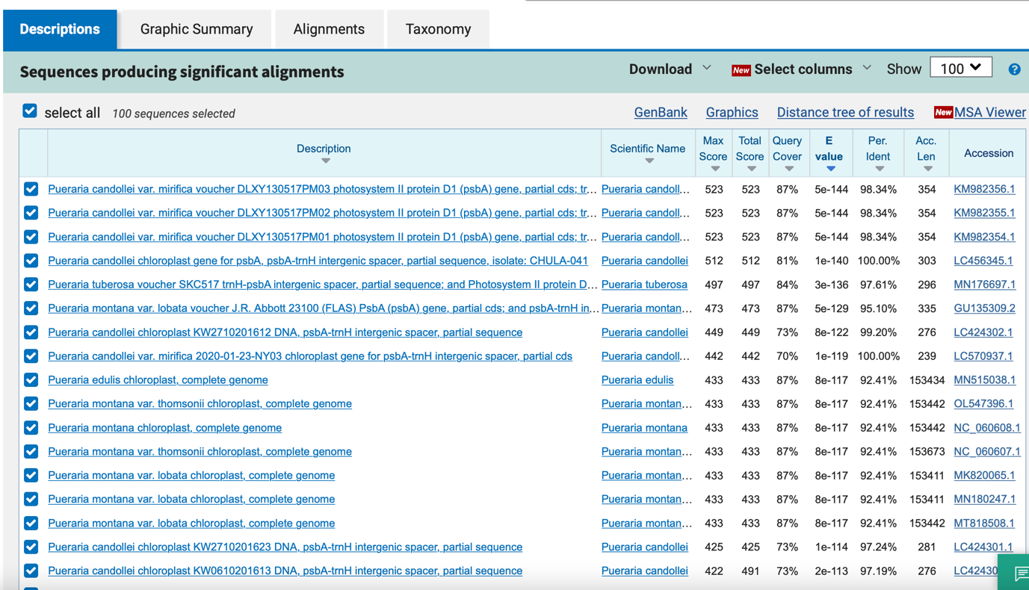

rbcL

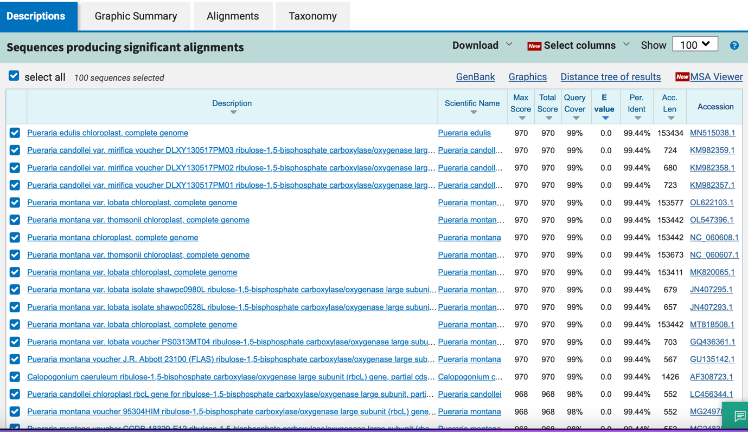

8_ Senna alata

ITS
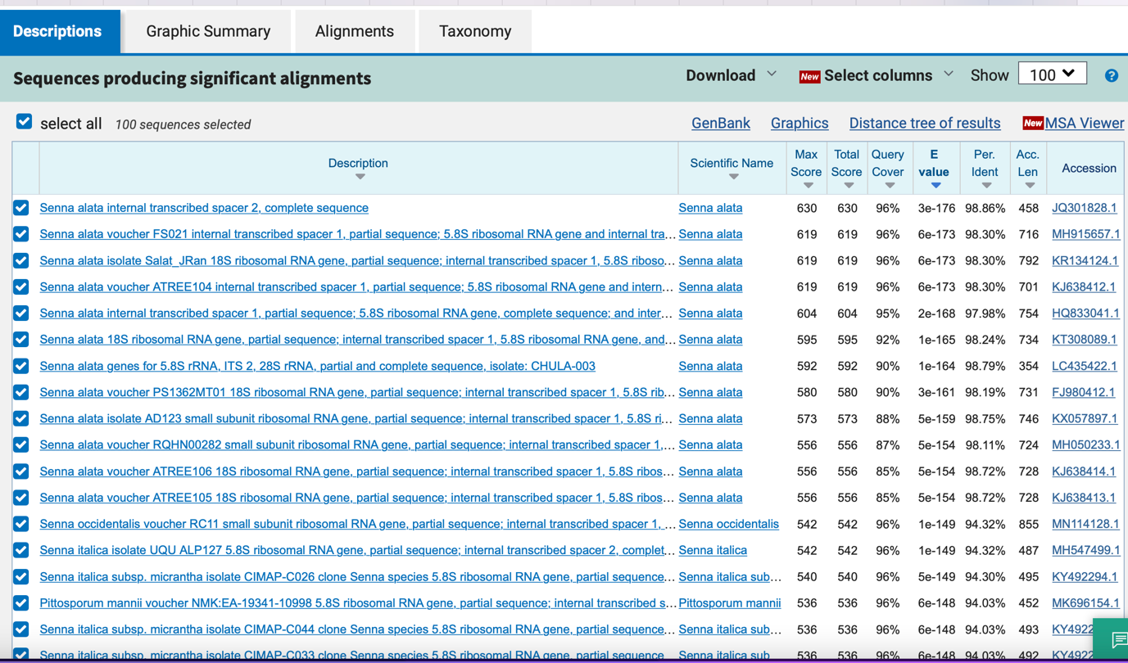

matK
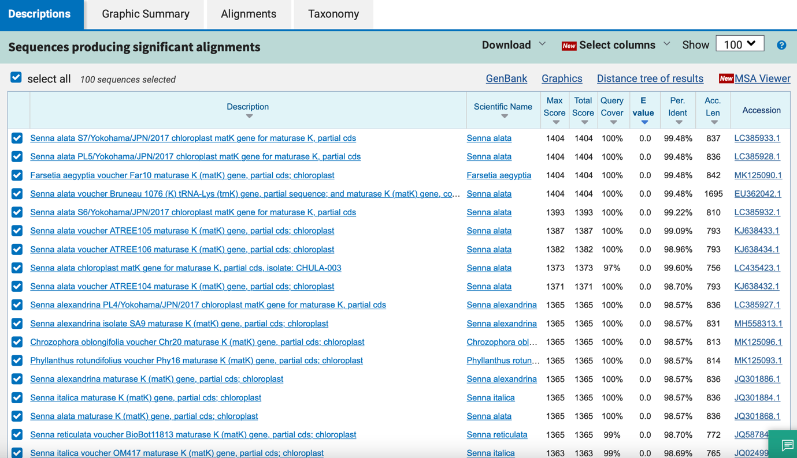

psbA_trnH

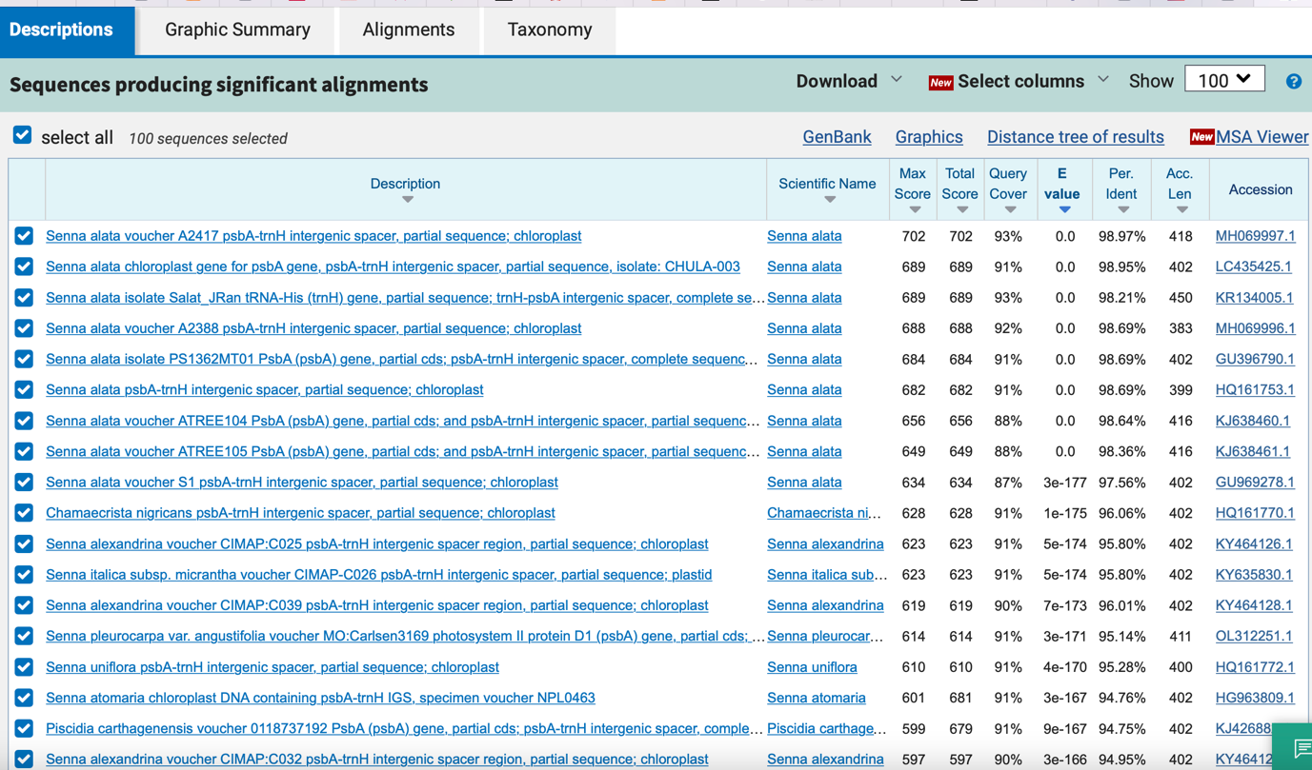

rbcL

9_ Boesenbergia rotunda

ITS
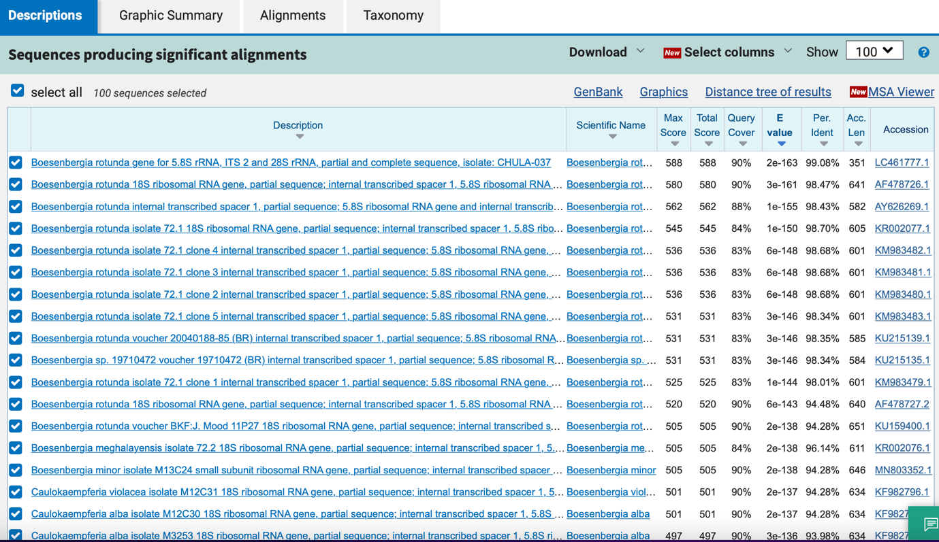

matK
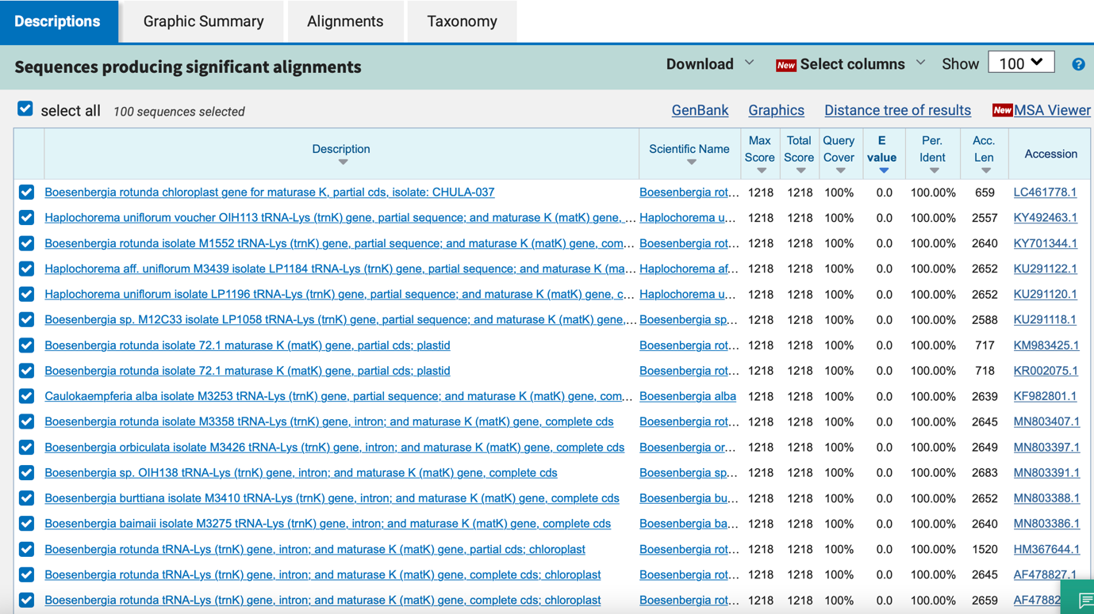

psbA_trnH

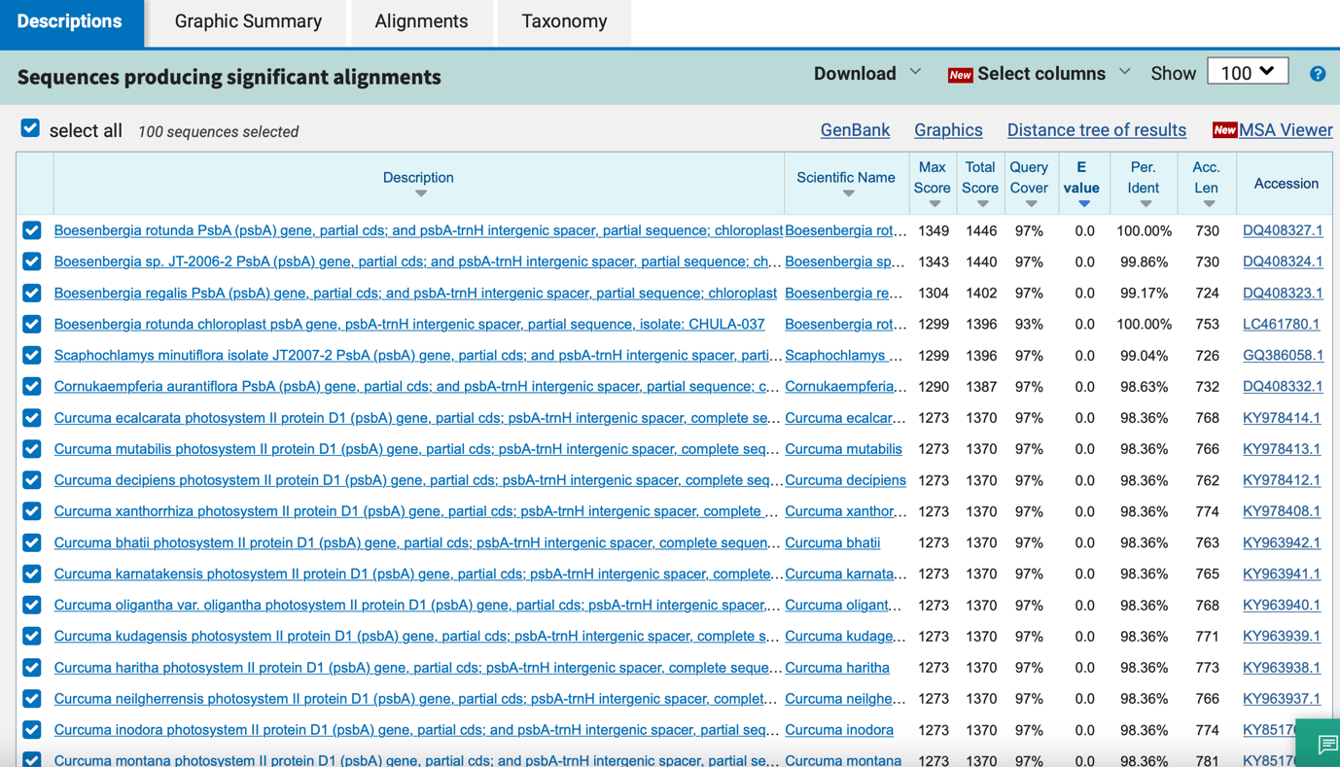

rbcL

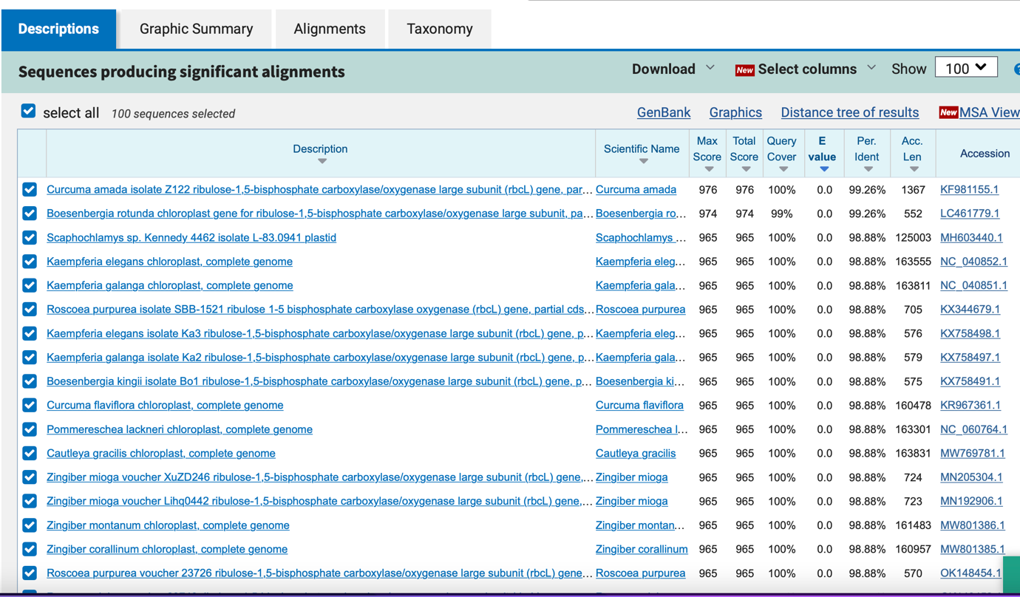

10_ Clinacanthus nutans

ITS
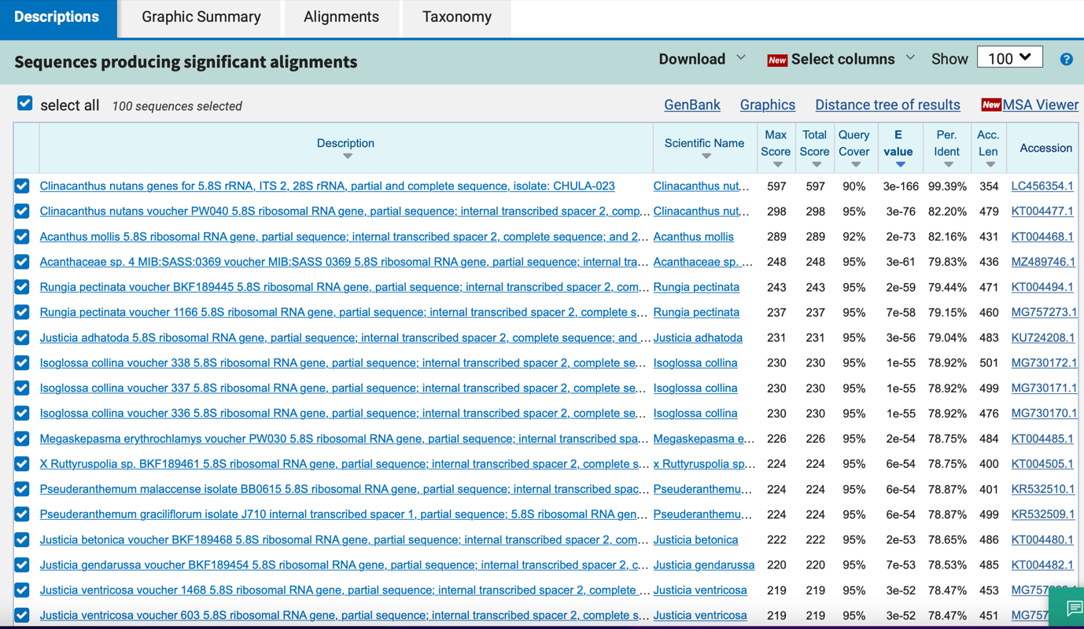

matK
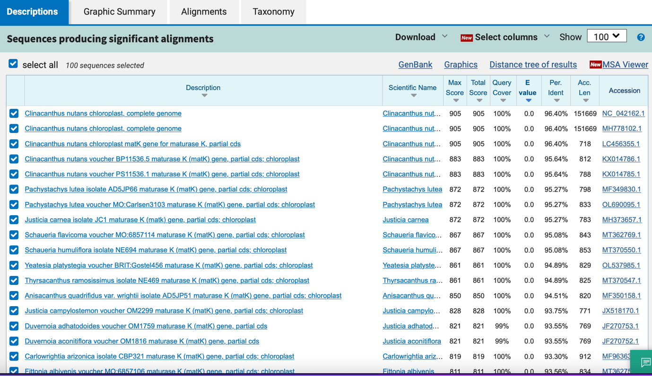

psbA_trnH
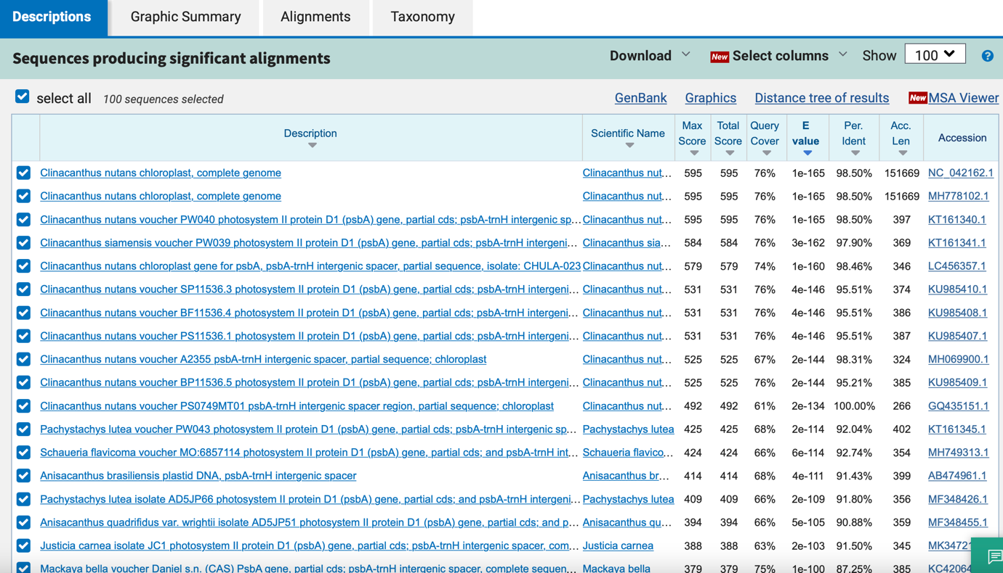

rbcL

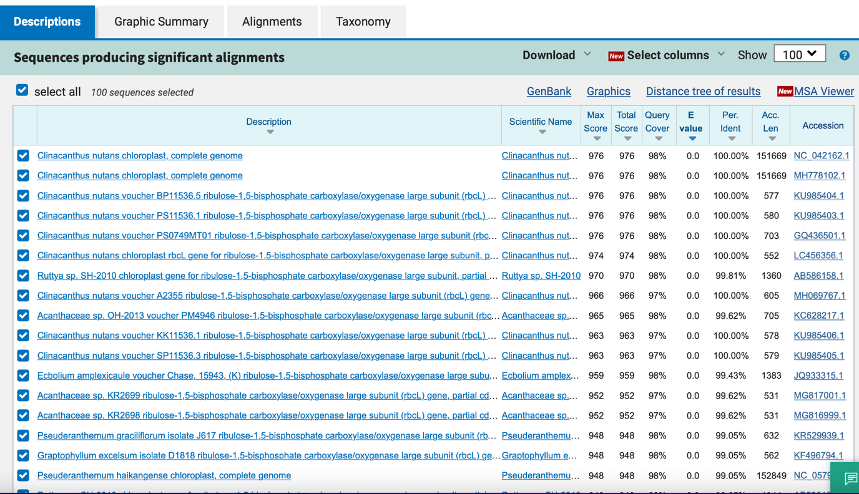

11_ Curcuma longa

ITS

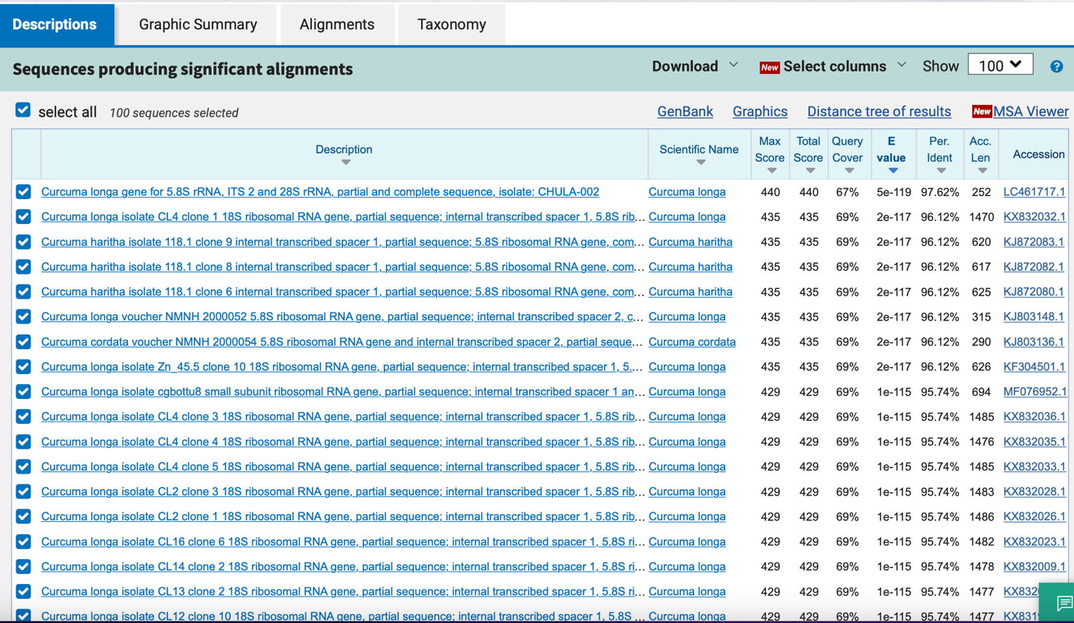

matK

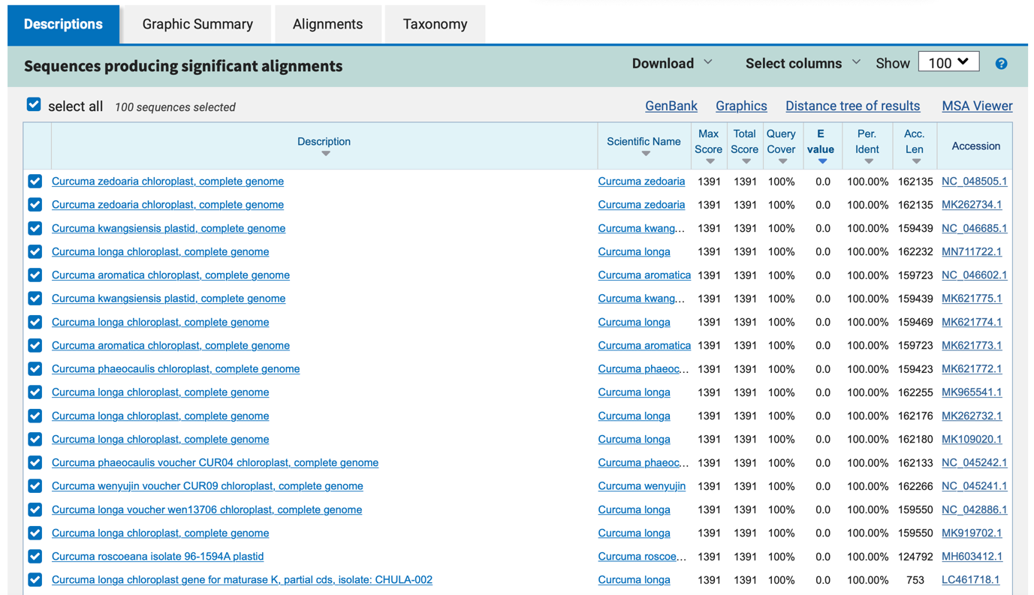

psbA_trnH
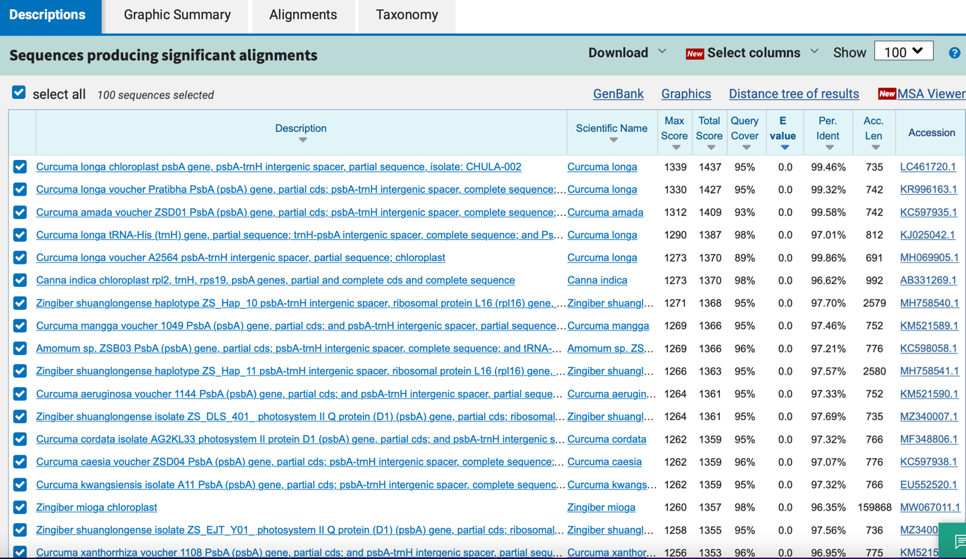

rbcL
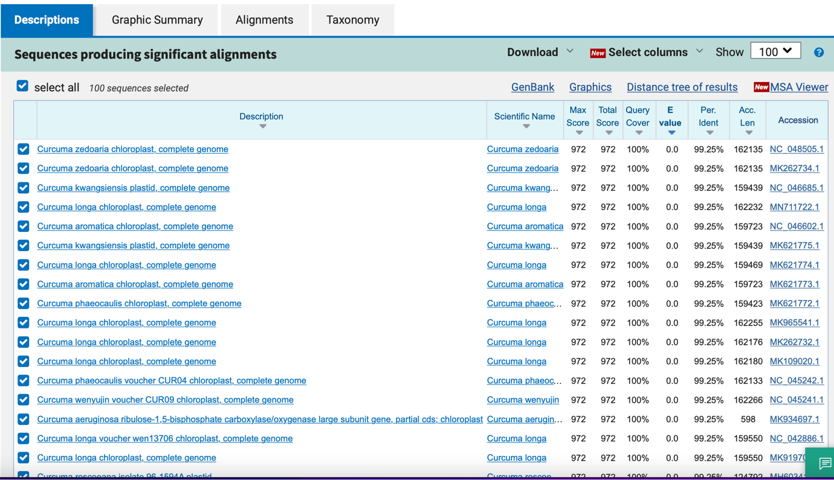

12_ Centella asiatica

ITS

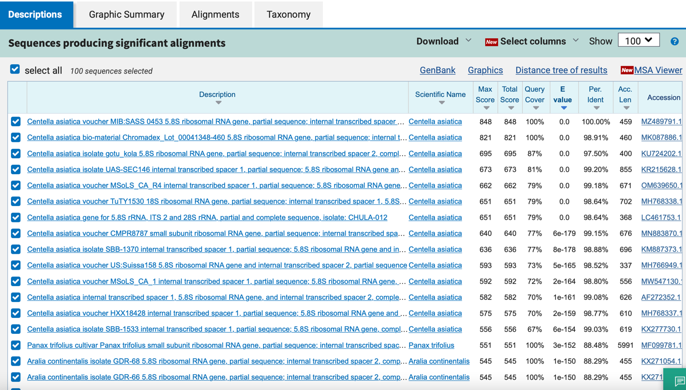

matK
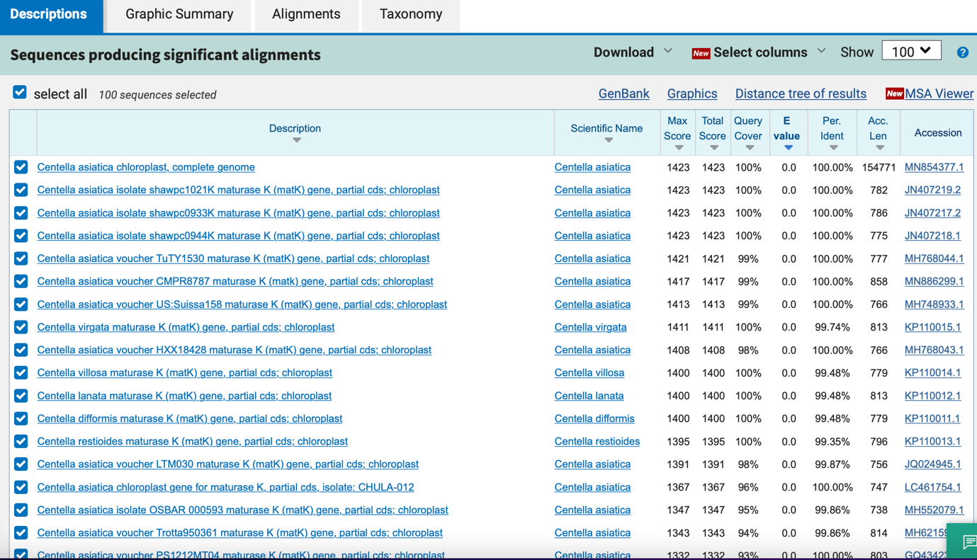

psbA_trnH
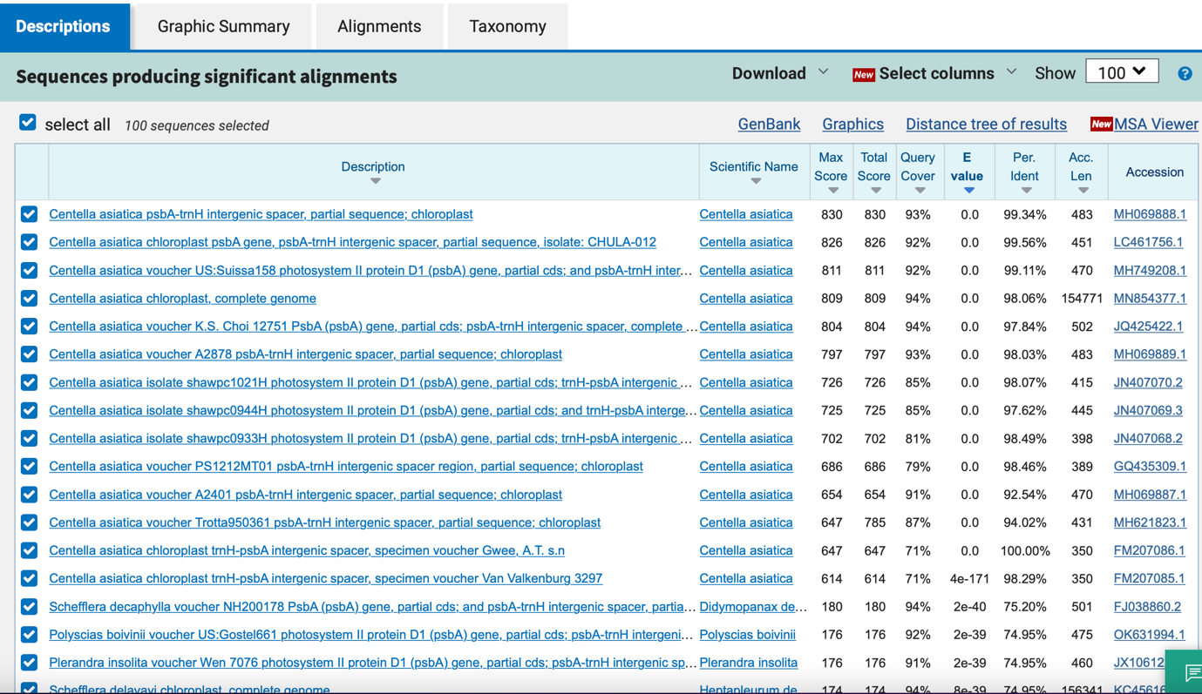

rbcL
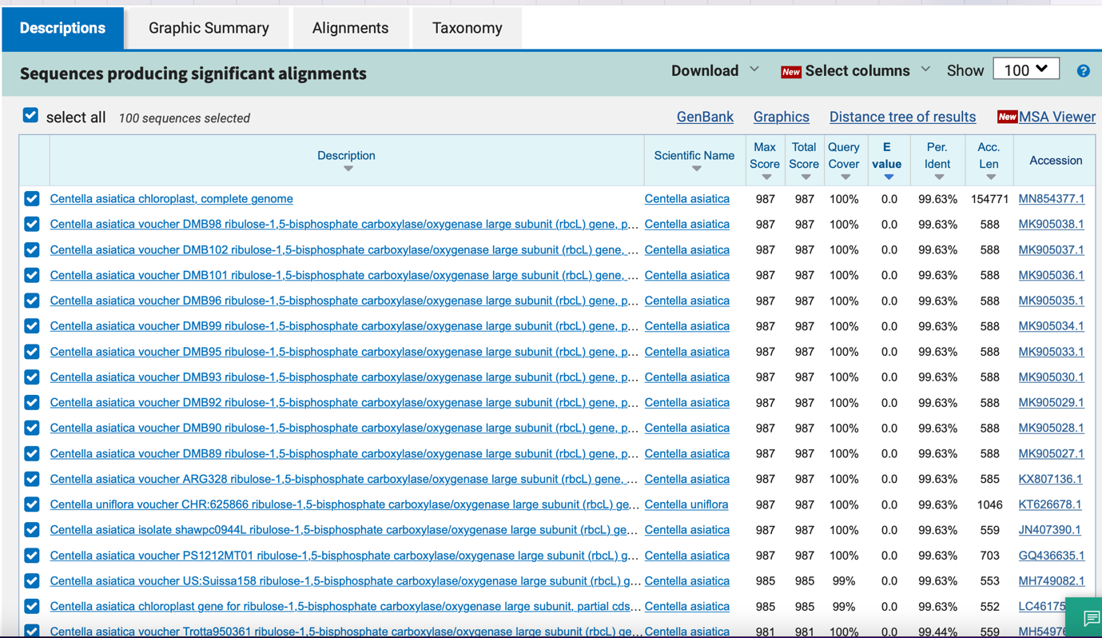

13_ Pueraria candollei butea

ITS

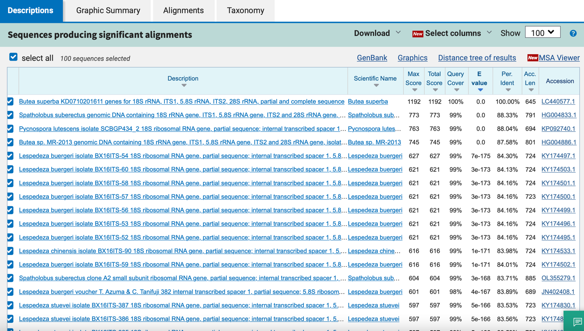

matK

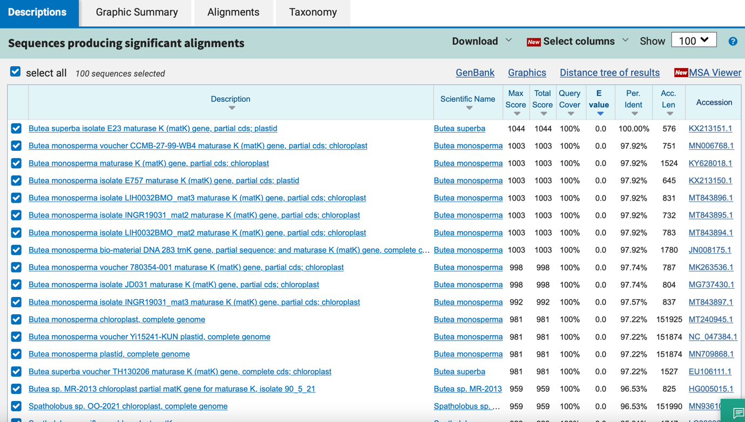

psbA_trnH

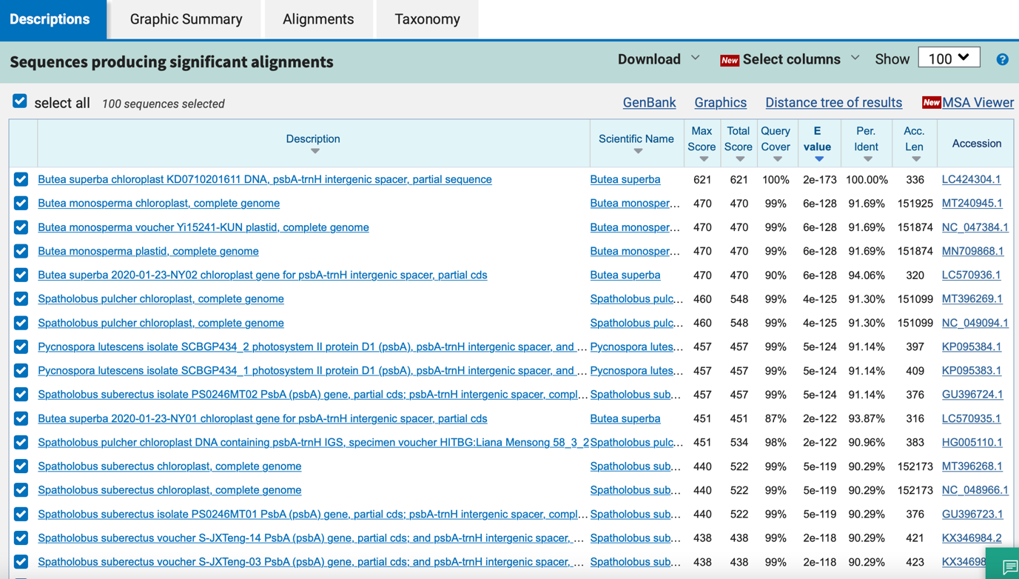

rbcL

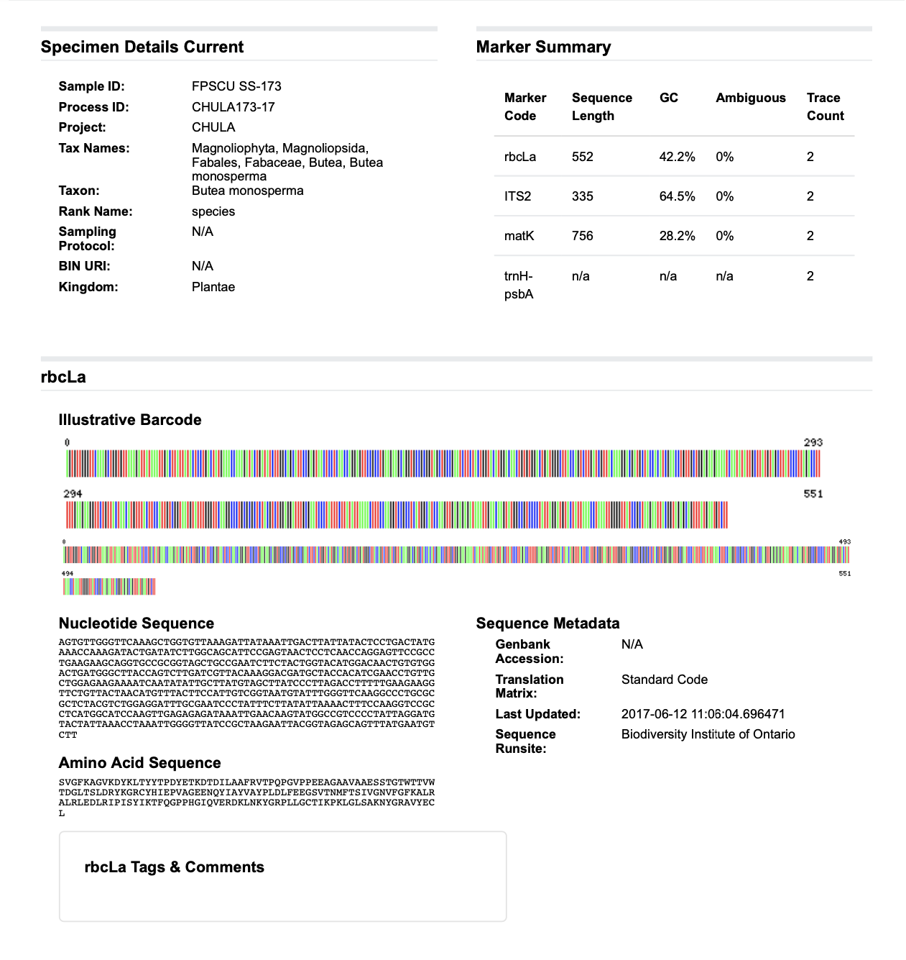

14_ Centella asiatica

ITS

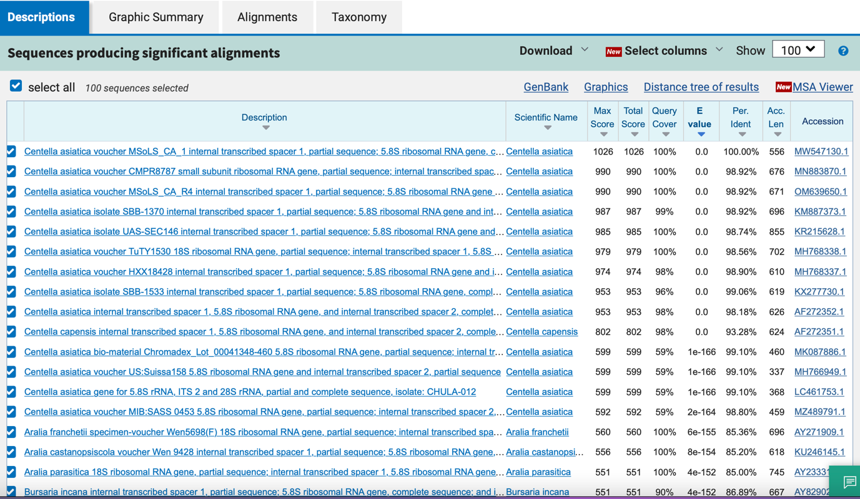

matK
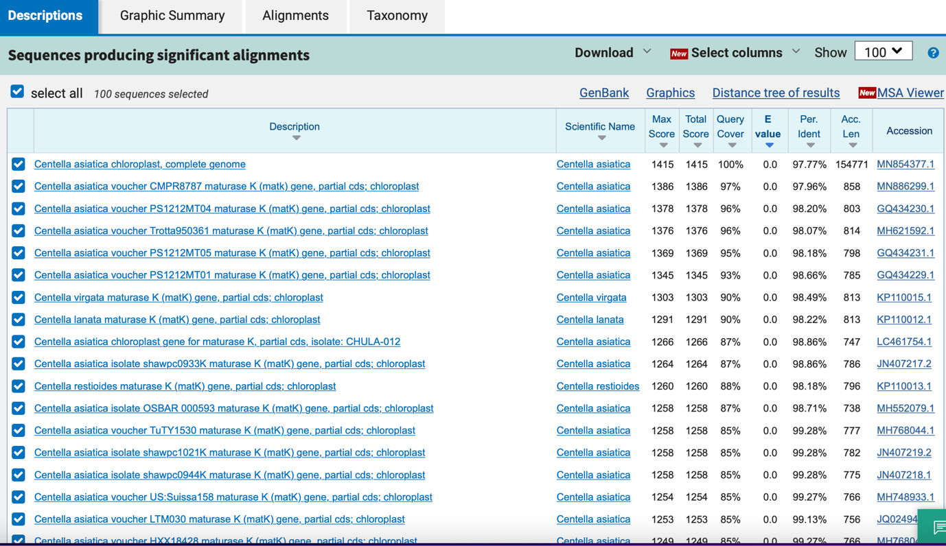

psbA_trnH

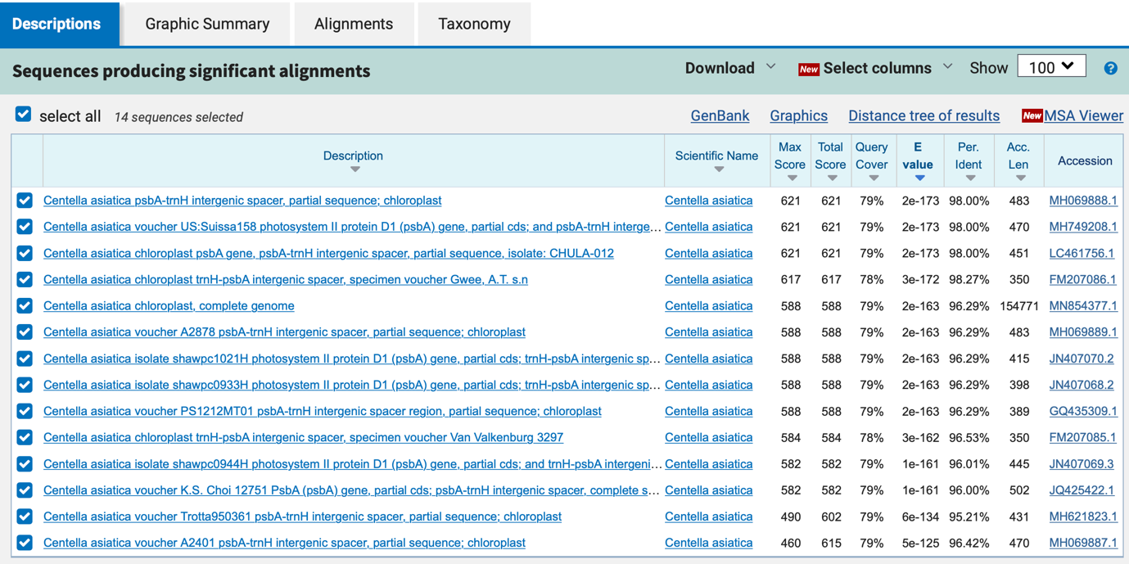

rbcL
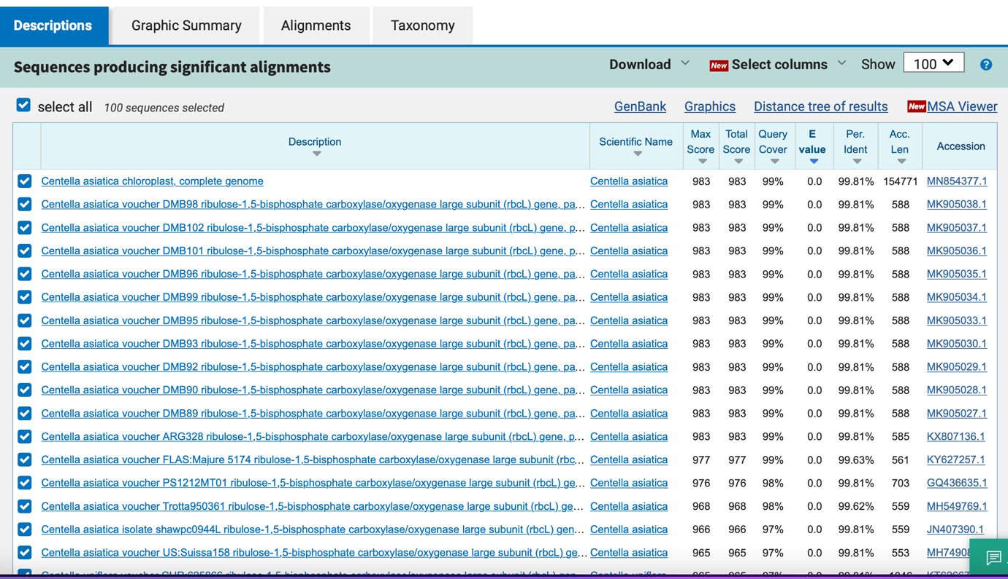

15_ Curcuma longa

ITS
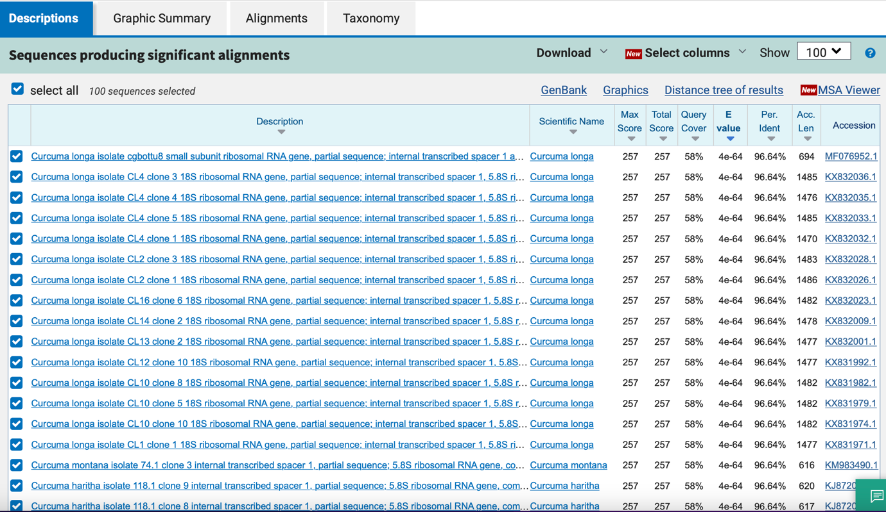

matK

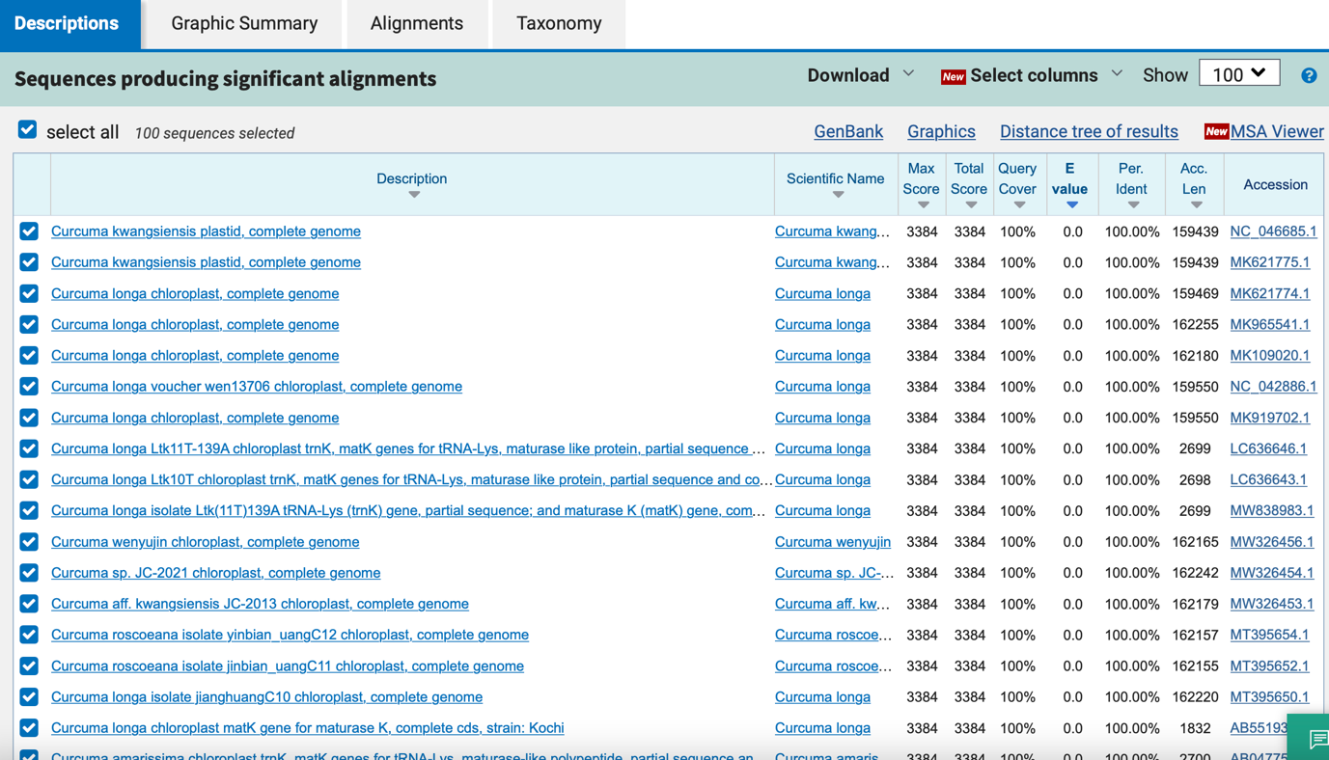

psbA_trnH

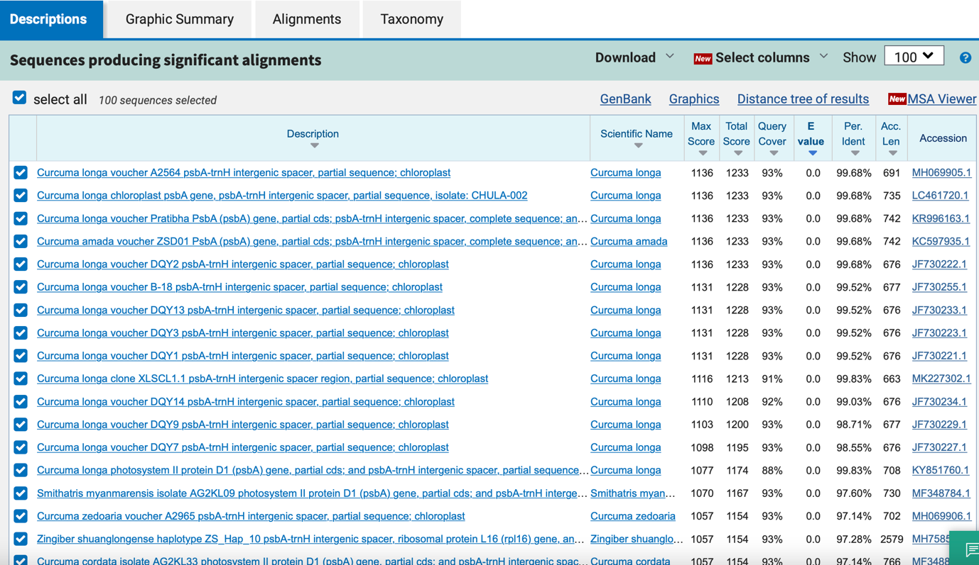

rbcL
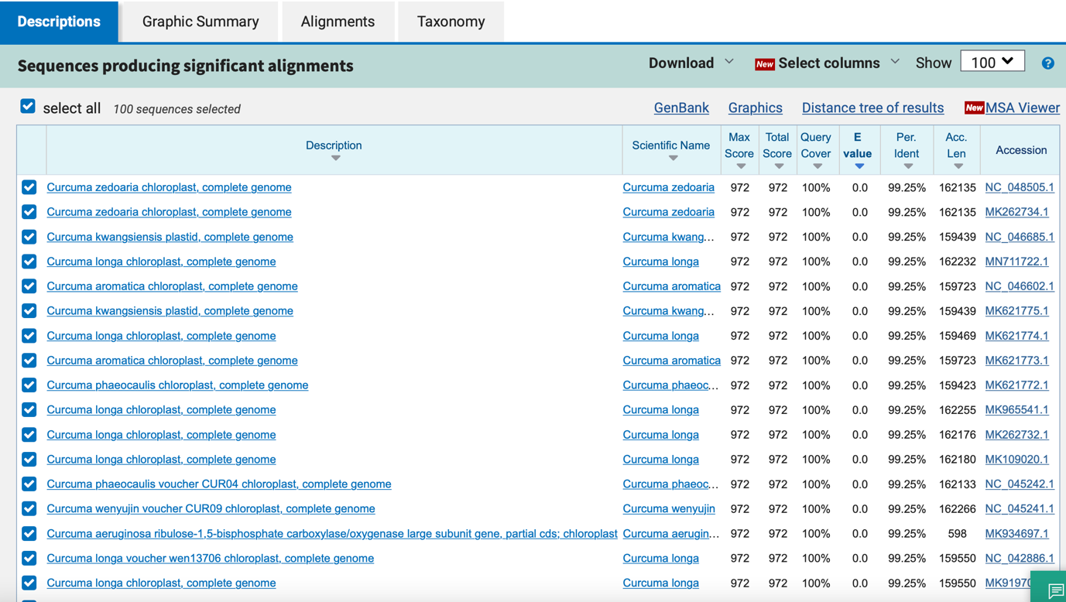

16_ Kaempferia parviflora

ITS
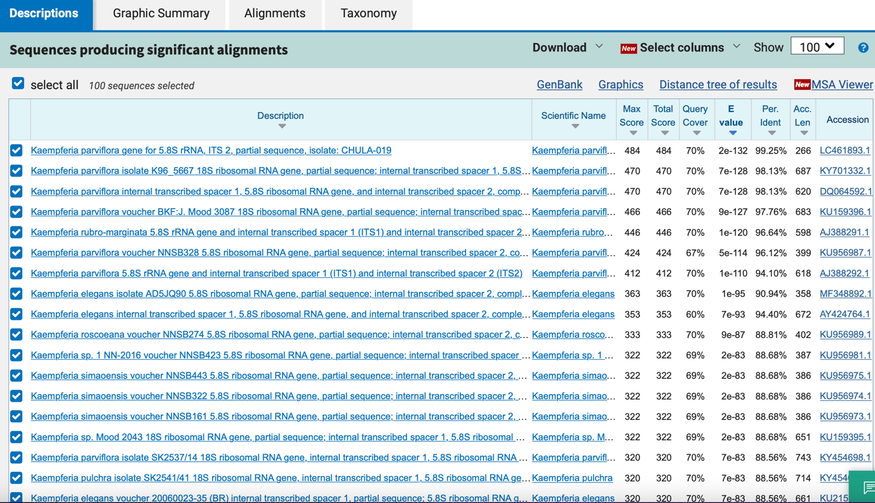

matK

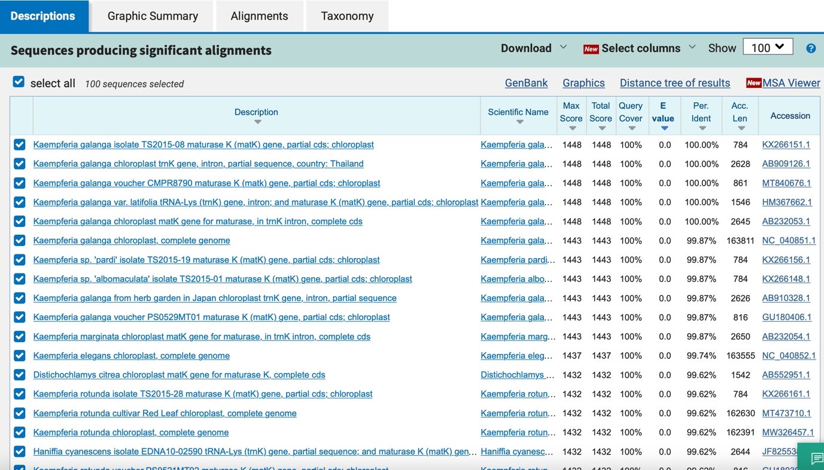

psbA_trnH

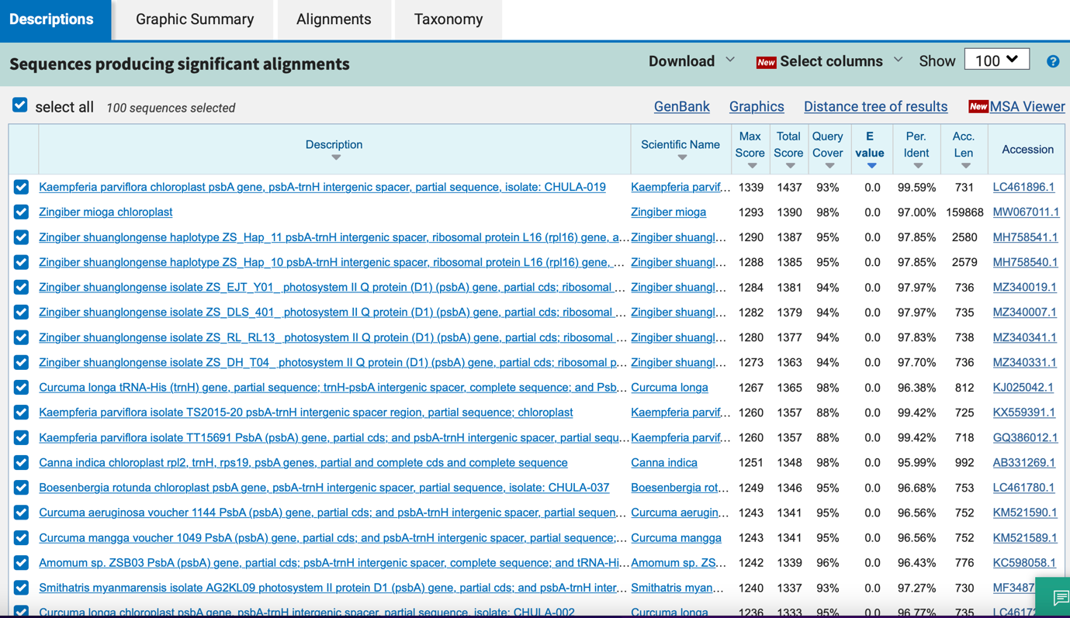

rbcL
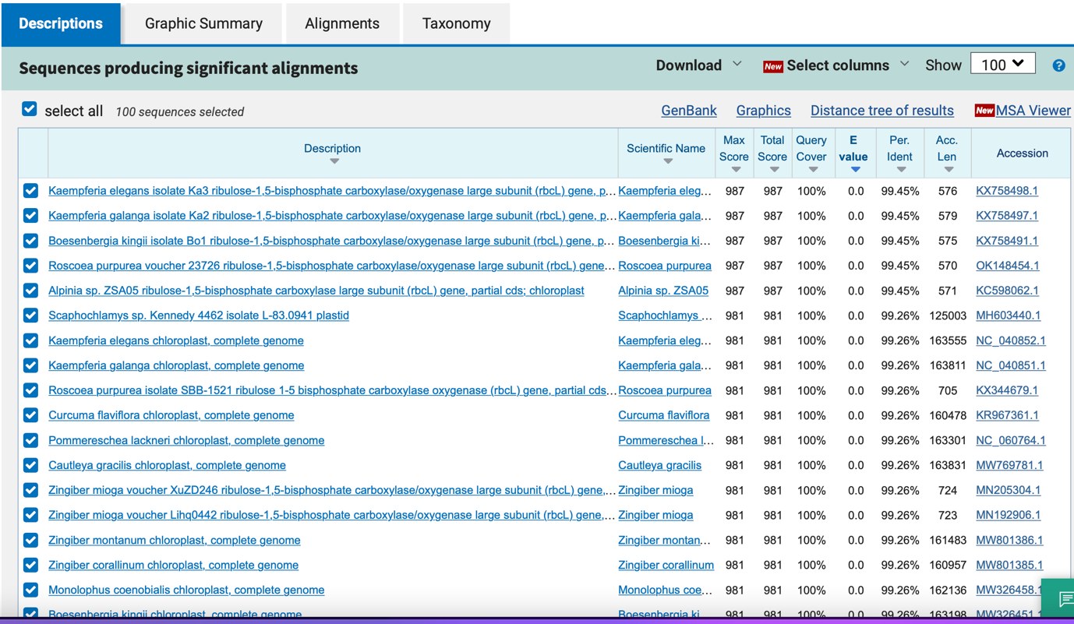

17_ Centella asiatica

ITS

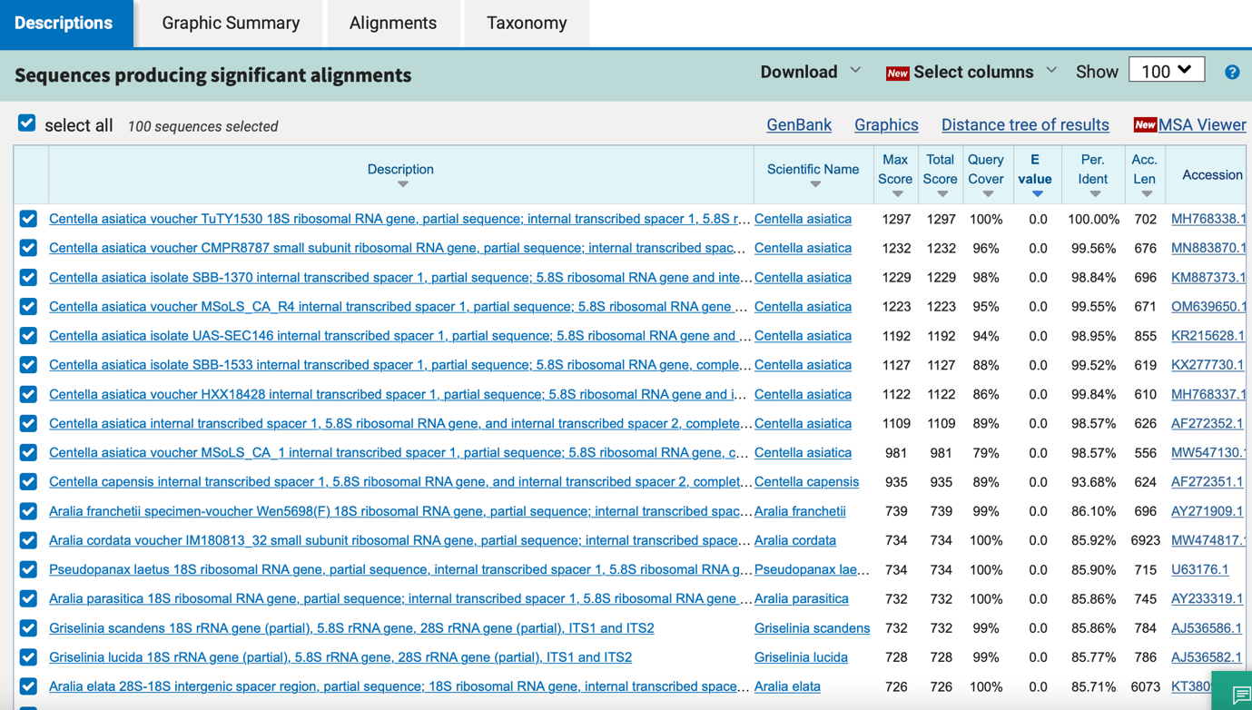

matK
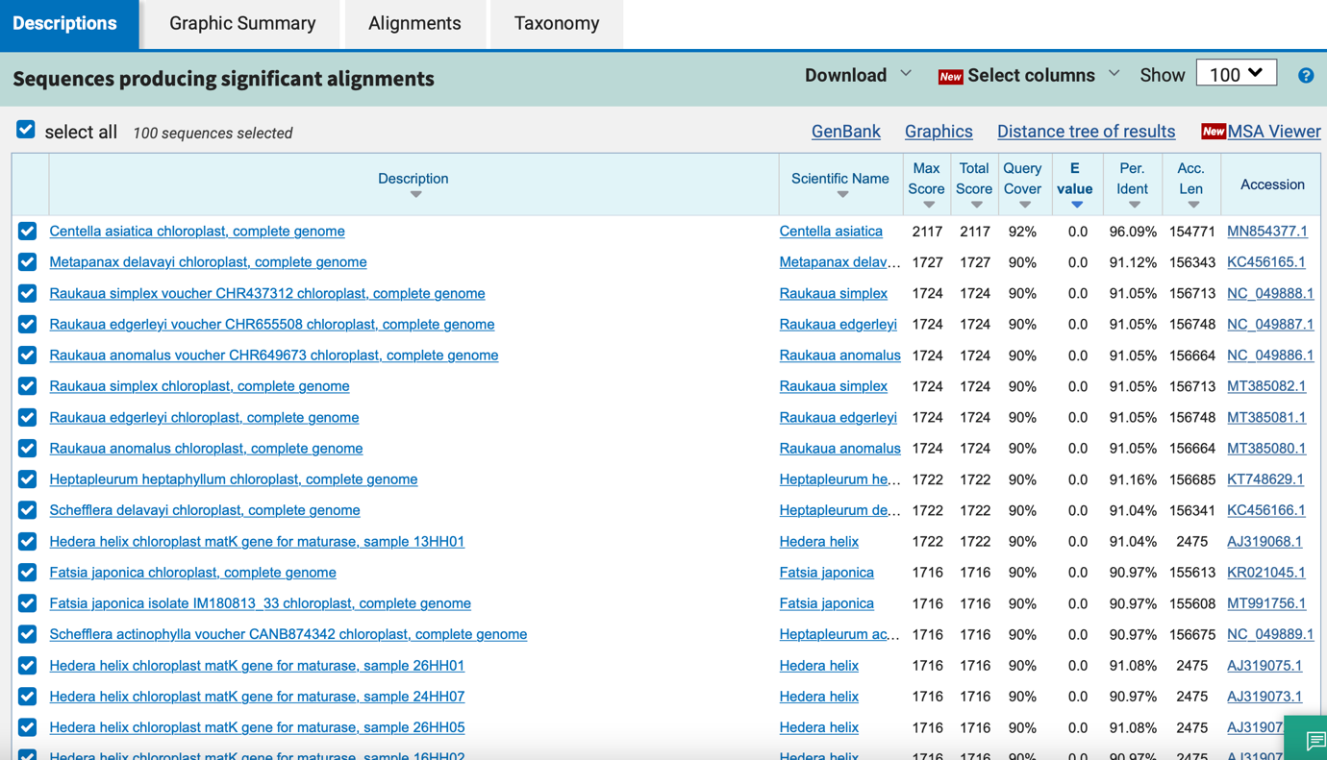

psbA_trnH
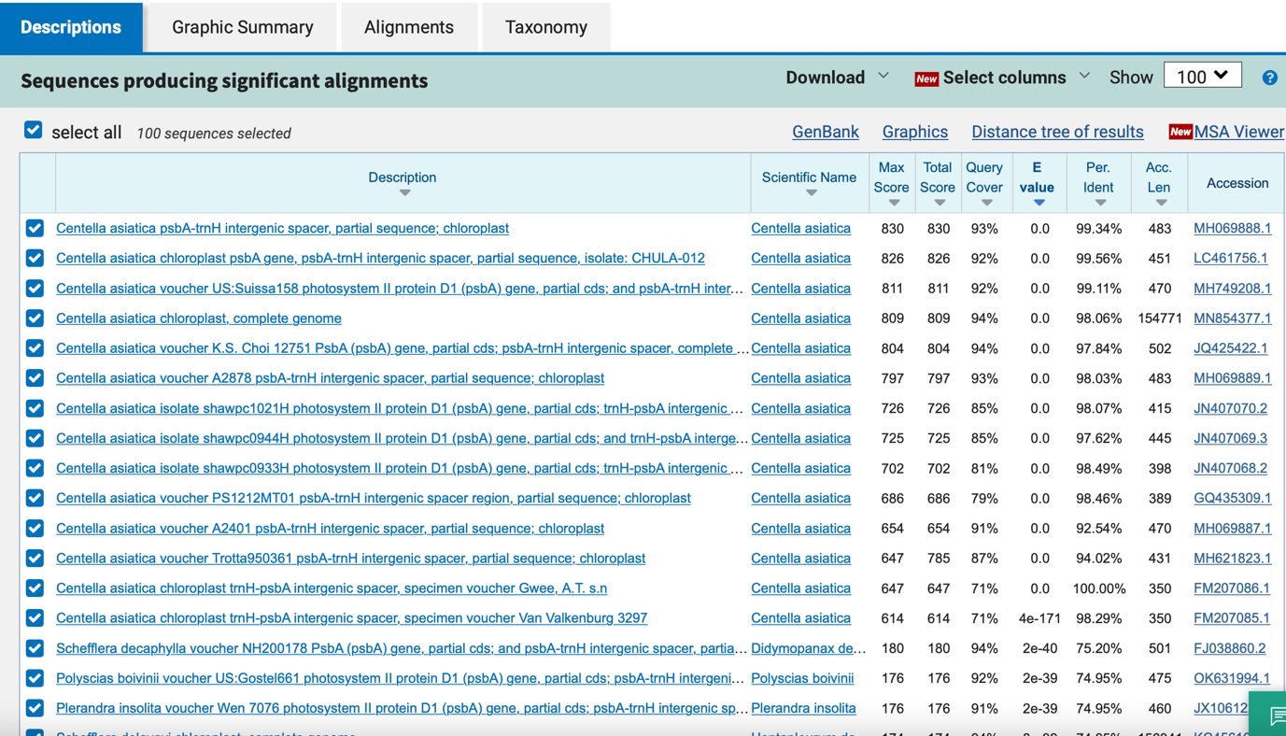

rbcL
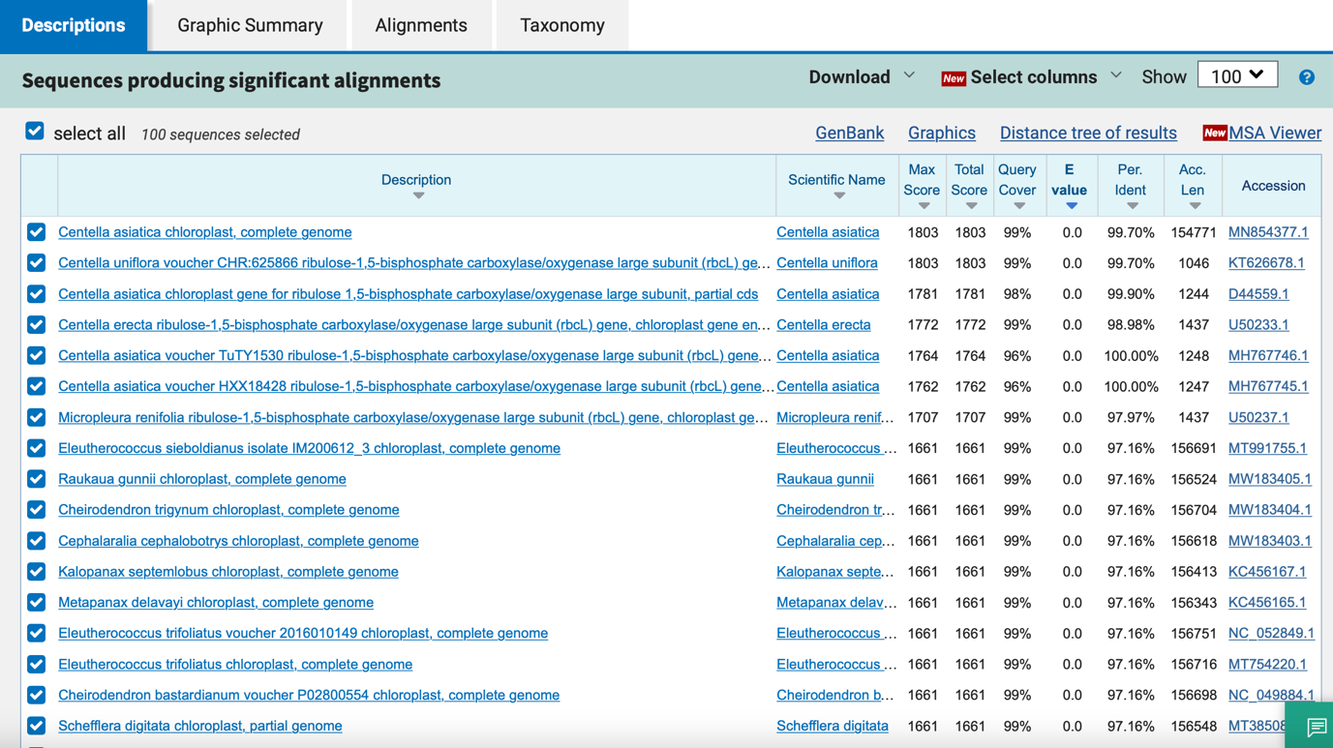

18_ Centella asiatica

ITS

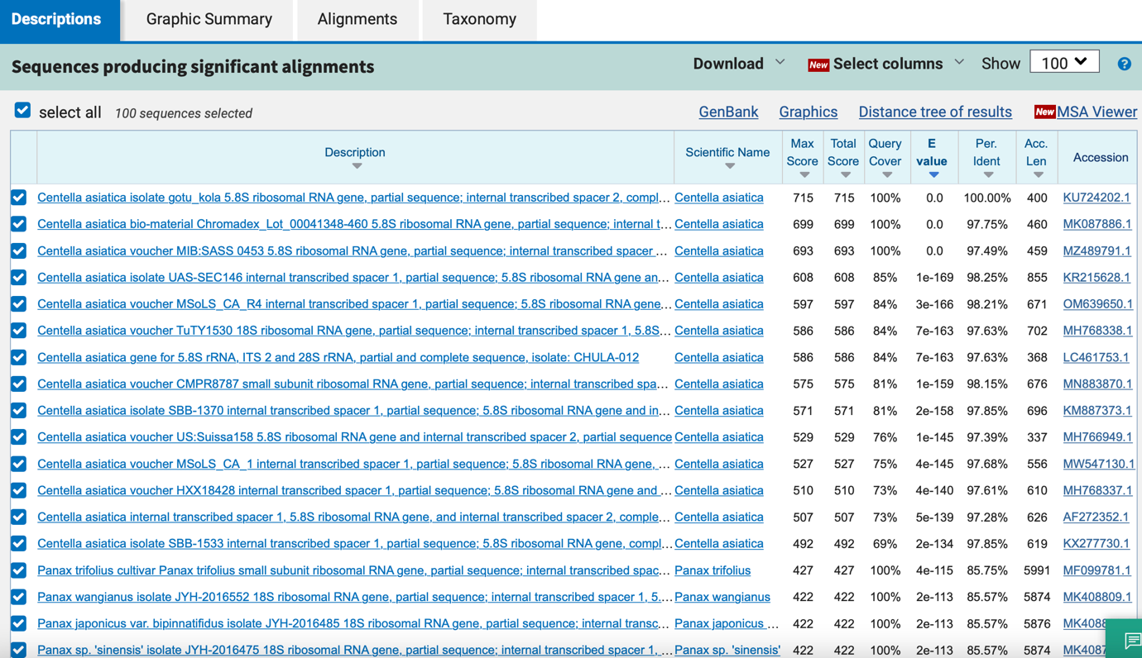

matK
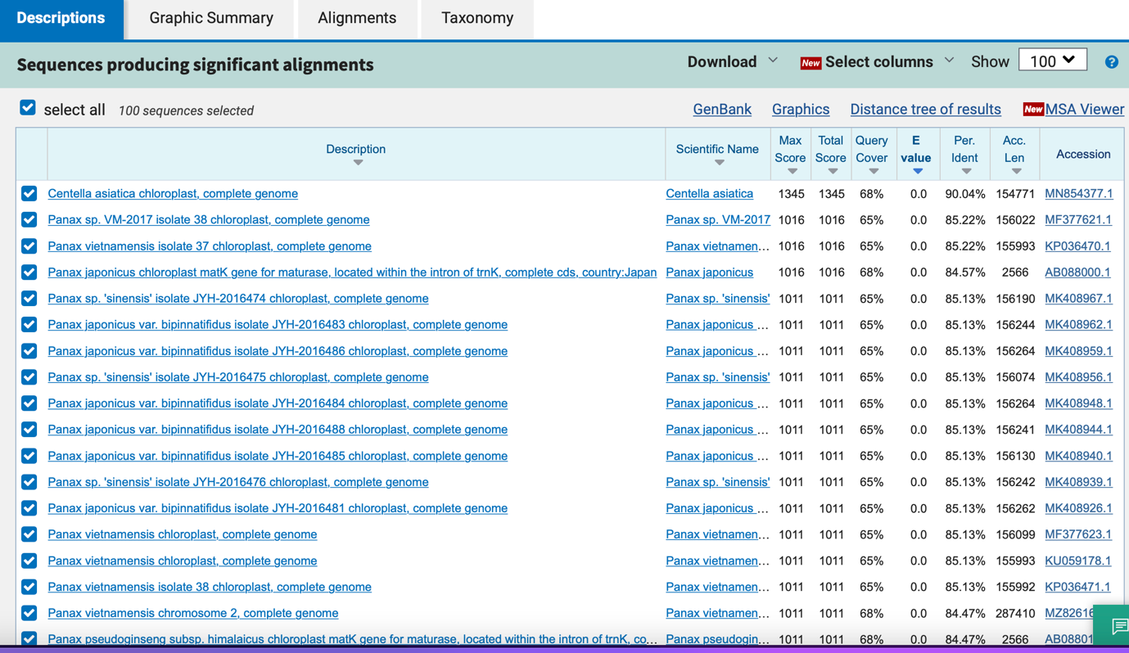

psbA_trnH

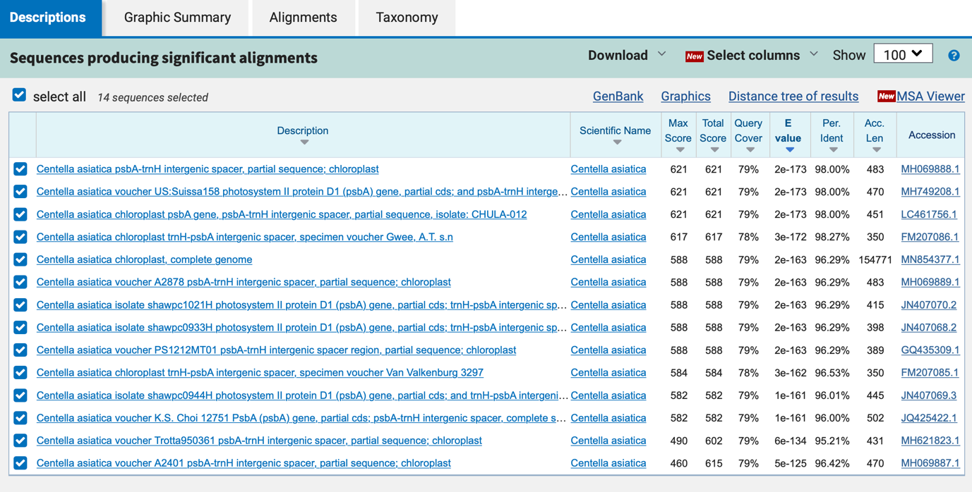

rbcL
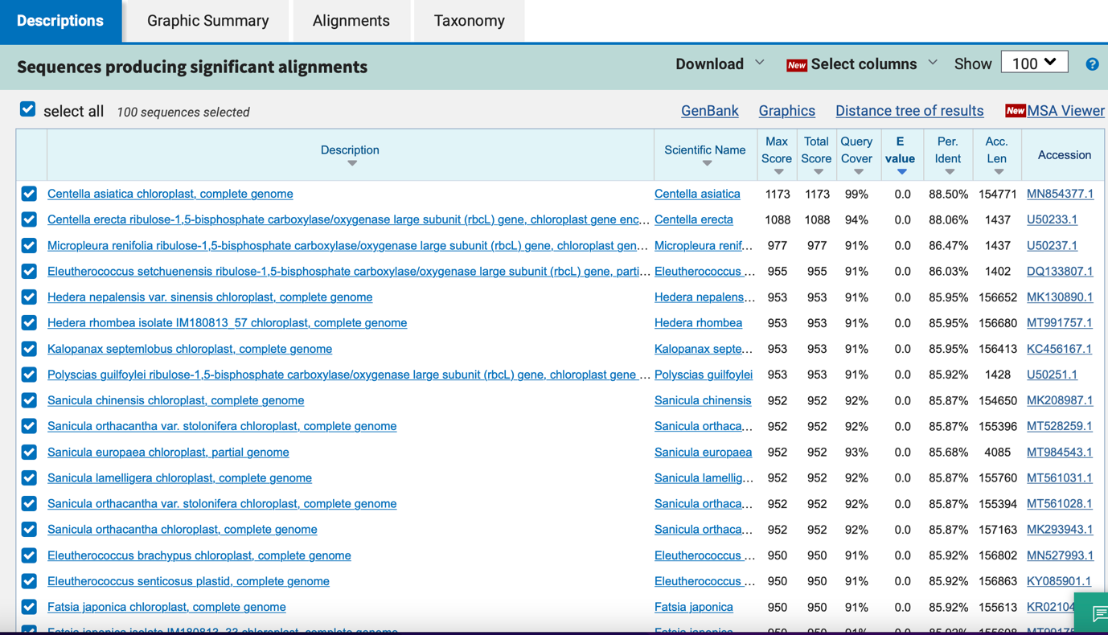

19_ Curcuma longa

ITS
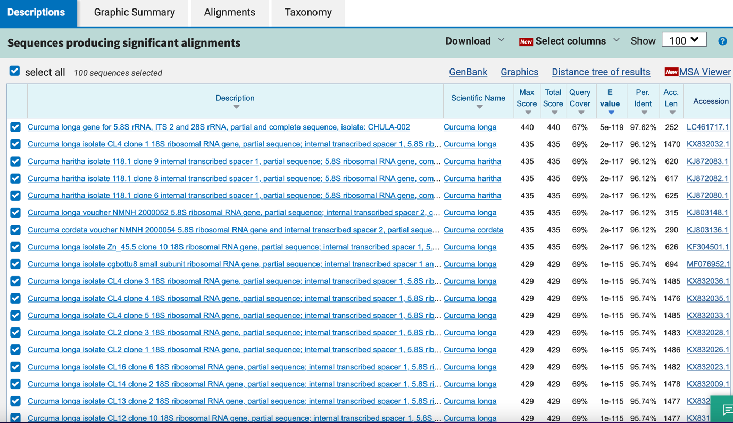

matK

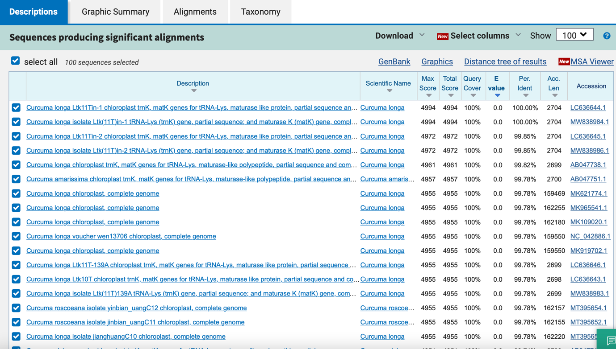

psbA_trnH
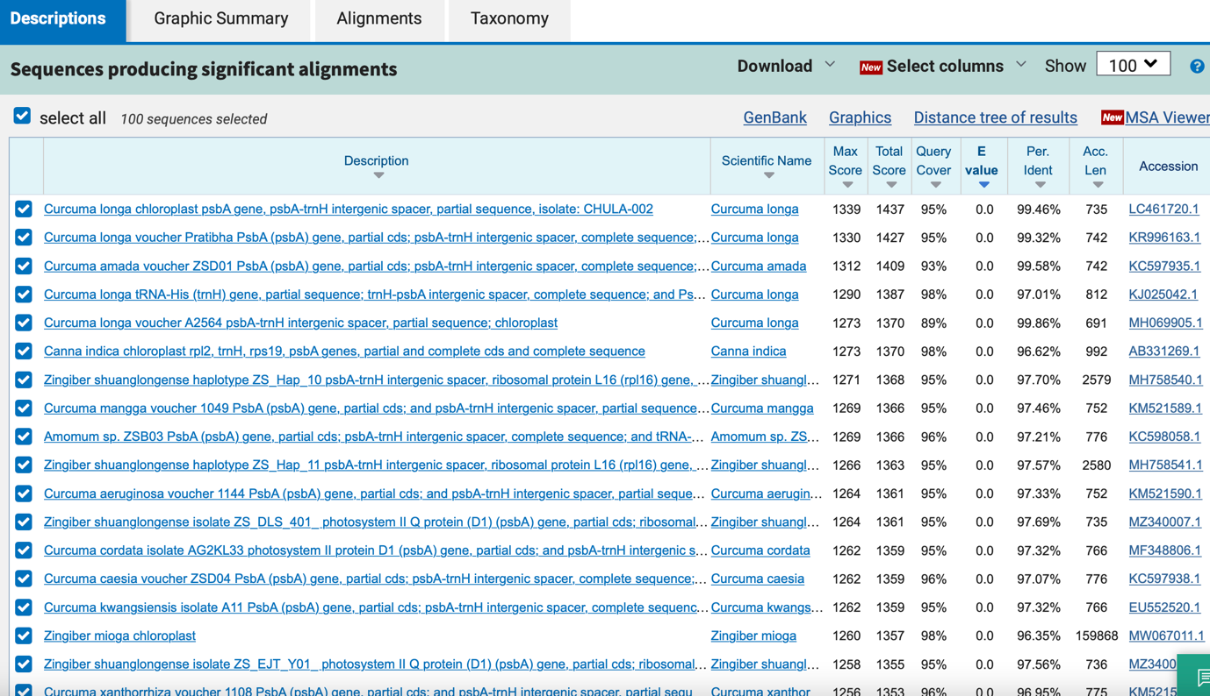

rbcL
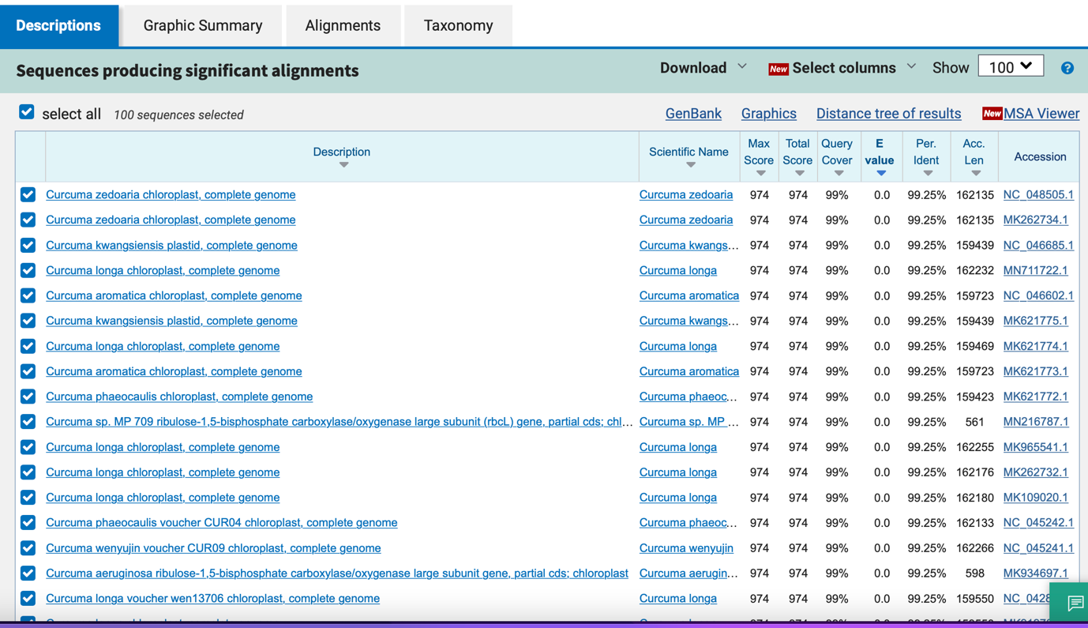

20_ Zingiber montanum

ITS

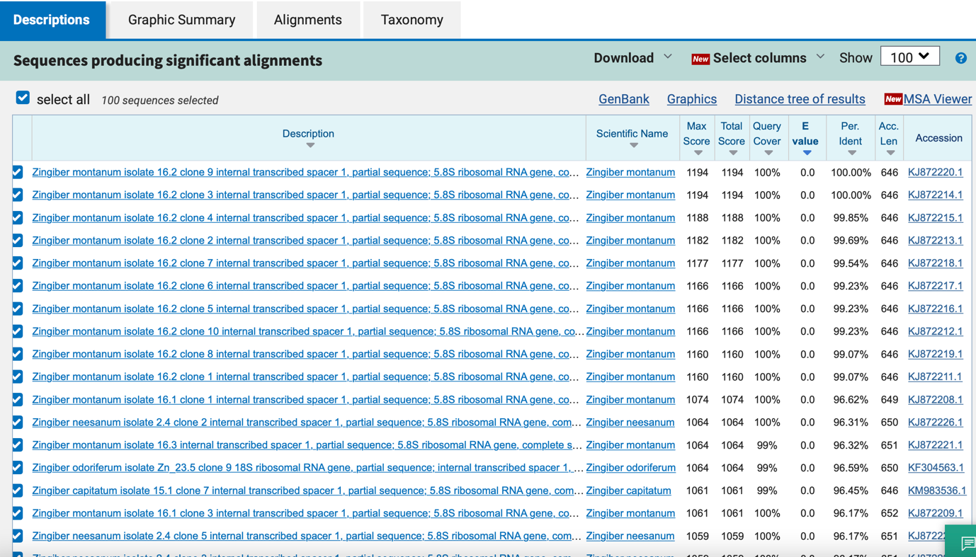

matK

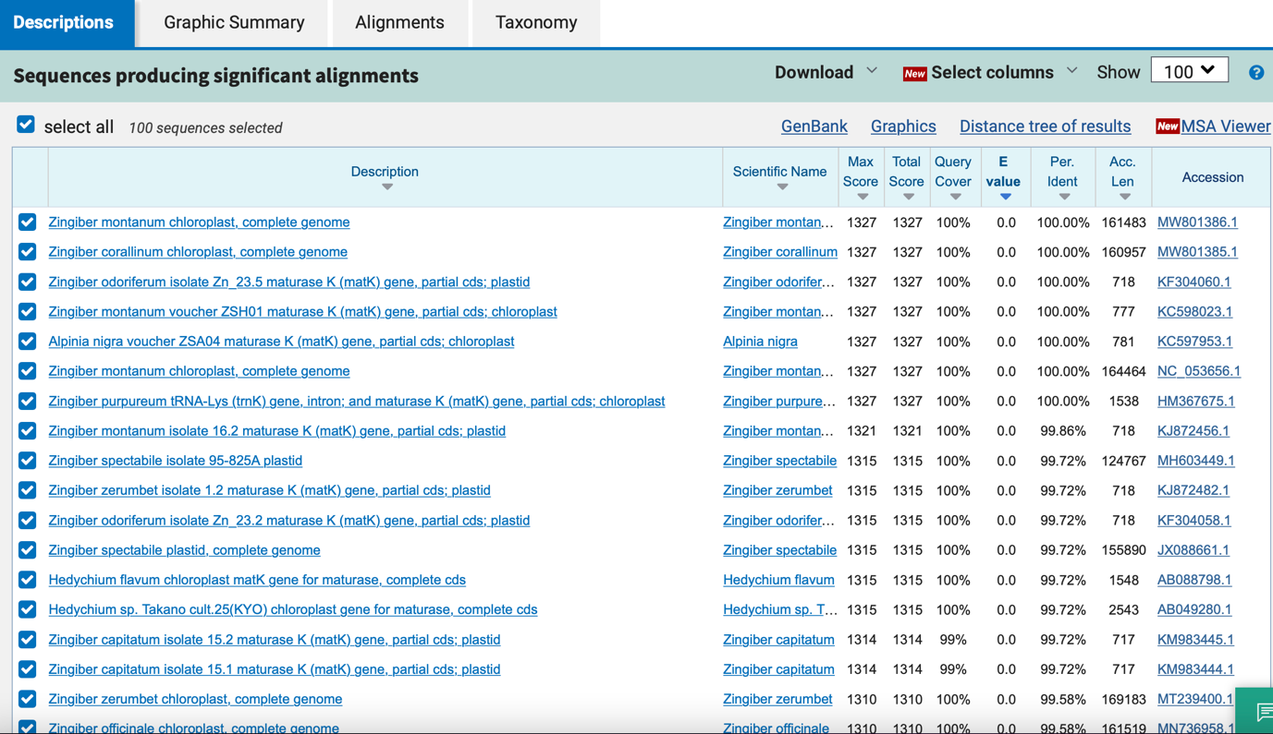

psbA_trnH

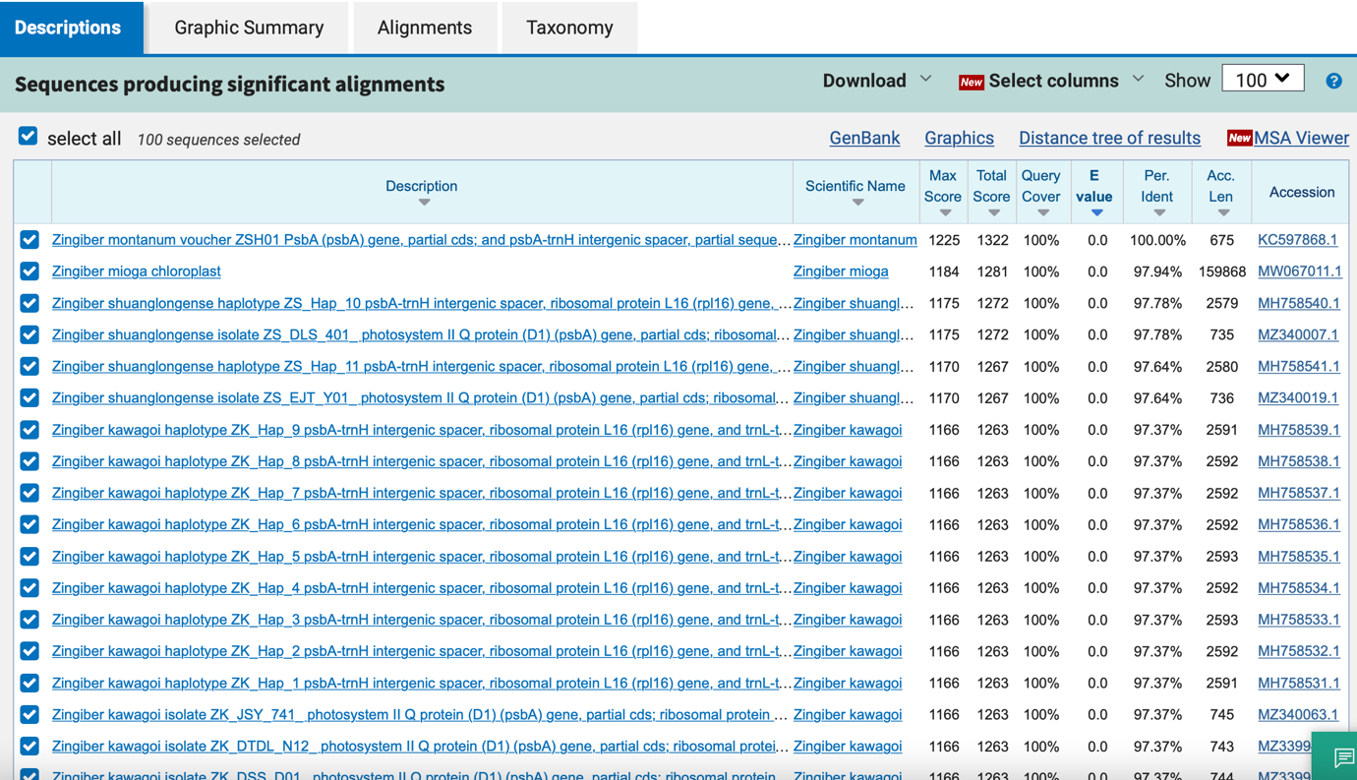

rbcL

