Supplementary materials
Self-rated health, socioeconomic status and all-cause mortality in Chinese middle-aged and elderly adults
Yayun Fan and Dingliu He
Department of Clinical Nutrition, The Fourth Affiliated Hospital of Nantong University, The First People's Hospital of Yancheng, Yancheng, 224001, P. R. China
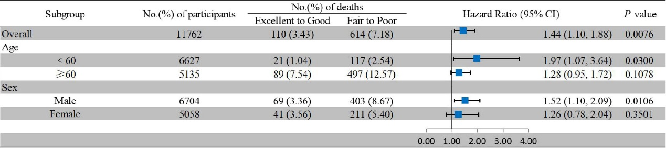
Supplementary Figure 1 Stratified analyses of age and sex in the association of SRH with all-cause mortality

