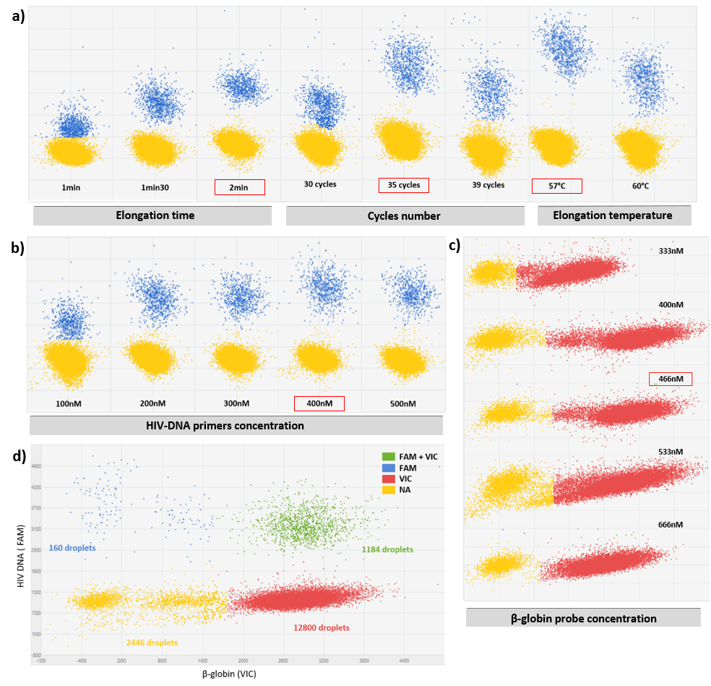
Supplemental Figure S1. Development of the HIV-1 DNA and β-globin duplex PCR. Optimization of a) the number of cycles, elongation time and temperature of the digital PCR program, b) the concentration of HIV DNA primers in the PCR mix, c) the concentration of the internal control β-globin probe. The red boxes show the choices made for each of these criteria. d) Example of a plot obtained with digital duplex PCR.

