Supporting Information: Rodrigo Tomazetto de Carvalho, Gustavo Miranda Rocha, Cláudia Santiago Karez, Ricardo da Gama Bahia, Renato Crespo Pereira, Alex Cardoso Bastos, Leonardo Tavares Salgado

Global assessment of coralline algae mineralogy points to high vulnerability of Southwestern Atlantic reefs and rhodolith beds to ocean acidification

Table S1: List of all the specimens collected for this study, their respective collection sites and Herbarium Voucher.

Specimen | Collection Site | Voucher
Amphiroa anastomosans | Espírito Santo | N.I.*
Amphiroa anastomosans | (19º54’00”S, 40º05’53”W)
Amphiroa brasiliana | Espírito Santo | N.I.*
Amphiroa brasiliana | (19º55’32”S, 40º06’13”W)
Amphiroa fragilissima | Espírito Santo | N.I.*
Amphiroa fragilissima | (19º55’93”S, 40º07’16”W)
Amphiroa rígida | Espírito Santo | N.I.*
Amphiroa rígida | (19º58’32”S, 40º08’18”W)
Corallina panizzoi | Espírito Santo | N.I.*
Corallina panizzoi | (19º59’99”S, 40º08’82”W)
Harveylithon rupestre (as Hydrolithon rupestre) | Saint Peter & Saint Paul Archipelago | RB 553503
Harveylithon rupestre (as Hydrolithon rupestre) | (0º91’73”N, 29º34’57”W)
Jania adhaerens | Espírito Santo | N.I.*
Jania adhaerens | (20º02’05”S, 40º09’32”W)
Jania cubensis | Espírito Santo | N.I.*
Jania cubensis | (20º02’14”S, 40º10’22”W)
Jania subulata | Espírito Santo | N.I.*
Jania subulata | (20º04’40”S, 40º10’49”W)
Lithophyllum attlanticum | Arvoredo Island | FLOR 14568
Lithophyllum attlanticum | (27º16’32”S, 48º22’74”W)
Lithophyllum corallinae | Rio de Janeiro | N.I.*
Lithophyllum corallinae | (22º95’31”S, 43º16’12”W)
Lithophyllum kaiseri (as Lithophyllum congestum) | Abrolhos | RB 382794
Lithophyllum kaiseri (as Lithophyllum congestum) | (17º57’50”S, 38º42’02”W)
Lithophyllum margaritae | Arvoredo Island | FLOR 14570
Lithophyllum margaritae | (27º16’32”S, 48º22’74”W)
Lithophyllum stictaeforme | Abrolhos | RB 525142
Lithophyllum stictaeforme | (17º57’45”S, 38º41’43”W)
Lithothamnion crispatum | Vitória | RB 623157
Lithothamnion crispatum | (20º31’61”S, 40º27’11”W)
Lithothamnion crispatum | Salvador | RB 563698
Lithothamnion crispatum | (12º58’01”S, 38º22’13”W)
Lithothamnion crispatum | Amazon River Mouth | N.I.*
Lithothamnion crispatum | (3º31’07N, 49º95’15”W)
Lithothamnion crispatum | Abrolhos | RB 525146
Lithothamnion crispatum | (17º57’45”S, 38º41’43”)
Lithothamnion crispatum | Trindade Island | RB 563699
Lithothamnion crispatum | (20º30’13”S, 29º21’19”W)
Lithothamnion muelleri | Abrolhos | RB 564946
Lithothamnion muelleri | (17º57’45”S, 38º40’18”W)
Melyvonnea erubescens (as Mesophyllum erubescens) | Abrolhos | RB 623166
Melyvonnea erubescens (as Mesophyllum erubescens) | (17º57’45”S, 38º41’43”W)
Melyvonnea erubescens (as Mesophyllum erubescens) | Aracruz | RB 537866
Melyvonnea erubescens (as Mesophyllum erubescens) | (3º87’19”S, 32º41’46”W)
Neogoniolithon sp. | Abrolhos | RB 581400
Neogoniolithon sp. | (17º57’45”S, 38º41’49”W)
Pneophyllum conicum | Abrolhos | RB 621929
Pneophyllum conicum | (17º57’45”S, 38º40’18”W)
Porolithon onkodes | Abrolhos | RB 623155
Porolithon onkodes | (17º47’00”S, 39º03’05”)
Porolithon onkodes | Salvador | RB 623151
Porolithon onkodes | (12º95’70”S, 38º35’92”W)
Sporolithon episporum | Abrolhos | RB 525149
Sporolithon episporum | (17º47’00”S, 39º03’05”W)
Sporolithon ptychoides | Abrolhos | RB 621750
Sporolithon ptychoides | (3º87’19”S, 32º41’46”W)
Sporolithon sp. | Campos | RB 614603
Sporolithon sp. | (21º88’40”S, 40º94’43”W)
Sporolithon yoneshigueae | Abrolhos | RB 621753
Sporolithon yoneshigueae | (17º48’35”S, 38º11’03”W)
*NI= Not included yet.

Table S2: Mineralogy of CCA in this study (bold letters) collected from the Southwest Atlantic Ocean (Brazil) and in other studies from four main regions: The Caribbean Sea; the Adriatic/Mediterranean Sea; the Indo-Pacific Ocean; and the North Atlantic Ocean, including the Arctic Ocean.

Family | Genus | Species | Location | Region | Wt% Calcite | Wt% MgCO₃ | Source
Corallinaceae | Neogoniolithon | acropetum | Culebra Island, Puerto Rico | Caribbean | 100 | 19.24 | Clarke & Wheeler, 1922 (as Goniolithon acropetum)
Corallinaceae | Neogoniolithon | brassica-florida | New Zeland | Pacific Ocean | 97 to 99 | 13.1 | Smith et al., 2011
Corallinaceae | Neogoniolithon | sp. | Abrolhos Bank, Brazil | Southwest Atlantic Ocean | 99.3 | 25.7 | This study
Corallinaceae | Neogoniolithon | fratescens | Cocos-Keeling Islands, Indian Ocean | Indian Ocean | 100 | 13.8 | Clarke & Wheeler, 1922 (as Goniolithon frutescens)
Corallinaceae | Neogoniolithon | orthoblastum | Murray Island, Torres Straits, Australia | Pacific Ocean | 100 | 13.7 | Clarke & Wheeler, 1922 (as Goniolithon orthoblastum)
Corallinaceae | Neogoniolithon | strictum | Bemini Harbour, Bahamas | Caribbean | 100 | 24 | Clarke & Wheeler, 1922 (as Goniolithon strictum)
Corallinaceae | Neogoniolithon | strictum | Soldiers Key, Florida | Caribbean | 100 | 25.2 | Clarke & Wheeler, 1922 (as Goniolithon strictum)
Corallinaceae | Neogoniolithon | strictum | Bemini Harbour, Bahamas | Caribbean | 100 | 23.3 | Clarke & Wheeler, 1922 (as Goniolithon strictum)
Corallinaceae | Harveylithon | rupestre | Saint Peter & Saint Paul Islands, Brazil | Southwest Atlantic Ocean | 87.5 | 32.5 | This study (*)
Corallinaceae | Hydrolithon | craspedium | Palmyra Island, Pacific | Pacific Ocean | 100 | 19.6 | Clarke & Wheeler, 1922 (as Lithophyllum craspedium)
Corallinaceae | Lithophyllum | attlanticum | Arvoredo Island, Brazil | Southwest Atlantic Ocean | 95.7 | 16.4 | This study (*)
Corallinaceae | Lithophyllum | antillarum | Culebra Island, Puerto Rico | Caribbean | 100 | 16.4 | Clarke & Wheeler, 1922
Corallinaceae | Lithophyllum | byssoides | Losini, middle Adriatic | Adriatic/Mediterrenean | 98 | 16 to 20 | Medakovic et al., 1995 (as Lithophyllum lichenoides)
Corallinaceae | Lithophyllum | byssoides | Kornati, middle Adriatic | Adriatic/Mediterrenean | 98 | 16 to 20 | Medakovic et al., 1995 (as Lithophyllum lichenoides)
Corallinaceae | Lithophyllum | byssoides | Ustica Island, Italy | Adriatic/Mediterrenean | 98,5 | 14 | Mannino, 2003
Corallinaceae | Lithophyllum | carpophylli | New Zeland | Pacific Ocean | 88 to 100 | 12 to 16 | Smith et al., 2012
Corallinaceae | Lithophyllum | corallinae | New Zeland | Pacific Ocean | 80 to 100 | 12 to 16 | Smith et al., 2012
Corallinaceae | Lithophyllum | corallinae | Rio de Janeiro, Brazil | Southwest Atlantic Ocean | 97.9 | 25.2 | This study
Corallinaceae | Lithophyllum | incrustans | Gatteville, Manche, France | North Atlantic Ocean | 100 | 10.8 | Clarke & Wheeler, 1922 (as Lithothamnion incrustans)
Corallinaceae | Lithophyllum | incrustans | Mazagan, Morocco | Adriatic/Mediterrenean | 100 | 9.8 | Clarke & Wheeler, 1922 (as Lithothamnion incrustans)
Corallinaceae | Lithophyllum | incrustans | Banyuls, Mediterranean, France | Adriatic/Mediterrenean | 100 | 14.4 | Clarke & Wheeler, 1922 (as Lithothamnion incrustans)
Corallinaceae | Lithophyllum | intermedium | Fort Clarence, near Kingston, Jamaica | Caribbean | 100 | 16.6 | Clarke & Wheeler, 1922
Corallinaceae | Lithophyllum | kaiseri | Salinas Bay, near Guanica, Puerto Rico | Caribbean | 100 | 19 | Clarke & Wheeler, 1922 (as Lithophyllum daedaleum)
Corallinaceae | Lithophyllum | kaiseri | Abrolhos, Brazil | Southwest Atlantic Ocean | 98.6 | 15.8 | This study
Corallinaceae | Lithophyllum | margaritae | Arvoredo Island, Brazil | Southwest Atlantic Ocean | 98.4 | 13.8 | This study (*)
Corallinaceae | Lithophyllum | oncodes | Coetivy Island, Indian Ocean | Indian Ocean | 100 | 18.2 | Clarke & Wheeler, 1922
Corallinaceae | Lithophyllum | pachydermum | Dollar Harbour, South Cat Cay, Bahamas | Caribbean | 100 | 18.5 | Clarke & Wheeler, 1922
Corallinaceae | Lithophyllum | pallescens | Bay of La Paz, Gulf of California | Pacific Ocean | 100 | 15.5 | Clarke & Wheeler, 1922
Corallinaceae | Lithophyllum | polymorphum | Kattegat | North Atlantic Ocean | 100 | 9.1 | Clarke & Wheeler, 1922 (as Lithothamnium polymorphum)
Corallinaceae | Lithophyllum | postulatum | New Zeland | Pacific Ocean | 95 to 100 | 12 to 15 | Smith et al., 2011
Corallinaceae | Lithophyllum | racemus | Istria, North Adriatic | Adriatic/Mediterrenean | 90 | 16 to 20 | Medakovic et al., 1995
Corallinaceae | Lithophyllum | racemus | Cres Island, middle Adriatic | Adriatic/Mediterrenean | 100 | 16 to 20 | Medakovic et al., 1995
Corallinaceae | Lithophyllum | racemus | Kornati, middle Adriatic | Adriatic/Mediterrenean | 100 | 16 to 20 | Medakovic et al., 1995
Corallinaceae | Lithophyllum | racemus | Naples, Italy | Adriatic/Mediterrenean | 100 | 11.3 | Clarke & Wheeler, 1922 (as Lithothamnium racemus)
Corallinaceae | Lithophyllum | racemus | Bahamas | Caribbean | 100 | 5.4 | Clarke & Wheeler, 1922
Corallinaceae | Lithophyllum | riosmenae | New Zeland | Pacific Ocean | 98 | 12.7 | Smith et al., 2012
Corallinaceae | Lithophyllum | stictaeforme | New Zeland | Pacific Ocean | 90 to 100 | 13 to 15 | Smith et al., 2012
Corallinaceae | Lithophyllum | stictaeforme | Abrolhos Bank, Brazil | Southwest Atlantic Ocean | 96.8 | 17.8 | This study
Corallinaceae | Lithophyllum | sp. | Mediterranean | Adriatic/Mediterrenean | 100 | 12.8 | Clarke & Wheeler, 1922
Corallinaceae | Lithophyllum | sp. | New Zeland | Pacific Ocean | 90 to 100 | 13 to 16 | Smith et al., 2012
Corallinaceae | Lithophyllum | pygmaeum | New Guinea | Pacific Ocean | 100 | 20 | Clarke & Wheeler, 1922 (as Lithophyllum tamiense)
Corallinaceae | Mastophora | pacifica | New Zeland | Pacific Ocean | 100 | 13.5 | Smith et al., 2012
Corallinaceae | Pneophyllum | conicum | Abrolhos Bank, Brazil | Southwest Atlantic Ocean | 90.4 | 25.7 | This study (*)
Corallinaceae | Porolithon | onkodes | Coetivy I., Indian Ocean | Indian Ocean | 100 | 18.2 | Clarke & Wheeler, 1922 (as Lithophyllum onkodes)
Corallinaceae | Porolithon | onkodes | Dollar Harbour, South Cat Cay, Bahamas | Caribbean | 100 | 18.5 | Clarke & Wheeler, 1922 (as Lithophyllum pachydermum)
Corallinaceae | Porolithon | onkodes | Culebra Island, Puerto Rico | Caribbean | 100 | 16.4 | Clarke & Wheeler, 1922 (as Lithophyllum antillarum)
Corallinaceae | Porolithon | onkodes | Abrolhos Bank, Brazil | Southwest Atlantic Ocean | 92.5 | 24.2 | This study
Corallinaceae | Pseudolithophyllum | expansum | Istria, North Adriatic | Adriatic/Mediterrenean | 94.6 | 16 to 20 | Medakovic et al., 1995
Corallinaceae | Pseudolithophyllum | expansum | Ist Island, middle Adriatic | Adriatic/Mediterrenean | 100 | 16 to 20 | Medakovic et al., 1995
Corallinaceae | Pseudolithophyllum | expansum | Kornati, middle Adriatic | Adriatic/Mediterrenean | 15 | 16 to 20 | Medakovic et al., 1995
Corallinaceae | Tenarea | tortuosa | Genoa, Italy | Adriatic/Mediterrenean | 100 | 9.3 | Clarke & Wheeler, 1922 (as Lithothamnion tortuosum)
Corallinaceae | Tenarea | tortuosa | Naples, Italy | Adriatic/Mediterrenean | 100 | 11.6 | Clarke & Wheeler, 1922
Corallinaceae | Tenarea | tortuosa | Kornati, middle Adriatic | Adriatic/Mediterrenean | 100 | 16 to 20 | Medakovic et al., 1995 (as Tenarea undulosa)
Corallinaceae | Spongites | fruticulosus | Naples, Italy | Adriatic/Mediterrenean | 100 | 8.1 | Clarke & Wheeler, 1922 (as Lithothamnion ramulosum)
Hapalidiaceae | Lithothamnion | crispatum | New Zeland | Pacific Ocean | 86 | 10.8 | Smith et al., 2011
Hapalidiaceae | Lithothamnion | crispatum | Abrolhos Bank, Brazil | Southwest Atlantic Ocean | 88.8 | 22.8 | This study
Hapalidiaceae | Lithothamnion | crispatum | Amazon river mouth, Brazil | Southwest Atlantic Ocean | 79.5 | 19.2 | This study
Hapalidiaceae | Lithothamnion | crispatum | Salvador, Bahia, Brazil | Southwest Atlantic Ocean | 79.9 | 16.4 | This study
Hapalidiaceae | Lithothamnion | crispatum | Trindade Island, Brazil | Southwest Atlantic Ocean | 80.3 | 16.4 | This study
Hapalidiaceae | Lithothamnion | crispatum | Vitória, Espírito Santo, Brazil | Southwest Atlantic Ocean | 76.7 | 16.2 | This study
Hapalidiaceae | Lithothamnion | fornicatum | Norway | North Atlantic Ocean | 100 | 9.3 | Clarke & Wheeler, 1922
Hapalidiaceae | Lithothamnion | glaciale | Isle of Arran, Loch Sween | North Atlantic Ocean | 100 | 12.9 to 24.6 | Kamenos et al., 2008
Hapalidiaceae | Lithothamnion | glaciale | Conception Bay, Newfoundland | North Atlantic Ocean | 100 | 10.9 | Clarke & Wheeler, 1922
Hapalidiaceae | Lithothamnion | glaciale | Arctic Ocean | Artic Ocean | 100 | 13.2 | Clarke & Wheeler, 1922
Hapalidiaceae | Lithothamnion | kaiseri | Cocos-Keeling Islands, Indian Ocean | Indian Ocean | 100 | 15.3 | Clarke & Wheeler, 1922 (as Lithophyllum kaiseri)
Hapalidiaceae | Lithothamnion | muelleri | Abrolhos Bank, Brazil | Southwest Atlantic Ocean | 89.7 | 14.5 | This study (*)
Hapalidiaceae | Lithothamnion | nodosum | no locality stated | - | 100 | 6.1 | Clarke & Wheeler, 1922
Hapalidiaceae | Lithothamnion | Tophiforme | Arctic Ocean | North Atlantic Ocean | 100 | 9.6 | Clarke & Wheeler, 1922 (as Lithothamnium soriferum)
Hapalidiaceae | Lithothamnion | sp. | Bay of Naples | Adriatic/Mediterrenean | 100 | 4.2 | Clarke & Wheeler, 1922
Hapalidiaceae | Lithothamnion | sp. | Java Sea | Pacific Ocean | 100 | 3.8 | Clarke & Wheeler, 1922
Hapalidiaceae | Lithothamnion | sp. | Galapagos Islands | Pacific Ocean | 100 | 6.5 | Clarke & Wheeler, 1922
Hapalidiaceae | Lithothamnion | sp. | Spitsbergen | Artic Ocean | 100 | 8.7 | Clarke & Wheeler, 1922
Hapalidiaceae | Lithothamnion | sp. | Honolulu | Caribbean | 100 | 9.4 | Clarke & Wheeler, 1922
Hapalidiaceae | Lithothamnion | sp. | Bering Islands | Pacific Ocean | 100 | 9.9 | Clarke & Wheeler, 1922
Hapalidiaceae | Lithothamnion | sp. | Bermuda | Caribbean | 100 | 12.4 | Clarke & Wheeler, 1922
Hapalidiaceae | Melobesia | sp. | coast of Algeria | Adriatic/Mediterrenean | 100 | 14.4 | Clarke & Wheeler, 1922
Hapalidiaceae | Mesophyllum | expansum | Istria, North Adriatic | Adriatic/Mediterrenean | 94,6 | 16 to 20 | Medakovic et al., 1995 (as Pseudolithophyllum expansum)
Hapalidiaceae | Mesophyllum | expansum | Ist Island, middle Adriatic | Adriatic/Mediterrenean | 100 | 16 to 20 | Medakovic et al., 1995 (as Pseudolithophyllum expansum)
Hapalidiaceae | Mesophyllum | expansum | Kornati, middle Adriatic | Adriatic/Mediterrenean | 15 | 16 to 20 | Medakovic et al., 1995 (as Pseudolithophyllum expansum)
Hapalidiaceae | Mesophyllum | engelhartii | New Zeland | Pacific Ocean | 96 to 100 | 12 to 15 | Smith et al., 2011
Hapalidiaceae | Mesophyllum | erubecens | New Zeland | Pacific Ocean | 92 to 100 | 11 to 13 | Smith et al., 2011
Hapalidiaceae | Mesophyllum | macroblastum | New Zeland | Pacific Ocean | 73 to 100 | 11 to 15 | Smith et al., 2011
Hapalidiaceae | Mesophyllum | philippii var funafutiensis | Funafuti Atoll | Pacific Ocean | 100 | 5.9 | Clarke & Wheeler, 1922 (as Lithothamnium philipi var. funafutiensis)
Hapalidiaceae | Mesophyllum | printzianum | New Zeland | Pacific Ocean | 73 to 100 | 11 to 16 | Smith et al., 2012
Hapalidiaceae | Mesophyllum | sp. | New Zeland | Pacific Ocean | 91.8 | 11.9 | Smith et al., 2012
Hapalidiaceae | Mesophyllum | sp. | New Zeland | Pacific Ocean | 91 to 100 | 11 to 13 | Smith et al., 2012
Hapalidiaceae | Melyvonnea | erubecens | New Zeland | Pacific Ocean | 92 to 100 | 11 to 13 | Smith et al., 2012
Hapalidiaceae | Melyvonnea | erubecens | Haingsisi, near Timor | Pacific Ocean | 100 | 16.9 | Clarke & Wheeler, 1922 (as Lithothamnion erubecens)
Hapalidiaceae | Melyvonnea | erubecens | Abrolhos Bank, Brazil | Southwest Atlantic Ocean | 95.2 | 17.8 | This study
Hapalidiaceae | Melyvonnea | erubecens | Aracruz, Espírito Santo, Brazil | Southwest Atlantic Ocean | 93.7 | 25.5 | This study
Hapalidiaceae | Phymatolithon | calcareum | Isle of Arran, Loch Sween | North Atlantic Ocean | 100 | 14.7 to 23.8 | Kamenos et al., 2008
Hapalidiaceae | Phymatolithon | calcareum | St Vaast la Hougue, Manche, France | North Atlantic Ocean | 100 | 11.8 | Clarke & Wheeler, 1922 (as Lithothamnium calcareum)
Hapalidiaceae | Phymatolithon | calcareum | Isle Glenan, Finistere, France | North Atlantic Ocean | 100 | 10.7 | Clarke & Wheeler, 1922 (as Lithothamnium calcareum)
Hapalidiaceae | Phymatolithon | calcareum | Roscoff, Finistere, France | North Atlantic Ocean | 100 | 11.8 | Clarke & Wheeler, 1922 (as Lithothamnium calcareum)
Hapalidiaceae | Phymatolithon | calcareum | Losini, middle Adriatic | Adriatic/Mediterrenean | 97 | 16 to 20 | Medakovic et al., 1995
Hapalidiaceae | Phymatolithon | repandum | New Zeland | Pacific Ocean | 100 | 11.2 | Smith et al., 2012
Hapalidiaceae | Clathromorphum | compactum | Torbay, Newfoundland | North Atlantic Ocean | 100 | 10.93 | Clarke & Wheeler, 1922
Sporolitaceae | Heydrichia | homalopasta | New Zeland | Pacific Ocean | 100 | 12.8 | Smith et al., 2012
Sporolitaceae | Heydrichia | woelkerlingii | New Zeland | Pacific Ocean | 100 | 14.5 | Smith et al., 2012
Sporolitaceae | Sporolithon | durum | New Zeland | Pacific Ocean | 98 to 100 | 12 to 15 | Smith et al., 2012
Sporolitaceae | Sporolithon | episporum | Point Toro, Isthmus of Panama | Caribbean | 100 | 13.09 | Clarke & Wheeler, 1922
Sporolitaceae | Sporolithon | episporum | Abrolhos Bank, Brazil | Southwest Atlantic Ocean | 95.5 | 19.9 | This study
Sporolitaceae | Sporolithon | sp. | New Zeland | Pacific Ocean | 90 to 100 | 11 to 14 | Smith et al., 2011
Sporolitaceae | Sporolithon | sp. | Rio de Janeiro, Brazil | Southwest Atlantic Ocean | 81.7 | 23.8 | This study (*)
Sporolitaceae | Sporolithon | amadoi | Fernando de Noronha Island, Brazil | Southwest Atlantic Ocean | 97.8 | 24.5 | This study (*)
Sporolitaceae | Sporolithon | yoneshigueae | Abrolhos Bank, Brazil | Southwest Atlantic Ocean | 69.8 | 28.9 | This study (*)

Figure S1:

Figure S1: Cluster analysis of the mineralogy of the three coralline algae families. SIMPROF Test showed no difference between the mineralogy from Corallinaceae, Hapalidiaceae and Sporolithaceae.

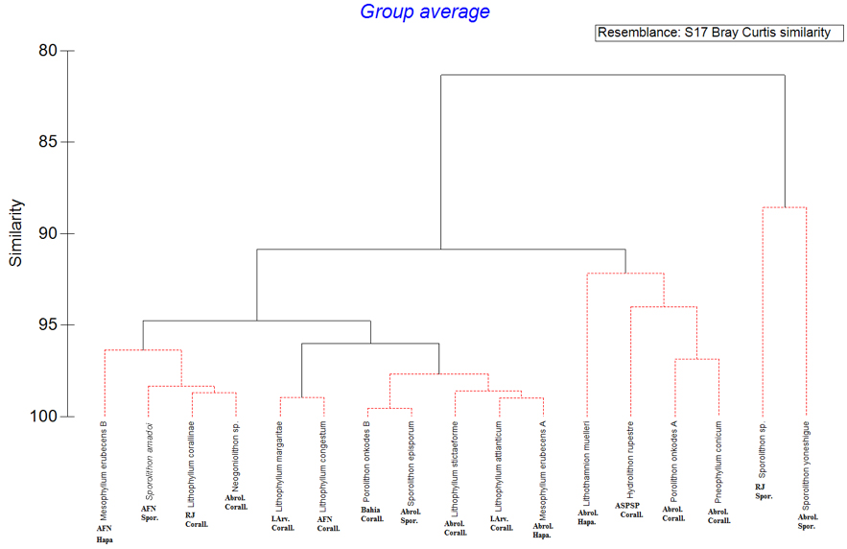
Figure S2

A
Figure S2: Cluster analysis of the mineralogy data from all the coralline algae species analyzed in this study. There were neither correlation between mineralogical data and coralline algae taxonomy nor collection site. Abbreviations: AFN – Archipelago of Fernando de Noronha; RJ – Rio de Janeiro; Abrol. –Abrolhos; I.Arv. – Island Arvoredo; ASPSP – Archipelago of São Pedro e São Paulo; Hapa. – Hapalidiaceae; Spor. – Sporolithaceae; Corall. – Corallinaceae.

Figure S3

Figure S3: Cluster analysis of the mineralogical data from Lithothamnion crispatum samples collected in different sites: A – Amazonia; B – Trindade Island (ES); C – Espírito Santo; D – Abrolhos (BA); E – Salvador (BA). ES = Espírito Santo State and BA = Bahia State.

Figure S4

Figure S4: Mineralogical data from Lithothamnion crispatum collected in five different sampling sites: Abrolhos (BA), Trindade Island (ES), Salvador (BA), Amazonia and Espírito Santo (coordinates listed in Table S1). Specimens from Abrolhos presented a distinct pattern from other localities with more high-Mg calcite, less aragonite and the highest Mg substitution in calcite. ES = Espírito Santo State and BA = Bahia State.

Figure S5

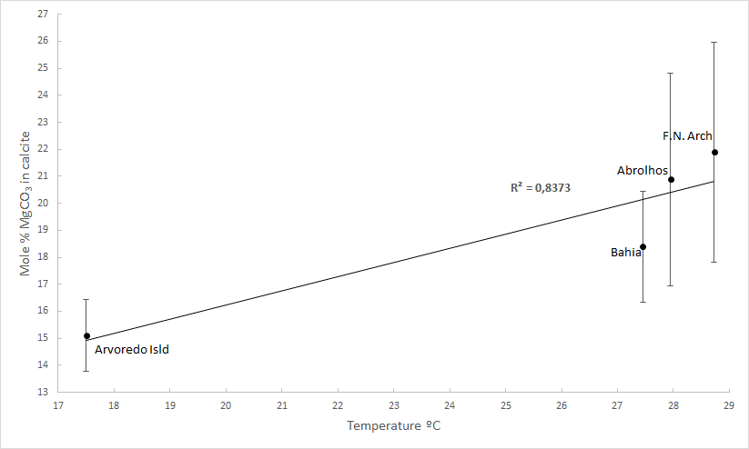Figure S5: Relationship between Mole % MgCO₃ in calcite and temperature from the locations with the highest sample size of coralline algae analyzed. Coefficient of determination from the linear regression (R² = 0.8373) indicates that the increase of Mg substitution in calcite from Southwestern Ocean coralline algae is related to the increase of seawater temperature.

