Supplementary Material
Supplementary Table 1. Patient Population.

Supplementary Table 2. ICD-10-CM Diagnoses included in the study.
# | Diagnosis
1 | D63: Anemia in chronic diseases classified elsewhere
2 | D64: Other anemias
3 | E03: Other hypothyroidism
4 | E11: Diabetes
5 | E55: Vitamin D deficiency
6 | E78: Lipidemia
7 | E86:Volume depletion
8 | E87: Other disorders of fluid, electrolyte and acid-base balance
9 | F03: Unspecified dementia
10 | F10: Alcohol related disorders
11 | F17: Nicotine dependence
12 | F32: Major depressive disorder, single episode
13 | F41: Anxiety Disorders
14 | G47: Sleep disorders are represented
15 | G89: Pain, not elsewhere classified
16 | I10: Hypertension
17 | I12: Hypertensive chronic kidney disease
18 | I25: Heart disease
19 | I48: Atrial fibrillation and flutter are prevalent
20 | I50: Heart failure
21 | I65: Occlusion and stenosis of precerebral arteries, not resulting in cerebral infarction
22 | I73: Other peripheral vascular diseases
23 | J44: Other chronic obstructive pulmonary disease
24 | J45: Asthma
25 | K21: GERD
26 | K57: Diverticular disease of intestine
27 | K59: Other functional intestinal disorders
28 | M17: Osteoarthritis of knee
29 | M19: Other and unspecified osteoarthritis
30 | M25: Other Joint Disorders
31 | M54: Dorsalgia
32 | M79: Other and unspecified soft tissue disorders, not elsewhere classified
33 | M81: Osteoporosis without current pathological fracture
34 | N17: Acute kidney failure
35 | N18: Chronic kidney disease (CKD)
36 | N28: Other disorders of kidney and ureter, not elsewhere classified
37 | N39: Other disorders of urinary system
38 | N40: Benign prostatic hyperplasia

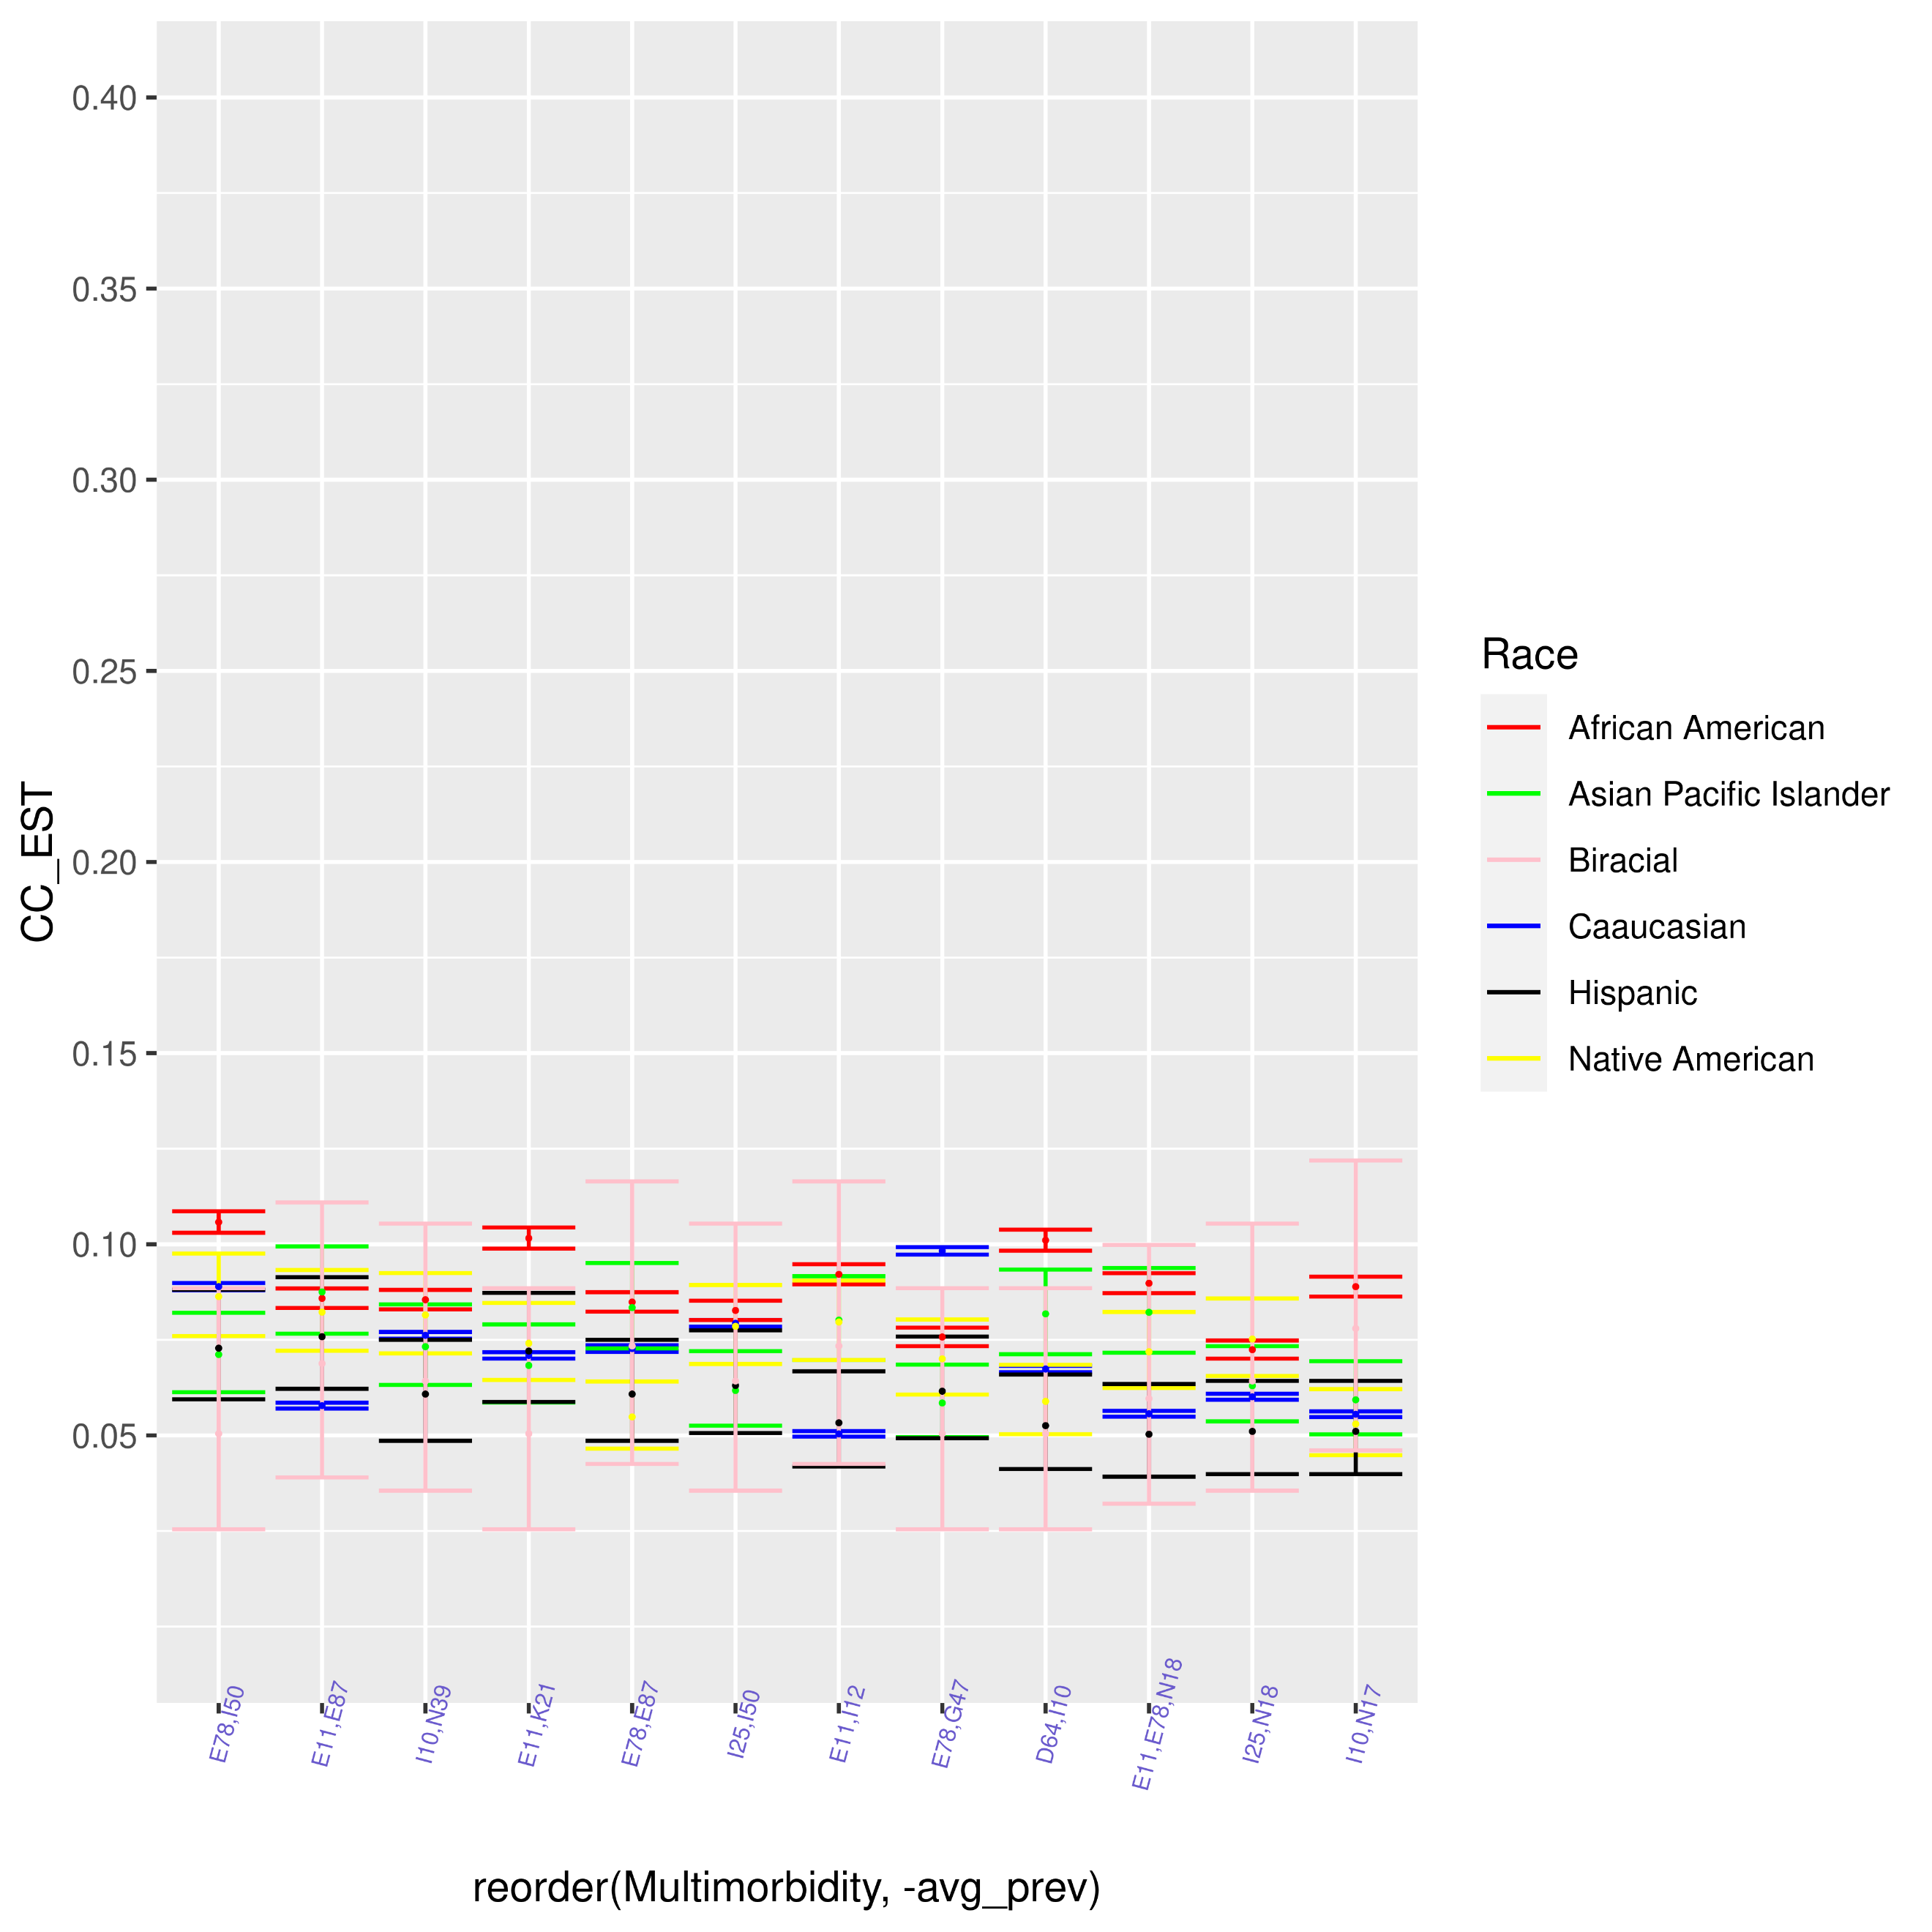
Supplementary Figure 1: Confidence Interval Overlap for Elderly Patients with Obesity Shared by All Races & Average Prevalence <0.08.
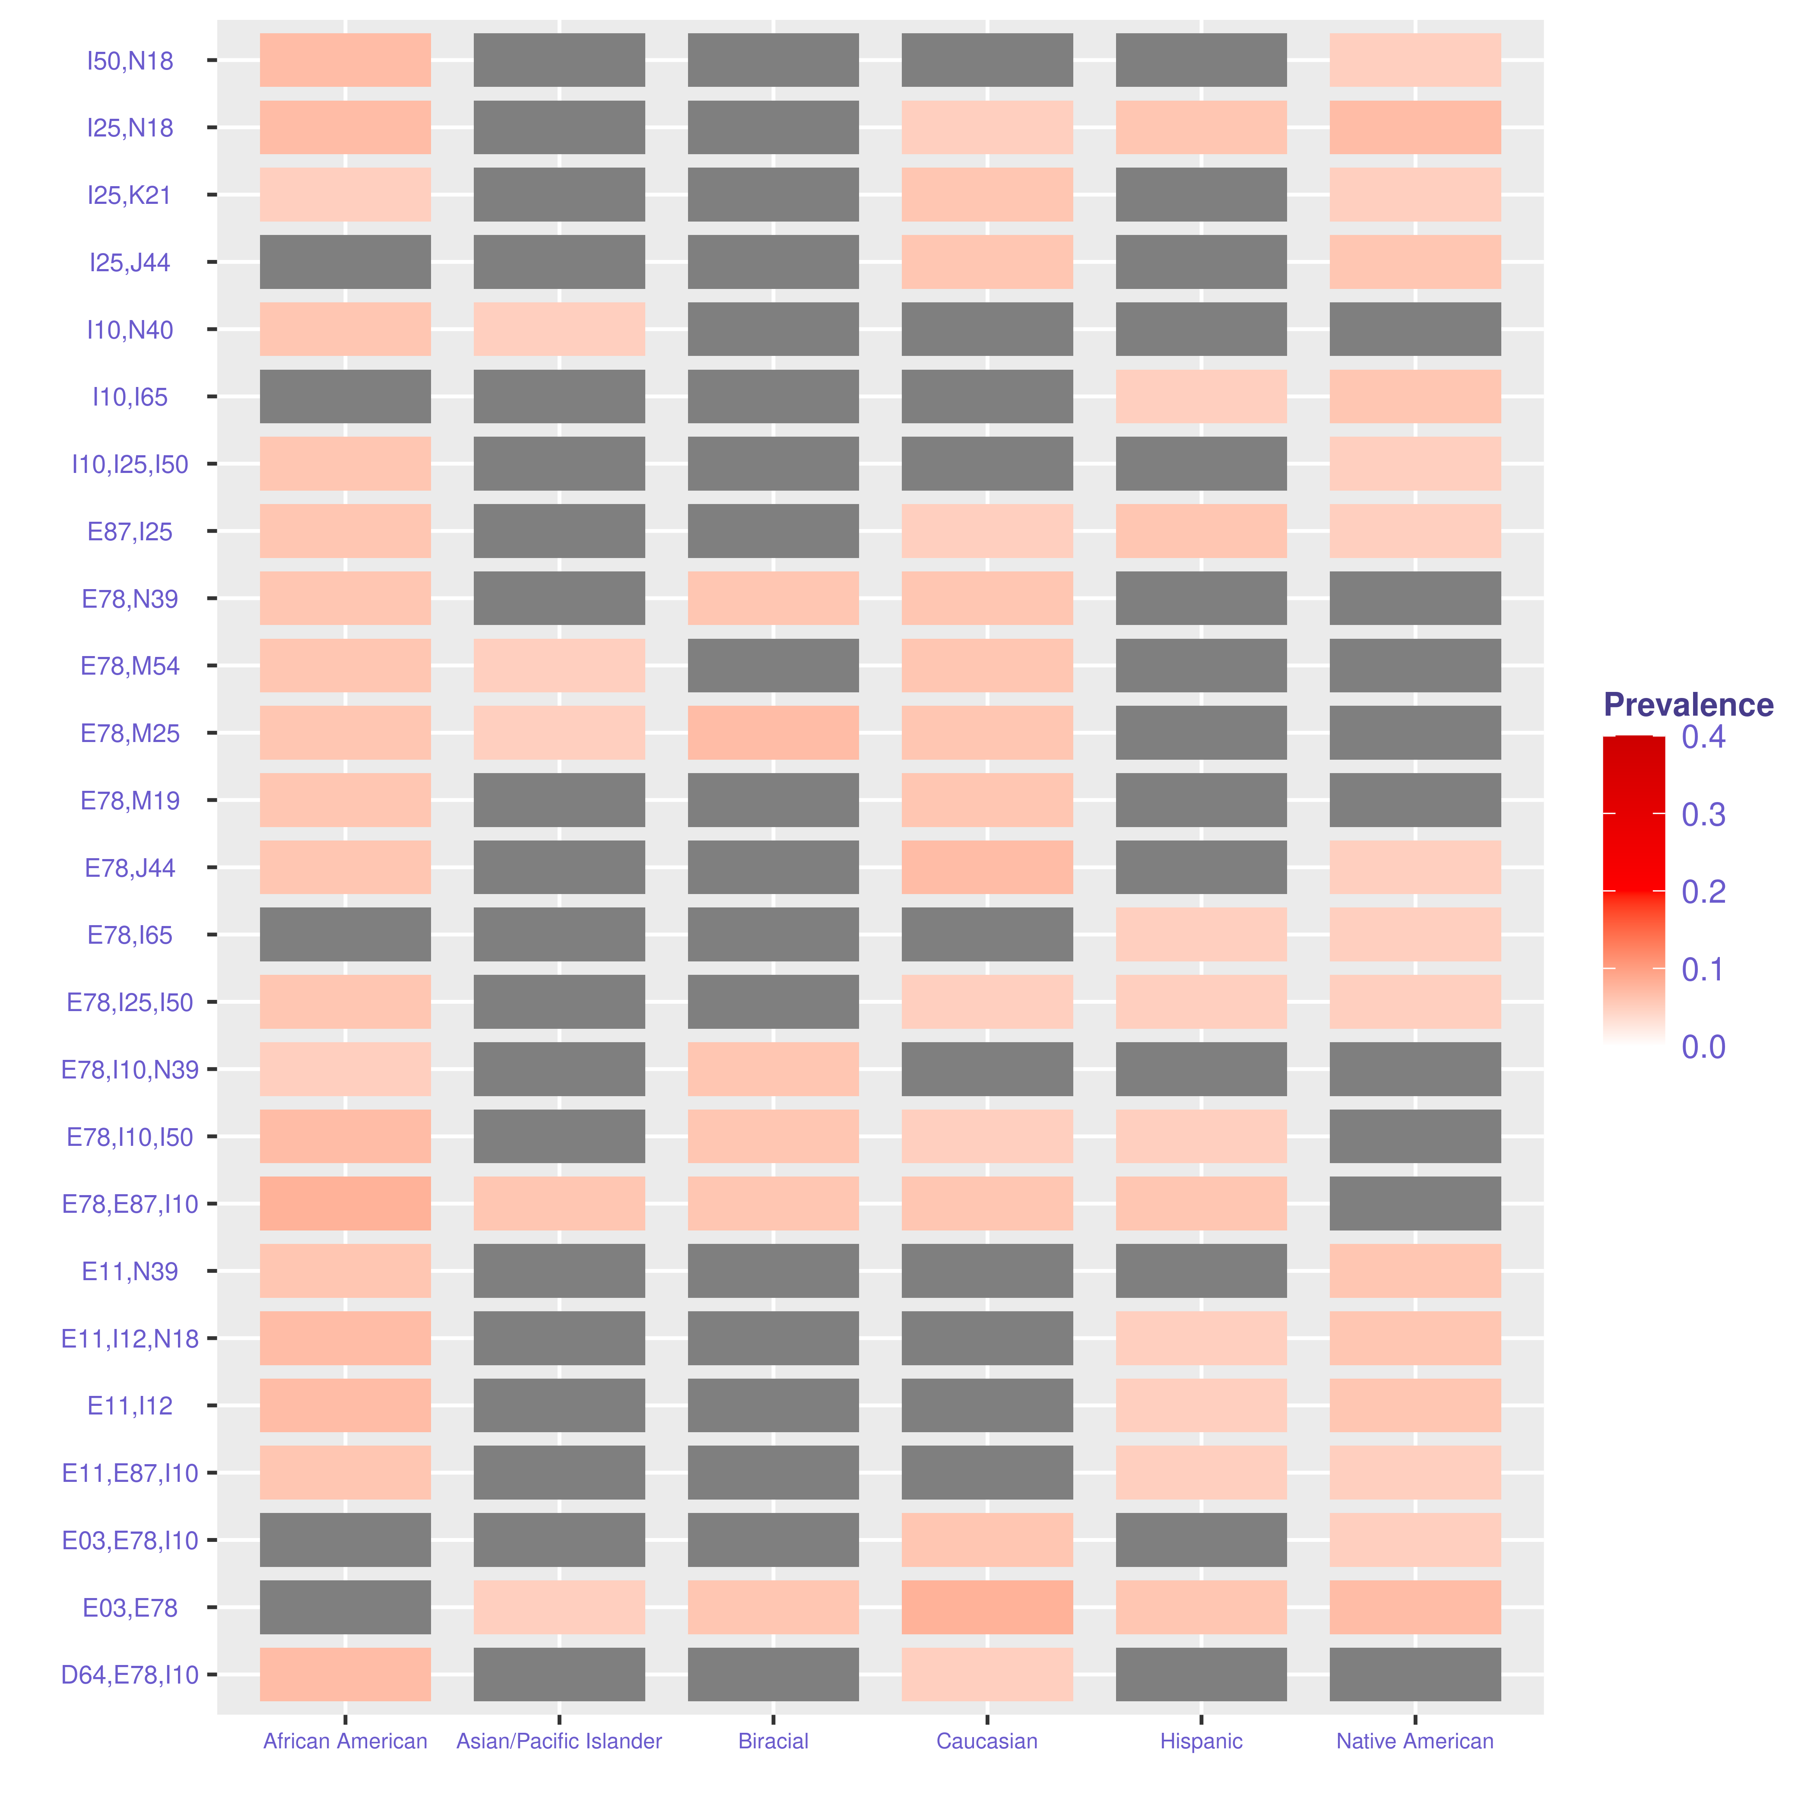
Supplementary Figure 2: Multimorbidities Shared by Some Races for Elderly Patients without Obesity & Average Prevalence < 0.065. Red box indicates non-significant g-test.

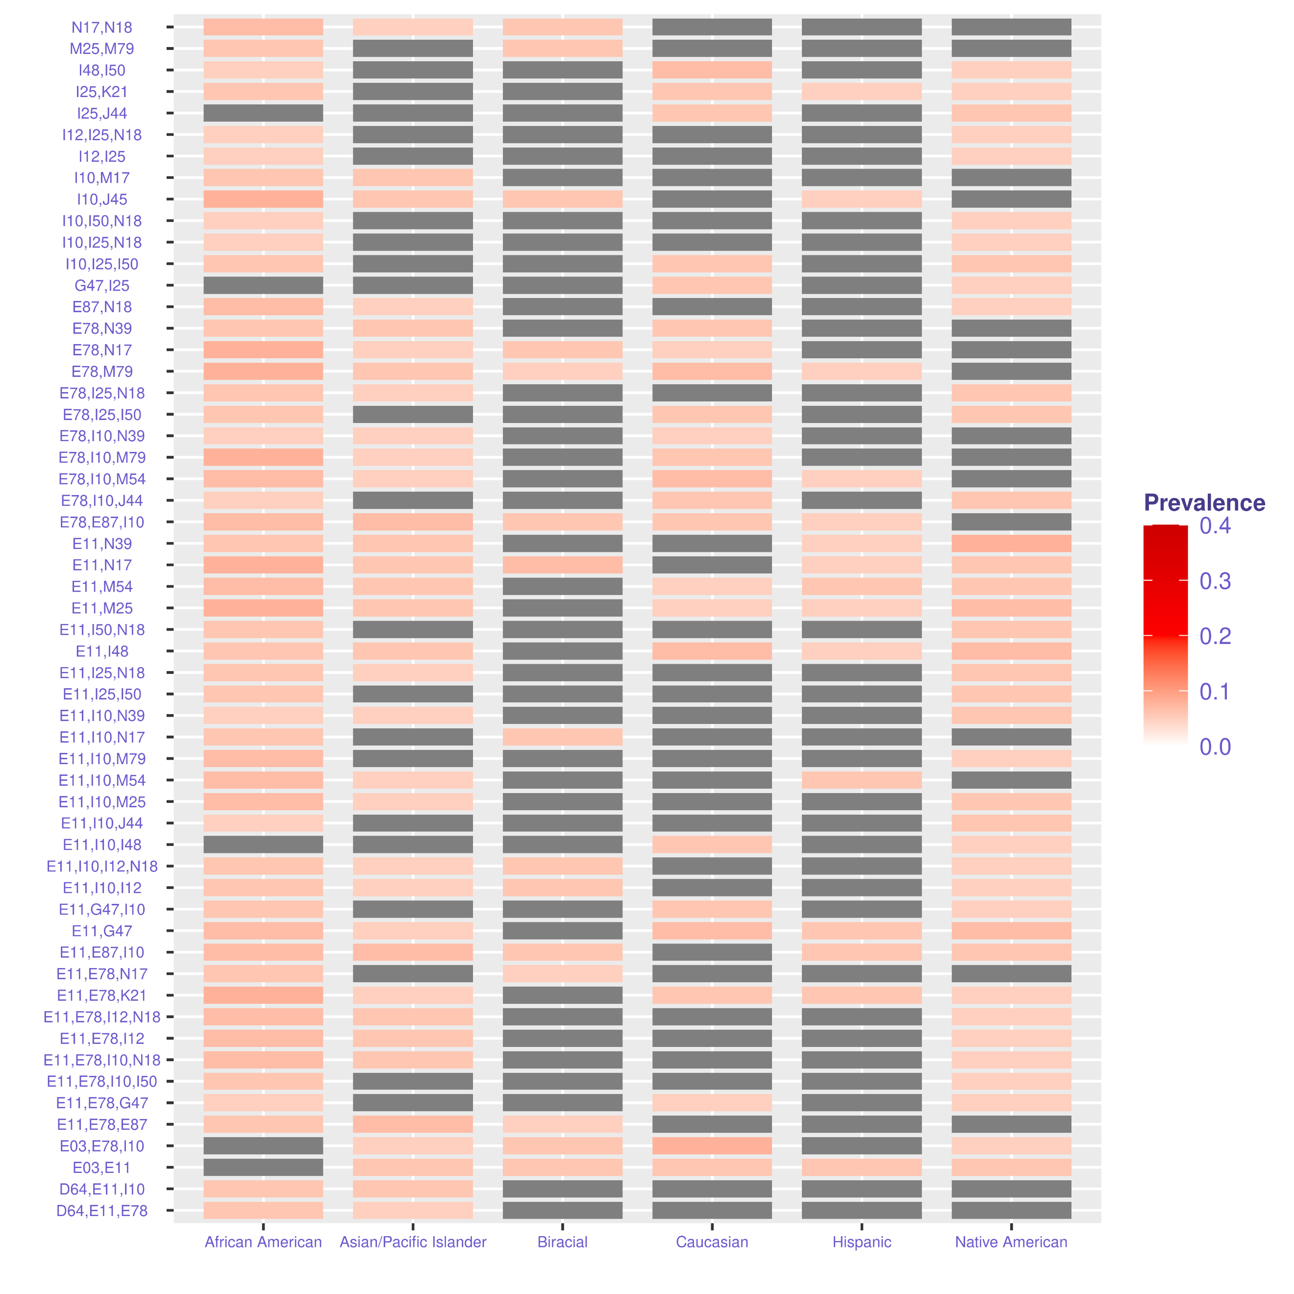
Supplementary Figure 3: Multimorbidities Shared by Some Races for Elderly Patients with Obesity & Average Prevalence <0.065.

