Supplementary materials

Supplementary Figures
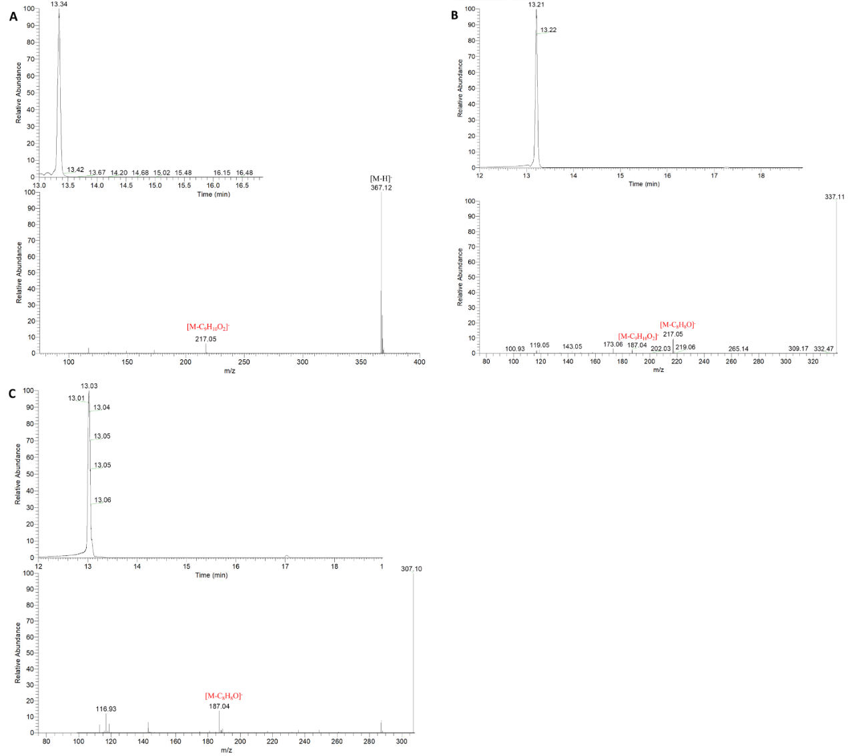

Figure S1: Identification of curcuminoids (curcumin, desmethoxycurcumin, bisdesmethoxycurcumin)
(A) Total ion chromatogram of curcumin in negative ionization modes and mass spectrum at RT 13.34 min. (B) Total ion chromatogram of desmethoxycurcumin in negative ionization modes and mass spectrum at RT 13.21 min. (C) Total ion chromatogram of bisdesmethoxycurcumin in negative ionization modes and mass spectrum at RT 13.04 min.

Flavonoids
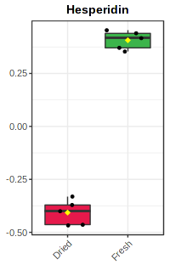 |  | 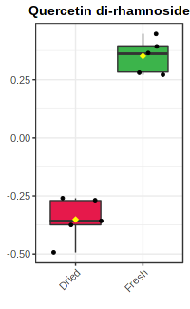
Amino acids
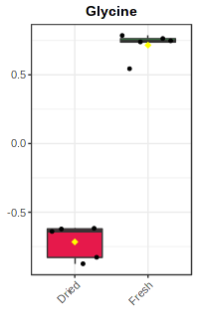 | 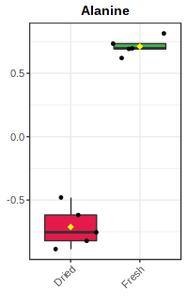 |  | 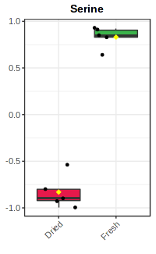 | 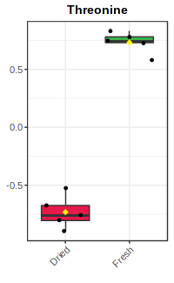 | 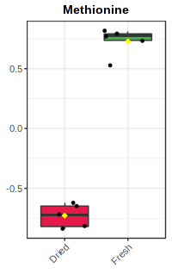
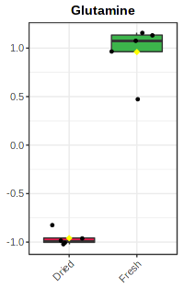 | 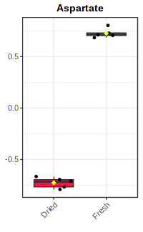 |  | 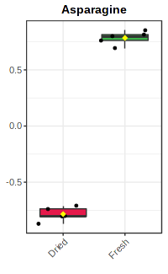
Organic acids
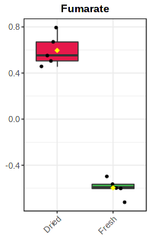 | 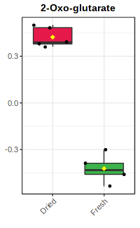 |  | 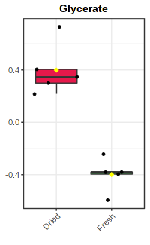 | 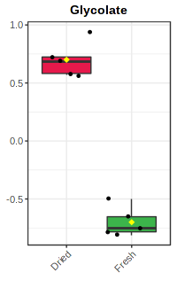
Others
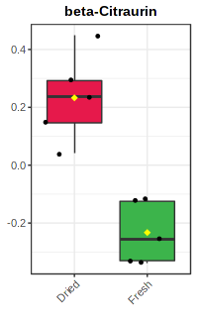 | 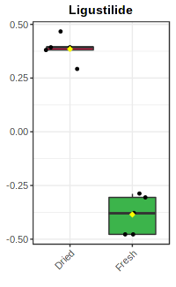 |  | 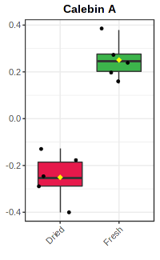 | 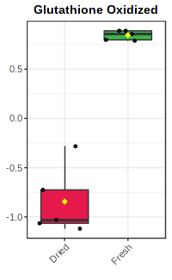 | 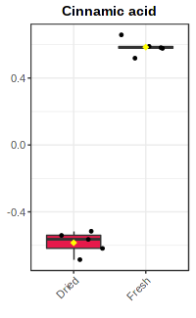

Suppl. Figure S2: Comparison between the relative abundances of some metabolites, i.e., amino acids and organic acids, detected in turmeric (Curcuma longa L.) in fresh and dried samples. Flavonoids and amino acids were richer in fresh samples, while organic acids in dried analogues.

Supplementary Tables
Table S1: Relative abundances of tentatively identified metabolites in turmeric fresh and dried rhizomes following application of a comprehensive extraction protocol, fractionation, and analysis by LC-MS/MS and GC-TOF-MS.
Metabolite # | Phase and technique of detection | Compound name | Molecular formula | Relative abundances ± SD (x10⁴)
 |  |  |  | Fresh sample | Dried samples
Curcuminoids
 | - Polar metabolites in MeOH/H₂O phase  - UPLC-C₁₈-FT-MS/MS | 1,2-dihydrobis(de-O-methyl)-curcumin | C₁₉H₁₈O₄ | 367.2±43.4 | 922.1±53.0
 | - Polar metabolites in MeOH/H₂O phase  - UPLC-C₁₈-FT-MS/MS | Bisdemthoxycurcumin | C₁₉H₁₆O₄ | 2198.7±304.3 | 5078±198.1
 | - Polar metabolites in MeOH/H₂O phase  - UPLC-C₁₈-FT-MS/MS | Curcumalongin A | C₂₀H₁₆O₆ | 2182.7±111.3 | 591.8±50.6
 | - Polar metabolites in MeOH/H₂O phase  - UPLC-C₁₈-FT-MS/MS | Curcumalongin B | C₂₁H₁₈O₇ | 503.7±79.7 | 1517.1±75.4
 | - Polar metabolites in MeOH/H₂O phase  - UPLC-C₁₈-FT-MS/MS | Curcumin | C₂₁H₂₀O₆ | 728.6±68.8 | 1887.5±160.7
 | - Polar metabolites in MeOH/H₂O phase  - UPLC-C₁₈-FT-MS/MS | Curcumin dimer | C₄₂H₃₈O₁₂ | 25.1±22.2 | 21.0±18.9
 | - Polar metabolites in MeOH/H₂O phase  - UPLC-C₁₈-FT-MS/MS | Demethoxy curcumin | C₂₀H₁₈O₅ | 3851.7±238.1 | 5670.1±51.8
 | - Polar metabolites in MeOH/H₂O phase  - UPLC-C₁₈-FT-MS/MS | Didemethoxybisabolocurcumin ether | C₃₄H₃₈O₆ | 12.8±1.5 | 17.6±1.8
 | - Polar metabolites in MeOH/H₂O phase  - UPLC-C₁₈-FT-MS/MS | Dihydrocurcumin | C₂₁H₂₂O₆ | 644.8±35.4 | 1062.3±65.7
 | - Polar metabolites in MeOH/H₂O phase  - UPLC-C₁₈-FT-MS/MS | Dihydrodemethoxycurcumin | C₂₀H₂₀O₅ | 113.2±8.3 | 242.6±20.7
 | - Polar metabolites in MeOH/H₂O phase  - UPLC-C₁₈-FT-MS/MS | keto-curcumin | C₂₁H₁₈O₇ | 503.7±79.7 | 1517.1±75.4
 | - Polar metabolites in MeOH/H₂O phase  - UPLC-C₁₈-FT-MS/MS | Monodemethylcurcumin | C₂₀H₁₈O₆ | 2.3±0.6 | 215.2±29.9
 | - Polar metabolites in MeOH/H₂O phase  - UPLC-C₁₈-FT-MS/MS | Tetrahydrodemethoxycurcumin | C₂₀H₂₄O₅ | 2.2±0.1 | 2.9±0.1
 | - Polar metabolites in MeOH/H₂O phase  - UPLC-C₁₈-FT-MS/MS | Tetrahydrodimethoxycurcumin | C₁₉H₂₀O₄ | 2.2±0.1 | 4.0±0.4
 | - Polar metabolites in MeOH/H₂O phase  - UPLC-C₁₈-FT-MS/MS | Bis(3-4-dihydroxybenzylidene) cyclopentanone | C₁₉H₁₆O₅ | 214.7±18.7 | 26.8±3.3
 | - Polar metabolites in MeOH/H₂O phase  - UPLC-C₁₈-FT-MS/MS | 1-7-Bis(4-hydroxyphenyl)-3-5-heptanediol | C₂₁H₂₀O₆ | 0.3±0.3 | 1.8±0.0
Lipids
Digalactosyldiacylglycerol (DGDG)
 | - Non -polar metabolites in MTBE phase  - UPLC-C₈-FT-MS/MS | DGDG (34:1) | C₄₉H₉₀O₁₅ | 2.2±0.2 | 1.8±0.1
 | - Non -polar metabolites in MTBE phase  - UPLC-C₈-FT-MS/MS | DGDG (34:2) | C₄₉H₈₈O₁₅ | 11.5±1.1 | 9.63±0.7
 | - Non -polar metabolites in MTBE phase  - UPLC-C₈-FT-MS/MS | DGDG (34:3) | C₄₉H₈₆O₁₅ | 3.0±0.2 | 2.2±0.2
 | - Non -polar metabolites in MTBE phase  - UPLC-C₈-FT-MS/MS | DGDG (35:2) | C₅₀H₉₀O₁₅ | 0.2±0.0 | 0.2±0.0
 | - Non -polar metabolites in MTBE phase  - UPLC-C₈-FT-MS/MS | DGDG (36:1) | C₅₁H₉₄O₁₅ | 0.3±0.0 | 0.3±0.0
 | - Non -polar metabolites in MTBE phase  - UPLC-C₈-FT-MS/MS | DGDG (36:2) | C₅₁H₉₂O₁₅ | 2.3±0.1 | 1.8±0.2
 | - Non -polar metabolites in MTBE phase  - UPLC-C₈-FT-MS/MS | DGDG (36:3) | C₅₁H₉₀O₁₅ | 1.1±0.1 | 1.3±0.1
 | - Non -polar metabolites in MTBE phase  - UPLC-C₈-FT-MS/MS | DGDG (36:4) | C₅₁H₈₈O₁₅ | 3.9±0.3 | 3.2±0.2
 | - Non -polar metabolites in MTBE phase  - UPLC-C₈-FT-MS/MS | DGDG (36:5) | C₅₁H₈₆O₁₅ | 3.1±0.2 | 2.2±0.2
 | - Non -polar metabolites in MTBE phase  - UPLC-C₈-FT-MS/MS | DGDG (36:6) | C₅₃H₈₈O₁₇ | 4.7±0.3 | 3.1±0.3
 | - Non -polar metabolites in MTBE phase  - UPLC-C₈-FT-MS/MS | DGDG (38:2) | C₅₃H₉₆O₁₅ | 0.2±0.0 | 0.2±0.0
 | - Non -polar metabolites in MTBE phase  - UPLC-C₈-FT-MS/MS | DGDG (40:2) | C₅₅H₁₀₀O₁₅ | 0.2±0.0 | 0.1±0.0
 | - Non -polar metabolites in MTBE phase  - UPLC-C₈-FT-MS/MS | DGDG (42:2) | C₅₇H₁₀₄O₁₅ | 9.0±0.6 | 7.3±0.6
Fatty acids (FA)
 | - Polar metabolites in MeOH/H₂O phase  - GC-TOF-MS | FA (9:0) | C₉H₁₈O₂ | 0.4±0.1 | 0.3±0.1
 | - Polar metabolites in MeOH/H₂O phase  - GC-TOF-MS | FA (16:0) | C₁₆H₃₂O₂ | 0.7±0.1 | 0.8±0.2
 | - Polar metabolites in MeOH/H₂O phase  - GC-TOF-MS | FA (17:0) | C₁₇H₃₄O₂ | 0.1±0.1 | 0.4±0.1
 | - Non -polar metabolites in MTBE phase  - UPLC-C₈-FT-MS/MS | FA (16:1) | C₁₆H₃₀O₂ | 0.4±0.1 | ND
 | - Non -polar metabolites in MTBE phase  - UPLC-C₈-FT-MS/MS | FA (18:1) | C₁₈H₃₄O₂ | 0.3±0.1 | 0.3±0.1
 | - Polar metabolites in MeOH/H₂O phase  - GC-TOF-MS | FA (18:3) | C₁₈H₃₀O₂ | 0.3±0.0 | 0.5±0.0
 | - Polar metabolites in MeOH/H₂O phase  - GC-TOF-MS | FA (26:0) | C₂₆H₅₂O₂ | 0.1±0.1 | 0.1±0.1
Glucoronosyldiacylglycerol (GlcADG)
 | - Non -polar metabolites in MTBE phase  - UPLC-C₈-FT-MS/MS | GlcADG (36:0) | C₄₅H₈₄O₁₁ | 0.8±0.1 | 0.7±0.1
 | - Non -polar metabolites in MTBE phase  - UPLC-C₈-FT-MS/MS | GlcADG (36:1) | C₄₅H₈₂O₁₁ | 3.9±0.3 | 3.5±0.2
 | - Non -polar metabolites in MTBE phase  - UPLC-C₈-FT-MS/MS | GlcADG (36:4) | C₄₅H₇₆O₁₁ | 0.7±0.0 | 0.4±0.1
 | - Non -polar metabolites in MTBE phase  - UPLC-C₈-FT-MS/MS | GlcADG (38:1) | C₄₇H₈₆O₁₁ | 0.3±0.0 | 0.3±0.0
 | - Non -polar metabolites in MTBE phase  - UPLC-C₈-FT-MS/MS | GlcADG (38:3) | C₄₇H₈₂O₁₁ | 0.7±0.1 | 0.7±0.1
 | - Non -polar metabolites in MTBE phase  - UPLC-C₈-FT-MS/MS | GlcADG (40:9) | C₄₉H₇₄O₁₁ | 3.1±0.2 | 5.5±0.4
Monogalactosyldiacylglycerol (MGDG)
 | - Non -polar metabolites in MTBE phase  - UPLC-C₈-FT-MS/MS | MGDG (34:3) | C₄₃H₇₈O₁₀ | 0.4±0.2 | 0.4±0.1
 | - Non -polar metabolites in MTBE phase  - UPLC-C₈-FT-MS/MS | MGDG (36:2) | C₄₅H₈₂O₁₀ | 0.3±0.3 | 0.1±0.0
 | - Non -polar metabolites in MTBE phase  - UPLC-C₈-FT-MS/MS | MGDG (36:5) | C₄₅H₇₆O₁₀ | 2.8±0.2 | 2.4±0.2
 | - Non -polar metabolites in MTBE phase  - UPLC-C₈-FT-MS/MS | MGDG (38:2) | C₄₇H₈₆O₁₀ | 0.7±0.0 | 0.6±0.0
 | - Non -polar metabolites in MTBE phase  - UPLC-C₈-FT-MS/MS | MGDG (43:5) | C₅₂H₉₀O₁₀ | 0.8±0.1 | 0.5±0.1
 | - Non -polar metabolites in MTBE phase  - UPLC-C₈-FT-MS/MS | MGDG (52:5) | C₆₁H₁₀₈O₁₀ | 0.2±0.0 | 0.7±0.1
Phospholipids
 | - Non -polar metabolites in MTBE phase  - UPLC-C₈-FT-MS/MS | PE (28:0) | C₃₃H₆₅O₈NP | 1.7±0.2 | 26.6±1.5
 | - Non -polar metabolites in MTBE phase  - UPLC-C₈-FT-MS/MS | PE (30:0) | C₃₅H₆₉O₈NP | 0.7±0.1 | 0.7±0.1
 | - Non -polar metabolites in MTBE phase  - UPLC-C₈-FT-MS/MS | PE (32:0) | C₃₉H₇₄O₈NP | 303.2±25.3 | 7.4±0.7
 | - Non -polar metabolites in MTBE phase  - UPLC-C₈-FT-MS/MS | PE (36:4) | C₄₁H₇₄O₈NP | 34.0±1.9 | 33.8±3.3
 | - Non -polar metabolites in MTBE phase  - UPLC-C₈-FT-MS/MS | PE (36:2) | C₄₁H₇₈O₈NP | 12.9±1.3 | 0.3±0.0
 | - Non -polar metabolites in MTBE phase  - UPLC-C₈-FT-MS/MS | PI (33:0) | C₄₂H₈₀O₁₃P | 0.2±0.0 | ND
 | - Non -polar metabolites in MTBE phase  - UPLC-C₈-FT-MS/MS | PS (40:6) | C₄₆H₇₇O₁₀NP | 12.1±4.1 | 4.6±1.6
Sulfoquinovosyl-diacylglycerol (SQDG)
 | - Non -polar metabolites in MTBE phase  - UPLC-C₈-FT-MS/MS | SQDG (38:5) | C₄₇H₈₀O₁₂ | 29.5±1.9 | 25.9±2.5
 | - Non -polar metabolites in MTBE phase  - UPLC-C₈-FT-MS/MS | SQDG (38:6) | C₄₇H₇₈O₁₂ | 25.5±2.7 | 19.2±1.4
 | - Non -polar metabolites in MTBE phase  - UPLC-C₈-FT-MS/MS | SQDG (50:4) | C₅₉H₁₀₆O₁₂ | 3.5±0.3 | 2.8±0.2
Triacylglycerols (TAG)
 | - Non -polar metabolites in MTBE phase  - UPLC-C₈-FT-MS/MS | TAG (50:3) | C₅₃H₉₆O₆ | 0.2±0.0 | 0.2±0.0
 | - Non -polar metabolites in MTBE phase  - UPLC-C₈-FT-MS/MS | TAG (52:4) | C₅₅H₉₈O₆ | 2.0±0.2 | 1.9±0.1
 | - Non -polar metabolites in MTBE phase  - UPLC-C₈-FT-MS/MS | TAG (52:5) | C₅₅H₉₆O₆ | 4.8±0.7 | 4.3±0.4
 | - Non -polar metabolites in MTBE phase  - UPLC-C₈-FT-MS/MS | TAG (52:6) | C₅₅H₉₄O₆ | 0.8±0.1 | 0.8±0.1
 | - Non -polar metabolites in MTBE phase  - UPLC-C₈-FT-MS/MS | TAG (54:4) | C₅₇H₁₀₂O₆ | 0.3±0.0 | 0.3±0.0
 | - Non -polar metabolites in MTBE phase  - UPLC-C₈-FT-MS/MS | TAG (54:6) | C₅₇H₉₈O₆ | 5.2±0.3 | 5.0±0.3
 | - Non -polar metabolites in MTBE phase  - UPLC-C₈-FT-MS/MS | TAG (54:7) | C₅₇H₉₆O₆ | 9.0±0.6 | 8.5±0.5
 | - Non -polar metabolites in MTBE phase  - UPLC-C₈-FT-MS/MS | TAG (54:8) | C₅₇H₉₄O₆ | 4.2±0.4 | 3.9±0.2
 | - Non -polar metabolites in MTBE phase  - UPLC-C₈-FT-MS/MS | TAG (54:9) | C₅₇H₉₂O₆ | 0.4±0.0 | 0.3±0.0
 | - Non -polar metabolites in MTBE phase  - UPLC-C₈-FT-MS/MS | TAG (56:5) | C₅₉H₁₀4O₆ | 0.1±0.0 | 0.1±0.0
Sesquiterpenoids
 | - Non -polar metabolites in MTBE phase  - UPLC-C₈-FT-MS/MS | Curcumenolactone A/B | C₁₅H₂₀O₃ | 2.9±0.3 | 2.3±0.2
 | - Non -polar metabolites in MTBE phase  - UPLC-C₈-FT-MS/MS | Zederol | C₁₅H₂₀O₃ | 2.8±0.3 | 2.3±0.2
 | - Non -polar metabolites in MTBE phase  - UPLC-C₈-FT-MS/MS | ar-Turmerone | C₁₅H₂₀O | 113.5±13.3 | 65.5±9.2
 | - Non -polar metabolites in MTBE phase  - UPLC-C₈-FT-MS/MS | Zedoarondiol | C₁₅H₂₄O₃ | 0.8±0.1 | 0.2±0.0
 | - Non -polar metabolites in MTBE phase  - UPLC-C₈-FT-MS/MS | Turmeronol A/B | C₁₅H₂₀O₂ | 17.1±1.1 | 6.4±1.0
 | - Non -polar metabolites in MTBE phase  - UPLC-C₈-FT-MS/MS | Curzerenone | C₁₅H₁₈O₂ | 5.1±0.8 | 1.1±0.2
 | - Non -polar metabolites in MTBE phase  - UPLC-C₈-FT-MS/MS | Furanodiene | C₁₅H₂₀O | 46.2±4.5 | 4.2±1.1
 | - Non -polar metabolites in MTBE phase  - UPLC-C₈-FT-MS/MS | Zederone | C₁₅H₁₈O₃ | 13.8±1.0 | 9.5±0.9
 | - Polar metabolites in MeOH/H₂O phase  - UPLC-C₁₈-FT-MS/MS | Curcumenol | C₁₅H₂₄O₂ | 8.5±0.7 | 5.2±0.9
 | - Polar metabolites in MeOH/H₂O phase  - UPLC-C₁₈-FT-MS/MS | α-Turmerone | C₁₅H₂₄O | 209.0±25.7 | 92.8±23.9
 | - Polar metabolites in MeOH/H₂O phase  - UPLC-C₁₈-FT-MS/MS | Xanthorrhizol | C₁₅H₂₂O | 2033.7±434.8 | 476.6±221.4
Terpecurcumins
 | - Non -polar metabolites in MTBE phase  - UPLC-C₈-FT-MS/MS | Terpecurcumin V/W | C₃₁H₃₆O₇ | 1.0±0.1 | 0.8±0.1
 | - Non -polar metabolites in MTBE phase  - UPLC-C₈-FT-MS/MS | Terpecurcumin J | C₃₄H₄₀O₆ | 2.7±0.2 | 0.6±0.1
 | - Non -polar metabolites in MTBE phase  - UPLC-C₈-FT-MS/MS | Terpecurcumin Q/R | C₃₆H₄₂O₆ | 25.1±2.3 | 34.8±3.5
 | - Non -polar metabolites in MTBE phase  - UPLC-C₈-FT-MS/MS | Terpecurcumin S | C₃₄H₄₀O₅ | 10.1±0.6 | 5.0±0.7
 | - Non -polar metabolites in MTBE phase  - UPLC-C₈-FT-MS/MS | Terpecurcumin L/M/N/O/T | C₃₆H₄₄O₆ | 3.9±0.3 | 3.8±0.2
 | - Non -polar metabolites in MTBE phase  - UPLC-C₈-FT-MS/MS | Terpecurcumin A/B/C/E/H/K | C₃₆H₄₄O₇ | 8.0±0.5 | 5.2±0.4
 | - Non -polar metabolites in MTBE phase  - UPLC-C₈-FT-MS/MS | Terpecurcumin F | C₃₆H₆₂O₈ | 3.2±0.2 | 2.6±0.2
 | - Non -polar metabolites in MTBE phase  - UPLC-C₈-FT-MS/MS | Terpecurcumin D | C₃₆H₄₂O₈ | 4.4±0.9 | 13.3±2.4
 | - Non -polar metabolites in MTBE phase  - UPLC-C₈-FT-MS/MS | Terpecurcumin G/U | C₃₅H₄₀O₇ | 1.9±0.3 | 7.8±1.3
 | - Non -polar metabolites in MTBE phase  - UPLC-C₈-FT-MS/MS | Terpecurcumin I/P | C₃₆H₄₂O₇ | 2.1±0.3 | 10.9.4±1.0
Flavonoids
 | - Polar metabolites in MeOH/H₂O phase  - UPLC-C₁₈-FT-MS/MS | Hesperidin | C₂₈H₃₄O₁₅ | 13.7±0.6 | 6.1±0.4
 | - Polar metabolites in MeOH/H₂O phase  - UPLC-C₁₈-FT-MS/MS | Quercetin di-rhamnoside | C₂₇H₃₀O₁₅ | 1.2±0.1 | 0.6±0.1
Iridoids
 | - Polar metabolites in MeOH/H₂O phase  - UPLC-C₁₈-FT-MS/MS | Morroniside (iridoid glycoside) | C₁₇H₂₆O₁₁ | 0.3±0.0 | 0.1±0.0
 | - Polar metabolites in MeOH/H₂O phase  - UPLC-C₁₈-FT-MS/MS | Secologanin | C₁₇H₂₄O₁₀ | 52.3±1.8 | 57.0±5.2
Amino acids
 | - Polar metabolites in MeOH/H₂O phase  - GC-TOF-MS | Alanine | C₃H₇NO₂ | 97.2±19.2 | 7.6±1.4
 | - Polar metabolites in MeOH/H₂O phase  - GC-TOF-MS | Asparagine | C₄H₈N₂O₃ | 30.7±8.0 | 1.5±0.4
 | - Polar metabolites in MeOH/H₂O phase  - GC-TOF-MS | Aspartic acid | C₄H₇NO₄ | 66.4±10.8 | 4.9±1.3
 | - Polar metabolites in MeOH/H₂O phase  - GC-TOF-MS | Glutamine | C₅H₁₀N₂O₃ | 2.1±1.0 | 0.02±0.0
 | - Polar metabolites in MeOH/H₂O phase  - GC-TOF-MS | Glycine | C₂H₅NO₂ | 17.1 ±4.4 | 1.3±0.2
 | - Polar metabolites in MeOH/H₂O phase  - GC-TOF-MS | Histidine | C₆H₉N₃O₂ | 0.3±0.2 | 0.1±0.0
 | - Polar metabolites in MeOH/H₂O phase  - GC-TOF-MS | Homoserine | C₄H₉NO₃ | 0.1±0.0 | 0.0±0.0
 | - Polar metabolites in MeOH/H₂O phase  - GC-TOF-MS | Isoleucine | C₆H₁₃NO₂ | 1.6±0.4 | 0.2±0.0
 | - Polar metabolites in MeOH/H₂O phase  - GC-TOF-MS | Leucine | C₆H₁₃NO₂ | 1.5±0.5 | 0.3±0.1
 | - Polar metabolites in MeOH/H₂O phase  - GC-TOF-MS | Methionine | C₅H₁₁NO₂S | 0.6±0.2 | 0.0±0.0
 | - Polar metabolites in MeOH/H₂O phase  - GC-TOF-MS | Methionine sulfoxide | C₅H₁₁NO₃S | 0.2±0.1 | 0.1±0.0
 | - Polar metabolites in MeOH/H₂O phase  - GC-TOF-MS | Ornithine | C₅H₁₂N₂O₂ | 0.9±0.2 | 0.2±0.1
 | - Polar metabolites in MeOH/H₂O phase  - GC-TOF-MS | Ornithine-1,5-lactam | C₅H₁₀N₂O | 0.1±0.0 | 0.0±0.0
 | - Polar metabolites in MeOH/H₂O phase  - GC-TOF-MS | Proline | C₅H₉NO₂ | 3.5±1.5 | 0.5±0.1
 | - Polar metabolites in MeOH/H₂O phase  - GC-TOF-MS | trans-4-Hydroxy-proline | C₅H₉NO₃ | 0.3±0.1 | 0.1±0.0
 | - Polar metabolites in MeOH/H₂O phase  - GC-TOF-MS | Putrescine | C₄H₁₂N₂ | 1.8±0.4 | 0.2±0.0
 | - Polar metabolites in MeOH/H₂O phase  - GC-TOF-MS | Pyroglutamate | C₅H₇NO₃ | 163±24.1 | 19.6±4.5
 | - Polar metabolites in MeOH/H₂O phase  - GC-TOF-MS | Serine | C₃H₇NO₃ | 42±11.6 | 1.4±0.7
 | - Polar metabolites in MeOH/H₂O phase  - GC-TOF-MS | Threonine | C₄H₉NO₃ | 9.3±2.3 | 0.6±0.2
 | - Polar metabolites in MeOH/H₂O phase  - GC-TOF-MS | Tryptophan | C₁₁H₁₂N₂O₂ | 2.1±1.9 | 0.5±0.2
 | - Polar metabolites in MeOH/H₂O phase  - GC-TOF-MS | Tyrosine | C₉H₁₁NO₃ | 11.5±4.4 | 1.3±0.4
 | - Polar metabolites in MeOH/H₂O phase  - GC-TOF-MS | Valine | C₅H₁₁NO₂ | 14.4±4.1 | 1.5±0.3
 | - Polar metabolites in MeOH/H₂O phase  - GC-TOF-MS | Phenylalanine | C₉H₁₁NO₂ | 3.3±0.7 | 0.4±0.1
 | - Polar metabolites in MeOH/H₂O phase  - GC-TOF-MS | 3-Cyano-alanine | C₄H₆N₂O₂ | 0.2±0.1 | 0.0±0.0
 | - Polar metabolites in MeOH/H₂O phase  - GC-TOF-MS | β-Alanine | C₃H₇NO₂ | 0.5±0.1 | 0.1±0.0
Sugars and sugar alcohols
 | - Polar metabolites in MeOH/H₂O phase  - GC-TOF-MS | Fructose 6-P | C₆H₁₃O₉P | 0.6±0.0 | 0.1±0.0
 | - Polar metabolites in MeOH/H₂O phase  - GC-TOF-MS | Fucose | C₆H₁₂O₅ | 4.7±0.9 | 3.6±0.8
 | - Polar metabolites in MeOH/H₂O phase  - GC-TOF-MS | Galactinol | C₁₂H₂₂O₁₁ | 0.3±0.1 | 0.4±0.1
 | - Polar metabolites in MeOH/H₂O phase  - GC-TOF-MS | Galactono-1,4-lactone | C₆H₁₀O₆ | 3.7±1.7 | 3.8±1.4
 | - Polar metabolites in MeOH/H₂O phase  - GC-TOF-MS | Glycerol | C₃H₈O₃ | 1.3±0.3 | 1.9±0.2
 | - Polar metabolites in MeOH/H₂O phase  - GC-TOF-MS | Myo-inositol | C₆H₁₂O₆ | 24.2±4.5 | 22.0±3.7
 | - Polar metabolites in MeOH/H₂O phase  - GC-TOF-MS | Melibiose | C₁₂H₂₂O₁₁ | 0.2±0.1 | 0.4±0.1
 | - Polar metabolites in MeOH/H₂O phase  - GC-TOF-MS | Raffinose | C₁₈H₃₂O₁₆ | 7.2±9.8 | 19.2±11.2
 | - Polar metabolites in MeOH/H₂O phase  - GC-TOF-MS | Rhamnose | C₆H₁₂O₅ | 5.4±1.1 | 2.1±0.4
 | - Polar metabolites in MeOH/H₂O phase  - GC-TOF-MS | Threose | C₄H₈O₄ | 0.1±0.0 | 0.9±0.2
 | - Polar metabolites in MeOH/H₂O phase  - GC-TOF-MS | Xylitol | C₅H₁₂O₅ | 1.0±0.2 | 0.8±0.2
 | - Polar metabolites in MeOH/H₂O phase  - GC-TOF-MS | Sucrose | C₁₂H₂₂O₁₁ | 65.1±8.0 | 65.1±8.5
Organic acids
 | - Polar metabolites in MeOH/H₂O phase  - UPLC-C₁₈-FT-MS/MS | Citric acid | C₆H₈O₇ | 87.0±16.6 | 69.0±13.5
 | - Polar metabolites in MeOH/H₂O phase  - GC-TOF-MS | Benzoic acid | C₇H₆O₂ | 0.4±0.4 | 0.3±0.1
 | - Polar metabolites in MeOH/H₂O phase  - GC-TOF-MS | 4-Hydroxy-benzoic acid | C₇H₆O₃ | 0.6±0.1 | 0.5±0.1
 | - Polar metabolites in MeOH/H₂O phase  - GC-TOF-MS | 4-Amino-butanoic acid | C₄H₉NO₂ | 4.8±1.0 | 0.7±0.2
 | - Polar metabolites in MeOH/H₂O phase  - GC-TOF-MS | 2-Amino-butyric acid | C₄H₉NO₂ | 0.4±0.1 | 0.1±0.0
 | - Polar metabolites in MeOH/H₂O phase  - GC-TOF-MS | 2-Hydroxy-butyric acid | C₄H₈O₃ | 0.1±0.0 | 0.1±0.0
 | - Polar metabolites in MeOH/H₂O phase  - GC-TOF-MS | Fumaric acid | C₄H₄O₄ | 0.9±0.2 | 4.8±0.9
 | - Polar metabolites in MeOH/H₂O phase  - GC-TOF-MS | Glyceric acid | C₃H₆O₄ | 1.3±0.3 | 2.9±0.4
 | - Polar metabolites in MeOH/H₂O phase  - GC-TOF-MS | Gluconic acid | C₆H₁₂O₇ | 3.2±1.0 | 1.6±0.4
 | - Polar metabolites in MeOH/H₂O phase  - GC-TOF-MS | Glycolic acid | C₂H₄O₃ | 0.1±0.0 | 0.9±0.1
 | - Polar metabolites in MeOH/H₂O phase  - GC-TOF-MS | Pipecolic acid | C₆H₁₁NO₂ | 0.8±0.3 | 0.3±0.1
 | - Polar metabolites in MeOH/H₂O phase  - GC-TOF-MS | Pyruvic acid | C₃H₄O₃ | 0.3±0.1 | 1.5±0.2
 | - Polar metabolites in MeOH/H₂O phase  - GC-TOF-MS | Succinic acid | C₄H₆O₄ | 0.3±0.0 | 0.5±0.1
 | - Polar metabolites in MeOH/H₂O phase  - GC-TOF-MS | 1-Dehydro-ascorbic acid | C₆H₆O₆ | 2.2±0.7 | 0.4±0.1
 | - Polar metabolites in MeOH/H₂O phase  - GC-TOF-MS | Nicotinic acid | C₆H₅NO₂ | 1.0±0.3 | 1.2±0.3
Miscellaneous/Others
 | - Non -polar metabolites in MTBE phase  - UPLC-C₈-FT-MS/MS | Di-methylenedioxy cinnamoylmethane | C₂₁H₁₆O₆ | 93.2±9.4 | 62.6±5.4
 | - Non -polar metabolites in MTBE phase  - UPLC-C₈-FT-MS/MS | Sabadelin | C₃₅H₆₂O₃ | 1.0±0.0 | 0.9±0.0
 | - Non -polar metabolites in MTBE phase  - UPLC-C₈-FT-MS/MS | Calebin A | C₂₁H₂₀O₇ | 34.6±1.9 | 25.1±1.7
 | - Polar metabolites in MeOH/H₂O phase  - GC-TOF-MS | Nicotinamide | C₆H₆N₂O | 0.01±0.0 | 0.01±0.0
 | - Polar metabolites in MeOH/H₂O phase  - GC-TOF-MS | 2-Hydroxy-pyridine | C₅H₅NO | 0.8±0.1 | 0.9±0.1
 | - Polar metabolites in MeOH/H₂O phase  - GC-TOF-MS | Riboflavin | C₁₇H₂₀N₄O₆ | 13.3±4.8 | 16.0±9.1
 | - Polar metabolites in MeOH/H₂O phase  - GC-TOF-MS | Uracil | C₄H₄N₂O₂ | 0.04±0.0 | 0.1±0.0
 | - Polar metabolites in MeOH/H₂O phase  - GC-TOF-MS | Urea | CH₄N₂O | 0.5±0.2 | 0.6±0.3
 | - Polar metabolites in MeOH/H₂O phase  - GC-TOF-MS | Spermidine | C₇H₁₉N₃ | 1.6±0.5 | 1.4±0.4
 | - Polar metabolites in MeOH/H₂O phase  - GC-TOF-MS | Orthophosphoric acid | H₃PO₄ | 59.6±8.8 | 74.1±6.4
 | - Polar metabolites in MeOH/H₂O phase  - UPLC-C₁₈-FT-MS/MS | Corchoionoside B (fatty acyl glycosides of mono- and disaccharides) | C₁₉H₂₈O₉ | 69.6±7.3 | 70.2±4.7
 | - Polar metabolites in MeOH/H₂O phase  - UPLC-C₁₈-FT-MS/MS | Drovomifoliol-O-glucopyranoside | C₂₀H₃₂O₁₀ | 9.2±0.6 | 9.4±0.5
 | - Polar metabolites in MeOH/H₂O phase  - UPLC-C₁₈-FT-MS/MS | Gibberellic acid (Growth regulator) | C₁₉H₂₂O₆ | ND | 1.1±0.2
 | - Polar metabolites in MeOH/H₂O phase  - UPLC-C₁₈-FT-MS/MS | Oleuropeoylsucrose (Saccharolipids) | C₂₂H₃₆O₁₃ | 0.4±0.0 | 0.4±0.1
 | - Non -polar metabolites in MTBE phase  - UPLC-C₈-FT-MS/MS | β-Citraurin | C₃₀H₄₀O₂ | 33.0±2.3 | 44.4±4.4
 | - Non -polar metabolites in MTBE phase  - UPLC-C₈-FT-MS/MS | β-Citraurol | C₃₀H₄₂O₂ | 81.1±4.6 | 77.9±4.5
ND: not detected

