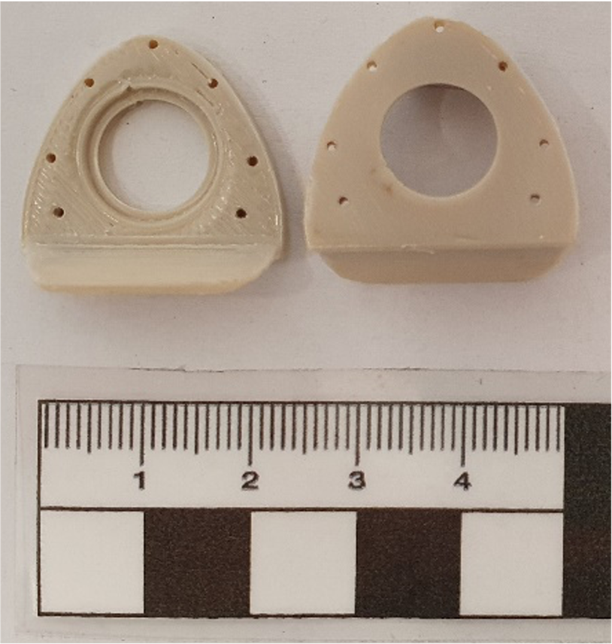

Supplementary Figure 1. Raw PEEK chamber following extrusion printing. To correct for irregularities the surface was ground before experimental use.

