Supplementary Information:
Plutonium isotopes in the North Western Pacific sediments coupled with radiocarbon in corals recording precise timing of the Anthropocene

Yusuke Yokoyama^{1,2,3,4,5*}, Stephen Tims⁵, Michaela Froehlich⁵, Shoko Hirabayashi¹, Takahiro Aze¹, L. Keith Fifield⁵, Dominik Koll⁵, Yosuke Miyairi¹, Stefan Pavetich⁵, and Michinobu Kuwae⁶

¹Atmosphere and Ocean Research Institute, The University of Tokyo, 5-1-5 Kashiwanoha, Kashiwa, Chiba 277-8564, Japan
²Department of Earth and Planetary Sciences, Graduate School of Science, The University of Tokyo, 7-3-1 Hongo, Bunkyo-ku, Tokyo 113-8033, Japan
³Graduate Program on Environmental Sciences, The University of Tokyo, 3-8-1 Komaba, Meguro-ku, Tokyo 153-8902, Japan
⁴Biogeochemistry Research Center, Research Institute for Marine Resources Utilization, Japan Agency for Marine-Earth Science and Technology, 2-15 Natsushima-cho, Yokosuka, Kanagawa 237-0061, Japan
⁵Research School of Physics, The Australian National University, Canberra, Acton, ACT 2601, Australia
⁶Center for Marine Environmental Studies, Ehime University, 2-5 Bunkyo-cho, Matsuyama, Ehime, 790-8577, Japan
*Corresponding author: Yusuke Yokoyama (yokoyama@aori.u-tokyo.ac.jp)

Table S1. Beppu Bay Pu and age depth information for BMC-19

Table S2. Beppu Bay Pu and age depth information for BMC-21
Table S3. High resolution radiocarbon data obtained from Guam and Ishigaki (1/4)

Table S3. High resolution radiocarbon data obtained from Guam and Ishigaki (2/4)
Table S3. High resolution radiocarbon data obtained from Guam and Ishigaki (3/4)
Table S3. High resolution radiocarbon data obtained from Guam and Ishigaki (4/4)
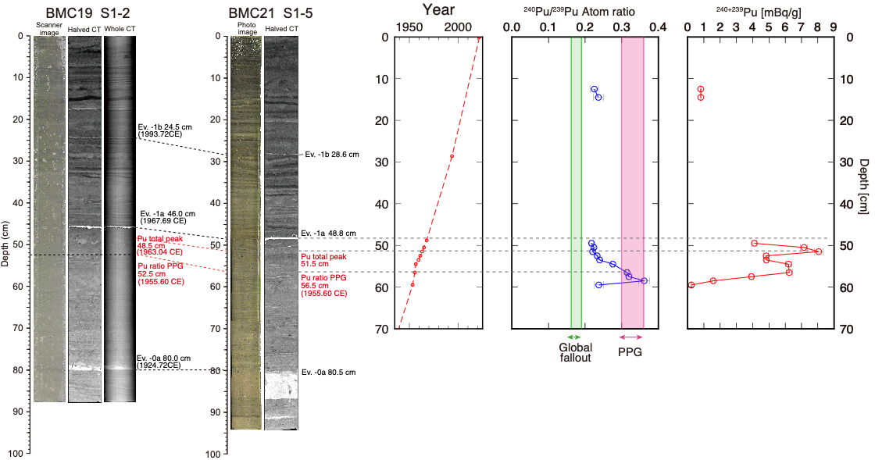
Figure S1. Correlation between BMC 19 S-1 and BMC-21
Well correlated layers observed in both cores in CT images can be observed. Both magnitude and shapes of Pu isotope signals in the core BMC 21 similar to the one that is observed in the master core BMC 19 (Fig. 2) are well identified.

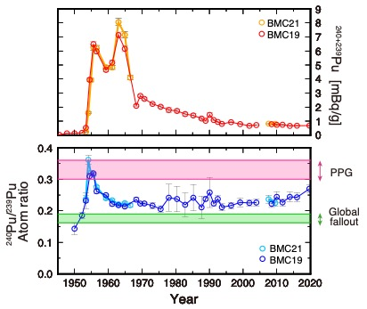
Figure S2. Total Pu and Pu isotopes results for BMC 19 S-1 and BMC-21
Plutonium isotope results found in both cores are almost identical.

