Integrated analysis reveals the pivotal interactions between immune cells in the melanoma tumor microenvironment
Jiawei Chen^{1, †}, Shan Hu^{1, 2, †}, Huiqi Wang^{1, †}, Tingxiu Zhao², Yue Song^{1, 3}, Xueying Zhong¹, Qingling Luo¹, Mansi Xu¹, Lina He¹, Qiugu Chen^{1, 3}, Biaoyan Du^{2, *}, Jianyong Xiao^{1, 3, *}, Kun Wang^{1, 2, *}
¹ Research Center of Integrative Medicine, School of Basic Medical Sciences, Guangzhou University of Chinese Medicine, Guangzhou 510006, China.
² Department of Pathology, Guangzhou University of Chinese Medicine, Guangzhou 510006, China.
³ Department of Biochemistry, Guangzhou University of Chinese Medicine, Guangzhou 510006, China.
* Correspondence:
wangkun@gzucm.edu.cn (K.W.), jianyongxiao@gzucm.edu.cn (J.X.) or dubiaoyan@gzucm.edu.cn (B.D.).
† These authors contributed equally to this work.

Supplementary Figures
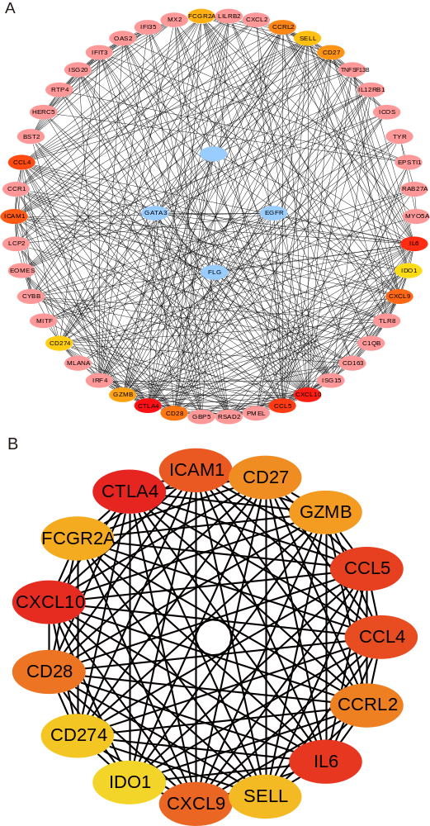
Figure S1. Differential genes with MCC score ≥ 10000 were screened to construct a PPI network.
Figure S2. The expression levels of marker genes used for cell annotation in different immune cells.

