Supplementary files
Abundance and distribution patterns of cetaceans and their overlap with vessel traffic in the Humboldt Current Ecosystem, Chile
*Luis Bedriñana-Romano^{1,2,3}, Patricia Zarate⁴, Rodrigo Hucke-Gaete^{1,2,3}, Francisco A., Viddi^{1,2}, Susannah J. Buchan^{3,5,6}, Ilia Cari⁴, Ljubitza Clavijo⁴, Robert Bello⁴, Alexandre N. Zerbini^{7,8,9}
¹Instituto de Ciencias Marinas y Limnológicas, Facultad de Ciencias, Universidad Austral de Chile, Valdivia, Chile
² NGO Centro Ballena Azul, 5090000, Valdivia, Chile
³Centro de Investigación Oceanográfica COPAS Coastal, Universidad de Concepción, 4070043, Concepción, Región del Bio Bio, Chile
⁴Instituto de Fomento Pesquero, Almirante Manuel Blanco Encalada 839, Valparaíso, Chile
⁵Centro de investigación Oceanográfica COPAS Sur-Austral, Universidad de Concepción, 4070043, Concepción, Región del Bio, Chile
⁶Centro de Estudios Avanzados en Zonas Áridas, Raúl Bitran 1305, La Serena, 1700000, Región del Coquimbo, Chile
⁷Cooperative Institute for Climate, Ocean and Ecosystem Studies, University of Washington & Marine Mammal Laboratory Alaska Fisheries Science Center/NOAA 7600 Sand Point Way NE, Seattle, WA, USA
⁸Marine Ecology and Telemetry Research, 2468 Camp McKenzie Tr NW, Seabeck, WA, 98380, USA
⁹Instituto Aqualie, Av. Dr. Paulo Japiassú Coelho, 714, Sala 206, 36033-310, Juiz de Fora, MG, Brazil.
*Corresponding author: luis.bedrinana.romano@gmail.com

Table S1. Summary of cruises´ information used as platforms during line transect surveys.
Cruise ID | Year | Ship | Cruise program | Months | Latitudinal range | Cruise Leader
CRC_06 | 2017 | ABATE MOLINA | MOBIO MPH | September-October | 18°50`S - 26°00`S | H.REYES J.ANGULO
CRC_07 | 2017 | ABATE MOLINA | RECLAN I y II | December | 18°50`S - 25°00`S | FRANCISCO LEIVA
CRC_08 | 2018 | ABATE MOLINA | RECLAN III y IV | February | 25°00`S - 31°00`S | FRANCISCO LEIVA
CRC_09 | 2018 | ABATE MOLINA | JUREL NORTE | April | 18°50´S - 23°25´S | JOSE CORDOVA
CRC_10 | 2018 | ABATE MOLINA | RECLAS V a X | May | 32°00`S - 40°30`S | Alvaro Saavedra
CRC_11 | 2018 | ABATE MOLINA | MOBIO MPH | September-October | 18°50`S - 26°00`S | HERNAN REYES
CRC_12 | 2018 | ABATE MOLINA | RECLAN I, XV y II | November-December | 18°50`S - 25°00`S | Francisco Leiva
CRC_14 | 2019 | ABATE MOLINA | JUREL NORTE | March-April | 18°50`S - 33°00`S | José Cordova
CRC_16 | 2019 | ABATE MOLINA | MOBIO MPH | September-October | 18°50`S - 26°03 S | Jessica Bonicelli
CRC_13 | 2019 | ABATE MOLINA | RECLAN III y IV | February-March | 25°00`S - 32°00`S | Francisco Leiva
CRC_15 | 2019 | ABATE MOLINA | RECLAS V a X | May | 32°00`S - 40°20`S | Alvaro Saavedra
CRC_17 | 2019 | ABATE MOLINA | RECLAN I, XV y II | November-December | 18°50`S - 25°00`S | Francisco Leiva
CRC_18 | 2020 | ABATE MOLINA | RECLAN III y IV | February-March | 25°00`S - 32°00`S | Francisco Leiva
CRC_19 | 2020 | ABATE MOLINA | JUREL NORTE | March-April | 18°50`S - 33°00`S | José Cordova
CRC_20 | 2020 | ABATE MOLINA | RECLAS V a X | May-June | 32°00`S - 40°30`S | Alvaro Saavedra
CRC_21 | 2020 | ABATE MOLINA | MOBIO MPH | September-October | 18°50´S - 26°00´S | Hernan Reyes
CRC_22 | 2020 | ABATE MOLINA | RECLAN I, XV y II | November-December | 18°50´S - 25°00´S | Francisco Leiva
CRC_23 | 2021 | ABATE MOLINA | RECLAN III y IV | February-March | 25°00`S - 32°00`S | Francisco Leiva
CRC_24 | 2021 | ABATE MOLINA | JUREL NORTE | March-April | 18°50´S - 23°25´S | José Cordova
CRC_25 | 2021 | ABATE MOLINA | RECLAS V a X | May-June | 32°00`S - 40°20`S | Alvaro Saavedra
CRC_26 | 2021 | ABATE MOLINA | MOBIO MPH | September-October | 18°50`S - 26°00`S | Hernan Reyes

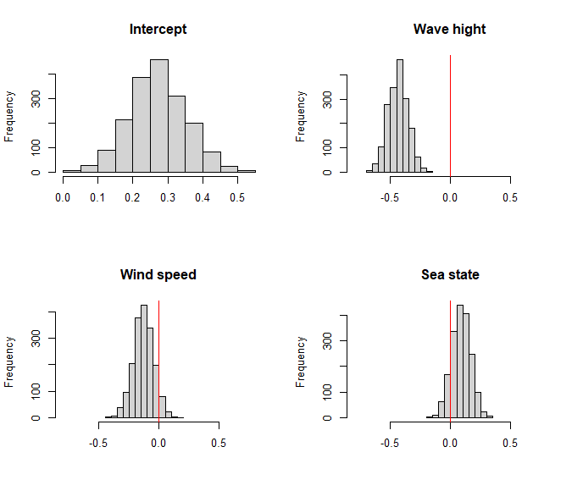
Figure S1. Posterior distributions for parameters controlling the effect of observational covariates on detection function for fin whale. Red vertical lines denote zero.

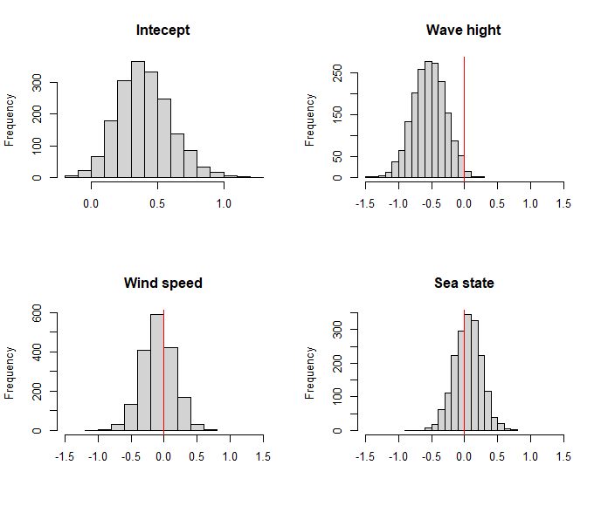
Figure S2. Posterior distributions for parameters controlling the effect of observational covariates on detection function for blue whale. Red vertical lines denote zero.

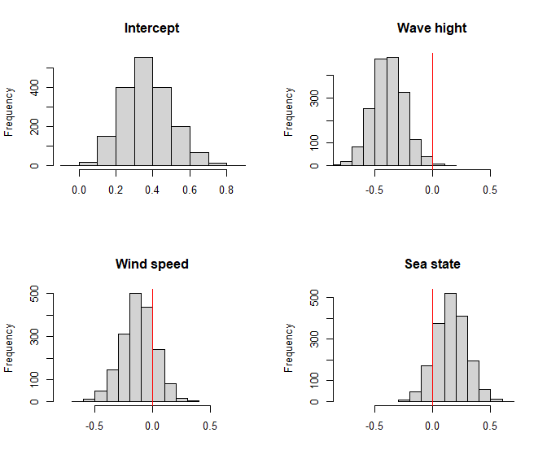
Figure S3. Posterior distributions for parameters controlling the effect of observational covariates on detection function for sperm whale. Red vertical lines denote zero.

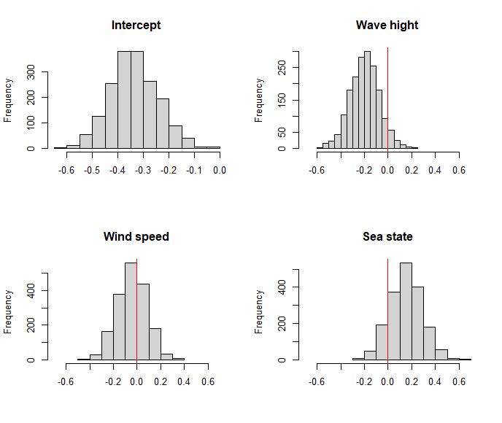
Figure S4. Posterior distributions for parameters controlling the effect of observational covariates on detection function for dusky dolphin. Red vertical lines denote zero.

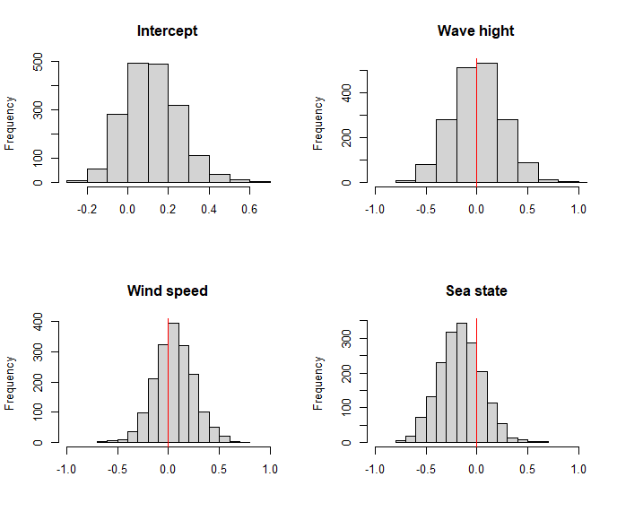
Figure S5. Posterior distributions for parameters controlling the effect of observational covariates on detection function for common dolphin. Red vertical lines denote zero.

Table S2. Results for model 1 fitted to fin whale data. Parameters for predictors are indicated by specific predictors’ name including quadratic terms. Parameters in bold indicate zero was not included in their posterior distribution. Psi (ψ) is the probability of a non-zero and prec corresponds to the precision (1/variance) of the normally distributed observation-level random effect.
Fin Whale - Model 1
 | mean | sd | 2.50% | 25% | 50% | 75% | 97.50%
Intercept | -4.49013 | 0.391454 | -5.34853 | -4.70943 | -4.43936 | -4.21614 | -3.85012
SST | 0.200159 | 0.085563 | 0.033511 | 0.142144 | 0.200506 | 0.256259 | 0.361769
SST² | -0.00807 | 0.072664 | -0.15254 | -0.05393 | -0.00759 | 0.041642 | 0.134727
LOGCHL | 0.532293 | 0.099809 | 0.346135 | 0.463704 | 0.534292 | 0.599884 | 0.726111
LOGCHL² | -0.34907 | 0.083987 | -0.52224 | -0.40234 | -0.34645 | -0.29318 | -0.18539
TG | -0.33086 | 0.128139 | -0.57826 | -0.41834 | -0.32884 | -0.24564 | -0.0798
TG² | 0.029943 | 0.052709 | -0.07589 | -0.00433 | 0.030711 | 0.065567 | 0.131458
SLO | 0.08145 | 0.103661 | -0.12147 | 0.013842 | 0.079318 | 0.151972 | 0.284013
SLO² | 0.037895 | 0.05964 | -0.07297 | -0.00555 | 0.036293 | 0.078979 | 0.156875
SSTA | -0.19749 | 0.085192 | -0.36513 | -0.25403 | -0.19532 | -0.14035 | -0.03471
SSTA² | -0.02913 | 0.05508 | -0.13696 | -0.06504 | -0.02763 | 0.007135 | 0.075363
Mean group size | 2.000323 | 0.078813 | 1.846808 | 1.944769 | 1.998668 | 2.05434 | 2.158228
Variance group size | 2.190282 | 0.140848 | 1.953825 | 2.089196 | 2.175568 | 2.27546 | 2.488871
psi | 0.262595 | 0.06684 | 0.176193 | 0.21786 | 0.247561 | 0.292602 | 0.433559
prec | 1.756711 | 0.854459 | 0.637107 | 1.108382 | 1.612135 | 2.148235 | 3.988895
A0 | 0.245721 | 0.075024 | 0.101557 | 0.196959 | 0.245984 | 0.293821 | 0.397129
Wave height | -0.24193 | 0.069433 | -0.37599 | -0.28824 | -0.24149 | -0.19702 | -0.10931
Wind speed | 0.050461 | 0.06814 | -0.08526 | 0.006305 | 0.05168 | 0.093817 | 0.185826
Sea State | -0.08969 | 0.073489 | -0.23974 | -0.13764 | -0.08722 | -0.04036 | 0.054009
bpv | 0.615 | 0.486731 | 0 | 0 | 1 | 1 | 1
c.hat | 1.034799 | 0.104685 | 0.846513 | 0.971352 | 1.024194 | 1.099278 | 1.247219
observed range | 6 | 0 | 6 | 6 | 6 | 6 | 6
expected range | 5.942222 | 1.355201 | 4 | 5 | 6 | 7 | 9

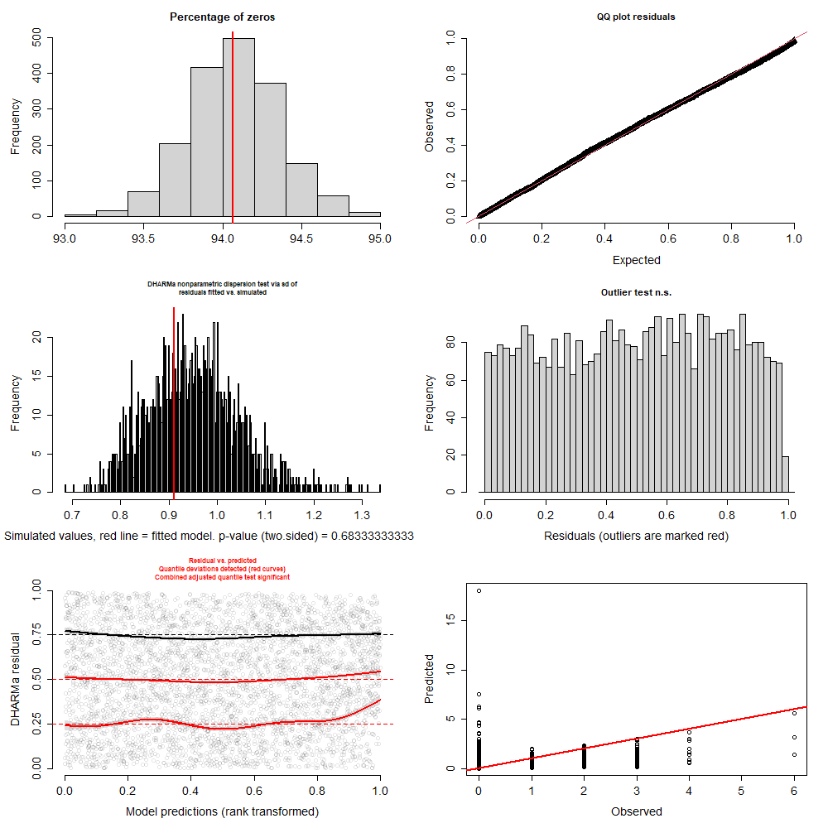
Figure S6. Fin whale – Model 1. Results for simulation-based and scaled residuals diagnostics for model-fit assessment. Left top panel shows the percentage of zeros in observed data (red line) and simulated data (histogram of posterior distribution). Right top panel show expected versus observed residual plot using scaled residuals. Left mid-panel show residual dispersion for observed data (red line) and simulated data (histogram of posterior distribution). Right mid-panel show result for outlier test, indicating now outliers detected. Left bottom panel show quantile deviation test, red lines indicate deviations detected. Right bottom panel show observed versus predicted plot.
Table S3. Results for model 2 fitted to fin whale data. Parameters for predictors are indicated by specific predictors’ name including quadratic terms. Parameters in bold indicate zero was not included in their posterior distribution. Psi (ψ) is the probability of a non-zero and prec corresponds to the precision (1/variance) of the normally distributed observation-level random effect.
Fin Whale - Model 2
 | mean | sd | 2.50% | 25% | 50% | 75% | 97.50%
Intercept | -4.4121 | 0.503675 | -5.76642 | -4.63158 | -4.3148 | -4.07577 | -3.71394
SSTLT | -0.07833 | 0.094193 | -0.26315 | -0.14268 | -0.07879 | -0.01835 | 0.111082
SSTLT² | -0.22153 | 0.086268 | -0.39098 | -0.27835 | -0.22195 | -0.16102 | -0.05111
LOGCHL | 0.52097 | 0.10318 | 0.321784 | 0.453005 | 0.52379 | 0.587877 | 0.730561
LOGCHL² | -0.35755 | 0.083558 | -0.52293 | -0.41427 | -0.35824 | -0.30112 | -0.19503
TG | -0.28376 | 0.1303 | -0.5419 | -0.36952 | -0.28531 | -0.19358 | -0.03495
TG² | 0.025499 | 0.052904 | -0.08093 | -0.0107 | 0.026735 | 0.060785 | 0.126882
SLO | 0.050682 | 0.103398 | -0.14654 | -0.02031 | 0.053695 | 0.120096 | 0.253618
SLO² | 0.03926 | 0.059909 | -0.07055 | -0.00181 | 0.035616 | 0.079408 | 0.154047
SSTA | -0.11607 | 0.080777 | -0.27129 | -0.17141 | -0.11577 | -0.06213 | 0.043393
SSTA² | -0.01979 | 0.056024 | -0.12825 | -0.05609 | -0.01968 | 0.016663 | 0.088762
Mean group size | 2.002077 | 0.078641 | 1.850202 | 1.948236 | 2.004017 | 2.053573 | 2.157022
Variance group size | 2.194365 | 0.13886 | 1.964714 | 2.094949 | 2.180042 | 2.279315 | 2.503051
psi | 0.286092 | 0.100238 | 0.178969 | 0.22515 | 0.25854 | 0.309693 | 0.59405
prec | 1.512032 | 0.739827 | 0.450714 | 0.985362 | 1.383977 | 1.927046 | 3.327136
A0 | 0.25101 | 0.072427 | 0.119113 | 0.200795 | 0.250589 | 0.298786 | 0.391812
Wave height | -0.25185 | 0.071249 | -0.38755 | -0.3012 | -0.25195 | -0.20391 | -0.10917
Wind speed | 0.050301 | 0.069035 | -0.082 | 0.005172 | 0.048253 | 0.095544 | 0.192552
Sea State | -0.08892 | 0.070429 | -0.22986 | -0.13551 | -0.08814 | -0.04261 | 0.050857
bpv | 0.607222 | 0.488504 | 0 | 0 | 1 | 1 | 1
c.hat | 1.034759 | 0.115157 | 0.83033 | 0.964657 | 1.023507 | 1.097252 | 1.289203
observed range | 6 | 0 | 6 | 6 | 6 | 6 | 6
expected range | 5.881111 | 1.32378 | 4 | 5 | 6 | 7 | 9

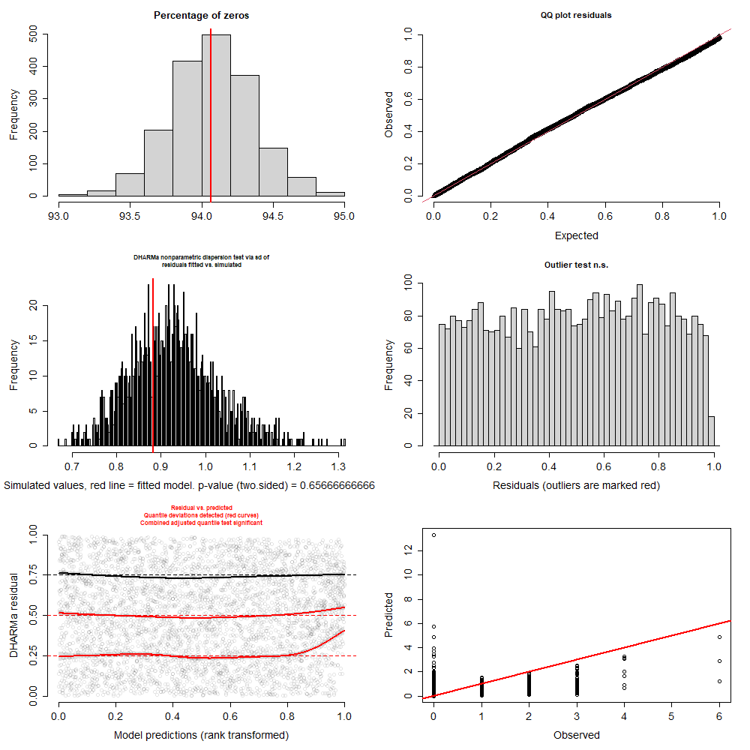
Figure S7. Fin whale – Model 2. Results for simulation-based and scaled residuals diagnostics for model-fit assessment. Left top panel shows the percentage of zeros in observed data (red line) and simulated data (histogram of posterior distribution). Right top panel show expected versus observed residual plot using scaled residuals. Left mid-panel show residual dispersion for observed data (red line) and simulated data (histogram of posterior distribution). Right mid-panel show result for outlier test, indicating now outliers detected. Left bottom panel show quantile deviation test, red lines indicate deviations detected. Right bottom panel show observed versus predicted plot.
Table S4. Results for model 3 fitted to fin whale data. Parameters for predictors are indicated by specific predictors’ name including quadratic terms. Parameters in bold indicate zero was not included in their posterior distribution. Psi (ψ) is the probability of a non-zero and prec corresponds to the precision (1/variance) of the normally distributed observation-level random effect.
Fin Whale - Model 3
 | mean | sd | 2.50% | 25% | 50% | 75% | 97.50%
Intercept | -4.57397 | 0.416726 | -5.55886 | -4.81647 | -4.52946 | -4.27448 | -3.89324
SST | 0.206955 | 0.087464 | 0.040568 | 0.146311 | 0.204006 | 0.264766 | 0.382187
SST² | -0.03675 | 0.072759 | -0.17401 | -0.08696 | -0.0378 | 0.013241 | 0.111562
CHLLT | 0.632969 | 0.103619 | 0.425864 | 0.563589 | 0.631464 | 0.703829 | 0.830891
CHLLT² | -0.3427 | 0.089268 | -0.52008 | -0.40088 | -0.34273 | -0.28122 | -0.16998
TG | -0.34629 | 0.127951 | -0.59183 | -0.43711 | -0.34399 | -0.2587 | -0.09615
TG² | 0.034014 | 0.050944 | -0.07035 | 0.000579 | 0.035323 | 0.068442 | 0.13401
SLO | 0.109652 | 0.104915 | -0.09197 | 0.037556 | 0.110441 | 0.182547 | 0.311789
SLO² | 0.028748 | 0.058345 | -0.08181 | -0.01224 | 0.025618 | 0.069128 | 0.142602
SSTA | -0.17454 | 0.084049 | -0.3435 | -0.22844 | -0.17197 | -0.11605 | -0.01506
SSTA² | -0.01665 | 0.053134 | -0.12373 | -0.05168 | -0.01701 | 0.019938 | 0.086746
Mean group size | 2.005659 | 0.076193 | 1.863406 | 1.953259 | 2.006213 | 2.055012 | 2.161108
Variance group size | 2.198442 | 0.138464 | 1.958511 | 2.096701 | 2.186663 | 2.283073 | 2.502038
psi | 0.281427 | 0.072316 | 0.185772 | 0.229767 | 0.265678 | 0.316348 | 0.464302
prec | 1.735992 | 0.868861 | 0.638204 | 1.114325 | 1.497358 | 2.177124 | 3.994453
A0 | 0.239359 | 0.072011 | 0.103383 | 0.189915 | 0.237807 | 0.28897 | 0.383758
Wave height | -0.23787 | 0.070226 | -0.37629 | -0.28477 | -0.23813 | -0.18811 | -0.10744
Wind speed | 0.061765 | 0.068547 | -0.06857 | 0.014382 | 0.060375 | 0.106797 | 0.197129
Sea State | -0.08914 | 0.074186 | -0.22935 | -0.13864 | -0.08811 | -0.03885 | 0.051859
bpv | 0.658333 | 0.4744 | 0 | 0 | 1 | 1 | 1
c.hat | 1.044937 | 0.114346 | 0.838939 | 0.974183 | 1.033124 | 1.108995 | 1.29578
observed range | 6 | 0 | 6 | 6 | 6 | 6 | 6
expected range | 5.919444 | 1.28819 | 4 | 5 | 6 | 7 | 9

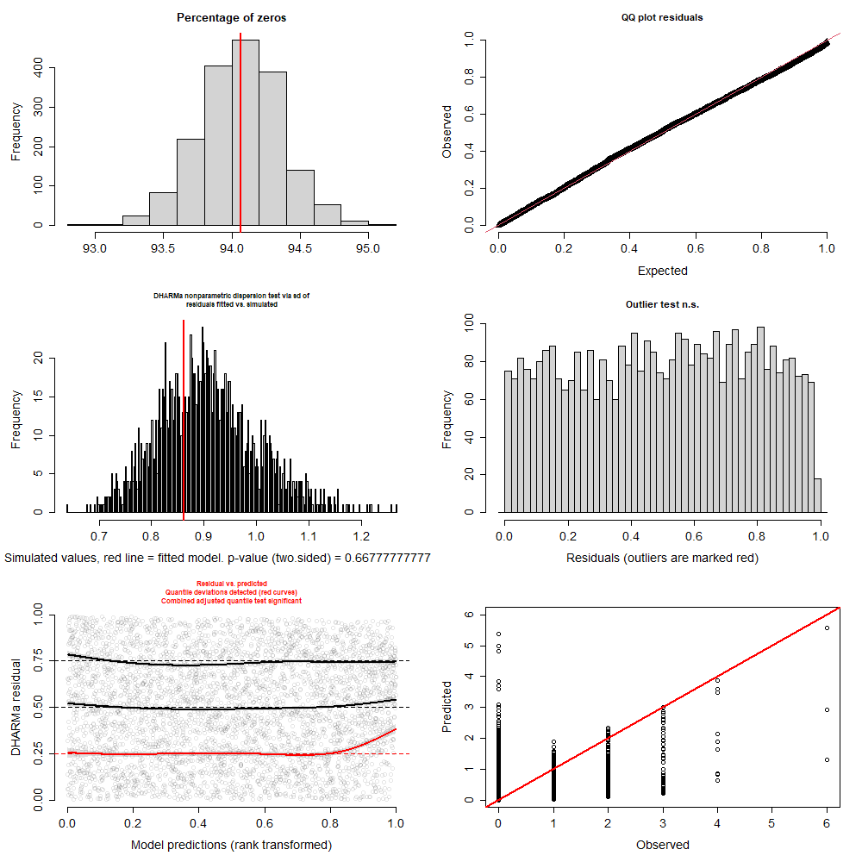
Figure S8. Fin whale – Model 3. Results for simulation-based and scaled residuals diagnostics for model-fit assessment. Left top panel shows the percentage of zeros in observed data (red line) and simulated data (histogram of posterior distribution). Right top panel show expected versus observed residual plot using scaled residuals. Left mid-panel show residual dispersion for observed data (red line) and simulated data (histogram of posterior distribution). Right mid-panel show result for outlier test, indicating now outliers detected. Left bottom panel show quantile deviation test, red lines indicate deviations detected. Right bottom panel show observed versus predicted plot.
Table S5. Results for model 4 fitted to fin whale data. Parameters for predictors are indicated by specific predictors’ name including quadratic terms. Parameters in bold indicate zero was not included in their posterior distribution. Psi (ψ) is the probability of a non-zero and prec corresponds to the precision (1/variance) of the normally distributed observation-level random effect.
Fin Whale - Model 4
 | mean | sd | 2.50% | 25% | 50% | 75% | 97.50%
Intercept | -4.47658 | 0.479234 | -5.62842 | -4.72514 | -4.39995 | -4.14596 | -3.76501
SSTLT | -0.01713 | 0.095979 | -0.19915 | -0.08257 | -0.01587 | 0.046732 | 0.165747
SSTLT² | -0.21057 | 0.086568 | -0.38403 | -0.26643 | -0.20873 | -0.15229 | -0.04125
CHLLT | 0.621448 | 0.106677 | 0.423711 | 0.548167 | 0.619809 | 0.691005 | 0.834325
CHLLT² | -0.35726 | 0.08891 | -0.53831 | -0.41411 | -0.35721 | -0.29844 | -0.18764
TG | -0.29881 | 0.130599 | -0.55762 | -0.38462 | -0.29795 | -0.21118 | -0.05407
TG² | 0.027797 | 0.051981 | -0.07776 | -0.00502 | 0.028528 | 0.062434 | 0.130139
SLO | 0.076102 | 0.108409 | -0.14029 | 0.001812 | 0.076778 | 0.147542 | 0.29096
SLO² | 0.037327 | 0.058845 | -0.06984 | -0.00482 | 0.033321 | 0.078931 | 0.155293
SSTA | -0.0989 | 0.080429 | -0.25593 | -0.15385 | -0.09953 | -0.04379 | 0.057579
SSTA² | -0.01373 | 0.054587 | -0.12177 | -0.0502 | -0.01377 | 0.023418 | 0.09414
Mean group size | 2.002722 | 0.078067 | 1.855932 | 1.950177 | 2.001534 | 2.055358 | 2.155704
Variance group size | 2.194459 | 0.142722 | 1.950222 | 2.093494 | 2.179616 | 2.27812 | 2.51973
psi | 0.295327 | 0.096167 | 0.18535 | 0.233003 | 0.27126 | 0.328723 | 0.537331
prec | 1.572296 | 0.842869 | 0.512628 | 0.944965 | 1.334069 | 1.99033 | 3.703727
A0 | 0.241719 | 0.071427 | 0.108464 | 0.190531 | 0.240814 | 0.290925 | 0.381768
Wave height | -0.24875 | 0.07095 | -0.38156 | -0.29932 | -0.24872 | -0.20111 | -0.10988
Wind speed | 0.06068 | 0.068483 | -0.06701 | 0.013597 | 0.059369 | 0.107159 | 0.197073
Sea State | -0.08709 | 0.074213 | -0.22906 | -0.13807 | -0.08885 | -0.03469 | 0.054828
bpv | 0.645556 | 0.478478 | 0 | 0 | 1 | 1 | 1
c.hat | 1.047529 | 0.11927 | 0.850376 | 0.97278 | 1.037409 | 1.113339 | 1.303761
observed range | 6 | 0 | 6 | 6 | 6 | 6 | 6
expected range | 5.934444 | 1.288394 | 4 | 5 | 6 | 7 | 9

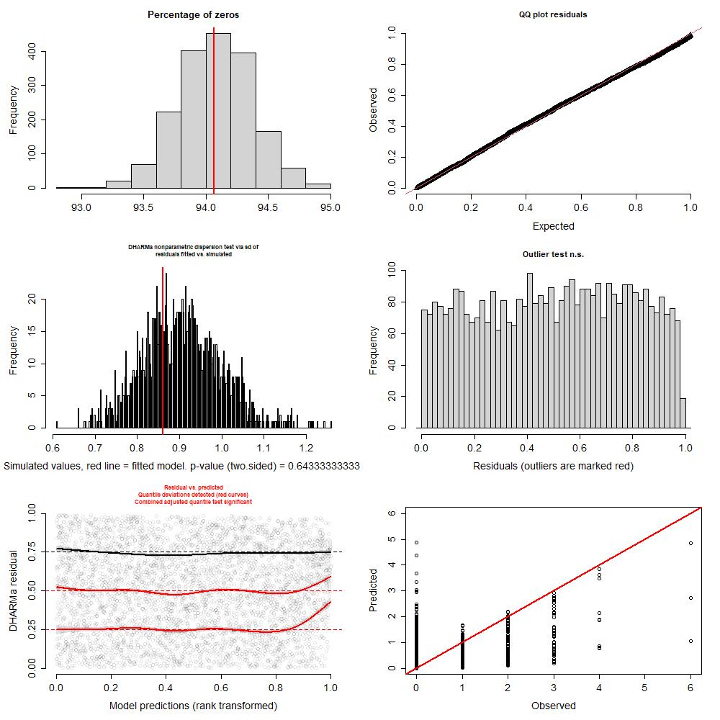
Figure S9. Fin whale – Model 4. Results for simulation-based and scaled residuals diagnostics for model-fit assessment. Left top panel shows the percentage of zeros in observed data (red line) and simulated data (histogram of posterior distribution). Right top panel show expected versus observed residual plot using scaled residuals. Left mid-panel show residual dispersion for observed data (red line) and simulated data (histogram of posterior distribution). Right mid-panel show result for outlier test, indicating now outliers detected. Left bottom panel show quantile deviation test, red lines indicate deviations detected. Right bottom panel show observed versus predicted plot.
Table S6. Results for model 1 fitted to blue whale data. Parameters for predictors are indicated by specific predictors’ name including quadratic terms. Parameters in bold indicate zero was not included in their posterior distribution. Psi (ψ) is the probability of a non-zero and prec corresponds to the precision (1/variance) of the normally distributed observation-level random effect.
Blue whale - Model 1
 | mean | sd | 2.50% | 25% | 50% | 75% | 97.50%
Intercept | -7.44547 | 1.253039 | -9.57318 | -8.4707 | -7.48224 | -6.54699 | -4.99676
CHLLT | -0.44109 | 0.231554 | -0.93495 | -0.59053 | -0.43522 | -0.28078 | 0.006317
CHLLT² | -0.51957 | 0.251881 | -1.04962 | -0.67297 | -0.50641 | -0.34937 | -0.05792
TG | 0.134679 | 0.287823 | -0.42384 | -0.0664 | 0.141619 | 0.325733 | 0.694442
TG² | -0.09385 | 0.123074 | -0.34991 | -0.16901 | -0.0878 | -0.00891 | 0.129384
JD | 0.711556 | 0.18534 | 0.356886 | 0.589609 | 0.704796 | 0.83182 | 1.085552
JD² | 0.044382 | 0.296602 | -0.54054 | -0.15603 | 0.042507 | 0.241172 | 0.629786
Mean group size | 1.695182 | 0.163799 | 1.390239 | 1.583138 | 1.688583 | 1.796453 | 2.037731
Variance group size | 1.757592 | 0.186849 | 1.424971 | 1.633505 | 1.744531 | 1.870365 | 2.166536
psi | 0.416494 | 0.243963 | 0.091161 | 0.212223 | 0.367266 | 0.596373 | 0.950332
prec | 0.648967 | 0.706122 | 0.229647 | 0.293282 | 0.397733 | 0.628563 | 3.262475
A0 | 0.333184 | 0.153227 | 0.064337 | 0.226451 | 0.323122 | 0.431209 | 0.65711
Wave height | -0.437 | 0.185642 | -0.7979 | -0.55997 | -0.437 | -0.31174 | -0.06469
Wind speed | 0.130814 | 0.173494 | -0.21518 | 0.01548 | 0.131645 | 0.249184 | 0.47259
Sea State | -0.094 | 0.182154 | -0.45566 | -0.21775 | -0.08953 | 0.030488 | 0.246558
bpv | 0.595556 | 0.490921 | 0 | 0 | 1 | 1 | 1
c.hat | 1.264295 | 0.951214 | 0.400326 | 0.861215 | 1.078168 | 1.390132 | 3.263369
observed range | 3 | 0 | 3 | 3 | 3 | 3 | 3
expected range | 3.149444 | 1.011001 | 2 | 2 | 3 | 4 | 6

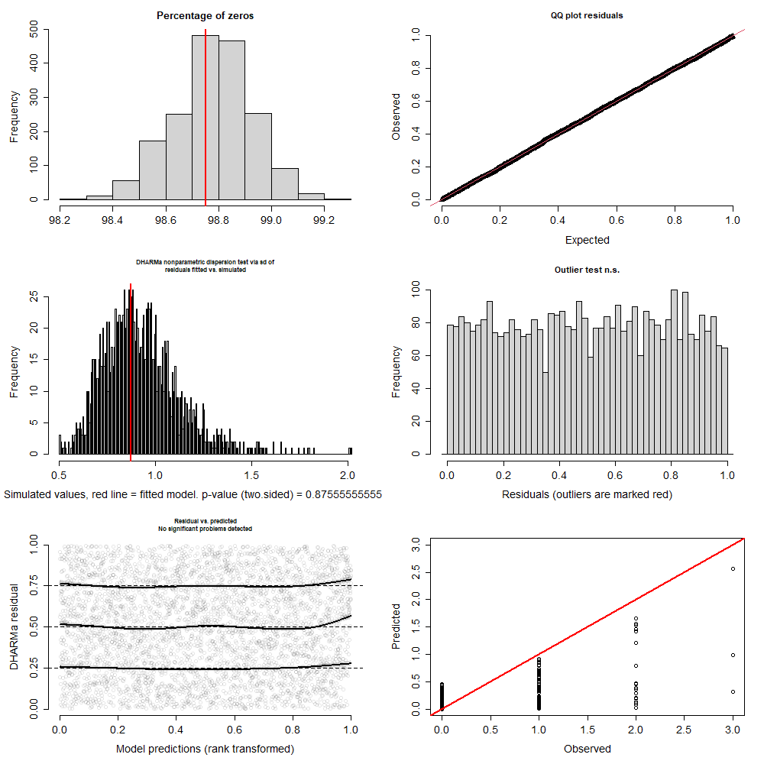
Figure S10. Blue whale – Model 1. Results for simulation-based and scaled residuals diagnostics for model-fit assessment. Left top panel shows the percentage of zeros in observed data (red line) and simulated data (histogram of posterior distribution). Right top panel show expected versus observed residual plot using scaled residuals. Left mid-panel show residual dispersion for observed data (red line) and simulated data (histogram of posterior distribution). Right mid-panel show result for outlier test, indicating now outliers detected. Left bottom panel show quantile deviation test, red lines indicate deviations detected. Right bottom panel show observed versus predicted plot.
Table S7. Results for model 2 fitted to blue whale data. Parameters for predictors are indicated by specific predictors’ name including quadratic terms. Parameters in bold indicate zero was not included in their posterior distribution. Psi (ψ) is the probability of a non-zero and prec corresponds to the precision (1/variance) of the normally distributed observation-level random effect.
Blue whale - Model 2
 | mean | sd | 2.50% | 25% | 50% | 75% | 97.50%
Intercept | -7.61364 | 1.181652 | -9.47168 | -8.49435 | -7.81956 | -6.89062 | -4.99875
LOGCHL | -0.43015 | 0.238911 | -0.88535 | -0.58614 | -0.42571 | -0.2696 | 0.032533
LOGCHL² | -0.65225 | 0.253189 | -1.17135 | -0.81028 | -0.64165 | -0.47939 | -0.19183
TG | 0.083159 | 0.280192 | -0.47187 | -0.09887 | 0.078968 | 0.268722 | 0.6415
TG² | -0.06699 | 0.121445 | -0.33591 | -0.14057 | -0.06096 | 0.01501 | 0.153417
JD | 0.701621 | 0.190703 | 0.348491 | 0.567739 | 0.697507 | 0.829673 | 1.08684
JD² | 0.115131 | 0.286768 | -0.45757 | -0.07194 | 0.113514 | 0.300404 | 0.689417
Mean group size | 1.689344 | 0.169674 | 1.38526 | 1.572687 | 1.67989 | 1.799373 | 2.046788
Variance group size | 1.753556 | 0.193052 | 1.419948 | 1.618582 | 1.741219 | 1.874705 | 2.170329
psi | 0.442045 | 0.22995 | 0.087759 | 0.251738 | 0.424672 | 0.608869 | 0.914136
prec | 0.647492 | 0.765205 | 0.229367 | 0.286927 | 0.366638 | 0.549474 | 3.355442
A0 | 0.331562 | 0.155616 | 0.056263 | 0.224006 | 0.320031 | 0.433581 | 0.651862
Wave height | -0.41193 | 0.184147 | -0.76447 | -0.53967 | -0.41584 | -0.29143 | -0.04048
Wind speed | 0.131931 | 0.17256 | -0.21505 | 0.014952 | 0.137086 | 0.24816 | 0.478435
Sea State | -0.1045 | 0.186604 | -0.47861 | -0.2269 | -0.10426 | 0.023574 | 0.267807
bpv | 0.593889 | 0.491242 | 0 | 0 | 1 | 1 | 1
c.hat | 1.323436 | 1.801144 | 0.396953 | 0.85896 | 1.088791 | 1.43699 | 3.250644
observed range | 3 | 0 | 3 | 3 | 3 | 3 | 3
expected range | 3.142778 | 1.041738 | 2 | 2 | 3 | 4 | 6
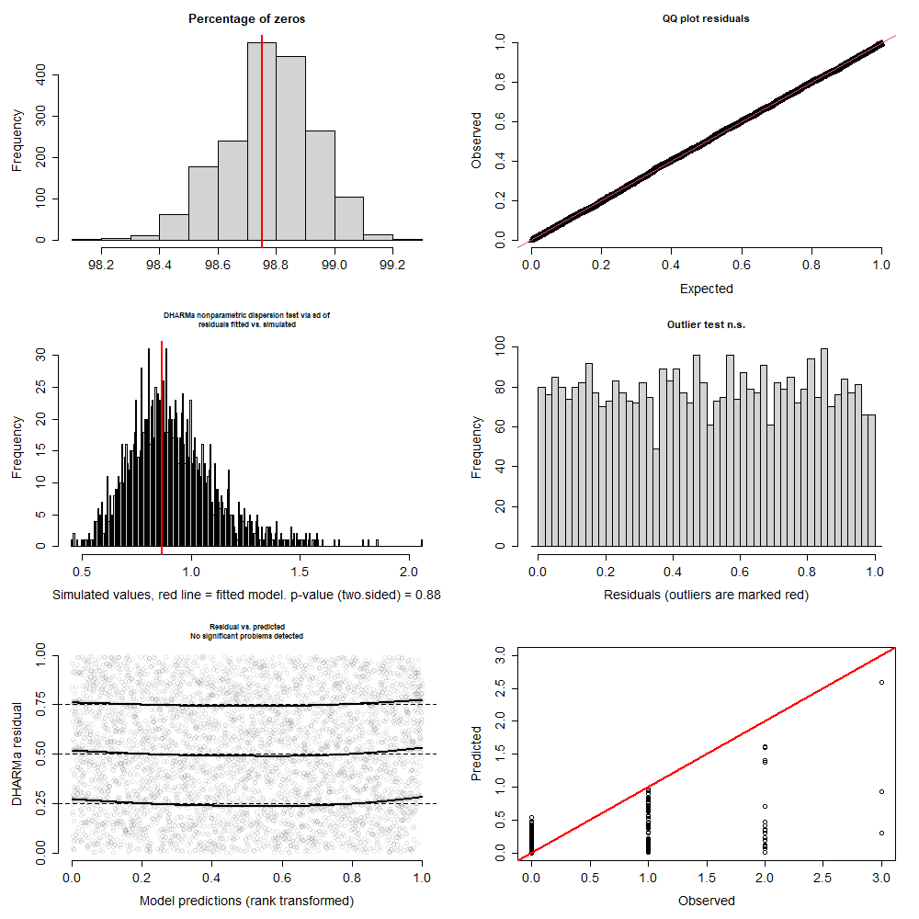
Figure S11. Blue whale – Model 2. Results for simulation-based and scaled residuals diagnostics for model-fit assessment. Left top panel shows the percentage of zeros in observed data (red line) and simulated data (histogram of posterior distribution). Right top panel show expected versus observed residual plot using scaled residuals. Left mid-panel show residual dispersion for observed data (red line) and simulated data (histogram of posterior distribution). Right mid-panel show result for outlier test, indicating now outliers detected. Left bottom panel show quantile deviation test, red lines indicate deviations detected. Right bottom panel show observed versus predicted plot.
Table S8. Results for model 1 fitted to sperm whale data. Parameters for predictors are indicated by specific predictors’ name including quadratic terms. Parameters in bold indicate zero was not included in their posterior distribution. Psi (ψ) is the probability of a non-zero and prec corresponds to the precision (1/variance) of the normally distributed observation-level random effect.
Sperm whale - Model 1
 | mean | sd | 2.50% | 25% | 50% | 75% | 97.50%
Intercept | -5.38531 | 0.918617 | -7.41284 | -5.96842 | -5.26909 | -4.69748 | -3.87157
SSTLT | 0.02785 | 0.202446 | -0.37829 | -0.10889 | 0.033639 | 0.167457 | 0.426007
SSTLT² | -0.04083 | 0.188966 | -0.40126 | -0.17377 | -0.03715 | 0.085168 | 0.322689
DEPTH | -1.41877 | 0.290615 | -2.01725 | -1.61077 | -1.40607 | -1.22072 | -0.88583
DEPTH² | -0.51172 | 0.17791 | -0.86996 | -0.62756 | -0.51103 | -0.39083 | -0.16966
SLO | 0.111319 | 0.207541 | -0.30356 | -0.03072 | 0.105658 | 0.248982 | 0.516983
SLO² | -0.1767 | 0.137774 | -0.4706 | -0.261 | -0.17049 | -0.07725 | 0.064846
Mean group size | 2.689018 | 0.159451 | 2.388579 | 2.577478 | 2.686234 | 2.79591 | 3.002468
Variance group size | 3.020484 | 0.324235 | 2.537371 | 2.794549 | 2.965721 | 3.188507 | 3.786102
psi | 0.138852 | 0.071271 | 0.060048 | 0.088489 | 0.117866 | 0.16673 | 0.332589
prec | 0.813358 | 0.573167 | 0.251467 | 0.437562 | 0.642812 | 0.981727 | 2.423023
A0 | 0.333136 | 0.121473 | 0.115244 | 0.250561 | 0.327191 | 0.4079 | 0.585977
Wave height | -0.33224 | 0.123202 | -0.56873 | -0.41578 | -0.33485 | -0.24883 | -0.09493
Wind speed | 0.092478 | 0.117589 | -0.12937 | 0.014599 | 0.089048 | 0.171881 | 0.320326
Sea State | -0.01633 | 0.128647 | -0.27798 | -0.10173 | -0.01431 | 0.075796 | 0.225188
bpv | 0.506111 | 0.500102 | 0 | 0 | 1 | 1 | 1
c.hat | 1.042765 | 0.333755 | 0.564766 | 0.875322 | 1.002936 | 1.165934 | 1.719342
observed range | 7 | 0 | 7 | 7 | 7 | 7 | 7
expected range | 6.85 | 1.655671 | 4 | 6 | 7 | 8 | 11

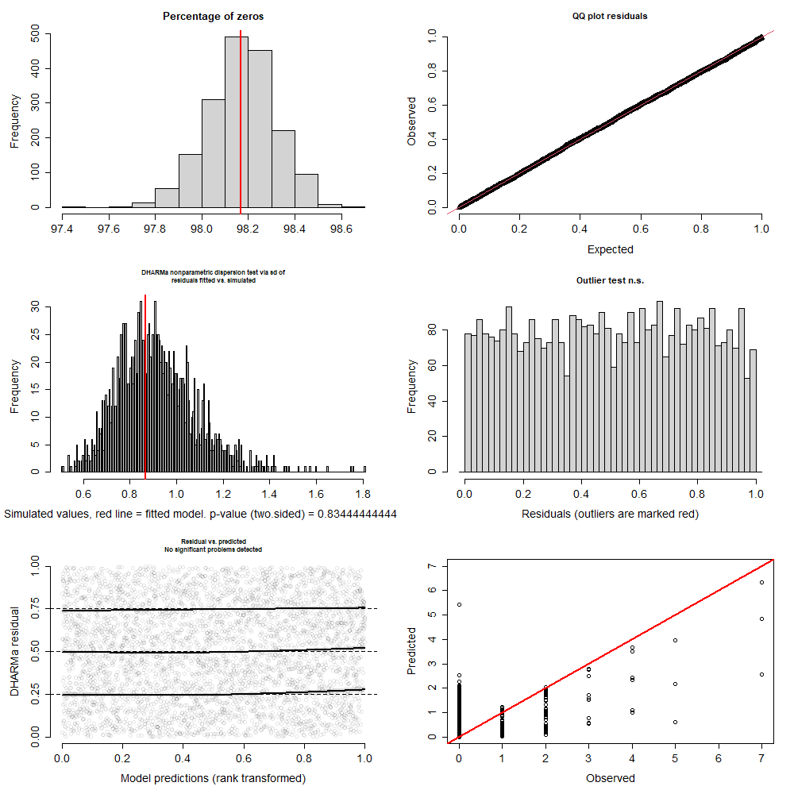
Figure S12. Sperm whale – Model 1. Results for simulation-based and scaled residuals diagnostics for model-fit assessment. Left top panel shows the percentage of zeros in observed data (red line) and simulated data (histogram of posterior distribution). Right top panel show expected versus observed residual plot using scaled residuals. Left mid-panel show residual dispersion for observed data (red line) and simulated data (histogram of posterior distribution). Right mid-panel show result for outlier test, indicating now outliers detected. Left bottom panel show quantile deviation test, red lines indicate deviations detected. Right bottom panel show observed versus predicted plot.
Table S9. Results for model 2 fitted to sperm whale data. Parameters for predictors are indicated by specific predictors’ name including quadratic terms. Parameters in bold indicate zero was not included in their posterior distribution. Psi (ψ) is the probability of a non-zero and prec corresponds to the precision (1/variance) of the normally distributed observation-level random effect.
Sperm whale - Model 2
 | mean | sd | 2.50% | 25% | 50% | 75% | 97.50%
Intercept | -7.61146 | 0.735832 | -8.84144 | -8.1504 | -7.69744 | -7.14089 | -5.96968
SST | -1.24715 | 0.228244 | -1.71061 | -1.39668 | -1.24282 | -1.10052 | -0.81228
SST² | -0.01616 | 0.19028 | -0.39693 | -0.13685 | -0.01139 | 0.111386 | 0.343302
DEPTH | -1.81176 | 0.306606 | -2.46431 | -2.0089 | -1.79736 | -1.60772 | -1.24638
DEPTH² | -0.73692 | 0.193394 | -1.14257 | -0.86088 | -0.72994 | -0.6019 | -0.38714
SLO | 0.227473 | 0.209324 | -0.18293 | 0.090277 | 0.224684 | 0.371705 | 0.650881
SLO² | -0.19069 | 0.132313 | -0.47761 | -0.27346 | -0.18185 | -0.09285 | 0.032107
Mean group size | 2.689819 | 0.156378 | 2.395915 | 2.581197 | 2.686528 | 2.796858 | 2.994346
Variance group size | 3.013828 | 0.321964 | 2.521833 | 2.787668 | 2.968523 | 3.177573 | 3.818083
psi | 0.420139 | 0.154978 | 0.176989 | 0.304953 | 0.402952 | 0.514743 | 0.770759
prec | 0.30962 | 0.096942 | 0.225958 | 0.249018 | 0.281282 | 0.335626 | 0.551742
A0 | 0.327844 | 0.120739 | 0.094635 | 0.247822 | 0.324984 | 0.412564 | 0.572666
Wave height | -0.32996 | 0.122101 | -0.56257 | -0.41209 | -0.33264 | -0.24604 | -0.08544
Wind speed | 0.108007 | 0.11889 | -0.11399 | 0.027175 | 0.0996 | 0.190395 | 0.349557
Sea State | -0.02652 | 0.124602 | -0.26768 | -0.11059 | -0.02367 | 0.056731 | 0.211924
bpv | 0.515556 | 0.499897 | 0 | 0 | 1 | 1 | 1
c.hat | 1.213522 | 1.087451 | 0.343347 | 0.824589 | 1.013544 | 1.275516 | 3.487673
observed range | 7 | 0 | 7 | 7 | 7 | 7 | 7
expected range | 7.102778 | 1.681734 | 4 | 6 | 7 | 8 | 11

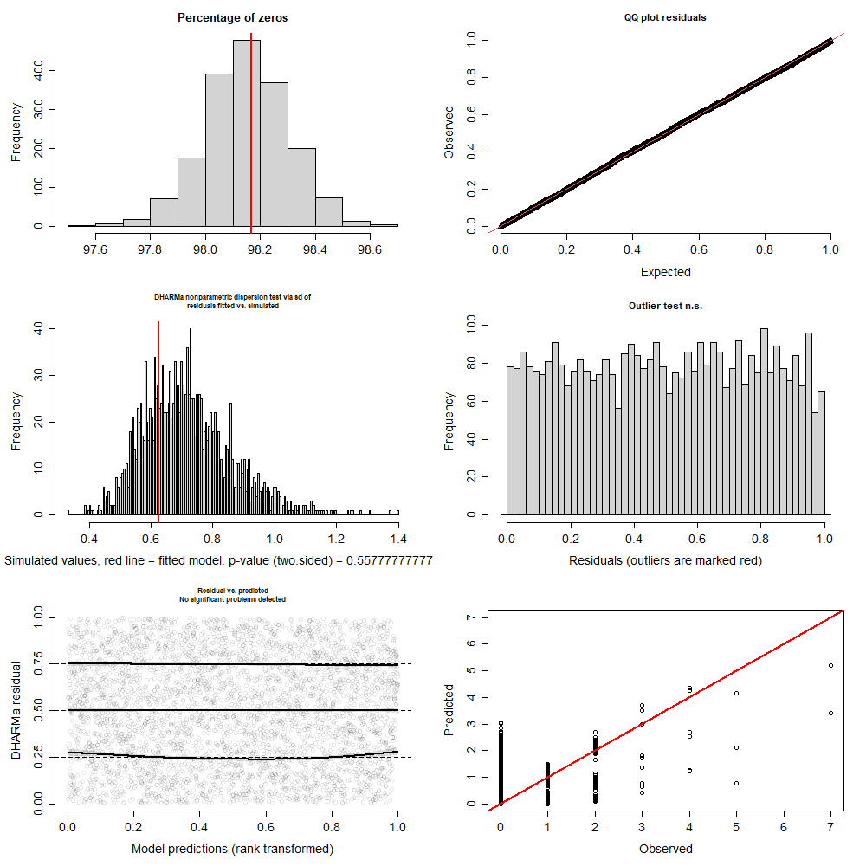
Figure S13. Sperm whale – Model 2. Results for simulation-based and scaled residuals diagnostics for model-fit assessment. Left top panel shows the percentage of zeros in observed data (red line) and simulated data (histogram of posterior distribution). Right top panel show expected versus observed residual plot using scaled residuals. Left mid-panel show residual dispersion for observed data (red line) and simulated data (histogram of posterior distribution). Right mid-panel show result for outlier test, indicating now outliers detected. Left bottom panel show quantile deviation test, red lines indicate deviations detected. Right bottom panel show observed versus predicted plot.
Table S10. Results for model 1 fitted to dusky dolphin data. Parameters for predictors are indicated by specific predictors’ name including quadratic terms. Parameters in bold indicate zero was not included in their posterior distribution. Psi (ψ) is the probability of a non-zero and prec corresponds to the precision (1/variance) of the normally distributed observation-level random effect.
Dusky dolphin - Model 1
 | mean | sd | 2.50% | 25% | 50% | 75% | 97.50%
Intercept | -9.3206 | 1.186888 | -11.6752 | -10.1504 | -9.26449 | -8.508 | -7.11616
SSTLT | 1.866241 | 0.356542 | 1.249588 | 1.620568 | 1.844293 | 2.087516 | 2.619399
SSTLT² | -0.96802 | 0.369436 | -1.76198 | -1.20489 | -0.93974 | -0.71286 | -0.31365
DEPTH | 4.373069 | 0.971437 | 2.876941 | 3.700482 | 4.253252 | 4.850211 | 6.712385
DEPTH² | 0.831254 | 0.76219 | -1.12749 | 0.427942 | 0.961203 | 1.347764 | 2.025603
SLO | 0.056704 | 0.270914 | -0.45881 | -0.12512 | 0.06138 | 0.239536 | 0.589019
SLO² | -0.3087 | 0.228642 | -0.79448 | -0.45195 | -0.28897 | -0.14034 | 0.067577
Mean group size | 18.61218 | 1.2774 | 16.33376 | 17.73167 | 18.53054 | 19.44915 | 21.19195
Variance group size | 272.6842 | 46.68879 | 199.921 | 239.1607 | 268.1178 | 300.3799 | 377.3196
psi | 0.388035 | 0.149617 | 0.191896 | 0.277427 | 0.355614 | 0.467341 | 0.785105
prec | 0.502094 | 0.23967 | 0.236506 | 0.329166 | 0.428732 | 0.623013 | 1.121146
A0 | -0.31943 | 0.089993 | -0.48972 | -0.38098 | -0.3244 | -0.26052 | -0.13116
Wave height | -0.1493 | 0.110354 | -0.36766 | -0.22021 | -0.15069 | -0.07541 | 0.063671
Wind speed | 0.135374 | 0.116688 | -0.098 | 0.057553 | 0.134673 | 0.215997 | 0.354454
Sea State | -0.15665 | 0.110462 | -0.37523 | -0.2309 | -0.15728 | -0.08156 | 0.071505
bpv | 0.573333 | 0.49473 | 0 | 0 | 1 | 1 | 1
c.hat | 1.743525 | 3.296345 | 0.35161 | 0.888263 | 1.033963 | 1.394566 | 8.273868
observed range | 6 | 0 | 6 | 6 | 6 | 6 | 6
expected range | 7.668333 | 1.628504 | 5 | 7 | 7 | 9 | 12

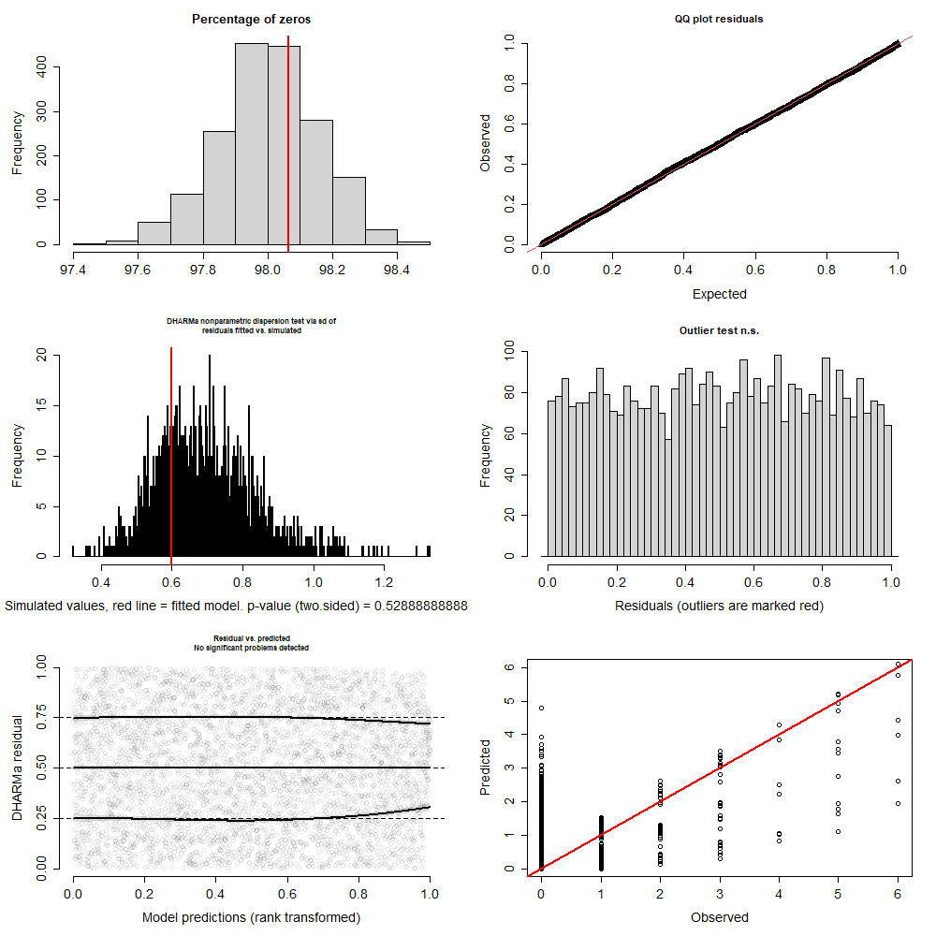
Figure S14. Dusky dolphin – Model 1. Results for simulation-based and scaled residuals diagnostics for model-fit assessment. Left top panel shows the percentage of zeros in observed data (red line) and simulated data (histogram of posterior distribution). Right top panel show expected versus observed residual plot using scaled residuals. Left mid-panel show residual dispersion for observed data (red line) and simulated data (histogram of posterior distribution). Right mid-panel show result for outlier test, indicating now outliers detected. Left bottom panel show quantile deviation test, red lines indicate deviations detected. Right bottom panel show observed versus predicted plot.
Table S11. Results for model 2 fitted to dusky dolphin data. Parameters for predictors are indicated by specific predictors’ name including quadratic terms. Parameters in bold indicate zero was not included in their posterior distribution. Psi (ψ) is the probability of a non-zero and prec corresponds to the precision (1/variance) of the normally distributed observation-level random effect.
Dusky dolphin - Model 2
 | mean | sd | 2.50% | 25% | 50% | 75% | 97.50%
Intercept | -9.31476 | 1.066228 | -11.3906 | -10.07 | -9.30017 | -8.60226 | -7.26725
SST | 1.230694 | 0.243786 | 0.777884 | 1.063106 | 1.220883 | 1.378097 | 1.752263
SST² | -0.80824 | 0.207141 | -1.25515 | -0.93768 | -0.79752 | -0.66582 | -0.44446
DEPTH | 4.116265 | 1.123578 | 2.643973 | 3.372017 | 3.848724 | 4.631435 | 6.946402
DEPTH² | 0.561625 | 0.882892 | -1.65732 | 0.163326 | 0.774268 | 1.166827 | 1.748375
SLO | -0.29342 | 0.253641 | -0.79888 | -0.46766 | -0.28684 | -0.13003 | 0.206738
SLO² | -0.22405 | 0.216342 | -0.68375 | -0.36029 | -0.2041 | -0.06426 | 0.123411
Mean group size | 18.61561 | 1.320562 | 16.19678 | 17.69688 | 18.57137 | 19.44233 | 21.34528
Variance group size | 273.7462 | 48.04307 | 196.2432 | 239.6013 | 268.6572 | 301.7448 | 383.0722
psi | 0.439898 | 0.177076 | 0.198025 | 0.309284 | 0.407106 | 0.528026 | 0.882689
prec | 0.361169 | 0.13785 | 0.227369 | 0.262363 | 0.31788 | 0.414728 | 0.723256
A0 | -0.30579 | 0.086681 | -0.47159 | -0.36154 | -0.30948 | -0.25155 | -0.12254
Wave height | -0.15791 | 0.109307 | -0.37452 | -0.23249 | -0.15839 | -0.08613 | 0.063491
Wind speed | 0.121607 | 0.119395 | -0.12337 | 0.042282 | 0.124986 | 0.20215 | 0.351834
Sea State | -0.1692 | 0.111255 | -0.39335 | -0.24025 | -0.16528 | -0.09532 | 0.040012
bpv | 0.558889 | 0.496658 | 0 | 0 | 1 | 1 | 1
c.hat | 1.942276 | 5.010608 | 0.275975 | 0.846957 | 1.03236 | 1.401231 | 9.335658
observed range | 6 | 0 | 6 | 6 | 6 | 6 | 6
expected range | 7.8 | 1.594529 | 5 | 7 | 8 | 9 | 11

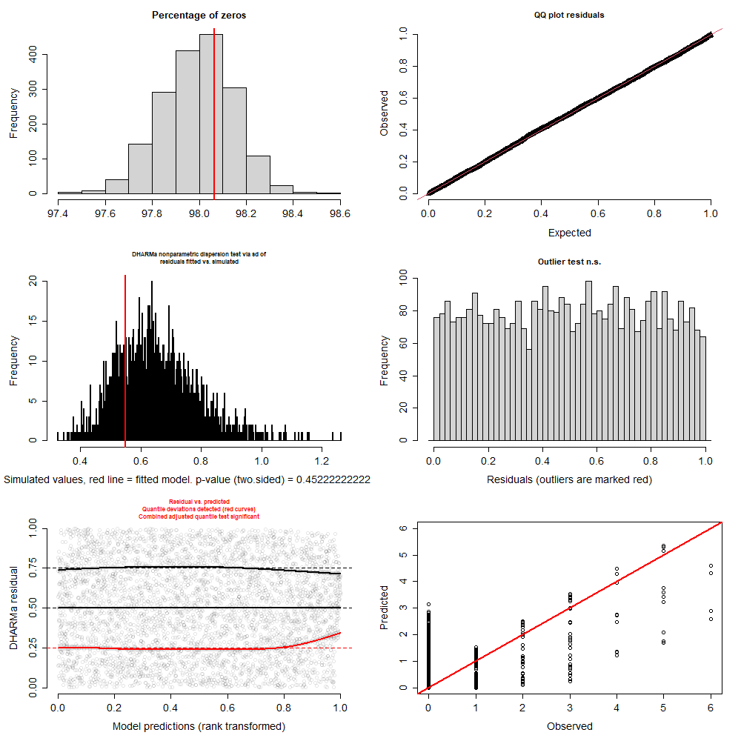
Figure S15. Dusky dolphin – Model 2. Results for simulation-based and scaled residuals diagnostics for model-fit assessment. Left top panel shows the percentage of zeros in observed data (red line) and simulated data (histogram of posterior distribution). Right top panel show expected versus observed residual plot using scaled residuals. Left mid-panel show residual dispersion for observed data (red line) and simulated data (histogram of posterior distribution). Right mid-panel show result for outlier test, indicating now outliers detected. Left bottom panel show quantile deviation test, red lines indicate deviations detected. Right bottom panel show observed versus predicted plot.
Table S12. Results for model 1 fitted to common dolphin data. Parameters for predictors are indicated by specific predictors’ name including quadratic terms. Parameters in bold indicate zero was not included in their posterior distribution. Psi (ψ) is the probability of a non-zero and prec corresponds to the precision (1/variance) of the normally distributed observation-level random effect.
Common dolphin - Model 1
 | mean | sd | 2.50% | 25% | 50% | 75% | 97.50%
Intercept | -7.0809 | 1.230293 | -8.82602 | -8.11167 | -7.37916 | -6.05202 | -4.71486
SST | 0.598169 | 0.227547 | 0.188474 | 0.438282 | 0.589952 | 0.754257 | 1.083275
SST² | -0.47711 | 0.185262 | -0.8462 | -0.60394 | -0.47224 | -0.34964 | -0.12984
DEPTH | -0.44025 | 0.224233 | -0.87468 | -0.58459 | -0.44166 | -0.28804 | -0.01163
DEPTH² | -0.03205 | 0.159317 | -0.33571 | -0.13985 | -0.02822 | 0.076795 | 0.282172
Mean group size | 46.9311 | 5.572096 | 37.75452 | 43.03957 | 46.43673 | 50.13282 | 58.62344
Variance group size | 2214.256 | 667.288 | 1274.206 | 1750.944 | 2094.541 | 2521.984 | 3776.481
psi | 0.52661 | 0.292094 | 0.098062 | 0.244158 | 0.516248 | 0.801111 | 0.984148
prec | 0.954506 | 0.991448 | 0.252117 | 0.35284 | 0.486102 | 1.07334 | 3.912544
A0 | 0.161956 | 0.129493 | -0.08367 | 0.070453 | 0.156713 | 0.24929 | 0.418774
Wave height | -0.1787 | 0.186618 | -0.53747 | -0.3036 | -0.18262 | -0.05231 | 0.193517
Wind speed | -0.30249 | 0.166989 | -0.62746 | -0.4117 | -0.30428 | -0.18719 | 0.020782
Sea State | 0.02188 | 0.168566 | -0.29961 | -0.08985 | 0.021143 | 0.129939 | 0.361796
bpv | 0.444444 | 0.497042 | 0 | 0 | 0 | 1 | 1
c.hat | 1.034627 | 0.56984 | 0.412195 | 0.793051 | 0.964204 | 1.153452 | 2.053162
observed range | 3 | 0 | 3 | 3 | 3 | 3 | 3
expected range | 2.971667 | 0.868687 | 2 | 2 | 3 | 3 | 5

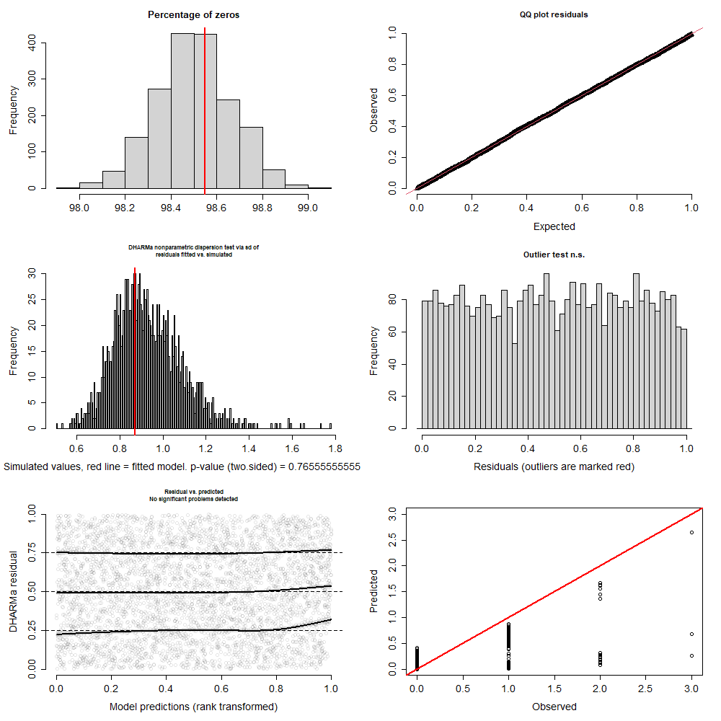
Figure S16. Common dolphin – Model 1. Results for simulation-based and scaled residuals diagnostics for model-fit assessment. Left top panel shows the percentage of zeros in observed data (red line) and simulated data (histogram of posterior distribution). Right top panel show expected versus observed residual plot using scaled residuals. Left mid-panel show residual dispersion for observed data (red line) and simulated data (histogram of posterior distribution). Right mid-panel show result for outlier test, indicating now outliers detected. Left bottom panel show quantile deviation test, red lines indicate deviations detected. Right bottom panel show observed versus predicted plot.
Table S13. Results for model 2 fitted to common dolphin data. Parameters for predictors are indicated by specific predictors’ name including quadratic terms. Parameters in bold indicate zero was not included in their posterior distribution. Psi (ψ) is the probability of a non-zero and prec corresponds to the precision (1/variance) of the normally distributed observation-level random effect.
Common dolphin - Model 2
 | mean | sd | 2.50% | 25% | 50% | 75% | 97.50%
Intercept | -6.71952 | 0.995821 | -8.85074 | -7.4082 | -6.5222 | -5.93751 | -5.20542
SSTLT | 1.192024 | 0.310012 | 0.630611 | 0.981591 | 1.177607 | 1.389304 | 1.854776
SSTLT2 | -0.29639 | 0.239809 | -0.79095 | -0.44648 | -0.279 | -0.13 | 0.138359
DEPTH | -0.28576 | 0.218861 | -0.72928 | -0.42451 | -0.28248 | -0.1408 | 0.144592
DEPTH2 | -0.06954 | 0.153364 | -0.38154 | -0.17097 | -0.0693 | 0.036651 | 0.234916
Mean group size | 46.76879 | 5.548721 | 36.89728 | 42.95904 | 46.24758 | 50.15738 | 58.87203
Variance group size | 2204.686 | 662.6679 | 1264.458 | 1762.38 | 2090.233 | 2525.698 | 3755.97
psi | 0.364786 | 0.2248 | 0.107072 | 0.187872 | 0.290881 | 0.485299 | 0.906012
prec | 1.681376 | 1.087629 | 0.313682 | 0.728465 | 1.443721 | 2.426931 | 4.136162
A0 | 0.149473 | 0.124001 | -0.0749 | 0.060587 | 0.142866 | 0.230754 | 0.411189
Wave height | -0.24785 | 0.178141 | -0.5884 | -0.37156 | -0.25307 | -0.13287 | 0.105355
Wind speed | -0.28459 | 0.162494 | -0.60636 | -0.39624 | -0.28055 | -0.17879 | 0.030288
Sea State | 0.065135 | 0.169394 | -0.2588 | -0.04568 | 0.065631 | 0.172373 | 0.403824
bpv | 0.441111 | 0.496658 | 0 | 0 | 0 | 1 | 1
c.hat | 1.010597 | 0.414946 | 0.469798 | 0.823802 | 0.968477 | 1.135011 | 1.688826
observed range | 3 | 0 | 3 | 3 | 3 | 3 | 3
expected range | 2.829444 | 0.771447 | 2 | 2 | 3 | 3 | 5

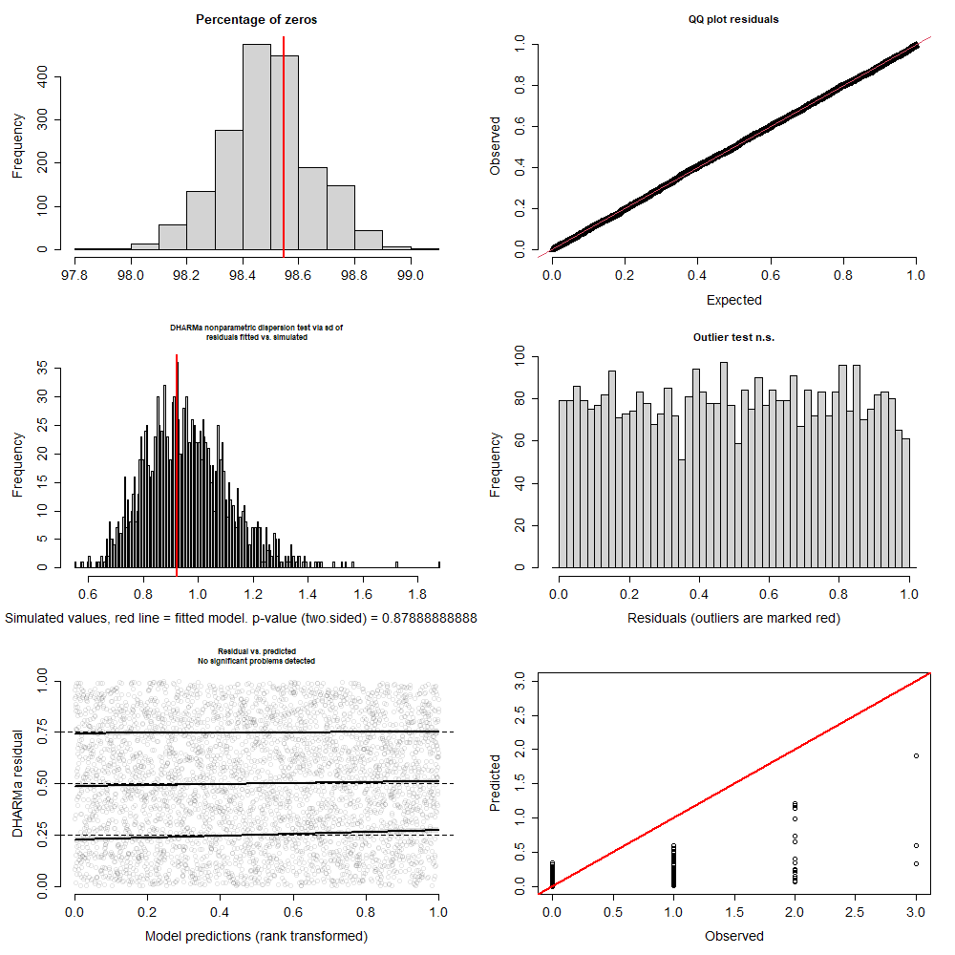
Figure S17. Common dolphin – Model 2. Results for simulation-based and scaled residuals diagnostics for model-fit assessment. Left top panel shows the percentage of zeros in observed data (red line) and simulated data (histogram of posterior distribution). Right top panel show expected versus observed residual plot using scaled residuals. Left mid-panel show residual dispersion for observed data (red line) and simulated data (histogram of posterior distribution). Right mid-panel show result for outlier test, indicating now outliers detected. Left bottom panel show quantile deviation test, red lines indicate deviations detected. Right bottom panel show observed versus predicted plot.

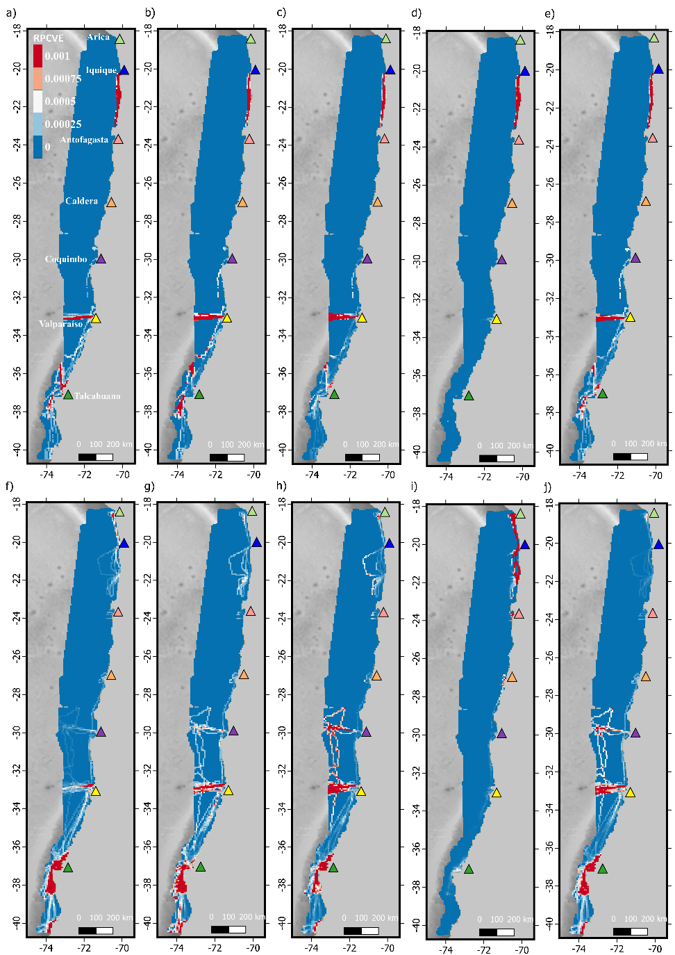
Figure S18. Predicted relative probability of cetacean-vessel encounter (RPCVE) for transport fleet (a-e) and aquaculture fishery fleet (f-j). Columns show results for fin whales (a,f), blue whales (b,g), sperm whales (c,h), dusky dolphins (d,i) and common dolphins (e,j). Colored triangles indicate the location of most important ports. Data layers (including maps) were created in R ver. 4.0.2 (www.r-project.org) and ensembled in QGIS ver. 3.8.0 (www.qgis.org) for final rendering. Maps were created using data on bedrock topography from the National Centers for Environmental Information (https://maps.ngdc.noaa.gov/viewers/grid-extract/index.html). Grid-cells with values above 0 were considered land coverage and assigned a uniform color.
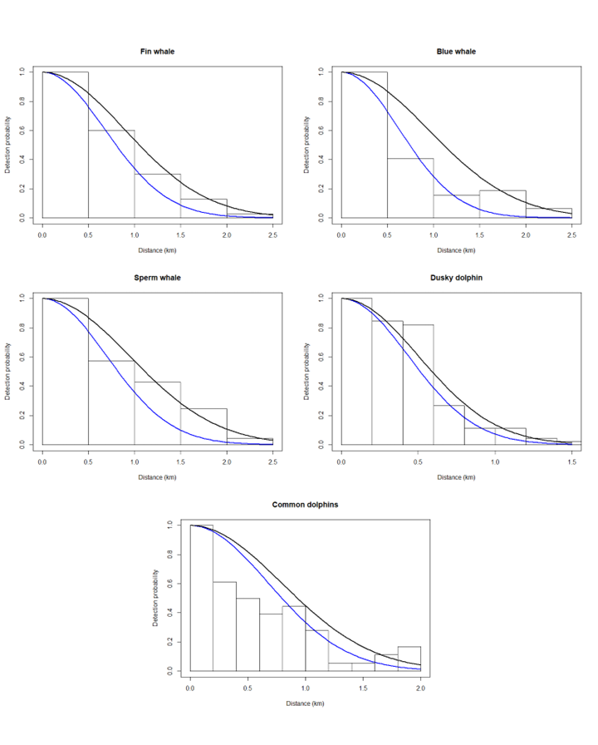
Figure S19. Detection curves for the five cetacean species in this study. Lines show effect of wave height condition on the detection curve with the black line indicating condition 1 (equal or less than 1.75-2.25 m) and the blue line condition 2 (above 2.25 410 m).
BUGS code for fitting the Bayesian Binomial N-mixture model
model{
Priors
#Environmental covariate parameters
for (i in 1:nCovs){
B[i]~ dnorm(0,0.01)
}
#Observation covariate parameters
A0 ~ dnorm(0,0.1)
A1 ~ dnorm(0,0.1)
A2 ~ dnorm(0,0.1)
A3 ~ dnorm(0,0.1)

#Group size priors
r ~ dgamma(0.01,0.01)#size
pg <- r/(r+mug)#prob of success
mug~dgamma(0.01,0.01)#mean
vg<-r*(1-pg)/(pg*pg)#variance

psi ~ dunif(0, 1)
logprec ~ dunif(-1.5,1.5)
prec <-exp(logprec)

#Detections
for (k in 1:nDet){
#Chelgren et al. Likelihood function
Lik[k] <- 1/sigma[k]*pow(2*pi,-0.5)*exp(-0.5*pow(x[k]/sigma[k],2)/(phi(W/sigma[k])-0.5))
sigma[k]<-exp(A0 + A1*wh_d[k]+ A2*ss_d[k]+ A3*ws_d[k])
p[k] <- Lik[k] / C
#The ones trick
ones[k] ~ dbern(p[k])
#Estimating group size
gsize[k]~ dnegbin(pg,r)
}

eta <- Xb %*% B

for(i in 1:UM){

mu[i] <- lambda[i]*z[i]+0.00001
OLRE[i] ~ dnorm(0, prec)
lambda[i] <- 2*W*L[i]*exp(eta[i]+ OLRE[i]) #OLRE
z[i] ~ dbern(psi)
N[i] ~ dpois(mu[i])
sigma_t[i]<-exp(A0 + A1*wh[i]+ A2*ss[i]+ A3*ws[i])
tau[i] <- pow(sigma_t[i],-2)
Pn[i]<- (1/W)*sqrt(2*pi/tau[i])*(phi(W*sqrt(tau[i]))-0.5)
n[i] ~ dbin(Pn[i],N[i])
e.count[i] <- lambda[i]*Pn[i]*psi # Expected datum
n.new[i]~ dbin(Pn[i],N[i])# Create new data set under model
resi[i]<-(n[i]-e.count[i]) / (sqrt(e.count[i])+0.00001) # Pearson residual
chi2[i] <- pow((n[i]-e.count[i]),2) / (e.count[i]+0.00001) # obs.
chi2.new[i] <- pow((n.new[i]-e.count[i]),2) / (e.count[i]+0.00001) # exp.
}

#Add up discrepancy measures for entire data set
fit <- sum(chi2[]) # Omnibus test statistic actual data
fit.new <- sum(chi2.new[]) # Omnibus test statistic replicate data
c.hat <- fit / fit.new # c-hat estimate
bpv <- step(fit-fit.new) # Bayesian p-value
#range of data as a second discrepancy measure
obs.range <- max(n[]) - min(n[])
exp.range <- max(n.new[]) - min(n.new[])

#Constants
C <- 100000
pi <- 3.14159
}

