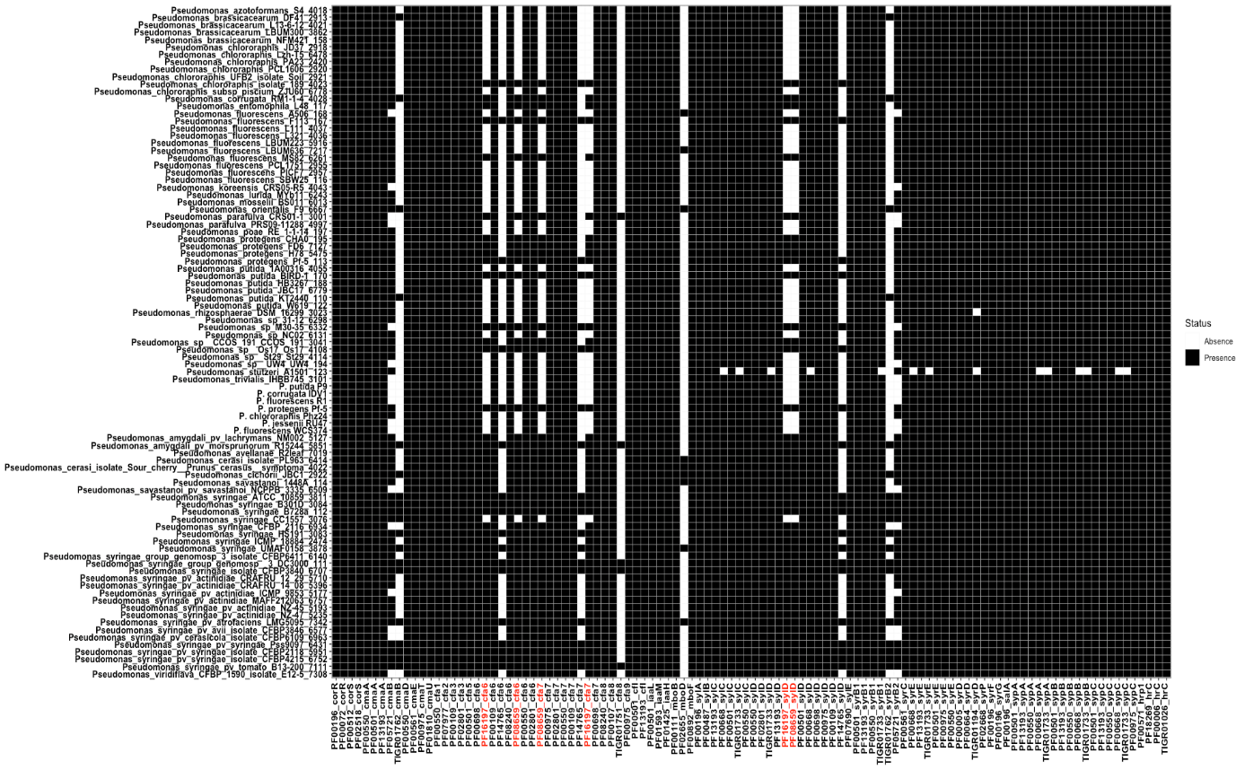

T3SS
Mangotoxin
IAA conjugation
Coronatine
Syringopeptin
Syringomycin
Syringolin
IAA synthesis

Supplementary Figure S5: Presence and absence of protein domains associated to genes related to selected pathogenic traits found in P. syringae¹. Colored vertical line distinguished between the beneficial (red) and the pathogen (blue) group. Protein domains in red are the member of the enriched protein domains for pathogenic group.

References

1. Ruinelli, M., Blom, J., Smits, T. H. M. & Pothier, J. F. Comparative genomics and pathogenicity potential of members of the Pseudomonas syringae species complex on Prunus spp. BMC Genomics 20, 172 (2019).

