Supporting Information for:

Cell-repellent polyampholyte for conformal coating on microstructures
Kohei Suzuki Yoshiomi Hiroi, Natsuki Abe-Fukasawa, Taito Nishino, Takeaki Shouji, Junko Katayama, Tatsuto Kageyama, and Junji Fukuda*
*SI correspondence to:
Junji Fukuda: fukuda@ynu.ac.jp

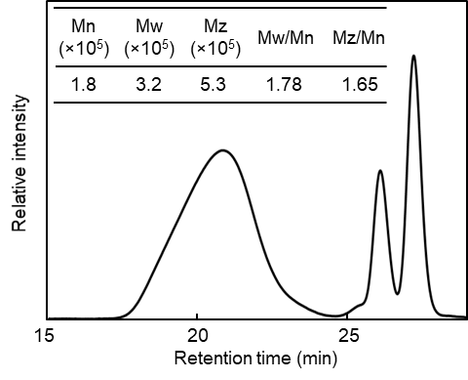
Fig. S1. Gel permeation chromatography (GPC) spectrum.
Prevelex was analyzed using GPC equipped with a refractive index detector (Prominence, Shimadzu, Kyoto, Japan). Polymer solutions (1 mg/ml, in ionic aqueous solution) were injected and eluted at a flow rate of 1 ml/min. The calibration curve was obtained using a set of primary polyethylene oxide standards. The weight-average (Mw), number-average (Mn), and z-average (Mz) molecular weights were calculated from the spectrum.

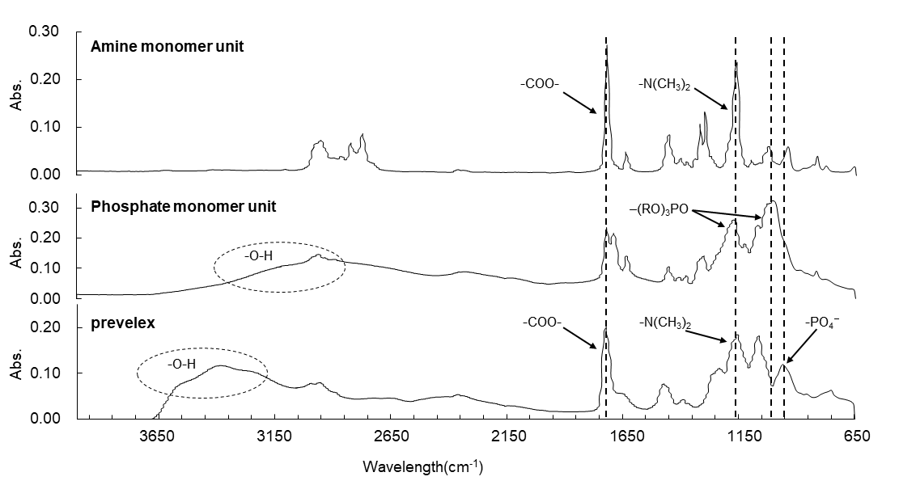
Fig. S2. Fourier transform infrared (FT-IR) spectra.
The chemical structures of each monomer and prevelex were analyzed by FT-IR (Nicolet iS5 with ATR iD5, Thermo Scientific, Massachusetts, USA) in the 4000–400 cm⁻¹ range, at a resolution of 4 cm⁻¹. The characteristic peaks are attributed to –O–H (3000~3500cm⁻¹), –C=O (1750 cm⁻¹), –N(CH₃)₂ (1160 cm⁻¹) , –(RO)₃PO (1000 and 1160 cm ⁻¹), and –PO4⁻ (960 cm ⁻¹) stretching vibrations.

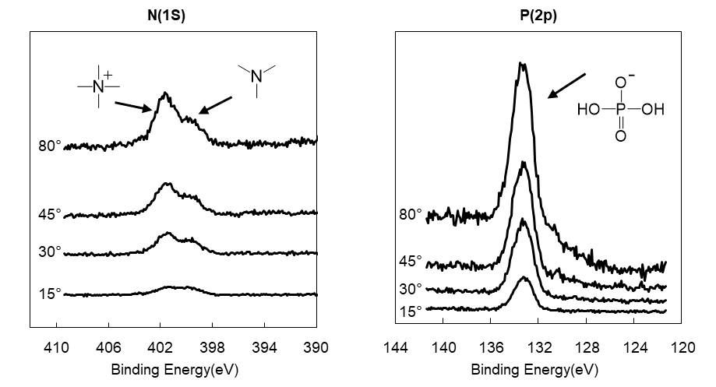
Fig. S3. X-ray photoelectron spectroscopy (XPS) spectra of a prevelex-coated silicon substrate surface.
The chemical structure of prevelex on the surface was analyzed by XPS (PHI Quantera SXM, ULVAC-PHI, Kanagawa, Japan) with Al Kα X-rays (1486.6 eV). During the analyses, the pressure in the chamber was set to be ~10⁻⁹ Torr. The measurements were carried out at 15, 30, 45, and 80° photoelectron take-off angles relative to the surface with an acceptance angle of ± 3°. The analyzer pass energy was set at 23.555 eV for the high-resolution spectra.

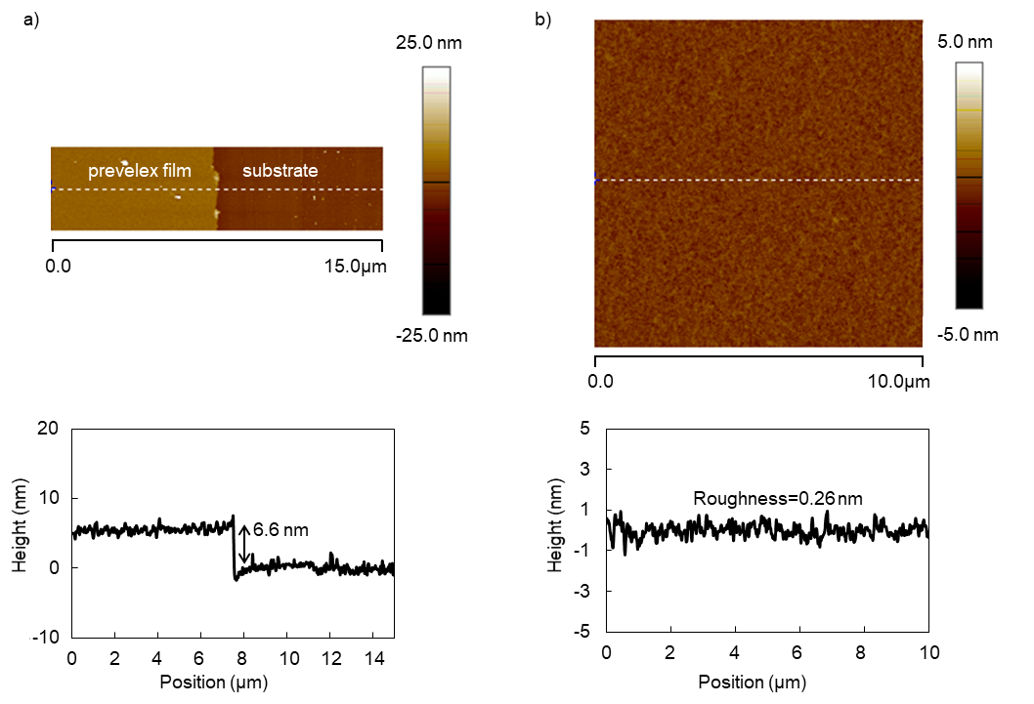
Fig. S4. Atomic force microscopy images of prevelex-coated silicon substrates.
a) The film thickness of prevelex on silicon substrates and b) the roughness of the surface. The measurements were conducted using atomic force microscopy (Dimention Icon, Bruker, MA, USA) with a tip (RTESPA-150, Bruker) in tapping mode at a frequency of a) 0.4 Hz and b) 0.8 Hz.

Fig. S5. Long-term culture of aggregates in prevelex-coated microwells.
Epithelial and mesenchymal cells were mixed and seeded in the prevelex-coated microwell array plate and cultured for 15 days (D1–15).

