Supplementary Material
Table S1. List of the 14 Euphausia superba putative opsins.
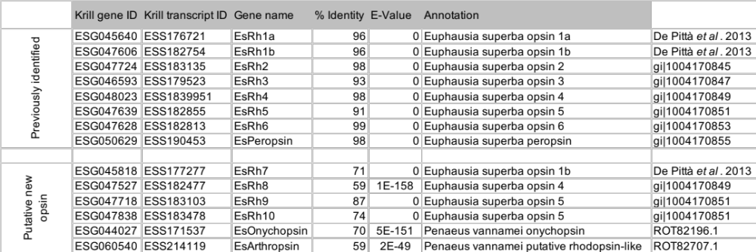
Table S4. Command line for each de novo assembly reconstruction performed. The column “Sample Group” refers to sample annotation as reported in Table S1. The command line for IDBA-tran program was the same for both sample groups as this software does not provide any option regarding the library type.
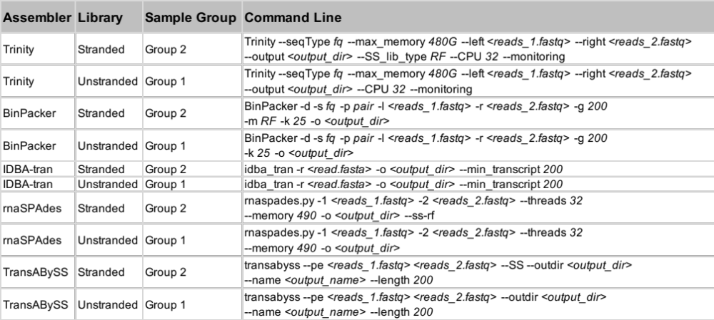

Data S1. Multiple sequence alignment produced using MEGA software. Multiple sequence alignments of opsin proteins performed to produced the phylogenetic tree.
Data S2. Protein sequences used to produce the opsins phylogenetic tree. Curated list of opsin sequences including invertebrate-only opsin data set [54], the cloned krill opsins from Biscontin et al. (2016) [20], and the full-length onychopsin and arthropsin sequences available on the NCBI Protein database (May 2021, ncbi.nlm.nih.gov/protein).

