Chemometric approach to evaluate the chemical behavior of rainwater at high altitude in Shaune Garang catchment, Western Himalaya

Ramesh Kumar¹, Rajesh Kumar^{1*}, Atar Singh¹, Mohammad Arif², Pankaj Kumar³, Anupma Kumari⁴
¹Department of Environmental Science, School of Earth sciences, Central University of Rajasthan, Bandar Seendri, Ajmer, India.
²National Institute of Urban Affairs, Ministry of Housing and Urban Affairs, India.
³Integrated Regional Office, Ministry of Environment, Forest & Climate Change (MoEFCC), Govt. of India, Saifabad, Hyderabad, Telangana, 500004, India
⁴Environmental Biology Laboratory, Department of Zoology, Patna University, Patna, India.
*Corresponding Author: rajesh.kumar@curaj.ac.in

b
a
Figure S1: Diurnal variation of in situ water parameters a) pH, b) Specific conductivity during the study period 2017 in Shaune Garang catchment.

Figure S2: Linear regression analysis between rainfall (mm) and H⁺ (Hydrogen Ion Concentration (µeq/l).

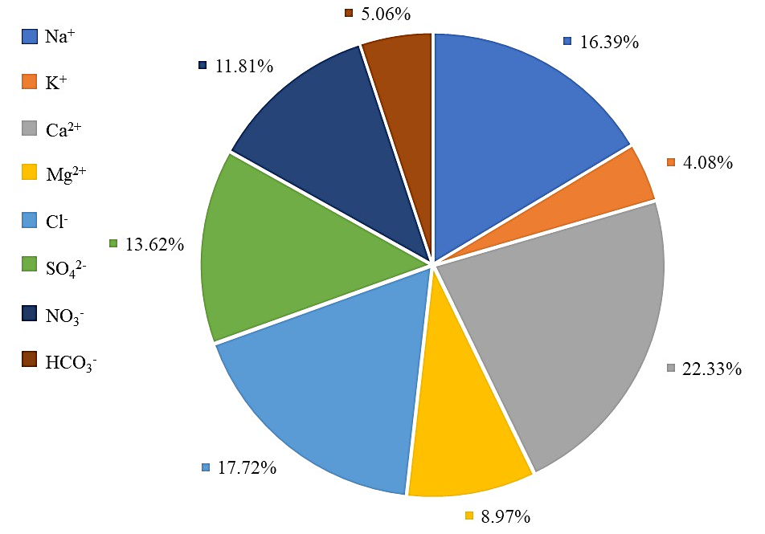
Figure S3: Percentage contribution of measured ionic species in rainwater in Shaune Garang catchment.

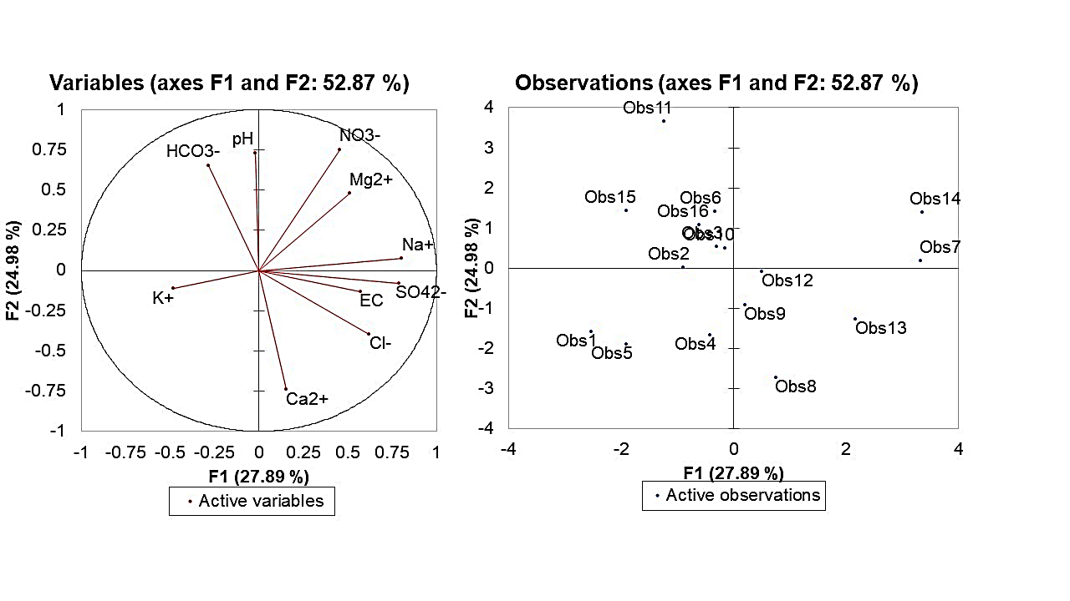
a.
b.
Figure S4: a. Loadings of the chemical constituent of the first two factors. b. Score plot of the first two scores.
Table S1. Concentration (μeq/l) of ionic species of rainwater during the summer monsoon season of the year 2017.
Parameters | Min | Max | Avg. | SD | VWM
pH | 4.59 | 6.73 | 5.47 | 0.72 | 5.56
Na⁺ | 15.23 | 56.45 | 27.66 | 10.66 | 27.35
K⁺ | 2.31 | 12.98 | 6.56 | 3.25 | 6.86
Ca²⁺ | 18.92 | 56 | 37.13 | 12.23 | 35.7
Mg² | 3.65 | 21.45 | 13.98 | 4.57 | 17.61
Cl⁻ | 11.26 | 56.21 | 31.28 | 16.59 | 29.47
SO₄²⁻ | 11.51 | 48.29 | 23.83 | 11.98 | 22.32
NO₃⁻ | 3.65 | 36.17 | 18.75 | 8.75 | 20.61
HCO₃⁻ | 2.36 | 18.26 | 8.09 | 3.64 | 7.71
NH₄ | 3.14 | 30.0 | 14.87 | 5.95 | 14.56

Table S2: The ionic ratio of the observed ionic concentration in the rainwater from Shaune Garang catchment (unit in µeq/l).
Parameters | Minimum | Maximum | Average | STD
H⁺/ NO₃⁻ + SO₄²⁻ | 0.02 | 0.17 | 0.07 | 0.04
NO₃⁻ / SO₄²⁻ | 0.24 | 2.47 | 0.97 | 0.60
NH₄⁺ / NO₃⁻ | 0.42 | 1.00 | 0.81 | 0.21
NH₄⁺ / SO₄²⁻ | 0.21 | 1.46 | 0.73 | 0.38
Ca²⁺ + NH₄⁺ / NO₃⁻ + SO₄²⁻ | 0.48 | 2.75 | 1.34 | 0.51
NO₃⁻ + Cl⁻ / SO₄²⁻ | 1.08 | 4.60 | 2.38 | 0.91
NO₃⁻ + SO₄²⁻ / Ca²⁺ + Mg²⁺ | 0.36 | 2.07 | 0.87 | 0.39

Table S3: Neutralization factors (NF) for selected chemical parameters of Shaune Garang catchment compared with some previous studies in India.
Studies | K⁺ | Na⁺ | Ca²⁺ | Mg²⁺ | NH₄ | References
Shaune Garang, Himachal Pradesh | 0.15 | 0.63 | 0.85 | 0.34 | 0.39 | Present study
Kothi, Himachal Pradesh | 0.12 | 0.5 | 0.71 | 0.24 | 0.31 | [1]
Manora Peak, Nainital, Uttarakhand | 1.28 | 1.63 | 4.08 | 1.42 | 0.32 | [2]
Singhagad, Western Ghat | 0.06 | 0.77 | 0.74 | 0.38 | 0.11 | [3]
Mahabaleshwar | 0.13 | 1.45 | 1.86 | 0.65 | 0.24 | [4]
Pune, Southwest India | 0.08 | - | 1.4 | 0.29 | 0.29 | [5]
Delhi, Northern India | 0.04 | - | 1.4 | 0.49 | 0.17 | [5]
Brahmaputra Valley, Tezpur 2012-18 | 0.39 | 0.5 | 1.01 | 0.28 | 1.02 | [6]

Table S4: Comparison of equivalent concentration ratios of various ionic species concerning sodium ion (Na⁺) along with seawater ratio, sea salt, and non-sea salt (nss) fractions (%) at Shaune Garang catchment.
 | Cl⁻/ Na⁺ | Mg²⁺/ Na⁺ | K⁺/ Na⁺ | Ca²⁺/ Na⁺ | SO₄²⁻/ Na⁺
Seawater Ratio | 1.16 | 0.22 | 0.02 | 0.04 | 0.12
Shaune Garang | 1.14 | 0.54 | 0.24 | 1.35 | 0.87
SSF | 98.27 | 40.74 | 8.33 | 2.96 | 13.79
NSSF | 1.73 | 59.26 | 91.67 | 97.04 | 86.21

Table S5: Enrichment factors (EF) of chemical parameters in rainwater of Shaune Garang catchment and comparison with previous studies.
Enrichment Factor | Cl⁻ | Mg²⁺ | K⁺ | Ca²⁺ | SO₄²⁻ | References
Shaune Garang, Himachal Pradesh | 0.98 | 2.45 | 12.0 | 33.75 | 7.25 | Present Study
Kothi, Himachal Pradesh | 1.05 | 1.98 | 10.9 | 32.23 | 9.32 | [1]
Monera Park Nainital, Uttarakhand | 1.18 | 3.79 | 38.07 | 61.73 | 3.28 | [2]
Panipat, Haryana | 1.08 | 7.84 | 46.79 | 142.6 | 51.12 | [7]
NTPC Dadri, Uttar Pradesh | 1.02 | 6.5 | 2.61 | 11.26 | 3.64 | [8]
Lucknow, Uttar Pradesh | 1.10 | 17.8 | 1.04 | 106.4 | 12.10 | [9]
New Delhi | 1.70 | 1.76 | - | 50.34 | 184.7 | [10]
Bhubaneswar, Odisha | 0.9 | 9.08 | - | 5.81 | 4.15 | [11]
Sinhagad, Western Ghats | 1.03 | 1.49 | 2.72 | 15.68 | 7.94 | [3]
Panipat, Haryana | 1.08 | 7.84 | 46.79 | 142.6 | 51.12 | [7]
Rameswaram, Tamil Nadu | 1.07 | 4.14 | 2.61 | 5.44 | 1.61 | [8]

Table S6: The correlation coefficient among the measured ionic constituents.
Variables | pH | EC | Na⁺ | K⁺ | Ca²⁺ | Mg²⁺ | Cl⁻ | SO₄²⁻ | NO₃⁻ | HCO₃⁻
pH | 1
EC | -0.031 | 1
Na⁺ | -0.045 | 0.422 | 1
K⁺ | -0.084 | -0.529 | -0.297 | 1
Ca²⁺ | -0.563 | 0.097 | -0.122 | 0.121 | 1
Mg²⁺ | 0.295 | -0.090 | 0.072 | -0.224 | -0.481 | 1
Cl⁻ | -0.117 | 0.152 | 0.562 | 0.007 | 0.507 | 0.016 | 1
SO₄²⁻ | 0.006 | 0.365 | 0.688 | -0.068 | 0.275 | -0.009 | 0.502 | 1
NO₃⁻ | 0.519 | 0.225 | 0.121 | -0.042 | -0.444 | 0.673 | -0.088 | 0.678 | 1
HCO₃⁻ | 0.405 | -0.206 | -0.181 | 0.278 | -0.220 | 0.045 | -0.410 | -0.068 | 0.536 | 1

References
- Tiwari, S., Chate, D. M., Bisht, D. S., Srivastava, M. K., Padmanabhamurty, B. Rainwater chemistry in the Northwestern Himalayan Region, India. Atmospheric Research 104-105, 128–138 (2012). https://doi.org/10.1016/j.atmosres.2011.09.006.
- Bisht, D. S. et al. Chemical characterization of rainwater at a high-altitude site “Nainital” in the central Himalayas, India. Environmental Science and Pollution Research 24(4), 3959–3969 (2017). https://doi.org/10.1007/s11356-016-8093-z.
- Budhavant, K. B., Rao, P. S. P., Safai, P. D., Granat, L., Rodhe, H. Chemical composition of the inorganic fraction of cloud-water at a high altitude station in West India. Atmospheric Environment 88, 59–65 (2014). https://doi.org/10.1016/j.atmosenv.2014.01.039.
- Waghmare, V.V., Aslam, M.Y., Yang, L. et al. Inorganic Ionic Composition of Rainwater at a High Altitude Station over the Western Ghats in Peninsular India. J Atmos Chem 78, 59–76 (2021). https://doi.org/10.1007/s10874-021-09416-x.
- Rao, P. S. P. et al. Sources of chemical species in rainwater during monsoon and non-monsoonal periods over two mega cities in India and dominant source region of secondary aerosols. Atmospheric Environment 146, 90–99 (2016). https://doi.org/10.1016/j.atmosenv.2016.06.069.
- Ahmed, M.S., Bhuyan, P., Sarkar, S. et al. Seven-year study of monsoonal rainwater chemistry over the mid-Brahmaputra plain, India: assessment of trends and source regions of soluble ions. Environ Science and Pollution Research (2021). https://doi.org/10.1007/s11356-021-17385-7.
- Tiwari S, Srivastava MK, Bisht DS. Chemical composition of rainwater in Panipat, an industrial city in Haryana. Indian J Radio Space Phys 37:443–449 (2008).
- Salve, P.R., Gobre, T., Lohkare, H. et al. Source identification and variation in the chemical composition of rainwater at coastal and industrial areas of India. J Atmos Chem 68, 183–198 (2011). https://doi.org/10.1007/s10874-012-9217-6.
- Khare P, Goel A, Patel D, Behari J. Chemical characterization of rainwater at a developing urban habitat of Northern India. Atmospheric Research 69(3–4):135–145 (2004).
- Kulshrestha UC, Sarkar AK, Srivastava SS, Parashar DC. A study on short-time sampling of individual rain events at New Delhi during monsoon, 1994. Water Air Soil Pollution 85(4):2143–2148 (1995).
- Das N, Das R, Chaudhury GR, Das SN. Chemical composition of precipitation at background level. Atmospheric Research 95(1):108–113 (2010).

