Supplemental Data

Correlative changes in Salivary Analytes and Periodontitis related to Type I Diabetes-induced Neuropathy
Running title: Saliva Analytes in Diabetes-induced Neuropathy
Larissa Steigmann^{1,$}, Shogo Maekawa^{1,2,3,$}, Frederic Kauffmann^{1,4,$}, Jacob Reiss⁵, Ashley Cornett^{6,7}, James Sugai^{1,7}, Julian Venegas⁸, Xudong Fan^{7,9}, Yuying Xie⁸, William V. Giannobile^{1,2}, Rodica Pop-Busui⁵, Isabelle M.A. Lombaert^{6,7}

¹ University of Michigan, School of Dentistry, Department of Periodontics and Oral Medicine, Ann Arbor, MI 48106
² Current address: Harvard School of Dental Medicine, Department of Oral Medicine, Infection, and Immunity, Boston, MA 02115
³ Tokyo Medical and Dental University, Department of Periodontology, Tokyo, Japan 113-8510
⁴ Department of Oral and Craniomaxillofacial Surgery, Center for Dental Medicine, University Medical Center Freiburg, Freiburg im Breisgau, Germany 79106
⁵ University of Michigan, School of Medicine, Department of Internal Medicine, Division of Metabolism, Metabolism Endocrinology and Diabetes, Ann Arbor, MI 48105
⁶ University of Michigan, School of Dentistry, Department of Biologic and Materials Sciences, Ann Arbor, MI 48109
⁷ University of Michigan, Biointerfaces Institute, Ann Arbor, MI 48109
⁸ Michigan State University, Department of Computational Mathematics, Science and Engineering, East Lansing, MI 48824
⁹ University of Michigan, College of Engineering, Department of Biomedical Engineering, Ann Arbor, MI 48109

Supplementary Table 1. Enrollment scheme.
Selection Inclusion Criteria
Healthy | Age matched healthy non-obese controls with normal glucose tolerance, normal blood pressure and cholesterol
Diabetes | Subjects with diagnosed diabetes as defined by the American Diabetes Association (Type I diabetes), and no complication of retinopathy, neuropathy, cardiovascular autonomic neuropathy, or mild-to-moderate peripheral neuropathy.
Diabetes with Neuropathy | Subjects with diagnosed diabetes as defined by the American Diabetes Association (Type I diabetes), and complications, including cardiovascular autonomic neuropathy and mild-to-moderate peripheral neuropathy.
Selection Exclusion Criteria
Diabetes | Presence of any retinopathy, nephropathy, peripheral and autonomic neuropathy, and cardiovascular disease
Diabetes with Neuropathy | Any other causes of neuropathy besides diabetes (e.g. active hepatitis C, and stage renal disease, systemic lupus erythematous or a known hereditary neuropathy) as determined through medical history, family history, history of mediations, occupational history, history of exposure to toxins, physical and neurological examinations;
Diabetes with Neuropathy | History of drug or alcohol abuse within the previous 2 years or current weekly alcohol consumption of > 10 units per week.
Diabetes with Neuropathy | Participation in an experimental medication trial within 3 months
Table represents the inclusion and exclusion selection for the 3 different groups (Healthy/Diabetes/Diabetes with Neuropathy).

Supplementary Table 2. Demographic and periodontal parameters of the three experimental groups.
Demographics |  |  | Healthy | Diabetes | Diabetes | Diabetes with Neuropathy | Diabetes with Neuropathy
 |  |  | Healthy | +Healthy Perio | +Gingivitis | +healthy Perio | +Gingivitis
 | N (%) |  | 10 | 6 | 3 | 5 | 6
 | Age (yrs) |  | 40 ± 12 | 50 ± 14 | 35 ± 17 | 54 ± 13 | 56 ± 10
Clinical Measurements
 |  | Weight (kg) | 71.6 ± 14.8 | 78.1 ± 23.8 | 97.2 ± 15.3 | 91.3 ± 8.2 | 91.1 ± 17.0
 |  | Height (m) | 1.72 ± 0.13 | 1.69 ± 0.10 | 1.79 ± 0.08 | 1.74 ± 0.09 | 1.77 ± 0.04
 |  | BMI | 24.0 ± 2.8 | 26.9 ± 5.1 | 30.3 ± 4.9 | 30.4 ± 4.1 | 29.2 ± 5.6
 |  | HbA1c | 5.4 ± 0.1 | 7.5 ± 0.9 | 10.0 ± 3.5ª | 8.5 ± 1.6 | 8.3 ± 1.8
 |  | Fasting Glucose | 85.0 ± 10.1 | 150.2 ± 53.8 | 212.7 ± 142.5 | 176.3 ± 64.9 | 132.0 ± 81.4
 |  | Duration of Disease | 0 | 18.5 ± 6.2ª | 11.7 ± 7.5 | 33.8 ± 18.1^{aa,d} | 31.7 ± 12.7^{aa}
 |  | Amount of Smoking (pack / year) | 0.11 ± 0.33 | 0.60 ± 1.34 | 0.0 ± 0.0 | 6.25 ± 12.50 | 0.0 ± 0.0
 |  | mean PSR | 0.30 ± 0.42 | 0.33 ± 0.52 | 1.89 ± 0.19^{aa,bb,cc} | 0.0 ± 0.0 | 1.83 ± 0.33^{aa,bb,cc}
 |  | α-Amylase level (U/ml) | 104.0 ± 91.8 | 166.9 ± 130.7 | 162.5 ± 117.6 | 163.5 ± 137.5 | 106.4 ± 104.0
 |  | CRP | 763.1 ± 799.2 | 507.4 ± 296.9 | 855.7 ± 415.7 | 577.9 ± 250.6 | 866.4 ± 376.2
 |  | IgA | 17182.2 ± 8899.3 | 9660.8 ± 5702.9 | 6882.8 ± 1847.1 | 5905.0 ± 3124.8ª | 16894.6 ± 7084.3 ^{p=0.059}
 |  | IL-10 | 6.5 ± 7.7 | 2.8 ± 1.7 | 2.2 ± 1.1 | 4.1 ± 2.6 | 13.8 ± 19.6
 |  | IL-6 | 409.6 ± 493.5 | 375.6 ± 287.7 | 894.6 ± 898.6 | 601.3 ± 271.6 | 967.3 ± 1248.2
 |  | NFkB | 2423.4 ± 1602.5 | 1775.3 ± 1331.8 | 2596.0 ± 1241.1 | 3304.5 ± 667.9 | 6676.9 ± 8320.0
 |  | TNF-α | 1893.4 ± 3027.6 | 1308.3 ± 893.8 | 752.1 ± 174.3 | 1483.7 ± 523.0 | 4987.5 ± 7527.6

Sociodemographic parameters and saliva biomarker levels are shown. Data are presented as mean ± standard deviation. Tukey test (for continuous data) was used to assess differences between groups. a) significantly different from Healthy, a: p < 0.05, aa: p < 0.01. b) significantly different from Diabetes+Healthy Perio, bb: p < 0.01. c) significantly different from Diabetes with Neuropathy+Healthy Perio, cc: p< 0.01. d) significantly different from Diabetes+Gingivitis, d: p< 0.05.

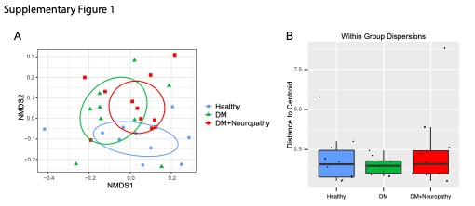
Supplementary Figure 1. Subject population analysis.
- Non-metric multi-dimensional scaling (NMDS) of all the systemic features and the saliva analytes.
- a box plot of the distances of the features from the respective group centroids.

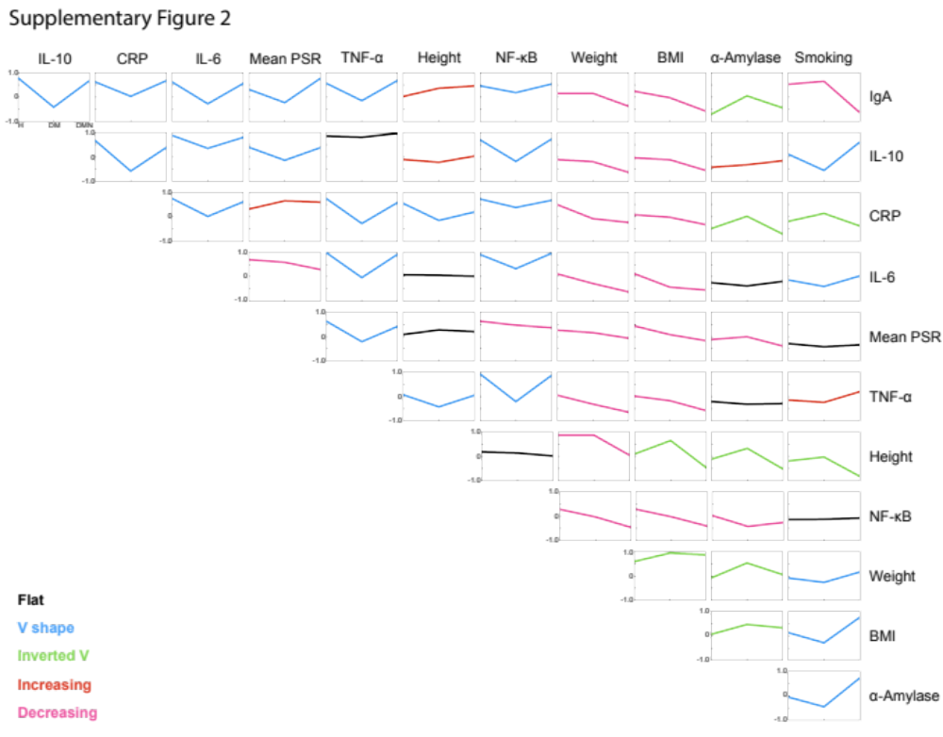
Supplementary Figure 2. Trend in correlation of the systemic features and analytes among the group.
The correlation values were represented in line graphs. There were 5 trends, the line looks Flat (black), V shape (blue), Inverted V shape (green), Increasing (Red), Decreasing (Pink).

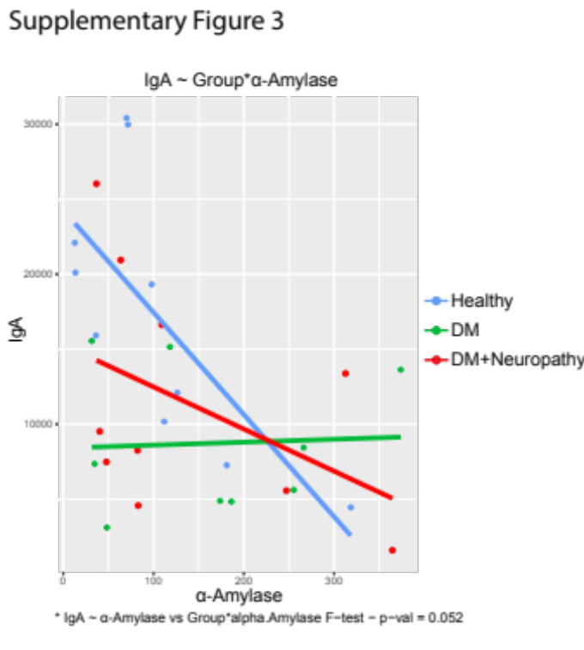
Supplementary Figure 3. The interaction regression plot using IgA and α-Amylase.
The p-value was corresponding to an F-test from ANOVA model comparison.

