Figure S1. Changes in body weight and random blood glucose levels during the experiment.
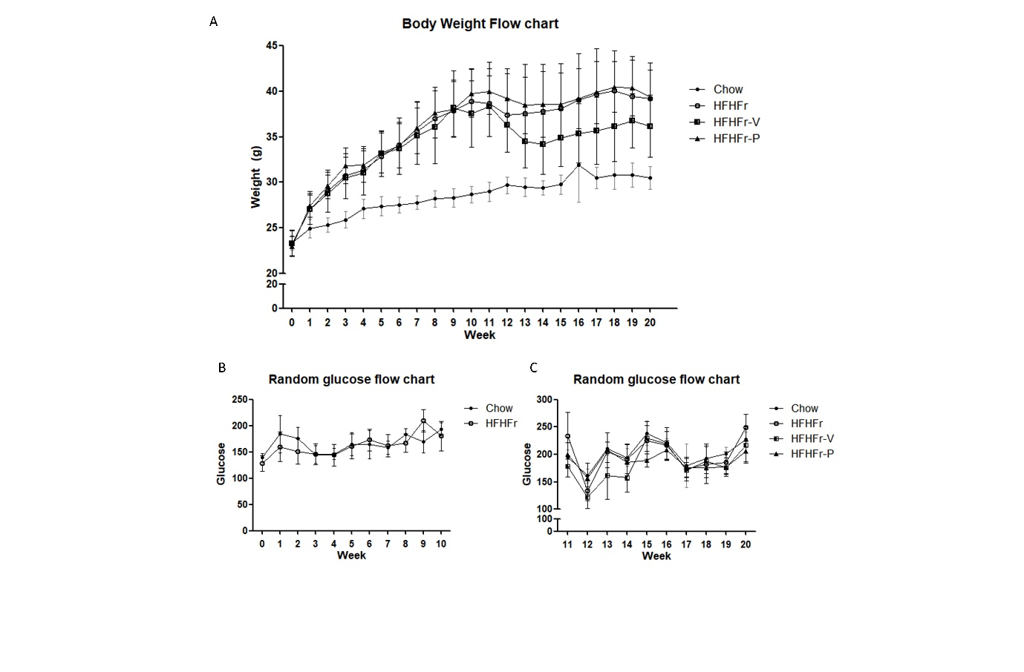
(A) Body weight flow chart during the whole experimental period, (B) random blood glucose flow chart during the first 10 weeks, and (C) random blood glucose flow chart during the latter 10 weeks
HFHFr, high-fat, high-fructose diet group; HFHFr-V, HFHFr diet with voglibose group; HFHFr-P, HFHFr diet with pioglitazone group

Figure S2. Effects of voglibose on hepatitis
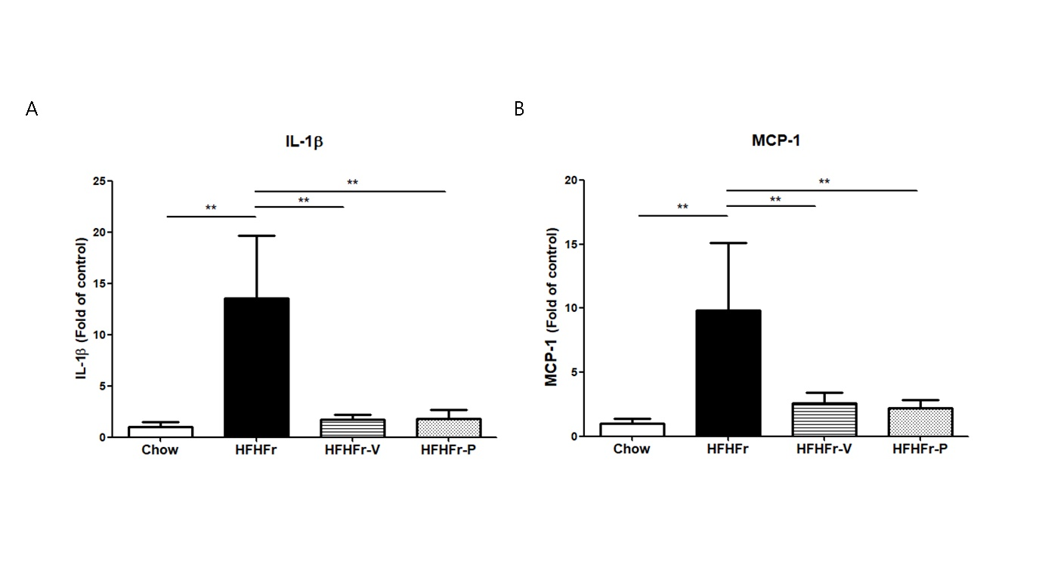
Protein levels of (A) interleukin-1β (IL-1β), and (B) monocyte chemoattractant protein-1 (MCP-1)
*p<0.05; **p<0.01; HFHFr, high-fat, high-fructose diet group; HFHFr-V, HFHFr diet with voglibose group; HFHFr-P, HFHFr diet with pioglitazone group

Figure S3. Raw images of Western blot with markings for groups and sizes
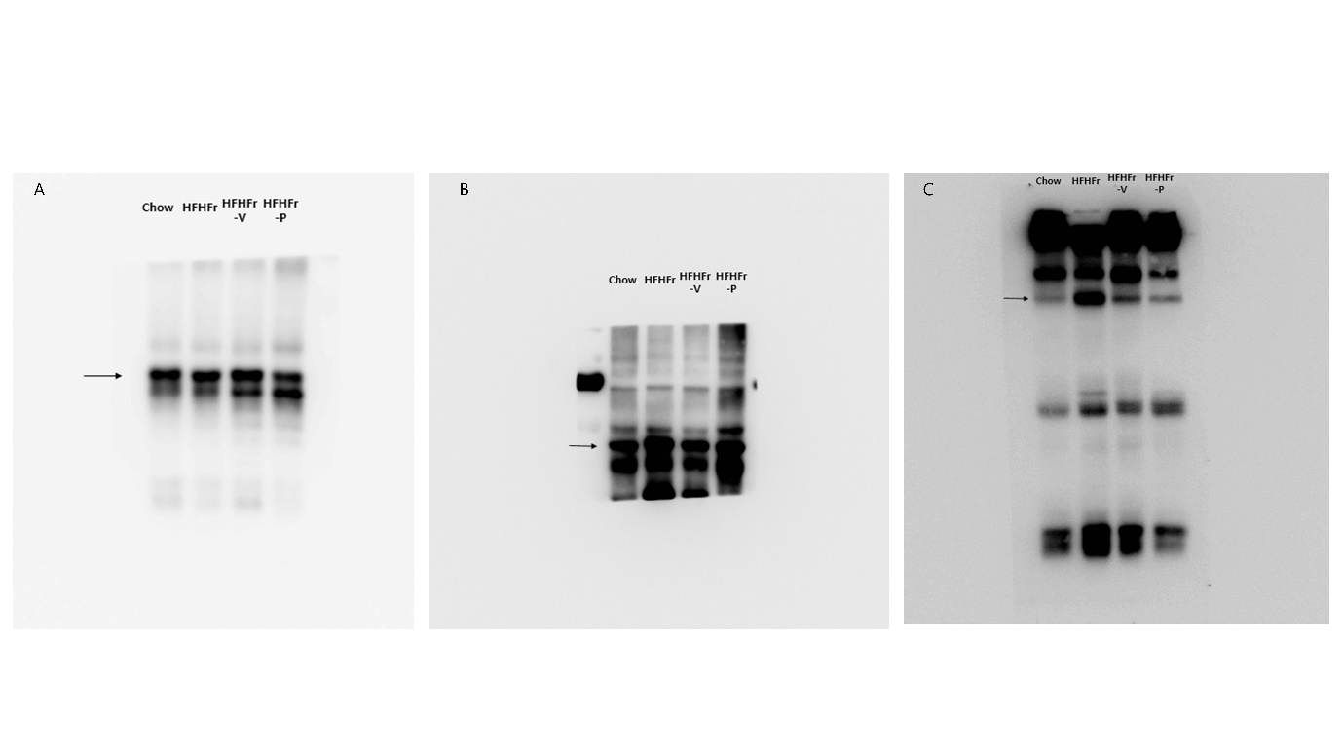
Blot images of (A) GAPDH, (B) sterol regulatory element-binding transcription factor-1 (SREBP-1), and (C) carbohydrate response element-binding protein (ChREBP)
HFHFr, high-fat, high-fructose diet group; HFHFr-V, HFHFr diet with voglibose group; HFHFr-P, HFHFr diet with pioglitazone group

Figure S4. Effects of voglibose on hepatic gluconeogenesis.
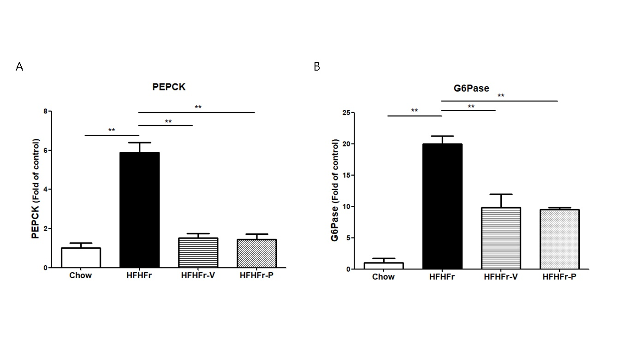
mRNA expression levels of (A) phosphoenolpyruvate carboxykinase (PEPCK) and (B) glucose 6-phosphatase (G6Pase)
*p<0.05; **p<0.01; HFHFr, high-fat, high-fructose diet group; HFHFr-V, HFHFr diet with voglibose group; HFHFr-P, HFHFr diet with pioglitazone group

