Supporting information
The mechanical characterization of the legs, fangs, and prosoma in the spider Harpactira curvipes (Pocock 1897)

Sara Residori^{1&}, Gabriele Greco^{1&} and Nicola M. Pugno^{1,2}*

¹ Laboratory for Bioinspired, Bionic, Nano, Meta Materials & Mechanics, Department of Civil, Environmental and Mechanical Engineering, University of Trento, Via Mesiano, 77, 38123 Trento, Italy
² School of Engineering and Material Science, Queen Mary University of London, Mile End Road, E1 4NS London, United Kingdom

& These authors contributed equally

*corresponding author: nicola.pugno@unitn.it

Table S1. Values of the Young’s modulus and hardness at different spacing for the longitudinal basal section of the fang, and the epoxy resin used to prepare the samples.

Spacing (μm) | Number of indentations |  | Young’s modulus (GPa) |  | p-value respect to 20 μm |  | Hardness (GPa) |  | p-value respect to 20 μm
Spacing (μm) | Fang | Resin | Fang | Resin | Fang | Resin | Fang | Resin | Fang | Resin
10 | 14 | 18 | 4.2±0.8 | 3.6±0.4 | 0.1573 | 0.1452 | 0.35±0.05 | 0.20±0.1 | 0.1262 | 0.2564
20 (used here) | 30 | 18 | 5.9±1.2 | 4.1±0.4 | / | / | 0.38±0.11 | 0.23±0.02 | / | /
30 | 19 | 18 | 4.2±2.2 | 4.4±0.3 | 0.1601 | 0.2563 | 0.31±0.2 | 0.24±0.03 | 0.0960 | 0.6543
40 | 15 | 18 | 5.4±0.7 | 4.0±0.4 | 0.0815 | 0.3581 | 0.36±0.08 | 0.22±0.03 | 0.1002 | 0.8021

Table S2. Values of the Young’s modulus and hardness for different sections of the prosoma.
 | Outer layer
Number of indentations | 31
Avg. Young’s modulus [GPa] | 3.42±0.57
Avg. Hardness [GPa] | 0.34±0.07
Avg. Depth [nm] | 3042±242

Table S3. Values of the Young’s modulus and hardness for different sections of legs.
 | Outer layer
Number of indentations | 173
Avg. Young’s modulus [GPa] | 7.20±1.18
Avg. Hardness [GPa] | 0.32±0.09
Avg. Depth [nm] | 2663±403

Table S4. Values of the Young’s modulus and hardness for different sections of the fang in the longitudinal direction.
LONGITUDINAL DIRECTION
 | TIP SECTION |  | CROSS SECTION |  | BASIS SECTION
 | Inner layer | Outer layer | Inner layer | Outer layer | Inner layer | Outer layer
Number of indentations | 175 | 42 | 87 | 35 | 107 | 28
Avg. Young’s modulus [GPa] | 5.60±0.36 | 6.20±0.52 | 4.02±0.15 | 4.11±0.35 | 3.64±0.27 | 3.60±0.24
Avg. Hardness [GPa] | 0.53±0.07 | 0.68±0.05 | 0.44±0.03 | 0.44±0.06 | 0.40±0.04 | 0.39±0.05
Avg. Depth [nm] | 2209±135 | 1996±172 | 2466±170 | 2514±164 | 2569±254 | 2666±398

Table S5. Values of the Young’s modulus and hardness for different sections of the fang in the transversal direction.
TRANSVERSAL DIRECTION
 | TIP SECTION |  | BASIS SECTION
 | Inner layer | Outer layer | Inner layer | Outer layer
Number of indentations | 187 | 56 | 165 | 166
Avg. Young’s modulus [GPa] | 6.57±0.59 | 7.56±0.48 | 3.66±0.36 | 3.15±0.69
Avg. Hardness [GPa] | 0.49±0.05 | 0.59±0.08 | 0.22±0.02 | 0.21±0.03
Avg. Depth [nm] | 2437±58 | 2216±43 | 2334±559 | 2463±178

Table S6-7 are reported below in the end of the file.

Table S8. Roughness values.
Ra [nm] | Rq [nm]
6.7 ± 0.9 | 8.5 ± 1.1

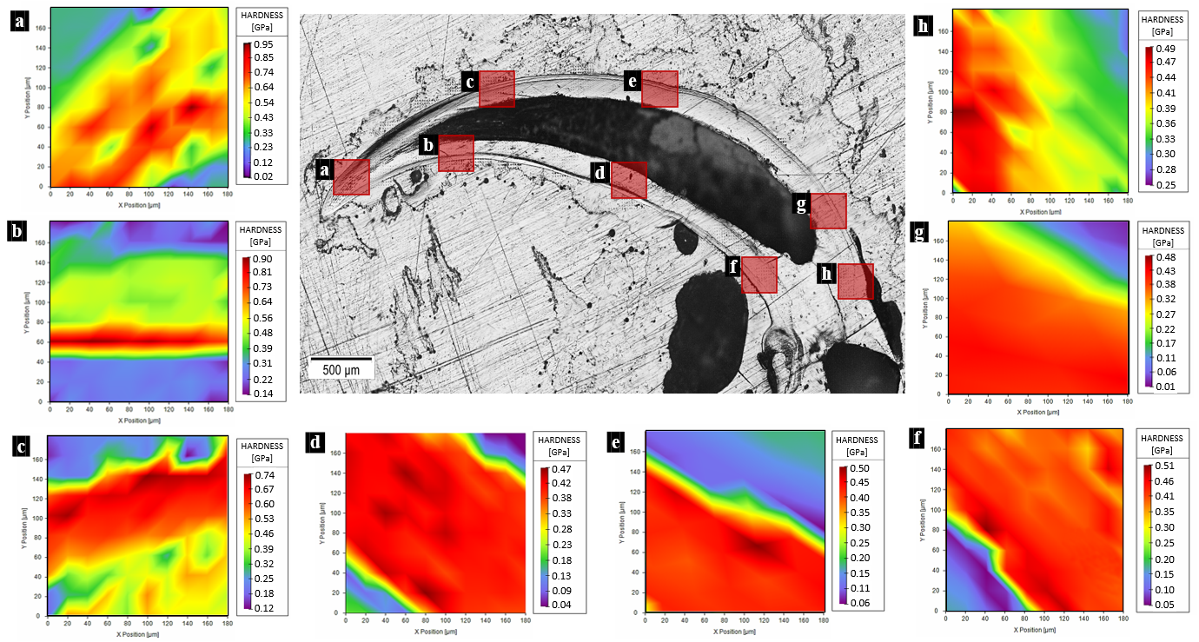
Figure S1. Map of hardness in different sections of the spider fang in the longitudinal direction. Images generated with the support of Nanoblitz 3d, Nanomechanics Inc.

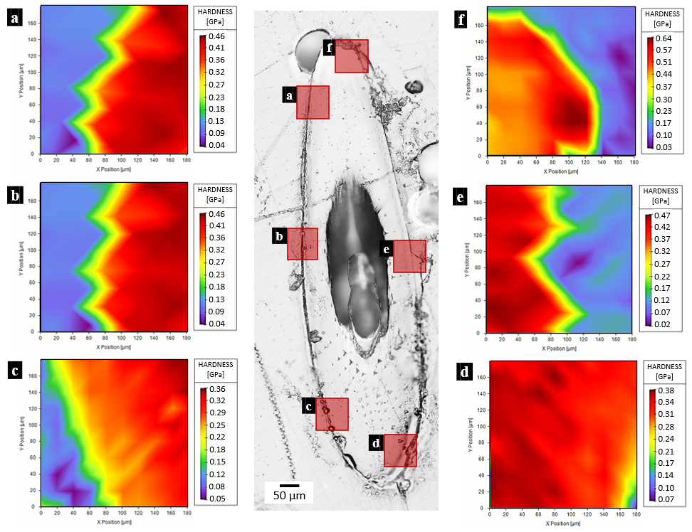
Figure S2. Map of hardness of the spider fang in the transversal section on the tip. Images generated with the support of Nanoblitz 3d, Nanomechanics Inc.

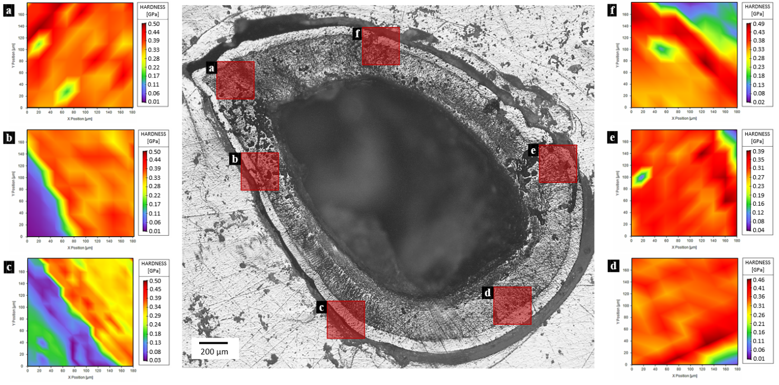
Figure S3. Map of hardness of the spider fang in the transversal section on the base. Images generated with the support of Nanoblitz 3d, Nanomechanics Inc.

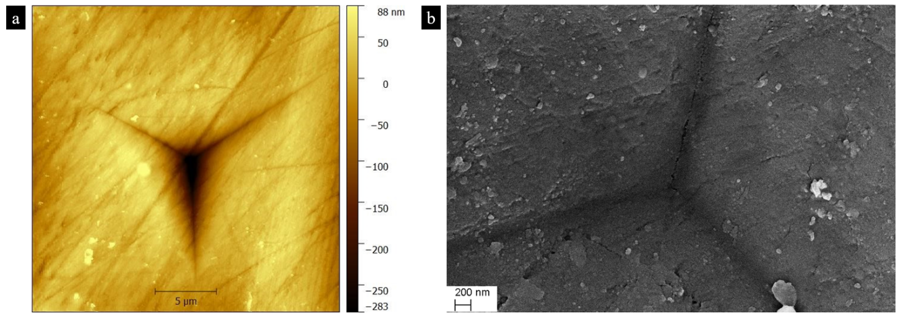
Figure S4. Images of the indentation print obtained with a) AFM and b) SEM.
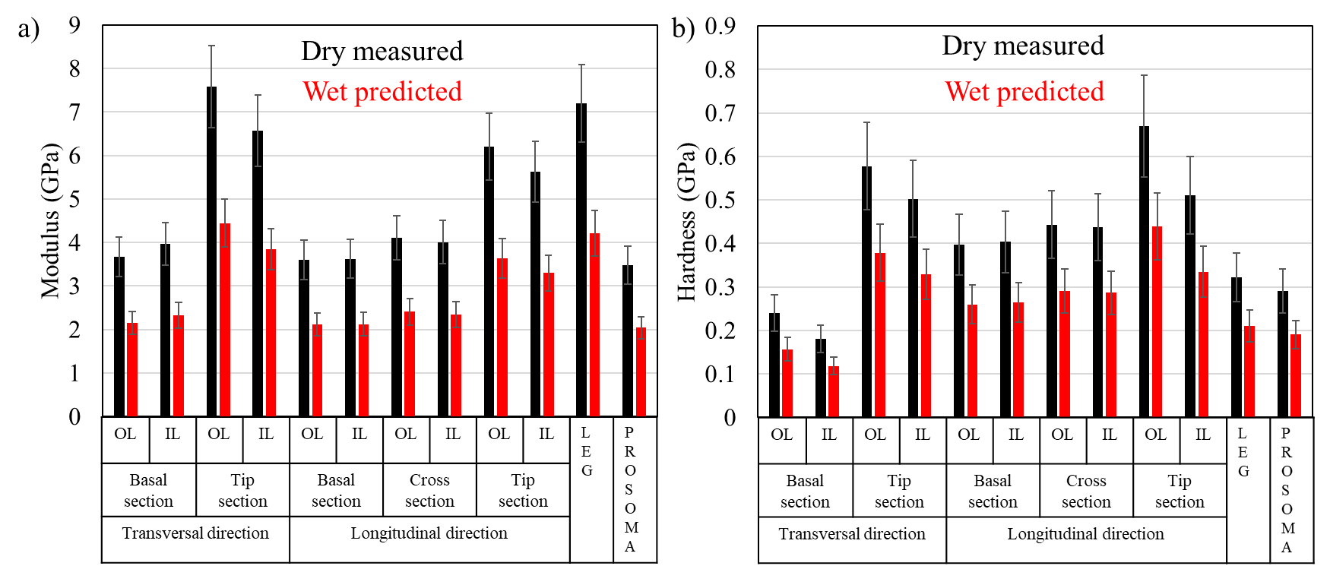
Figure S5. Avearges values of the a) Young’s modulus and b) the hardness obtained in this study with nanoindentation and those in wet state predicted using the values in Tadayon et al.¹⁹. In this case, we averaged the mean relative differences and used them to estimate the reduction in the mechanical properties due to hydration. In particular, for hardness a reduction of 35% has been used and for Young’s modulus a reduction of 41.4%.

Table S6: p-values and Cohen coefficient (in italic) of the comparison of Young’s modulus among the different body parts of the spider.
Young’s modulus |  |  | TRANSVERSAL DIRECTION |  |  |  | LONGITUDINAL DIRECTION |  |  |  |  |  | LEG | PROSOMA
 |  |  | BASIC SECTION |  | TIP SECTION |  | BASIC SECTION |  | CROSS SECTION |  | TIP SECTION |  | LEG | PROSOMA
 |  |  | Outer layer | Inner layer | Outer layer | Inner layer | Outer layer | Inner layer | Outer layer | Inner layer | Outer layer | Inner layer | Outer layer | Outer layer
TRANSVERSAL DIRECTION | BASIC SECTION | Outer layer | - | 0.0030  0.3570 | 0.0000 5.2191 | 0.0000 3.8100 | 0.6530  0.0944 | 0.5839  0.0727 | 0.0006  0.6196 | 0.0002  0.5315 | 0.0000 3.2477 | 0.0000 2.5375 | 0.0000  3.1756 | 0.2373  0.2487
TRANSVERSAL DIRECTION | BASIC SECTION | Inner layer |  | - | 0.0000  4.3784 | 0.000 3.1676 | 0.02840.4513 | 0.0001  0.4941 | 0.3285  0.1677 | 0.7240  0.0468 | 0.0000  2.6234 | 0.0000  2.0291 | 0.0000  2.9147 | 0.0048  0.5838
TRANSVERSAL DIRECTION | TIP SECTION | Outer layer |  |  | - | 0.0000  1.4769 | 0.0000  7.3601 | 0.0000  9.6443 | 0.0000 6.7807 | 0.0000  8.0571 | 0.0000 2.0305 | 0.0000 2.6755 | 0.0329  0.3300 | 0.0000 6.8505
TRANSVERSAL DIRECTION | TIP SECTION | Inner layer |  |  |  | - | 0.00004.5535 | 0.0000  5.5430 | 0.0000  3.9328 | 0.00004.5685 | 0.0071  0.4966 | 0.0000  1.2588 | 0.0000  0.5736 | 0.0000  4.5265
LONGITUDINAL DIRECTION | BASIC SECTION | Outer layer |  |  |  |  | - | 0.6086  0.1090 | 0.0000  1.7746 | 0.0000  1.5368 | 0.0000 4.3849 | 0.0000 2.8564 | 0.0000 2.9964 | 0.2927  0.2840
LONGITUDINAL DIRECTION | BASIC SECTION | Inner layer |  |  |  |  |  | - | 0.0000 1.9795 | 0.0000 1.5906 | 0.0000 6.0094 | 0.0000  3.2778 | 0.0000  3.4979 | 0.0288  0.4691
LONGITUDINAL DIRECTION | CROSS SECTION | Outer layer |  |  |  |  |  |  | - | 0.0509  0.3674 | 0.0000  3.7900 | 0.0000 2.2093 | 0.0000 2.6647 | 0.0000  1.5640
LONGITUDINAL DIRECTION | CROSS SECTION | Inner layer |  |  |  |  |  |  |  | - | 0.0000  4.7047 | 0.0000 2.5528 | 0.0000 3.0079 | 0.0000  1.5309
LONGITUDINAL DIRECTION | TIP SECTION | Outer layer |  |  |  |  |  |  |  |  | - | 0.0000  0.7651 | 0.0000 0.8253 | 0.0000 4.1444
LONGITUDINAL DIRECTION | TIP SECTION | Inner layer |  |  |  |  |  |  |  |  |  | - | 0.0000  1.4867 | 0.0000 2.9468
LEG |  | Outer layer |  |  |  |  |  |  |  |  |  |  | - | 0.0000 3.0667
PROSOMA |  | Outer layer |  |  |  |  |  |  |  |  |  |  |  | -

Table S7: p-values and Cohen coefficient (in italic) of the comparison of hardness among the different body parts of the spider.
Hardness |  |  | TRANSVERSAL DIRECTION |  |  |  | LONGITUDINAL DIRECTION |  |  |  |  |  | LEG | PROSOMA
 |  |  | BASIC SECTION |  | TIP SECTION |  | BASIC SECTION |  | CROSS SECTION |  | TIP SECTION |  | LEG | PROSOMA
 |  |  | Outer layer | Inner layer | Outer layer | Inner layer | Outer layer | Inner layer | Outer layer | Inner layer | Outer layer | Inner layer | Outer layer | Outer  layer
TRANSVERSAL DIRECTION | BASIC SECTION | Outer layer | - | 0.0000  0.8716 | 0.0000 4.7272 | 0.0000 3.5767 | 0.0000  2.2337 | 0.0000  2.8274 | 0.0000  3.0462 | 0.0000  3.3127 | 0.000 5.3582 | 0.0000 3.8241 | 0.00000.8754 | 0.0028  0.6370
TRANSVERSAL DIRECTION | BASIC SECTION | Inner layer |  | - | 0.0000 6.4694 | 0.0000  4.9290 | 0.0000  3.6843 | 0.0000  4.4160 | 0.00004.6679 | 0.0000  4.9859 | 0.0000 7.1149 | 0.0000 5.1148 | 0.0000  1.6370 | 0.0000 1.6333
TRANSVERSAL DIRECTION | TIP SECTION | Outer layer |  |  | - | 0.0000  1.1119 | 0.0000  3.2932 | 0.0000 4.1840 | 0.0000  2.7176 | 0.0000  3.3026 | 0.0000  1.2081 | 0.0000  1.0137 | 0.0000 2.6705 | 0.0000 3.8658
TRANSVERSAL DIRECTION | TIP SECTION | Inner layer |  |  |  | - | 0.0000  1.6073 | 0.0000 1.8457 | 0.0000  0.9637 | 0.0000  1.1767 | 0.0000  2.1619 | 0.3160  0.1228 | 0.0000 1.9414 | 0.0000 2.7732
LONGITUDINAL DIRECTION | BASIC SECTION | Outer layer |  |  |  |  | - | 0.2672  0.2365 | 0.0000  1.4204 | 0.0000  1.4725 | 0.0000 3.5980 | 0.0000 1.7716 | 0.0002  0.7656 | 0.0000  1.4629
LONGITUDINAL DIRECTION | BASIC SECTION | Inner layer |  |  |  |  |  | - | 0.0000  1.4793 | 0.0000  1.3698 | 0.0000 4.9636 | 0.0000 1.9283 | 0.0000  0.9794 | 0.0000  2.3205
LONGITUDINAL DIRECTION | CROSS SECTION | Outer layer |  |  |  |  |  |  | - | 0.2666  0.2080 | 0.0000  3.3414 | 0.0000 1.1013 | 0.0000  1.2817 | 0.0000 2.4018
LONGITUDINAL DIRECTION | CROSS SECTION | Inner layer |  |  |  |  |  |  |  | - | 0.0000  4.1491 | 0.0000 1.2880 | 0.0000  1.3424 | 0.0000  2.8951
LONGITUDINAL DIRECTION | TIP SECTION | Outer layer |  |  |  |  |  |  |  |  | - | 0.0000 2.1832 | 0.0000 3.4021 | 0.0000 4.0494
LONGITUDINAL DIRECTION | TIP SECTION | Inner layer |  |  |  |  |  |  |  |  |  | - | 0.0000 2.1541 | 0.0000 3.0703
LEG |  | Outer layer |  |  |  |  |  |  |  |  |  |  | - | 0.1389  0.3027
PROSOMA |  | Outer layer |  |  |  |  |  |  |  |  |  |  |  | -

