Supplemental Information for:
Deep-sea infauna with calcified exoskeletons imaged in situ using a new 3D acoustic coring system (A-core-2000)

Katsunori Mizuno^{1,2*}, Hidetaka Nomaki², Chong Chen², Koji Seike^{3, 4}

¹Department of Environment Systems, Graduate School of Frontier Sciences, The University of Tokyo,
Kashiwanoha, Kashiwa, Chiba 277-8561, Japan

² X-STAR, Japan Agency for Marine-Earth Science and Technology (JAMSTEC), 2-15 Natsushima-cho, Yokosuka 237-0061, Japan

³ Geological Survey of Japan, National Institute of Advanced Industrial Science and Technology (AIST), Central 7, 1-1-1 Higashi, Tsukuba, Ibaraki, 305-8567, Japan

⁴ Department of Natural Environmental Studies, Graduate School of Frontier Sciences, The University of Tokyo, 5-1-5 Kashiwanoha, Kashiwa, Chiba, 277-8564, Japan

*Corresponding author: Katsunori Mizuno
kmizuno@edu.k.u-tokyo.ac.jp

(a)
(b)
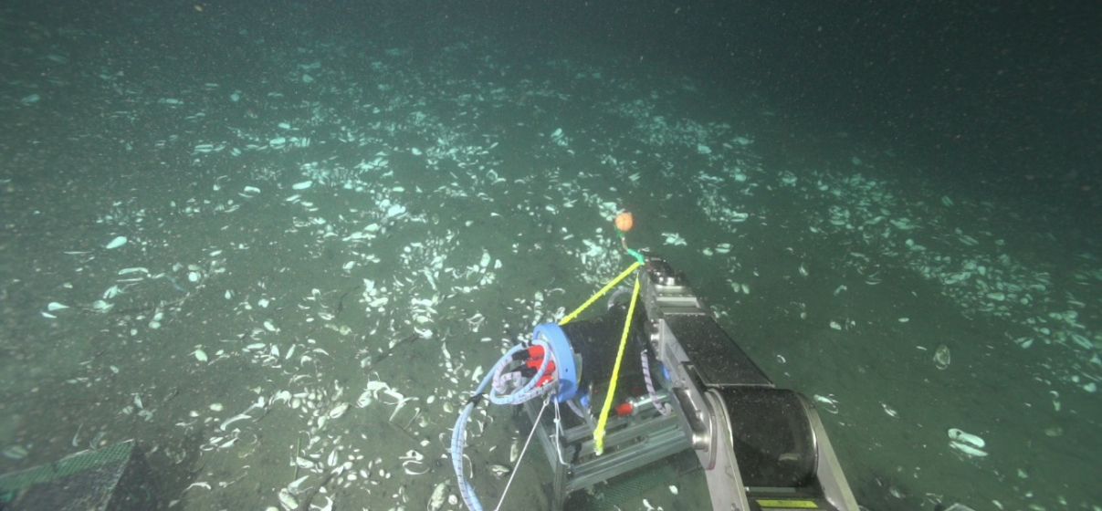
Supplementary Fig. 1. (a) Close-up view of vesicomyid clams. Juvenile clams live infaunally with only the siphon exposed on the surface. The photo was captured near the acoustic measurement area during the same dive. (b) A dense vesicomyid colony (mixture of dead shells and live colonies within approximately ~50 cm diameter) in the Off Hatsushima hydrocarbon seep site, Sagami Bay, Japan.
Supplementary Fig. 2. Photos of the laboratory experiments. Three Meretrix sp. (Me) and four Corbicula sp. (Co) were prepared for the laboratory experiments and then completely buried into the sediment.

Supplementary Table 1. Grain size distribution of the sediment for the laboratory experiments.
Size [mm] | 0.425 | 0.3 | 0.212 | 0.15 | 0.106 | 0.075 | 0.053 | <0.053
% | 0 | 0.94 | 13.08 | 54.7 | 24.05 | 6.45 | 0.62 | 0.16

Supplementary Fig. 3. Photos of the laboratory experiments. The clam shell samples and sediment were collected with a scoop manipulated by DSV Shinkai 6500 at Off Hatsushima, Sagami Bay, Japan.

Supplementary Fig.4. A 3D acoustic image was constructed and the space under the water bottom was visualized following this data processing flow. The spatial resolution of the image was 2 mm³/voxel. The origin is the start position of the measurement. Some broken lotus rods were found on the bottom surface. In this case, we adjusted the attenuation coefficient α for the image correction on GUI (Graphical User Interface) and set the value to 50 [dB/m].

Supplementary Fig. 5. The test for the position accuracy in horizontal plane onboard the Shinkai 6500 (a). The plastic grid illustrated in (b) was measured by A-core-2000 in the deep sea (depth 1,000 m). The difference between actual grid and the acoustic image was around 3 mm in this test (c).

Supplementary Fig. 6. Attenuation coefficients with different grain sizes on the basis of the Biot – Stoll model and the multiple scattering model developed by Schwartz and Plona.

Supplementary Fig. 7. Cross-sectional acoustic images of the laboratory observations with Meretrix sp. (Me) whose reflectors are enclosed by the red squares Me1, Me2, and Me3 and four Corbicula sp. (Co) specimens whose reflectors are enclosed by red squares Co1, Co2, Co3, and Co4.

Supplementary Table 2. The coordinates of strong backscatters below the sediment surface interpreted as live (or very fresh dead) clams with articulated shells containing seawater or soft parts.

* The top of the shell was exposed above the sediment surface in this individual, and so this value indicates the position the top instead of sediment surface.

