Appendix A

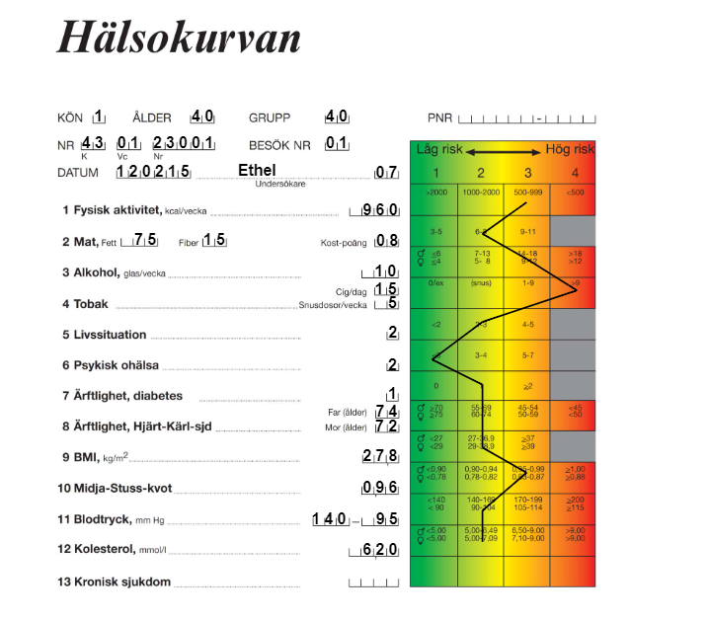
Figure A. Health Dialogue, the summary page (coloured, original Swedish version)

