Supplementary Material for ‘Industrialised fishing nations largely contribute to floating plastic pollution in the North Pacific subtropical gyre’
Laurent Lebreton^{1,2,*}, Sarah-Jeanne Royer¹, Axel Peytavin¹, Wouter Jan Strietman³, Ingeborg Smeding-Zuurendonk³, Matthias Egger^{1,4}
¹The Ocean Cleanup, Rotterdam, The Netherlands
²The Modelling House, Raglan, New Zealand
³Wageningen University & Research, Wageningen, The Netherlands
⁴Egger Research and Consulting, St Gallen, Switzerland
*Corresponding author: laurent.lebreton@theoceancleanup.com

Supplementary Figures
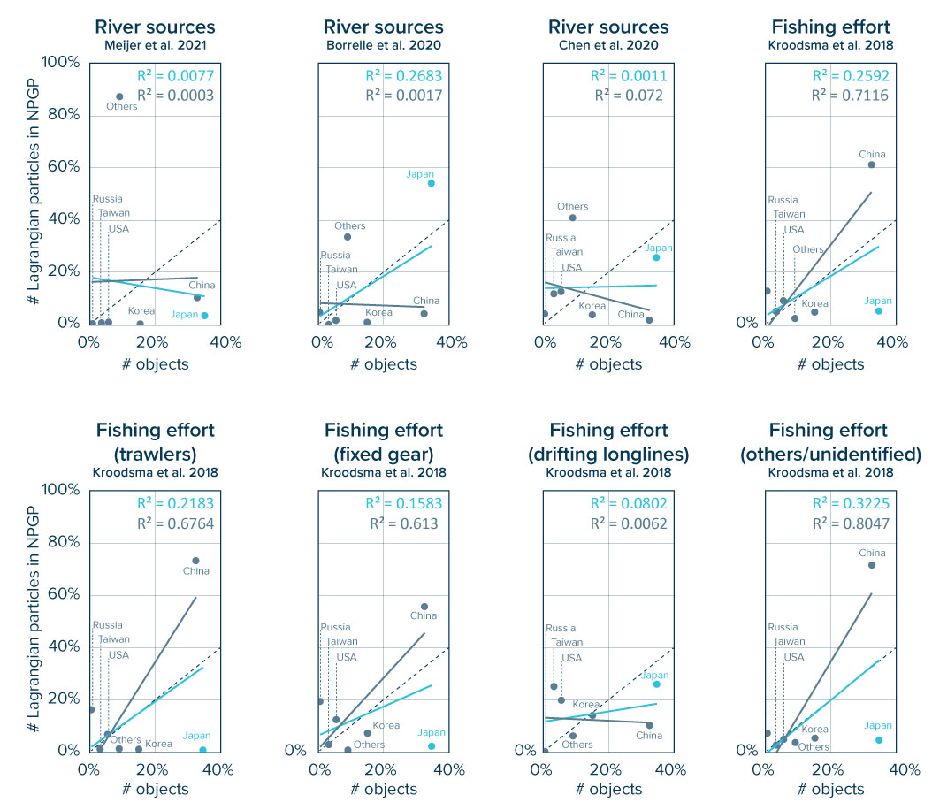
Figure S1 | Regression analysis between origins by number of objects retrieved from the NPGP and the contribution by countries for different Lagrangian modelling scenarios. The results are provided for no beaching scenario (τ_{beach} = ∞). The relative modelled contribution per country with different beaching scenarios is very similar, and beaching has mostly an effect on the absolute quantities reaching the NPGP. The coefficient of determination is calculated with (light blue) and without (grey) the contribution of Japan to account for the bias introduced by debris originating from the 2011 tsunami.

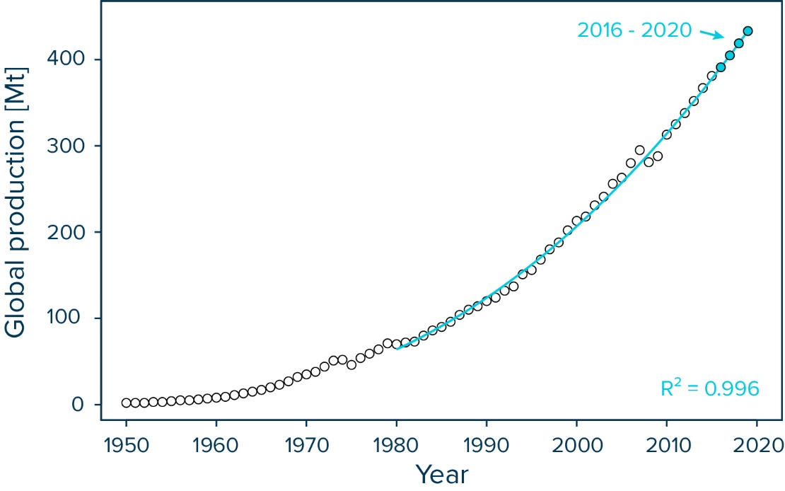
Figure S2 | Global plastic production since 1950 in million tonnes (Mt). The white dots represent values between 1950 and 2015 as reported in Geyer et al. (2017)¹. The blue dots represent values for the years 2016-2019 (i.e., 391, 405, 419, and 433 Mt) estimated by extrapolating the exponential trend (blue line; R² = 0.996) between the years 1980 to 2015.

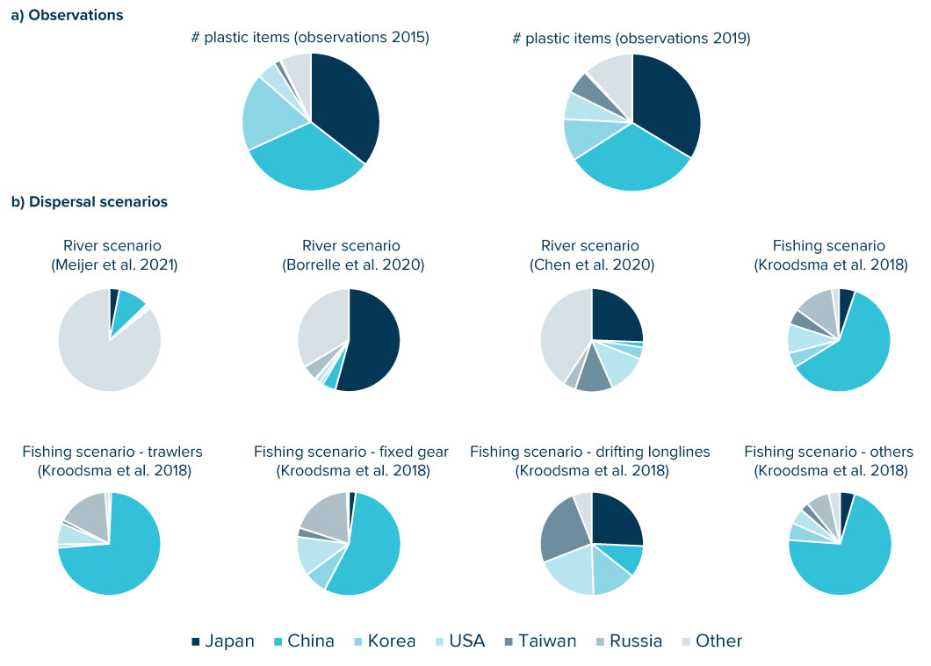
Figure S3 | Contribution by countries for (a) origins identified on debris collected in the NPGP and (b) modelled particles in the NPGP for different dispersal scenarios.
Supplementary Tables
Table S1 | Composition of hard debris > 5 cm (e.g., excluding nets and ropes) collected from the North Pacific Garbage Patch in 2019 regrouped into OSPAR material categories.
Material | [#] | [kg] | % [#] | % [kg]
Plastic / Polystyrene | 6048 | 513.91 | 99.26 | 89.68
Rubber | 4 | 0.08 | 0.07 | 0.01
Cloth | 3 | 0.09 | 0.05 | 0.02
Paper / Cardboard | 5 | 0.00 | 0.08 | 0.00
Wood | 2 | 0.01 | 0.03 | 0.00
Metal | 11 | 53.67 | 0.18 | 9.37
Glass | 14 | 4.70 | 0.23 | 0.82
Ceramics | 1 | 0.54 | 0.02 | 0.09
Other | 5 | 0.04 | 0.08 | 0.01
Total | 6093 | 573 | 100.00 | 100.00

Table S2 | Item counts [#] and associated weights [kg] of hard debris collected from the NPGP during The Ocean Cleanup’s System 001/B operations in 2019. The item categories are based on the OSPAR Beach Litter Monitoring Guideline². Material categories are highlighted in grey.
OSPAR ID | Items | # items | Weight [kg]
 | Plastic / Polystyrene | 6048 | 546.797
1 | 4/6-pack yokes | 0 | 0.000
2 | Bags (e.g., shopping) | 0 | 0.000
3 | Small plastic bags, e.g., freezer bags | 0 | 0.000
112 | Plastic bag ends | 2 | 0.018
4 | Drinks (bottles, containers, and drums) | 9 | 0.197
5 | Cleaner (bottles, containers, and drums) | 45 | 2.043
6 | Food containers incl. fast food containers | 24 | 2.077
7 | Cosmetics
7A | Shampoo bottles | 12 | 0.353
7B | Sun lotion | 4 | 0.413
7C | Deodorant | 2 | 0.054
7D | Shower gel | 0 | 0.000
7E | Other cosmetics bottles / containers | 3 | 0.045
8 | Engine oil containers and drums < 50 cm | 34 | 1.632
9 | Engine oil containers and drums > 50 cm | 0 | 0.000
10 | Jerry cans (square plastic containers with handle) | 63 | 18.139
11 | Injection gun containers | 8 | 0.441
12 | Other bottles, containers, and drums
12A | Barrel liner | 58 | 2.556
12B | Other bottles, containers, and drums | 244 | 26.969
13 | Crates | 208 | 56.805
14 | Car parts | 10 | 1.166
15 | Caps / lids | 726 | 3.602
16 | Cigarette lighters | 2 | 0.020
17 | Pens | 21 | 0.065
18 | Combs / hairbrushes | 7 | 0.027
19 | Crisp / sweet packets and lolly sticks | 1 | 0.001
20 | Toys & party poppers | 44 | 1.179
21 | Cups | 0 | 0.000
22 | Cutlery / trays / straws
22A | Straws | 1 | 0.000
22B | Cutlery | 5 | 0.013
22C | Plastic dishes | 1 | 0.074
22D | Other cutlery | 0 | 0.000
23 | Fertilizer / animal feed bags | 0 | 0.000
24 | Mesh vegetable bags | 0 | 0.000
25 | Gloves (typical washing up gloves) | 0 | 0.000
113 | Gloves (industrial / professional gloves) | 0 | 0.000
26 | Crab / lobster pots | 37 | 0.334
114 | Lobster and fish tags | 1 | 0.001
27 | Octopus pots | 0 | 0.000
28 | Oyster nets or mussel bags including plastic stoppers | 779 | 4.361
29 | Oyster trays (round from oyster cultures) | 2 | 0.015
30 | Plastic sheeting from mussel culture (Tahitians) | 0 | 0.000
34 | Fish boxes | 430 | 30.542
35 | Fishing line (angling) | 0 | 0.000
36 | Light sticks (tubes with fluid) | 3 | 0.050
37 | Floats / Buoys | 173 | 108.800
38 | Buckets | 183 | 21.925
39 | Strapping bands | 0 | 0.000
40 | Industrial packaging, plastic sheeting | 0 | 0.000
41 | Fiber glass | 0 | 0.000
42 | Hard hats | 2 | 0.160
43 | Shotgun cartridges | 5 | 0.016
44 | Shoes / sandals | 1 | 0.079
45 | Foam sponge | 0 | 0.000
117 | Unidentifiable fragments
117A | <0.5mm | 0 | 0.265
117B | 0.5-1.5 mm | 0 | 0.772
117C | 1.5-5mm | 0 | 4.605
117D | 0.5-1.5cm | 0 | 12.898
117E | 1.5-5cm | 0 | 14.351
117F | 5-50cm | 1964 | 40.711
117G | >50cm | 35 | 104.335
48 | Other plastic / polystyrene items
48A | Inner tube for wrapping | 0 | 0.000
48B | Pipes / tubes | 62 | 4.496
48C | Cylinder for fishing net repair rope | 0 | 0.000
48D | Conveyor belt items vessel | 13 | 0.256
48E | Styrofoam small (<5 cm) | 10 | 0.002
48F | Styrofoam large (>5 cm) | 8 | 0.074
48G | Detonation chord | 3 | 0.003
48H | Electrical wire | 62 | 0.098
48I | Plastic cleaning brush | 5 | 0.230
48J | Melted / burned | 182 | 7.391
48K | Baskets | 55 | 20.206
48L | Eel traps | 310 | 6.968
48M | Other plastic items | 121 | 44.613
 | Sanitary waste
97 | Condoms | 0 | 0.000
98 | Cotton bud sticks | 1 | 0.001
99 | Sanitary towels / panty liners / backing strips | 0 | 0.000
100 | Tampons and tampon applicators | 0 | 0.000
101 | Toilet fresheners | 4 | 0.016
102 | Other sanitary items
102A | Toothpaste | 4 | 0.007
102B | Toothbrush | 56 | 0.317
102C | Ear plug | 0 | 0.000
102D | Other sanitary items | 0 | 0.000
 | Medical waste
103 | Containers / tubes | 0 | 0.000
104 | Syringes | 1 | 0.003
105 | Other medical items (swabs, bandaging etc.) | 2 | 0.012
 | Rubber | 4 | 0.077
49 | Balloons, including plastic valves, ribbons, strings etc. | 0 | 0.000
50 | Boots | 0 | 0.000
52 | Tires and belts | 0 | 0.000
53 | Other rubber pieces | 4 | 0.077
 | Cloth | 3 | 0.091
54 | Clothing | 0 | 0.000
55 | Furnishing | 0 | 0.000
56 | Sacking | 0 | 0.000
57 | Shoes (leather) | 0 | 0.000
59 | Other textiles | 3 | 0.091
 | Paper / Cardboard | 5 | 0.003
60 | Bags | 0 | 0.000
61 | Cardboard | 0 | 0.000
118 | Cartons e.g., tetrapak (milk) | 0 | 0.000
62 | Cartons e.g., tetrapak (other) | 0 | 0.000
63 | Cigarette packets | 0 | 0.000
64 | Cigarette butts | 4 | 0.002
65 | Cups | 0 | 0.000
66 | Newspapers & magazines | 0 | 0.000
67 | Other paper items | 1 | 0.001
 | Wood (machined) | 2 | 0.008
68 | Corks | 0 | 0.000
69 | Pallets | 0 | 0.000
70 | Crates | 0 | 0.000
71 | Crab / lobster pots | 0 | 0.000
119 | Fish boxes | 0 | 0.000
72 | Ice lolly sticks / chip forks | 0 | 0.000
73 | Paint brushes | 0 | 0.000
74 | Other wood < 50 cm | 2 | 0.008
75 | Other wood > 50 cm | 0 | 0.000
 | Metal | 11 | 53.671
76 | Aerosol / Spray cans | 0 | 0.000
77 | Bottle caps | 0 | 0.000
78 | Drink cans | 0 | 0.000
120 | Disposable BBQ’s | 0 | 0.000
79 | Electric appliances | 0 | 0.000
80 | Fishing weights | 0 | 0.000
81 | Foil wrappers | 2 | 0.001
82 | Food cans | 0 | 0.000
83 | Industrial scrap | 0 | 0.000
84 | Oil drums | 0 | 0.000
86 | Paint tins | 0 | 0.000
87 | Lobster / crab pots and tops | 0 | 0.000
88 | Wire, wire mesh, barbed wire | 0 | 0.000
89 | Other metal pieces < 50 cm | 8 | 0.420
90 | Other metal pieces > 50 cm | 1 | 53.250
 | Glass | 14 | 4.700
91 | Bottles | 9 | 3.110
92 | Light bulbs / tubes | 0 | 0.000
93 | Other glass items
93A | Japanese glass buoy | 2 | 0.240
93B | Other glass items | 3 | 1.350
 | Ceramics | 1 | 0.539
94 | Construction material (e.g., tiles) | 0 | 0.000
95 | Octopus pots | 0 | 0.000
96 | Other ceramic / pottery items | 1 | 0.539
 | Other | 5 | 0.044
108 | Paraffin or wax pieces 0 - 1 cm | 0 | 0.000
109 | Paraffin or wax pieces 1 - 10 cm | 5 | 0.044
110 | Paraffin or wax pieces > 10 cm | 0 | 0.000
111 | Other pollutants | 0 | 0.000
121 | Bagged dog faeces | 0 | 0.000
Total | Entire hard debris fraction | 6093 | 605.931

Table S3| Exemplary photos of hard plastic items collected from the NPGP during The Ocean Cleanup’s System 001/B operations and associated item categories [OSPAR ID]. Table S1 provides a complete list of item categories considered in this study.
Fishing and aquaculture gear
Crab / lobster pots [26] 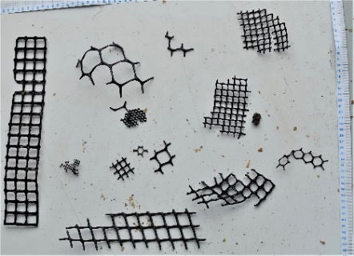 | Lobster and fish tags [114] 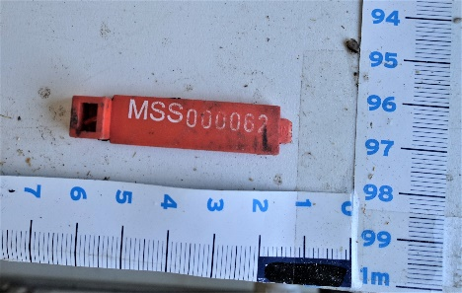 | Oyster nets, bags, spacers [28] 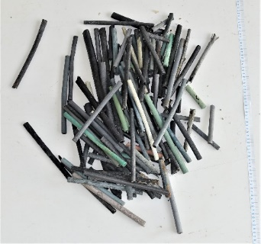
Oyster trays [29] 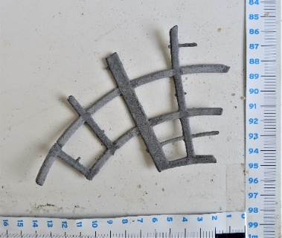 | Fish boxes [34]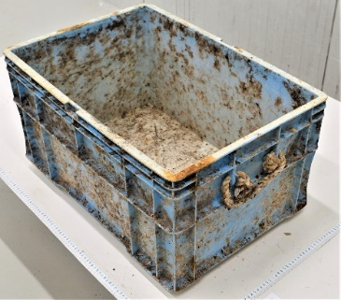 | Light sticks [36]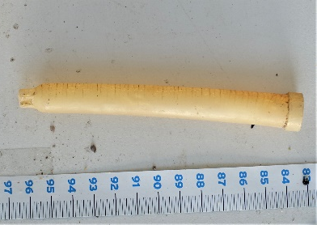
 | Eel traps [48L]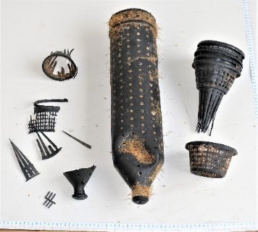
Floats / Buoys [37]
 | 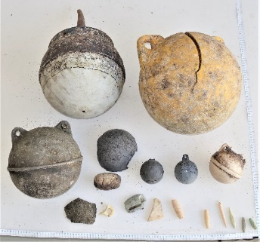
Crates [13]
 | 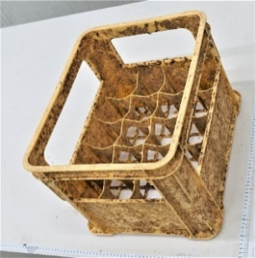
Buckets [38]
 | 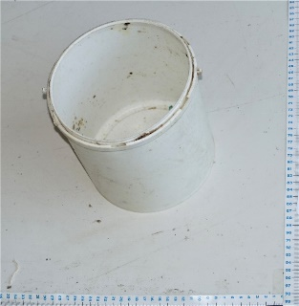
Food / Drinks
Bottles, containers, and drums [4]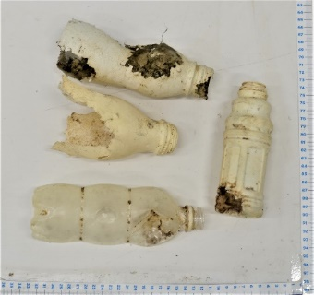 | Food containers [6]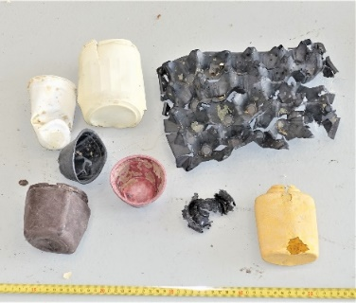 | Caps / lids [15]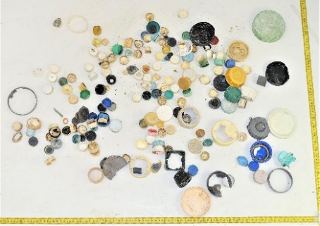
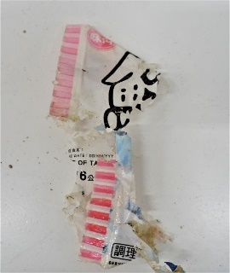
Crisp / sweet packets and lolly sticks [19]
Household items
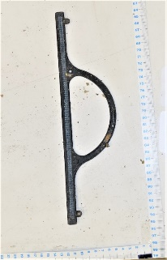  Plastic bag ends [112] | 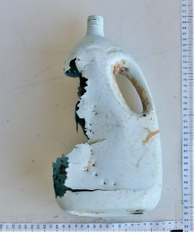  Cleaner (bottles, containers, and drums) [5] | Cosmetics (e.g., sun lotion, shampoo, shower gel, deodorant) [7]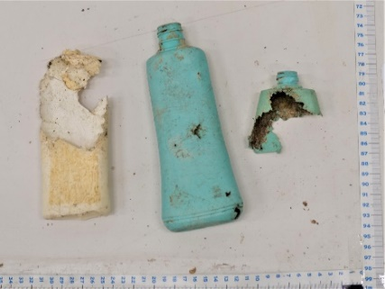
Engine oil containers and drums [8]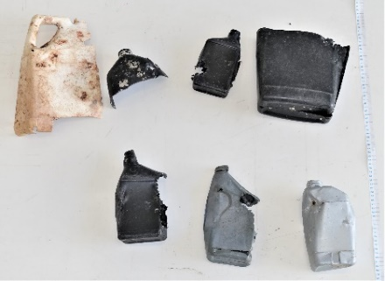 | 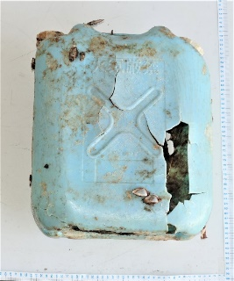  Jerry cans [10] | 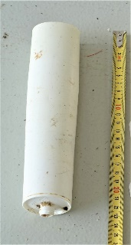  Injection gun containers [11]
Other bottles, containers and drums [12]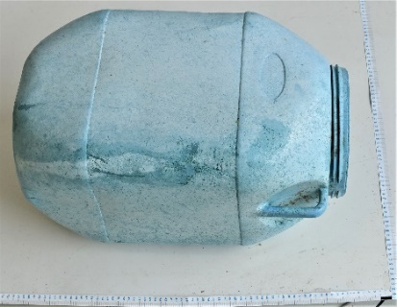 | Car parts [14]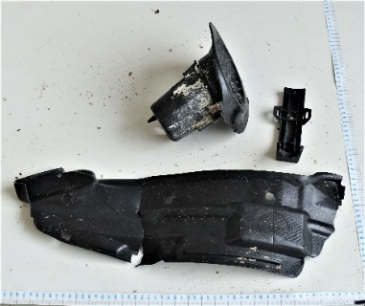 | Cigarette lighters [16] 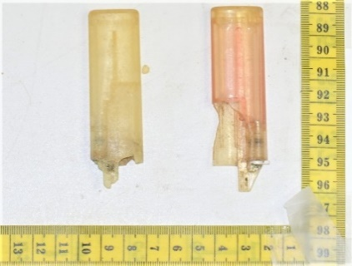
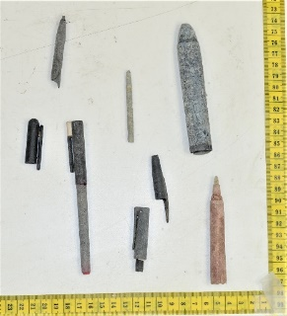  Pens [17] | Combs / hairbrushes [18] 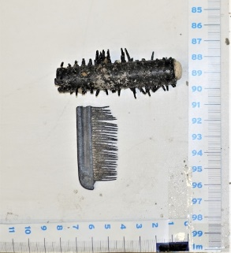 | Toys & party poppers [20]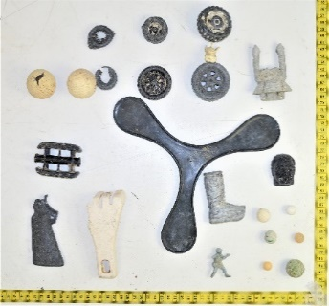
Cutlery / trays / straws [22]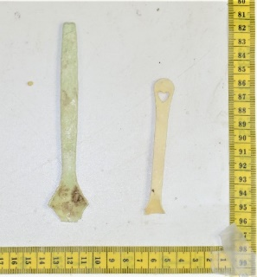 | Hard hats [42]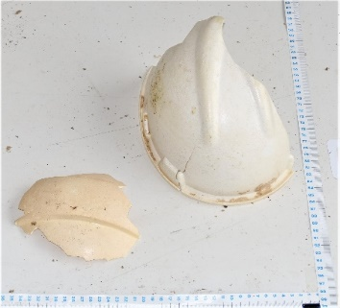 | Shotgun cartridges [43]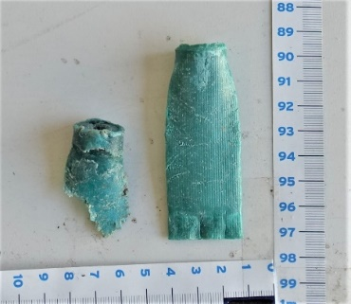
Shoes / sandals [44] 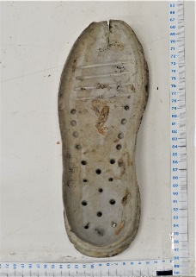 | Sanitary waste [98, 101-102]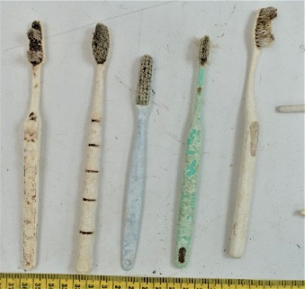 | Medical waste [104-105] 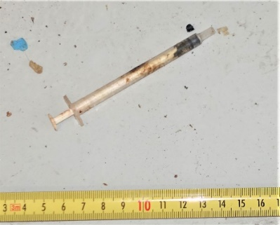
Pipes / tubes [48B]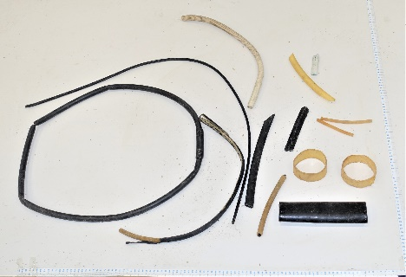 | Electrical wire [48H]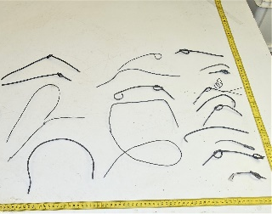 | 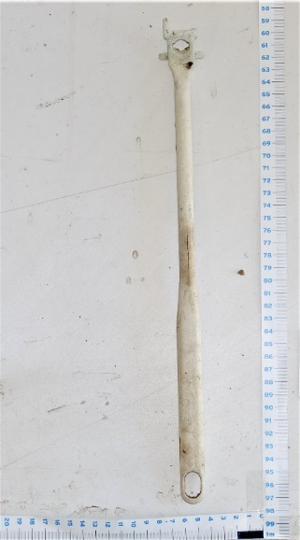  Plastic cleaning brush [48I]
 | Baskets [48K]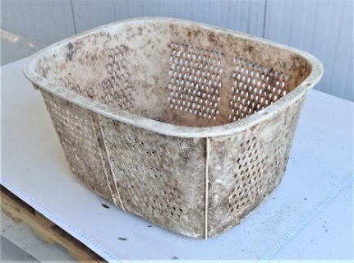
Other
Conveyor belt items vessel [48D]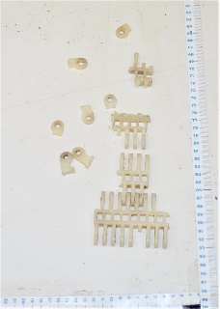 | Detonation chord [48G] 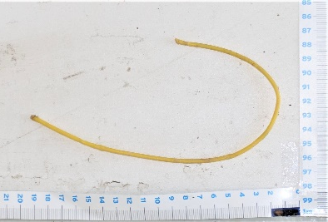 | Melted / burnt [48J] 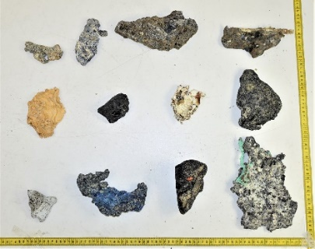
 | Other plastic items [48M] 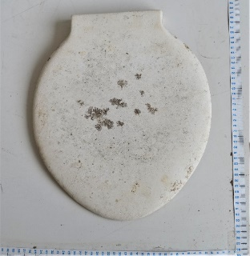
Fragments
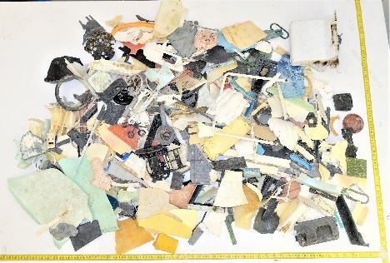  Unidentifiable fragments (5-50 cm) [46-47F] | 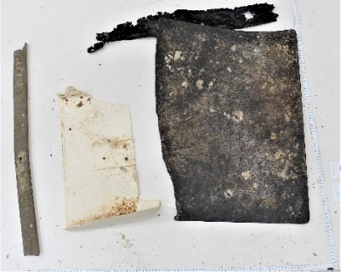  Unidentifiable fragments (>50 cm) [46-47G] | 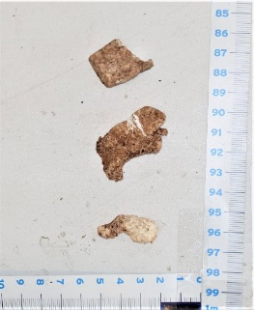  Styrofoam small (<5 cm) [48E]
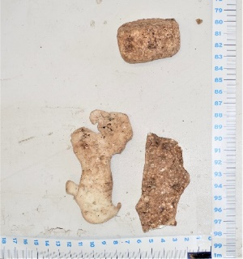
Styrofoam large (>5 cm) [48F]

Table S4 | Modelled source scenarios for global Lagrangian dispersal simulations for ocean plastics.
Source | Reference | # particles | Definition
Rivers | Meijer et al. (2021)³ | 7.9*10⁶ | One model particle is released for every tonne of plastic emissions at modelled river mouth locations. The baseline is for 2015, inputs from 2013 to 2019 are scaled with annual global plastic production (Supplementary Figure S2). Particles carry the country of origin corresponding to river mouth location (i.e., upstream countries are not recorded).
Rivers | Borrelle et al. (2020)⁴ | 7.9*10⁶ | Same as above but model particles carry a mass converted for difference in national mismanaged plastic waste (MPW) generation between Meijer et al. (2021) and Borrelle et al. (2020).
Rivers | Chen et al. (2020)⁵ | 7.9*10⁶ | Same as above but model particles carry a mass converted for difference in national mismanaged plastic waste (MPW) generation between Meijer et al. (2021) and Chen et al. (2020).
Fishing | Kroodsma et al (2018)⁶ | 10*10⁶ | One model particle is released for every space-borne observation of fishing effort (>15 mins) in 0.1 x 0.1-degree from 2013 to 2019. Particles carry fishing effort in hours, type of gear and country flag.

Table S5 | Identified global fishing effort per country and per gear of interest between 2013 and 2019⁶.
 | Japan | China | Korea | USA | Taiwan | Russia | Others | World
Identified fishing effort globally (2013-2019, for AIS equipped vessels, in million hours)
Trawlers | 0.4 | 50.3 | 0.9 | 3.8 | 0.8 | 7.1 | 62.9 | 126.1
Fixed gear | 0.6 | 17.7 | 2.5 | 1.4 | 0.8 | 2.0 | 14.5 | 39.5
Drifting longline | 6.2 | 7.5 | 3.8 | 1.3 | 12.4 | 0.0 | 9.8 | 41.1
Others / unidentified | 0.9 | 21.1 | 2.2 | 1.7 | 1.0 | 1.0 | 15.9 | 43.9
Total | 8.1 | 96.7 | 9.4 | 8.1 | 15.0 | 10.2 | 103.2 | 250.7

Table S6 | Languages identified on hard plastic objects collected from the North Pacific Garbage Patch in 2019.
Language | [#] | [%]
Chinese | 69 | 34.3
Japanese | 66 | 32.8
English | 35 | 17.4
Korean | 21 | 10.4
Chinese or Japanese | 5 | 2.5
Other | 5 | 2.5
Spanish | 2 | 1.0
Russian | 1 | 0.5
Bahasa | 1 | 0.5
Thai | 1 | 0.5
Total | 201 | 100.0

Table S7 | Origin identified on hard plastic objects collected from the North Pacific Garbage Patch in 2019. Note that the origin was identified based on a combination of languages, company logos, as well as specific text revealing clues of origin (such as an address, company name, vessel name, etc.).
Origin | Total |  | Fishing gear ª | Others ^{b}
 | [#] | [%] | [#] | [#]
Japan | 78 | 33.6 | 21 | 57
China | 75 | 32.3 | 16 | 59
Korea | 23 | 9.9 | 5 | 18
USA | 15 | 6.5 | 5 | 10
Taiwan | 13 | 5.6 | 2 | 11
Canada | 11 | 4.7 | 1 | 10
Other | 17 | 7.3 | 2 | 15
France | 3 | 1.3 | 0 | 3
Indonesia | 2 | 0.9 | 0 | 2
Mexico | 2 | 0.9 | 0 | 2
Vietnam | 2 | 0.9 | 0 | 2
Belgium | 1 | 0.4 | 1 | 0
Colombia | 1 | 0.4 | 0 | 1
Germany | 1 | 0.4 | 0 | 1
Netherlands | 1 | 0.4 | 0 | 1
Philippines | 1 | 0.4 | 0 | 1
Russia | 1 | 0.4 | 1 | 0
Thailand | 1 | 0.4 | 0 | 1
UK | 1 | 0.4 | 0 | 1
Total | 232 | 100.0 % | 52 | 180
ª Items from the following OSPAR categories were assumed to likely originate from fishing activities: Crab / lobster pots [26], Oyster nets, bags, spacers [28], Oyster trays [29], Fish boxes [34], Light sticks [36], Float / buoys [37], Buckets [38], Lobster and fish tags [114], Eel traps [48L]; ^{b} Includes items from all other OSPAR categories except the categories allocated to ª. This category includes household and food / drinks items such as containers and bottle caps for which it is difficult to determine whether they were discarded at sea or on land.

Table S8 | Global plastic production in million tonnes (Mt) for each decade and corresponding % contribution to the total global plastic production since 1950. Values for the years 1950 – 2015 are based on Geyer et al. (2017)¹, while values for the years 2016 – 2019 were estimated by extrapolating the exponential trend between the years 1980 and 2015 (see Figure S2).
Years | Global plastic production [Mt] | Total % since 1950
1950 – 1959 | 39 | 0.4
1960 – 1969 | 175 | 1.8
1979 – 1979 | 514 | 5.4
1980 – 1989 | 895 | 9.4
1990 – 1999 | 1558 | 16.5
2000 – 2009 | 2566 | 27.1
2010 – 2019 | 3724 | 39.3
Total | 9471 | 100.0

Table S9 | Fishing gear categories considered in this study with global effort in hours and contribution to NPGP under different Lagrangian dispersal modelling scenarios.
Gear category | Global fishing effort from AIS equipped vessels ⁶  (2013-2019, in hours) | Contribution from model particles detected in NPGP
Gear category |  | No beaching | Low beaching | High beaching
Drifting longlines | 41,104,456 | 14% | 22% | 35%
Seiners (seines, purse seines, tuna purse seines) | 9,146,594 | 2% | 2% | 2%
Trawlers | 126,140,598 | 48% | 42% | 31%
Pole and Line | 2,288,918 | 1% | 2% | 3%
Trollers | 243,992 | 0% | 0% | 0%
Fixed gear (set gillnet, set longlines, traps/pots) | 39,513,493 | 18% | 14% | 9%
Dredge fishing | 2,086,820 | 0% | 0% | 0%
Squid jigger | 4,883,495 | 1% | 2% | 3%
Unknown | 25,283,313 | 16% | 16% | 15%

Table S10 | Comparison between identified origins of hard plastic items > 5 cm collected from the NPGP in 2015³ and in 2019 (this study) against modelled contribution of countries for different river input scenarios (expressed in tonnes)^{3–5} and fishing effort scenarios (expressed in hours of fishing activity)⁶. Results are reported for different characteristic beaching time scales and showing the relative impact of coastlines on the fate of plastic pollution from different sources. Coefficients of determination R² and R²* between model predictions and observations are reported for regressions made respectively with and without the contribution of Japan.
Observations | Japan | China | Korea | USA | Taiwan | Russia | Others | Total
# plastic items 2015 | 124 | 114 | 64 | 16 | 5 | 1 | 25 | 349
# plastic items 2019 | 78 | 75 | 23 | 15 | 13 | 1 | 27 | 232
Total | 202 | 189 | 87 | 31 | 18 | 2 | 52 | 581
% | 35% | 33% | 15% | 5% | 3% | 0% | 9%
Modelled river sources contributing to NPGP (2013-2019, in tonnes) |  |  |  |  |  |  |  |  | R² | R²*
- no beaching (τ_{beach} = ∞)
Meijer et al. 2021 ³ | 697 | 2,162 | 31 | 164 | 124 | 51 | 19,192 | 22,421 | 0.01 | 0.00
Borrelle et al. 2020 ⁴ | 34,762 | 2,724 | 634 | 1,146 | 124 | 3,101 | 21,585 | 64,076 | 0.27 | 0.00
Chen et al. 2020 ⁵ | 4,374 | 279 | 629 | 2,145 | 2,005 | 682 | 6,972 | 17,087 | 0.00 | 0.07
- low beaching scenario (τ_{beach} = 24 days)
Meijer et al. 2021 ³ | 314 | 745 | 3 | 62 | 64 | 22 | 5,784 | 6,995 | 0.00 | 0.00
Borrelle et al. 2020 ⁴ | 15,653 | 939 | 61 | 435 | 64 | 1,365 | 5,774 | 24,292 | 0.35 | 0.00
Chen et al. 2020 ⁵ | 1,969 | 96 | 60 | 815 | 1,039 | 300 | 1,330 | 5,610 | 0.04 | 0.26
- high beaching scenario (τ_{beach} = 2 days)
Meijer et al. 2021 ³ | 53 | 112 | 0 | 24 | 7 | 5 | 443 | 644 | 0.00 | 0.02
Borrelle et al. 2020 ⁴ | 2,618 | 142 | 2 | 169 | 7 | 281 | 663 | 3,881 | 0.36 | 0.02
Chen et al. 2020 ⁵ | 329 | 15 | 2 | 316 | 106 | 62 | 129 | 958 | 0.02 | 0.22
Observed fishing effort contributing to NPGP (2013-2019, in million hours)
- no beaching (τ_{beach} = ∞)
Trawlers | 0.09 | 9.45 | 0.13 | 0.87 | 0.15 | 2.09 | 0.16 | 12.93 | 0.22 | 0.68
Fixed gear | 0.10 | 2.64 | 0.34 | 0.58 | 0.13 | 0.92 | 0.03 | 4.74 | 0.16 | 0.61
Drifting longlines | 0.93 | 0.36 | 0.50 | 0.71 | 0.90 | 0.00 | 0.22 | 3.62 | 0.08 | 0.01
Others /Unidentified | 0.25 | 3.90 | 0.29 | 0.27 | 0.15 | 0.39 | 0.20 | 5.45 | 0.32 | 0.80
All fishing | 1.37 | 16.35 | 1.26 | 2.43 | 1.33 | 3.40 | 0.61 | 26.74 | 0.26 | 0.71
- low beaching scenario (τ_{beach} = 24 days)
Trawlers | 0.07 | 4.73 | 0.04 | 0.40 | 0.07 | 1.21 | 0.10 | 6.63 | 0.21 | 0.65
Fixed gear | 0.06 | 1.18 | 0.06 | 0.24 | 0.09 | 0.50 | 0.02 | 2.14 | 0.13 | 0.51
Drifting longlines | 0.90 | 0.34 | 0.44 | 0.70 | 0.83 | 0.00 | 0.21 | 3.41 | 0.08 | 0.01
Others/Unidentified | 0.23 | 2.41 | 0.11 | 0.16 | 0.13 | 0.22 | 0.16 | 3.41 | 0.34 | 0.79
All fishing | 1.25 | 8.66 | 0.65 | 1.51 | 1.12 | 1.93 | 0.49 | 15.60 | 0.28 | 0.70
- high beaching scenario (τ_{beach} = 2 days)
Trawlers | 0.06 | 1.86 | 0.01 | 0.19 | 0.02 | 0.58 | 0.06 | 2.77 | 0.19 | 0.60
Fixed gear | 0.03 | 0.41 | 0.01 | 0.08 | 0.03 | 0.19 | 0.01 | 0.77 | 0.12 | 0.45
Drifting longlines | 0.85 | 0.30 | 0.37 | 0.69 | 0.75 | 0.00 | 0.19 | 3.15 | 0.08 | 0.01
Others/Unidentified | 0.20 | 1.49 | 0.07 | 0.11 | 0.11 | 0.14 | 0.09 | 2.21 | 0.37 | 0.78
All fishing | 1.14 | 4.07 | 0.46 | 1.06 | 0.91 | 0.91 | 0.35 | 8.90 | 0.36 | 0.67
Table S11 | Identified production dates (n = 39), as well as associated country of origin and language on hard plastic debris collected from the North Pacific Garbage Patch in 2019.
Language | 1960s | 1970s | 1980s | 1990s | 2000s | 2010s
Japanese | - | 2 | 2 | 2 | 1 | -
English | - | - | - | - | 2 | 2
Chinese | - | 1 | - | - | - | 1
Spanish | - | - | - | - | 1 | -
None | 1 | - | 6 | 5 | 8 | 5
Total (%) | 2.6 | 7.7 | 20.5 | 17.9 | 30.8 | 20.5
Origin | 1960s | 1970s | 1980s | 1990s | 2000s | 2010s
Japan | - | 2 | 2 | 2 | 2 | -
USA | - | - | 1 | 1 | 2 | -
Taiwan | - | 1 | - | - | - | 1
Belgium | - | - | - | 1 | - | -
China | - | - | - | 1 | - | -
Korea | - | - | - | - | 1 | -
Canada | - | - | - | - | - | 1
Germany | - | - | - | - | - | 1
Origin unknown | 1 | - | 5 | 2 | 7 | 5
Total (%) | 2.6 | 7.7 | 20.5 | 17.9 | 30.8 | 20.5

Supplementary References
1. Geyer, R., Jambeck, J. R. & Law, K. L. Production, use, and fate of all plastics ever made. Science Advances 3, (2017).
2. OSPAR. Guideline for monitoring marine litter on the beachs in the OSPAR Maritime Area. OSPAR Comm. 1, (2010).
3. Meijer, L. J. J., van Emmerik, T., van der Ent, R., Schmidt, C. & Lebreton, L. More than 1000 rivers account for 80% of global riverine plastic emissions into the ocean. Science Advances 7, (2021).
4. Borrelle, S. B. et al. Predicted growth in plastic waste exceeds efforts to mitigate plastic pollution. Science 369, (2020).
5. Chen, D. M.-C., Bodirsky, B. L., Krueger, T., Mishra, A. & Popp, A. The world’s growing municipal solid waste: trends and impacts. Environmental Research Letters 15, (2020).
6. Kroodsma, D. A. et al. Tracking the global footprint of fisheries. Science 359, (2018).
7. Lebreton, L. et al. Evidence that the Great Pacific Garbage Patch is rapidly accumulating plastic. Scientific Reports 8, (2018).

