Novel Zn (II)-2-phenyl benzimidazole framework (ZPBIF-1) for the efficient removal of organic dyes: synthesis, characterization, adsorption, kinetic, and thermodynamic studies

Shabnam Alibakhshi¹, Ashraf S. Shahvelayati^{a1}, Shabnam Sheshmani¹, Maryam Ranjbar², Saeid Souzangarzadeh¹

¹Department of Chemistry, College of Basic Sciences, Yadegar-e- Imam Khomeini (RAH) Shahre Ray Branch, Islamic Azad University, Tehran, Iran. * Corresponding Author: avelayati@yahoo.com, a_shahvelayati@iausr.ac.ir

²Department of Chemical Technologies, Iranian Research Organization for Science and Technology (IROST), Tehran, Iran

Supplementry file 5: The molecular structures of dyes and IR, ¹HNMR, ¹³CNMR and the mass spectra of ZPBIF-1.

The molecular structures of dyes.

Chemical structure of Acid red 88 Chemical structure of Congo red

Chemical structure of Basic Blue 54 Chemical structure of Basic Violet -14
The FT-IR spectrum of Zn(II)-2-phenyl benzimidazole framework.

Wavenumber cm⁻¹

¹H NMR ZPBIF-1

¹³ C NMR ZPBIF-1

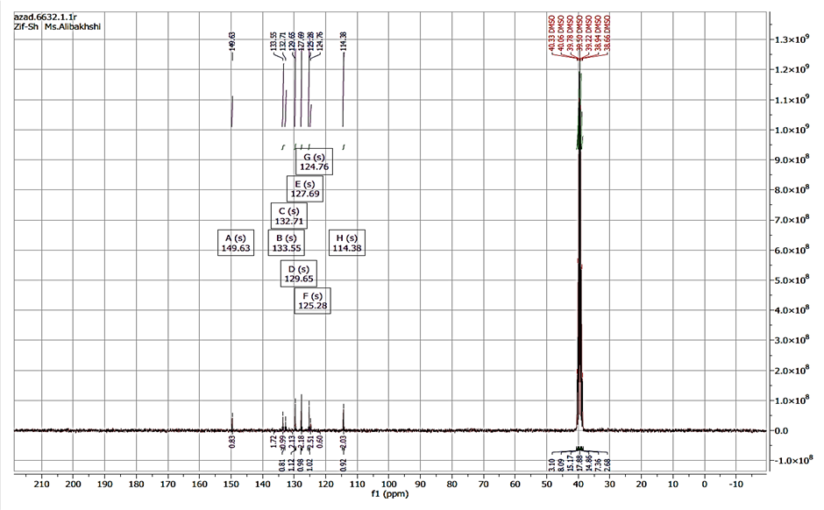

The mass spectra of ZPBIF-1

