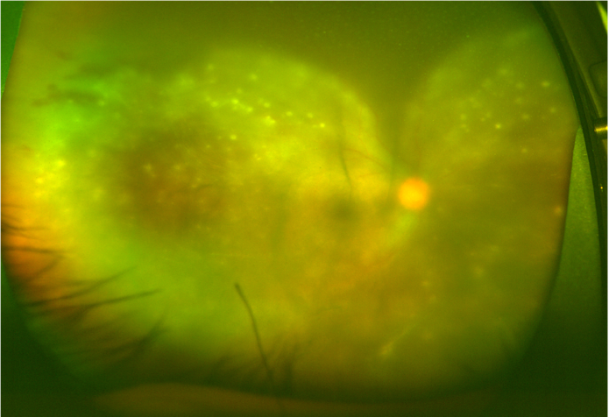

Figure S1. Wide-field fundus photograph demonstrating the feature of opacified retinitis with multiple superficial retinal precipitates.

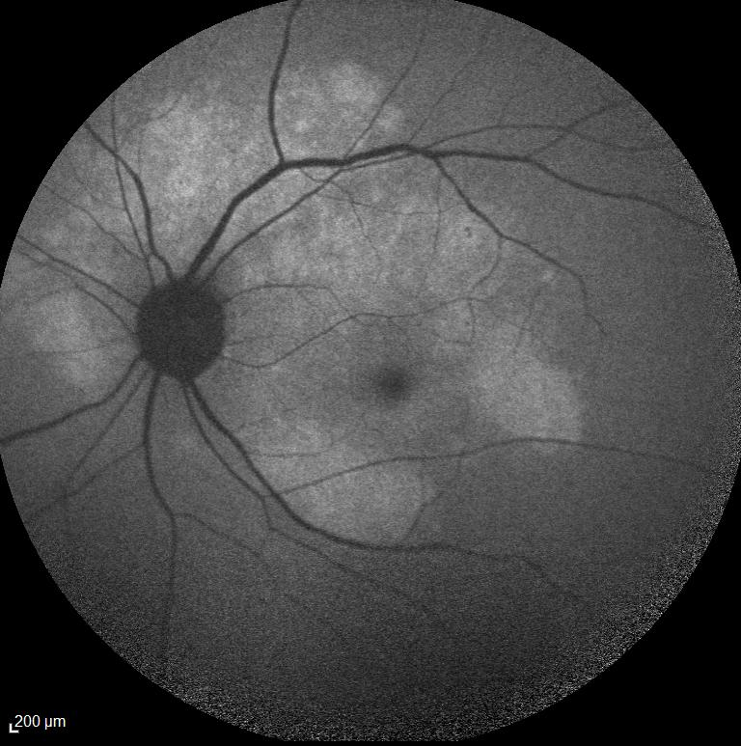

Figure S2. Fundus autofluorescence photo demonstrating area of the posterior placoid chorioretinopathy.

